Name: - Dev Chhawachharia  
Roll Number:- 322014  
PRN:- 22010381  
TY B

## Assignment 4

# AIM: - Write a program using LEX Tool, to implement a lexical analyser for parts of speech in C programming language for English language.

Source code:

%%

[/t ]+ ;

is | am |are |were | was |running |walking |rotating |be {printf("%s: is a verb\n", yytext); }

a |an | the {printf("%s: is an article\n", yytext); }

Earth | Mars | Jupiter | Dev | Ansfred | Nadkarni | Deshpande | Atharva | Prathamesh | Dhroov | Japan | Dubai {printf("%s: is a noun\n", yytext); }

I | i |he | He |she | She | they | They | them | her | him {printf("%s: is a pronoun\n", yytext); }

for |and |but |nor |or |yet |so {printf("%s: is a conjunction\n", yytext); }

in |on |at |over |under |through |above |with |by {printf("%s: is a prepostion\n", yytext); }

good |bad |best |biggest |largest |tallest |fastest {printf("%s: is an adjective\n", yytext); }

quietly |very |yesterday |daily |here {printf("%s: is a adverb\n", yytext); }

[a-zA-Z]+ {printf("%s:Not recognised by this program....\n", yytext);}

%%

main()

{

yylex();

return 0;

}

int yywrap(){return(1);}

(in screenshot form:)

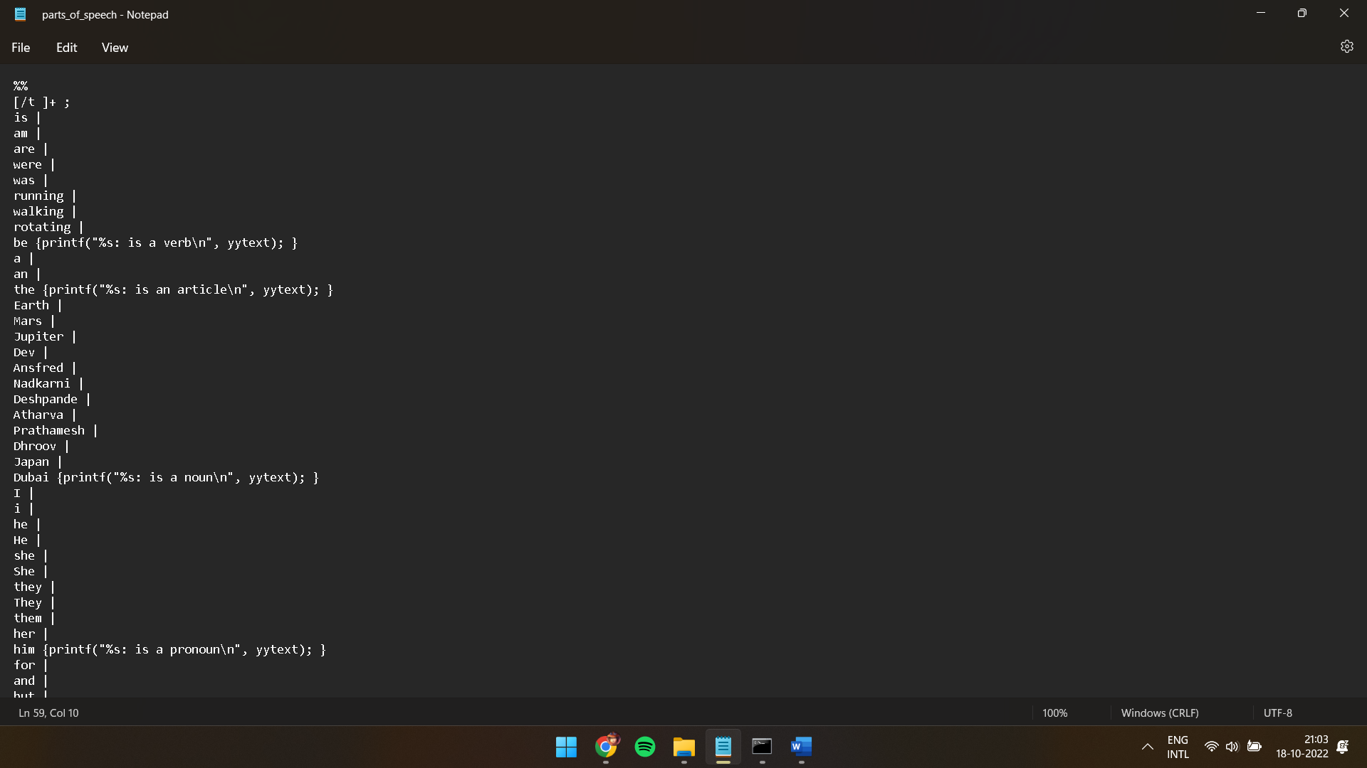

Compilation:

Output:

Input Statement:

Hello, my name is Dev. Some of the facts that I know are , Jupiter is largest planet. The colour of planet Mars is red. Earth is our planet. Some of close friends are Dhroov , Atharva Deshpande , Ansfred , Prathamesh and Atharva Nadkarni. It is very difficult to walk silently in a room at night. The weather here is going crazy. On a daily basis , here we experience all types of seasons.The best thing to do in this weather is to have lots of rest.



Final Output:

