A PROJECT REPORT ON

**“Universal Font Converter”**

FOR

**GMIT**

SUBMITTED IN PARTIAL

FULFILLMENT OF INTERNSHIP

PROJECT

UNDER THE GUIDANCE OF

**Director**

U Ravi Chhabra

**Supervisor**

Daw Htwe Htwe Pyone

**SUBMITTED BY**

Ma Mya Theingi (5cs-63)

Ma Khin Yandar Soe(5cs-67)

Ma Zue Zue Myat Maw (5cs-68)

Ma Thae Ngon Phu(5cs-66)

Ma Ei Thanda Phyo (5cs-62)

Ma Theint Thandar Naing(5cs-64)

**University of Computer Studies (Mandalay)**

**Date 5.9.2018**

Group Members

|  |  |  |  |
| --- | --- | --- | --- |
| Roll No | Name | Signature | Date |
| 5CS-63 | Ma Mya Theingi |  |  |
| 5CS-64 | Ma Theint Thandar Naing |  |  |
| 5CS-62 | Ma Ei Thandar Phyo |  |  |
| 5CS-68 | Ma Zue Zue Myat Maw |  |  |
| 5CS-66 | Ma Thae Ngon Phu |  |  |
| 5CS-67 | Ma Khin Yadanar Soe |  |  |

Project Supervisor Name Signature/Date

Daw Htwe Htwe Pyone

**CONTENTS**

Page Number

Abstract 1

Acknowledgement 2

Declaration 3

List of figures 4

List of tables 5

CHAPTER 1 INTRODUCTION

* 1. Introduction 9
  2. Background 10
     1. HTML 10
     2. CSS 11
     3. Javascript 11
     4. Git 12
     5. Github 13
     6. GitBash 13
     7. Python 14
     8. Pycharm 15
     9. Materalize 16
     10. Heroku 17
  3. Objectives of the project 18

CHAPTER 2 METHODLOGY

2.1 Software selection

2.1.1 Software requirements 19

2.1.2 Hardware requirements 19

2.2 Project plan 20

CHAPTER 3 PROJECT DEVELOPMENT

3.1 Design

3.1.1 Flowchart Diagram 21

3.1.2 Form Design 22

3.2 Implementation

3.2.1 Unicode table& Unicode reference 26

3.2.2 Zawgyi table& Zawgyi reference 33

3.2.3 Wininnwa table& Wininnwa reference 36

3.3 Testing 40

CHAPTER 4 EVALUATION AND CONCLUSION

4.1 Conclusion 46

4.2 Advantages of the project 46

4.3 Limitations of the project 47

4.4 Further extension

4.4.1 References 47

ABSTARCT

Universal Font Converter provide users to easy convert from one font to another font.Zawgyi is not an input method but just a font. The numeric codes used in Zawgyi are not the same as in the Unicode Standard.

Unicode is a computing industry standard for the consistent encoding, representation, and handling of text expressed in most of the world’s writing system.Unicode converter that works for all the availabe ASCII fonts.

Win Myanmar Font system is common in Myanmar for digitally processing Burmese script.By using this project to read easily the words on the online.

ACKNOWLEDGEMENTS

Firstly, we would like to thank to our Professor **U Kyaw Zwa Soe**, rector of the University of Computer Studies (Mandalay) for his permission to submit our project.

Then, we would like to thank our pro-rector **Dr. San San Tint** for her valuable and constructive suggestions during planning and development of this project.

We would like to acknowledge and thank all of my teachers who supported directly or indirectly to finish our project. This project could not have been completed well without their guidance.

And then, we would like to thank our teacher **Dr. Daw Aye Aye Chaw**, professor of Faculty of Software Department, **Dr. Daw Mya Thida Kyaw,** professor of Faculty of Information Science Department and our supervisor **Daw Htwe Htwe Pyone,** lecturer of Faculty of Information Science Department for her great suggestions and supervision throughout the work along this project.

We especially thank and appreciate **U Ravi Chhabra,** Chief Operation Officer GMIT for his trust and guidance and teach certainly such a heavy responsibility in this project.

Then also thanks to other people who support other needs in our project.

DECLARATION

We declare that this project report or part of it was not a copy of a document done by any organization, university any other institute or a previous student project group at Computer University (Mandalay) and was not copied from the internet or other sources.I understand that Plagiarism is an academic offence and if in found to have committed or abetted the offence of plagiarism in relation to this submitted work, disciplinary action will be enforced.

Project Details

|  |  |
| --- | --- |
| Project Title | Universal Font Converter |
| Project ID | Geo Mandalar Investment and Technology |

**List of Figures**

**Figure** **Page**

Figure(1.1) Using HTML in project 10

Figure(1.2) Using CSS in project 11

Figure(1.3) Using Javascript in project 12

Figure(1.4) Using Git in project 12

Figure(1.5) Using Github in project 13

Figure(1.6) Using GitBash in project 14

Figure(1.7) Using Python in project 14

Figure(1.8) Using Pycharm in project 15

Figure(1.9) Using Materalize in project 16

Figure(1.10) Using Heroku in project 17

Figure(3.1) Flowchart Diagram 21

Figure(3.2) Main Page of Universal font converter 22

Figure(3.3) Choose required fonts 23

Figure(3.4)Choose required fonts with mobile 25

Figure(3.5) Convert from ZawGyi to Unicode 39

Figure(3.6) Convert from ZawGyi to Win Innwa 40

Figure(3.7) Convert from Win Innwa to Unicode 41

Figure(3.8) Convert from Win Innwa to ZawGyi 42

Figure(3.9) Convert from Unicode to Win Innwa 43

Figure(3.10) Convert from Unicode to ZawGyi 44

Figure(3.11) Convert from Win Innwa to ZawGyi 45

**List of Tables**

**Table**  **Page**

Table(3.1) Unicode Table 26

Table(3.2) Zawgyi Table 33

Table(3.3) Wininnwa Table 36

**CHAPTER 1**

**INTRODUCTION**

s

* 1. **Introduction**

The Universal Font Converter was created by **Kilo-Mdy-Geo** with funding from the **"Geo Mandalar Investment and Technology".** The objective of the development is to provide the community a tool for converting files between different encoding schemes with different file formats. The converter also can translate script with different encodings to variant Wylie transliterations, and vice versa. **Universal Font Converter (UFC)** has been developed and maintained by GEO. The objective of the development is to provide the community a tool for converting files between different encoding schemes with different file formats. But we played more attention on the conversions from the legacy encoding schemes to the Unicode. The converter also can translate script with different encodings to variant Wylie transliterations, and vice versa. The converter covers 3 different encoding schemes, Unicode, and other languages including:

1.Zawgyi

2.Unicode

3.WinInnwa

4.Other Language

The converter also covers four common file formats including txt, Unicode txt, rich text file format (RTF) and HTML web page. You can convert file between arbitrary two encoding schemes from 16 ones mentioned above with certain file formats. You may download stand-alone version of UFC by click here and install UFC on your local machine. UFC was developed under support from Trace Foundation in 2004. The copyright of the software belongs to the foundation.

**1.2 Background**

* We have to know about the methods, approaches, programming languages and tools in developing the project
* In this project, we use HTML, CSS, Javascript,and Materalize is to draw our web site’s design
* And then, we use Git, Github and Heroku is to post for our working tasks
* We also use Python is to know how write the code
* Finally, we use GitBash and Pycharm is to write for our program code

**1.2.1 HTML**

HTML is the standard markup language for creating Web pages.

* HTML stands for Hyper Text Markup language
* HTML describes the structure of Web pages using markup
* HTML elements are the building blocks of HTML pages
* HTML elements are represented by tags
* HTML tags label pieces of content of such as “heading”, “paragraph”, “table” and so on



Figure (1.1) Using HTML in project

**1.2.2 CSS**

* CSS stands for Cascading Style Sheets
* CSS describes how HTML elements are to be displayed on screen, paper, or in other media
* CSS saves a lot of work. It can control the layout of multiple web pages all at once.
* External style sheets are stored in CSS files
* CSS is independent of HTML and can be used with any XML-based markup language



Figure (1.2) Using CSS in project

**1.2.3 Javascript**

* Javascript is a programming language for the web and used to enhance HTML pages
* Javascript is an interpreted language and doesn’t need to be compiled
* Javascript is supported by most web browsers including Chrome, Firefox, Internet Explorer and so on
* Javascript includes dynamically updating web pages , user interface enhancements such as menus and dialog boxes ,animations,2D, and 3D graphics ,interactive maps, video players and more

 Figure(1.3) Using Javascript in project

**1.2.4 Git**

Git is a free and open source distributed version control system.

* Git is designed to handle everything from small to very large projects with quickly speed and efficiency.
* Git is aimed at speed, data inte grity and supported for distributed, non-linear workflows.



Figure(1.4) Using Git in project

**1.2.5 Github**

* Github is a web-based hosting service for version control using Git
* Github is mostly used for computer code
* Github offers all of the distributed version control and source code management functionality of Git as well as adding its own features



Figure(1.5)Using Github in project

**1.2.6 GitBash**

* GitBash is a bash shell for use on Microsoft Window systems to enable the Git repository functions on that platforms
* GitBash includes the basic operations such as commit, push, pull, fetch and merge
* GitBash focus on the functionality of its commands



Figure(1.6 )Using GitBash in project

**1.2.7 Python**

* Python is an interpreted high-level programming language with dynamic semantics
* Python is a general-purpose programming language that can be used on any modern computer operating systems
* Python can be used for processing text, numbers, images, scientific data and just about anything that you might save on a computer



Figure(1.7) Using Python in project

**1.2.8 Pycharm**

* Pycharm is an integrated development environment used in computer programming, specially for the Python language
* Pycharm is developed by the Czech company JetBrains
* Pycharm is compatible with Windows, Linux and macOs and supported version 2.x and 3.x of Python



Figure(1.8) Using Pycharm in project

**1.2.9 Materalize**

* Materalize is a modern responsive CSS framework based on Materalize Design
* Materalize Design is a design language that combines the classic principles of successful design along with innovation and technology



Figure(1.9)Using Materalize in project

**1.2.10 Heroku**

* Heroku is a cloud platform as a service supporting several programming languages
* Heroku is so easy to use that it is a top choice for many projects
* Heroku platform manages hardware and servers, businesses that use Heroku are able to focus on perfecting their apps



Figure(1.10) Using Heroku in project

**1.3 Objectives of the project**

* To provide the community a tool for converting files between different languages.
* To attention on the conversions from the legacy encoding schemes to the unicode.
* To translate this language each other.
* To help the users for using the different language

**CHAPTER(2)**

**METHODOLOGY**

**2.1 Software selection**

**2.1.1 Software Requirements**

* Python 3.6(64-bit)
* JetBrains Pycharm Community Edition 2018.1.4
* Heroku CLI
* Git Bash
* Github Desktop
* Skype
* Messenger

**2.1.2 Hardware Requirements**

* Android phones
* Internet access
* PC with Window OS

**2.2 Project plan**

|  |  |  |  |  |  |  |  |
| --- | --- | --- | --- | --- | --- | --- | --- |
| Development  Phase | 1-7  Day | 8-14  Day | 15-21  Day | 22 -28  Day | 29 -35 Day | 36- 45 Day | Duration |
| Analysis |  |  |  |  |  |  | 5 |
| Documentation |  |  |  |  |  |  | 9 |
| Design |  |  |  |  |  |  | 21 |
| Coding |  |  |  |  |  |  | 26 |
| Testing |  |  |  |  |  |  | 6 |
| Total Time |  |  |  |  |  |  | 45 |

**CHAPTER 3**

**PROJECT DEVELOPMENT**

**3.1 Design**

**3.1.1 Flowchart Diagram**

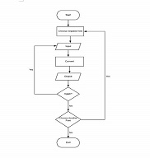

Figure(3.1) Flowchart Diagram

**3.1.2 Form Design**

**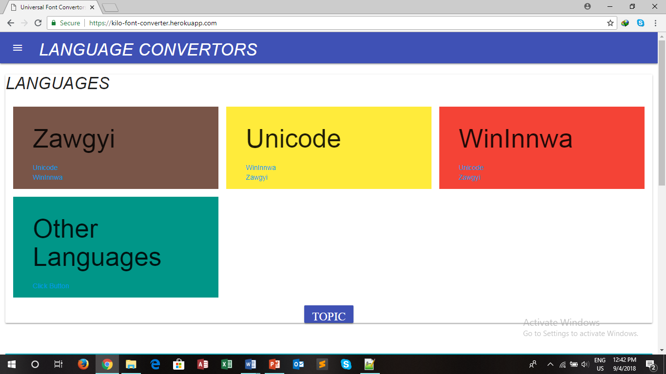With laptop version**

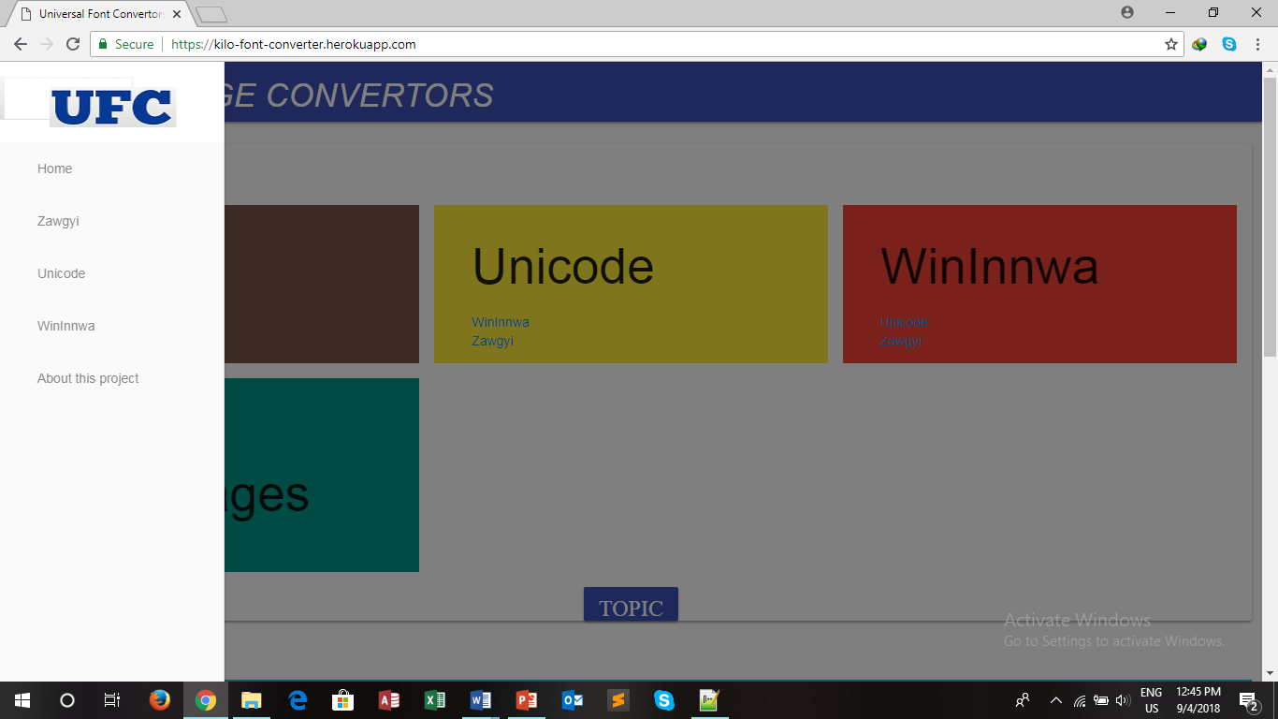

Figure (3.2) Main Page of Universal font converter

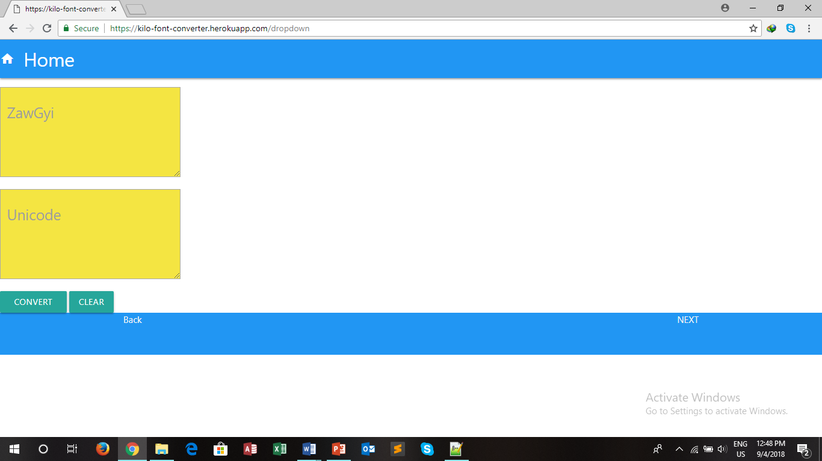

Figure(3.3) Choose required fonts

**With Mobile Version**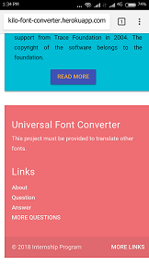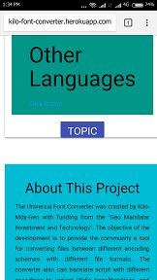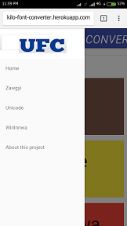

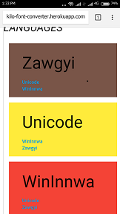

Figure(3.4)Choose required font with Mobile Version

**3.2 Implementation**

**3.2.1 Unicode table& Unicode reference**

**Table(3.1) Unicode Table**

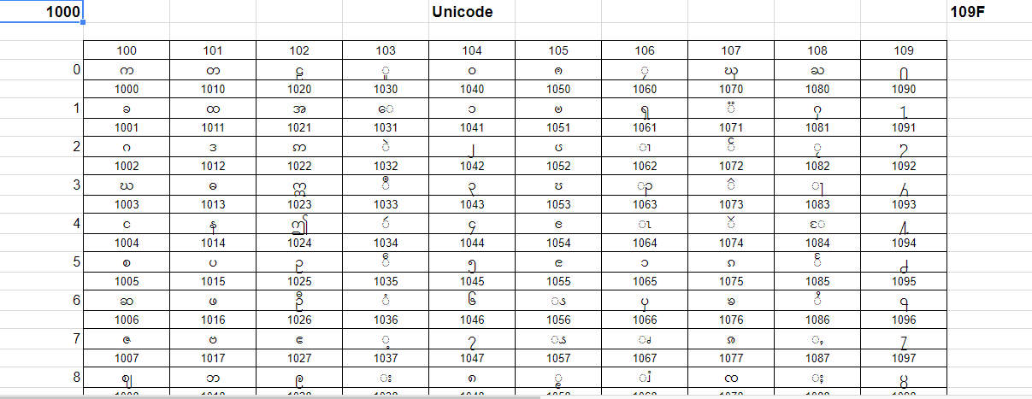

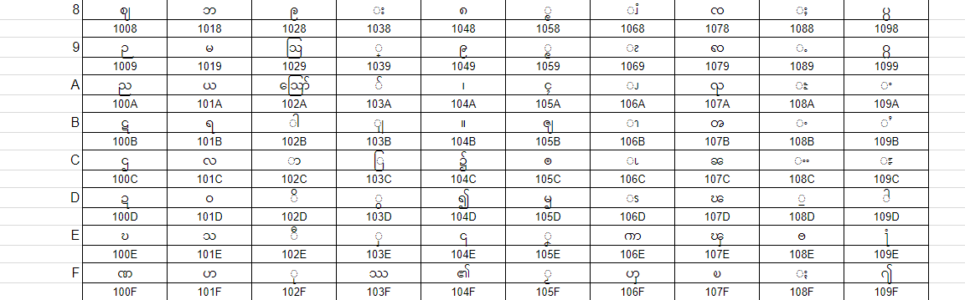

**Unicode reference**

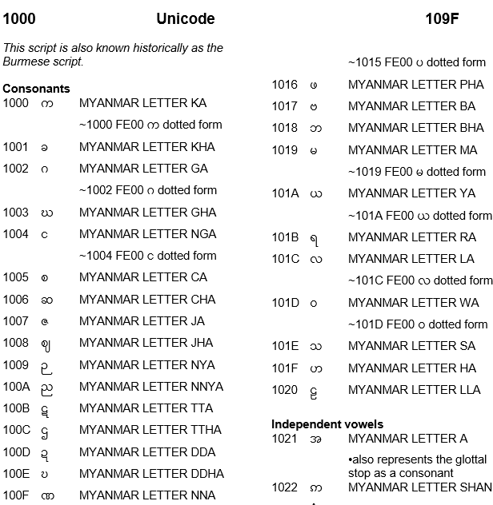

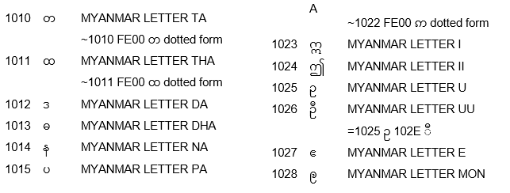

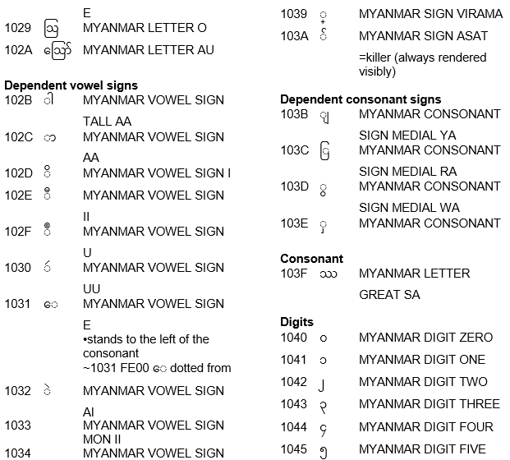

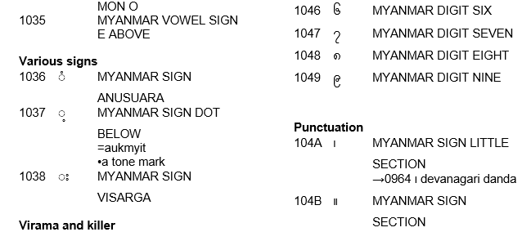

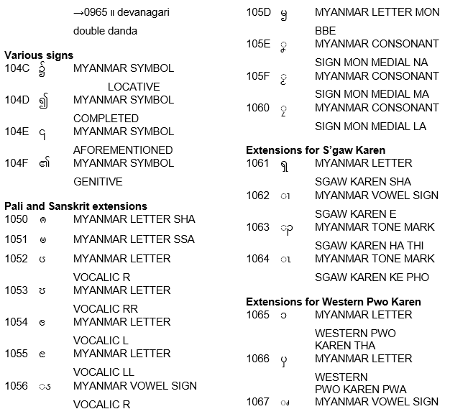

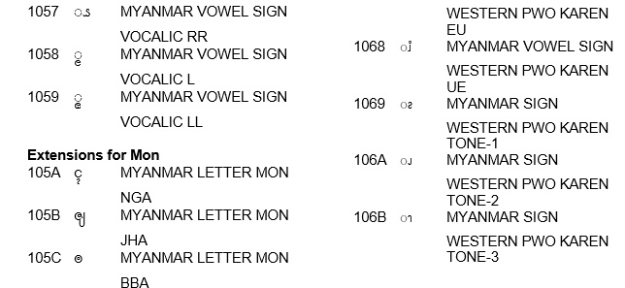

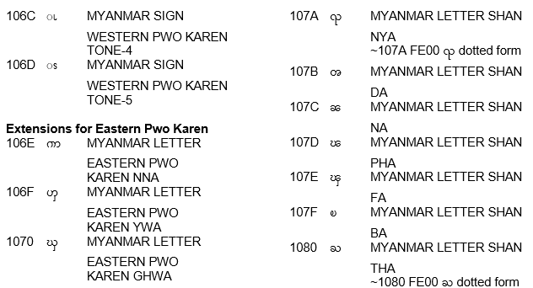

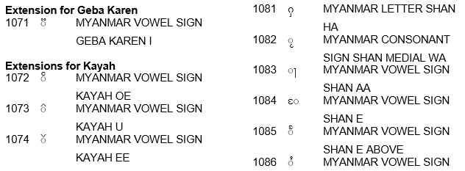

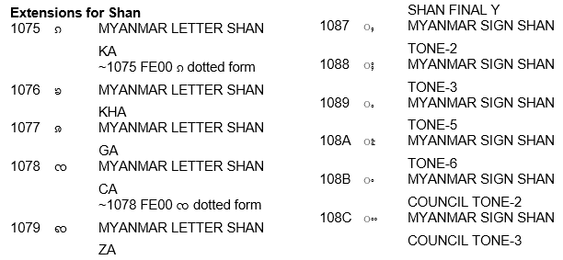

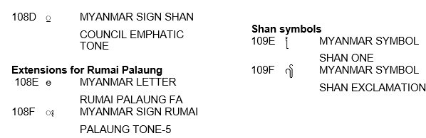

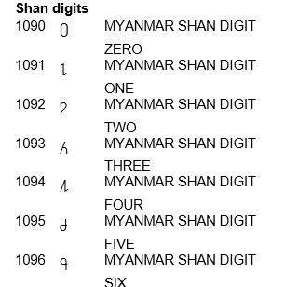

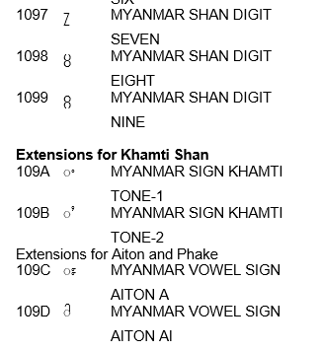

**3.2.2 Zawgyi table& Zawgyi reference**

**Table(3.2) Zawgyi Table**

|  |  |  |  |  |  |  |  |  |  |  |  |
| --- | --- | --- | --- | --- | --- | --- | --- | --- | --- | --- | --- |
|  | 100 | 101 | 102 | 103 | 104 | 105 | 106 | 107 | 108 | 109 | |
| 0 | က | တ | ဠ | ူ | ၀ | ------ | ၠ | ၰ | ႀ | ႐ | |
|  | 1000 | 1010 | 1020 | 1030 | 1040 | 1050 | 1060 | 1070 | 1080 | 1090 | |
| 1 | ခ | ထ | အ | ေ | ၁ | ------ | ၡ |  | ႁ | ႑ | |
|  | 1001 | 1011 | 1021 | 1031 | 1041 | 1051 | 1061 | 1071 | 1081 | 1091 | |
| 2 | ဂ | ဒ | ------- | ဲ | ၂ | ------- | ၢ | ၲ | ႂ | ႒ | |
|  | 1002 | 1012 | 1022 | 1032 | 1042 | 1052 | 1062 | 1072 | 1082 | 1092 | |
| 3 | ဃ | ဓ | ဣ | ဳ | ၃ | ----- | ၣ | ၳ | ႃ | ႓ | |
|  | 1003 | 1013 | 1023 | 1033 | 1043 | 1053 | 1063 | 1073 | 1083 | 1093 | |
| 4 | င | န | ဤ | ဴ | ၄ | ---- | ၤ | ၴ | ႄ | ႔ | |
|  | 1004 | 1014 | 1024 | 1034 | 1044 | 1054 | 1064 | 1074 | 1084 | 1094 | |
| 5 | စ | ပ | ဥ | ------- | ၅ | ------ | ၥ | ၵ | ႅ | ႕ | |
|  | 1005 | 1015 | 1025 | 1035 | 1045 | 1055 | 1065 | 1075 | 1085 | 1095 | |
| 6 | ဆ | ဖ | ဦ | ံ | ၆ | ------ | ၦ | ၶ | ႆ | ႖ | |
|  | 1006 | 1016 | 1026 | 1036 | 1046 | 1056 | 1066 | 1076 | 1086 | 1096 | |
| 7 | ဇ | ဗ | ဧ | ့ | ၇ | ----- | ၧ | ၷ | ႇ | ႗ | |
|  | 1007 | 1017 | 1027 | 1037 | 1047 | 1057 | 1067 | 1077 | 1087 | 1097 | |
| 8 | ဈ | ဘ | -------- | း | ၈ | ----- | ၨ | ၸ | ႈ | ------------- | |
|  | 1008 | 1018 | 1028 | 1038 | 1048 | 1058 | 1068 | 1078 | 1088 | 1098 | |
| 9 | ဉ | မ | ဩ | ် | ၉ | ------ | ၩ | ၹ | ႉ | --------------- | |
| ` | 1009 | 1019 | 1029 | 1039 | 1049 | 1059 | 1069 | 1079 | 1089 | 1099 |
| A | ည | ယ | ဪ | ျ | ၊ | ၚ | ၪ | ၺ | ႊ | ------------ | |
|  | 100A | 101A | 102A | 103A | 104A | 105A | 106A | 107A | 108A | 109A | |
| B | ဋ | ရ | ါ | ြ | ။ | ----- | ၫ | ၻ | ႋ | ------------- | |
|  | 100B | 101B | 102B | 103B | 104B | 105B | 106B | 107B | 108B | 109B | |
| C | ဌ | လ | ာ | ွ | ၌ | ----- | ၬ | ၼ | ႌ | ----------- | |
|  | 100C | 101C | 102C | 103C | 104C | 105C | 106C | 107C | 108C | 109C | |
| D | ဍ | ဝ | ိ | ွ | ၍ | ----- | ၭ | ၽ | ႍ | ----------- | |
|  | 100D | 101D | 102D | 103D | 104D | 105D | 106D | 107D | 108D | 109D | |
| E | ဎ | သ | ီ | ------ |  | ----- | ၮ | ၾ | ႎ | ---------- | |
|  | 100E | 101E | 102E | 103E | 104E | 105E | 106E | 107E | 108E | 109E | |
| F | ဏ | ဟ | ု | ----- | ၏ | ------ | ၯ | ၿ | ႏ | ------------ | |
|  | 100F | 101F | 102F | 103F | 104F | 105F | 106F | 107F | 108F | 109F | |
|  |  |  |  |  |  |  |  |  |  |  | |
|  |  |  |  |  |  |  |  |  |  |  | |

**Zawgyi reference**

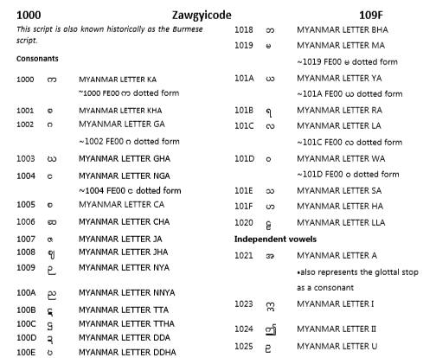

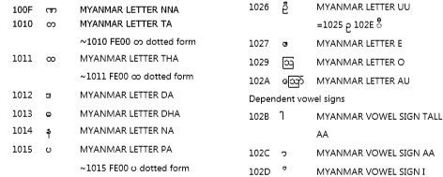

C:\Users\Windows10\Pictures\Saved Pictures\received_1845894615489791 (3).png

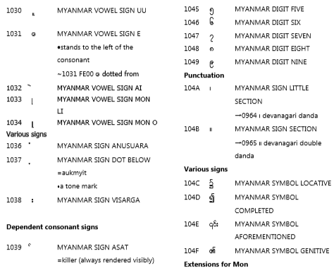

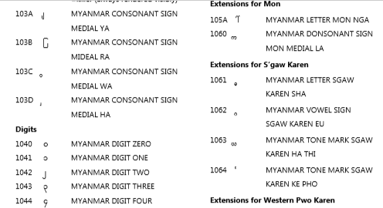

**3.2.3 Wininnwa table& Wininnwa reference**

**Table(3.3) Wininnwa table**

|  |  |  |  |  |  |  |  |  |  |
| --- | --- | --- | --- | --- | --- | --- | --- | --- | --- |
|  | 1 | 2 | 3 | 4 | 5 | 6 | 7 | 8 | 9 |
| 1 | !  U+0021 | 5  U+0035 | I  U+0049 | ]  U+005D | q  U+0071 | ¦  U+00A6 | À  U+00C0 | á  U+00E1 | þ  U+00FE |
| 2 | ‘"  U+0022 | 6  U+0036 | J  U+004A | ^  U+005E | r  U+0072 | §  U+00A7 | Á  U+00C1 | â  U+00E2 | Š  U+0160 |
| 3 | ‘#  U+0023 | 7  U+0037 | K  U+004B | \_  U+005F | s  U+0073 | ¨  U+00A8 | Â  U+00C2 | ã  U+00E3 | ƒ  U+0192 |
| 4 | ‘$  U+0024 | 8  U+0038 | L  U+004C | `  U+0060 | t  U+0074 | ©  U+00A9 | Ã  U+00C3 | ä  U+00E4 | ˆ  U+02C6 |
| 5 | ‘‘%  U+0025 | 9  U+0039 | M  U+004D | a  U+0061 | u  U+0075 | ª  U+00AA | Ä  U+00C4 | å  U+00E5 | μ  U+03BC |
| 6 | &  U+0026 | :  U+003A | N  U+004E | b  U+0062 | v  U+0076 | «  U+00AB | Å  U+00C5 | æ  U+00E6 | ‐  U+2010 |
| 7 | '  U+0027 | ;  U+003B | O  U+004F | c  U+0063 | w  U+0077 | ¬  U+00AC | Æ  U+00C6 | ç  U+00E7 | ‘  U+2018 |
| 8 | (  U+0028 | <  U+003C | P  U+0050 | d  U+0064 | x  U+0078 | ®  U+00AE | Ç  U+00C7 | è  U+00E8 | ’  U+2019 |
| 9 | )  U+0029 | =  U+003D | Q  U+0051 | e  U+0065 | y  U+0079 | °  U+00B0 | É  U+00C9 | é  U+00E9 | ‚  U+201A |
| 10 | \*  U+002A | >  U+003E | R  U+0052 | f  U+0066 | z  U+007A | ²  U+00B2 | Í  U+00CD | ê  U+00EA | „  U+201E |
| 11 | +  U+002B | ?  U+003F | S  U+0053 | g  U+0067 | {  U+007B | ³  U+00B3 | Ð  U+00D0 | í  U+00ED | †  U+2020 |
| 12 | ,  U+002C | @  U+0040 | T  U+0054 | h  U+0068 | |  U+007C | ´  U+00B4 | Ñ  U+00D1 | ð  U+00F0 | ‡  U+2021 |
| 13 | -  U+002D | A  U+0041 | U  U+0055 | i  U+0069 | }  U+007D | µ  U+00B5 | Ó  U+00D3 | ñ  U+00F1 | …  U+2026 |
| 14 | .  U+002E | B  U+0042 | V  U+0056 | j  U+006A | ~  U+007E | ¶  U+00B6 | Ö  U+00D6 | ó  U+00F3 | ‰  U+2030 |
| 15 | /  U+002F | C  U+0043 | W  U+0057 | k  U+006B | U+00A0 | ¹  U+00B9 | ×  U+00D7 | ö  U+00F6 | ‹  U+2039 |
| 16 | 0  U+0030 | D  U+0044 | X  U+0058 | l  U+006C | ¡  U+00A1 | »  U+00BB | Ø  U+00D8 | ÷  U+00F7 |  |
| 17 | 1  U+0031 | E  U+0045 | Y  U+0059 | m  U+006D | ¢  U+00A2 | ¼  U+00BC | Ú  U+00DA | ø  U+00F8 |  |
| 18 | 2  U+0032 | F  U+0046 | Z  U+005A | n  U+006E | £  U+00A3 | ½  U+00BD | Ü  U+00DC | ú  U+00FA |  |
| 19 | 3  U+0033 | G  U+0047 | [  U+005B | o  U+006F | ¤  U+00A4 | ¾  U+00BE | ß  U+00DF | û  U+00FB |  |
| 20 | 4  U+0034 | H  U+0048 | \  U+005C | p  U+0070 | ¥  U+00A5 | ¿  U+00BF | à  U+00E0 | ü  U+00FC |  |

**Wininnwa reference**

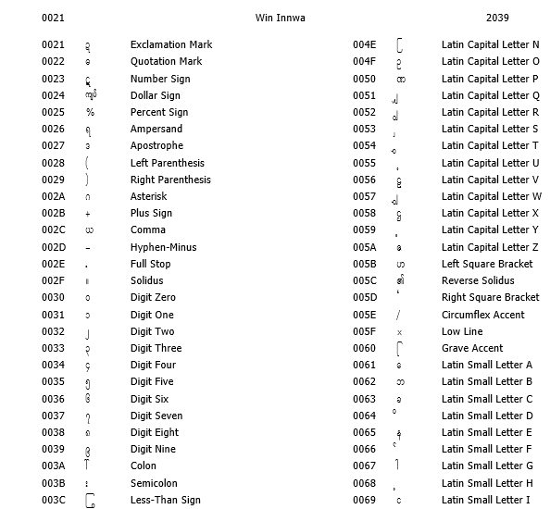

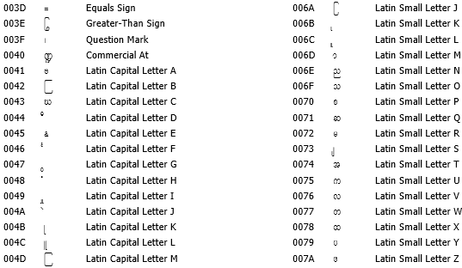

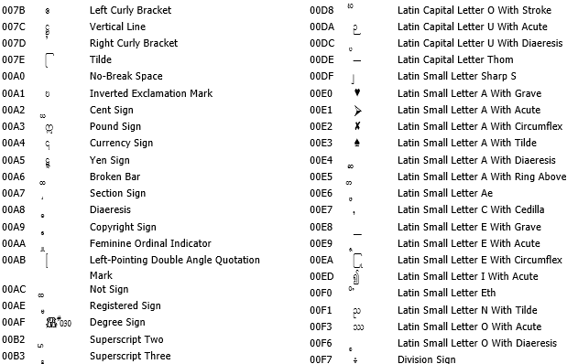

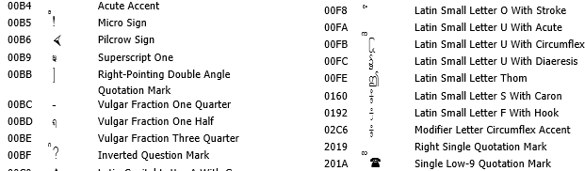

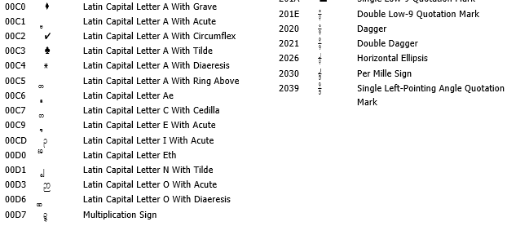

**3.3 Testing**

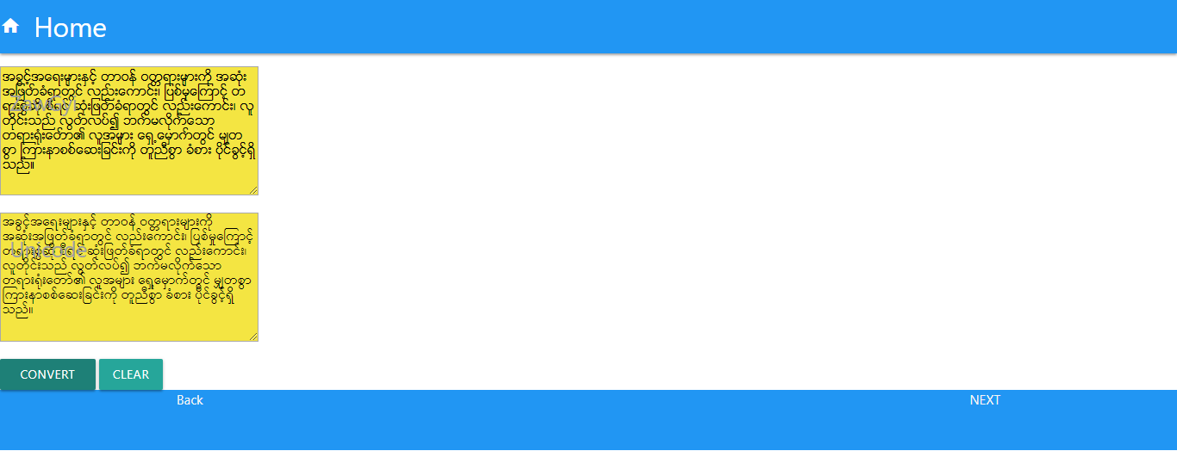

Figure (3.6) Convert from ZawGyi to Unicode

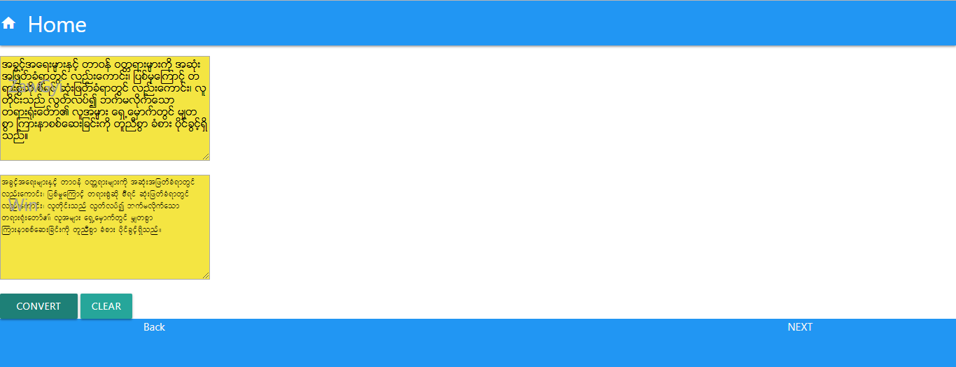

Figure (3.7) Convert from ZawGyi to WinInnwa

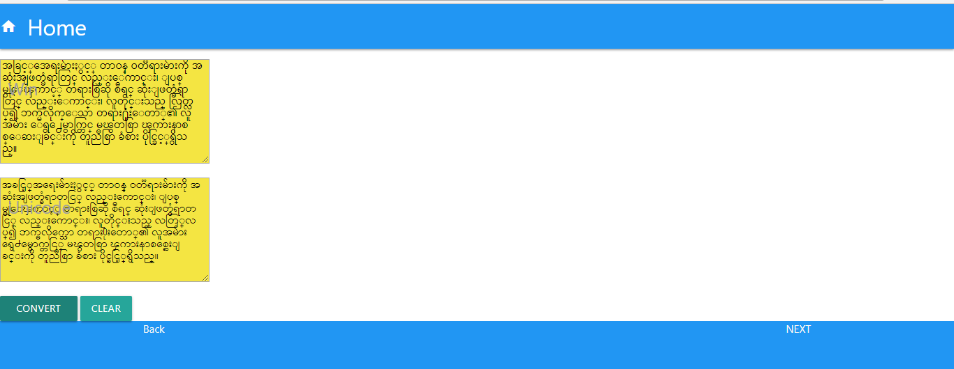

Figure (3.8) Convert from WinInnwa to Unicode

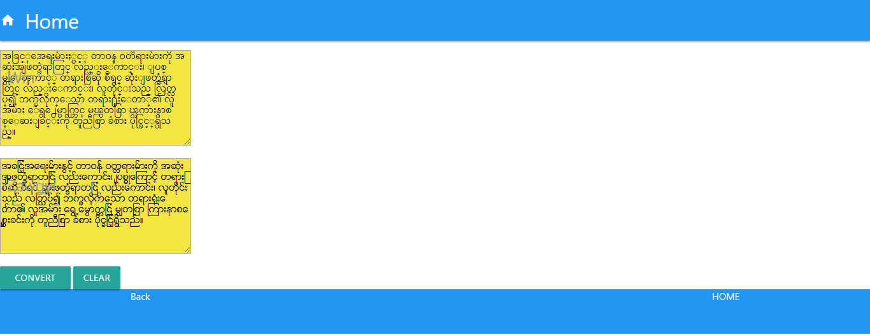

Figure (3.9) Convert from WinInnwa to ZawGyi

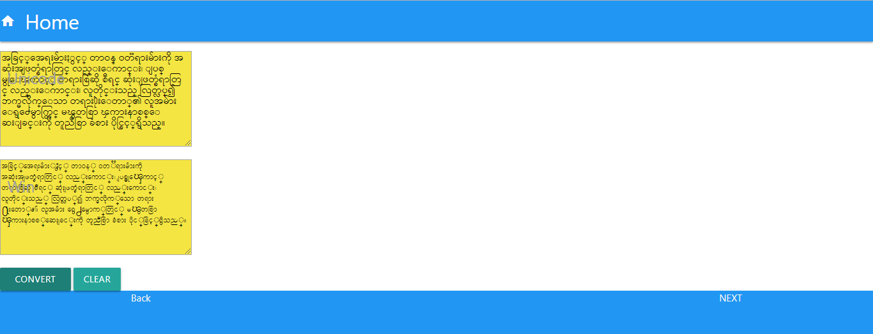

Figure (3.10) Convert from Unicode to Win Innwa

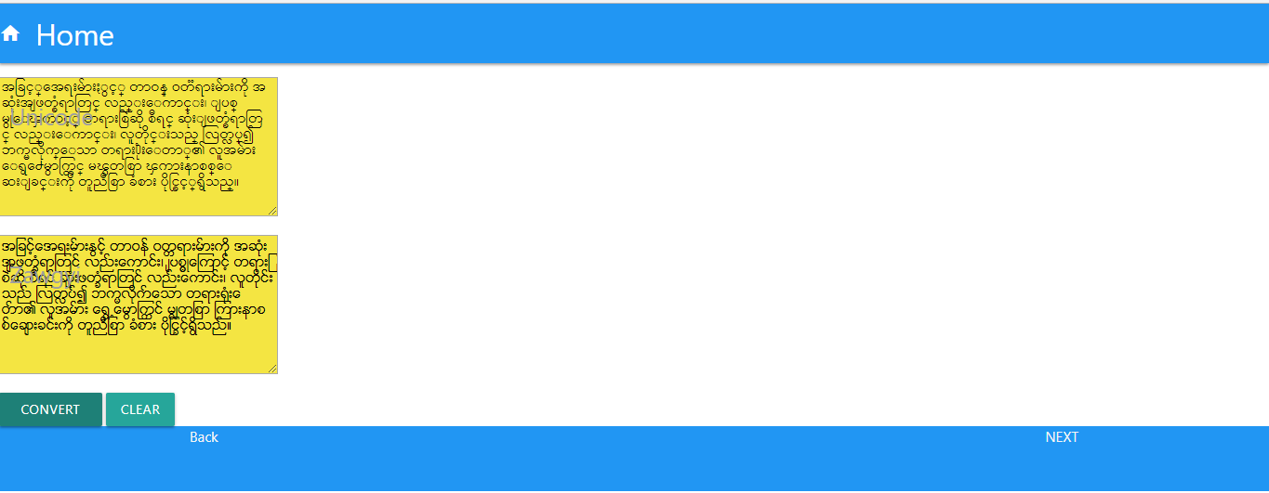

Figure (3.11) Convert from Unicode to ZawGyi

**CHAPTER 4**

**EVALUATION AND CONCLUSION**

**4.1 Conclusion**

In this project, we presented word segmentation program for Myanmar text based on World Wide Web. Then, we presented both word level and character level by this program. The program performed segmentation work well and proved itself to be used as a practical word. For future task, we plan to extend our program by converting all possible Myanmar words. It is hope that this project will give benefits for our Myanmar language development tasks.

**4.2 Advantages of the project**

* Font converter utility help format portability and compatibility that servers the purpose of using conversion from one font to another.
* In the present scenario, interchangeable formats are more in demand and software developers around the world need utilities that can convert files from one font to another easily and without too much difficulty.
* This is where the font converter utility comes into the play and the benefits of using the same are required.
* Furthermore, many of the users (example; IT Technicians, Typists and Staffs in Literature teams) use the converted files to store and retrieve data whenever they needed.
* This helps files restoring of files at one’s convenience making life easier for everyone in the processes.

**4.3 Limitations of the project**

* Although Unicode is an international language, it cannot be used easily and understood for everyone.
* Although some of the code-points in Zawgyi are similar to the Myanmar scripts as encoded in Unicode, the font does not correspond to the correct Unicode encoding and therefore is incompatible.
* In WinInnwa, many of us cannot remember all the alphabets on the keys which one contains four alphabets so it is very hard to recognize all of them. Therefore, WinInnwa Keyboard Layout is a handy one to reply on.

**4.4 Further extension**

**4.4.1 References**

* [www.wikipedia.com](http://www.wikipedia.com)
* <http://materialize.css.com>
* <http://getmdl.com>
* <http://lostfoodsteps.org/my/>
* <http://www.yunkey9.com>
* <http://www.herokuapp.com>
* <https://en.bem.info/>
* <https://en.bem.info/methodlogy/key-concepts/>
* UDHR-ZG.txt
* UDHR-UNI.txt
* UDHR-WIN.txt
* Windows-commdline-cheat-sheet.pdf
* Learn-PYTHON 2-the Hard way.pdf
* Learn-PYTHON 3-the Hard way.pdf
* Learning –Flask-Framework.pdf
* https://github.com/cloudnative/ufc/blob/master/resources/

**Our project link**

**https://kilo-font-converter.herokuapp.com**

**Thanks For Your Attentations!**