1.程序结构：

当前628默认频点模式采用客户分离的结构，即通过继承来区分不同的客户。如下图

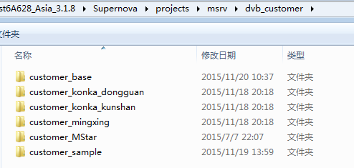

Dtv

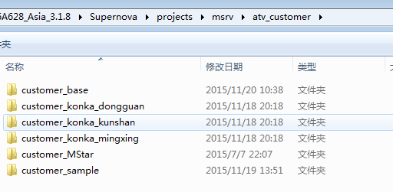

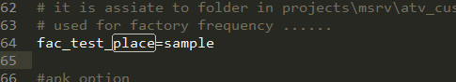

客制化脚本中要定义fac_test_place这个变量，然后再atv_customer和dvb_customer中添加对应的文件夹,命名规则是’customer_’加上定义的名字,如上图的sample，然后把customer_sample下的内容复制过去。

Customer_sample是定义的模版程序，里面只定义了结构，没有默认的频点。

2. dtv默认频点

在msrv_DTV_Player_DVBT.cpp中定义了鼎科的默认频点代码部分如下

|  |
| --- |
| ST_Default_FREQ_INFO_DVB_T DefaultFreqDVB_T[]=  {  #if(FACTORY_TEST_FREQ_DVBT2_6M == 1)  {  {0,0,28,4,9,13,0,0,23334,0,1,1,0,0,0,0,0,0,0,0,1,0,0,0,1,0,2,0,0,0,1,201,201,1,255,255,0,4220,16768,65535,255,255,255,202,0,"Moving Picture"},  {0,0,0,16384,9018,12307,0,24,491000,0,0,0,0,65535,0,0,1,0,0,0},  },  {  {0,0,28,4,9,13,0,0,23334,0,1,1,0,0,0,0,0,0,0,0,1,0,0,0,1,0,2,0,0,0,1,221,221,2,255,255,0,4284,16832,65535,255,255,255,222,0,"Monoscope"},  {0,0,0,16384,9018,12307,0,24,491000,0,0,0,0,65535,0,0,1,0,0,0},  },  {  {0,0,28,4,9,13,0,0,23334,0,1,1,0,0,0,0,0,0,0,0,1,0,0,0,1,0,2,0,0,0,1,281,281,3,255,255,0,4412,16960,65535,255,255,255,282,0,"Color Bar"},  {0,0,0,16384,9018,12307,0,24,491000,0,0,0,0,65535,0,0,1,0,0,0},  },  #endif  #if(FACTORY_TEST_FREQ_DVBT_6M == 1)  #endif  #if(FACTORY_TEST_FREQ_DVBT_8M == 1)  #endif  /* factory */  #if(FACTORY_TEST_FREQ_ISDB_T == 1)  {  {0,0,0,0,0,255,0,0,17252,0,1,1,0,0,0,0,0,0,0,0,2,0,0,0,1,0,0,0,0,0,0,1536,1024,1,2,0,0,8136,1416,65535,255,255,255,1280,3," test1"},  {0,0,0,32737,32737,32737,0,10,195143,0,0,0,0,65535,0,0,1,0,0,0},  },  {  {0,0,0,0,0,255,0,0,17252,0,1,1,0,0,0,0,0,0,0,0,1,0,0,0,1,0,0,0,0,0,0,768,256,2,2,0,0,80,1032,65535,255,255,255,512,3," test2"},  {0,0,0,32737,32737,32737,0,10,195143,0,0,0,0,65535,0,0,1,0,0,0},  },  #endif  {  {0},  {0},  },  }; |

代码必需已0结束，如上图红色部分。通过宏（如FACTORY_TEST_FREQ_DVBT2_6M）来选择默认频点类型，该宏在脚本中定义，如下

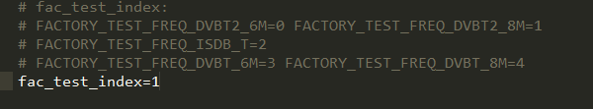

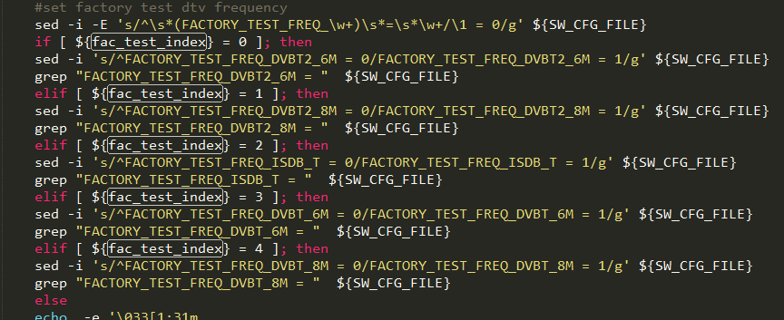

客户默认频点在dvb_customer文件夹下定义，文件为MSrv_DTV_Player_DVBT_Customer.cpp

代码部分为

|  |
| --- |
| ST_Default_FREQ_INFO_DVB_T CustomDefaultFreqDVB_T[]=  {  #if(FACTORY_TEST_FREQ_DVBT2_6M == 1)  #endif  #if(FACTORY_TEST_FREQ_DVBT_6M == 1)  #endif  #if(FACTORY_TEST_FREQ_DVBT_8M == 1)  #endif  #if(FACTORY_TEST_FREQ_ISDB_T == 1)  /* isdb ch43 647.143MHZ*/  {  {0,0,2,1,2,2,0,0,65535,0,1,1,0,0,0,0,0,0,0,0,2,0,0,0,1,0,2,0,0,0,1,511,259,1,13,0,0,32,59264,65535,255,255,255,256,3,"BAND HDTV"},  {0,0,0,1852,1852,1852,0,43,647143,0,0,0,0,65535,0,0,1,0,0,0},  },  #endif  {  {0},  {0},  },  }; |

同样是用宏来控制默认频点的类型

3.ATV默认频点

鼎科默认频点，文件msrv_atv_player.cpp

|  |
| --- |
| #if(COLUMBIA_NTSC_SYSTEM_ENABLE==0)  ST_Default_FREQ_INFO_PAL DefaultFreqPAL[]=  {  //{527250,E_AUDIOSTANDARD_BG_,E_MAPI_VIDEOSTANDARD_PAL_BGHI},  //{535250,E_AUDIOSTANDARD_BG,E_MAPI_VIDEOSTANDARD_PAL_BGHI},  //{551250,E_AUDIOSTANDARD_I,E_MAPI_VIDEOSTANDARD_PAL_BGHI},  //{759250,E_AUDIOSTANDARD_I,E_MAPI_VIDEOSTANDARD_NTSC_M}  {55250,E_AUDIOSTANDARD_BG,E_MAPI_VIDEOSTANDARD_PAL_BGHI},  {65750,E_AUDIOSTANDARD_DK,E_MAPI_VIDEOSTANDARD_PAL_BGHI},  {0},  };  #else  ST_Default_FREQ_INFO_NTSC air_table[]=  {  {55250,E_AUDIOSTANDARD_M,E_MAPI_VIDEOSTANDARD_NTSC_M, 2},  {61250,E_AUDIOSTANDARD_M,E_MAPI_VIDEOSTANDARD_NTSC_M, 3},  {100,E_AUDIOSTANDARD_M,E_MAPI_VIDEOSTANDARD_PAL_BGHI, 30},  {801250,E_AUDIOSTANDARD_M,E_MAPI_VIDEOSTANDARD_NTSC_M, 69},  {0},  };  ST_Default_FREQ_INFO_NTSC cable_table[]=  {  {73250,E_AUDIOSTANDARD_M,E_MAPI_VIDEOSTANDARD_NTSC_M, 1},  {55250,E_AUDIOSTANDARD_M,E_MAPI_VIDEOSTANDARD_NTSC_M, 2},  {100,E_AUDIOSTANDARD_M,E_MAPI_VIDEOSTANDARD_PAL_BGHI, 100},  {799250,E_AUDIOSTANDARD_M,E_MAPI_VIDEOSTANDARD_NTSC_M, 125},  {0},  };  #endif |

宏COLUMBIA_NTSC_SYSTEM_ENABLE选择是pal或者是ntsc，结束位置为0，如上图。

客户默认频点，atv_customer文件夹下客户对应文件夹，文件MSrv_ATV_Player_Customer.cpp。代码如下

|  |
| --- |
| #if(COLUMBIA_NTSC_SYSTEM_ENABLE==0)  ST_Default_FREQ_INFO_PAL CusDefaultFreqPAL[]=  {  //{527250,E_AUDIOSTANDARD_BG_,E_MAPI_VIDEOSTANDARD_PAL_BGHI},  {0},////end flag  };  #else  ST_Default_FREQ_INFO_NTSC cus_air_table[]=  {  //{55250,E_AUDIOSTANDARD_M,E_MAPI_VIDEOSTANDARD_NTSC_M, 2},  {0},////end flag  };  ST_Default_FREQ_INFO_NTSC cus_cable_table[]=  {  //{73250,E_AUDIOSTANDARD_M,E_MAPI_VIDEOSTANDARD_NTSC_M, 1},  {0},////end flag  };  #endif |

以0为结束点