FOR 338 S/W UPGRADEING

1, put the messi.bin file into the Root of a USB pen drive. Connect the USB pen dirve to the USB2.0 port of the TV set.

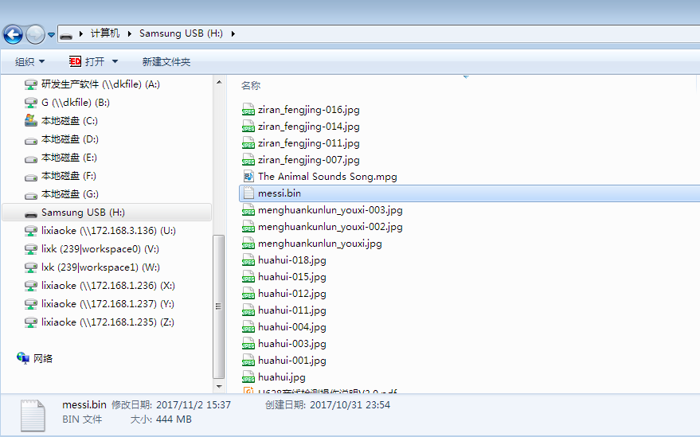

Root of a USB Device

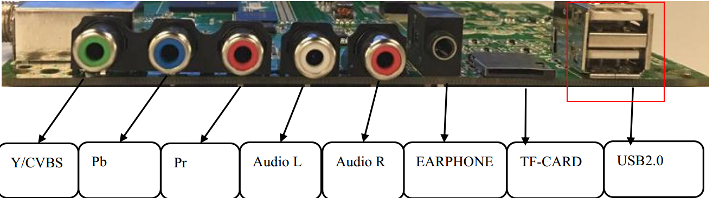

Use the USB2.0 port marked in red box

2, Normally, there are two different methods to upgrade the s/w for the smart TV.

2-1, Keep the TV set in standby mode, press and hold the power key for a while(you can wait till there is upgrading OSD in the screen and the LED start flashing).

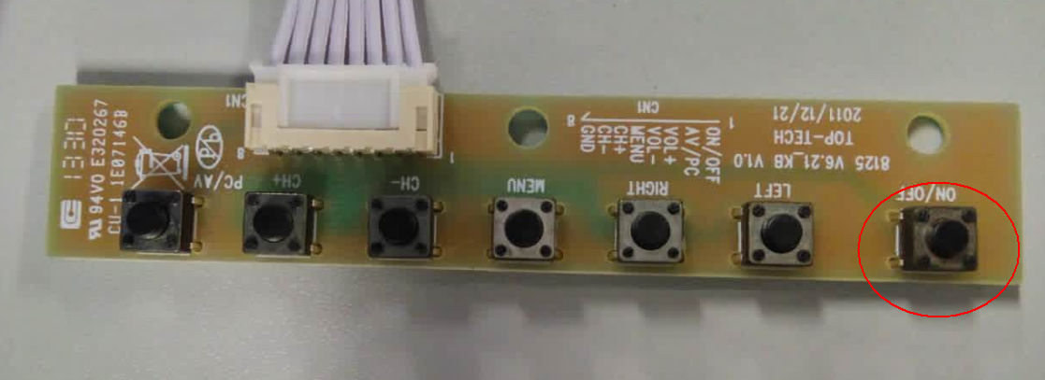

Power key has been marked in RED cycle.

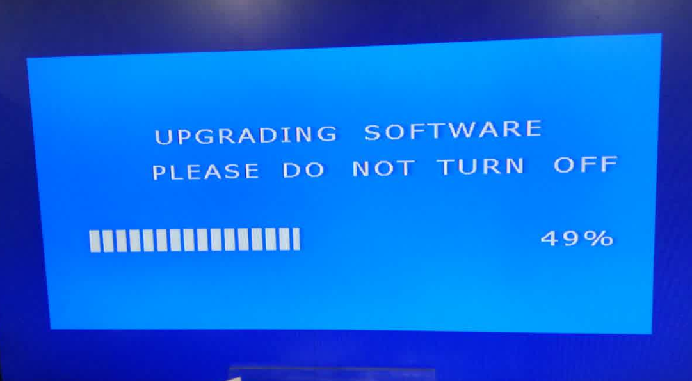

Upgrading OSD

2-2, Select the update option in factory menu OSD.

2-2-1, Press Menu then input 1201 with the Main Menu OSD in the screen, it will bring out the factory OSD.

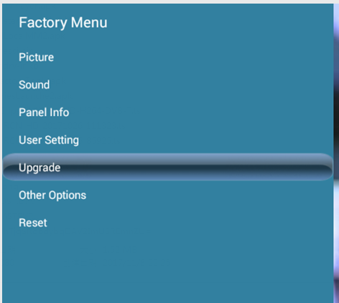

Factory menu OSD

2-2-2, Select the Upgrade item and you can see the Upgrade page, in which please select the Upgrade Main item.

Showing as below:

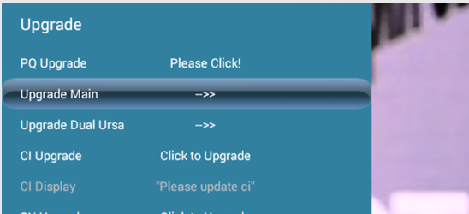

Upgrade page

2-2-3, Select Confirm button in coming OSD. The TV set will go into standby mode. Press power key (in remote or keyboard) to wake up the TV set, it will start the upgrading process.



Upgrade confirming

When it start the upgrading there will be upgrading progress bar in the screen and the LED will keep flashing.

Note: Please don`t switch off the TV set during s/w upgrading process otherwise the tv system will be breakdown.