FOR S/W UPGRADE

1, put the MstarUpgrade.bin file in the Root of a pen drive. Connect the pen drive to the USB2.0 port of the TV set..

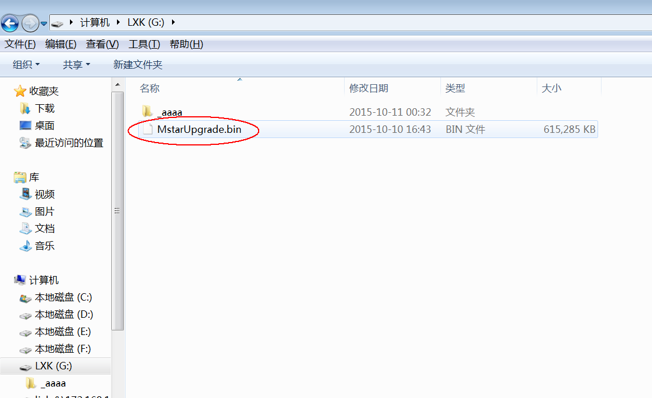

Root of a USB Device

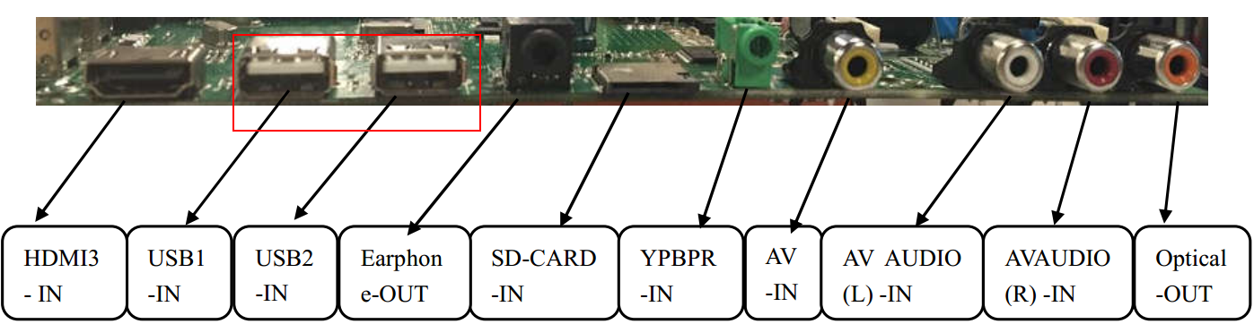

Use the USB2.0 port marking in red circle

2, There are two different methods to upgrade the software for the smart TV.

2-1, Keep the TV set in standby mode, press and hold the power key in the keypad for a while(Can wait till there is upgrading OSD in the screen and the LED will keep flashing).

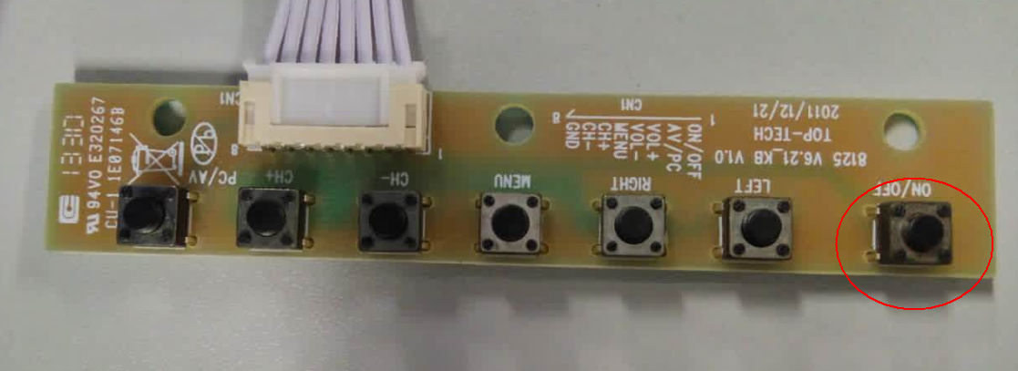

Power key marking in RED cycle for information.

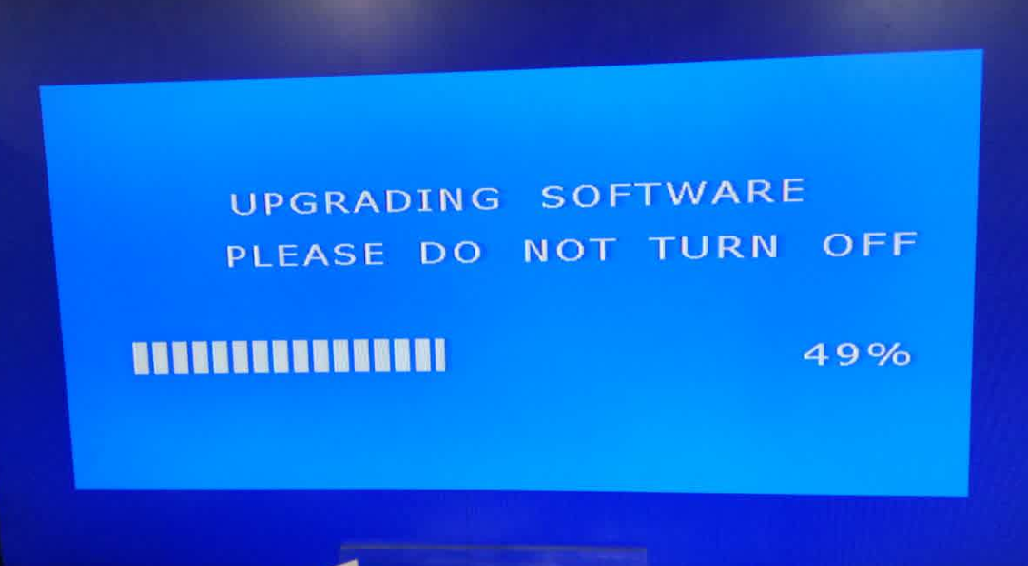

Upgrading OSD

Notice: If it not work, you should mains switch off the TV set and with the power key in the keypad pressing and mains switch on the TV.

2-2, Select the update option in factory menu OSD.

2-2-1, Press Menu then press 2008 with the Main Menu OSD in the screen, it will go into factory OSD.

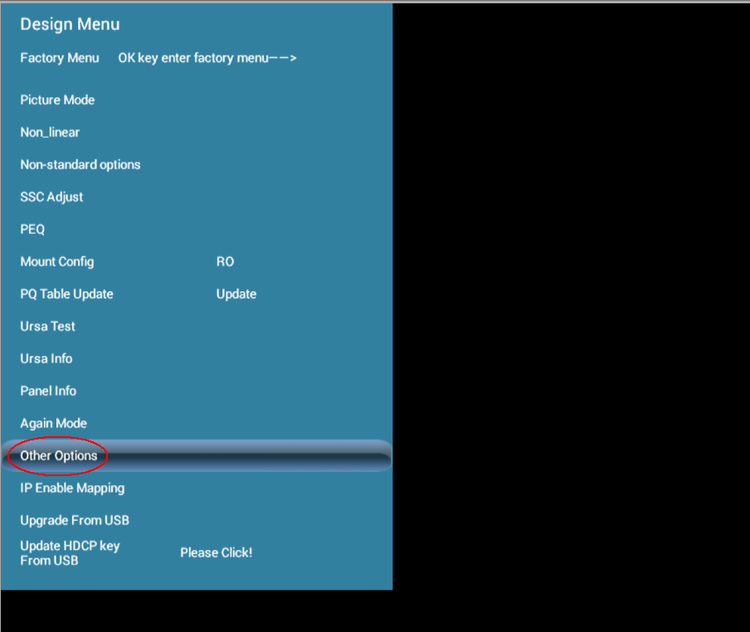

Factory menu OSD

2-2-2, Select Other Options item and then go into Other Option page, then select the Upgrade Main item. Showing as below:

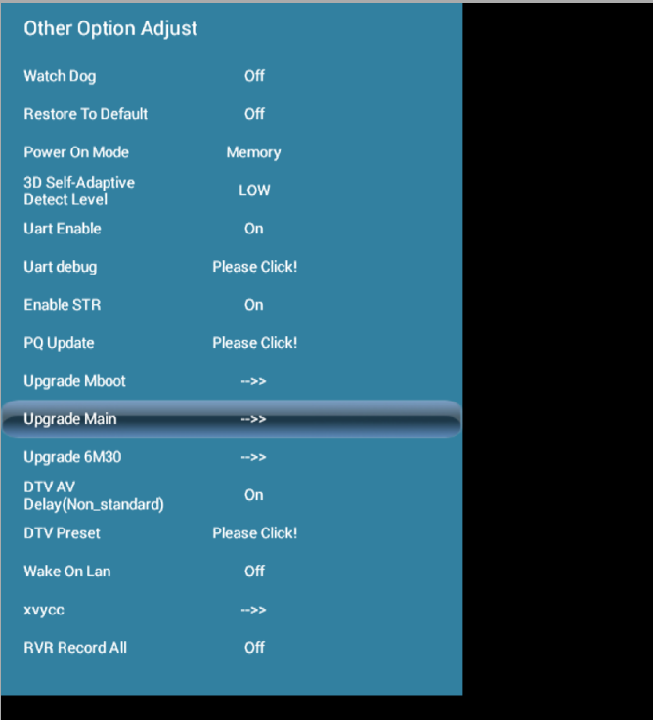

Other option page

2-2-3, Select Confirm item in coming OSD after above step. The TV set will go into standby mode. Press power key (in remote or keyboard), the upgrading process will start.



Upgrade confirming

When it start upgrading, there will be upgrading progress bar in the screen and the LED will keep flashing.

Note: Please do not switch off the TV set during s/w upgrading otherwise the system will get damage.