## FOR KEYS UPGRADE

### For HDCP upgrading:

1, Rename the hdcp key bin file into hdcp_key_xxxxxx.bin(xxxx means the name number), then put the keys into the root of the U Flash Disk. Showing as below:

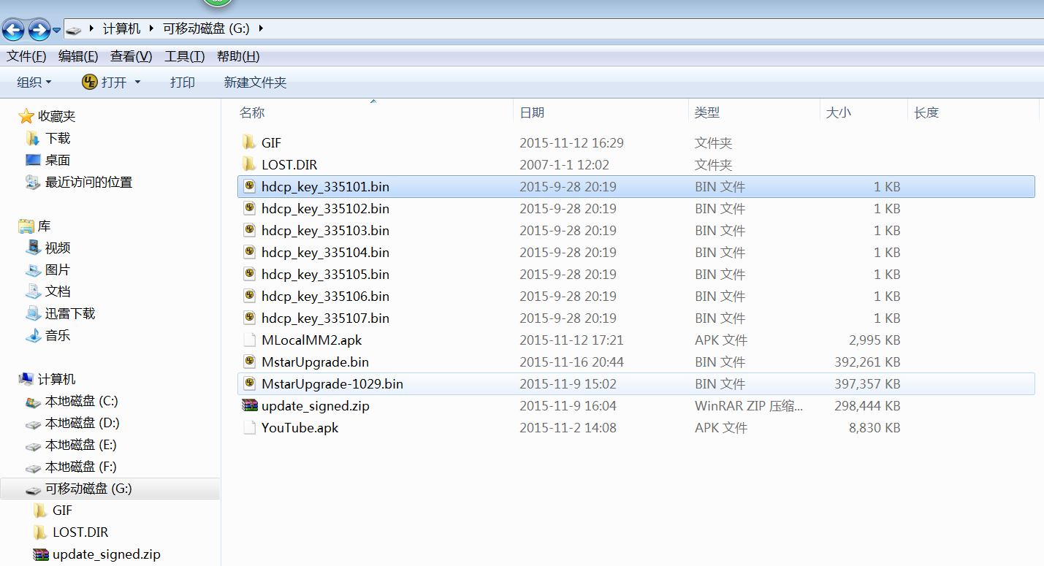

Root of a USB Device

2, Connect the U Flash Disk to any of the USB port, no meter USB3.0 or USB 2.0.

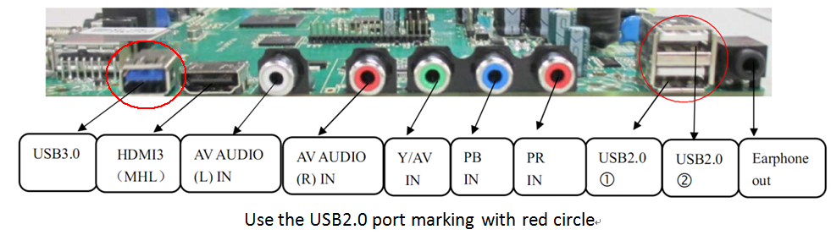

3, Menu + 2008, go to factory menu:

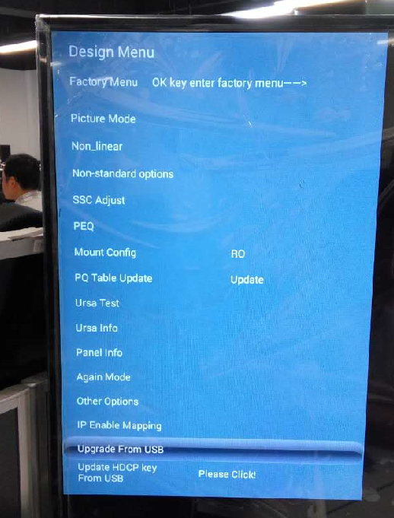

Factory mode main page

4, Select the Upgrade From USB item as above figure.(Not the last one)

5, In the new page, you will find the option and select it. Press the OK key to upgrade the hdcp key. As below:

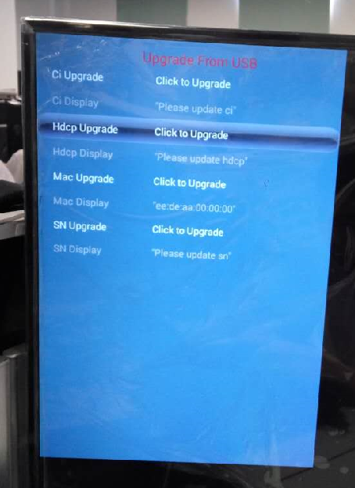

Upgrade from USB page

6, If the upgrade success there will be message in Hdcp Upgrade item value, and there will be the index number showing in the screen as below:

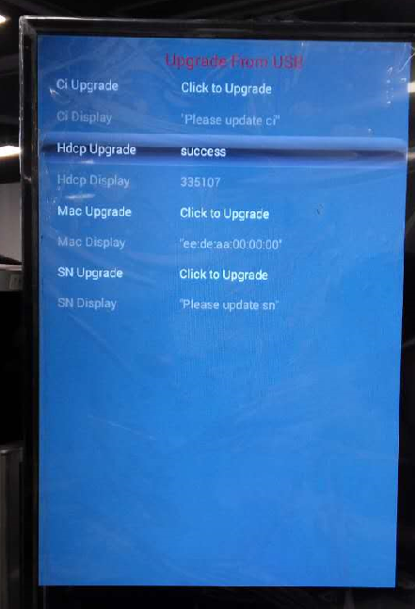

The number displaying here just the index number in the name of the key

7, After a success upgrade of the hdcp key, the key file will be deleted from the U Flash Disk.

### For MAC upgrading:

1, Put the MAC bin files along with the MACIndex.ini file into the root of a USB Device. See figure below:

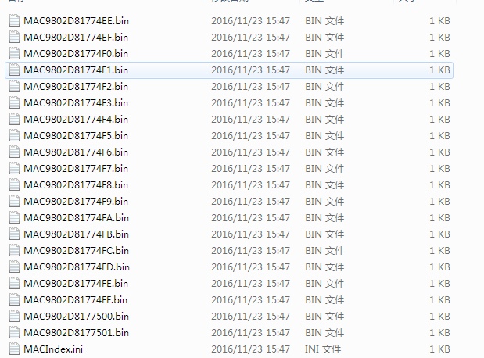

2, Connect the U Flash Disk to any of the USB port, no meter USB3.0 or USB 2.0.



3, Menu + 2008, go to factory menu:



Factory mode main page

4, Select the (Upgrade From USB) item as showing in the figure above.(Not the last one)

5, In the new page, you will find the option and select it. Press the OK key to upgrade the MAC. As below:

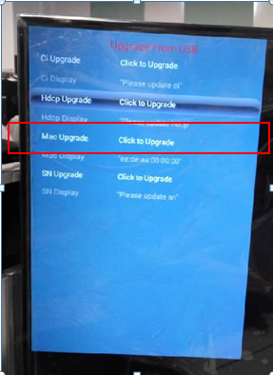

Upgrade from USB page

6, If the upgrade success there will be message in Mac Display item, and there will be the Mac address showing in the screen as below:

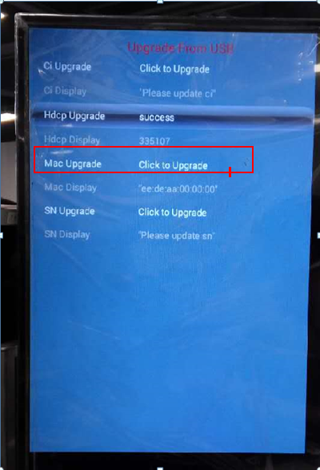

he number displaying here just the index number in the name of the key

7, After a success upgrade of the MAC, the Value showing in the MACIndex.ini file with increase automaticly.

