## FOR KEYS UPGRADE

### For MAC upgrading:

1, Put the MAC bin files along with the MACIndex.ini file into the root of a USB Device. See figure below:

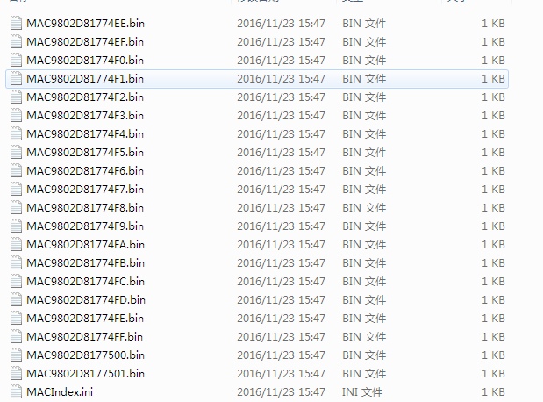

2, Connect the U Flash Disk to any of the USB port, no meter USB3.0 or USB 2.0.

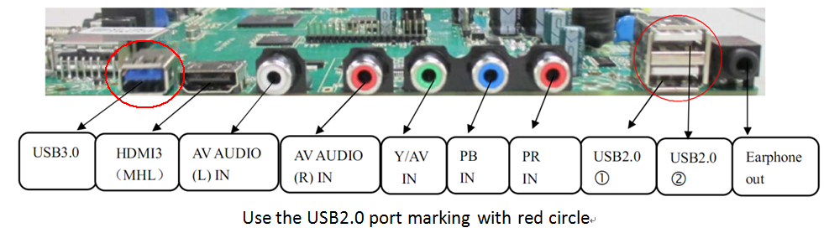

3, Menu + 2008, go to factory menu:

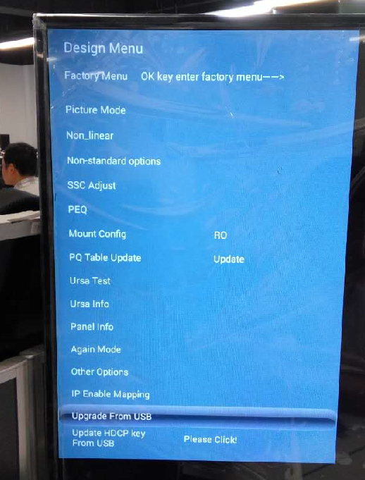

Factory mode main page

4, Select the (Upgrade From USB) item as showing in the figure above.(Not the last one)

5, In the new page, you will find the option and select it. Press the OK key to upgrade the MAC. As below:

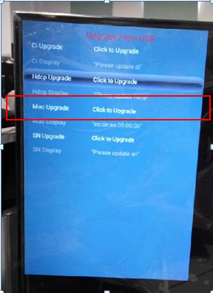

Upgrade from USB page

6, If the upgrade success there will be message in Mac Display item, and there will be the Mac address showing in the screen as below:

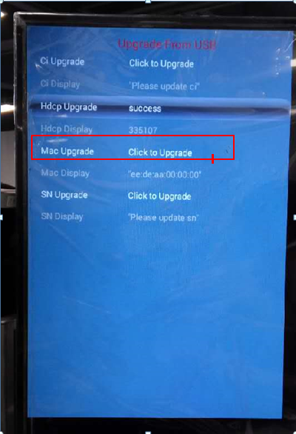

he number displaying here just the index number in the name of the key

7, After a success upgrade of the MAC, the Value showing in the MACIndex.ini file with increase automaticly.

