Cars Analysis
2026-01-31

Cases by District
## district n percent
## Kambia 1 0.005
## Bo 2 0.010
## Kono 2 0.010
## Port Loko 2 0.010
## Western Urban 4 0.020
## Kenema 34 0.170
## Kailahun 155 0.775

Plot
## Warning in geom_bar(stat = "identity", position = "stack", colour = "black", :
## Ignoring unknown parameters: `size`
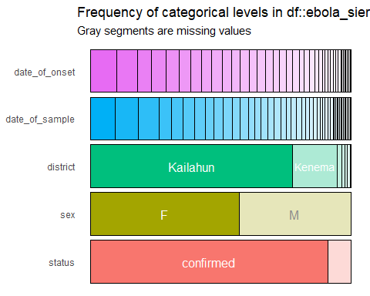
These are my favorite Cars:
- Toyota Prado
- Mitsubishi Pajero
- BMW X5
You can see more different options here
This is my R Markdown document. Markdown is a simple formatting syntax for authoring HTML, PDF, and MS Word documents. For more details on using R Markdown see http://rmarkdown.rstudio.com.
When you click the Knit button a document will be generated that includes both content as well as the output of any embedded R code chunks within the document. You can embed an R code chunk like this:
summary(cars)
## speed dist
## Min. : 4.0 Min. : 2.00
## 1st Qu.:12.0 1st Qu.: 26.00
## Median :15.0 Median : 36.00
## Mean :15.4 Mean : 42.98
## 3rd Qu.:19.0 3rd Qu.: 56.00
## Max. :25.0 Max. :120.00

Including Plots
You can also embed plots, for example:
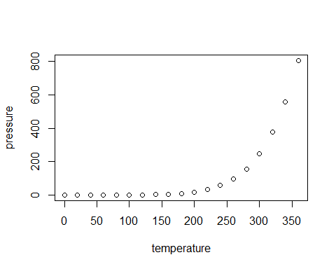
Note that the echo = FALSE parameter was added to the code chunk to prevent printing of the R code that generated the plot.

