**TP - Pattern Matching**

**RANDO Tomás**

1)

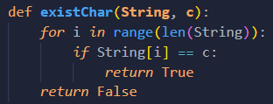

2)

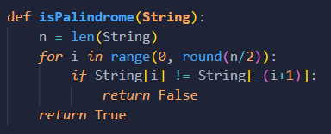

4)

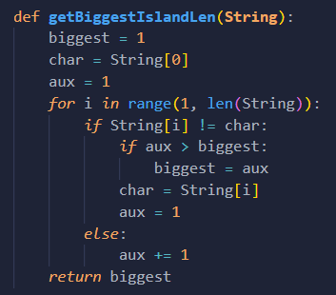

5)

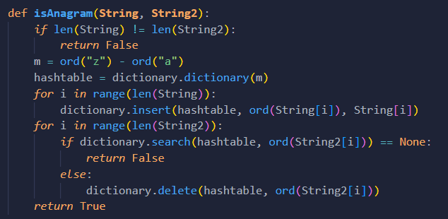

6)

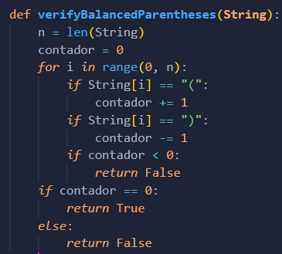

7)

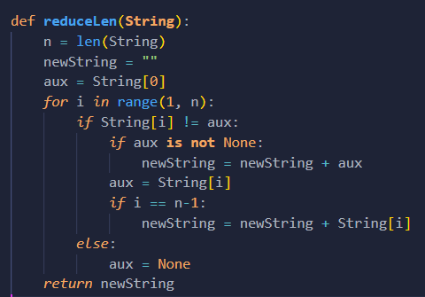

8)

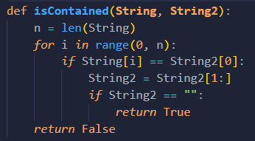

9)

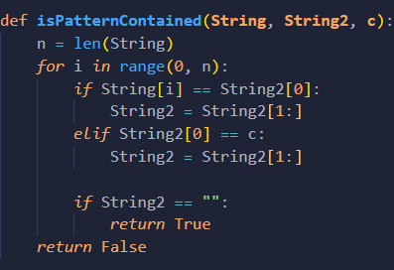

10)

|  |  |  |  |
| --- | --- | --- | --- |
| input | a | b |  |
| 0 | 1 | 0 | a |
| 1 | 2 | 0 | a |
| 2 | 2 | 3 | b |
| 3 | 4 | 0 | a |
| 4 | 2 | 5 | b |

|  |  |  |  |  |  |  |  |  |  |  |  |  |  |  |  |  |  |
| --- | --- | --- | --- | --- | --- | --- | --- | --- | --- | --- | --- | --- | --- | --- | --- | --- | --- |
| Estado inicial | 0 | 1 | 2 | 2 | 3 | 4 | 0 | 1 | 2 | 3 | 4 | 2 | 3 | 4 | 0 | 1 | 2 |
| Estado final | 1 | 2 | 2 | 3 | 4 | 5 | 1 | 2 | 3 | 4 | 2 | 3 | 4 | 5 | 1 | 2 | 3 |
| Input | a | a | a | b | a | b | a | a | b | a | a | b | a | b | a | a | b |

11)

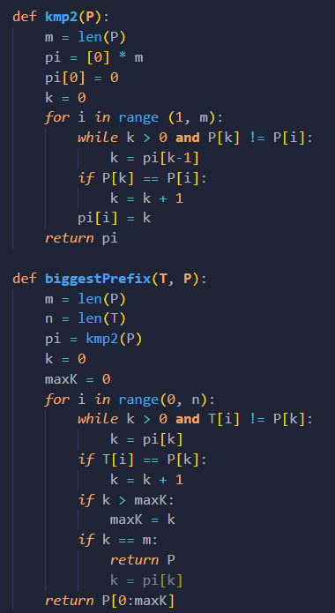

12)

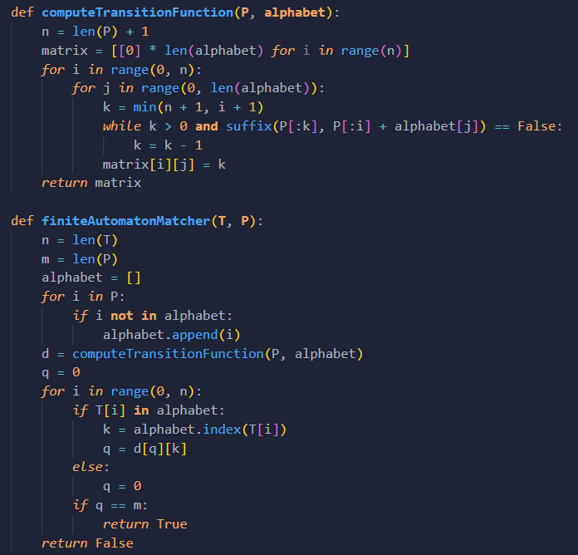

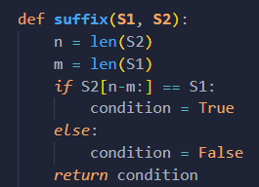

13)

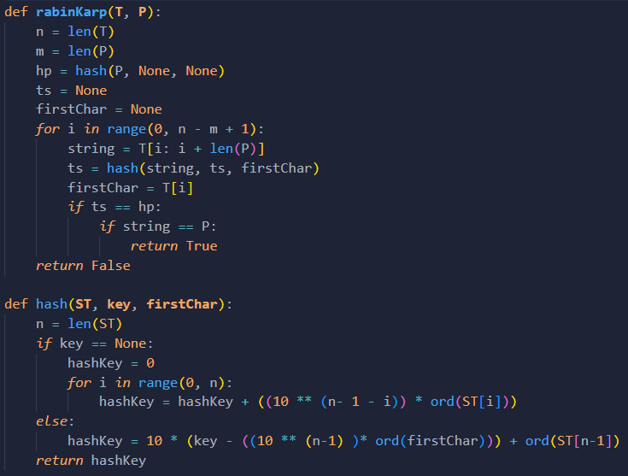

14)

