**KIM, ANTONETTE BRON BSIT-3C WEB DEVELOPMENT- POPULATING PAGES**

The feed.blade.php file contains the structure for a feed page, representing a content delivery section of the application.

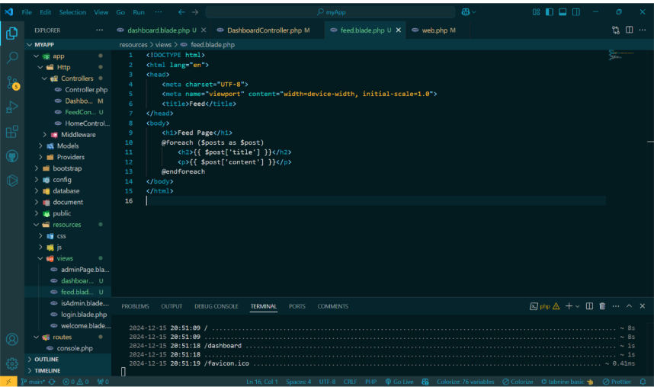

This is the dashboard.blade.php file which displays the data provided by the simulated database, as managed by the DashboardController file.

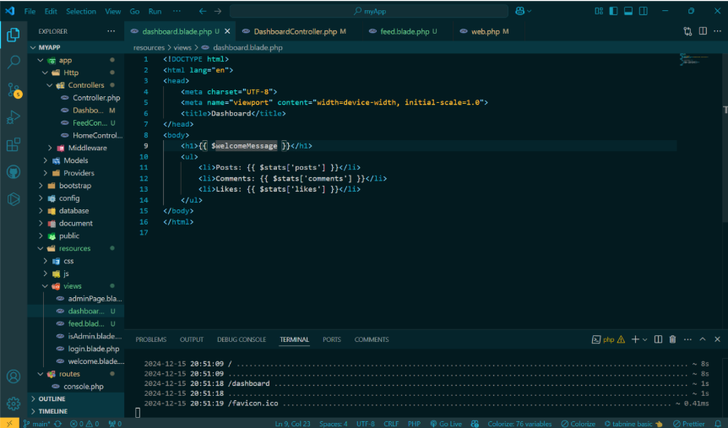

This is the FeedController file which is responsible for simulating data retrieval from a database and sending it to the feed.blade.php view for display.

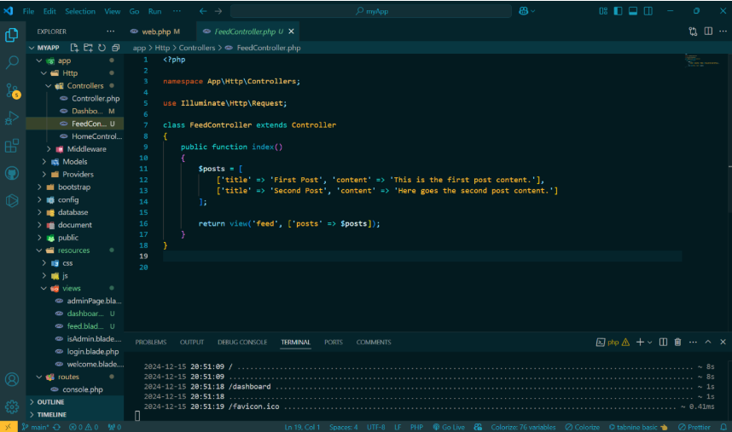

This is the routing setup, where both the dashboard and feed files are assigned distinct URL endpoints

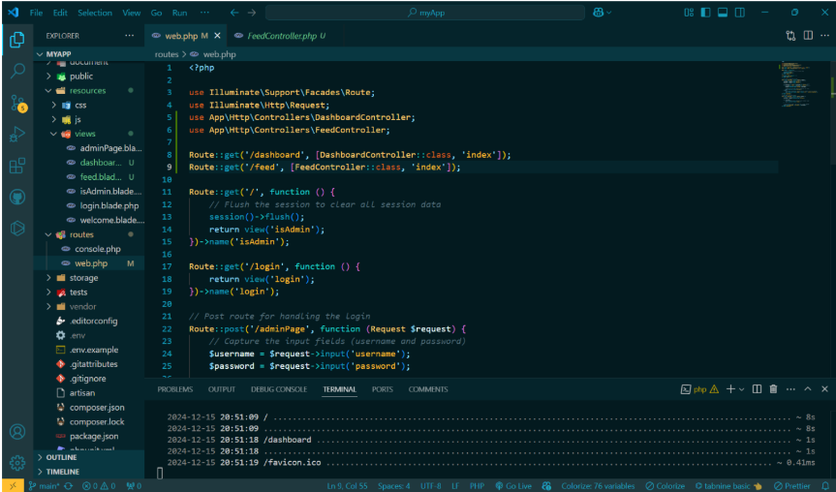

This is how the dashboard.blade.php view appears when accessed by the user, displaying the data passed to it by the DashboardController.

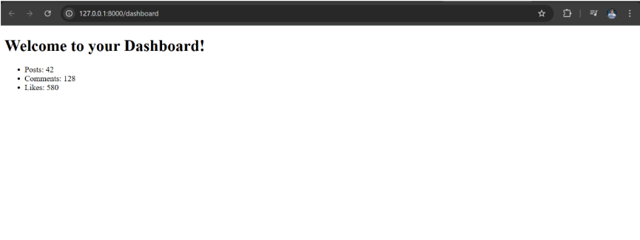

This is how the feed.blade.php file appears when the user accesses the page, displaying the data provided by the FeedController.

