Numerical Analysis

Assignment 2

Professor | Donggyu Sim
Department | Computer engineering
Student ID | 2014722057
Name | 김진아
Date | 2016. 10. 14

- Assignment specification
This assignment is to understand the interpolation. We have to make 128x128 images from 512x512 images. And then we have to make 512x512 images from 128x128 images by using the bilinear interpolation, 3th Lagrange interpolation and six_tab interpolation. When we make 512x512 images from 128x128 images by using the six_tab interpolation, we have to use integer. If we make them, we have to evaluate how accurate the interpolated images are with the original 512x512 image. So, we can compare performance of images made by the bilinear interpolation, 3th Lagrange interpolation and six_tab interpolation.
The bilinear interpolation is a method that a point between two standard points has an average value between two standard points’ values. The 3th Lagrange interpolation is a method that makes the cubic equation in basis of four points and look for y at x. The cubic equation is ((x-x1)*(x-x2)*(x-x3)/(x0-x1)*(x0-x2)*(x0-x3))*f(x0)+((x-x0)*(x-x2)*(x-x3)/(x1-x0)*(x1-x2)*(x1-x3))*f(x1)+((x-x0)*(x-x1)*(x-x3)/(x2-x0)*(x2-x1)*(x2-x3))*f(x2)+((x-x0)*(x-x1)*(x-x2)/(x3-x0)*(x3-x1)*(x3-x2))*f(x3).
The six_tab interpolation is a method that uses six tab FIR filter. The six tab FIR filter’s coefficient is (1, -5, 20, 20, -5, 1)/32. There are some examples.
a |  |  |  | b |  |  |  | c | Y | X |  | d |  |  |  | e |  |  |  | f
There are six standards points (a, b, c, d, e, f). If I want to fill X, I use six tab FIR filter to fill it. So it is (a–5*b+20*c+20*d-5*e+f)/32. And Y between c and X is (a+X)/2.
a |  | b |  | c
 | X1 |  | X2
d |  | e |  | f
 | X3 |  | X4
g |  | g |  | i
X1, X2, X3 and X4 are (b+d)/2, (b+f)/2, (d+g)/2 and (g+f)/2.
Lastly, RMS’s formula is 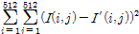. And PSNR’s formula is 20log(255/RMS).

- Design detail
- Down sampling
To reduce 512x512 images four times, I make the starting point which indicates (0, 0). The following process repeats before the number of the starting point’s row is 512. I extract 4x4 pixels from 512x512 images on the basis of the starting point. I sort the light values of pixels in ascending order. I choose the middle value of pixel and insert it in 128x128 images. Then, the starting point moves the number of the starting point’s row plus 4. If the process is done, I change the number of the starting point’s line to the number of the starting point’s line plus 4. And then, I repeat the upper process before the starting point is (512, 512).

- Up sampling
To expand 128x128 images four times, I put pixels of 128x128 images on pixels of 512x512 images. At this time, I put a pixel at an interval of 4 pixels from the (2, 2). Also, 2x2 pixels corners of the 512x512 images are filled by 1x1 pixel corners of 128x128 images. When the interpolation is done, the external parts of empty pixels are copied by the external part of filled pixels.

1) Bilinear interpolation
Lines are filled before. And then, rows are filled. When I fill the lines, I filled them at intervals of 4. When I fill the rows, I filled them at interval of 1. To fill empty pixels, I start from the second position. And the ending point is the sixth position. To fill the pixels between the starting point and the ending point, the pixel beside the starting point is filled with (3 x the starting point + the ending point)/4. The pixel in the middle of the starting point and ending point is filled with (2 x the starting point + 2 x the ending point)/4. The pixel ahead of the ending point is filled with (the starting point + 3 x the ending point)/4. When this calculation is done, the starting point replaces the ending point. The ending point moves previous ending point plus 4. These operations are done if the starting point is more than 512.

2) 3th Lagrange interpolation
Lines are filled before. And then, rows are filled. When I fill the lines, I filled them at intervals of 4. When I fill the rows, I filled them at interval of 1. I try to fill empty pixels of 512x512 images. I make a cubic equation by using three Lagrange functions. The first Lagrange function is (x-x1)*(x-x2)*(x-x3)/(x0-x1)*(x0-x2)*(x0-x3). The second Lagrange function is (x-x0)*(x-x2)*(x-x3)/(x1-x0)*(x1-x2)*(x1-x3). The third Lagrange function is (x-x0)*(x-x1)*(x-x3)/(x2-x0)*(x2-x1)*(x2-x3). The fourth Lagrange function is (x-x0)*(x-x1)*(x-x2)/(x3-x0)*(x3-x1)*(x3-x2). By using these functions, we can calculate empty pixels’ value. I start from the second position. I make the standard point which indicates starting point. The following the process repeats before the starting point is more than 500. The starting point, the starting point plus 4, the starting point plus 8 and the starting point plus 12 indicate x0, x1, x2 and x3 in Lagrange function. By using them, we make four Lagrange functions. The other following process repeats three times. I calculate three pixels’ value between the standard point and the standard point plus 4. I input the row number of empty pixels in x to solve the Lagrange functions. The light value of empty pixels is L0*f0+L1*f1+L2*f2+L3*f3. If the light value is less than 0, 0 is inserted in empty pixels. Also, if the light value is more than 255, 255 is inserted in empty pixels. If the empty pixels are filled, the standard point moves the standard point plus 4. If the pixels between the standard point and the standard point plus 12 are filled, the starting point moves the starting point plus 4.

3) Six_tab interpolation
First, lines are filled at intervals of 4. Second, rows are filled at intervals of 2. Third, lines are filled at intervals of 2. Lastly, diagonal lines are filled at intervals of 4.To fill empty pixels of 512x512 images in lines or row, I start from the second position. The ending point is 510th position. And I make a standard point which is equal to starring point plus 2. I want to look for the standard point’s value. The following process repeats before the standard point is more than 510. There are four conditions. First, if the standard point is equal to the starting point plus 2, the standard point is {starting point*16 + (starting point + 4)*20 - (starting point + 8)*5 + (starting point + 12)} / 32. Second, if the standard point is equal to the starting point plus 6, the standard point is {staring point*(-4) + (starting + 4)*20 + (starting point + 8)*20 – (starting point + 12)*5 + (starting point + 16)} / 32. Third, if the standard point is equal to the ending point minus 2, the standard point is {ending point*16 + (ending point – 4)*20 – (ending point – 8)*5 + (ending point -12)} / 32. Fourth, if the standard point is equal to the ending point minus 6, the standard point is {ending point*(-4) + (ending point – 4)*20 + (ending point -8)*20 –(ending point – 12)*5 + (ending point – 16)} / 32. Lastly, if the upper conditions don’t satisfy, the standard point is {(standard point – 10) – (standard point - 6)*5 + (standard point – 2)*20 + (stand point + 2)*20 – (standard point + 6)*5 + (standard point + 10)} / 32. If the standard point is filled, both side of the standard point are filled. One which locates ahead of the standard point is (standard point + (standard point – 2)) / 2. The other which locates the next of the standard point is (standard point + (standard point +2)) / 2. If these calculations are done, the standard point moves to standard point plus 4. To fill empty pixels of 512x512 images in diagonal lines, I use a double for statements. They start from 2 (A, B). Four pixels are filled whenever inner for statement rotates. The pixel[A+1][B+1] is (pixel[A][B+2] + pixel[A+2][B]) / 2. The pixel[A+1][B+3] is (pixel[A][B+2] + pixel[A+2][B+4]) / 2. The pixel[A+3][B+1] is (pixel[A+2][B] + pixel[A+4][B+2]) / 2. The pixel[A+3][B+3] is (pixel[A+2][B+4] + pixel[A+4][B+2]) / 2. If these calculations are done, B moves to B plus 4. If B is more than 510, the inner for statement is done. A move to A plus 4 and the inner for statement restart. This process is executed until A is more than 510.

- Conclusion
To make a 128x128 image from 512x512 images, I extracted 2x2 pixels in 512x512 images and then I chose random pixel in 2x2 pixels. This process was repeated twice. The image quality didn’t have a sharp picture. And I thought that this method wasn’t effective to make a 128x128 image. So, I changed a method. I extracted 4x4 pixels in 512x512 images and then I chose random pixel in 4x4 pixels. The image quality was better than previous image. But the image quality was changed a little whenever the program was executed. So, I sort 4x4 pixels in ascending order. And I insert middle value in a 128x128 pixel. To make a bilinear interpolation, I extracted pixel of 128x128 images in intervals of 8. And then I executed this program. The 512x512 image made by the bilinear interpolation didn’t have a sharp picture. So, I extracted pixel of 128x128 images in intervals of 4. When I executed this method, the image was better than previous image. When I made the Lagrange interpolation, I thought that only integer variables were used. So, I didn’t use float variable. When I used only integer variables, the image quality wasn’t good. To solve this problem, I used float variables. But when made a Lagrange function, the denominator was uint8 variable. So, the Lagrange function’s values weren’t accurate. I change the denominator’s variable type to float variable. And then if a value which was inserted in a pixel is less than 0, 0 was inserted in a pixel. Also, if a value which was inserted in a pixel is more than 255, 255 was inserted in a pixel. This was because range of value which could be inserted in a pixel was 0~255. There were several problems when I made the six_tab interpolation. When I filled pixels which were located between filled pixels, I used the bilinear interpolation method. But the bilinear interpolation was filled three pixels between filled pixels. So, the filled pixels were filled one more time. In this case, the six_tab interpolation didn’t need. To solve this problem, I filled a middle pixel by using six tab FIR filter. And then I filled pixels beside a middle pixel by using average.

Original Image |  | Down sampling
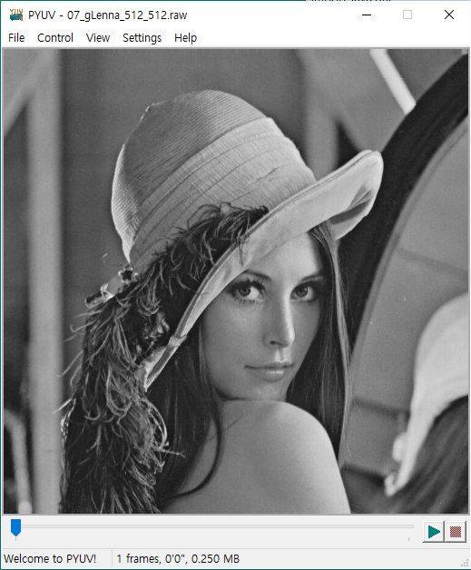 |  | 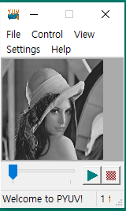
Bilinear interpolation | Lagrange interpolation |  | Six_tab interpolation
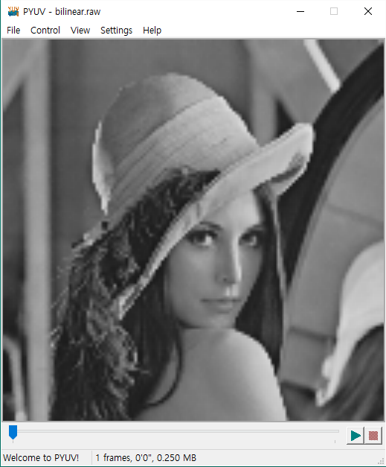 | 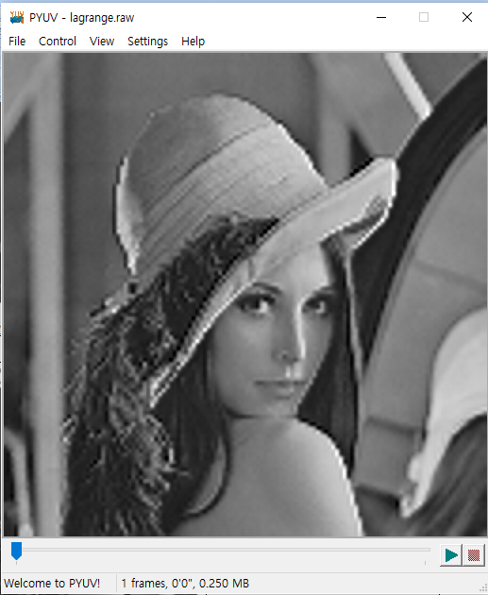 |  | 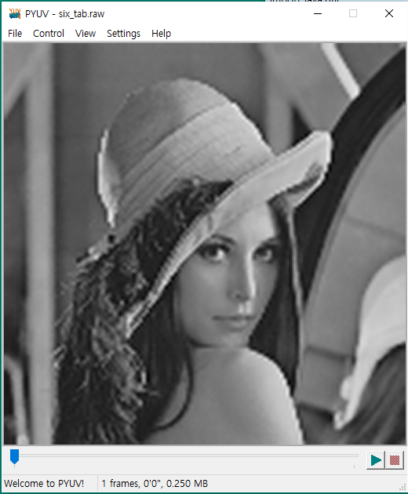

 | Bilinear interpolation | Lagrange interpolation | Six_tab interpolation
RMS | 10.2197 | 9.71473 | 9.92007
PSNR | 27.9421 | 28.3822 | 28.2005

- Reference
심동규 교수님/3.Interpolation/ 참빛관101호/2016
심동규 교수님/3.Interpolation-2/참빛관101호/2016

