Numerical Analysis

Assignment 4

Professor | Donggyu Sim
Department | Computer engineering
Student ID | 2014722057
Name | 김진아
Date | 2016. 11. 25

- Assignment specification
This assignment is to make a PCA program to calculate face recognition rate about given images. We have to calculate eigenvector and eigenvalue by PCA from given training image sets. And then, we have to adjust the eigenvector and calculate face recognition rate about given test images. Face recognition database set is given 48 pages of training image and 12 pages of test images. There are 8 pages of face images per 6 people. We have to convert bitmap file to raw file. To make PCA program, we know next concepts. There is a NXN image. We make N NXN training vectors. And we calculate P average vectors which are averages of P NX1 training vectors. P Normalized vectors are P NX1 training vectors minus P average vectors. We make NXP training vector by using P normalized vectors. NXN covariance matrix is NXP training vector*PXN training vector which are transposed NXP training vector. eigenvalues and corresponding eigenvector are computed by an equation which is covariance matrix*eigenvalues=eigenvector*eigenvalues. So we can get NXP eigenvector. PX1 representative vector is got by PXN transposed eigenvector*NX1 normalized vector. There are two points (A, B). Euclidean distance of A and B is equal to this equation’s result which is .

- Design detail
To convert bitmap file to raw file, I make a function named bmp_to_raw. I read a file as binary by using ifstream. There is information of header in bitmap file. It is 54bytes. So, I read the bitmap file until 54. And then, I read and save information of pixel. At this time, I multiply value which indicated RGB information. That is because the bitmap file has RGB. And I make PCA function to solve eigenvector and eigenvalues. In the function, I calculate an average vector by using 2 for statements. At this time, the average vector is 1D array whose size is 10304. And then I calculate a training vector by using 2 for statements and the average vector. The training vector is a 10304X48 2D array. To make covariance matrix, I transpose 10304X48 training vector by using 2 for statements. The 10304X48 training vector and 48X10304 transposed training vector are symmetric matrix. I calculate a covariance matrix by 3 for statements to do matrix multiplication. The covariance matrix is a 48X48 2D array. That is because the program is multiplied by 48X10304 transposed training vector and 10304X48 training vector. And I use svdcmp function to solve eigenvalues and eigenvector. At this time, the eigenvalue is a 1D array whose size is 48. The eigenvector is a 48X48 2D array. I used 2 for statements and multiplied 10304X48 training vector by 48X48 eigenvector to make 10304X48 eigenvector. And I choose 10 big eigenvalues which indicated big distributions. And I make 10304X10 eigenvalue by using 2 for statements. To count Euclidean distance, I make E_distance function. I calculate 10304X12 test image’s training vector by using 2 for statements and average vector. And then, I transpose 10304X10 eigenvector to make 10X10304 eigenvector by using 2 for statements. I calculate a 10X48 representative vector of training images by using 3 for statements and multiply 10X10304 transposed eigenvector by 10304X48 training vector. And, to solve a 10X12 representative vector of test images, I used 3 for statements and multiply 10X10304 transposed eigenvector by 10304X12 test image’s training vector. To calculate Euclidean distance between training images and test images, I use 3 for statements and calculate the square of training images’ representative vector minus test images’ representative vector. I save this result in a 12X48 matrix. I find training image that has similarity with test image by using find_picture function. The program compare Euclidean distance to find the smallest distance by using 2 for statements and if statement. If the program finds the smallest Euclidean distance, it prints the result that indicates person. At this time, print result to meet six recognitions. Lastly, in the main function, I use 2 for statements to open 48 training images and convert bitmap to raw file. And then, the program goes to PCA function to calculate eigenvector and eigenvalue. Also, I use a for statement to open 12 test images and convert bitmap to raw file. The program goes to E_distance function to solve Euclidean distance. And the program moves to find_picture function to find similar image. The svdcmp function which gets eigenvalues and eigenvector is made by code in Numerical Recipes in C.
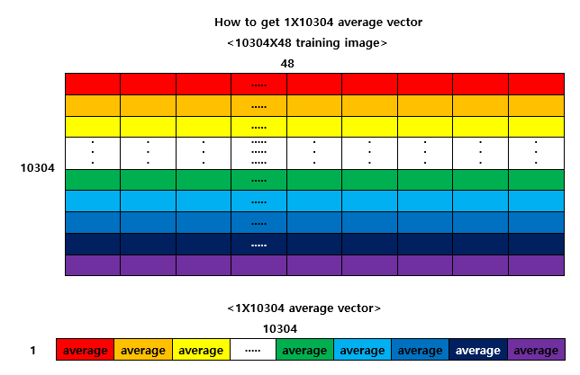
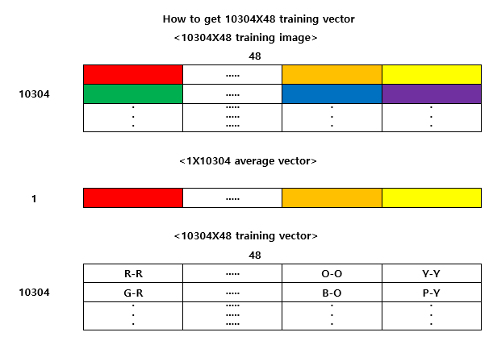
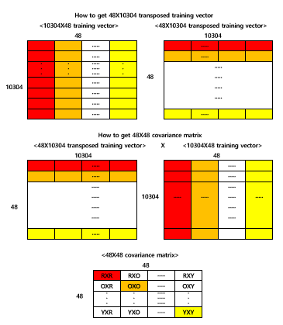
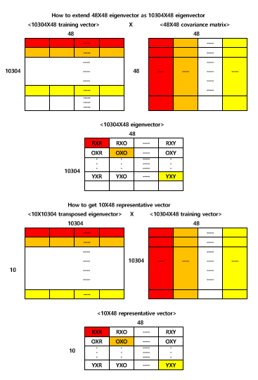
- Conclusion
When I made a PCA program, I didn’t know how to convert bmp to raw. I searched on the Internet about form of bitmap. So, I knew that there were information of header and pixels. The pixels were stored in reverse and they had RGB information. Therefore I read training image after 54 bytes and multiplied RGB values. I thought that I had to calculate average values of training image per person. So, I got a 8X48 average vector. But the maximum limit of the number of eigenvector was 10. If I got 8X48, the eigenvector was strong. Therefore, I calculate average values of every people’s training image. I got a 1X48 average vector. When I obtained a 48X48 eigenvector and 48 eigenvalues, I didn’t know how to calculate them. I could only 2X2 matrix’s eigenvector and eigenvalues. So, I looked how to solve them easily in Numerical Recipes in C. At first, I searched by keyword which was eigen. But there weren’t information I wanted. I searched on the Internet about eigenvalue. And I found that eigenvector was got by SUV (Singular Value Decomposition). I retrieved SUV in Numerical Recipes in C. And I found svdcmp function which calculated eigenvector and eigenvalues. So, I used this function to get eigenvector and eigenvalues. I made a 48X48 covariance vector which is 48X10304 transposed training vector* 10304X48 training vector. So, I got a 48X48 eigenvector. But when I looked for representative vector, I couldn’t get it. That was because 10X48*10304*48 was impracticable. So, I extended 48X48 eigenvector as 10304X48 eigenvector. However, I didn’t know how to do it. I looked the lecture material. I found how to extend eigenvector. The 10304X48 eigenvector was made by 10304X48 transposed training vector*48X48 eigenvector.
< Face recognition rate >
First, if I used 10304X1 eigenvector, the result was as follow.
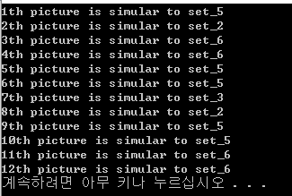
Second, if I used 10304X2 eigenvectors, the result was as follow.
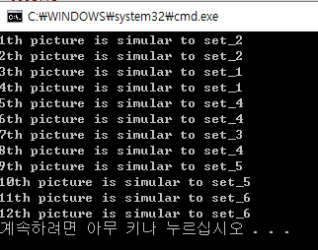
Third, if I used 10304X3 eigenvectors, the result was as follow.
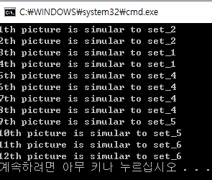
Forth, if I used 10304X4 eigenvectors, the result was as follow.
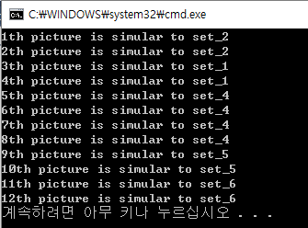
Fifth, if I used 10304X5 eigenvectors, the result was as follow.
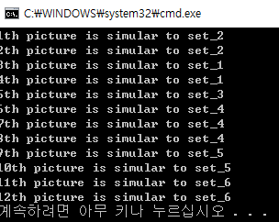
Sixth, if I used 10304X6 eigenvectors, the result was as follow.
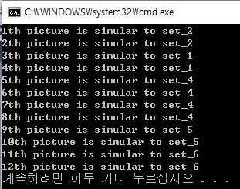
Seventh, if I used 10304X7 eigenvectors, the result was as follow.
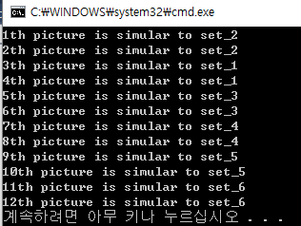
Eighth, if I used 10304X8 eigenvectors, the result was as follow.
Ninth, if I used 10304X9 eigenvectors, the result was as follow.
Finally, if I used 10304X10 eigenvectors, the result was as follow.
The number of eigenvector | Face recognition rate
1 | about 33.3%
2 | 75%
3 | about 83.3%
4 | about 83.3%
5 | about 91.6%
6 | about 83.3%
7 | 100%
8 | 100%
9 | 100%
10 | 100%
When eigenvector were selected in excess of 7, the face recognition rate is 100%. So, I used 10 eigenvectors to find same person’s picture.
< Result >
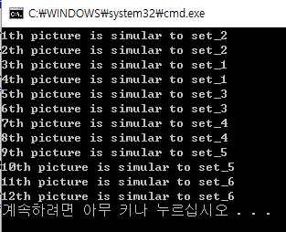

- Reference
bmp to raw 변환 /
http://blog.naver.com/PostView.nhn?blogId=ddarunglee&logNo=220198731459&beginTime=0&jumpingVid=&from=section&redirect=Log&widgetTypeCall=true
eigenvector eigenvalue / http://darkpgmr.tistory.com/106
William H. Press, Saul A. Teukolsky, William T. Vetterling, Brian P. Flannery /Numerical Recipes in C <The Art of Scientific Computing Second Edition> / CAMBRIDGE UNIVERSITY PRESS /1992
심동규 교수님 / 9.pca / 참빛관 101호 / 2016

