# Explanation on Variance Reduction

## Halton Sequence

1. Halton Sequence is invented to generate points in space for numerical methods such as Monte Carlo simulations. Sequences produced by this method has low discrepancy.
2. The sequence is produced using a certain prime number. For example, to generate the sequence for 2, we start by dividing the interval (0,1) in 1/2, then 1/4, 1/8, ...
3. If we want to get 6th number (3/8), then use 6 = 2^2 + 1^2 + 0^2 and invert 2(110) after decimal point as 2(0.011), which is 3/8.

## Importance Sampling

The strategy of importance sampling is to put more weight on the direction that is more significant for rendering in sampling.

1. We do not need to sample directions in a sphere space but a semi-sphere space as we do not need to calculate information inside an object.
2. For diffuse, we want to sample more directions when they are closed to normal vector because light from around normal is important for diffuse or reflectance.
3. For specular, we use acos(e^(1/glossiness)) as phi. When glossiness is larger, e ^ (1/glossiness) will be near 1, then acos() will be near zero. So phi will be near zero, which means we are more likely to sample points near ideal reflection direction. So we can speed up the process of specular if glossiness is larger.

## Next Event Estimation

1. For each bounce, we want to combine direct light and indirect light. It would be slow for original method as random direction may hardly hit light source.
2. For each bounce, create a new ray towards every light source and calculate whether there are obstacles. If there are no obstacles, we can calculate direct light and add to final result.
3. When calculating direct light, we pick a random point on the sphere light source. Then calculate the intersection point on the sphere between light sample point and current hit point, and update the light sample. The reason to do so is to avoid error when judging whether there is an obstacle afterwards.

## Ground Truth

Use original method(no variance reduction methods) and render image for 100,000 step in resolution 1024x512 and 256x128.

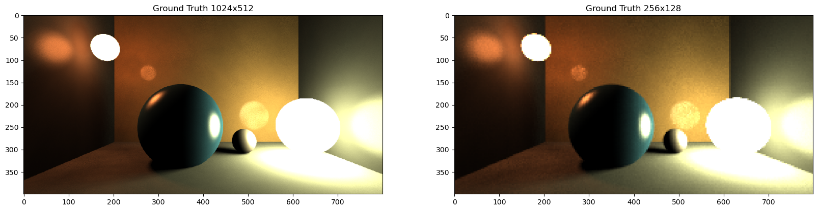

## Illustrate whether the variance is reduced

1. Set max step to 10 and observe the performance of each method. If the variance is reduced, there will be more points rendered.
2. Calculate PSNR and SSIM values between ground truth and each method.

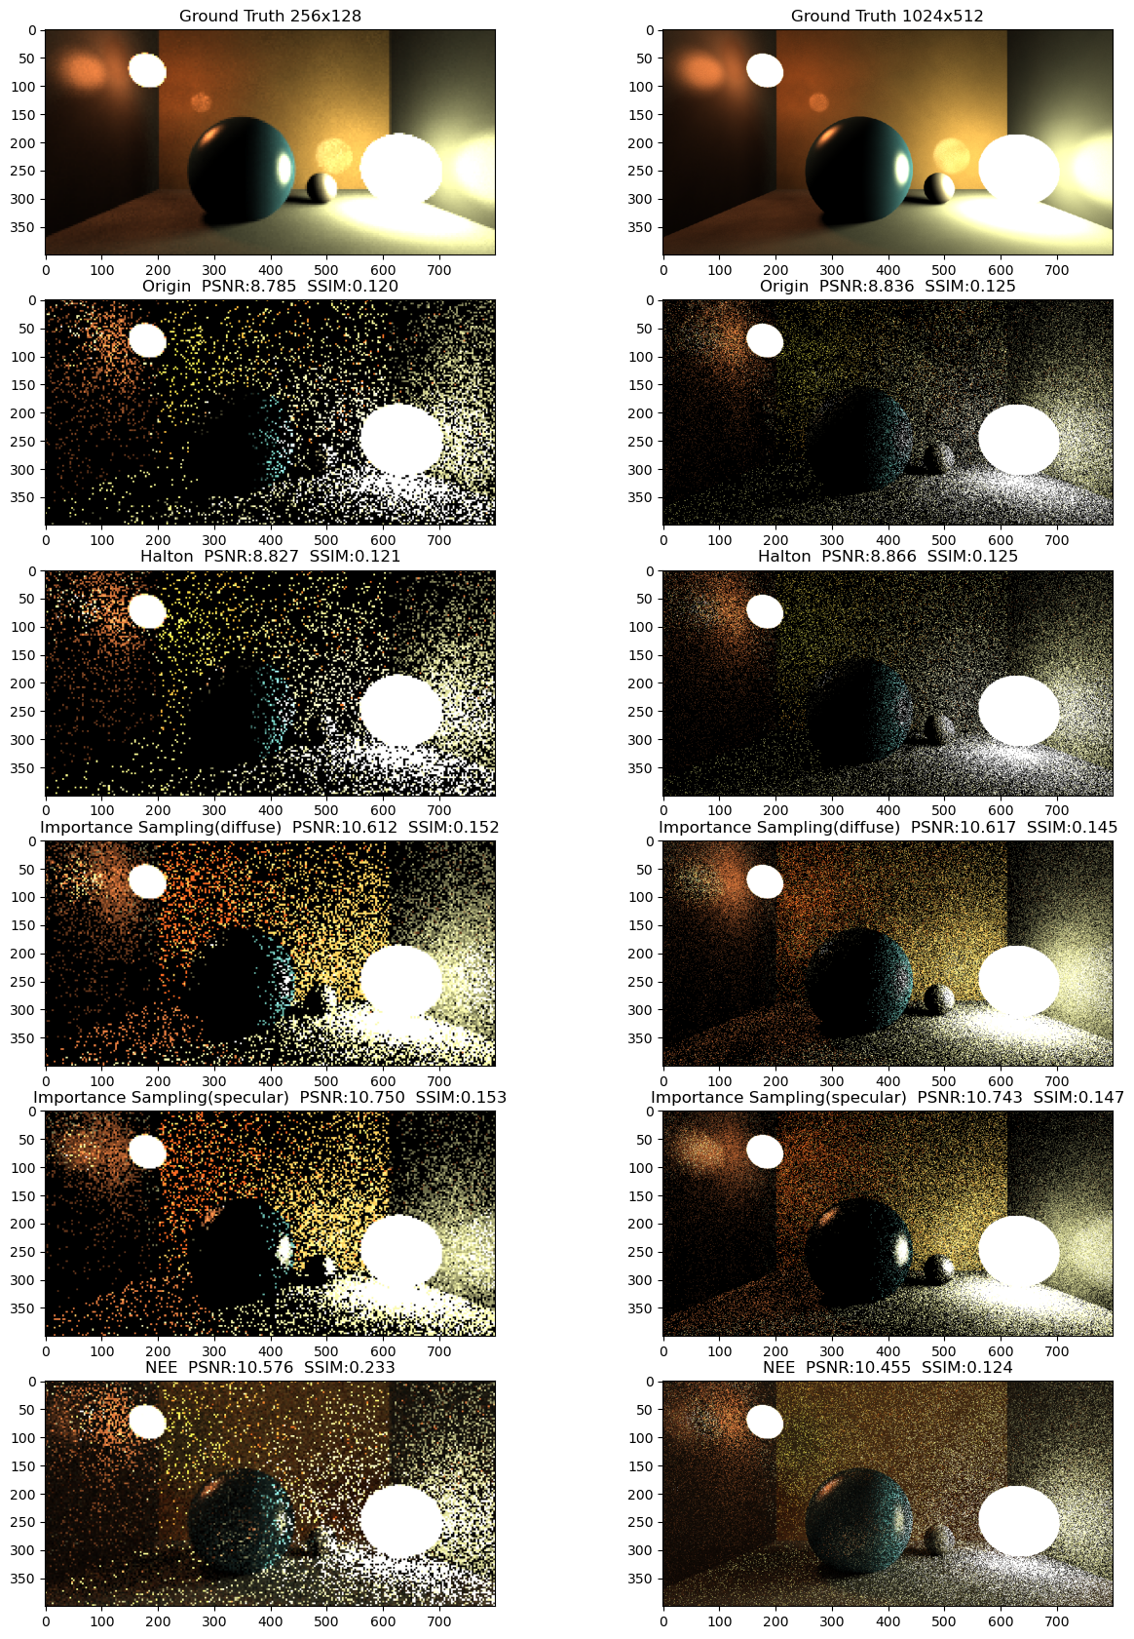



1. The first row shows the ground truth in two resolution(256x128 & 1024x512). The other rows show the performance for each method and their PSNR/SSIM values.
2. The origin method means no variance reduction techniques are applied. It scores 8.785 in PSNR and 0.120 in SSIM for 256x128 resolution, and 8.836 in PSNR and 0.125 in SSIM for 1024x512 resolution.
3. Halton Sequence method has little improvement and can hardly seen by eyes.
4. For Importance Sampling(diffuse), it is obvious that sample points have more density and colors compared with origin version. Importance Sampling(diffuse) method only speeds up diffusion process, and its score for PSNR is over 10.6 and 0.152 for SSIM. This method performs very well.
5. For Importance Sampling(specular), it is obvious that sample points have more density and color compared with origin version. But compared with Importance Sampling(diffuse), it has more information about specular reflection but less information about diffuse reflection. Importance Sampling(specular) method speeds up both diffusion process and specular process, and its score for PSNR is over 10.7 and 0.153 for SSIM. This method performs very well, especially for highlight reflection.
6. Next Event Estimation method performs well in early steps because it considers direct light. Its score for PSNR is around 10.5. Its score for SSIM is 0.233 in 512x256 resolution and 0.124 in 1024x512 resolution.

## Illustrate whether the algorithm is unbiased

1. Set max set to 100,000, render the image for all variance reduction methods.
2. Compare improved images with ground truth by calculating PSNR/SSIM/L2 Loss values. If the algorithm is unbiased, there will be nearly no difference.

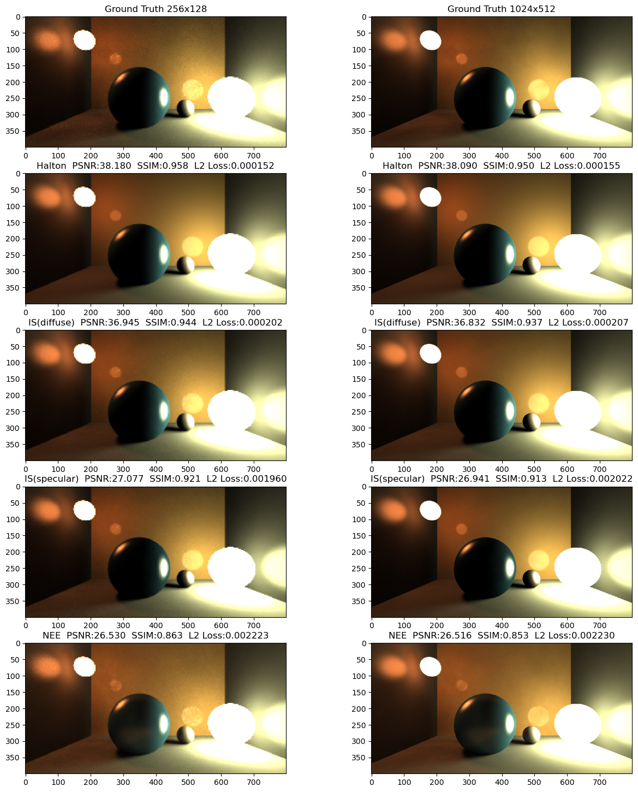

1. The first row shows the ground truth in two resolution(256x128 & 1024x512). The other rows show the performance for each method and their PSNR/SSIM/L2 loss values.
2. The result for Halton Sequence method is very good, with over 38. in PSNR and over 0.95 in SSIM. L2 loss for this method is around 1.5e-4, which is near zero. Besides, Halton method seems to have better performance than ground truth as the reflected spherical light sources on the wall are smoother and walls are cleaner. Ground truth still seems to have noise even it renders for 100,000 steps.
3. For Importance Sampling(diffuse), there is still some noise but hardly noticed by eyes. Its score in PSNR is around 39. and 0.94 in SSIM. Its L2 loss is around 2e-4, which is near zero but not as good as Halton Sequence method.
4. For Importance Sampling(specular), the image is darker because some part of path tracing are used for speeding up specular reflection. So this method is not satisfied. In my opinion, this method is useful if we want to render something in early steps with good performance as human eyes are more sensitive to highlight information.
5. For Next Event Estimation, it looks almost the same but there are some reflections on the backwards of the blue ball. The extra reflection comes from the ground while ground plane gains light from direct light calculation. While the scores are not as good as other methods, the overall performance by eyes is acceptable.