####### Installing SHAP by typing:
# conda install conda-forge::shap in Anaconda prompt
# pip install shap in command prompt ########
### Importing the necessary libraries #########
# For Tabular data
import pandas as pd
# For generic Maths
import numpy as np
from numpy import absolute
# For scaling purposes
from sklearn.preprocessing import StandardScaler
# For Variance Inlfation Factor (VIF)
from statsmodels.stats.outliers_influence import variance_inflation_factor
# To split the dataset
from sklearn.model_selection import train_test_split
# Metrics
from sklearn.metrics import mean_squared_error, mean_absolute_error, r2_score
from sklearn.model_selection import cross_val_score
# Modeling
from sklearn.ensemble import GradientBoostingRegressor
# Shap
import shap
# To ignore warning messages
import warnings
warnings.filterwarnings("ignore")
# For reproducibility purposes
seed = 7
# Reading the dataset
lake = pd.read_csv('E:/XAI/LakeXAI.csv')
#lake = pd.read_csv('C:/Users/Public/XAI/LakeXAI.csv')
lake.head()
T R_E R_AT R_P G_E G_AT G_P R_LL G_LL
0 1/1/2013 0.635469 26.684 0.06 12.7 22.55 0.0 281.86 280.39
1 2/1/2013 0.409592 28.214 0.00 13.1 24.40 0.0 281.60 280.19
2 3/1/2013 0.501878 30.321 0.45 11.5 31.85 0.0 281.34 279.96
3 4/1/2013 1.896789 30.941 2.53 11.2 33.15 0.0 281.09 279.65
4 5/1/2013 11.177511 30.767 8.78 9.6 32.60 0.0 281.00 279.40
# Exploratory Data Analysis
# Importing the necessary libraries and functions
import matplotlib.pyplot as plt
import seaborn as sns
%matplotlib inline
# Data description
lake.describe()
R_E R_AT R_P G_E G_AT G_P \
count 108.000000 108.000000 108.000000 108.000000 108.000000 108.000000
mean 20.992243 28.368933 41.858056 9.208333 28.912500 24.374074
std 24.699415 2.807062 64.048078 4.786432 3.714131 47.042366
min 0.244746 21.720941 0.000000 0.200000 20.750000 0.000000
25% 0.789197 26.863723 0.052500 4.975000 25.375000 0.000000
50% 7.116494 28.687451 4.310000 9.700000 30.275000 0.000000
75% 44.921698 30.633814 72.317501 13.625000 31.675000 27.075000
max 75.910866 33.223901 229.970001 16.800000 33.800000 209.700000
R_LL G_LL
count 108.000000 108.000000
mean 281.426111 279.761852
std 0.453857 0.553939
min 280.510000 278.300000
25% 281.052500 279.360000
50% 281.410000 279.745000
75% 281.822500 280.237500
max 282.400000 280.830000
## Preparing the input and output variables or target
# The output variables
# The remote sensing variable
y_R = lake['R_LL']
y_R.shape
(108,)
print(y_R[:5])
0 281.86
1 281.60
2 281.34
3 281.09
4 281.00
Name: R_LL, dtype: float64
# The groundtruth variable
y_G = lake['G_LL']
y_G.shape
(108,)
print(y_G[:5])
0 280.39
1 280.19
2 279.96
3 279.65
4 279.40
Name: G_LL, dtype: float64
# The input variables or features
# The remote sensing features
X_R = lake.drop(['T','R_LL','G_LL','G_E', 'G_AT','G_P'], axis = 1)
X_R.shape
(108, 3)
print(X_R[:5])
R_E R_AT R_P
0 0.635469 26.684 0.06
1 0.409592 28.214 0.00
2 0.501878 30.321 0.45
3 1.896789 30.941 2.53
4 11.177511 30.767 8.78
# The ground-truth features
X_G = lake.drop(['T','R_LL','G_LL','R_E', 'R_AT','R_P'], axis = 1)
X_G.shape
(108, 3)
print(X_G[:5])
G_E G_AT G_P
0 12.7 22.55 0.0
1 13.1 24.40 0.0
2 11.5 31.85 0.0
3 11.2 33.15 0.0
4 9.6 32.60 0.0
# Standardizing / Scaling the features
# Scaling the RS input features
X_R_scaled = pd.DataFrame(StandardScaler().fit_transform(X_R),
columns= X_R.columns, index = X_R.index)
# Scaling the GT input features
X_G_scaled = pd.DataFrame(StandardScaler().fit_transform(X_G),
columns= X_G.columns, index = X_G.index)
# VIF
### X_R VIF
vif = pd.DataFrame()
vif['vif'] = [variance_inflation_factor(X_R_scaled,i) for i in range(X_R_scaled.shape[1])]
vif['Features'] = X_R.columns
vif.round(2)
vif Features
0 6.67 R_E
1 1.11 R_AT
2 6.43 R_P
### X_G VIF
vif = pd.DataFrame()
vif['vif'] = [variance_inflation_factor(X_G_scaled,i) for i in range(X_G_scaled.shape[1])]
vif['Features'] = X_G.columns
vif.round(2)
vif Features
0 2.38 G_E
1 1.27 G_AT
2 2.02 G_P
# Splitting the feature data into training and testing datasets
# Splitting the RS Data
X_R_train, X_R_test, y_R_train, y_R_test = train_test_split(X_R_scaled, y_R, test_size = 0.30, random_state = 30, shuffle = True)
print(X_R_train.shape, X_R_test.shape)
(75, 3) (33, 3)
# Splitting the GT Data
X_G_train, X_G_test, y_G_train, y_G_test = train_test_split(X_G_scaled, y_G, test_size = 0.30, random_state = 30, shuffle = True)
print(X_G_train.shape, X_G_test.shape)
(75, 3) (33, 3)
##################### GRADIENT BOOSTING REGRESSION ###################
############ MODEL 4: GT Features (X_G) and GT Target (LL_G)###############
model = GradientBoostingRegressor()
gbr_param_grid = { 'learning_rate' : [0.01, 0.02, 0.03, 0.04, 0.05],
'n_estimators' : [100, 500, 1000, 1500],
'subsample' : [0.1, 0.3, 0.5, 0.7, 0.9, 1],
'max_depth' : [4, 6, 8, 10, 12],
}
gbr_cv = KFold(n_splits = 10, random_state = 1, shuffle = True)
gbr4 = GridSearchCV(model, gbr_param_grid, cv = gbr_cv, scoring = 'neg_mean_squared_error', n_jobs = -1)
gbr4.fit(X_G, y_G)
GridSearchCV(cv=KFold(n_splits=10, random_state=1, shuffle=True),
estimator=GradientBoostingRegressor(), n_jobs=-1,
param_grid={'learning_rate': [0.01, 0.02, 0.03, 0.04, 0.05],
'max_depth': [4, 6, 8, 10, 12],
'n_estimators': [100, 500, 1000, 1500],
'subsample': [0.1, 0.3, 0.5, 0.7, 0.9, 1]},
scoring='neg_mean_squared_error')
# Printing the best parameters and the best score
print('The best parameters are:', gbr4.best_params_)
print('The best score is:', gbr4.best_score_)
The best parameters are: {'learning_rate': 0.01, 'max_depth': 8, 'n_estimators': 500, 'subsample': 0.1}
The best score is: -0.09652131992343284
########### Fitting the model on the training dataset using the best parameters
# Instantiation
model = GradientBoostingRegressor(learning_rate = 0.01, max_depth = 8, n_estimators = 500, subsample = 0.1)
# Fitting the model
gbr4 = model.fit(X_G_train, y_G_train)
# Evaluation of the performance of the training model:
gbr_y_predtr = gbr4.predict(X_G_train)
print('The training MAE is:', mean_absolute_error(y_G_train, gbr_y_predtr))
print('The training MSE is:', mean_squared_error(y_G_train, gbr_y_predtr))
print('The training R2 Score is:', r2_score(y_G_train, gbr_y_predtr))
The training MAE is: 0.19115812190117215
The training MSE is: 0.05908902380283678
The training R2 Score is: 0.7972873564374166
# Evaluation of the performance of the testing model:
gbr_y_predts = gbr4.predict(X_G_test)
print('The testing MAE is:', mean_absolute_error(y_G_test, gbr_y_predts))
print('The testing MSE is:', mean_squared_error(y_G_test, gbr_y_predts))
print('The testing R2 Score is:', r2_score(y_G_test, gbr_y_predts))
The testing MAE is: 0.2306346273858942
The testing MSE is: 0.09264025482291452
The testing R2 Score is: 0.7095978637145317
##################### k-fold Cross-validation ##############################
############# On the training dataset
score_gbr4tr = cross_val_score(gbr4, X_G_train, y_G_train, scoring = 'neg_mean_squared_error', cv = 10)
# The mean training score
print('The mean training CV score is:', absolute(np.mean(score_gbr4tr)))
The mean training CV score is: 0.10276843635922348
############# On the testing dataset
score_gbr4ts = cross_val_score(gbr4, X_G_test, y_G_test, scoring = 'neg_mean_squared_error', cv = 10)
# The mean testing score
print('The mean testing CV score is:', absolute(np.mean(score_gbr4ts)))
The mean testing CV score is: 0.1211948915203658
##################### SHAP ###################
shap.initjs()
<IPython.core.display.HTML object>
###### Initializing the explainer on the training dataset
explainer = shap.KernelExplainer(gbr4.predict, X_G_train)
# Explanation of the prediction using the training datasset
shap_valuestr = explainer.shap_values(X_G_train)
{"model_id":"2f1738bc45b04b0bad4ce254dbefbb9a","version_major":2,"version_minor":0}
shap_valuestr
array([[-0.14104272, 0.05320957, -0.29606444],
[ 0.04151375, -0.50857534, 0.09933352],
[-0.04028202, -0.42851596, 0.10173107],
[-0.13897789, -0.13743684, -0.22170898],
[ 0.03185273, 0.07287036, -0.05209543],
[ 0.12733718, -0.39920569, 0.09544032],
[ 0.03035446, 0.06701557, 0.09795585],
[ 0.01408875, -0.05398829, -0.28968699],
[ 0.14932053, 0.3827531 , 0.09542377],
[-0.01138361, -0.41520367, -0.19007448],
[ 0.04741933, 0.31410653, 0.09700875],
[ 0.01413828, 0.11305221, -0.15779285],
[-0.11353748, -0.23282582, -0.16411964],
[-0.15286512, 0.0951702 , -0.27875252],
[-0.02841939, -0.17041145, -0.31745747],
[ 0.16275015, 0.38392037, 0.09558391],
[ 0.04138968, 0.00239492, 0.09952517],
[-0.01412741, -0.44926522, 0.08853395],
[ 0.03533128, -0.18722021, 0.09665888],
[-0.02917129, 0.37114599, 0.08626827],
[-0.03582395, -0.31138563, 0.0840837 ],
[-0.03381773, 0.2951729 , 0.08979556],
[-0.15202588, -0.14301224, -0.31859751],
[-0.02033715, 0.34763956, 0.08966173],
[-0.00483835, -0.41995355, 0.07290883],
[ 0.14432039, 0.4095912 , 0.0983709 ],
[-0.06844877, 0.25766281, 0.08618446],
[ 0.11467399, 0.43438921, 0.1039354 ],
[ 0.17608069, 0.38451713, 0.09573525],
[-0.15435327, -0.1501532 , 0.07774537],
[-0.0447219 , 0.32116596, 0.08528022],
[ 0.02429035, 0.09612353, 0.10837954],
[ 0.15027004, -0.40876614, 0.09907413],
[-0.0861742 , 0.41054713, 0.07431106],
[ 0.04708496, 0.37736 , 0.10268917],
[-0.12912039, 0.15326877, -0.04869608],
[ 0.02287768, 0.13383375, 0.1101928 ],
[ 0.07592281, 0.41374977, 0.10254474],
[-0.01010148, -0.57550339, 0.09735075],
[-0.15122539, -0.11567954, -0.31345904],
[ 0.03431076, 0.10465693, 0.10595269],
[-0.04303632, 0.12862226, 0.09066732],
[ 0.01444506, 0.33614027, 0.09176213],
[-0.01852839, -0.01657996, -0.32200587],
[ 0.04615518, -0.4501705 , 0.09040668],
[ 0.13676653, 0.35423242, 0.09575931],
[-0.02427167, 0.37366773, 0.08606544],
[-0.0577377 , -0.55925018, 0.10182832],
[ 0.0191943 , 0.2559674 , -0.28341887],
[ 0.08614494, -0.09950057, 0.09990734],
[ 0.17306024, -0.43734664, 0.0966529 ],
[ 0.02088621, -0.05046936, 0.09504879],
[-0.03320451, -0.17193766, -0.29634282],
[ 0.08834732, -0.42455474, 0.09328832],
[ 0.03890772, -0.46816047, 0.10062296],
[-0.02315809, -0.2651581 , 0.07520911],
[-0.16825217, -0.31174093, -0.30411201],
[ 0.00163745, 0.28463231, 0.08935738],
[-0.05310636, 0.35217053, 0.08735779],
[ 0.02785017, 0.088125 , -0.30750441],
[-0.06064022, 0.31846843, 0.08501346],
[-0.14064459, -0.28041271, -0.28664253],
[-0.14384211, -0.10157946, -0.300547 ],
[-0.14958577, -0.23375053, -0.19227124],
[ 0.13654707, -0.43219913, 0.09962438],
[ 0.03050218, 0.26805953, 0.10675632],
[ 0.02618212, -0.51458815, 0.09907783],
[-0.12297809, -0.129082 , -0.1706961 ],
[ 0.14944162, -0.22626922, 0.10448108],
[ 0.14260913, 0.32538439, 0.09484202],
[ 0.0315235 , 0.30961974, 0.09106411],
[-0.08217676, 0.11621077, 0.10909506],
[-0.02526725, 0.12992975, 0.1098047 ],
[ 0.14814663, 0.3892924 , 0.0961129 ],
[-0.09644981, 0.25401207, 0.08458084]])
##### Shap summary plot
shap.summary_plot(shap_valuestr, X_G_train, feature_names = X_G_train.columns)
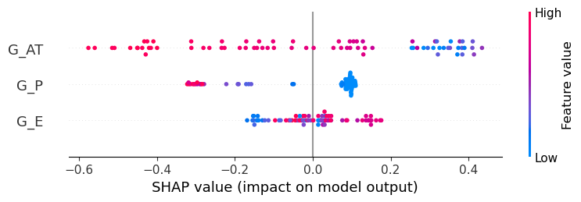
###### Shap feature importance plot
shap.summary_plot(shap_valuestr, X_G_train, feature_names = X_G_train.columns, plot_type = 'bar')
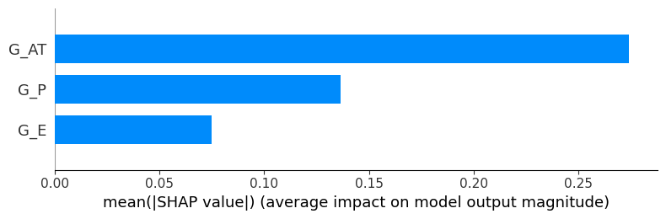
## Global bar plot
shap_valuestr = explainer(X_G_train)
shap.plots.bar(shap_valuestr)
{"model_id":"3035ebe82a9249a18a3a544371068b64","version_major":2,"version_minor":0}
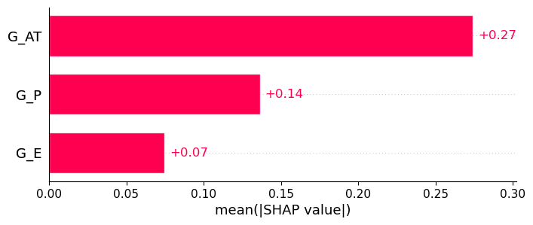
## Local bar plot
shap.plots.bar(shap_valuestr[0])
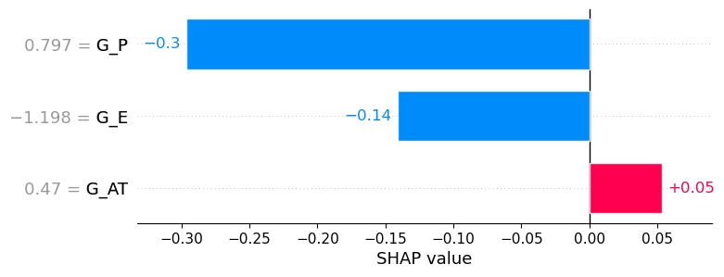
# Auto-cohort plot
shap.plots.bar(shap_valuestr.cohorts(2).abs.mean(0))
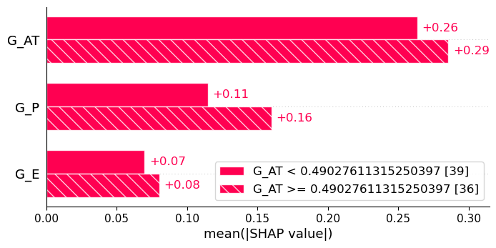
# Feature clustering
clustering = shap.utils.hclust(X_G_train, y_G_train)
shap.plots.bar(shap_valuestr, clustering = clustering)
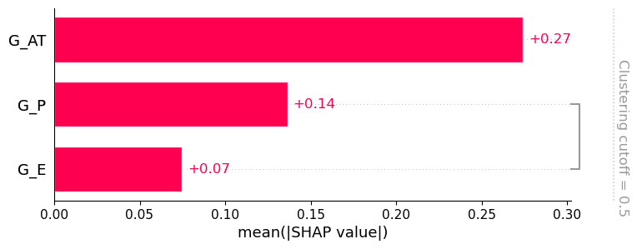
# Feature clustering
clustering = shap.utils.hclust(X_G_train, y_G_train)
shap.plots.bar(shap_valuestr, clustering = clustering, clustering_cutoff = 0.9)
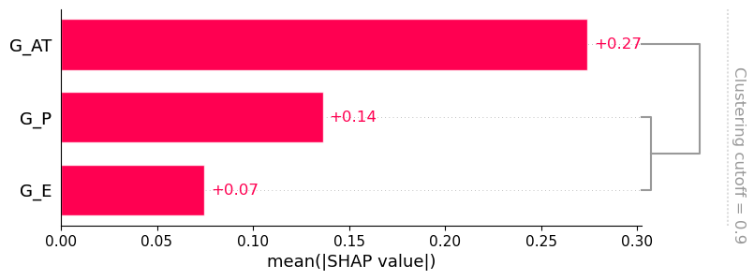
# shap.maskers.TabularPartitions
def f(x):
return gbr4.predict(x)
# Defining a partition nasker that uses the ckustering
masker = shap.maskers.Partition(X_G_train, clustering = clustering)
# Model explanation
explainerts = shap.Explainer(f, masker)
# shap_values
shap_values_partition = explainerts(X_G_train)
# Generating the plot
shap.plots.bar(shap_values_partition)
ExactExplainer explainer: 76it [00:11, 4.63it/s]
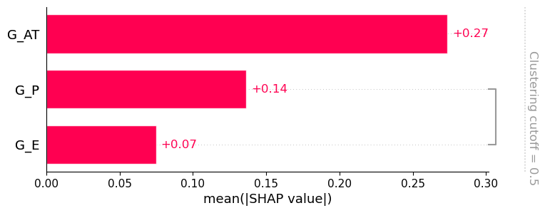
# Waterfall plot
shap.plots.waterfall(shap_valuestr[0])
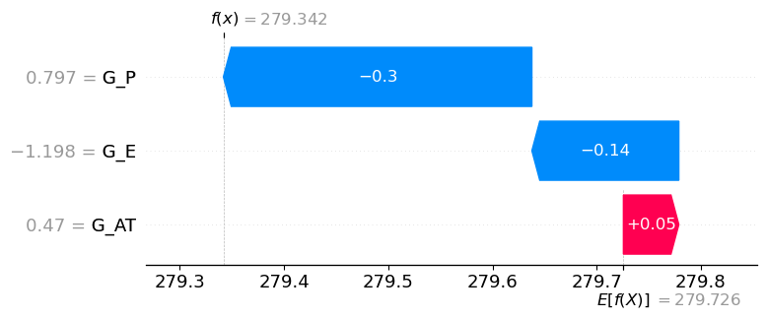
# Froce plot
shap.plots.force(shap_valuestr[0])
<shap.plots._force.AdditiveForceVisualizer at 0x2e346bcdf50>
################## Explanation of the prediction for the testing datasset#################
shap_valuests = explainer.shap_values(X_G_test)
{"model_id":"e57f5b2c3fcd41deb13be15927c51435","version_major":2,"version_minor":0}
# SHAP Summary Plot
# Combination of feature importance and feature effect
shap.summary_plot(shap_valuests, X_G_test, feature_names = X_G_test.columns)
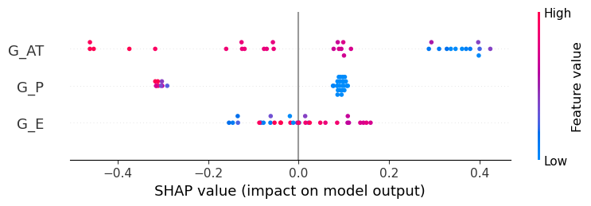
# SHAP Feature Importance Plot
# Features with large absolute Shapley values are important
shap.summary_plot(shap_valuests, X_G_test, feature_names = X_G_test.columns, plot_type = 'bar')
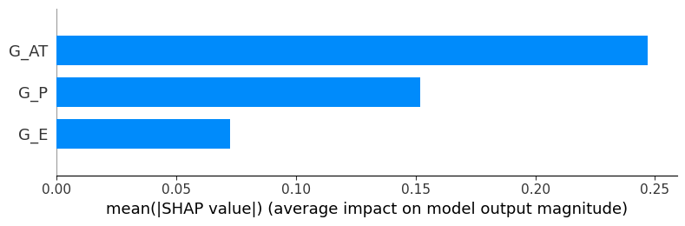
# Global Bar plot
shap_valuests = explainer(X_G_test)
shap.plots.bar(shap_valuests)
{"model_id":"1bc8036d33d44b478d3224754d4c23df","version_major":2,"version_minor":0}
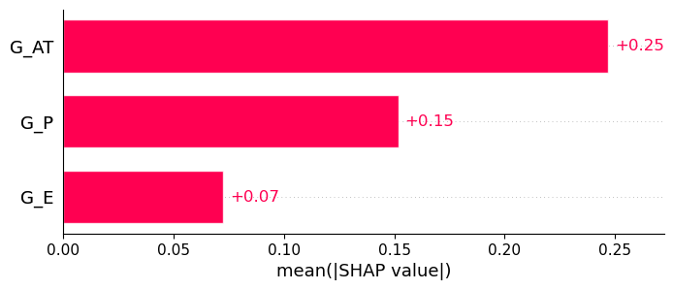
# Local bar plot
shap.plots.bar(shap_valuests[0])
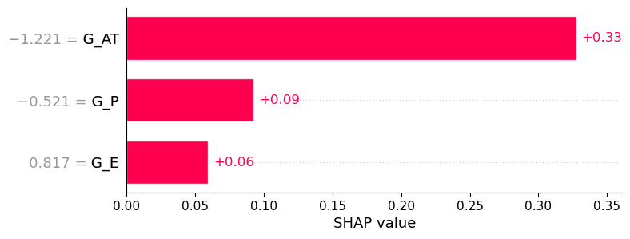
# Feature clustering
clustering = shap.utils.hclust(X_G_test, y_G_test)
shap.plots.bar(shap_valuests, clustering = clustering)
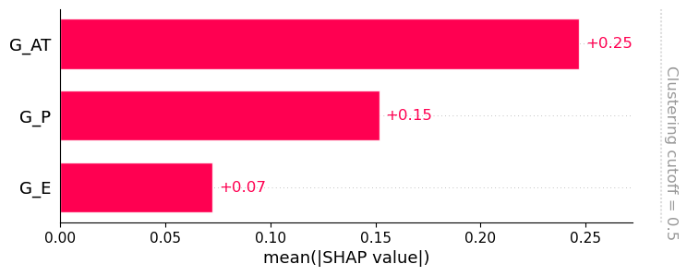
# Feature clustering
clustering = shap.utils.hclust(X_G_test, y_G_test)
shap.plots.bar(shap_valuests, clustering = clustering, clustering_cutoff = 0.9)
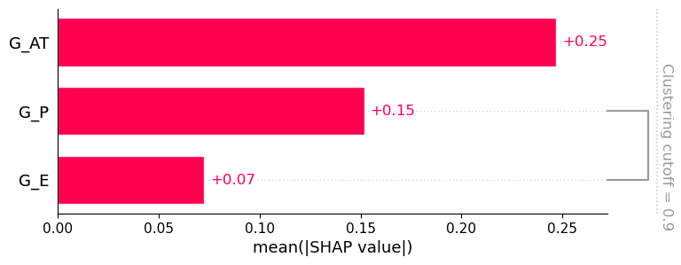
# shap.maskers.TabularPartitions
def f(x):
return gbr4.predict(x)
# Defining a partition nasker that uses the ckustering
masker = shap.maskers.Partition(X_G_test, clustering = clustering)
# Model explanation
explainerts = shap.Explainer(f, masker)
# shap_values
shap_values_partition = explainerts(X_G_test)
# Generating the plot
shap.plots.bar(shap_values_partition)
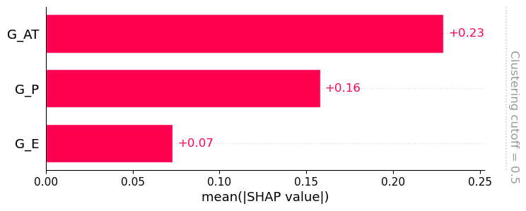
# Waterfall plot
shap.plots.waterfall(shap_valuests[0])
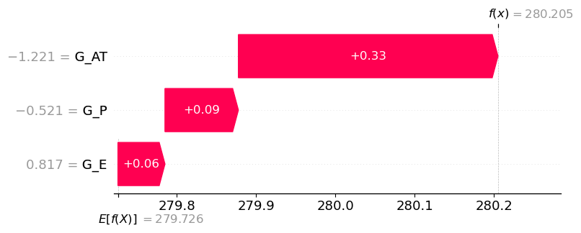
# Force plot
shap.plots.force(shap_valuests[0])
<shap.plots._force.AdditiveForceVisualizer at 0x2e3461a7590>
######################################## END ###############################################
#######################################################################################################
#######################################################################################################
#######################################################################################################

