####### Installing SHAP by typing:
# conda install conda-forge::shap in Anaconda prompt
# pip install shap in command prompt ########
### Importing the necessary libraries #########
# For Tabular data
import pandas as pd
# For generic Maths
import numpy as np
from numpy import absolute
# For scaling purposes
from sklearn.preprocessing import StandardScaler
# For Variance Inlfation Factor (VIF)
from statsmodels.stats.outliers_influence import variance_inflation_factor
# To split the dataset
from sklearn.model_selection import train_test_split
# Metrics and GridSearchCV
from sklearn.metrics import mean_squared_error, mean_absolute_error, r2_score
from sklearn.model_selection import cross_val_score, KFold, GridSearchCV
# Modeling
from sklearn.ensemble import GradientBoostingRegressor
# Shap
import shap
# To ignore warning messages
import warnings
warnings.filterwarnings("ignore")
# For reproducibility purposes
seed = 7
# Reading the dataset
lake = pd.read_csv('E:/XAI/LakeXAI.csv')
#lake = pd.read_csv('C:/Users/Public/XAI/LakeXAI.csv')
lake.head()
T R_E R_AT R_P G_E G_AT G_P R_LL G_LL
0 1/1/2013 0.635469 26.684 0.06 12.7 22.55 0.0 281.86 280.39
1 2/1/2013 0.409592 28.214 0.00 13.1 24.40 0.0 281.60 280.19
2 3/1/2013 0.501878 30.321 0.45 11.5 31.85 0.0 281.34 279.96
3 4/1/2013 1.896789 30.941 2.53 11.2 33.15 0.0 281.09 279.65
4 5/1/2013 11.177511 30.767 8.78 9.6 32.60 0.0 281.00 279.40
# Data description
lake.describe()
R_E R_AT R_P G_E G_AT G_P \
count 108.000000 108.000000 108.000000 108.000000 108.000000 108.000000
mean 20.992243 28.368933 41.858056 9.208333 28.912500 24.374074
std 24.699415 2.807062 64.048078 4.786432 3.714131 47.042366
min 0.244746 21.720941 0.000000 0.200000 20.750000 0.000000
25% 0.789197 26.863723 0.052500 4.975000 25.375000 0.000000
50% 7.116494 28.687451 4.310000 9.700000 30.275000 0.000000
75% 44.921698 30.633814 72.317501 13.625000 31.675000 27.075000
max 75.910866 33.223901 229.970001 16.800000 33.800000 209.700000
R_LL G_LL
count 108.000000 108.000000
mean 281.426111 279.761852
std 0.453857 0.553939
min 280.510000 278.300000
25% 281.052500 279.360000
50% 281.410000 279.745000
75% 281.822500 280.237500
max 282.400000 280.830000
## Preparing the input and output variables
# The output variables or targets
# The remote sensing ouput variable
y_R = lake['R_LL']
y_R.shape
(108,)
print(y_R[:5])
0 281.86
1 281.60
2 281.34
3 281.09
4 281.00
Name: R_LL, dtype: float64
# The ground-truth output variable
y_G = lake['G_LL']
y_G.shape
(108,)
print(y_G[:5])
0 280.39
1 280.19
2 279.96
3 279.65
4 279.40
Name: G_LL, dtype: float64
# The features or input variables
# The remote sensing features
X_R = lake.drop(['T','R_LL','G_LL','G_E', 'G_AT','G_P'], axis = 1)
X_R.shape
(108, 3)
print(X_R[:5])
R_E R_AT R_P
0 0.635469 26.684 0.06
1 0.409592 28.214 0.00
2 0.501878 30.321 0.45
3 1.896789 30.941 2.53
4 11.177511 30.767 8.78
# The ground-truth features
X_G = lake.drop(['T','R_LL','G_LL','R_E', 'R_AT','R_P'], axis = 1)
X_G.shape
(108, 3)
print(X_G[:5])
G_E G_AT G_P
0 12.7 22.55 0.0
1 13.1 24.40 0.0
2 11.5 31.85 0.0
3 11.2 33.15 0.0
4 9.6 32.60 0.0
# Standardizing / Scaling the features
# Scaling the RS input features
X_R_scaled = pd.DataFrame(StandardScaler().fit_transform(X_R),
columns= X_R.columns, index = X_R.index)
# Scaling the GT features
X_G_scaled = pd.DataFrame(StandardScaler().fit_transform(X_G),
columns= X_G.columns, index = X_G.index)
# VIF
### X_R VIF
vif = pd.DataFrame()
vif['vif'] = [variance_inflation_factor(X_R_scaled,i) for i in range(X_R_scaled.shape[1])]
vif['Features'] = X_R.columns
vif.round(2)
vif Features
0 6.67 R_E
1 1.11 R_AT
2 6.43 R_P
### X_G VIF
vif = pd.DataFrame()
vif['vif'] = [variance_inflation_factor(X_G_scaled,i) for i in range(X_G_scaled.shape[1])]
vif['Features'] = X_G.columns
vif.round(2)
vif Features
0 2.38 G_E
1 1.27 G_AT
2 2.02 G_P
# Splitting the data into training and testing datasets
# Splitting the RS Data
X_R_train, X_R_test, y_R_train, y_R_test = train_test_split(X_R_scaled, y_R, test_size = 0.30, random_state = 30, shuffle = True)
print(X_R_train.shape, X_R_test.shape)
(75, 3) (33, 3)
# Splitting the GT Data
X_G_train, X_G_test, y_G_train, y_G_test = train_test_split(X_G_scaled, y_G, test_size = 0.30, random_state = 30, shuffle = True)
print(X_G_train.shape, X_G_test.shape)
(75, 3) (33, 3)
##################### GRADIENT BOOSTING REGRESSION ###################
############ MODEL 3: RS Features (X_R) and GT Target (LL_G)###############
model = GradientBoostingRegressor()
gbr_param_grid = { 'learning_rate' : [0.01, 0.02, 0.03, 0.04, 0.05],
'n_estimators' : [100, 500, 1000, 1500],
'subsample' : [0.1, 0.3, 0.5, 0.7, 0.9, 1],
'max_depth' : [4, 6, 8, 10, 12],
}
gbr_cv = KFold(n_splits = 10, random_state = 1, shuffle = True)
gbr3 = GridSearchCV(model, gbr_param_grid, cv = gbr_cv, scoring = 'neg_mean_squared_error', n_jobs = -1)
gbr3.fit(X_R, y_G)
GridSearchCV(cv=KFold(n_splits=10, random_state=1, shuffle=True),
estimator=GradientBoostingRegressor(), n_jobs=-1,
param_grid={'learning_rate': [0.01, 0.02, 0.03, 0.04, 0.05],
'max_depth': [4, 6, 8, 10, 12],
'n_estimators': [100, 500, 1000, 1500],
'subsample': [0.1, 0.3, 0.5, 0.7, 0.9, 1]},
scoring='neg_mean_squared_error')
# Printing the best parameters and the best score
print('The best parameters are:', gbr3.best_params_)
print('The best score is:', gbr3.best_score_)
The best parameters are: {'learning_rate': 0.01, 'max_depth': 4, 'n_estimators': 1000, 'subsample': 0.1}
The best score is: -0.12583137036701456
# learning_rate = 0.02, max_depth = 12, n_estimators = 500, subsample = 0.1
########### Fitting the model on the training dataset using the best parameters
# Instantiation
model = GradientBoostingRegressor(learning_rate = 0.01, max_depth = 4, n_estimators = 1000, subsample = 0.1)
# Fitting the model
gbr3 = model.fit(X_R_train, y_G_train)
# Evaluation of the performance of the training model:
gbr_y_predtr = gbr3.predict(X_R_train)
print('The training MAE is:', mean_absolute_error(y_G_train, gbr_y_predtr))
print('The training MSE is:', mean_squared_error(y_G_train, gbr_y_predtr))
print('The training R2 Score is:', r2_score(y_G_train, gbr_y_predtr))
The training MAE is: 0.19148726842929592
The training MSE is: 0.06280958996328376
The training R2 Score is: 0.7845234664051448
# Evaluation of the performance of the testing model:
gbr_y_predts = gbr3.predict(X_R_test)
print('The testing MAE is:', mean_absolute_error(y_G_test, gbr_y_predts))
print('The testing MSE is:', mean_squared_error(y_G_test, gbr_y_predts))
print('The testing R2 Score is:', r2_score(y_G_test, gbr_y_predts))
The testing MAE is: 0.2750937913256752
The testing MSE is: 0.1123096868404203
The testing R2 Score is: 0.6479395156419334
##################### k-fold Cross-validation ##############################
############# On the training dataset
score_gbr3tr = cross_val_score(gbr3, X_R_train, y_G_train, scoring = 'neg_mean_squared_error', cv = 10)
# The mean training score
print('The mean training CV score is:', absolute(np.mean(score_gbr3tr)))
The mean training CV score is: 0.16701771054968556
############# On the testing dataset
score_gbr3ts = cross_val_score(gbr3, X_R_test, y_G_test, scoring = 'neg_mean_squared_error', cv = 10)
# The mean testing score
print('The mean testing CV score is:', absolute(np.mean(score_gbr3ts)))
The mean testing CV score is: 0.15117817509740625
##################### SHAP ###################
shap.initjs()
<IPython.core.display.HTML object>
###### Initializing the explainer on the training dataset
explainer = shap.KernelExplainer(gbr3.predict, X_R_train)
# Explanation of the prediction using the training datasset
shap_valuestr = explainer.shap_values(X_R_train)
{"model_id":"c4587159b5ec401689780ae311020ebc","version_major":2,"version_minor":0}
shap_valuestr
array([[ 0.2570538 , 0.11469071, -0.69797732],
[ 0.0031302 , -0.29889921, -0.03358882],
[ 0.00133364, -0.26584841, -0.07892959],
[ 0.24247911, 0.04551202, -0.69883707],
[ 0.21132352, 0.16686916, -0.44653832],
[-0.03205634, -0.26799409, 0.21642279],
[-0.23624385, 0.12223618, 0.38023302],
[ 0.0689857 , 0.02546329, -0.58150855],
[-0.08970373, 0.17834457, 0.52735981],
[ 0.14908456, -0.23518143, -0.44030782],
[-0.02877215, 0.12308846, 0.50285526],
[ 0.22212995, 0.11928527, -0.41600855],
[ 0.11450355, -0.01713126, -0.39126047],
[ 0.14933953, 0.10143886, -0.63719398],
[ 0.19421108, 0.06341941, -0.7054218 ],
[ 0.03043273, 0.18428829, 0.54062625],
[-0.28631604, 0.07583772, 0.30358777],
[-0.04557978, -0.3313239 , 0.07222213],
[-0.26267534, 0.08375807, 0.3245473 ],
[-0.19575831, 0.17755849, 0.5417704 ],
[ 0.10969582, 0.0713824 , -0.38563445],
[-0.22267659, 0.12873594, 0.52615173],
[ 0.2354463 , -0.27825643, -0.6670284 ],
[-0.25205894, 0.11310462, 0.3815293 ],
[ 0.17585846, -0.16761925, -0.1744086 ],
[ 0.00628359, 0.1405195 , 0.51537535],
[-0.18438023, 0.15686407, 0.52300842],
[ 0.02757557, 0.17195569, 0.51739272],
[-0.10284936, 0.15545199, 0.53193049],
[ 0.17982199, -0.26981448, -0.44471381],
[-0.23388023, 0.11314544, 0.36693775],
[ 0.18000153, 0.0584716 , 0.16385081],
[-0.0899462 , -0.28089728, 0.17605037],
[ 0.20808862, -0.21587364, 0.14375013],
[-0.03517449, 0.16084637, 0.43217945],
[ 0.12862957, -0.00973951, -0.4083704 ],
[ 0.02778646, -0.14935346, 0.15575683],
[ 0.01014136, 0.09979939, 0.50526747],
[-0.1366843 , -0.41057074, -0.06150016],
[ 0.10768089, 0.05682549, -0.70621834],
[ 0.1807851 , 0.07576022, -0.27323318],
[-0.25158984, 0.04991383, 0.32302013],
[-0.24592756, 0.11735259, 0.37985437],
[ 0.23174244, 0.07171452, -0.71618937],
[-0.09700235, -0.29579068, 0.13531431],
[-0.09384137, 0.12336956, 0.5392037 ],
[-0.16354444, 0.19778865, 0.52772342],
[ 0.00380246, -0.20093535, -0.1650359 ],
[ 0.25327159, 0.10960692, -0.59032422],
[ 0.09905102, 0.12492072, 0.39222366],
[-0.22512809, 0.03785572, 0.19488036],
[-0.12833885, 0.10112122, -0.06534173],
[ 0.05416862, 0.05063751, -0.62483594],
[-0.05355919, -0.05982429, -0.28328954],
[-0.11843048, -0.18317087, -0.35010167],
[ 0.20743917, -0.25505221, -0.29401029],
[ 0.10562192, 0.02028858, -0.59985556],
[-0.09546055, 0.17722687, 0.52152464],
[-0.24634954, 0.10902504, 0.38033343],
[ 0.10596567, 0.12092362, -0.49240381],
[-0.26810751, 0.12987535, 0.36616104],
[ 0.14954011, -0.21452662, -0.45821995],
[ 0.14682506, 0.06880657, -0.70502867],
[ 0.138983 , -0.22532141, -0.50157859],
[-0.02470318, -0.30868557, 0.21891489],
[ 0.00871787, 0.07122998, 0.50404199],
[-0.05998922, 0.00387623, -0.32221449],
[ 0.18376824, -0.27330633, -0.4626894 ],
[-0.27412299, -0.00326011, 0.34241287],
[-0.09054467, 0.1201392 , 0.53981586],
[-0.20317716, 0.13473673, 0.53762195],
[ 0.26642638, 0.02834954, -0.28944859],
[ 0.15917609, -0.10577713, 0.00610488],
[ 0.01409919, 0.16823668, 0.54473963],
[-0.27582856, 0.10250481, 0.36655068]])
##### Shap summary plot
shap.summary_plot(shap_valuestr, X_R_train, feature_names = X_R_train.columns)
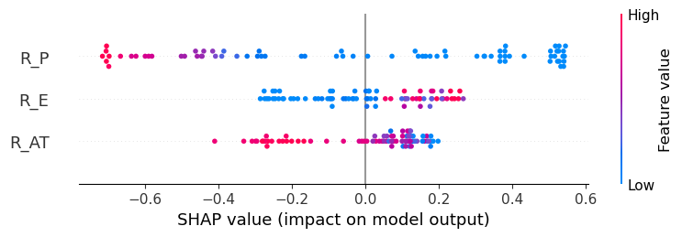
###### Shap feature importance plot
shap.summary_plot(shap_valuestr, X_R_train, feature_names = X_R_train.columns, plot_type = 'bar')
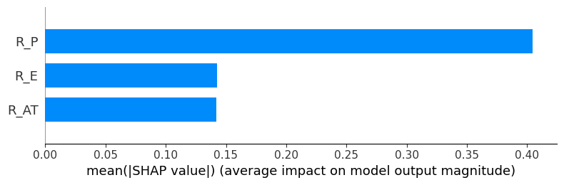
## Global bar plot
shap_valuestr = explainer(X_R_train)
shap.plots.bar(shap_valuestr)
{"model_id":"56a034fee3564387b415be3f39b9a569","version_major":2,"version_minor":0}
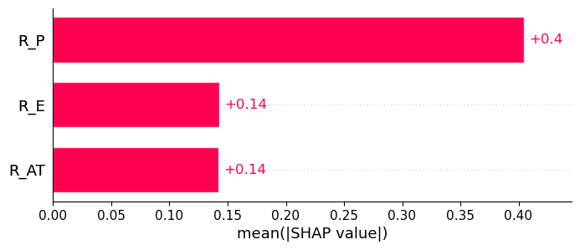
## Local bar plot
shap.plots.bar(shap_valuestr[0])
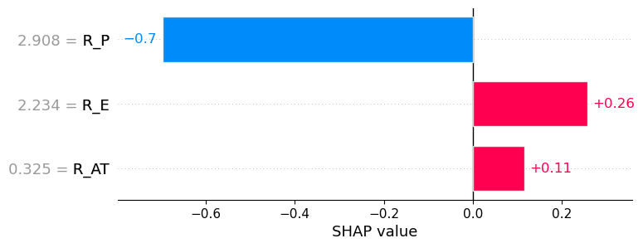
# Auto-cohort plot
shap.plots.bar(shap_valuestr.cohorts(2).abs.mean(0))
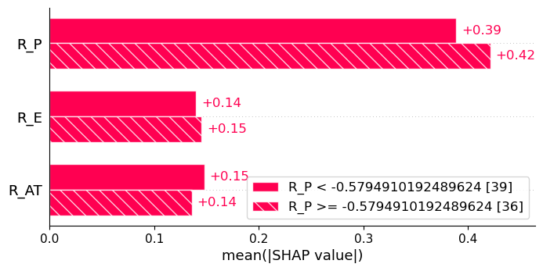
# Feature clustering
clustering = shap.utils.hclust(X_R_train, y_G_train)
shap.plots.bar(shap_valuestr, clustering = clustering)
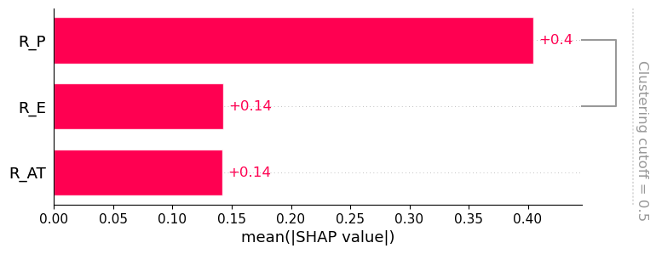
# Feature clustering
clustering = shap.utils.hclust(X_R_train, y_G_train)
shap.plots.bar(shap_valuestr, clustering = clustering, clustering_cutoff = 0.9)
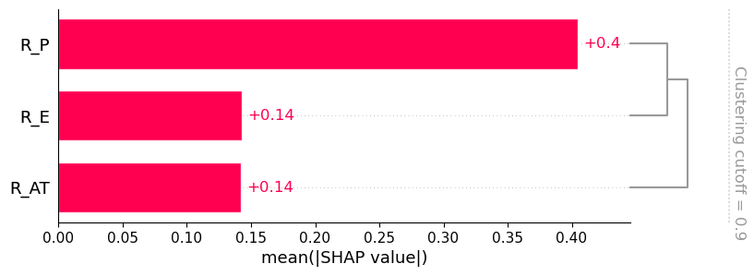
# shap.maskers.TabularPartitions
def f(x):
return gbr3.predict(x)
# Defining a partition nasker that uses the ckustering
masker = shap.maskers.Partition(X_R_train, clustering = clustering)
# Model explanation
explainerts = shap.Explainer(f, masker)
# shap_values
shap_values_partition = explainerts(X_R_train)
# Generating the plot
shap.plots.bar(shap_values_partition)
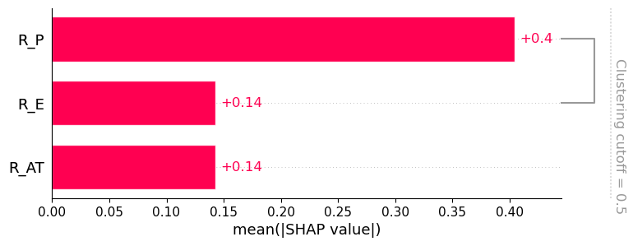
# Waterfall plot
shap.plots.waterfall(shap_valuestr[0])
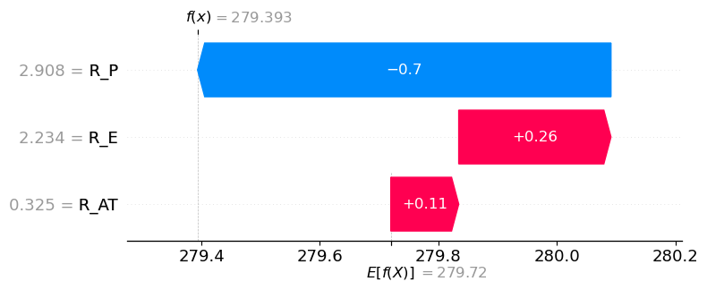
# Froce plot
shap.plots.force(shap_valuestr[0])
<shap.plots._force.AdditiveForceVisualizer at 0x1f16ff79ad0>
################## Explanation of the prediction for the testing datasset#################
shap_valuests = explainer.shap_values(X_R_test)
{"model_id":"0517a268259141f383da7e7a12e261e5","version_major":2,"version_minor":0}
# SHAP Summary Plot
# Combination of feature importance and feature effect
shap.summary_plot(shap_valuests, X_R_test, feature_names = X_R_test.columns)
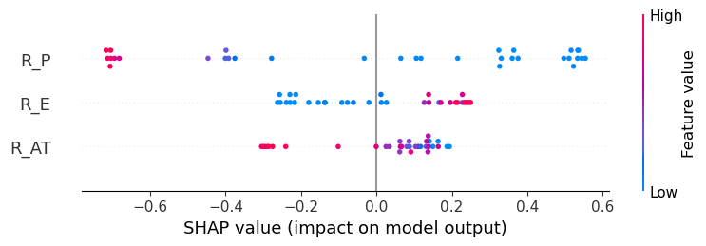
# SHAP Feature Importance Plot
# Features with large absolute Shapley values are important
shap.summary_plot(shap_valuests, X_R_test, feature_names = X_R_test.columns, plot_type = 'bar')
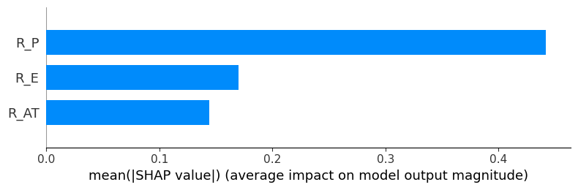
# Global Bar plot
shap_valuests = explainer(X_R_test)
shap.plots.bar(shap_valuests)
{"model_id":"b9c0674b5b2b43fb95ff1224d63a9796","version_major":2,"version_minor":0}
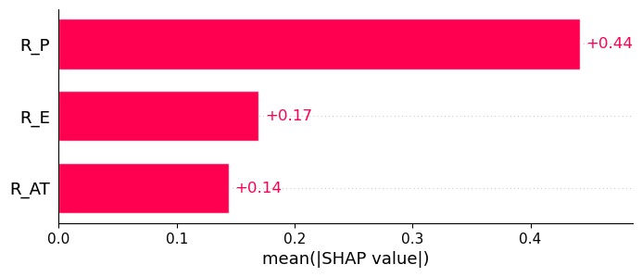
# Local bar plot
shap.plots.bar(shap_valuests[0])
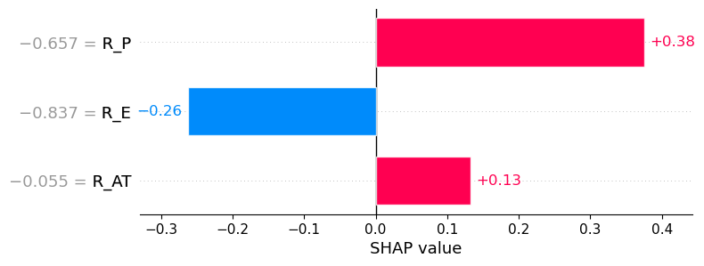
# Feature clustering
clustering = shap.utils.hclust(X_R_test, y_G_test)
shap.plots.bar(shap_valuests, clustering = clustering)
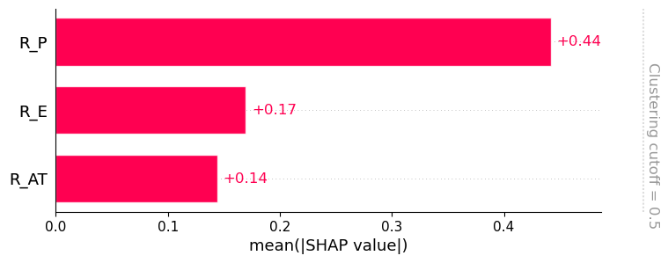
# Feature clustering
clustering = shap.utils.hclust(X_R_test, y_G_test)
shap.plots.bar(shap_valuests, clustering = clustering, clustering_cutoff = 0.9)
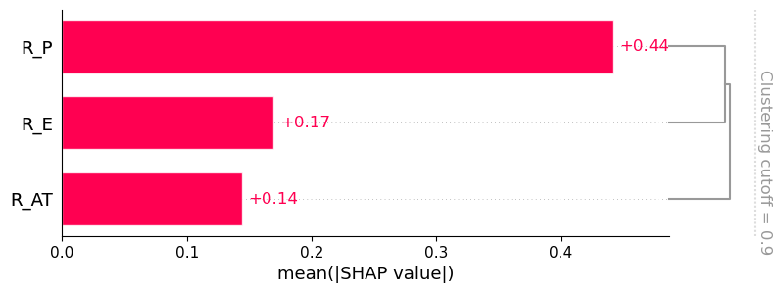
# shap.maskers.TabularPartitions
def f(x):
return gbr3.predict(x)
# Defining a partition nasker that uses the ckustering
masker = shap.maskers.Partition(X_R_test, clustering = clustering)
# Model explanation
explainerts = shap.Explainer(f, masker)
# shap_values
shap_values_partition = explainerts(X_R_test)
# Generating the plot
shap.plots.bar(shap_values_partition)
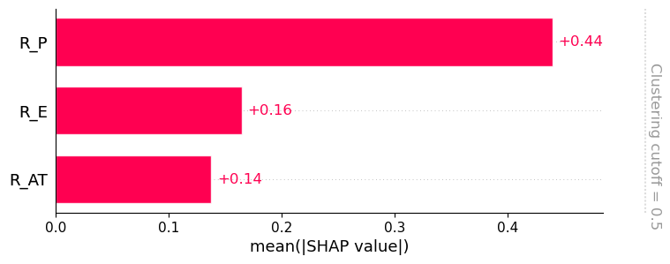
# Waterfall plot
shap.plots.waterfall(shap_valuests[0])
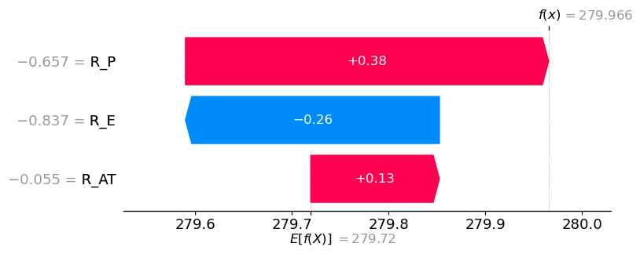
# Force plot
shap.plots.force(shap_valuests[0])
<shap.plots._force.AdditiveForceVisualizer at 0x1f16f2e7a50>
################################ END ##########################

