# Reading the dataset
# Importing pandas library
import pandas as pd
# Loading the dataset
lake = pd.read_csv('E:/XAI/LakeXAI.csv')
#lake = pd.read_csv('C:/Users/Public/XAI/LakeXAI.csv')
seed = 7
lake
T R_E R_AT R_P G_E G_AT G_P R_LL \
0 1/1/2013 0.635469 26.684000 0.060000 12.7 22.55 0.0 281.86
1 2/1/2013 0.409592 28.214000 0.000000 13.1 24.40 0.0 281.60
2 3/1/2013 0.501878 30.321000 0.450000 11.5 31.85 0.0 281.34
3 4/1/2013 1.896789 30.941000 2.530000 11.2 33.15 0.0 281.09
4 5/1/2013 11.177511 30.767000 8.780000 9.6 32.60 0.0 281.00
.. ... ... ... ... ... ... ... ...
103 8/1/2021 54.353870 27.372797 111.480003 2.4 30.80 66.5 281.46
104 9/1/2021 55.176441 28.473566 85.570000 2.1 30.10 139.3 281.82
105 10/1/2021 27.200169 30.365717 25.629999 5.8 30.00 0.0 281.99
106 11/1/2021 4.567200 28.635095 0.000000 8.9 27.45 0.0 281.98
107 12/1/2021 2.425670 23.681909 0.030000 12.1 23.20 0.0 281.79
G_LL
0 280.39
1 280.19
2 279.96
3 279.65
4 279.40
.. ...
103 279.15
104 279.53
105 280.14
106 280.36
107 280.28
[108 rows x 9 columns]

lake.head()
T R_E R_AT R_P G_E G_AT G_P R_LL G_LL
0 1/1/2013 0.635469 26.684 0.06 12.7 22.55 0.0 281.86 280.39
1 2/1/2013 0.409592 28.214 0.00 13.1 24.40 0.0 281.60 280.19
2 3/1/2013 0.501878 30.321 0.45 11.5 31.85 0.0 281.34 279.96
3 4/1/2013 1.896789 30.941 2.53 11.2 33.15 0.0 281.09 279.65
4 5/1/2013 11.177511 30.767 8.78 9.6 32.60 0.0 281.00 279.40
# Exploratory Data Analysis
# Importing the necessary libraries and functions
import matplotlib.pyplot as plt
import seaborn as sns
%matplotlib inline
# Data description
lake.describe()
R_E R_AT R_P G_E G_AT G_P \
count 108.000000 108.000000 108.000000 108.000000 108.000000 108.000000
mean 20.992243 28.368933 41.858056 9.208333 28.912500 24.374074
std 24.699415 2.807062 64.048078 4.786432 3.714131 47.042366
min 0.244746 21.720941 0.000000 0.200000 20.750000 0.000000
25% 0.789197 26.863723 0.052500 4.975000 25.375000 0.000000
50% 7.116494 28.687451 4.310000 9.700000 30.275000 0.000000
75% 44.921698 30.633814 72.317501 13.625000 31.675000 27.075000
max 75.910866 33.223901 229.970001 16.800000 33.800000 209.700000
R_LL G_LL
count 108.000000 108.000000
mean 281.426111 279.761852
std 0.453857 0.553939
min 280.510000 278.300000
25% 281.052500 279.360000
50% 281.410000 279.745000
75% 281.822500 280.237500
max 282.400000 280.830000
### Correlation analysis
lake_corr = lake.drop(['T'], axis = 1).corr()
lake_corr
R_E R_AT R_P G_E G_AT G_P R_LL \
R_E 1.000000 0.220126 0.914329 -0.895073 0.392979 0.791937 -0.235223
R_AT 0.220126 1.000000 0.111853 -0.334988 0.819145 0.017828 -0.519301
R_P 0.914329 0.111853 1.000000 -0.795202 0.337752 0.886110 -0.310967
G_E -0.895073 -0.334988 -0.795202 1.000000 -0.446201 -0.704554 0.182688
G_AT 0.392979 0.819145 0.337752 -0.446201 1.000000 0.233625 -0.607375
G_P 0.791937 0.017828 0.886110 -0.704554 0.233625 1.000000 -0.188731
R_LL -0.235223 -0.519301 -0.310967 0.182688 -0.607375 -0.188731 1.000000
G_LL -0.541670 -0.487631 -0.572185 0.488293 -0.660223 -0.451311 0.857672
G_LL
R_E -0.541670
R_AT -0.487631
R_P -0.572185
G_E 0.488293
G_AT -0.660223
G_P -0.451311
R_LL 0.857672
G_LL 1.000000
lake_num = lake.drop(['T'], axis = 1)
lake_num
R_E R_AT R_P G_E G_AT G_P R_LL G_LL
0 0.635469 26.684000 0.060000 12.7 22.55 0.0 281.86 280.39
1 0.409592 28.214000 0.000000 13.1 24.40 0.0 281.60 280.19
2 0.501878 30.321000 0.450000 11.5 31.85 0.0 281.34 279.96
3 1.896789 30.941000 2.530000 11.2 33.15 0.0 281.09 279.65
4 11.177511 30.767000 8.780000 9.6 32.60 0.0 281.00 279.40
.. ... ... ... ... ... ... ... ...
103 54.353870 27.372797 111.480003 2.4 30.80 66.5 281.46 279.15
104 55.176441 28.473566 85.570000 2.1 30.10 139.3 281.82 279.53
105 27.200169 30.365717 25.629999 5.8 30.00 0.0 281.99 280.14
106 4.567200 28.635095 0.000000 8.9 27.45 0.0 281.98 280.36
107 2.425670 23.681909 0.030000 12.1 23.20 0.0 281.79 280.28
[108 rows x 8 columns]
lake_corr['R_LL']
R_E -0.235223
R_AT -0.519301
R_P -0.310967
G_E 0.182688
G_AT -0.607375
G_P -0.188731
R_LL 1.000000
G_LL 0.857672
Name: R_LL, dtype: float64
lake_corr['G_LL']
R_E -0.541670
R_AT -0.487631
R_P -0.572185
G_E 0.488293
G_AT -0.660223
G_P -0.451311
R_LL 0.857672
G_LL 1.000000
Name: G_LL, dtype: float64
# Correlation coefficients using SNS heatmap
plt.figure(figsize=(10, 5))
sns.heatmap(lake_corr, vmin = 1, vmax = 1, cmap = 'PiYG', annot = True)
plt.show()
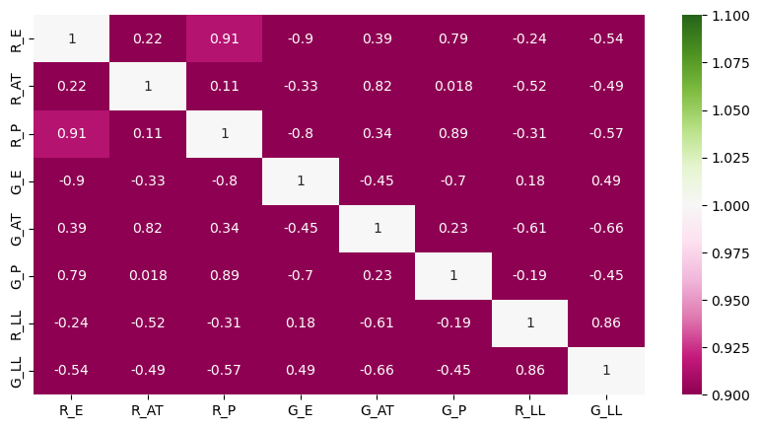
# Important features for each target
# R_LL
RLL_corr = lake_corr['R_LL']
RLL_corr
R_E -0.235223
R_AT -0.519301
R_P -0.310967
G_E 0.182688
G_AT -0.607375
G_P -0.188731
R_LL 1.000000
G_LL 0.857672
Name: R_LL, dtype: float64
GLL_corr = lake_corr['G_LL']
GLL_corr
R_E -0.541670
R_AT -0.487631
R_P -0.572185
G_E 0.488293
G_AT -0.660223
G_P -0.451311
R_LL 0.857672
G_LL 1.000000
Name: G_LL, dtype: float64

Visualization
sns.pairplot(lake_num)
C:\Users\Administrator\anaconda3\Lib\site-packages\seaborn\axisgrid.py:118: UserWarning: The figure layout has changed to tight
self._figure.tight_layout(*args, **kwargs)
<seaborn.axisgrid.PairGrid at 0x17392f62d10>
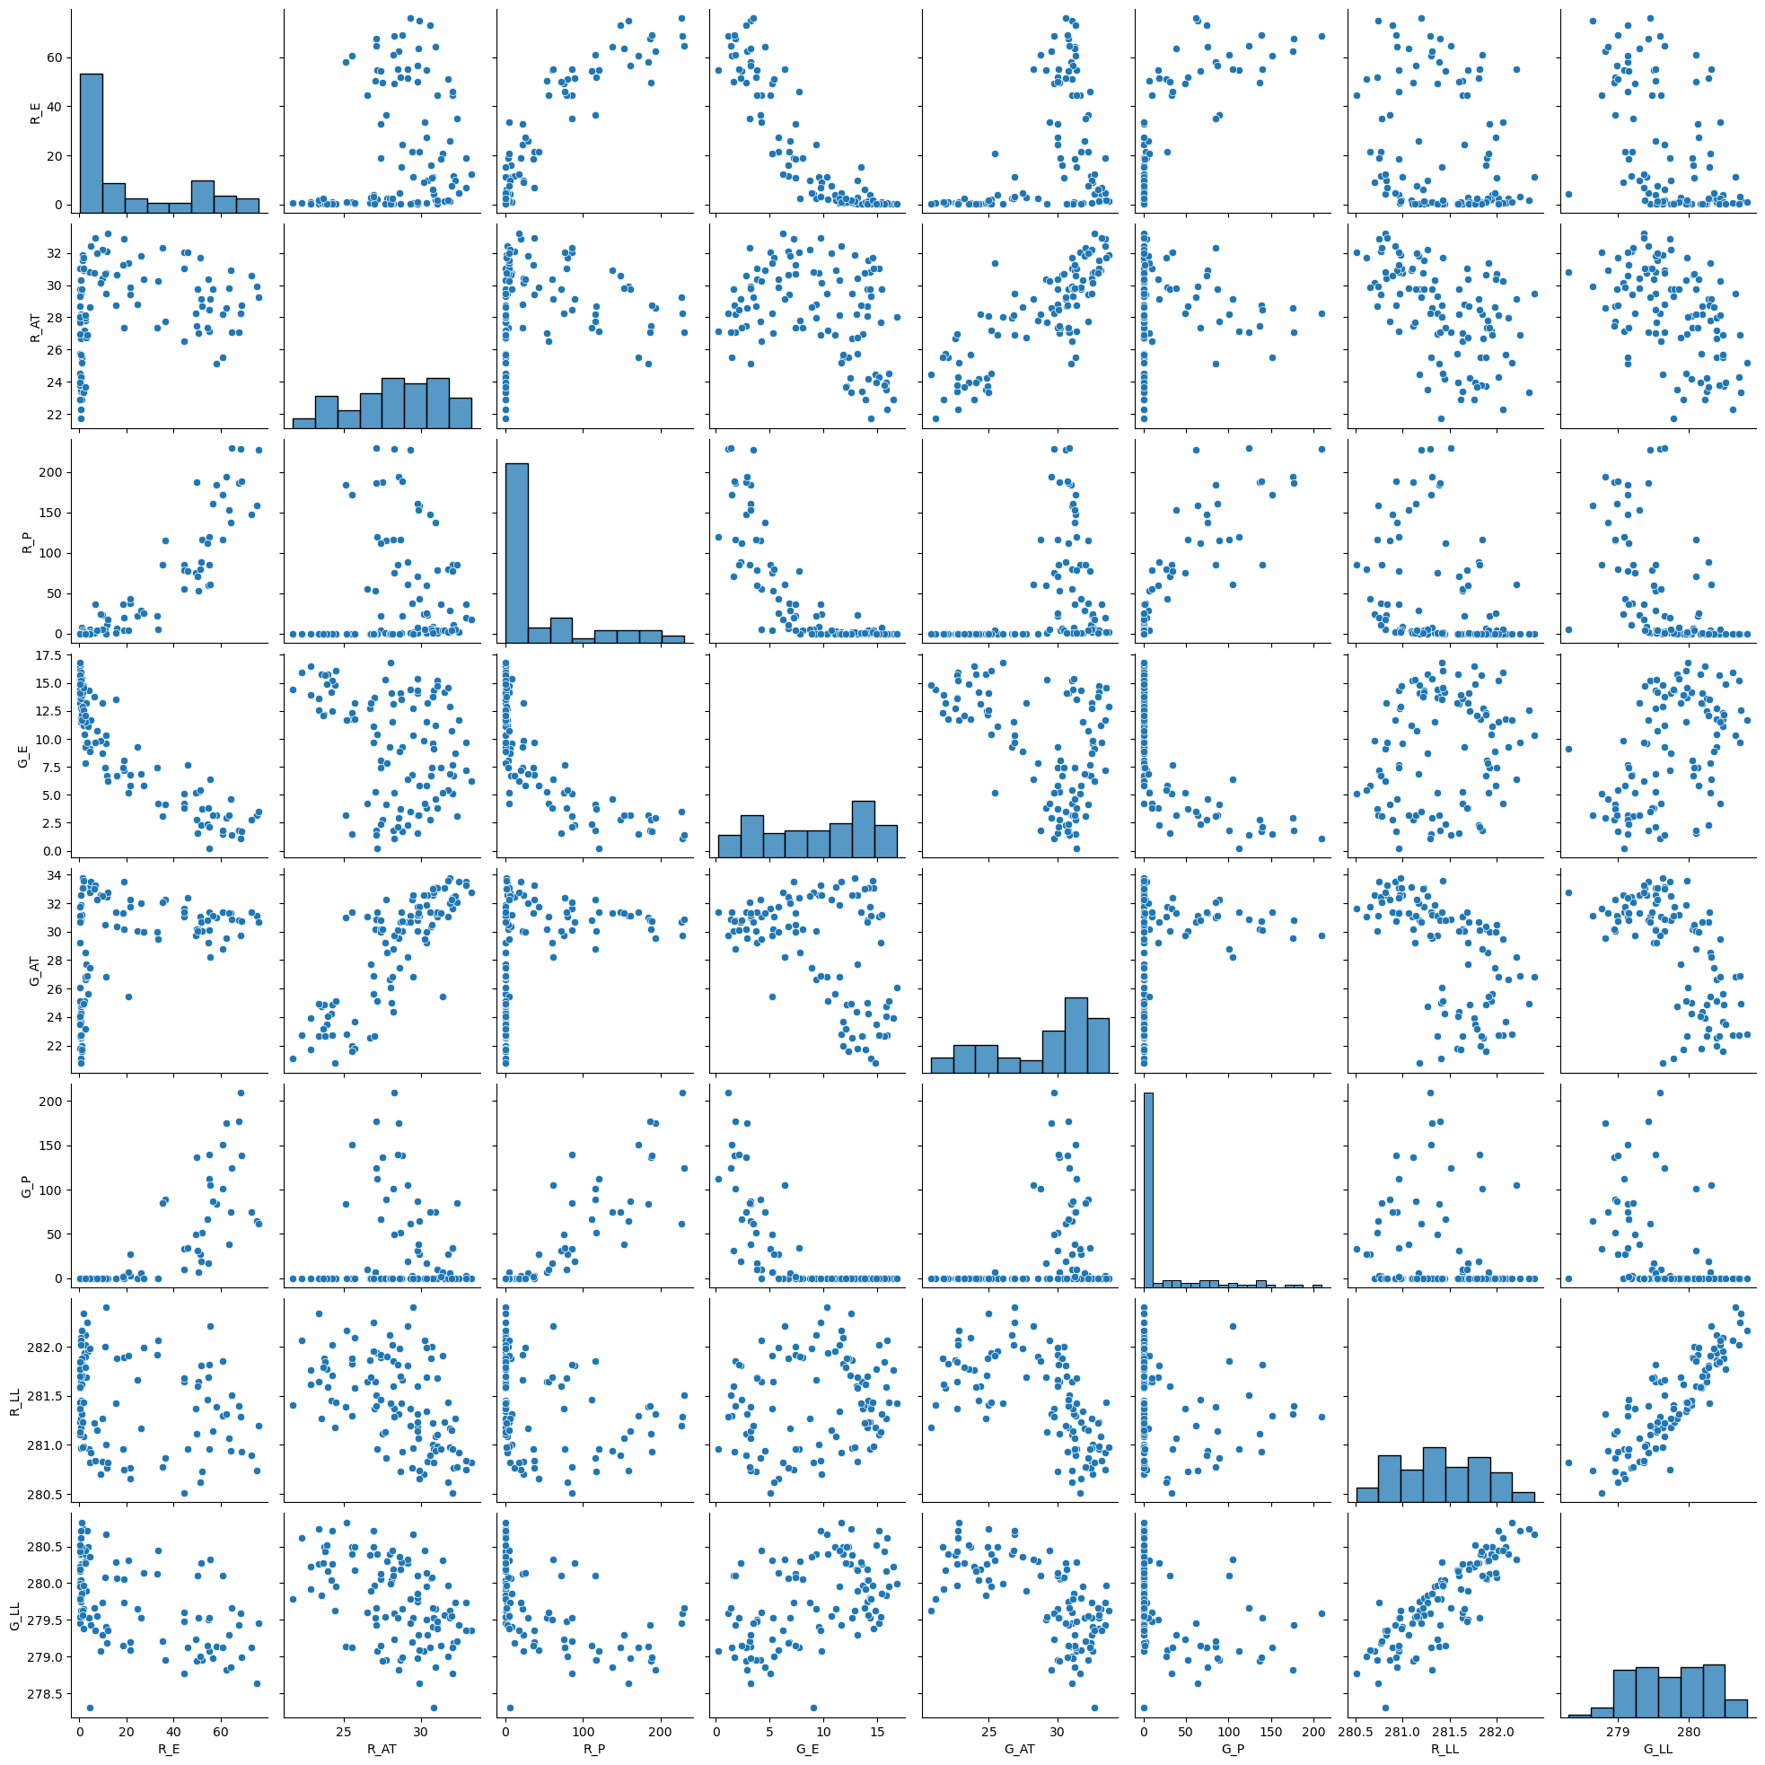
# R_LL vs RS features
fig, axes = plt.subplots(1,3, sharex = True, figsize = (15,5))
sns.scatterplot(data = lake, x = 'R_LL', y = 'R_AT', ax = axes[0])
sns.scatterplot(data = lake, x = 'R_LL', y = 'R_E', ax = axes[1])
sns.scatterplot(data = lake, x = 'R_LL', y = 'R_P', ax = axes[2])
plt.show()
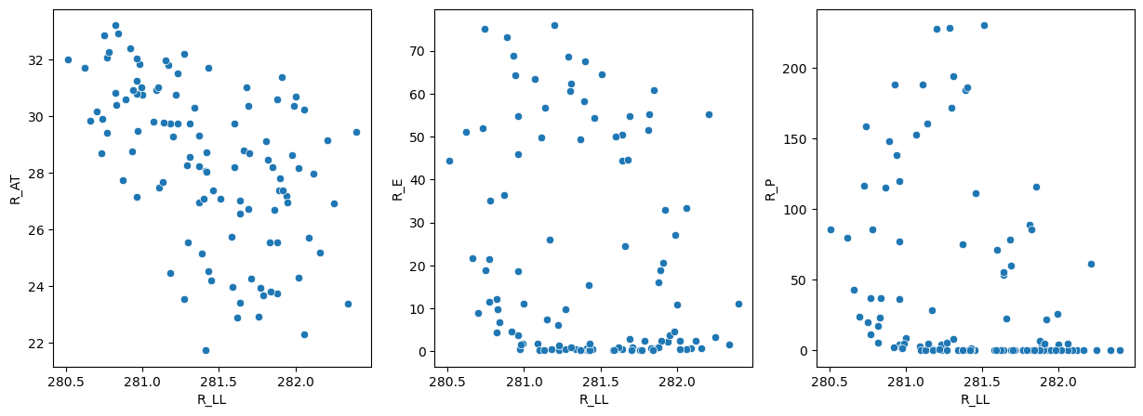
# R_LL vs GT features
fig, axes = plt.subplots(1,3, sharex = True, figsize = (15,5))
sns.scatterplot(data = lake, x = 'R_LL', y = 'G_AT', ax = axes[0])
sns.scatterplot(data = lake, x = 'R_LL', y = 'G_E', ax = axes[1])
sns.scatterplot(data = lake, x = 'R_LL', y = 'G_P', ax = axes[2])
plt.show()
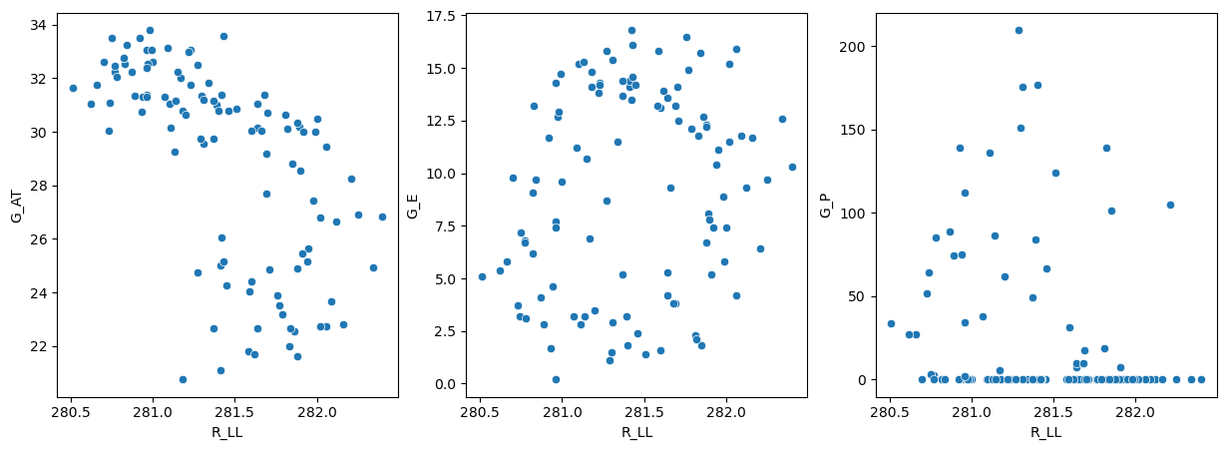
# G_LL vs RS features
fig, axes = plt.subplots(1,3, sharex = True, figsize = (15,5))
sns.scatterplot(data = lake, x = 'G_LL', y = 'R_AT', ax = axes[0])
sns.scatterplot(data = lake, x = 'G_LL', y = 'R_E', ax = axes[1])
sns.scatterplot(data = lake, x = 'G_LL', y = 'R_P', ax = axes[2])
plt.show()
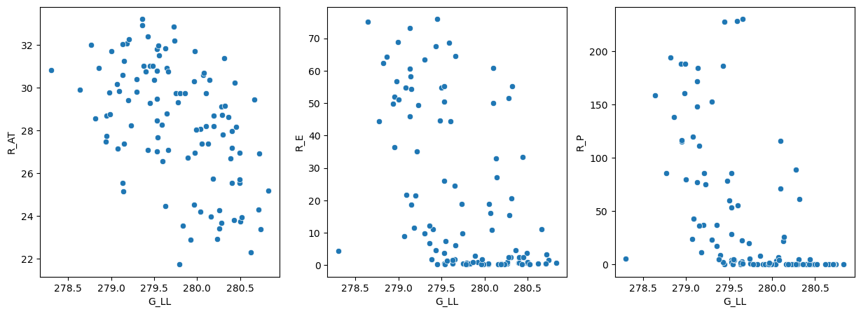
# LL_G vs GT features
fig, axes = plt.subplots(1,3, sharex = True, figsize = (15,5))
sns.scatterplot(data = lake, x = 'G_LL', y = 'G_AT', ax = axes[0])
sns.scatterplot(data = lake, x = 'G_LL', y = 'G_E', ax = axes[1])
sns.scatterplot(data = lake, x = 'G_LL', y = 'G_P', ax = axes[2])
plt.show()
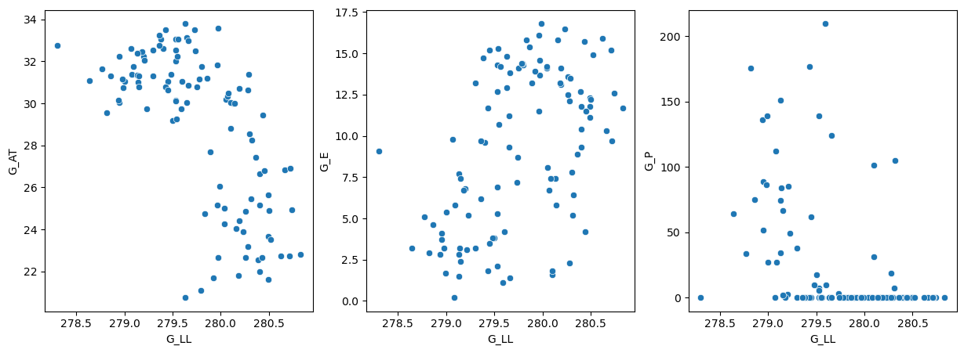
# Features vs Features
# RS
fig, axes = plt.subplots(1,2, sharex = True, figsize = (15,5))
sns.scatterplot(data = lake, x = 'R_AT', y = 'R_E', ax = axes[0])
sns.scatterplot(data = lake, x = 'R_AT', y = 'R_P', ax = axes[1])
plt.show()
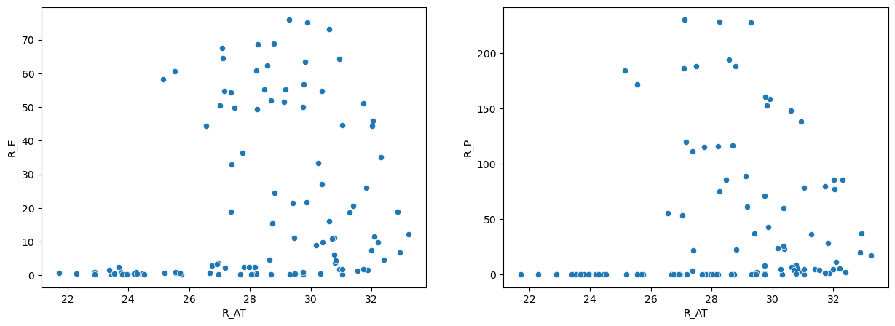
# GT
fig, axes = plt.subplots(1,2, sharex = True, figsize = (15,5))
sns.scatterplot(data = lake, x = 'G_AT', y = 'G_E', ax = axes[0])
sns.scatterplot(data = lake, x = 'G_AT', y = 'G_P', ax = axes[1])
plt.show()
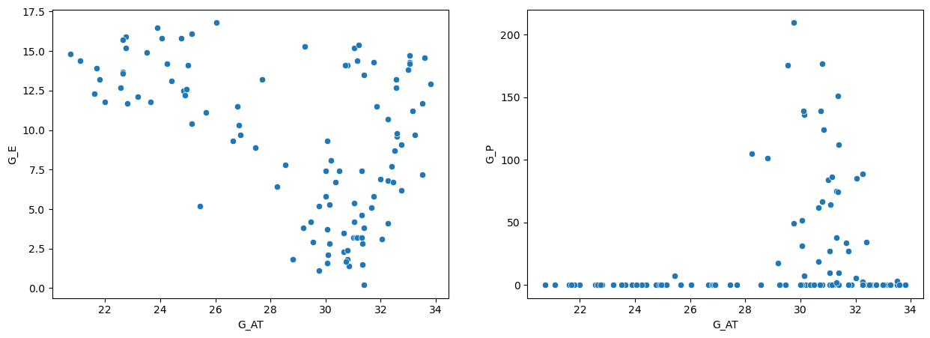
lake.plot.scatter(x = 'G_LL', y = 'R_LL')
<Axes: xlabel='G_LL', ylabel='R_LL'>
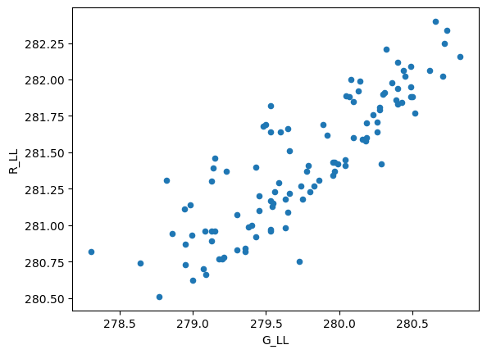
lake['R_LL'].plot()
<Axes: >
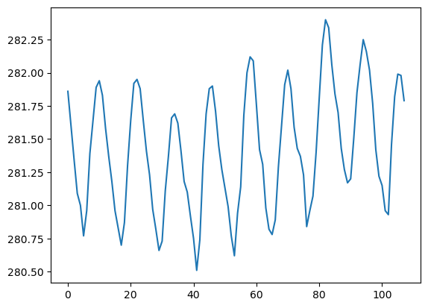
lake['G_LL'].plot()
<Axes: >
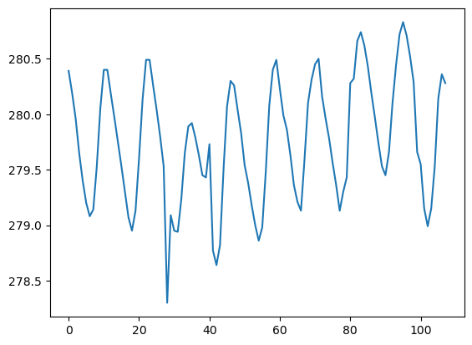
## Preparing the input and output variables
# # The output variables or targets
# The remote sensing ouput variable
y_R = lake['R_LL']
y_R.shape
(108,)
print(y_R[:5])
0 281.86
1 281.60
2 281.34
3 281.09
4 281.00
Name: R_LL, dtype: float64
# The ground-truth output variable
y_G = lake['G_LL']
y_G.shape
(108,)
print(y_G[:5])
0 280.39
1 280.19
2 279.96
3 279.65
4 279.40
Name: G_LL, dtype: float64
# The features or input variables
# The remote sensing features
X_R = lake.drop(['T','R_LL','G_LL','G_E', 'G_AT','G_P'], axis = 1)
X_R.shape
(108, 3)
print(X_R[:5])
R_E R_AT R_P
0 0.635469 26.684 0.06
1 0.409592 28.214 0.00
2 0.501878 30.321 0.45
3 1.896789 30.941 2.53
4 11.177511 30.767 8.78
# The ground-truth features
X_G = lake.drop(['T','R_LL','G_LL','R_E', 'R_AT','R_P'], axis = 1)
X_G.shape
(108, 3)
print(X_G[:5])
G_E G_AT G_P
0 12.7 22.55 0.0
1 13.1 24.40 0.0
2 11.5 31.85 0.0
3 11.2 33.15 0.0
4 9.6 32.60 0.0
# Standardizing / Scaling the features
from sklearn.preprocessing import StandardScaler
# Scaling the RS input features
X_R_scaled = pd.DataFrame(StandardScaler().fit_transform(X_R),
columns= X_R.columns, index = X_R.index)
# Scaling the GT features
X_G_scaled = pd.DataFrame(StandardScaler().fit_transform(X_G),
columns= X_G.columns, index = X_G.index)
# VIF
from statsmodels.stats.outliers_influence import variance_inflation_factor
### X_R VIF
vif = pd.DataFrame()
vif['vif'] = [variance_inflation_factor(X_R_scaled,i) for i in range(X_R_scaled.shape[1])]
vif['Features'] = X_R.columns
vif.round(2)
vif Features
0 6.67 R_E
1 1.11 R_AT
2 6.43 R_P
### X_G VIF
vif = pd.DataFrame()
vif['vif'] = [variance_inflation_factor(X_G_scaled,i) for i in range(X_G_scaled.shape[1])]
vif['Features'] = X_G.columns
vif.round(2)
vif Features
0 2.38 G_E
1 1.27 G_AT
2 2.02 G_P
# Splitting the feature data into training and testing datasets
# Importing train_test_splt function
from sklearn.model_selection import train_test_split
# Splitting the RS Data
X_R_train, X_R_test, y_R_train, y_R_test = train_test_split(X_R_scaled, y_R, test_size = 0.30, random_state = 30, shuffle = True)
print(X_R_train.shape, X_R_test.shape)
(75, 3) (33, 3)
# Splitting the GT Data
X_G_train, X_G_test, y_G_train, y_G_test = train_test_split(X_G_scaled, y_G, test_size = 0.30, random_state = 30, shuffle = True)
print(X_G_train.shape, X_G_test.shape)
(75, 3) (33, 3)
### Importing the necessary libraries #########
import pandas as pd
import numpy as np
from numpy import absolute
from sklearn.metrics import mean_squared_error, mean_absolute_error, r2_score
from lime.lime_tabular import LimeTabularExplainer
from sklearn.model_selection import cross_val_score, KFold, GridSearchCV
seed = 7
# Importing wanrnings to ignore warning messages
import warnings
warnings.filterwarnings("ignore")
############################### LINEAR REGRESSION ###############################
from sklearn.linear_model import LinearRegression
####### MODEL 1: RS Features (X_R) and RS Target (LL_R)#####################
# Instantiation using LinearRegression
model = LinearRegression(fit_intercept = True, copy_X = True, positive = False, n_jobs = None)
################## Fitting the linear model on the training dataset #####################
lm1 = model.fit(X_R_train, y_R_train)
# The training data metrics
lm1_predtr = lm1.predict(X_R_train)
print('The Training R2 is:', lm1.score(X_R_train, y_R_train))
print('The training MAE is:', mean_absolute_error(y_R_train, lm1_predtr))
print('The training MSE is:', mean_squared_error(y_R_train, lm1_predtr))
The Training R2 is: 0.44468015395494787
The training MAE is: 0.2726078062971995
The training MSE is: 0.11684932591834306
# The testing data metrics
lm1_predts = lm1.predict(X_R_test)
print('The testing R2 is:', lm1.score(X_R_test, y_R_test))
print('The testing MAE is:', mean_absolute_error(y_R_test, lm1_predts))
print('The testing MSE is:', mean_squared_error(y_R_test, lm1_predts))
The testing R2 is: 0.0517451186979595
The testing MAE is: 0.3183202547743866
The testing MSE is: 0.15526946598835867
## The k-fold Cross-validation
# On the training dataset
score_train = cross_val_score(lm1, X_R_train, y_R_train, scoring = 'neg_mean_squared_error', cv = 10)
# The absolute mean score on the training dataset
print('The training CV MSE is:', absolute(np.mean(score_train)))
The training CV MSE is: 0.13280975378570561
## On the testing dataset
score_test = cross_val_score(lm1, X_R_test, y_R_test, scoring = 'neg_mean_squared_error', cv = 10)
# The absolute mean score on the testing dataset
print('The testing CV MSE is:', absolute(np.mean(score_test)))
The testing CV MSE is: 0.12752695070821135
#######################################################################################################
#######################################################################################################
#######################################################################################################
####### MODEL 2: GT Features (X_G) and RS Target (LL_R)#####################
# Instantiation using LinearRegression
model = LinearRegression(fit_intercept = True, copy_X = True, positive = False, n_jobs = None)
###### Fiting the linear model on the training dataset
lm2 = model.fit(X_G_train, y_R_train)
# The training data metrics
lm2_predtr = lm2.predict(X_G_train)
print('The Training R2 is:', lm2.score(X_G_train, y_R_train))
print('The training MAE is:', mean_absolute_error(y_R_train, lm2_predtr))
print('The training MSE is:', mean_squared_error(y_R_train, lm2_predtr))
The Training R2 is: 0.40510019974685374
The training MAE is: 0.2920039459811445
The training MSE is: 0.12517766318565454
# The testing data metrics
lm2_predts = lm2.predict(X_G_test)
print('The testing R2 is:', lm2.score(X_G_test, y_R_test))
print('The testing MAE is:', mean_absolute_error(y_R_test, lm2_predts))
print('The testing MSE is:', mean_squared_error(y_R_test, lm2_predts))
The testing R2 is: 0.21763778732929362
The testing MAE is: 0.2801820449493751
The testing MSE is: 0.12810581349610595
## The k-fold Cross-validation
# On the training dataset
score_train = cross_val_score(lm2, X_G_train, y_R_train, scoring = 'neg_mean_squared_error', cv = 10)
# The absolute mean score on the training dataset
print('The training CV MSE is:', absolute(np.mean(score_train)))
The training CV MSE is: 0.14405754851218322
## On the testing dataset
score_test = cross_val_score(lm2, X_G_test, y_R_test, scoring = 'neg_mean_squared_error', cv = 10)
# The absolute mean score on the testing dataset
print('The testing CV MSE is:', absolute(np.mean(score_test)))
The testing CV MSE is: 0.11364517723510485
###################################################################################################################
###################################################################################################################
###################################################################################################################
##################### MODEL 3: RS Features (X_R) and GT Target (LL_G)#####################
# Instantiation using LinearRegression
model = LinearRegression(fit_intercept = True, copy_X = True, positive = False, n_jobs = None)
###### Fitting the linear model on the training dataset
lm3 = model.fit(X_R_train, y_G_train)
# The training data metrics
lm3_predtr = lm3.predict(X_R_train)
print('The Training R2 is:', lm3.score(X_R_train, y_G_train))
print('The training MAE is:', mean_absolute_error(y_G_train, lm3_predtr))
print('The training MSE is:', mean_squared_error(y_G_train, lm3_predtr))
The Training R2 is: 0.5107545819554109
The training MAE is: 0.3041072184620399
The training MSE is: 0.14261090795424644
# The testing data metrics
lm3_predts = lm3.predict(X_R_test)
print('The testing R2 is:', lm3.score(X_R_test, y_G_test))
print('The testing MAE is:', mean_absolute_error(y_G_test, lm3_predts))
print('The testing MSE is:', mean_squared_error(y_G_test, lm3_predts))
The testing R2 is: 0.42844784293534177
The testing MAE is: 0.3284014510746398
The testing MSE is: 0.18232902192911987
## The k-fold Cross-validation
# On the training dataset
score_train = cross_val_score(lm3, X_R_train, y_G_train, scoring = 'neg_mean_squared_error', cv = 10)
# The absolute mean score on the training dataset
print('The training CV MSE is:', absolute(np.mean(score_train)))
The training CV MSE is: 0.1577899530123998
## On the testing dataset
score_test = cross_val_score(lm3, X_R_test, y_G_test, scoring = 'neg_mean_squared_error', cv = 10)
# The absolute mean score on the tesing dataset
print('The testing CV MSE is:', absolute(np.mean(score_test)))
The testing CV MSE is: 0.18846176526380673
#######################################################################################################
#######################################################################################################
#######################################################################################################
############ MODEL 4: GT Features (X_G) and GT Target (LL_G)###############
###### Training and fitting the linear model on the whole dataset
# Instantiation using LinearRegression
model = LinearRegression(fit_intercept = True, copy_X = True, positive = False, n_jobs = None)
###### Fitting the linear model on the training dataset
lm4 = model.fit(X_G_train, y_G_train)
# The training data metrics
lm4_predtr = lm4.predict(X_G_train)
print('The Training R2 is:', lm4.score(X_G_train, y_G_train))
print('The training MAE is:', mean_absolute_error(y_G_train, lm4_predtr))
print('The training MSE is:', mean_squared_error(y_G_train, lm4_predtr))
The Training R2 is: 0.5110225656510103
The training MAE is: 0.29903406254632575
The training MSE is: 0.14253279296995267
# The testing data metrics
lm4_predts = lm4.predict(X_G_test)
print('The testing R2 is:', lm4.score(X_G_test, y_G_test))
print('The testing MAE is:', mean_absolute_error(y_G_test, lm4_predts))
print('The testing MSE is:', mean_squared_error(y_G_test, lm4_predts))
The testing R2 is: 0.4860654066544777
The testing MAE is: 0.30972539012205663
The testing MSE is: 0.16394862757840736
## The k-fold Cross-validation
# On the training dataset
score_train = cross_val_score(lm4, X_G_train, y_G_train, scoring = 'neg_mean_squared_error', cv = 10)
# The absolute mean score on the training dataset
print('The training CV MSE is:', absolute(np.mean(score_train)))
The training CV MSE is: 0.15636312288577894
## On the testing dataset
score_test = cross_val_score(lm4, X_G_test, y_G_test, scoring = 'neg_mean_squared_error', cv = 10)
# The absolute mean score on the testing dataset
print('The testing CV MSE is:', absolute(np.mean(score_test)))
The testing CV MSE is: 0.1761563650230094
# Plotting the residuals
from yellowbrick.regressor import ResidualsPlot
# Plotting the residuals
visualizer = ResidualsPlot(lm4)
visualizer.fit(X_G_train, y_G_train)
visualizer.score(X_G_test, y_G_test)
visualizer.poof()
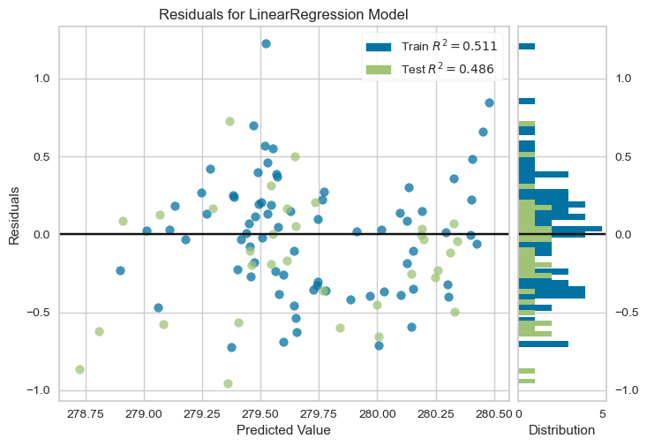
<Axes: title={'center': 'Residuals for LinearRegression Model'}, xlabel='Predicted Value', ylabel='Residuals'>
# Plotting the prediction error
from yellowbrick.regressor import PredictionError
visualizer = PredictionError(lm4)
visualizer.fit(X_G_train, y_G_train)
visualizer.score(X_G_test, y_G_test)
visualizer.poof()
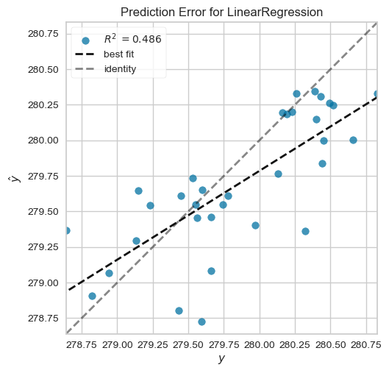
<Axes: title={'center': 'Prediction Error for LinearRegression'}, xlabel='$y$', ylabel='$\\hat{y}$'>
# Plotting the predicted against the observed data
import matplotlib.pyplot as plt
# The training predicted against the observed
# Setting the boundaaries and characteristics
fig, ax = plt.subplots()
ax.scatter(y_G_train, lm4_predtr)
ax.plot([y_G_train.min(),y_G_train.max()], [y_G_train.min(), y_G_train.max()], 'k--',lw =4) # Line of best fit
# Labelling
ax.set_xlabel('Observed lake level (m)')
ax.set_ylabel('Predicted lake level (m)')
plt.show()
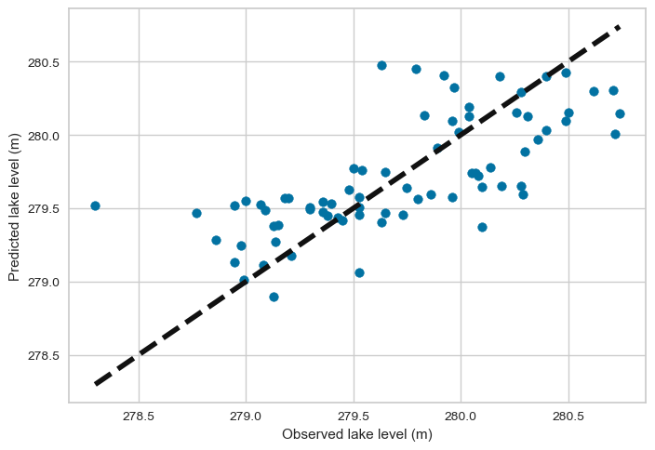
# Plotting the testing predicted against the observed data
# Setting the boundaaries and characteristics
fig, ax = plt.subplots()
ax.scatter(y_G_test, lm4_predts)
ax.plot([y_G_test.min(),y_G_test.max()], [y_G_test.min(), y_G_test.max()], 'k--',lw =4) # Line of best fit
# Labelling
ax.set_xlabel('Observed lake level (m)')
ax.set_ylabel('Predicted lake level (m)')
plt.show()
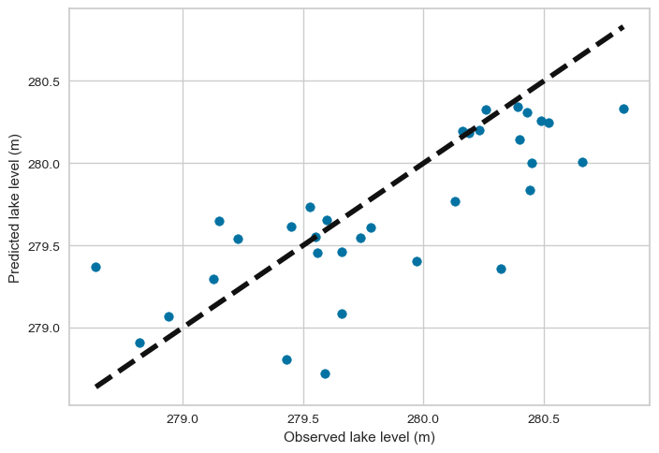
#######################################################################################################
#######################################################################################################
##################################END##############################################################
##################### DECISION TREE REGRESSION ###################
from sklearn.tree import DecisionTreeRegressor
############ MODEL 1: RS Features (X_R) and RS Target (LL_R)###############
########### GridSearchCV on the whole dataset
model = DecisionTreeRegressor()
dt_params = {'max_depth': [3, 6, 8, 10, 12],
'min_samples_leaf': [2, 3, 4, 5, 6],
'min_samples_split': [2, 4, 6, 8, 10, 12],
'max_leaf_nodes': [30, 80, 120, 150, 180 ]
}
dt_cv = KFold(n_splits = 10, random_state = 1, shuffle = True)
dt1 = GridSearchCV(model, dt_params, cv = dt_cv, scoring = 'neg_mean_squared_error', n_jobs = -1)
dt1.fit(X_R, y_R)
GridSearchCV(cv=KFold(n_splits=10, random_state=1, shuffle=True),
estimator=DecisionTreeRegressor(), n_jobs=-1,
param_grid={'max_depth': [3, 6, 8, 10, 12],
'max_leaf_nodes': [30, 80, 120, 150, 180],
'min_samples_leaf': [2, 3, 4, 5, 6],
'min_samples_split': [2, 4, 6, 8, 10, 12]},
scoring='neg_mean_squared_error')
# Printing the best parameters and the best score
print('The best parameters are:', dt1.best_params_)
print('The best score is:', dt1.best_score_)
The best parameters are: {'max_depth': 8, 'max_leaf_nodes': 120, 'min_samples_leaf': 6, 'min_samples_split': 12}
The best score is: -0.12189391094992344
# Modeling using the pest parameters and fitting on the training dataset
# Initialization
model = DecisionTreeRegressor(max_depth = 8, max_leaf_nodes = 120, min_samples_leaf = 6, min_samples_split = 8)
# Fitting the model on the training dataset
dt1 = model.fit(X_R_train, y_R_train)
# Evaluation of the performance of the model on the training dataset:
dt_y_predtr = dt1.predict(X_R_train)
print('The training MAE is:', mean_absolute_error(y_R_train, dt_y_predtr))
print('The training MSE is:', mean_squared_error(y_R_train, dt_y_predtr))
print('The training R2 Score is:', r2_score(y_R_train, dt_y_predtr))
The training MAE is: 0.1922596248196275
The training MSE is: 0.06640822164502046
The training R2 Score is: 0.6843986635762923
# Evaluation of the performance of the model on the testing dataset:
dt_y_predts = dt1.predict(X_R_test)
print('The testing MAE is:', mean_absolute_error(y_R_test, dt_y_predts))
print('The testing MSE is:', mean_squared_error(y_R_test, dt_y_predts))
print('The testing R2 Score is:', r2_score(y_R_test, dt_y_predts))
The testing MAE is: 0.2692384887839315
The testing MSE is: 0.09897532667598363
The testing R2 Score is: 0.39554222041310916
####### k-fold Cross-validation ###########
############# On the training dataset
score_dt1tr = cross_val_score(dt1, X_R_train, y_R_train, scoring = 'neg_mean_squared_error', cv = 10)
# The mean training score
print('The mean training CV score is:', absolute(np.mean(score_dt1tr)))
The mean training CV score is: 0.14542639844247252
############# On the testing dataset
score_dt1ts = cross_val_score(dt1, X_R_test, y_R_test, scoring = 'neg_mean_squared_error', cv = 10)
# The mean training score
print('The mean training CV score is:', absolute(np.mean(score_dt1ts)))
The mean training CV score is: 0.1255384244760221
#######################################################################################################
#######################################################################################################
#######################################################################################################
############ MODEL 2: GT Features (X_G) and RS Target (LL_R) ###############
########### GridSearchCV on the whole dataset
model = DecisionTreeRegressor()
dt_params = {'max_depth': [3, 6, 8, 10, 12],
'min_samples_leaf': [2, 3, 4, 5, 6],
'min_samples_split': [2, 4, 6, 8, 10, 12],
'max_leaf_nodes': [30, 80, 120, 150, 180 ]
}
dt_cv = KFold(n_splits = 10, random_state = 1, shuffle = True)
dt2 = GridSearchCV(model, dt_params, cv = dt_cv, scoring = 'neg_mean_squared_error', n_jobs = -1)
dt2.fit(X_G, y_R)
GridSearchCV(cv=KFold(n_splits=10, random_state=1, shuffle=True),
estimator=DecisionTreeRegressor(), n_jobs=-1,
param_grid={'max_depth': [3, 6, 8, 10, 12],
'max_leaf_nodes': [30, 80, 120, 150, 180],
'min_samples_leaf': [2, 3, 4, 5, 6],
'min_samples_split': [2, 4, 6, 8, 10, 12]},
scoring='neg_mean_squared_error')
# Printing the best parameters and the best score
print('The best parameters are:', dt2.best_params_)
print('The best score is:', dt2.best_score_)
The best parameters are: {'max_depth': 8, 'max_leaf_nodes': 180, 'min_samples_leaf': 4, 'min_samples_split': 10}
The best score is: -0.07818218075348024
# Modeling using the pest parameters and fitting on the training dataset
# Initialization
model = DecisionTreeRegressor(max_depth = 8, max_leaf_nodes = 180, min_samples_leaf = 4, min_samples_split = 10)
# Fitting the model on the training dataset
dt2 = model.fit(X_G_train, y_R_train)
# Evaluation of the performance of the model on the training dataset:
dt_y_predtr = dt2.predict(X_G_train)
print('The training MAE is:', mean_absolute_error(y_R_train, dt_y_predtr))
print('The training MSE is:', mean_squared_error(y_R_train, dt_y_predtr))
print('The training R2 Score is:', r2_score(y_R_train, dt_y_predtr))
The training MAE is: 0.156313015873014
The training MSE is: 0.04316405820105725
The training R2 Score is: 0.7948652423408804
# Evaluation of the performance of the model on the testing dataset:
dt_y_predts = dt2.predict(X_G_test)
print('The testing MAE is:', mean_absolute_error(y_R_test, dt_y_predts))
print('The testing MSE is:', mean_squared_error(y_R_test, dt_y_predts))
print('The testing R2 Score is:', r2_score(y_R_test, dt_y_predts))
The testing MAE is: 0.23513588263587293
The testing MSE is: 0.0772219788493379
The testing R2 Score is: 0.5283933133821834
#####################k-fold Cross-validation ##############################
############# On the training dataset
score_dt2tr = cross_val_score(dt2, X_G_train, y_R_train, scoring = 'neg_mean_squared_error', cv = 10)
# The mean training score
print('The mean training CV score is:', absolute(np.mean(score_dt2tr)))
The mean training CV score is: 0.09794477756207094
############# On the testing dataset
score_dt2ts = cross_val_score(dt2, X_G_test, y_R_test, scoring = 'neg_mean_squared_error', cv = 10)
# The mean testing score
print('The mean testing CV score is:', absolute(np.mean(score_dt2ts)))
The mean testing CV score is: 0.06887887161045034
#######################################################################################################
#######################################################################################################
#######################################################################################################
############ MODEL 3: RS Features (X_R) and GT Target (LL_G)###############
########### GridSearchCV on the whole dataset
model = DecisionTreeRegressor()
dt_params = {'max_depth': [3, 6, 8, 10, 12],
'min_samples_leaf': [2, 3, 4, 5, 6],
'min_samples_split': [2, 4, 6, 8, 10, 12],
'max_leaf_nodes': [30, 80, 120, 150, 180 ]
}
dt_cv = KFold(n_splits = 10, random_state = 1, shuffle = True)
dt3 = GridSearchCV(model, dt_params, cv = dt_cv, scoring = 'neg_mean_squared_error', n_jobs = -1)
dt3.fit(X_R, y_G)
GridSearchCV(cv=KFold(n_splits=10, random_state=1, shuffle=True),
estimator=DecisionTreeRegressor(), n_jobs=-1,
param_grid={'max_depth': [3, 6, 8, 10, 12],
'max_leaf_nodes': [30, 80, 120, 150, 180],
'min_samples_leaf': [2, 3, 4, 5, 6],
'min_samples_split': [2, 4, 6, 8, 10, 12]},
scoring='neg_mean_squared_error')
# Printing the best parameters and the best score
print('The best parameters are:', dt3.best_params_)
print('The best score is:', dt3.best_score_)
The best parameters are: {'max_depth': 8, 'max_leaf_nodes': 30, 'min_samples_leaf': 5, 'min_samples_split': 12}
The best score is: -0.1566985516447616
# Modeling using the pest parameters and fitting on the training dataset
# Initialization
model = DecisionTreeRegressor(max_depth = 8, max_leaf_nodes = 30, min_samples_leaf = 5, min_samples_split = 12)
# Fitting the model on the training dataset
dt3 = model.fit(X_R_train, y_G_train)
# Evaluation of the performance of the model on the training dataset:
dt_y_predtr = dt3.predict(X_R_train)
print('The training MAE is:', mean_absolute_error(y_G_train, dt_y_predtr))
print('The training MSE is:', mean_squared_error(y_G_train, dt_y_predtr))
print('The training R2 Score is:', r2_score(y_G_train, dt_y_predtr))
The training MAE is: 0.2383689947089988
The training MSE is: 0.08838778465608542
The training R2 Score is: 0.6967741158483103
# Evaluation of the performance of the model on the testing dataset:
dt_y_predts = dt3.predict(X_R_test)
print('The testing MAE is:', mean_absolute_error(y_G_test, dt_y_predts))
print('The testing MSE is:', mean_squared_error(y_G_test, dt_y_predts))
print('The testing R2 Score is:', r2_score(y_G_test, dt_y_predts))
The testing MAE is: 0.298973304473305
The testing MSE is: 0.1410544569819527
The testing R2 Score is: 0.5578324377621025
#####################k-fold Cross-validation ##############################
############# On the training dataset
score_dt3tr = cross_val_score(dt3, X_R_train, y_G_train, scoring = 'neg_mean_squared_error', cv = 10)
# The mean training score
print('The mean training CV score is:', absolute(np.mean(score_dt3tr)))
The mean training CV score is: 0.17087611572122802
############# On the testing dataset
score_dt3ts = cross_val_score(dt3, X_R_test, y_G_test, scoring = 'neg_mean_squared_error', cv = 10)
# The mean testing score
print('The mean testing CV score is:', absolute(np.mean(score_dt3ts)))
The mean testing CV score is: 0.17106998033801474

#######################################################################################################
#######################################################################################################
#######################################################################################################
############ MODEL 4: GT Features (X_G) and GT Target (LL_G)###############
########### GridSearchCV on the whole dataset
model = DecisionTreeRegressor()
dt_params = {'max_depth': [3, 6, 8, 10, 12],
'min_samples_leaf': [2, 3, 4, 5, 6],
'min_samples_split': [2, 4, 6, 8, 10],
'max_leaf_nodes': [30, 80, 120, 150, 180]
}
dt_cv = KFold(n_splits = 10, random_state = 1, shuffle = True)
dt4 = GridSearchCV(model, dt_params, cv = dt_cv, scoring = 'neg_mean_squared_error', n_jobs = -1)
dt4.fit(X_G, y_G)
GridSearchCV(cv=KFold(n_splits=10, random_state=1, shuffle=True),
estimator=DecisionTreeRegressor(), n_jobs=-1,
param_grid={'max_depth': [3, 6, 8, 10, 12],
'max_leaf_nodes': [30, 80, 120, 150, 180],
'min_samples_leaf': [2, 3, 4, 5, 6],
'min_samples_split': [2, 4, 6, 8, 10]},
scoring='neg_mean_squared_error')
# Printing the best parameters and the best score
print('The best parameters are:', dt4.best_params_)
print('The best score is:', dt4.best_score_)
The best parameters are: {'max_depth': 8, 'max_leaf_nodes': 150, 'min_samples_leaf': 2, 'min_samples_split': 10}
The best score is: -0.10088170213358134
# Modeling using the pest parameters and fitting on the training dataset
# Initialization
model = DecisionTreeRegressor(max_depth = 8, max_leaf_nodes = 150, min_samples_leaf = 2, min_samples_split = 10)
# Fitting the model on the training dataset
dt4 = model.fit(X_G_train, y_G_train)
# Evaluation of the performance of the model on the training dataset:
dt_y_predtr = dt4.predict(X_G_train)
print('The training MAE is:', mean_absolute_error(y_G_train, dt_y_predtr))
print('The training MSE is:', mean_squared_error(y_G_train, dt_y_predtr))
print('The training R2 Score is:', r2_score(y_G_train, dt_y_predtr))
The training MAE is: 0.13529227513227396
The training MSE is: 0.03224182328042326
The training R2 Score is: 0.8893901978773515
# Evaluation of the performance of the model on the testing dataset:
dt_y_predts = dt4.predict(X_G_test)
print('The testing MAE is:', mean_absolute_error(y_G_test, dt_y_predts))
print('The testing MSE is:', mean_squared_error(y_G_test, dt_y_predts))
print('The testing R2 Score is:', r2_score(y_G_test, dt_y_predts))
The testing MAE is: 0.2477294372294454
The testing MSE is: 0.10350809598823343
The testing R2 Score is: 0.6755301218106189
#####################k-fold Cross-validation ##############################
############# On the training dataset
score_dt4tr = cross_val_score(dt4, X_G_train, y_G_train, scoring = 'neg_mean_squared_error', cv = 10)
# The mean training score
print('The mean training CV score is:', absolute(np.mean(score_dt4tr)))
The mean training CV score is: 0.12718975445730582
############# On the testing dataset
score_dt4ts = cross_val_score(dt4, X_G_test, y_G_test, scoring = 'neg_mean_squared_error', cv = 10)
# The mean testing score
print('The mean testing CV score is:', absolute(np.mean(score_dt4ts)))
The mean testing CV score is: 0.1067500947450887
# Plotting the residuals
visualizer = ResidualsPlot(dt4)
visualizer.fit(X_G_train, y_G_train)
visualizer.score(X_G_test, y_G_test)
visualizer.poof()
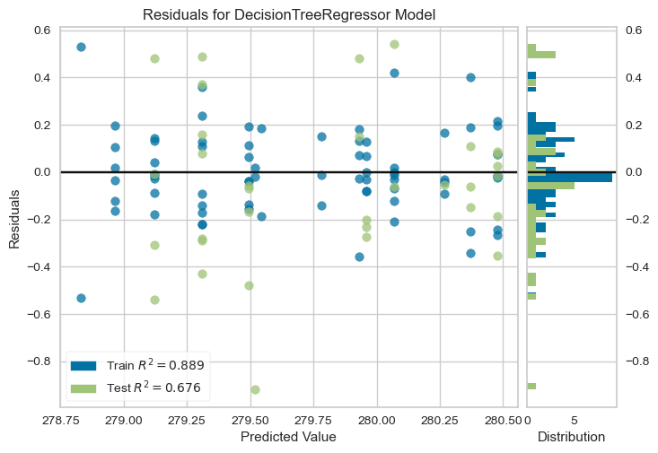
<Axes: title={'center': 'Residuals for DecisionTreeRegressor Model'}, xlabel='Predicted Value', ylabel='Residuals'>
# Plotting the prediction error
from yellowbrick.regressor import PredictionError
visualizer = PredictionError(dt4)
visualizer.fit(X_G_train, y_G_train)
visualizer.score(X_G_test, y_G_test)
visualizer.poof()
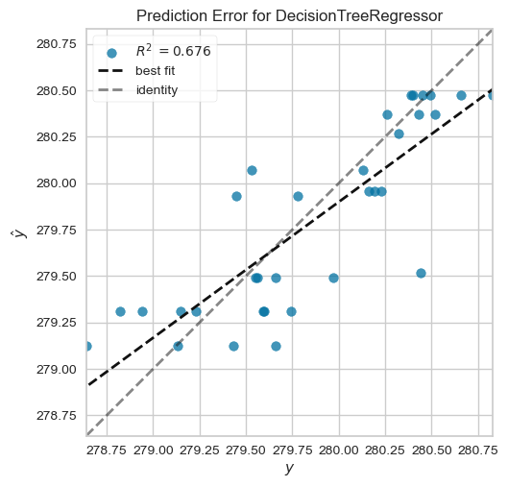
<Axes: title={'center': 'Prediction Error for DecisionTreeRegressor'}, xlabel='$y$', ylabel='$\\hat{y}$'>
# Plotting the predicted against the observed data
# The training predicted against the observed
# Setting the boundaaries and characteristics
fig, ax = plt.subplots()
ax.scatter(y_G_train, dt_y_predtr)
ax.plot([y_G_train.min(),y_G_train.max()], [y_G_train.min(), y_G_train.max()], 'k--',lw =4) # Line of best fit
# Labelling
ax.set_xlabel('Observed lake level (m)')
ax.set_ylabel('Predicted lake level (m)')
plt.show()
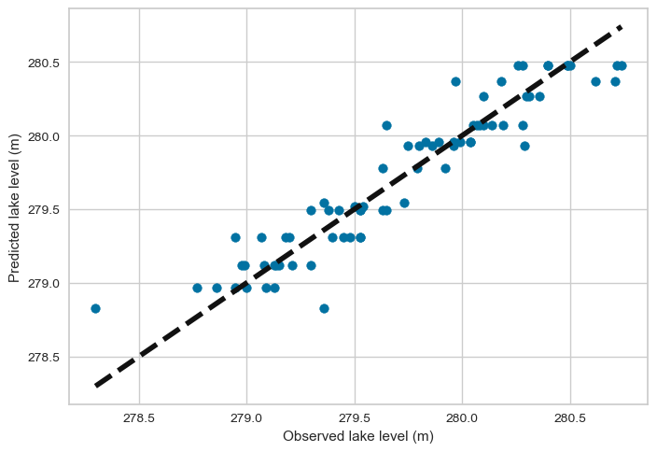
# Plotting the testing predicted against the observed data
# Setting the boundaaries and characteristics
fig, ax = plt.subplots()
ax.scatter(y_G_test, dt_y_predts)
ax.plot([y_G_test.min(),y_G_test.max()], [y_G_test.min(), y_G_test.max()], 'k--',lw =4) # Line of best fit
# Labelling
ax.set_xlabel('Observed lake level (m)')
ax.set_ylabel('Predicted lake level (m)')
plt.show()
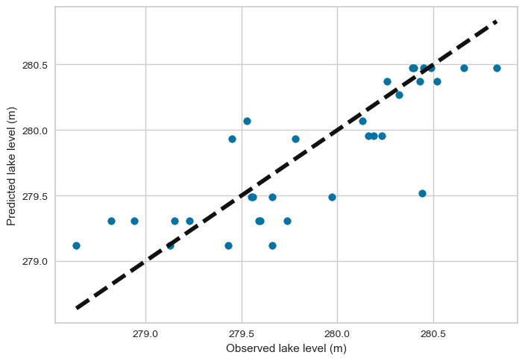

#################3############################## END ###############################################
#######################################################################################################
#######################################################################################################
#######################################################################################################
##################### RANDOM FOREST REGRESSION ###################
from sklearn.ensemble import RandomForestRegressor
############ MODEL 1: RS Features (X_R) and RS Target (LL_R)###############
########### On the whole dataset
model = RandomForestRegressor()
rf_param_grid = {'n_estimators' : [1, 50, 100, 150, 200],
'max_depth' : ['None', 3, 6, 9, 12, 15],
'min_samples_leaf' : [1, 2, 3, 4, 5],
'min_samples_split' : [2, 4, 6, 8, 10, 12],
'max_leaf_nodes' : ['None', 1, 2, 3, 4, 5],
}
rf_cv = KFold(n_splits = 10, random_state = 1, shuffle = True)
rf1 = GridSearchCV(model, rf_param_grid, cv = rf_cv, scoring = 'neg_mean_squared_error', n_jobs = -1)
rf1.fit(X_R, y_R)
GridSearchCV(cv=KFold(n_splits=10, random_state=1, shuffle=True),
estimator=RandomForestRegressor(), n_jobs=-1,
param_grid={'max_depth': ['None', 3, 6, 9, 12, 15],
'max_leaf_nodes': ['None', 1, 2, 3, 4, 5],
'min_samples_leaf': [1, 2, 3, 4, 5],
'min_samples_split': [2, 4, 6, 8, 10, 12],
'n_estimators': [51, 50, 100, 150, 200]},
scoring='neg_mean_squared_error')
# Printing the best parameters and the best score
print('The rf best parameters are:', rf1.best_params_)
print('The rf best score is:', rf1.best_score_)
The rf best parameters are: {'max_depth': 12, 'max_leaf_nodes': 5, 'min_samples_leaf': 4, 'min_samples_split': 2, 'n_estimators': 50}
The rf best score is: -0.1192655566038503
#The rf best parameters are: {'max_depth': 12, 'max_leaf_nodes': 5, 'min_samples_leaf': 4, 'min_samples_split': 2, 'n_estimators': 50}
#The rf best score is: -0.1192655566038503
########### Fitting the model on the training dataset using the best parameters
model = RandomForestRegressor()
rf_param_grid = {'n_estimators' : [50],
'max_depth' : [12],
'min_samples_leaf' : [4],
'min_samples_split' : [2],
'max_leaf_nodes' : [5],
}
rf_cv = KFold(n_splits = 10, random_state = 1, shuffle = True)
rf1 = GridSearchCV(model, rf_param_grid, cv = rf_cv, scoring = 'neg_mean_squared_error', n_jobs = -1)
rf1.fit(X_R_train, y_R_train)
GridSearchCV(cv=KFold(n_splits=10, random_state=1, shuffle=True),
estimator=RandomForestRegressor(), n_jobs=-1,
param_grid={'max_depth': [12], 'max_leaf_nodes': [5],
'min_samples_leaf': [4], 'min_samples_split': [2],
'n_estimators': [50]},
scoring='neg_mean_squared_error')
# Printing the best score
print('The rf best score is:', rf1.best_score_)
The rf best score is: -0.14262626271056228
# Model instantiation
model = RandomForestRegressor(max_depth = 12, max_leaf_nodes = 5, min_samples_leaf = 4, min_samples_split = 2, n_estimators= 50)
# Fitting the model on the training dataset
rf1 = model.fit(X_R_train, y_R_train)
# Evaluation of the performance of the model on the training dataset:
rf_y_predtr = rf1.predict(X_R_train)
print('The training MAE is:', mean_absolute_error(y_R_train, rf_y_predtr))
print('The training MSE is:', mean_squared_error(y_R_train, rf_y_predtr))
print('The training R2 Score is:', r2_score(y_R_train, rf_y_predtr))
The training MAE is: 0.2215216985260622
The training MSE is: 0.07765992486802777
The training R2 Score is: 0.6309255771683187
# Evaluation of the performance of the model on the testing dataset:
rf_y_predts = rf1.predict(X_R_test)
print('The testing MAE is:', mean_absolute_error(y_R_test, rf_y_predts))
print('The testing MSE is:', mean_squared_error(y_R_test, rf_y_predts))
print('The testing R2 Score is:', r2_score(y_R_test, rf_y_predts))
The testing MAE is: 0.24320425140402938
The testing MSE is: 0.09166497604074468
The testing R2 Score is: 0.44018767359200106
########### Cross-validation ###########################
############# On the training dataset
score_rf1tr = cross_val_score(rf1, X_R_train, y_R_train, scoring = 'neg_mean_squared_error', cv = 10)
# The mean training score
print('The mean training CV score is:', absolute(np.mean(score_rf1tr)))
The mean training CV score is: 0.1393738845148173
############# On the testing dataset
score_rf1ts = cross_val_score(rf1, X_R_test, y_R_test, scoring = 'neg_mean_squared_error', cv = 10)
# The mean testing score
print('The mean testing CV score is:', absolute(np.mean(score_rf1ts)))
The mean testing CV score is: 0.11125178614065465
#######################################################################################################
#######################################################################################################
#######################################################################################################
############ MODEL 2: GT Features (X_G) and RS Target (LL_R) ###############
########### On the whole dataset
model = RandomForestRegressor()
rf_param_grid = {'n_estimators' : [1, 50, 100, 150, 200],
'max_depth' : ['None', 3, 6, 9, 12, 15],
'min_samples_leaf' : [1, 2, 3, 4, 5],
'min_samples_split' : [2, 4, 6, 8, 10, 12],
'max_leaf_nodes' : ['None', 1, 2, 3, 4, 5],
}
rf_cv = KFold(n_splits = 10, random_state = 1, shuffle = True)
rf2 = GridSearchCV(model, rf_param_grid, cv = rf_cv, scoring = 'neg_mean_squared_error', n_jobs = -1)
rf2.fit(X_G, y_R)
C:\Users\Administrator\anaconda3\Lib\site-packages\sklearn\model_selection\_validation.py:425: FitFailedWarning:
24000 fits failed out of a total of 54000.
The score on these train-test partitions for these parameters will be set to nan.
If these failures are not expected, you can try to debug them by setting error_score='raise'.
Below are more details about the failures:
--------------------------------------------------------------------------------
9000 fits failed with the following error:
Traceback (most recent call last):
File "C:\Users\Administrator\anaconda3\Lib\site-packages\sklearn\model_selection\_validation.py", line 732, in _fit_and_score
estimator.fit(X_train, y_train, **fit_params)
File "C:\Users\Administrator\anaconda3\Lib\site-packages\sklearn\base.py", line 1144, in wrapper
estimator._validate_params()
File "C:\Users\Administrator\anaconda3\Lib\site-packages\sklearn\base.py", line 637, in _validate_params
validate_parameter_constraints(
File "C:\Users\Administrator\anaconda3\Lib\site-packages\sklearn\utils\_param_validation.py", line 95, in validate_parameter_constraints
raise InvalidParameterError(
sklearn.utils._param_validation.InvalidParameterError: The 'max_depth' parameter of RandomForestRegressor must be an int in the range [1, inf) or None. Got 'None' instead.
--------------------------------------------------------------------------------
7500 fits failed with the following error:
Traceback (most recent call last):
File "C:\Users\Administrator\anaconda3\Lib\site-packages\sklearn\model_selection\_validation.py", line 732, in _fit_and_score
estimator.fit(X_train, y_train, **fit_params)
File "C:\Users\Administrator\anaconda3\Lib\site-packages\sklearn\base.py", line 1144, in wrapper
estimator._validate_params()
File "C:\Users\Administrator\anaconda3\Lib\site-packages\sklearn\base.py", line 637, in _validate_params
validate_parameter_constraints(
File "C:\Users\Administrator\anaconda3\Lib\site-packages\sklearn\utils\_param_validation.py", line 95, in validate_parameter_constraints
raise InvalidParameterError(
sklearn.utils._param_validation.InvalidParameterError: The 'max_leaf_nodes' parameter of RandomForestRegressor must be an int in the range [2, inf) or None. Got 'None' instead.
--------------------------------------------------------------------------------
7500 fits failed with the following error:
Traceback (most recent call last):
File "C:\Users\Administrator\anaconda3\Lib\site-packages\sklearn\model_selection\_validation.py", line 732, in _fit_and_score
estimator.fit(X_train, y_train, **fit_params)
File "C:\Users\Administrator\anaconda3\Lib\site-packages\sklearn\base.py", line 1144, in wrapper
estimator._validate_params()
File "C:\Users\Administrator\anaconda3\Lib\site-packages\sklearn\base.py", line 637, in _validate_params
validate_parameter_constraints(
File "C:\Users\Administrator\anaconda3\Lib\site-packages\sklearn\utils\_param_validation.py", line 95, in validate_parameter_constraints
raise InvalidParameterError(
sklearn.utils._param_validation.InvalidParameterError: The 'max_leaf_nodes' parameter of RandomForestRegressor must be an int in the range [2, inf) or None. Got 1 instead.
warnings.warn(some_fits_failed_message, FitFailedWarning)
C:\Users\Administrator\anaconda3\Lib\site-packages\sklearn\model_selection\_search.py:976: UserWarning: One or more of the test scores are non-finite: [ nan nan nan ... -0.07979145 -0.08067239
-0.0813421 ]
warnings.warn(
GridSearchCV(cv=KFold(n_splits=10, random_state=1, shuffle=True),
estimator=RandomForestRegressor(), n_jobs=-1,
param_grid={'max_depth': ['None', 3, 6, 9, 12, 15],
'max_leaf_nodes': ['None', 1, 2, 3, 4, 5],
'min_samples_leaf': [1, 2, 3, 4, 5],
'min_samples_split': [2, 4, 6, 8, 10, 12],
'n_estimators': [1, 50, 100, 150, 200]},
scoring='neg_mean_squared_error')
# Printing the best parameters and the best score
print('The rf best parameters are:', rf2.best_params_)
print('The rf best score is:', rf2.best_score_)
The rf best parameters are: {'max_depth': 15, 'max_leaf_nodes': 5, 'min_samples_leaf': 5, 'min_samples_split': 8, 'n_estimators': 50}
The rf best score is: -0.075394885493102
##########################################################################################
#The rf best parameters are: {'max_depth': 6, 'max_leaf_nodes': 5, 'min_samples_leaf': 5, 'min_samples_split': 8, 'n_estimators': 1}
########### Fitting the model on the training dataset using the best parameters
model = RandomForestRegressor()
rf_param_grid = {'n_estimators' : [100],
'max_depth' : [15],
'min_samples_leaf' : [5],
'min_samples_split' : [8],
'max_leaf_nodes' : [5],
}
rf_cv = KFold(n_splits = 10, random_state = 1, shuffle = True)
rf2 = GridSearchCV(model, rf_param_grid, cv = rf_cv, scoring = 'neg_mean_squared_error', n_jobs = -1 )
rf2.fit(X_G_train, y_R_train)
GridSearchCV(cv=KFold(n_splits=10, random_state=1, shuffle=True),
estimator=RandomForestRegressor(), n_jobs=-1,
param_grid={'max_depth': [15], 'max_leaf_nodes': [5],
'min_samples_leaf': [5], 'min_samples_split': [8],
'n_estimators': [100]},
scoring='neg_mean_squared_error')
# Printing the best score
print('The rf best score is:', rf2.best_score_)
The rf best score is: -0.07907463315007554
# Evaluation of the performance of the model on the training dataset:
rf_y_predtr = rf2.predict(X_G_train)
print('The training MAE is:', mean_absolute_error(y_G_train, rf_y_predtr))
print('The training MSE is:', mean_squared_error(y_G_train, rf_y_predtr))
print('The training R2 Score is:', r2_score(y_G_train, rf_y_predtr))
The training MAE is: 1.6496792014736645
The training MSE is: 2.853710207679436
The training R2 Score is: -8.790027029223914
# Evaluation of the performance of the model on the testing dataset:
rf_y_predts = rf2.predict(X_G_test)
print('The testing MAE is:', mean_absolute_error(y_G_test, rf_y_predts))
print('The testing MSE is:', mean_squared_error(y_G_test, rf_y_predts))
print('The testing R2 Score is:', r2_score(y_G_test, rf_y_predts))
The testing MAE is: 1.6094741133152246
The testing MSE is: 2.8203663953885427
The testing R2 Score is: -7.8410856370614095
#####################Cross-validation ##############################
############# On the training dataset
score_rf2tr = cross_val_score(rf2, X_G_train, y_R_train, scoring = 'neg_mean_squared_error', cv = 10)
# The mean training score
print('The mean training CV score is:', absolute(np.mean(score_rf2tr)))
The mean training CV score is: 0.10834475935519323
############# On the testing dataset
score_rf2ts = cross_val_score(rf2, X_G_test, y_R_test, scoring = 'neg_mean_squared_error', cv = 10)
# The mean testing score
print('The mean testing CV score is:', absolute(np.mean(score_rf2ts)))
The mean testing CV score is: 0.1040276821007251
###################################################################################################################
###################################################################################################################
###################################################################################################################
############ MODEL 3: RS Features (X_R) and GT Target (LL_G)###############
########### On the whole dataset
model = RandomForestRegressor()
rf_param_grid = {'n_estimators' : [1, 50, 100, 150, 200],
'max_depth' : ['None', 3, 6, 9, 12, 15],
'min_samples_leaf' : [1, 2, 3, 4, 5],
'min_samples_split' : [2, 4, 6, 8, 10, 12],
'max_leaf_nodes' : ['None', 1, 2, 3, 4, 5],
}
rf_cv = KFold(n_splits = 10, random_state = 1, shuffle = True)
rf3 = GridSearchCV(model, rf_param_grid, cv = rf_cv, scoring = 'neg_mean_squared_error', n_jobs = -1)
rf3.fit(X_R, y_G)
GridSearchCV(cv=KFold(n_splits=10, random_state=1, shuffle=True),
estimator=RandomForestRegressor(), n_jobs=-1,
param_grid={'max_depth': ['None', 3, 6, 9, 12, 15],
'max_leaf_nodes': ['None', 1, 2, 3, 4, 5],
'min_samples_leaf': [1, 2, 3, 4, 5],
'min_samples_split': [2, 4, 6, 8, 10, 12],
'n_estimators': [1, 50, 100, 150, 200]},
scoring='neg_mean_squared_error')
# Printing the best parameters and the best score
print('The rf best parameters are:', rf3.best_params_)
print('The rf best score is:', rf3.best_score_)
The rf best parameters are: {'max_depth': 12, 'max_leaf_nodes': 3, 'min_samples_leaf': 3, 'min_samples_split': 12, 'n_estimators': 1}
The rf best score is: -0.13978661102563764
#The rf best parameters are: {'max_depth': 12, 'max_leaf_nodes': 3, 'min_samples_leaf': 3, 'min_samples_split': 12, 'n_estimators': 1}
#The rf best score is: -0.13978661102563764
#################################################################################################
########### Fitting the model on the training dataset using the best parameters
model = RandomForestRegressor()
rf_param_grid = {'n_estimators' : [100],
'max_depth' : [12],
'min_samples_leaf' : [3],
'min_samples_split' : [12],
'max_leaf_nodes' : [3],
}
rf_cv = KFold(n_splits = 10, random_state = 1, shuffle = True)
rf3 = GridSearchCV(model, rf_param_grid, cv = rf_cv, scoring = 'neg_mean_squared_error', n_jobs = -1 )
rf3.fit(X_R_train, y_G_train)
GridSearchCV(cv=KFold(n_splits=10, random_state=1, shuffle=True),
estimator=RandomForestRegressor(), n_jobs=-1,
param_grid={'max_depth': [12], 'max_leaf_nodes': [3],
'min_samples_leaf': [3], 'min_samples_split': [12],
'n_estimators': [100]},
scoring='neg_mean_squared_error')
# Printing the best score
print('The rf best score is:', rf3.best_score_)
The rf best score is: -0.1623162314308318
# Evaluation of the performance of the model on the training dataset:
rf_y_predtr = rf3.predict(X_R_train)
print('The training MAE is:', mean_absolute_error(y_G_train, rf_y_predtr))
print('The training MSE is:', mean_squared_error(y_G_train, rf_y_predtr))
print('The training R2 Score is:', r2_score(y_G_train, rf_y_predtr))
The training MAE is: 0.27342602765217405
The training MSE is: 0.12193927896535844
The training R2 Score is: 0.5816713155447928
# Evaluation of the performance of the model on the testing dataset:
rf_y_predts = rf3.predict(X_R_test)
print('The testing MAE is:', mean_absolute_error(y_G_test, rf_y_predts))
print('The testing MSE is:', mean_squared_error(y_G_test, rf_y_predts))
print('The testing R2 Score is:', r2_score(y_G_test, rf_y_predts))
The testing MAE is: 0.2846009642527196
The testing MSE is: 0.1343928183030082
The testing R2 Score is: 0.5787148728031692
#####################Cross-validation ##############################
############# On the training dataset
score_rf3tr = cross_val_score(rf3, X_R_train, y_G_train, scoring = 'neg_mean_squared_error', cv = 10)
# The mean training score
print('The mean training CV score is:', absolute(np.mean(score_rf3tr)))
The mean training CV score is: 0.1833129509817898
############# On the testing dataset
score_rf3ts = cross_val_score(rf3, X_R_test, y_G_test, scoring = 'neg_mean_squared_error', cv = 10)
# The mean testing score
print('The mean testing CV score is:', absolute(np.mean(score_rf3ts)))
The mean testing CV score is: 0.276795997825006
#######################################################################################################
#######################################################################################################
#######################################################################################################
############ MODEL 4: GT Features (X_G) and GT Target (LL_G)###############
########### On the whole dataset
model = RandomForestRegressor()
rf_param_grid = {'n_estimators' : [1, 50, 100, 150, 200],
'max_depth' : ['None', 3, 6, 9, 12, 15],
'min_samples_leaf' : [1, 2, 3, 4, 5],
'min_samples_split' : [2, 4, 6, 8, 10, 12],
'max_leaf_nodes' : ['None', 1, 2, 3, 4, 5],
}
rf_cv = KFold(n_splits = 10, random_state = 1, shuffle = True)
rf4 = GridSearchCV(model, rf_param_grid, cv = rf_cv, scoring = 'neg_mean_squared_error', n_jobs = -1)
rf4.fit(X_G, y_G)
GridSearchCV(cv=KFold(n_splits=10, random_state=1, shuffle=True),
estimator=RandomForestRegressor(), n_jobs=-1,
param_grid={'max_depth': ['None', 3, 6, 9, 12, 15],
'max_leaf_nodes': ['None', 1, 2, 3, 4, 5],
'min_samples_leaf': [1, 2, 3, 4, 5],
'min_samples_split': [2, 4, 6, 8, 10, 12],
'n_estimators': [1, 50, 100, 150, 200]},
scoring='neg_mean_squared_error')
# Printing the best parameters and the best score
print('The rf best parameters are:', rf4.best_params_)
print('The rf best score is:', rf4.best_score_)
The rf best parameters are: {'max_depth': 15, 'max_leaf_nodes': 5, 'min_samples_leaf': 3, 'min_samples_split': 10, 'n_estimators': 1}
The rf best score is: -0.10302734011258081
#The rf best parameters are: {'max_depth': 15, 'max_leaf_nodes': 5, 'min_samples_leaf': 3, 'min_samples_split': 10, 'n_estimators': 1}
#The rf best score is: -0.10302734011258081
#The rf best parameters are: {'max_depth': 15, 'max_leaf_nodes': 5, 'min_samples_leaf': 1, 'min_samples_split': 2, 'n_estimators': 100}
########### Fitting the model on the training dataset using the best parameters
model = RandomForestRegressor()
rf_param_grid = {'n_estimators' : [100],
'max_depth' : [15],
'min_samples_leaf' : [3],
'min_samples_split' : [10],
'max_leaf_nodes' : [5],
}
rf_cv = KFold(n_splits = 10, random_state = 1, shuffle = True)
rf4 = GridSearchCV(model, rf_param_grid, cv = rf_cv, scoring = 'neg_mean_squared_error', n_jobs = -1 )
rf4.fit(X_G_train, y_G_train)
GridSearchCV(cv=KFold(n_splits=10, random_state=1, shuffle=True),
estimator=RandomForestRegressor(), n_jobs=-1,
param_grid={'max_depth': [15], 'max_leaf_nodes': [5],
'min_samples_leaf': [3], 'min_samples_split': [10],
'n_estimators': [100]},
scoring='neg_mean_squared_error')
# Printing the best score
print('The rf best score is:', rf4.best_score_)
The rf best score is: -0.11022137409591866
# Model instantiation
model = RandomForestRegressor(max_depth = 15, max_leaf_nodes = 5, min_samples_leaf = 3, min_samples_split = 10, n_estimators= 100)
# Fitting the model on the training dataset
rf4 = model.fit(X_G_train, y_G_train)
# Evaluation of the performance of the model on the training dataset:
rf_y_predtr = rf4.predict(X_G_train)
print('The training MAE is:', mean_absolute_error(y_G_train, rf_y_predtr))
print('The training MSE is:', mean_squared_error(y_G_train, rf_y_predtr))
print('The training R2 Score is:', r2_score(y_G_train, rf_y_predtr))
The training MAE is: 0.19238318389065398
The training MSE is: 0.06726256226279662
The training R2 Score is: 0.7692469610840014
# Evaluation of the performance of the model on the testing dataset:
rf_y_predts = rf4.predict(X_G_test)
print('The testing MAE is:', mean_absolute_error(y_G_test, rf_y_predts))
print('The testing MSE is:', mean_squared_error(y_G_test, rf_y_predts))
print('The testing R2 Score is:', r2_score(y_G_test, rf_y_predts))
The testing MAE is: 0.2632760627204031
The testing MSE is: 0.11006488493908845
The testing R2 Score is: 0.6549763623014182
#####################Cross-validation ##############################
############# On the training dataset
score_rf4tr = cross_val_score(rf4, X_G_train, y_G_train, scoring = 'neg_mean_squared_error', cv = 10)
# The mean training score
print('The mean training CV score is:', absolute(np.mean(score_rf4tr)))
The mean training CV score is: 0.14150754031075288
############# On the testing dataset
score_rf4ts = cross_val_score(rf4, X_G_test, y_G_test, scoring = 'neg_mean_squared_error', cv = 10)
# The mean testing score
print('The mean testing CV score is:', absolute(np.mean(score_rf4ts)))
The mean testing CV score is: 0.17098366199931975
# Plotting the residuals
visualizer = ResidualsPlot(rf4)
visualizer.fit(X_G_train, y_G_train)
visualizer.score(X_G_test, y_G_test)
visualizer.poof()
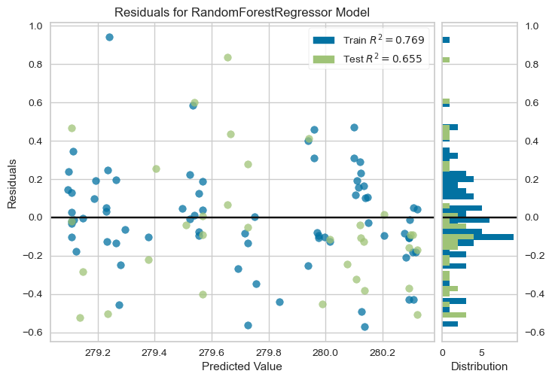
<Axes: title={'center': 'Residuals for RandomForestRegressor Model'}, xlabel='Predicted Value', ylabel='Residuals'>
# Plotting the prediction error
from yellowbrick.regressor import PredictionError
visualizer = PredictionError(rf4)
visualizer.fit(X_G_train, y_G_train)
visualizer.score(X_G_test, y_G_test)
visualizer.poof()
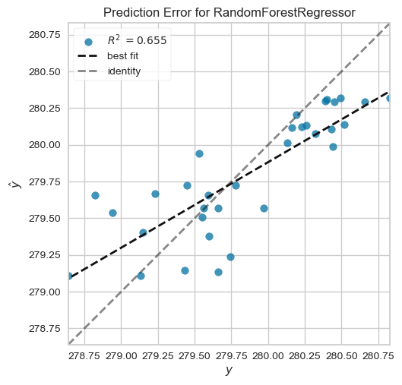
<Axes: title={'center': 'Prediction Error for RandomForestRegressor'}, xlabel='$y$', ylabel='$\\hat{y}$'>
# Plotting the predicted against the observed data
# The training predicted against the observed
# Setting the boundaaries and characteristics
fig, ax = plt.subplots()
ax.scatter(y_G_train, rf_y_predtr)
ax.plot([y_G_train.min(),y_G_train.max()], [y_G_train.min(), y_G_train.max()], 'k--',lw =4) # Line of best fit
# Labelling
ax.set_xlabel('Observed lake level (m)')
ax.set_ylabel('Predicted lake level (m)')
plt.show()
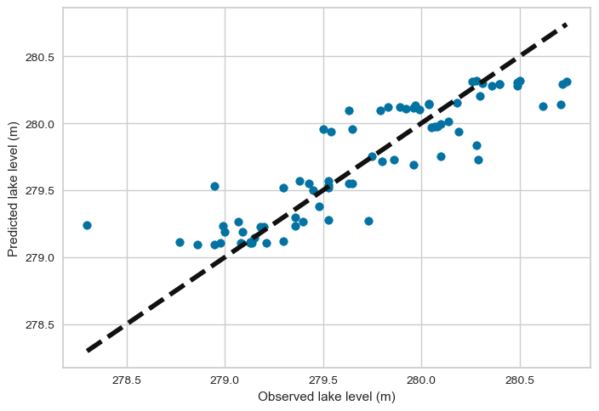
# Plotting the testing predicted against the observed data
# Setting the boundaaries and characteristics
fig, ax = plt.subplots()
ax.scatter(y_G_test, rf_y_predts)
ax.plot([y_G_test.min(),y_G_test.max()], [y_G_test.min(), y_G_test.max()], 'k--',lw =4) # Line of best fit
# Labelling
ax.set_xlabel('Observed lake level (m)')
ax.set_ylabel('Predicted lake level (m)')
plt.show()
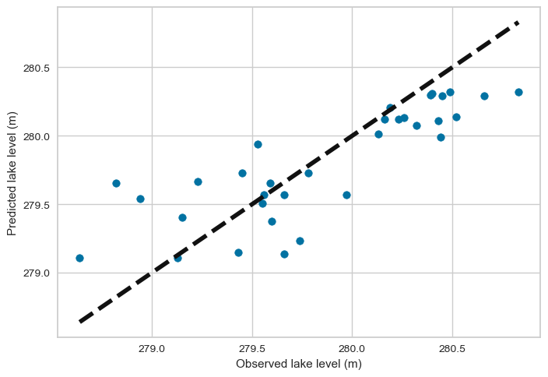
##################### END ####################################
#######################################################################################################
#######################################################################################################
#######################################################################################################
##################### GRADIENT BOOSTING REGRESSION ###################
from sklearn.ensemble import GradientBoostingRegressor
############ MODEL 1: RS Features (X_R) and RS Target (LL_R)###############
model = GradientBoostingRegressor()
gbr_param_grid = { 'learning_rate' : [0.01, 0.02, 0.03, 0.04, 0.05],
'n_estimators' : [100, 500, 1000, 1500],
'subsample' : [0.1, 0.3, 0.5, 0.7, 0.9, 1],
'max_depth' : [4, 6, 8, 10, 12],
}
gbr_cv = KFold(n_splits = 10, random_state = 1, shuffle = True)
gbr1 = GridSearchCV(model, gbr_param_grid, cv = gbr_cv, scoring = 'neg_mean_squared_error', n_jobs = -1)
gbr1.fit(X_R, y_R)
GridSearchCV(cv=KFold(n_splits=10, random_state=1, shuffle=True),
estimator=GradientBoostingRegressor(), n_jobs=-1,
param_grid={'learning_rate': [0.01, 0.02, 0.03, 0.04, 0.05],
'max_depth': [4, 6, 8, 10, 12],
'n_estimators': [100, 500, 1000, 1500],
'subsample': [0.1, 0.3, 0.5, 0.7, 0.9, 1]},
scoring='neg_mean_squared_error')
# Printing the best parameters and the best score
print('The best parameters are:', gbr1.best_params_)
print('The best score is:', gbr1.best_score_)
The best parameters are: {'learning_rate': 0.05, 'max_depth': 4, 'n_estimators': 100, 'subsample': 0.3}
The best score is: -0.09899054324498541
########### Fitting the model on the training dataset using the best parameters
# Instantiation
model = GradientBoostingRegressor(learning_rate = 0.05, max_depth = 4, n_estimators = 100, subsample = 0.3)
# Fitting the model
gbr1 = model.fit(X_R_train, y_R_train)
# Evaluation of the performance of the training model:
gbr_y_predtr = gbr1.predict(X_R_train)
print('The training MAE is:', mean_absolute_error(y_R_train, gbr_y_predtr))
print('The training MSE is:', mean_squared_error(y_R_train, gbr_y_predtr))
print('The training R2 Score is:', r2_score(y_R_train, gbr_y_predtr))
The training MAE is: 0.12497450581019469
The training MSE is: 0.023535149877601066
The training R2 Score is: 0.8881505245840277
# Evaluation of the performance of the testing model:
gbr_y_predts = gbr1.predict(X_R_test)
print('The testing MAE is:', mean_absolute_error(y_R_test, gbr_y_predts))
print('The testing MSE is:', mean_squared_error(y_R_test, gbr_y_predts))
print('The testing R2 Score is:', r2_score(y_R_test, gbr_y_predts))
The testing MAE is: 0.1991928970873935
The testing MSE is: 0.07382556834678221
The testing R2 Score is: 0.5491357228279363
########### Cross-validation ###########################
############# On the training dataset
score_gbr1tr = cross_val_score(gbr1, X_R_train, y_R_train, scoring = 'neg_mean_squared_error', cv = 10)
# The mean training score
print('The mean training CV score is:', absolute(np.mean(score_gbr1tr)))
The mean training CV score is: 0.13958288618740705
############# On the testing dataset
score_gbr1ts = cross_val_score(gbr1, X_R_test, y_R_test, scoring = 'neg_mean_squared_error', cv = 10)
# The mean testing score
print('The mean testing CV score is:', absolute(np.mean(score_gbr1ts)))
The mean testing CV score is: 0.09547321082291037
#######################################################################################################
#######################################################################################################
#######################################################################################################
############ MODEL 2: GT Features (X_G) and RS Target (LL_R) ###############
model = GradientBoostingRegressor()
gbr_param_grid = { 'learning_rate' : [0.01, 0.02, 0.03, 0.04, 0.05],
'n_estimators' : [100, 500, 1000, 1500],
'subsample' : [0.1, 0.3, 0.5, 0.7, 0.9, 1],
'max_depth' : [4, 6, 8, 10, 12],
}
gbr_cv = KFold(n_splits = 10, random_state = 1, shuffle = True)
gbr2 = GridSearchCV(model, gbr_param_grid, cv = gbr_cv, scoring = 'neg_mean_squared_error', n_jobs = -1)
gbr2.fit(X_G, y_R)
GridSearchCV(cv=KFold(n_splits=10, random_state=1, shuffle=True),
estimator=GradientBoostingRegressor(), n_jobs=-1,
param_grid={'learning_rate': [0.01, 0.02, 0.03, 0.04, 0.05],
'max_depth': [4, 6, 8, 10, 12],
'n_estimators': [100, 500, 1000, 1500],
'subsample': [0.1, 0.3, 0.5, 0.7, 0.9, 1]},
scoring='neg_mean_squared_error')
# Printing the best parameters and the best score
print('The best parameters are:', gbr2.best_params_)
print('The best score is:', gbr2.best_score_)
The best parameters are: {'learning_rate': 0.01, 'max_depth': 4, 'n_estimators': 1500, 'subsample': 0.1}
The best score is: -0.06827599661425132
########### Fitting the model on the training dataset using the best parameters
# Instantiation
model = GradientBoostingRegressor(learning_rate = 0.01, max_depth = 4, n_estimators = 1500, subsample = 0.1)
# Fitting the model
gbr2 = model.fit(X_G_train, y_R_train)
# Evaluation of the performance of the training model:
gbr_y_predtr = gbr2.predict(X_G_train)
print('The training MAE is:', mean_absolute_error(y_R_train, gbr_y_predtr))
print('The training MSE is:', mean_squared_error(y_R_train, gbr_y_predtr))
print('The training R2 Score is:', r2_score(y_R_train, gbr_y_predtr))
The training MAE is: 0.12127312982338935
The training MSE is: 0.02606075822851495
The training R2 Score is: 0.8761477130181338
# Evaluation of the performance of the testing model:
gbr_y_predts = gbr2.predict(X_G_test)
print('The testing MAE is:', mean_absolute_error(y_R_test, gbr_y_predts))
print('The testing MSE is:', mean_squared_error(y_R_test, gbr_y_predts))
print('The testing R2 Score is:', r2_score(y_R_test, gbr_y_predts))
The testing MAE is: 0.2248937883261471
The testing MSE is: 0.0722869859418752
The testing R2 Score is: 0.5585320858955333
############# On the training dataset
score_gbr2tr = cross_val_score(gbr2, X_G_train, y_R_train, scoring = 'neg_mean_squared_error', cv = 10)
# The mean training score
print('The mean training CV score is:', absolute(np.mean(score_gbr2tr)))
The mean training CV score is: 0.0817069262708515
############# On the testing dataset
score_gbr2ts = cross_val_score(gbr2, X_G_test, y_R_test, scoring = 'neg_mean_squared_error', cv = 10)
# The mean testing score
print('The mean testing CV score is:', absolute(np.mean(score_gbr2ts)))
The mean testing CV score is: 0.08436987048358642

#######################################################################################################
#######################################################################################################
#######################################################################################################
############ MODEL 3: RS Features (X_R) and GT Target (LL_G)###############
model = GradientBoostingRegressor()
gbr_param_grid = { 'learning_rate' : [0.01, 0.02, 0.03, 0.04, 0.05],
'n_estimators' : [100, 500, 1000, 1500],
'subsample' : [0.1, 0.3, 0.5, 0.7, 0.9, 1],
'max_depth' : [4, 6, 8, 10, 12],
}
gbr_cv = KFold(n_splits = 10, random_state = 1, shuffle = True)
gbr3 = GridSearchCV(model, gbr_param_grid, cv = gbr_cv, scoring = 'neg_mean_squared_error', n_jobs = -1)
gbr3.fit(X_R, y_G)
GridSearchCV(cv=KFold(n_splits=10, random_state=1, shuffle=True),
estimator=GradientBoostingRegressor(), n_jobs=-1,
param_grid={'learning_rate': [0.01, 0.02, 0.03, 0.04, 0.05],
'max_depth': [4, 6, 8, 10, 12],
'n_estimators': [100, 500, 1000, 1500],
'subsample': [0.1, 0.3, 0.5, 0.7, 0.9, 1]},
scoring='neg_mean_squared_error')
# Printing the best parameters and the best score
print('The best parameters are:', gbr3.best_params_)
print('The best score is:', gbr3.best_score_)
The best parameters are: {'learning_rate': 0.01, 'max_depth': 4, 'n_estimators': 1000, 'subsample': 0.1}
The best score is: -0.12583137036701456
# learning_rate = 0.02, max_depth = 12, n_estimators = 500, subsample = 0.1
########### Fitting the model on the training dataset using the best parameters
# Instantiation
model = GradientBoostingRegressor(learning_rate = 0.01, max_depth = 4, n_estimators = 1000, subsample = 0.1)
# Fitting the model
gbr3 = model.fit(X_R_train, y_G_train)
# Evaluation of the performance of the training model:
gbr_y_predtr = gbr3.predict(X_R_train)
print('The training MAE is:', mean_absolute_error(y_G_train, gbr_y_predtr))
print('The training MSE is:', mean_squared_error(y_G_train, gbr_y_predtr))
print('The training R2 Score is:', r2_score(y_G_train, gbr_y_predtr))
The training MAE is: 0.19148726842929592
The training MSE is: 0.06280958996328376
The training R2 Score is: 0.7845234664051448
# Evaluation of the performance of the testing model:
gbr_y_predts = gbr3.predict(X_R_test)
print('The testing MAE is:', mean_absolute_error(y_G_test, gbr_y_predts))
print('The testing MSE is:', mean_squared_error(y_G_test, gbr_y_predts))
print('The testing R2 Score is:', r2_score(y_G_test, gbr_y_predts))
The testing MAE is: 0.2750937913256752
The testing MSE is: 0.1123096868404203
The testing R2 Score is: 0.6479395156419334
##################### k-fold Cross-validation ##############################
############# On the training dataset
score_gbr3tr = cross_val_score(gbr3, X_R_train, y_G_train, scoring = 'neg_mean_squared_error', cv = 10)
# The mean training score
print('The mean training CV score is:', absolute(np.mean(score_gbr3tr)))
The mean training CV score is: 0.16701771054968556
############# On the testing dataset
score_gbr3ts = cross_val_score(gbr3, X_R_test, y_G_test, scoring = 'neg_mean_squared_error', cv = 10)
# The mean testing score
print('The mean testing CV score is:', absolute(np.mean(score_gbr3ts)))
The mean testing CV score is: 0.15117817509740625
#######################################################################################################
#######################################################################################################
#######################################################################################################
############ MODEL 4: GT Features (X_G) and GT Target (LL_G)###############
model = GradientBoostingRegressor()
gbr_param_grid = { 'learning_rate' : [0.01, 0.02, 0.03, 0.04, 0.05],
'n_estimators' : [100, 500, 1000, 1500],
'subsample' : [0.1, 0.3, 0.5, 0.7, 0.9, 1],
'max_depth' : [4, 6, 8, 10, 12],
}
gbr_cv = KFold(n_splits = 10, random_state = 1, shuffle = True)
gbr4 = GridSearchCV(model, gbr_param_grid, cv = gbr_cv, scoring = 'neg_mean_squared_error', n_jobs = -1)
gbr4.fit(X_G, y_G)
GridSearchCV(cv=KFold(n_splits=10, random_state=1, shuffle=True),
estimator=GradientBoostingRegressor(), n_jobs=-1,
param_grid={'learning_rate': [0.01, 0.02, 0.03, 0.04, 0.05],
'max_depth': [4, 6, 8, 10, 12],
'n_estimators': [100, 500, 1000, 1500],
'subsample': [0.1, 0.3, 0.5, 0.7, 0.9, 1]},
scoring='neg_mean_squared_error')
# Printing the best parameters and the best score
print('The best parameters are:', gbr4.best_params_)
print('The best score is:', gbr4.best_score_)
The best parameters are: {'learning_rate': 0.01, 'max_depth': 8, 'n_estimators': 500, 'subsample': 0.1}
The best score is: -0.09652131992343284
#learning_rate = 0.01, max_depth = 8, n_estimators = 1500, subsample = 0.1
########### Fitting the model on the training dataset using the best parameters
# Instantiation
model = GradientBoostingRegressor(learning_rate = 0.01, max_depth = 8, n_estimators = 500, subsample = 0.1)
# Fitting the model
gbr4 = model.fit(X_G_train, y_G_train)
# Evaluation of the performance of the training model:
gbr_y_predtr = gbr4.predict(X_G_train)
print('The training MAE is:', mean_absolute_error(y_G_train, gbr_y_predtr))
print('The training MSE is:', mean_squared_error(y_G_train, gbr_y_predtr))
print('The training R2 Score is:', r2_score(y_G_train, gbr_y_predtr))
The training MAE is: 0.1965657240826772
The training MSE is: 0.06096169206069384
The training R2 Score is: 0.7908629224455368
# Evaluation of the performance of the testing model:
gbr_y_predts = gbr4.predict(X_G_test)
print('The testing MAE is:', mean_absolute_error(y_G_test, gbr_y_predts))
print('The testing MSE is:', mean_squared_error(y_G_test, gbr_y_predts))
print('The testing R2 Score is:', r2_score(y_G_test, gbr_y_predts))
The testing MAE is: 0.2528989484271199
The testing MSE is: 0.10266400792768704
The testing R2 Score is: 0.678176109523674
##################### k-fold Cross-validation ##############################
############# On the training dataset
score_gbr4tr = cross_val_score(gbr4, X_G_train, y_G_train, scoring = 'neg_mean_squared_error', cv = 10)
# The mean training score
print('The mean training CV score is:', absolute(np.mean(score_gbr4tr)))
The mean training CV score is: 0.1047834519978064
############# On the testing dataset
score_gbr4ts = cross_val_score(gbr4, X_G_test, y_G_test, scoring = 'neg_mean_squared_error', cv = 10)
# The mean testing score
print('The mean testing CV score is:', absolute(np.mean(score_gbr4ts)))
The mean testing CV score is: 0.1211948915203658
# Plotting the residuals and prediction errors using yellowbrick
# conda install conda-forge::yellowbrick in Anaconda prompt
# Plotting the residuals
visualizer = ResidualsPlot(gbr4)
visualizer.fit(X_G_train, y_G_train)
visualizer.score(X_G_test, y_G_test)
visualizer.poof()
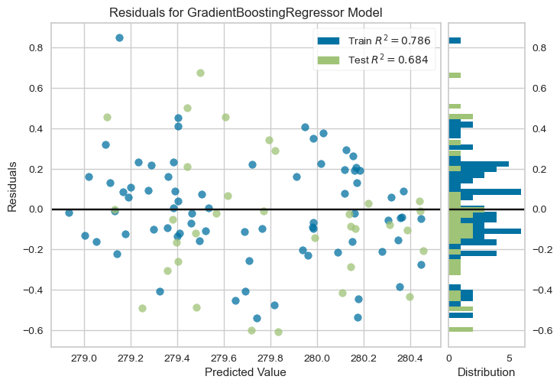
<Axes: title={'center': 'Residuals for GradientBoostingRegressor Model'}, xlabel='Predicted Value', ylabel='Residuals'>
# Plotting the prediction error
from yellowbrick.regressor import PredictionError
visualizer = PredictionError(gbr4)
visualizer.fit(X_G_train, y_G_train)
visualizer.score(X_G_test, y_G_test)
visualizer.poof()
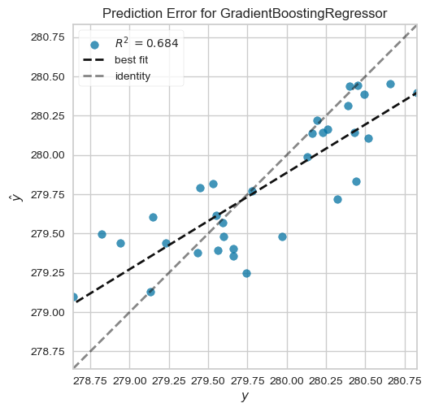
<Axes: title={'center': 'Prediction Error for GradientBoostingRegressor'}, xlabel='$y$', ylabel='$\\hat{y}$'>
# Plotting the predicted against the observed data
import matplotlib.pyplot as plt
# The training predicted against the observed
# Setting the boundaaries and characteristics
fig, ax = plt.subplots()
ax.scatter(y_G_train, gbr_y_predtr)
ax.plot([y_G_train.min(),y_G_train.max()], [y_G_train.min(), y_G_train.max()], 'k--',lw =4) # Line of best fit
# Labelling
ax.set_xlabel('Observed lake level (m)')
ax.set_ylabel('Predicted lake level (m)')
plt.show()
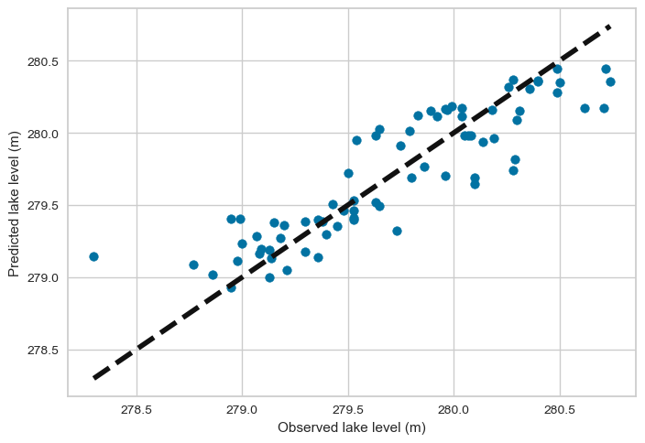
# Plotting the testing predicted against the observed data
import matplotlib.pyplot as plt
# Setting the boundaaries and characteristics
fig, ax = plt.subplots()
ax.scatter(y_G_test, gbr_y_predts)
ax.plot([y_G_test.min(),y_G_test.max()], [y_G_test.min(), y_G_test.max()], 'k--',lw =4) # Line of best fit
# Labelling
ax.set_xlabel('Observed lake level (m)')
ax.set_ylabel('Predicted lake level (m)')
plt.show()
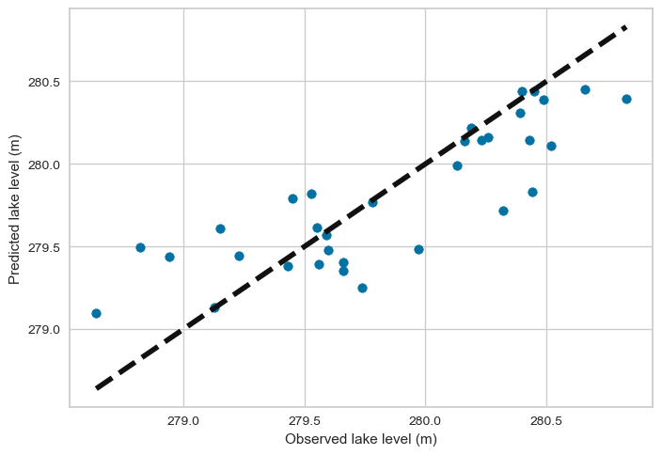

######################################## END ###############################################
#######################################################################################################
#######################################################################################################
#######################################################################################################

