The Council
AI Governance Playbook
A Practical Framework for Responsible AI · Chapters 1–7
Version 19.9.23 draft · Draft for Council review · 16 October 2026
Author: Kim Abercromby
© 2026 Kim Abercromby · Drafted with AI assistance; structured, directed and verified by the author.

Contents
Chapter 1 — Introduction 6
1.1 Introduction 6
1.2 The Strategic Context for AI in The Council 6
1.3 The Council AI Opportunity 7
1.4 Executive Assessment 7
1.5 Key Governance Gaps and Strategic Priorities 9
1.6 Strategic Opportunities 9
1.7 Strategic Outcomes and Benefits 9
Chapter 1 Summary 11
Chapter 2 — The AI Governance Imperative 11
2.1 Why Local Authorities Must Act Now 11
2.2 Why Traditional Governance Is No Longer Sufficient 12
2.3 The Emerging AI Risk Landscape 13
2.4 The Growth of Shadow AI and Uncontrolled Adoption 14
2.5 Regulatory Expectations and Public Trust 15
2.6 Current Maturity Assessment 16
2.7 The Cost of Inaction 18
Chapter 2 Summary 19
Chapter 3 — The Council AI Governance & Responsible AI Operating Model 20
3.1 Introduction 20
3.2 Design Principles 21
3.3 The Council AI Governance & Responsible AI Operating Model 23
3.4 Governance Structure 25
3.5 Roles and Responsibilities 30
3.6 AI Lifecycle Governance 34
3.7 The Council AI Register 38
3.8 AI Intake and Approval Process 41
3.9 AI Governance Triage and Prioritisation Framework 45
3.10 Risk Escalation and Decision-Making Authority 58
3.11 Governance Performance and Success Measures 63
3.12 The AI Management System (AIMS) and ISO/IEC 42001 Alignment 65
Chapter 3 Summary 68
Chapter 4 — AI Risk Management and Assurance Framework 69
4.1 Introduction 69
4.2 AI Risk Management Principles 71
4.3 AI Risk Taxonomy 73
4.4 AI Risk Scoring Methodology 76
4.5 AI Risk Classification Framework 80
4.6 AI Impact Assessment Framework 83
4.7 AI Control Framework 85
4.8 AI Assurance Framework 88
4.9 Monitoring, Reporting and Escalation 89
4.10 Chapter Summary 90
Chapter 5 — AI Policy Framework, Standards and Operational Procedures 91
5.1 Introduction 91
5.2 The Council AI Policy Architecture 92
5.3 Responsible AI Policy 93
5.4 AI Acceptable Use Policy 94
5.5 AI Procurement and Supplier Governance Policy 96
5.6 AI Data Governance Policy 97
5.7 AI Transparency Policy 97
5.8 AI Register Policy 98
5.9 AI Skills, Awareness and Capability Development Policy 99
5.10 AI Incident Management Policy 100
5.11 AI Ethics Review Process 101
5.12 Chapter Summary 101
Chapter 6 — AI Assurance, Monitoring and Oversight 102
6.1 Introduction 102
6.2 Why Assurance Matters 103
6.3 The Council AI Assurance Framework 104
6.4 AI Performance Monitoring 110
6.5 Model Drift and Performance Degradation 115
6.6 Compliance Monitoring 120
6.7 Internal Audit and Independent Assurance 126
6.8 AI Incident Management and Escalation 131
6.9 Reporting and Governance Oversight 141
6.10 Governance Effectiveness Reviews 146
6.11 Chapter Summary 152
Chapter 7 — People, Capability and Governance Maturity 154
7.1 Introduction 154
7.2 The Human Dimension of AI Governance 155
7.3 AI Skills and Competency Framework 159
7.4 Training and Awareness Programme 164
7.5 Leadership, Culture and Responsible AI Behaviours 170
7.6 AI Governance Maturity Framework 175
7.7 AI Governance Implementation Roadmap 181
7.8 Future Outlook and Evolving Governance 187
Chapter 7 Summary 192
Document Conclusion 193
Appendix A: Technical Implementation Standards 195
A.1 Model Lifecycle and Versioning 195
A.2 Data Lineage and Provenance 195
A.3 Audit Logging and Traceability 195
A.4 Model Documentation (Model Cards) 195
A.5 Integration with the Delivery Lifecycle 196
A.6 Technical Evidence Intake and Reconciliation 197
Appendix B: Glossary and Abbreviations 198
Appendix C: The First 100 Days 203
C.1 Days 1 to 15: Discovery and Visibility 203
C.2 Days 16 to 30: Coalition and Mandate 203
C.3 Days 31 to 45: Quick Wins and Interim Guardrails 204
C.4 Days 46 to 70: Governance Foundations 204
C.5 Days 71 to 100: Operational Risk and Assurance 204
C.6 Throughout: Culture and Capability 205
C.7 The Day 100 Checkpoint 205
Appendix D: Framework Alignment Mapping 206
D.1 Status and scope 206
D.2 ISO/IEC 42001 — management system clauses (4 to 10) 206
D.3 ISO/IEC 42001 — Annex A reference controls 209
D.4 NIST AI Risk Management Framework — the four functions 210
D.5 NIST AI RMF — characteristics of trustworthy AI 211
D.6 What full ISO/IEC 42001 conformity would additionally require 212
Appendix E: Post-Deployment Monitoring Evidence and Closed-Loop Risk Control 213
E.1 System-level monitoring evidence 213
E.2 Monitoring cadence (controlled minimum rule) 213
E.3 Controlled definitions 213
E.4 Mandatory reassessment triggers 214
E.5 Escalation and governance re-entry 214
E.6 Portfolio oversight 214
E.7 Retirement and closure 215
E.8 Post-deployment control flow 215
Appendix F: Agentic AI Governance Layer 216
F.1 Core principle and invariants 216
F.2 Triage: two functions, one route 216
F.3 The record and the graph 217
F.4 Relationship to the existing controls 218
F.5 Status 218
F.6 Proportionate light-touch path 218
F.7 Agentic AI Governance Operating Requirements 218
Proposed Annex G — Register and Gate Operating Architecture (Draft; Not Adopted) 224
Status and scope 224
G.1 Identity, current state and assurance 224
G.2 Gate Plan, append-only Events and Conditions 225
G.3 Decision authority, minutes and evidence references 226
G.4 Material access changes, priority overrides and agent records 226
G.5 Migration and open items before any adoption 227
G.6 Post-adoption controlled-suite amendment authority — unresolved 227
G.7 Identifier formats (proposed) 228
Standards and legal applicability — proposed QA cross-reference 229
Document control 231
Historical change history — prior identifiers are historical references only 231

Chapter 1 — Introduction

1.1 Purpose of This Playbook
Artificial Intelligence (AI) is rapidly becoming a foundational capability across government, public services and the wider economy. Advances in machine learning, predictive analytics, natural language processing and generative AI are reshaping how organisations understand information, make decisions and deliver services. For The Council, these developments arrive at a time of significant challenge: rising demand for services, financial pressures, workforce constraints and increasing expectations for transparency, fairness and value for money.
AI offers The Council a strategic opportunity to strengthen service quality, enhance organisational insight and improve outcomes for residents. When deployed responsibly, AI can support earlier intervention, improve forecasting, automate routine activity and enable more informed decision-making. These benefits are particularly important in a context where councils must do more with limited resources while maintaining high standards of accountability and public trust.
However, the opportunities presented by AI are matched by significant responsibilities. AI systems may influence decisions, generate recommendations, identify patterns and support frontline services in ways that directly affect individuals and communities. As a result, AI must be deployed lawfully, transparently, ethically and with appropriate human oversight. This aligns with UK government guidance on the use of AI in the public sector (see §2.5).
The strategic question is no longer whether AI should be used, but how it can be governed in a way that maintains public trust, supports accountability and delivers measurable public value.
This playbook sets out The Council’s approach to meeting that challenge. It establishes the strategic rationale for AI governance and provides the foundation for The Council’s AI Governance and Responsible AI Operating Model. Chapter 2 establishes the case for governance by examining the emerging AI risk landscape, the limitations of traditional governance approaches and the regulatory expectations shaping public-sector AI adoption. Chapters 3 onwards set out the governance structures, leadership arrangements, risk management processes and assurance mechanisms required to support responsible AI adoption across the organisation.
By establishing clear governance foundations now, The Council can position itself as a trusted and responsible adopter of AI — delivering innovation in a manner consistent with its public-service values, legal obligations and organisational responsibilities.

1.2 The Strategic Context for AI in The Council
The pressures described in §1.1 create a strong imperative for innovation. Residents expect services that are accessible, responsive and informed by data. Councils therefore require new tools to improve outcomes, enhance efficiency and strengthen decision-making while operating within finite resources. AI has emerged as one of the most significant technologies capable of supporting these objectives.
AI also marks a shift from digital transformation to intelligent transformation — moving beyond digitisation to insight-driven, proactive, data-enabled public services where AI supports earlier, more accurate and more joined-up responses to complex needs.

1.3 The Council AI Opportunity
The Council has established important foundations through sustained investment in digital transformation, enterprise data capability, service modernisation and organisational change.
Key strengths include:
- Established digital and technology capabilities
- Growing enterprise data maturity
- Experience delivering transformation programmes
- A culture supportive of innovation
- A strategic focus on resident outcomes and public value
The greatest value will be realised where AI augments human judgement rather than replacing it.

1.4 Executive Assessment
The Council is well positioned to become a leading local authority in the responsible adoption and governance of Artificial Intelligence. Existing investments in digital transformation, data-driven service delivery, cloud technologies, analytics platforms and AI-enabled service improvements provide a strong foundation upon which a mature AI governance capability can be developed.
The Council has already demonstrated significant ambition through initiatives involving AI-supported contact-centre services, enterprise data platforms, predictive analytics capabilities and wider digital transformation programmes. These initiatives illustrate a clear organisational commitment to leveraging technology to improve resident outcomes, enhance service efficiency and support evidence-based decision-making.
However, as AI adoption expands, The Council faces a challenge common to many public-sector organisations. Technological capability is often developing faster than the governance structures required to oversee it. While many councils have established data governance arrangements, information governance controls and cyber security frameworks, fewer have developed comprehensive governance mechanisms specifically designed to address the unique characteristics of AI systems.
AI introduces governance considerations that extend beyond traditional technology management. Issues relating to transparency, explainability, bias, fairness, accountability, human oversight, model performance and ethical decision-making require dedicated governance structures and specialist assurance processes. Without these safeguards, organisations may struggle to maintain public trust, demonstrate accountability or respond effectively to regulatory developments.
This executive assessment is an illustrative desk-based assessment of a typical council position against the maturity model in §7.6. It is to be replaced by The Council’s own baseline assessment. On that basis, The Council’s current position can be broadly characterised as Level 2 – Developing, with some areas at Level 1 – Initial (§2.6 gives the position by capability area). Opportunities remain to formalise AI-specific governance arrangements, establish consistent oversight mechanisms and embed Responsible AI principles across all stages of the AI lifecycle.
A review of The Council’s current operating environment suggests several areas of organisational strength. These include executive support for innovation, an established culture of digital transformation, growing awareness of AI opportunities, mature information governance functions and increasing organisational interest in data-driven decision-making.
At the same time, a number of governance challenges are likely to emerge as AI adoption increases. These include the need to identify and manage Shadow AI usage, maintain visibility of AI systems across the organisation, establish consistent approval processes, strengthen supplier assurance arrangements, develop AI-specific risk management practices and ensure that employees possess the knowledge and skills required to use AI technologies responsibly.
When assessed against recognised frameworks such as ISO/IEC 42001 (Artificial Intelligence Management Systems) and the NIST AI Risk Management Framework, The Council demonstrates many characteristics associated with organisations in the early stages of governance maturity. Core governance functions exist, but AI-specific processes, controls and accountability mechanisms require further formalisation. This is not unusual; indeed, it reflects the position of many organisations currently transitioning from AI experimentation to structured enterprise adoption.
The target state described within this playbook is Level 3 – Defined, moving towards Level 4 – Managed (§7.6). In this future state, The Council maintains a comprehensive inventory of AI systems, applies proportionate risk management controls, conducts structured impact assessments, operates a formal governance and assurance framework and provides clear accountability for AI-enabled decision-making. Governance activities become integrated into business-as-usual operations rather than being applied retrospectively or on an exception basis.
The Council has the opportunity to establish itself as a leader in responsible AI adoption across local government. By implementing the governance structures, policies, controls and assurance mechanisms described within The Council AI Governance and Responsible AI Operating Model, The Council can create an environment in which innovation and governance reinforce one another rather than compete for priority.
The assessment presented within this chapter is therefore positive but realistic. The challenge is not whether The Council should adopt AI, but how it can do so in a manner that is transparent, accountable, ethical and worthy of the trust placed in it by residents, elected members and wider stakeholders.
The remainder of this playbook provides the governance framework through which that ambition can be realised. The following section sets out the strategic priorities that must be addressed to achieve this target state.

1.5 Strategic Priorities
The assessment identifies five strategic priorities:
- Establish formal AI governance structures
- Improve AI visibility and accountability
- Establish a Responsible AI Operating Model
- Strengthen AI risk management
- Establish assurance and oversight mechanisms
These priorities are interdependent and will be pursued in sequence as well as in parallel. Establishing formal governance structures is the enabling foundation: without clear accountability, ownership and decision-making authority in place, the remaining priorities cannot be implemented with consistency or durability. The priorities align with UK regulatory expectations and form the foundation of The Council’s future AI governance capability.

1.6 Strategic Opportunities
The Council’s size, diversity and profile mean that AI has genuine transformative potential across the full range of council activity. The following areas represent the highest-value opportunities identified through the executive assessment.
Resident services and case management. AI can support earlier identification of residents at risk, improve triage of complex cases and enable more personalised service delivery — reducing escalation and improving outcomes across housing, social care and benefits.
Housing and homelessness prevention. Predictive modelling can identify households at risk of homelessness before crisis point, enabling early intervention that is both more effective and more cost-efficient than reactive support.
Public health and community wellbeing. Data-driven population health analysis can support targeted public health campaigns, improve coordination between health and social care services and help The Council understand wellbeing trends across its communities in near real time.
Environmental and operational services. Optimised routing, predictive asset maintenance and intelligent monitoring of public spaces can reduce operational costs, improve service reliability and support The Council’s environmental commitments.
Corporate services and workforce productivity. AI-assisted drafting, document summarisation, meeting transcription and process automation can reduce administrative burden across finance, HR, legal and communications functions — releasing officer time for higher-value activity.
Strategic decision-making. AI can strengthen the evidence base for policy decisions by synthesising complex datasets, modelling scenarios and surfacing insights that would be impractical to derive through manual analysis alone. In each case, AI supports rather than supplants informed human judgement.

1.7 Strategic Outcomes and Benefits
The implementation of The Council’s AI Governance and Responsible AI Operating Model is intended to deliver more than regulatory compliance. It aims to create the conditions for The Council to adopt AI confidently, responsibly and at scale. The expected outcomes span three dimensions: organisational capability, public accountability and service improvement.
Organisational capability. The Council will have the governance structures, policies, skills and processes required to assess, decide and monitor each AI use under the correct decision-making authority, consistently and at pace. Officers will understand their responsibilities, and The Council will demonstrate AI governance maturity to regulators, auditors and scrutiny bodies.
Public accountability and trust. The Council will be able to explain how AI is used across its services, demonstrate that decisions affecting residents are made fairly and lawfully, and provide meaningful mechanisms for challenge and redress (see §5.7.1). Public trust will be earned through transparency rather than asserted through policy.
Service improvement and value for money. Responsible AI adoption will support measurable improvements in service quality, earlier intervention, operational efficiency and decision-making. Benefits will be tracked against a defined outcomes framework and reported through The Council’s existing performance and scrutiny arrangements.
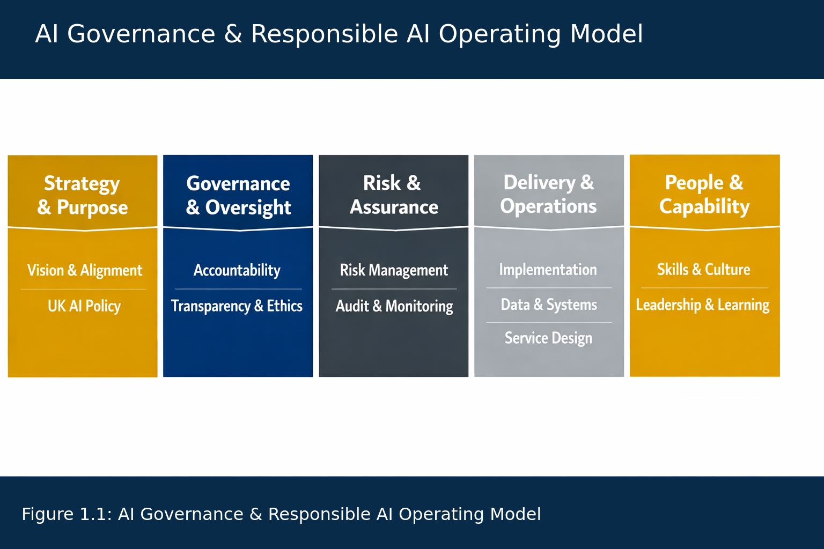
Figure 1.1: The Council AI Governance and Responsible AI Operating Model (explained in §3.3)
This figure illustrates the relationship between The Council’s strategic AI ambitions, governance structures, risk management processes, assurance mechanisms and operational controls. It demonstrates how Responsible AI principles, governance oversight, risk management and organisational capability combine to support the safe, ethical and effective adoption of Artificial Intelligence across The Council.

Chapter 1 Summary
AI can help The Council improve services and outcomes for residents, but only if it is used lawfully, fairly, transparently and with proper human oversight. This chapter has argued that good governance is what allows The Council to use AI with confidence, rather than a barrier to it.
The executive assessment in §1.4 found a sound platform to build on, with AI-specific governance still to be formalised, and set the target maturity level for this playbook.
The five strategic priorities in §1.5 give that work its shape, starting with formal governance structures. The rest of this playbook sets out the structures, processes and controls that deliver them, and §1.7 describes the outcomes The Council can expect.
The next chapter examines the growing imperative for AI governance, the emerging AI risk landscape and the reasons why local authorities must act now to establish effective governance arrangements.

Chapter 2 — The AI Governance Imperative

2.1 Why Local Authorities Must Act Now
AI is rapidly becoming embedded within the technologies, platforms and services used across The Council. Unlike previous waves of digital transformation, AI can analyse patterns, generate content, support complex decision-making and influence activities previously undertaken exclusively by human employees.
The challenge is no longer adoption — AI is already entering organisations through enterprise platforms, supplier tools and generative AI services. The challenge is ensuring that adoption occurs within a framework of governance, accountability and oversight.
Local authorities must act now because:
- public accountability is high
- decisions affect vulnerable individuals
- legal obligations are extensive
- public trust is essential
- regulatory expectations are increasing
The Council has the opportunity to shape AI adoption proactively rather than reactively.

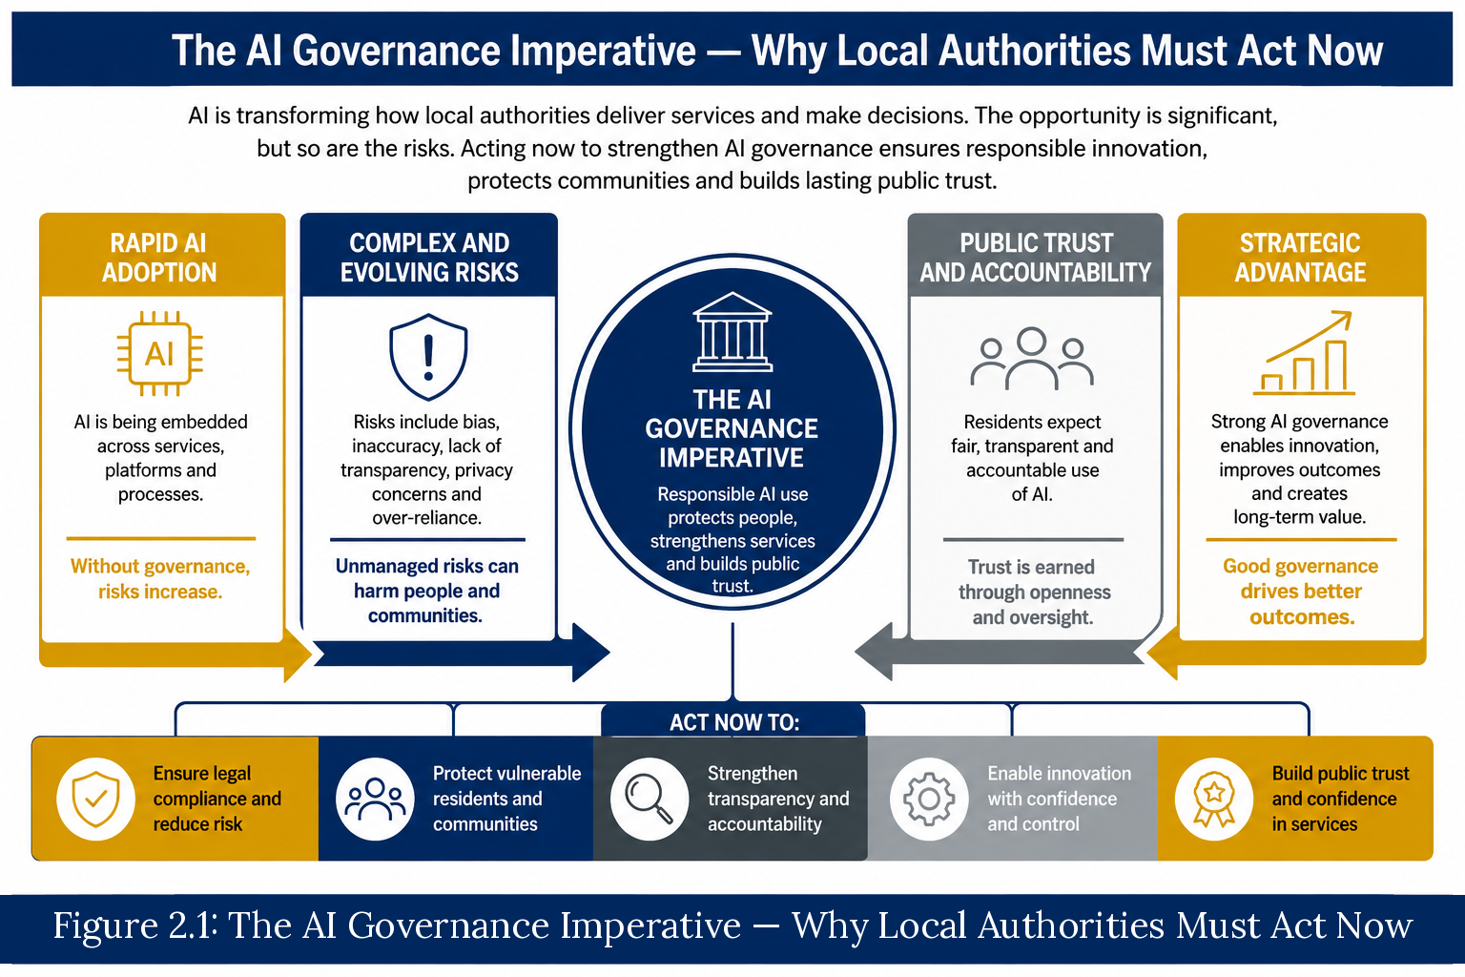
Figure 2.1: The AI Governance Imperative — Why Local Authorities Must Act Now

2.2 Why Traditional Governance Is No Longer Sufficient
Traditional governance frameworks were designed for predictable, rule-based systems. AI introduces characteristics that extend beyond these assumptions, including:
- probabilistic outputs
- data dependency
- explainability challenges
- bias and fairness considerations
- evolving performance
- influence on human decisions
AI governance must therefore extend beyond traditional IT controls to include:
- accountability
- transparency
- human oversight
- risk management
- assurance
Each of these AI characteristics requires a corresponding governance response: probabilistic outputs demand human oversight and contestability mechanisms; data dependency demands data quality assurance and lineage tracking; explainability challenges demand transparency obligations; and evolving performance demands continuous monitoring and review. The Council must build upon existing governance strengths to develop these capabilities systematically, creating a mature AI governance model that is proportionate, evidence-based and operationally embedded.
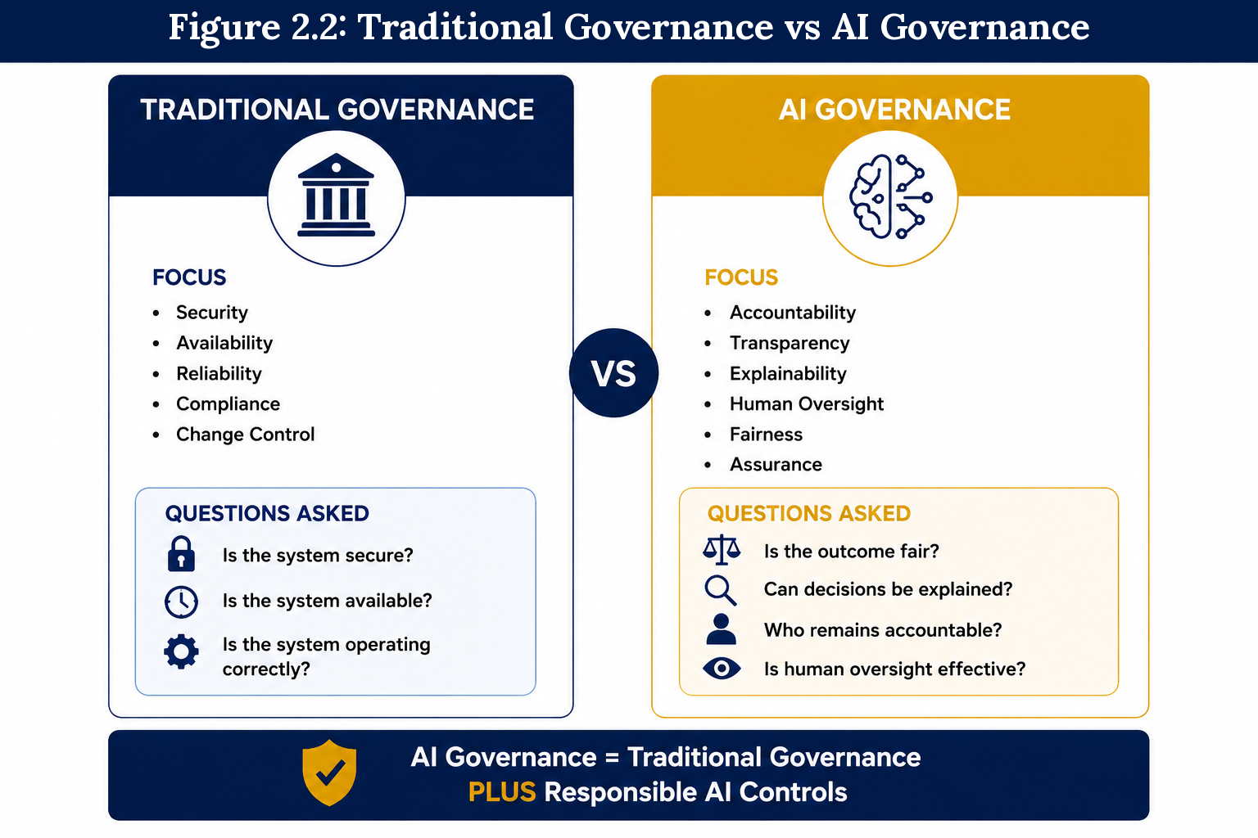
Figure 2.2: Traditional Governance vs AI Governance

2.3 The Emerging AI Risk Landscape
AI introduces risks that differ significantly from those of traditional technology systems. These include (full taxonomy in §4.3):
- bias and fairness
- transparency and explainability
- data quality
- model drift
- hallucinations (where AI systems generate plausible but factually inaccurate outputs)
- privacy and data protection
- security
- accountability
The Council must adopt a risk-based approach to AI governance, ensuring that higher-risk use cases receive enhanced scrutiny. A provisional risk classification will be applied to each materially distinct use (UC-ID) at intake and confirmed through the Chapter 4 risk assessment, using a four-tier, score-based framework (§4.4 to §4.5), aligned with the NIST AI RMF. Uses affecting individual rights, vulnerable populations or high-volume automated decisions will be classified as higher-risk and subject to mandatory impact assessment, independent review and enhanced monitoring. The full risk tiering methodology is set out in Chapter 4.
Use case (UC-ID): each distinct way a system is used, recorded separately because the people affected, data and risk can differ.

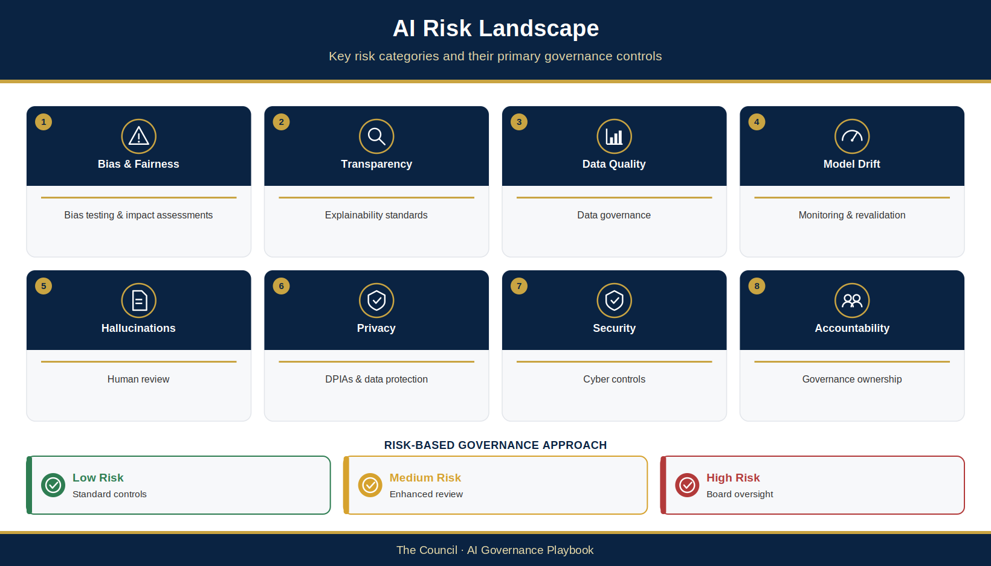
Figure 2.3: AI Risk Landscape — Key Risk Categories and Controls

2.4 The Growth of Shadow AI and Uncontrolled Adoption
Shadow AI — the unapproved, unmanaged use of AI tools by employees, teams or suppliers — is one of the most significant governance challenges facing modern organisations.
It arises due to:
- accessibility of AI tools
- embedded AI features
- productivity pressures
- low barriers to entry
Shadow AI introduces risks relating to:
- information governance
- security
- accuracy
- accountability
- reputation
The Council must adopt a proactive approach that balances innovation with accountability. In practice this means establishing a clear AI tools policy that defines which tools are approved for use, under what conditions and with what controls. It means creating a simple, low-friction mechanism for employees to disclose AI tools they are already using, so that unregistered use can be assessed rather than simply prohibited. It means working with procurement and IT to identify AI capabilities embedded in existing platforms — AI assistants built into office productivity suites being the most significant current example — and ensuring those are brought within the governance framework before deployment at scale. And it means building a culture in which responsible AI use is understood and supported, rather than driven underground by overly restrictive policy. The Council’s AI Acceptable Use Policy (§5.4) and AI Register (§3.7) are the primary tools for managing this risk.
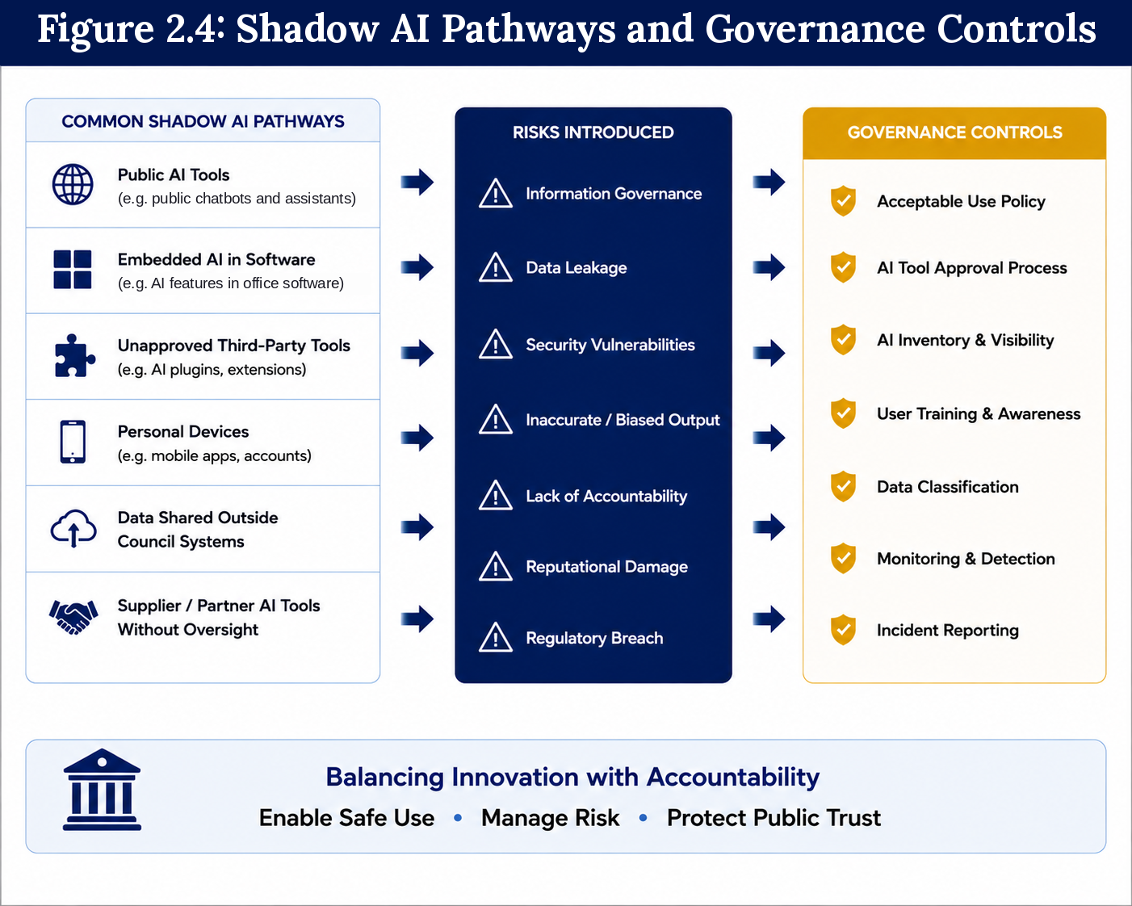
Figure 2.4: Shadow AI Pathways and Governance Controls

2.5 Regulatory Expectations and Public Trust
AI adoption is occurring within a complex regulatory environment shaped by:
- UK GDPR & Data Protection Act 2018 (as amended by the Data (Use and Access) Act 2025)
- Equality Act 2010
- Public Sector Equality Duty
- Human Rights Act 1998
- FOI obligations
- Procurement Act 2023 (and the Public Contracts Regulations 2015 for procurements begun before 24 February 2025)
- Algorithmic Transparency Recording Standard
- the AI Playbook for the UK Government (February 2025), the Data and AI Ethics Framework (December 2025) and the AI Opportunities Action Plan (January 2025), the government’s adoption and growth agenda
- EU AI Act (Regulation (EU) 2024/1689, as amended by Regulation (EU) 2026/1744). Being a UK public authority does not of itself bring The Council within scope; scope must nevertheless be assessed case by case (Article 2(1)), including where a provider or deployer is established in the Union, a system is placed on the market or put into service in the Union, or its output is used in the Union. Supplier due diligence must record the applicable scope analysis and compliance status.
Local authorities must demonstrate transparency, fairness, accountability and lawful decision-making. Public trust is as important as technical performance.
It is important to note that the regulatory landscape for AI is evolving rapidly. The UK Government continues to develop guidance through the AI Security Institute (formerly the AI Safety Institute, renamed in February 2025) and other relevant bodies. The Council’s governance framework has been designed with this in mind: rather than hard-wiring compliance with any single instrument, it establishes principles-based structures capable of adapting as the regulatory environment matures. This playbook will be reviewed annually and updated to reflect material changes in the legal and regulatory context.
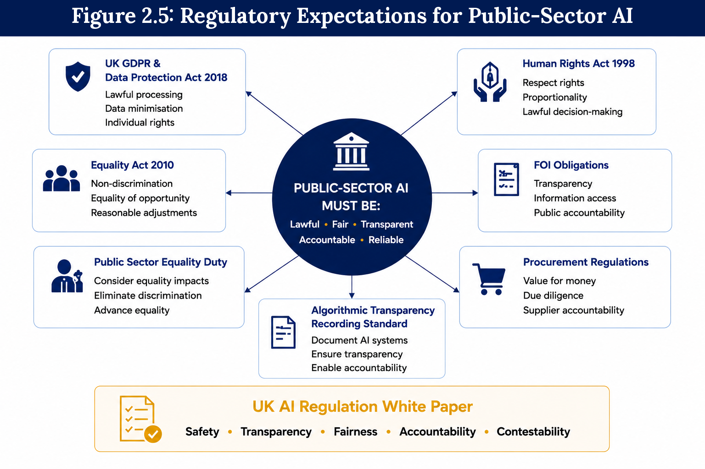
Figure 2.5: Regulatory Expectations for Public-Sector AI

2.6 Current Maturity Assessment
The executive assessment in §1.4 gives The Council’s overall governance position. The analysis below provides a more granular view, mapping current and target maturity across specific capability areas, using the maturity levels defined in §7.6.
Capability Area | Current State | Target State
AI Strategy & Leadership | Level 2 – Developing | Level 3 – Defined, moving towards Level 4 – Managed
AI Inventory & Visibility | Level 2 – Developing | Level 3 – Defined, moving towards Level 4 – Managed
AI Governance Structures | Level 2 – Developing | Level 3 – Defined
AI Risk Management | Level 2 – Developing | Level 3 – Defined, moving towards Level 4 – Managed
AI Assurance & Monitoring | Level 1 – Initial | Level 3 – Defined
AI Procurement Oversight | Level 2 – Developing | Level 3 – Defined, moving towards Level 4 – Managed
AI Policy Framework | Level 2 – Developing | Level 3 – Defined
AI Skills & Awareness | Level 2 – Developing | Level 3 – Defined, moving towards Level 4 – Managed
Responsible AI Controls | Level 2 – Developing | Level 3 – Defined, moving towards Level 4 – Managed
Transparency & Accountability | Level 2 – Developing | Level 3 – Defined, moving towards Level 4 – Managed
Several capability areas are already progressing towards maturity, particularly in relation to data governance, information management and organisational oversight. However, AI-specific governance arrangements remain at an earlier stage of development. Areas such as AI inventory management, lifecycle governance, assurance monitoring, model oversight and supplier assurance require further formalisation to support enterprise-scale adoption.
The target state described within this playbook (Level 3 – Defined, moving towards Level 4 – Managed) is one in which AI governance becomes embedded within The Council’s normal operating practices. Governance controls are applied consistently across the AI lifecycle, risk management activities are proportionate and evidence-based, accountability is clearly defined and assurance mechanisms provide ongoing visibility of AI-related risks and performance.
Achieving this target state will require continued investment in governance capability, workforce development, assurance activities and organisational learning. The governance structures, policies and controls described throughout this playbook are intended to support that progression and provide a practical roadmap towards long-term AI governance maturity.

2.7 The Cost of Inaction
While the opportunities associated with AI are significant, the risks associated with unmanaged adoption are equally substantial. Failure to establish appropriate governance arrangements may expose The Council to operational, legal, ethical and reputational harm.
The cost of inaction should not be measured solely in terms of regulatory compliance. It should also be considered in terms of public trust, organisational resilience and The Council’s ability to realise the benefits of AI safely and responsibly.
Potential consequences include:

Regulatory and Legal Risk
The use of AI without appropriate oversight may create breaches of data protection legislation, equality obligations, procurement requirements or wider public-sector governance expectations. Regulatory scrutiny of AI systems is increasing, and public bodies are expected to demonstrate clear accountability for automated and AI-supported decision-making.

Reputational Damage
Public trust is one of The Council’s most valuable assets. A poorly governed AI implementation that produces inaccurate, biased or harmful outcomes could rapidly undermine confidence in both the technology and The Council itself.

Poor Resident Outcomes
AI systems may influence decisions affecting vulnerable individuals and communities. Without effective governance, there is an increased risk of unfair outcomes, inappropriate recommendations, inaccurate information or decisions that do not align with The Council’s public-service responsibilities.

Shadow AI Expansion
In the absence of clear governance, the Shadow AI use described in §2.4 is likely to grow, along with the risks it brings.

Procurement and Supplier Risk
AI is increasingly embedded in supplier solutions (§2.4). Without structured procurement controls, The Council may take on AI-related risks through third-party systems without fully understanding them.

Lost Opportunity
Perhaps the greatest risk is not technological failure but organisational hesitation. Councils that fail to establish effective governance may become reluctant to adopt AI altogether, limiting their ability to improve services, enhance productivity and deliver greater value for residents.
The objective of AI governance is therefore not to restrict innovation but to enable it. Effective governance creates the confidence, trust and assurance necessary for The Council to realise the benefits of AI while protecting residents, employees and the organisation.

Chapter 2 Summary
Artificial Intelligence is rapidly reshaping how public services are designed, delivered and managed. For local authorities, AI presents both significant opportunities and significant responsibilities. The challenge facing The Council is not whether AI will be adopted, but how it will be governed.
This chapter has established the strategic imperative for AI governance. It has demonstrated why traditional governance approaches are insufficient for AI-enabled systems, examined the emerging AI risk landscape, highlighted the growing challenge of Shadow AI and outlined the regulatory expectations that increasingly shape public-sector AI adoption.
The maturity assessment in §2.6 shows that AI-specific governance now needs to be formalised to ensure consistent oversight, accountability and assurance across the organisation.
The cost of failing to act is substantial. Regulatory exposure, reputational harm, reduced public trust and unmanaged risk all represent credible threats in an environment where AI adoption is accelerating. Equally, failure to establish effective governance may limit The Council’s ability to realise the substantial benefits AI can deliver for residents and communities.
The next chapter sets out The Council’s proposed AI Governance and Responsible AI Operating Model, defining the structures, responsibilities, processes and controls required to support safe, lawful, ethical and effective AI adoption across The Council.

Chapter 3 — The Council AI Governance & Responsible AI Operating Model

3.1 Introduction
The purpose of this chapter is to define the governance structures, processes, controls and accountability mechanisms required to support the responsible adoption of Artificial Intelligence (AI) across The Council.
The preceding chapters established the strategic rationale for AI governance and identified the risks, opportunities and regulatory expectations associated with AI adoption. Chapter 1 set out five strategic priorities: establishing formal governance structures; improving AI visibility and accountability; establishing a Responsible AI Operating Model; strengthening AI risk management; and establishing assurance and oversight mechanisms. This chapter moves from strategic intent to governance design, defining the structures, processes and controls through which The Council will address each of those priorities in practice. Assurance and oversight mechanisms — the fifth strategic priority — are developed in full in Chapter 6.
Effective AI governance is not intended to restrict innovation. Rather, it provides the structures and safeguards necessary to enable innovation confidently, responsibly and at scale. By establishing clear governance arrangements, The Council can encourage experimentation and technological advancement while ensuring that appropriate controls exist to manage risk, maintain accountability and protect public trust.
AI introduces new considerations that extend beyond traditional technology governance. AI systems may evolve over time, produce probabilistic outputs, influence decision-making and utilise complex datasets in ways that require enhanced oversight. Governance arrangements must therefore address not only technical performance, but also transparency, fairness, explainability, accountability and human oversight.
The Council AI Governance and Responsible AI Operating Model provides a practical and proportionate framework for AI use cases across council activities. It establishes clear responsibilities and decision pathways, assesses systems and materially distinct uses, records delegated decisions by UC-ID, and monitors approved uses and shared system controls throughout their lifecycle.
The operating model aligns with recognised good practice including the UK Government AI governance principles, the NIST AI Risk Management Framework and ISO/IEC 42001. It has been designed to support The Council’s broader strategic objectives while remaining adaptable to future technological, organisational and regulatory developments.
The objective is straightforward: to create an environment in which AI can be used safely, lawfully, ethically and effectively in support of better outcomes for residents, communities and the organisation.

3.2 Design Principles
The Council AI Governance and Responsible AI Operating Model is founded upon a set of core design principles that guide decision-making, governance activities and the implementation of AI across The Council.
These principles provide the foundation upon which all AI governance processes, controls and oversight arrangements are built.

Principle 1: Risk-Based Governance
AI governance activities shall be proportionate to the level of risk presented by a particular AI system or use case. Higher-risk systems will be subject to enhanced scrutiny, additional assurance requirements and stronger oversight arrangements, while lower-risk systems will be governed through proportionate controls.
This approach ensures that governance resources are focused where potential impacts are greatest while avoiding unnecessary barriers to innovation.

Principle 2: Human Accountability and Oversight
Responsibility for decisions remains with people, not technology.
AI systems may support, inform or augment decision-making, but accountability for outcomes remains with appropriately authorised officers and decision-makers. Human oversight shall be maintained throughout the AI lifecycle, particularly where AI influences decisions affecting residents, employees or service users.

Principle 3: Transparency and Explainability
The Council will seek to ensure that AI systems operate in a manner that is understandable, transparent and capable of explanation.
Residents, employees, elected members and oversight bodies should be able to understand when AI is being used, why it is being used and how decisions or recommendations are generated to an appropriate level of detail.
Transparency is fundamental to maintaining public trust and supporting effective scrutiny.

Principle 4: Fairness, Inclusion and Public Value
AI systems must be designed, deployed and monitored in a manner that promotes fairness, supports inclusion and delivers measurable public value.
The Council will seek to identify and mitigate bias, discrimination and unintended consequences while ensuring that AI adoption supports equitable outcomes for all residents and communities.

Principle 5: Privacy, Security and Data Responsibility
AI systems must operate within The Council’s established information governance, cyber security and data protection frameworks.
Appropriate safeguards shall be implemented to protect information assets, maintain confidentiality, ensure data quality and support compliance with relevant legal and regulatory obligations.
Good AI governance begins with good data governance.

Principle 6: Accountability and Assurance
All AI systems shall have clearly identified ownership, defined responsibilities and appropriate governance oversight.
The Council must be able to demonstrate how AI systems are governed, how risks are managed and how compliance with policies, standards and regulatory expectations is achieved.
Independent assurance activities shall provide confidence that governance controls are operating effectively.

Principle 7: Innovation with Responsibility
The Council recognises that AI presents significant opportunities to improve services, strengthen decision-making and enhance organisational effectiveness.
Governance should therefore enable innovation rather than inhibit it. The objective is to provide a safe environment in which new technologies can be explored, assessed and deployed responsibly.
Innovation and governance should be viewed as complementary disciplines rather than competing priorities.

Principle 8: Continuous Improvement
AI technologies, risks and regulatory expectations continue to evolve rapidly.
The Operating Model will therefore be subject to regular review, monitoring and improvement. Lessons learned from implementation, assurance activities, audits and operational experience will be used to strengthen governance arrangements over time and ensure continued alignment with emerging best practice.

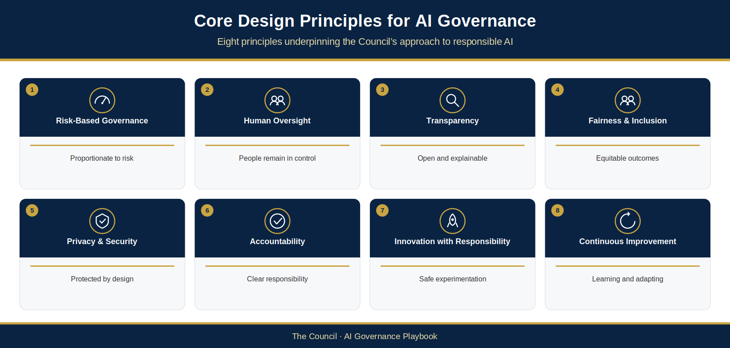
Figure 3.1: Core Design Principles for AI Governance

3.3 The Council AI Governance & Responsible AI Operating Model
The Council AI Governance and Responsible AI Operating Model provides the organisational framework through which AI activities are governed, monitored and assured.
The model is structured around five interconnected governance pillars that together support the safe, lawful and effective adoption of AI across The Council.
These pillars provide a holistic governance framework that integrates strategy, oversight, risk management, operational delivery and organisational capability into a single operating model.

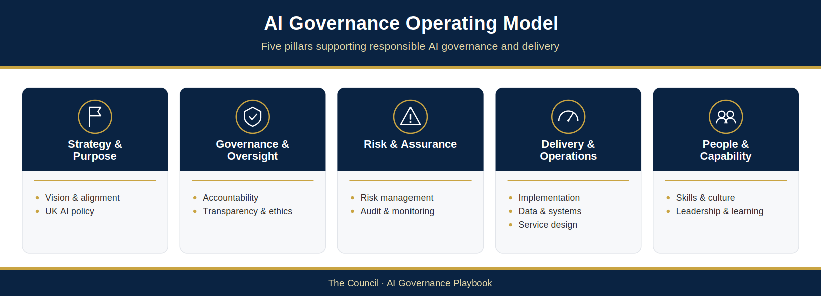
Figure 3.2: AI Governance Operating Model

Pillar 1: Strategy and Purpose
The Strategy and Purpose pillar ensures that AI adoption remains aligned with The Council’s corporate objectives, public-service responsibilities and organisational priorities.
This pillar provides strategic direction, establishes governance objectives and ensures that AI initiatives are focused on delivering measurable public value.
Key components include:
- Strategic vision and objectives
- Alignment with council priorities
- Responsible AI principles
- Policy direction
- Benefits realisation

Pillar 2: Governance and Oversight
The Governance and Oversight pillar establishes accountability, decision-making authority and organisational ownership for AI activities.
It defines the structures through which AI initiatives are reviewed, approved, monitored and challenged throughout their lifecycle.
Key components include:
- Governance boards and committees
- Executive accountability
- Decision-making structures
- Transparency arrangements
- Escalation pathways

Pillar 3: Risk and Assurance
The Risk and Assurance pillar provides the controls required to identify, assess, monitor and manage AI-related risks.
It ensures that governance decisions are informed by evidence and that AI systems operate within The Council’s risk appetite and control environment.
Key components include:
- Risk management processes
- Impact assessments
- Compliance monitoring
- Assurance reviews
- Audit and reporting

Pillar 4: Delivery and Operations
The Delivery and Operations pillar governs the practical implementation and operation of AI systems.
It provides the processes through which AI solutions are assessed, approved, deployed, monitored and ultimately retired.
Key components include:
- AI lifecycle governance
- AI inventory management
- Change control
- Performance monitoring
- Operational review

Pillar 5: People and Capability
The People and Capability pillar ensures that The Council develops the skills, awareness and organisational culture required to support responsible AI adoption.
Technology alone cannot deliver effective governance. Successful AI adoption requires informed leadership, capable employees and a strong culture of accountability.
Key components include:
- Skills development
- Awareness programmes
- Responsible AI culture
- Leadership capability
- Continuous learning
Together, these five pillars create an integrated governance ecosystem that supports responsible AI adoption across The Council. The following sections define the governance structures, roles, responsibilities and operational processes that bring this model into practice.

3.4 Governance Structure
Effective AI governance requires more than policies and procedures. It requires clear organisational accountability, defined decision-making authority and formal oversight arrangements that ensure AI systems are implemented and operated responsibly throughout their lifecycle.
The Council’s AI Governance Structure has been designed to provide strategic oversight, operational governance and independent assurance while remaining proportionate to the scale and maturity of The Council’s AI adoption programme.
The controlled AI Governance Terms of Reference (AIG-GOV-06) operationalises this section. It sets out how AI governance operates as an assurance and continuity overlay on The Council’s existing decision-making forums (see the AI Assurance Board below). It records the remit, proposed membership and quorum, decision rights, conflicts-of-interest controls, meeting arrangements and escalation routes. It must be formally adopted and the relevant Council delegations confirmed before it is treated as effective.
The governance model adopts a three-layer structure:
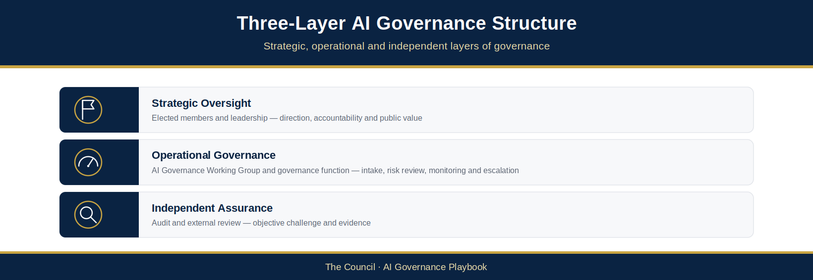
Figure 3.3: Three-Layer AI Governance Structure

Strategic Oversight Layer
Provides executive accountability, strategic direction and organisational oversight.
Responsible for:
- AI strategy and direction
- Recommending governance policy for adoption by the competent Council authority
- Oversight of significant risks
- Assurance opinion and recommendations on high-risk AI initiatives ahead of the owning forum’s decision
- Review of governance performance
- Assurance of compliance with legal and regulatory obligations

Operational Governance Layer
Provides day-to-day governance, coordination and management of AI activities.
Responsible for:
- AI intake and assessment
- Risk review
- Governance monitoring
- Policy implementation
- Maintenance of the AI Register
- Escalation of issues and risks

Independent Assurance Layer
Provides objective challenge, review and assurance.
Responsible for:
- Independent assurance reviews
- Audit activities
- Compliance assessments
- Governance effectiveness reviews
- Reporting on control effectiveness
Together, these layers create a governance structure that enables innovation while ensuring appropriate accountability, oversight and assurance.

AI Assurance Board
The AI Assurance Board is The Council’s body for oversight, scrutiny and assurance of AI. It does not itself approve individual AI initiatives: approval remains with The Council’s existing decision-making forums under their delegated authority (see §3.10.1 and the Gate Map, AIG-DEC-01).
The Board provides oversight and scrutiny of The Council’s use of AI and seeks assurance that AI adoption remains aligned with organisational objectives, public-service responsibilities and The Council’s risk appetite.
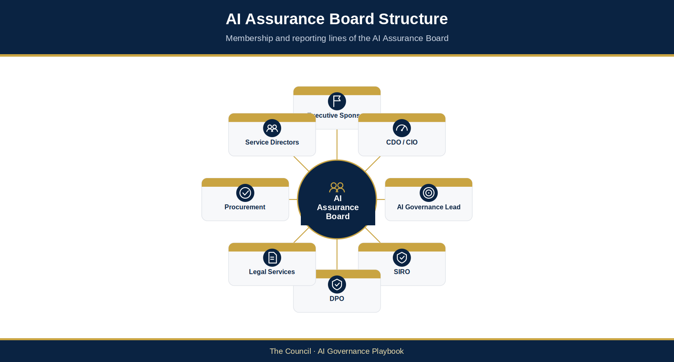
Figure 3.4: AI Assurance Board Structure
The Board shall meet on a regular basis and may convene extraordinary sessions where significant AI-related issues, risks or incidents require urgent consideration.

Core Responsibilities
The AI Assurance Board is responsible for:
- Recommending AI governance policies and standards for adoption by the competent Council authority (approving only where formally delegated)
- Recommending The Council’s AI Operating Model for adoption by the competent Council authority (approving only where formally delegated)
- Reviewing significant AI risks and emerging issues
- Providing assurance opinions and recommendations on high-risk AI use cases, including whether further evidence, conditions, escalation or deferral are required
- Monitoring governance maturity and capability development
- Reviewing assurance and audit findings
- Seeking assurance on compliance with legal and regulatory obligations
- Advising on strategic direction for AI adoption

Suggested Membership
- Executive Sponsor (proposed Chair; the Chair is to be confirmed by The Council)
- Chief Digital Officer / Chief Information Officer
- AI Governance Lead
- Senior Information Risk Owner (SIRO)
- Data Protection Officer (DPO)
- Legal Services Representative
- Procurement Representative
- Service Director Representatives
- Information Governance Representative
Additional subject matter experts may attend where specialist input is required.

AI Governance Working Group
The AI Governance Working Group provides operational governance and acts as the primary coordination mechanism for AI activities across The Council. It is chaired by the AI Governance Lead.
The Working Group supports the AI Assurance Board by undertaking detailed review activities (including the detailed review of Medium-risk uses), confirming triage priorities proposed by the AI Governance Lead, coordinating assessments and ensuring governance controls are operating effectively.

Core Responsibilities
- Reviewing AI intake submissions
- Overseeing the AI Register
- Coordinating AI risk assessments
- Reviewing impact assessments
- Monitoring governance compliance
- Tracking remediation actions
- Reviewing AI incidents and lessons learned
- Escalating significant matters to the AI Assurance Board
The Working Group serves as the operational centre of The Council’s AI governance capability.

Suggested Membership
- AI Governance Lead (Chair)
- Information Governance Representative
- Data Governance Representative
- Cyber Security Representative
- Digital, Data and Technology (DDaT) Representative
- Procurement Representative
- Legal Representative
- Service Owner Representatives
The Working Group may establish specialist sub-groups where required for specific initiatives or technical reviews.

Executive Sponsorship
The Executive Sponsor provides senior leadership accountability for The Council’s AI governance programme. The role is defined in §3.5.

Service Ownership Model
Responsibility for AI systems remains with the business services that use them, through a named Service Owner. The role is defined in §3.5.

Assurance Functions
Independent challenge and specialist assurance are critical components of effective AI governance.
The Council’s assurance model incorporates existing assurance functions to provide objective review and confidence that governance controls are operating effectively.
These functions include independent assurance from Internal Audit and External Assurance Providers, and specialist second-line assurance from:
- Information Governance
- Risk Management
- Legal Services
- Cyber Security
These assurance activities provide confidence that AI governance arrangements remain effective, proportionate and aligned with organisational requirements.

3.5 Roles and Responsibilities
Effective AI governance requires clear accountability, defined decision-making authority and appropriate oversight throughout the AI lifecycle. The Council’s governance model establishes distinct responsibilities for strategic leadership, governance oversight, operational management, risk management and assurance activities.
The following roles support the implementation and operation of The Council’s AI Governance Framework.

Executive Sponsor
The Executive Sponsor provides strategic leadership and executive accountability for The Council’s AI governance programme, and acts as the senior accountable officer for The Council’s AI governance arrangements.
Responsibilities include:
- Championing responsible AI adoption across The Council.
- Ensuring alignment with organisational objectives and priorities.
- Securing organisational support and investment in governance capability and resources.
- Providing executive oversight of Critical-risk uses (UC-IDs), alongside the SRO (§3.10.1).
- Escalating significant governance concerns where appropriate.
- Reporting governance performance to senior leadership.
- Supporting capability development and organisational change.

Senior Responsible Owner (SRO)
The SRO is the senior officer accountable for delivering a specific AI-enabled programme or project and realising its benefits. For a Critical-risk use, the SRO provides oversight alongside the Executive Sponsor (§3.10.1). The SRO decides only where The Council’s scheme of delegation gives that officer the relevant authority.

AI Governance Lead: Governance Operation
The AI Governance Lead is responsible for the operation and continuous improvement of The Council’s AI governance framework and chairs the AI Governance Working Group.
Responsibilities include:
- Maintaining the AI Governance Framework and supporting policies.
- Managing The Council AI Register.
- Coordinating governance reviews and assessments.
- Supporting governance reporting, performance monitoring and assurance activities.
- Monitoring compliance with governance requirements.
- Advising governance bodies on AI-related risks and controls.

AI Governance Lead: Strategy and Innovation
In addition to operating the governance framework, the AI Governance Lead provides strategic direction for AI adoption and innovation across The Council. The Council may assign these strategy responsibilities to a separate officer; that officer does not chair the AI Governance Working Group or hold governance decision rights.
Responsibilities include:
- Developing The Council’s AI strategy and roadmap.
- Supporting the identification of AI opportunities.
- Promoting responsible innovation.
- Coordinating AI capability development.

Service Owner
Every AI system must have an identified Service Owner, so that governance responsibility stays with those responsible for service outcomes rather than becoming isolated within technology teams.
The Service Owner is accountable for ensuring that AI systems operating within their service area comply with The Council’s governance requirements.
Responsibilities include:
- Identifying AI systems operating within their area of responsibility.
- Submitting AI systems for intake and ensuring they are registered and assessed.
- Completing or supporting governance and risk assessments and reviews.
- Implementing required controls and mitigation measures, and managing operational risks.
- Ensuring appropriate human oversight.
- Maintaining oversight of operational performance, outcomes and compliance.
- Maintaining documentation and supporting audits and assurance reviews.
- Escalating governance concerns, incidents and emerging risks.
Service Owners remain accountable for business outcomes regardless of whether an AI capability is developed internally or supplied by a third party.
AI System Owner: where a Service Owner assigns day-to-day operation and monitoring of a specific AI system to a named officer (for example a technical, product or contract lead), that officer is the AI System Owner. The AI System Owner monitors the system, keeps its operational records and may apply an immediate precautionary pause (§4.7.17). The Service Owner remains accountable. Where no AI System Owner is named, the Service Owner performs the role.

Data Protection Officer (DPO)
The DPO provides independent oversight of data protection compliance.
Responsibilities include:
- Advising on UK GDPR and Data Protection Act requirements.
- Reviewing Data Protection Impact Assessments where required.
- Monitoring privacy-related governance risks.
- Supporting investigations involving personal data.

Senior Information Risk Owner (SIRO)
The SIRO provides strategic oversight of information risk management.
Responsibilities include:
- Overseeing information-related risks associated with AI systems.
- Supporting governance decision-making regarding data use.
- Escalating significant information governance concerns.
- Ensuring alignment with The Council’s information risk framework.

Legal Services
Legal Services provide advice on legal, regulatory and contractual matters associated with AI deployment.
Responsibilities include:
- Supporting legal compliance reviews.
- Advising on regulatory obligations.
- Reviewing contractual arrangements where appropriate.
- Supporting governance decisions involving legal risk.

Procurement
Procurement supports supplier governance and third-party assurance activities.
Responsibilities include:
- Supporting supplier due diligence.
- Reviewing supplier governance arrangements.
- Ensuring contractual obligations support The Council’s governance requirements.
- Monitoring supplier-related governance risks.

Internal Audit
Internal Audit provides independent assurance regarding the effectiveness of The Council’s AI governance arrangements.
Responsibilities include:
- Reviewing governance effectiveness.
- Assessing compliance with governance requirements.
- Providing independent assurance to senior management and governance bodies.
- Identifying opportunities for governance improvement.

All Employees
All employees have a responsibility to use AI technologies in accordance with The Council’s policies, governance requirements and ethical principles.
Responsibilities include:
- Completing required training and awareness activities.
- Using AI only within an approved use-specific scope.
- Reporting governance concerns, incidents or policy breaches.
- Supporting transparency and accountability in AI use.
Responsible AI adoption is ultimately dependent upon organisational culture, awareness and individual accountability.

3.5.1 Governance Responsibilities Matrix
The Governance Responsibilities Matrix (RACI) shows who is responsible, accountable, consulted and informed for each governance activity across the AI lifecycle, from use-case identification through deployment, monitoring and review, where activities involve more than one role or body. It aligns with the AI Governance Operating Model (Figure 3.2), the Three-Layer Governance Structure (Figure 3.3) and the AI Assurance Board Structure (Figure 3.4).

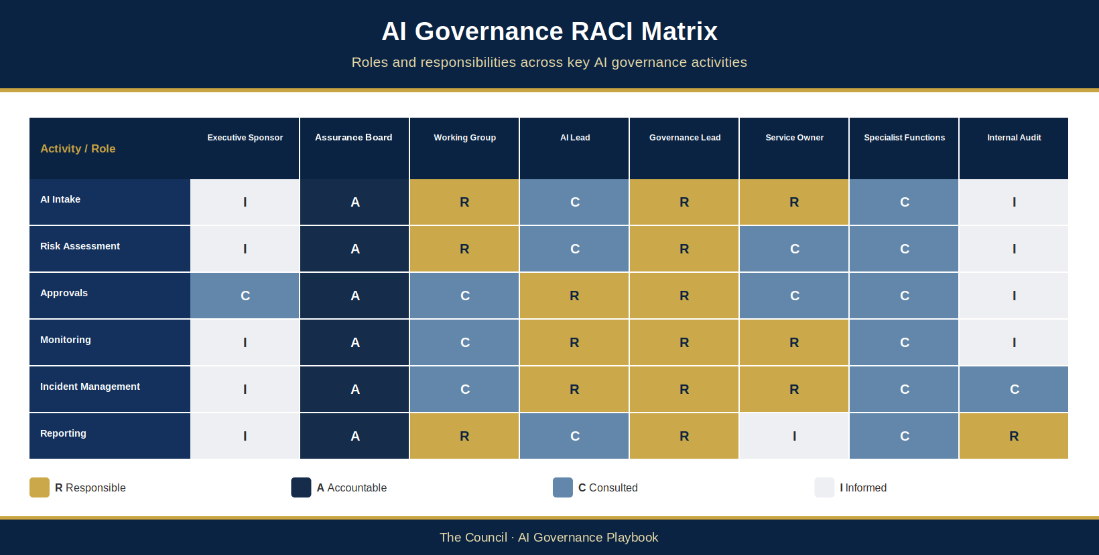
Figure 3.5: AI Governance RACI Matrix

Key
R – Responsible: Performs and manages the activity.
A – Accountable: Ultimately answerable for the decision, outcome or approval.
C – Consulted: Provides advice, expertise, challenge or specialist input.
I – Informed: Kept informed of decisions, actions and outcomes.
Specialist Functions include the Data Protection Officer (DPO), Senior Information Risk Owner (SIRO), Legal Services, Cyber Security and Procurement.
The matrix does not itself confer decision rights. Decision rights come from the AI Governance Terms of Reference (AIG-GOV-06) and The Council’s delegations, and the assurance thresholds, escalation requirements and decision-making authority for each risk tier apply per UC-ID as set out in §3.10. A low-risk use may be decided within service-level arrangements only where the decision-maker holds the applicable delegation and records its exact scope and conditions. Higher-risk uses trigger progressively greater assurance: detailed review by the Working Group, an AI Assurance Board opinion for every High- and Critical-risk use, and Executive Sponsor oversight for Critical-risk uses. The Board advises and does not decide; the competent delegated forum or officer decides. The competent delegated authority records the outcome for each covered UC-ID.

3.6 AI Lifecycle Governance
Effective AI governance requires oversight throughout the entire lifecycle of an AI system. Governance cannot be treated as a one-time approval activity undertaken at the point of procurement or deployment. AI systems may evolve over time, utilise changing datasets, receive vendor updates and operate within changing regulatory environments.
The Council shall therefore apply governance controls across the full AI lifecycle, ensuring that risks, impacts and performance are continuously monitored and managed.
The Council AI Lifecycle consists of seven governance stages.

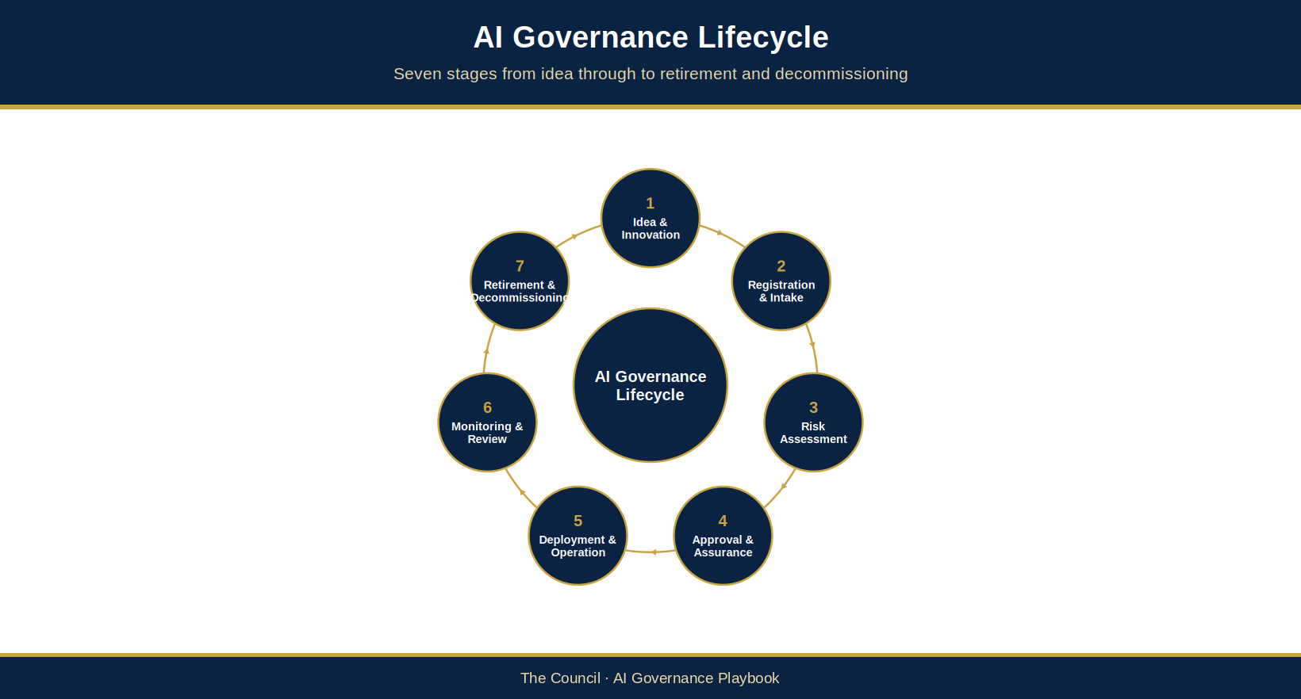
Figure 3.6: AI Governance Lifecycle

Stage 1: Idea and Innovation
The lifecycle begins when an AI opportunity, requirement or proposal is identified.
Potential sources include:
- Service improvement initiatives
- Supplier proposals
- Technology projects
- Process automation opportunities
- Data and analytics programmes
- Employee innovation initiatives
At this stage, services should consider:
- Intended business outcomes
- Potential resident impacts
- Data requirements
- Ethical considerations
- Alternative non-AI solutions
The objective is to ensure that AI is adopted to solve genuine business challenges and deliver measurable public value.

Stage 2: Registration and Intake
Before procurement, development or deployment activities commence, all AI systems must be registered through The Council’s AI Intake Process.
The intake process provides visibility of AI activity across the organisation and ensures governance review occurs before significant commitments are made.
Information collected includes:
- System name
- Service Owner
- Business purpose
- Supplier details
- Intended users
- Data categories used
- Expected benefits
- Initial risk indicators
Once intake is accepted, a Register entry is created (§3.8).

Stage 3: Risk Assessment and Review
Following registration, the proposed AI use case undergoes a structured governance assessment.
The assessment evaluates:
- Data protection considerations
- Equality impacts
- Human rights implications
- Ethical considerations
- Security risks
- Operational risks
- Supplier risks
- Reputational risks
A preliminary risk classification is assigned.
The four risk tiers are Low, Medium, High and Critical (§4.4.8).
The outcome determines the level of review, assurance and approval required.

Stage 4: Approval and Assurance
Each materially distinct use needs its own delegated decision before it is deployed or operated (§3.10.1).
Approval requirements are proportionate to risk.
Activities may include:
- Governance review
- Privacy review
- Legal review
- AI Security Review Checklist (AIG-ASS-11)
- Procurement review
- Equality assessment
- Independent assurance review
Authoritative approval decisions are documented in the Governance Decision Record (AIG-DEC-03) and/or approved forum minutes. AIG-DEC-04 records the dated Gate Event, outcome, linked conditions and decision-record/minutes reference; it is not a second decision record. AIG-INV-04 retains the current system and governance state.

Stage 5: Deployment and Operation
Following a delegated decision, only the UC-ID(s) expressly covered may be implemented and used, once their required assurance is complete and within the approved scope and conditions; other uses require their own decision.
Before go-live, the Service Owner and AI Governance Lead complete the AI Deployment and Rollout Plan (AIG-OPS-01), carrying each use’s decision conditions into readiness evidence, human oversight, monitoring, rollback and authorisation. Operational use begins only after required readiness controls are met. Reconcile the Governance Approval Status and Operational Status fields in the AI Register as system-level current-state fields (§3.7).
Governance requirements continue during operation.
Services must ensure:
- Appropriate human oversight
- User training
- Operational controls
- Documentation maintenance
- Incident reporting
- Compliance monitoring
Responsibility for operational management remains with the designated Service Owner.

Stage 6: Monitoring and Review
AI systems must be subject to ongoing review throughout their operational life.
Monitoring activities may include:
- Performance monitoring
- Risk reviews
- Compliance reviews
- User feedback
- Incident analysis
- Supplier performance reviews
- Assurance activities
Particular attention should be given to:
- Model drift
- Bias
- Accuracy
- Explainability
- Emerging risks
- Regulatory changes
Higher-risk systems may require enhanced monitoring arrangements.

Stage 7: Retirement and Decommissioning
AI systems must be formally retired when they are no longer required, replaced or deemed unsuitable for continued use.
Decommissioning activities include:
- Closure approvals
- Data retention reviews
- Supplier offboarding
- Documentation updates
- Register updates
- Lessons learned reviews
The retirement process ensures governance accountability continues until the system is formally removed from service.

Lifecycle Governance Principle
No AI system should exist outside the governance lifecycle.
Every governed system must be identifiable by AIR-ID, and each materially distinct use must be identifiable by UC-ID, assessed, decided, monitored and ultimately closed or retired through a controlled governance process. Approval applies only to the UC-ID scope expressly decided.
This principle forms one of The Council’s most important governance controls and provides the foundation for visibility, accountability and assurance across the organisation.

3.7 The Council AI Register
The Council AI Register (AIG-INV-04) serves as the authoritative inventory of AI systems operating across The Council.
The register provides organisational visibility, supports accountability and enables governance oversight of AI activities.
The register is a mandatory governance control.
All AI systems, AI-enabled services and significant AI capabilities must be recorded.

Purpose of the AI Register
The register supports The Council’s ability to:
- Maintain visibility of AI use
- Support governance decision-making
- Monitor risks
- Demonstrate accountability
- Support audits and assurance reviews
- Meet transparency obligations
- Manage supplier relationships
- Identify emerging governance concerns
The Register is the authoritative portfolio and current-state record. It holds one system row per governed system, keyed by a permanent AIR-ID issued only through Council governance and never reused, and a separate, stable UC-ID for each materially distinct purpose, workflow or outcome. Any approved purpose, permission and condition must remain expressly linked to the UC-ID(s) covered by the delegated decision. A Register entry or system-level status is not approval of any or all uses: a use is authorised only by a delegated decision that expressly covers its UC-ID. The AI Register template (AIG-INV-04) holds the field-level structure, including a system-level assessment summary that points to use-specific conclusions but does not replace source assessment evidence or gate history.
The append-only AI Governance Gate Log (AIG-DEC-04), linked by AIR-ID and UC-ID, records dated gate events and conditions and explains changes to current state; current-state updates must not overwrite its history. Gate decisions, approvers, decision dates, conditions, escalations, priority-override events, assurance references and next-gate details are not held in the Register: they are recorded as dated events in AIG-DEC-04, with each distinct condition on its own row linked to its Gate Event. Prospective gate requirements belong in a separate Gate Plan, not in the event history. Each Gate Event keeps its Event ID, decision-maker and role, and a reference to the approved forum minutes or Governance Decision Record, which remain authoritative. Decision authority remains with the forum or officer authorised under the applicable terms of reference and delegation; the Gate Log provides traceability and does not confer or replace it.

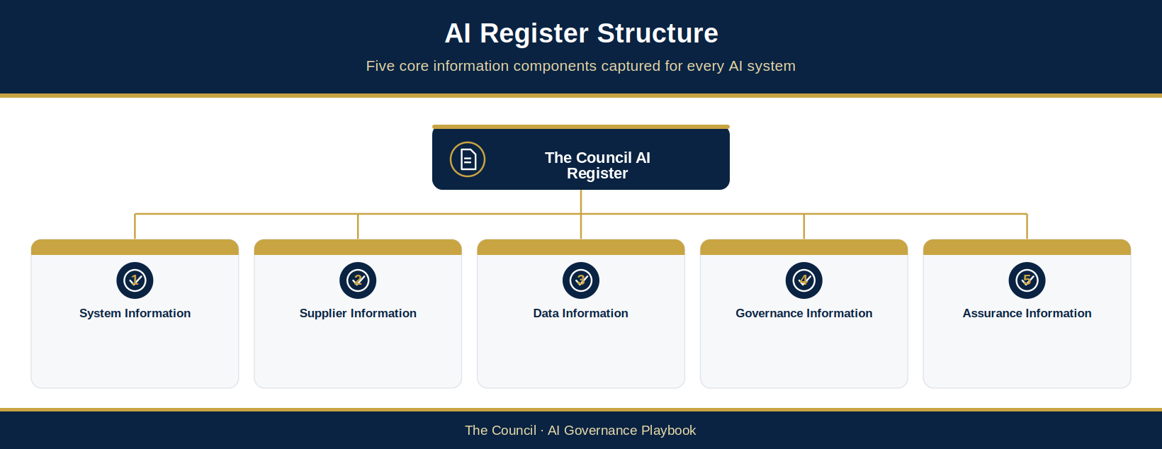
Figure 3.7: AI Register Structure

Minimum Register Requirements
The AI Register shall contain, as a minimum:

Identity and Scope
- Permanent AIR-ID (issued only through Council governance; immutable and never reused)
- System / model name
- Approved purpose and scope, each linked to the expressly covered UC-ID(s)
- Service area
- Service Owner
- Supplier / developer and source

Current Lifecycle State
- AI capability and systems/tools permitted for linked UC-ID(s)
- Current lifecycle stage
- Date registered
- Date first used
- Operational Status (system baseline)

Governance Priority and Risk
- AGPI score
- Effective Governance Priority
- Inherent risk
- Control effectiveness, residual risk and risk tier
- Personal / special category data indicator

Impact Assessment and Transparency Status
- DPIA requirement and reference
- Equality Impact Assessment requirement and reference
- ATRS requirement
- Model Card completion
- Governance Approval Status (system baseline; not use approval)

Monitoring and Reviews
- Monitoring in place
- Last review date
- Next review date

Register Ownership
The AI Governance Lead has operational custody of the register, administering the current-state record and continuity of its identifiers issued through Council governance. Service Owners remain accountable for submitting accurate system information and reporting changes promptly. The AI Assurance Board exercises portfolio oversight through existing governance arrangements; that oversight does not make it the register’s operational custodian.
Service Owners remain responsible for ensuring that information relating to their AI systems remains accurate and up to date.
The register shall be reviewed regularly and reported through The Council’s governance structures.

Transparency and Reporting
Appropriate information from the register may be used to support:
- Executive reporting
- Governance dashboards
- Internal audits
- Regulatory enquiries
- Public transparency commitments, including voluntary Algorithmic Transparency Recording Standard (ATRS) publication where agreed, using the ATRS Record Template (AIG-ASS-10)
Where The Council uses AI to support decisions affecting members of the public, relevant entries in the AI Register should be reviewed for ATRS reportability. The ATRS requires government departments and in-scope arm’s-length bodies to publish details of algorithmic tools used in decision-making, and is recommended for the wider public sector, including local authorities. The Council adopts the standard on a voluntary basis. The AI Governance Lead is responsible for ensuring that ATRS submissions are made where publication has been agreed and that register entries contain sufficient information to support this commitment.
The register provides a critical mechanism for demonstrating accountability and responsible governance.

3.8 AI Intake and Approval Process
Intake is how a proposed or existing AI system enters The Council’s governance. It must happen before procurement, development, commissioning or deployment of any use begins, and no use may proceed without completing intake and any delegated decision required for its scope. Two identifiers keep the record straight:
- AIR-ID: the permanent identifier for one AI system, issued when the system is registered.
- UC-ID: the identifier for each materially distinct use of that system. For example, a transcription tool used to minute council meetings and the same tool used to record social care visits are one AIR-ID with two UC-IDs, because the people affected, the data and the risks differ.
Priority, risk, the delegated decision, permitted scope, conditions and review date are recorded for each UC-ID. A system entry in the Register records that the system is in governance; it never approves a use (§3.7).
The governance function uses five administrative steps, but the Service Owner experience is deliberately lean: one submission, one AIR-ID, a route for each materially distinct UC-ID, and only the evidence each triage outcome requires.
These steps sit within lifecycle Stages 1 and 2 (§3.6). Triage (§3.9) happens during Steps 2 to 4, and decisions are taken at the gates set out in the Gate Map (AIG-DEC-01), explained in §3.8.1.
Step 1 — Submission. The Service Owner completes one AI Intake Form (AIG-INV-03).
Step 2 — Initial screening. The AI Governance Lead reviews the intake form within five working days and determines whether it is complete; each proposed UC-ID falls within the Framework; mandatory escalation triggers apply (see §4.4.6); and provisional use-specific priority/risk classifications can be proposed (the AI Governance Lead scores the AGPI and proposes the priority; the AI Governance Working Group confirms it; see §3.9.4, triage stage 5). Where the form is incomplete, it is returned to the Service Owner with written guidance. Where mandatory escalation triggers apply, the AI Governance Lead notifies the AI Assurance Board immediately.
Step 3 — AI Register entry. Once intake is accepted, the AI Governance Lead creates or reconciles one AI Register system row under the permanent AIR-ID and links the materially distinct UC-ID(s) in the intake schedule. Record the Service Owner, intake date and current system governance state; retain each use’s priority/risk and decision/condition references under its UC-ID. The Register row records system entry into governance only (§3.7).
Step 4 — Governance pathway assignment. For each UC-ID, the provisional route is set from the provisional risk tier, taking account of any mandatory trigger (§4.4.6) and, for uses that can take actions, the agentic minimum (see §3.10.1 for the governing tier). The route is recorded in the Governance Checklist (AIG-ASS-03). The AGPI priority sets how soon and in what order the case is taken, not the route (§3.9.5). The route determines required assessments and assurance, not decision authority. Decision authority and final assurance depth are set from the confirmed Chapter 4 risk tier; if the confirmed tier differs from the provisional tier, the UC-ID is re-routed.
Step 5 — Confirmation and next steps. The AI Governance Lead issues a formal intake acknowledgement to the Service Owner confirming the applicable route and, for each materially distinct UC-ID, the priority/risk basis, required assessment, decision authority, conditions and next actions. Shared system evidence may be referenced with an applicability check. Procurement or deployment proceeds only for the UC-ID(s) covered by a current decision of the authority holding the relevant delegation and only within its conditions.
The AI Intake Form (AIG-INV-03, a Level 5 template under §5.2.5) and supporting guidance are maintained by the AI Governance Lead and are available to all staff on The Council’s intranet governance pages. Staff uncertain whether a tool or capability requires formal intake should err on the side of submission and contact the AI Governance Lead for informal guidance before beginning any procurement or deployment activity.

3.8.1 The Three Routes
Every use comes through the same front door and then follows one of three routes. Light-touch is for validated Low-risk uses; Standard covers Low- and Medium-risk uses; Enhanced covers High- and Critical-risk uses and any use that can take actions.
Light-touch — routine, low-impact AI. Fast-Track Screening (AIG-INV-02) is a step within AI Intake that screens each materially distinct UC-ID separately for the Light-touch route, using Yes / No / Unsure. Only a use with all-No answers, no mandatory trigger and a validated low-consequence, low-agency and low-exposure finding may follow the Light-touch route; the AI Governance Lead validates it. The screen never replaces intake facts, never creates an AIR-ID by itself and never authorises use (§3.7). After validation, a proportionate delegated decision for the UC-ID is recorded (AIG-DEC-03 or approved minutes) and a Gate Event is logged in AIG-DEC-04 before operation. Any Yes or Unsure, mandatory trigger or material change routes that use to full triage. If every Fast-Track answer is No but the governing tier from triage is above Low, the higher tier stands and the mismatch is flagged to the AI Governance Lead to check the answers and scores (Proposed — for Council confirmation).
Standard — ordinary operational AI. One system Intake Form with a separate UC-ID for every materially distinct use; governance-led triage and specialist assessments are scoped per use and trigger. The governance function carries AIR-ID, UC-ID links, Gate Log and decision references so the Service Owner does not recreate evidence. Normally: intake → priority and risk assessment → triggered specialist assurance → governance decision → deployment → monitoring.
Enhanced / Agentic — higher-impact or action-capable AI. The same front door applies, but the relevant additional controls are triggered: detailed risk assessment and, where the system can act, Agentic Triage, an Agent Record (Agentic System Bill of Materials, ASBOM), authority, tool, memory, runtime and action evidence as applicable. Action-capable means the AI can take actions, invoke tools, communicate externally, alter records, spend money, delegate to another agent or otherwise exercise delegated authority. Recording a separate UC-ID does not by itself make a routine tool agentic. Agents that staff build on a platform already on the Register, such as Microsoft 365 Copilot, are governed by platform and pattern (Appendix F.8); only those that meet an F.8 trigger come through this route individually.
Decisions are taken at the gates set out in the Gate Map (AIG-DEC-01): Gate 0 Intake / opportunity; Gate 1 Strategic prioritisation; Gate 2 Technical design review; Gate 3 Case for change / strategic alignment; Gate 4 Procurement; Gate 5 Ethics assessment; Gate 6 Deployment / go-live; Gate 7 Operate, monitor, review and change; and Gate 8 Retirement / closure. Under the Gate 1 and 3 rule in AIG-DEC-01, a new use of an existing approved system whose approval is current and that needs no new investment normally needs only Gate 0, Gate 6 and Gate 7, and the screening may be done by reference (§4.6). A new system that costs nothing still goes to Gate 1, so that a decision-maker agrees The Council takes it on, but not to Gate 3.
The AI Governance Lead coordinates routing for each UC-ID and keeps the continuity record. Service Owners remain accountable for their service and outcomes; specialist authorities retain their statutory or delegated responsibilities.

3.8.2 How the Governance Documents Fit Together
The governance framework and its templates are designed to be rigorous without making every AI project complete every governance artefact. The operating principle is: capture evidence once, reference it by AIR-ID, and trigger additional assurance only where the characteristics of the AI require it. For the Service Owner the journey is: tell us once → we route it → complete only what applies → decision → operate and monitor. The internal governance record can stay detailed without the Service Owner repeating it.

3.8.2.1 Capture Once / Do Not Create Another Form
- The AIR-ID is the single evidence spine for the lifecycle. Evidence is created once at its source and referenced by the Register, Gate Log, Decision Record and deployment checks; existing evidence must be linked rather than recopied into new artefacts.
- A new governance artefact should only be introduced where a distinct governance purpose cannot reasonably be fulfilled by an existing controlled record, field, workflow state, link or derived view.
- Decision-Ready Papers, dashboards, crosswalks and governance maps are presentation/management aids unless explicitly designated as authoritative records.

3.8.2.2 Agentic Simplification
- The Agent Record (ASBOM) is the authoritative agentic master record for identity, capability, autonomy, authority, components, interfaces, tools, memory, delegation and control evidence.
- The Agent Authority Graph is a derived view of the ASBOM authority and delegation data. It should not require separate manual duplication of those relationships.
- Capability, autonomy and agency are recorded once and reused by downstream assurance. A positive “can it act?” trigger routes the AI into the agentic path; it does not create a second intake process.

3.8.2.3 Specialist Assurance Is Trigger-Based
- DPIA, Equality Impact Assessment, Human Rights Assessment, security review, supplier due diligence, ATRS and other specialist controls are triggered by applicability and risk rather than applied universally. An artefact is required because a risk, impact, legal duty, agency characteristic or gate makes it relevant, not simply because it exists in the governance documents. A gate that is not applicable is recorded as N/A rather than creating extra work.

3.8.2.4 Management-System Controls Sit Behind the Workflow
- The AIMS, ISO/IEC 42001 crosswalks, audit records, management review, source assurance and clause-level evidence are management-system infrastructure. They demonstrate organisational control; they are not additional forms for every Service Owner.

3.8.2.5 Legal Requirement versus Council Governance Requirement
- The governance documents must distinguish statutory/regulatory obligations, government policy or guidance, international standards, industry frameworks and Council-imposed governance controls. Internal thresholds must not be presented as if they are statutory requirements.

3.8.2.6 Runtime Boundary
- The governance documents define required authority, controls, evidence and release conditions. The runtime platform, identity and access management (IAM), security and service technology must implement enforcement such as least privilege, per-action authorisation, credential revocation, tool interception, kill-switch, rollback and audit logging.

3.8.2.7 Minimum Decision Principle
The question is not “Which forms must I complete?” It is “What risk and authority does this AI create, and what evidence is needed to demonstrate that it is controlled?”

3.8.3 AI Already in Use: Retrospective Intake and Public AI Tools
Retrospective intake. Where an AI system is found already in use, through Shadow AI monitoring, AI capability embedded in existing products, audit or self-declaration, the Service Owner must submit the AI Intake Form for retrospective intake without delay. The system goes through the same five steps, and its Register entry is marked retrospective. It may be assigned to the Governance Investigation pathway (§3.9.5) and remains subject to The Council’s suspension and withdrawal controls (§4.7.17) until assessment is complete. Retrospective intake is routine, not disciplinary: early declaration of existing AI use is encouraged and supported.
Public AI tools disclosed by staff. Where disclosures under §5.4.2 (see also §2.4) show several staff using the same public AI tool, one tool-level Register entry is created through retrospective intake rather than one entry per disclosure. The date of first use is the earliest credibly disclosed date, and the individual disclosures are kept with the intake as evidence of the scale, spread and nature of use.
Ownership works at two levels. The AI Governance Lead holds the tool-level entry for The Council while the tool’s status is decided, because no individual can meaningfully own a tool that was neither procured nor commissioned. Each Service Owner remains accountable for the disclosed use in their service (§3.5). Where ownership, purpose or use cannot yet be determined, the entry may be assigned to Governance Investigation (§3.9.5).
Disclosed uses are grouped by use case, each with its own UC-ID, because the risk of a public tool depends on the task and the data. Each group is triaged (priority through the AGPI, §3.9.6, and risk tier under Chapter 4) and may reach a different outcome: lower-risk uses may become approved use under §5.4.1 with guidance, while uses involving personal or special category data, or any prohibited use under §5.4.3, are assessed against the mandatory escalation triggers in §4.4.6.
The tool-level entry is not a blanket approval. Under the Risk-Based Approval Framework (§3.10.1) the delegated authority records a separate outcome, permitted scope and conditions for each UC-ID and owns the residual risk for its decisions. Disclosure stays outside conduct procedures however many disclosures are received (§5.4.2). Where personal data may already have been entered into a public tool, the Data Protection Officer assesses it as a potential data protection incident; this concerns the data event and does not change the position of the member of staff who disclosed it. Widespread use of the same tool is also evidence of unmet demand and should inform The Council’s provision of approved alternatives.

3.9 AI Governance Triage and Prioritisation Framework
“Effective governance is not about governing everything equally. It is about directing oversight where it delivers the greatest protection for residents, public trust and organisational resilience.”

3.9.1 Purpose of Governance Triage
Artificial Intelligence is increasingly becoming embedded across enterprise platforms, supplier solutions, productivity tools and operational services. As adoption accelerates, The Council will inevitably encounter a growing number of AI-enabled systems requiring governance oversight. These systems will vary significantly in purpose, complexity, risk and organisational impact.
In practice, governance resources are finite. It is neither proportionate nor practical to apply the same level of scrutiny to every AI system. Low-risk productivity tools may require only routine oversight, while AI systems supporting statutory decision-making, vulnerable residents or critical public services demand substantially greater governance, assurance and executive oversight.
The purpose of AI Governance Triage is to provide The Council with a structured, proportionate and defensible mechanism for determining where governance effort should be directed first. Rather than treating every AI-enabled solution equally, governance triage enables The Council to identify those systems that present the greatest potential impact on residents, legal compliance, organisational resilience and public trust.
Governance triage is carried out during intake Steps 2 to 4 (§3.8) and is the first assessment step in The Council’s AI governance lifecycle. It is undertaken as soon as an AI capability has been identified and brought into intake, whether it was identified through procurement, project initiation, supplier engagement, innovation activity or discovery through Shadow AI monitoring. The outcome of triage determines the level of governance, assurance and assessment required before an AI system progresses further through The Council’s governance framework.
Importantly, governance triage is not a detailed risk assessment. It does not replace a Data Protection Impact Assessment (DPIA), Equality Impact Assessment (EIA), AI Impact Assessment or formal assurance review. Instead, it acts as a prioritisation mechanism, enabling governance teams to allocate finite resources where they will deliver the greatest public value and risk reduction.
Priority and risk are set for each use (UC-ID), not only for the system, wherever the context, the people affected, the decision impact, the data or the authority differ. Controls shared across the system can be cited once their fit to the use has been checked, but each use is assessed on its own risks and mandatory triggers. An average or system-wide score must not hide a higher-risk use.

3.9.2 Why Governance Triage Matters
AI governance does not fail only when organisations ignore risk. It can also fail when attention is directed towards the wrong risks.
In many organisations, governance attention naturally follows visibility. The systems that receive the most scrutiny are often the newest, most public, most politically sensitive or most easily identifiable. However, these are not always the systems that present the greatest risk. Some of the most significant AI risks may emerge quietly through supplier platforms, operational workarounds, informal experimentation or tools already embedded within existing digital systems.
This is particularly important for The Council. AI systems may begin as low-profile pilots, analytics tools, productivity aids or supplier features, but gradually become relied upon in operational decision-making. Over time, a tool that was originally used to support analysis may begin to shape prioritisation, resource allocation, case handling or service access. If this transition is not visible to governance teams, The Council may find that AI is influencing public services before appropriate oversight, assessment or accountability has been established.
Governance triage helps address this risk by creating an explicit decision point. It requires The Council to ask not only whether an AI system exists, but whether it could affect residents, statutory duties, vulnerable groups, public trust, service access or organisational resilience. This prevents governance activity from being driven solely by visibility, novelty or urgency.
The triage process is especially important in relation to Shadow AI. Unapproved or unmanaged AI use may not appear on formal project plans, procurement records or technology registers. Without a structured discovery and triage mechanism, these uses may remain outside governance oversight entirely. Triage therefore acts as both a prioritisation tool and an early-warning mechanism, helping The Council identify where AI activity requires immediate review.
The objective is not to slow innovation. The objective is to ensure that innovation does not move faster than accountability. By introducing governance triage at the point of discovery, The Council can make informed decisions about which AI systems require full assessment, which require enhanced assurance, which can proceed under standard controls and which should be paused pending further review.

3.9.3 The Council Governance Lens
Before detailed risk assessments, impact assessments or assurance activities are undertaken, every AI system should first be viewed through The Council Governance Lens. This provides a structured method for considering the wider implications of AI adoption beyond technical performance alone.
Traditional technology governance often focuses on questions such as whether a system is secure, reliable or compliant with organisational standards. While these remain important, AI introduces additional considerations relating to fairness, transparency, accountability, human oversight and the potential impact on residents and communities.
The Council Governance Lens provides an initial governance perspective through which every AI capability is assessed before progressing through the wider governance framework. Rather than immediately evaluating technical controls, the lens encourages governance practitioners to consider the broader public-sector implications of AI adoption.
The framework consists of five complementary governance perspectives, each reflecting The Council’s statutory responsibilities, organisational values and commitment to responsible innovation.
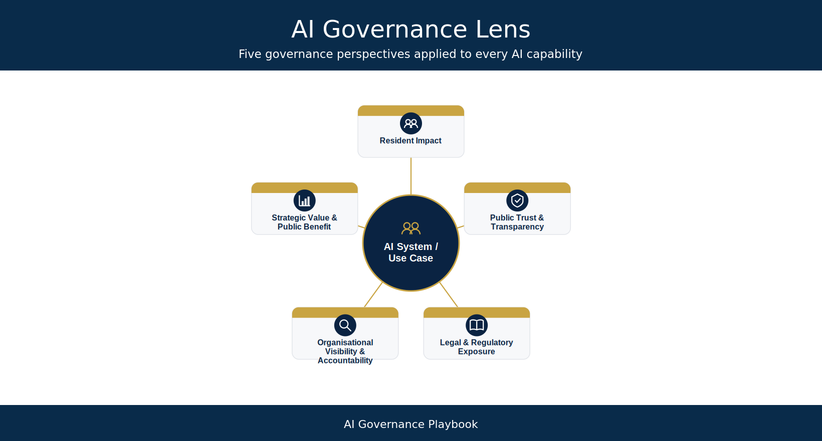
Figure 3.8: The Council Governance Lens

Lens 1 – Resident Impact
The first consideration is the potential impact on residents and service users. Governance should assess whether an AI system could directly or indirectly influence the services residents receive, the decisions made about them or their overall experience of interacting with The Council. Particular attention should be given to vulnerable individuals, protected characteristics and situations where AI may influence eligibility, prioritisation, safeguarding or access to public services.
Key questions include:
- Could this AI influence decisions affecting residents?
- Could vulnerable individuals be disproportionately impacted?
- Could errors result in harm or reduced service quality?
- Are appropriate human review mechanisms in place?

Lens 2 – Public Trust and Transparency
Public confidence is fundamental to the successful adoption of Artificial Intelligence within The Council. Residents should have confidence that AI is being used lawfully, ethically and transparently. Governance should therefore consider whether the use of AI could affect public confidence, whether appropriate transparency arrangements exist and whether decisions supported by AI can be adequately explained when challenged.
Key questions include:
- Would residents expect AI to be used in this service?
- Can The Council explain how AI supports decision-making?
- Would the use of AI withstand public scrutiny?
- Are appropriate transparency measures in place?

Lens 3 – Legal and Regulatory Exposure
AI must operate within The Council’s legal, regulatory and policy obligations. This lens considers whether an AI system introduces obligations under legislation, regulatory guidance or internal governance policies. Consideration should include data protection, equality duties, procurement obligations, human rights, information governance and sector-specific regulatory expectations.
Key questions include:
- Does the AI process personal or sensitive information?
- Could statutory duties be affected?
- Are additional impact assessments required?
- Does the procurement approach adequately address AI-related risks?

Lens 4 – Organisational Visibility and Accountability
Effective governance depends upon visibility. An AI system cannot be governed if its existence, ownership or operation is unknown. This lens assesses whether The Council has sufficient visibility of the AI capability, clear ownership, defined accountability and appropriate governance documentation throughout the AI lifecycle.
Key questions include:
- Is the AI Register entry complete and current?
- Is there a clearly identified Service Owner?
- Are governance responsibilities documented?
- Can the system be effectively monitored and reviewed?

Lens 5 – Strategic Value and Public Benefit
Governance should enable innovation rather than create unnecessary barriers. This final lens considers whether the proposed AI capability supports The Council’s strategic objectives, improves outcomes for residents and delivers measurable public value. Governance should ensure that the anticipated benefits justify the associated risks, costs and governance effort.
Key questions include:
- Does the AI support The Council’s strategic priorities?
- Will it improve outcomes for residents or communities?
- Can benefits be measured?
- Is the expected value proportionate to the risks involved?

Bringing the Five Lenses Together
Collectively, The Council Governance Lens provides a balanced method for assessing AI systems before detailed governance activity begins. Rather than focusing exclusively on technical risk, it encourages governance practitioners to consider the broader organisational, legal, ethical and societal implications of AI adoption.
By viewing every AI capability through these five governance lenses, The Council can ensure that governance decisions remain aligned with public-sector values, proportionate to risk and focused on delivering safe, transparent and accountable innovation.

3.9.4 The Council AI Governance Triage Process
The Council AI Governance Triage Process provides a structured method for determining the level of governance attention required for every AI system entering the organisation. It is designed to be applied consistently across all AI-enabled technologies, regardless of whether they are internally developed, procured from suppliers, embedded within enterprise software or identified through Shadow AI discovery activities.
The process is deliberately lightweight. Its purpose is not to replace detailed assurance activities, but to establish an initial governance view that enables resources to be directed towards the areas of greatest organisational importance.
Every AI system should pass through the following five stages before progressing to detailed assessment.
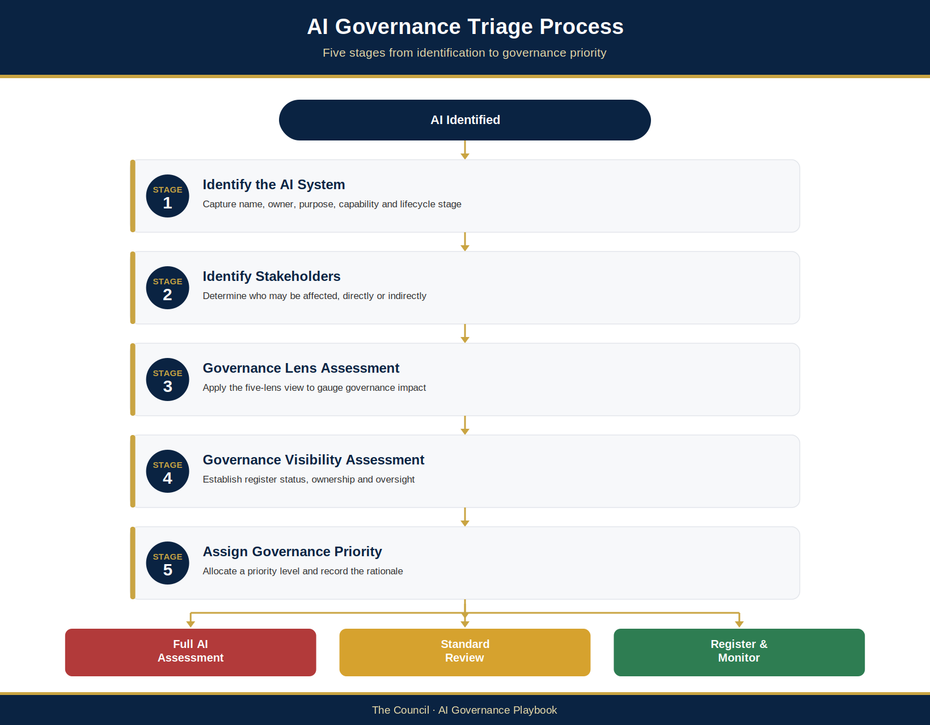
Figure 3.9: The five triage stages. Priority sets the order in which cases are taken; the route is always set by the governing tier (§3.10.1).

Stage 1 – Identify the AI System
Governance begins with visibility. Before risk can be assessed, The Council must establish a basic understanding of the AI capability under consideration. This initial identification stage creates the foundation for governance by capturing key information about the system, its purpose and its ownership.
Information gathered during this stage should include:
- Name of the AI system
- Service Owner
- Service area
- Supplier or developer
- Intended purpose
- AI capability utilised (e.g. Generative AI, Agentic AI, Predictive AI, Computer Vision, Natural Language Processing, or other Machine Learning techniques)
- Current Operational Status as recorded in the AI Register (Not live, Active, Suspended, Decommissioned) and governance lifecycle stage (§3.6 Stages 1 to 7)
- Whether the AI Register entry is complete and current
Where ownership or purpose cannot be clearly established, assign the system to the Governance Investigation pathway (§3.9.5) and consider a precautionary pause or suspension of its use (§4.7.17). The system may be paused; the governance review carries on.

Stage 2 – Identify Who May Be Affected
AI governance should always begin with people rather than technology. This stage considers the individuals, communities and organisations that may be affected directly or indirectly by the AI system. The objective is to understand who may experience the consequences of AI-assisted decisions, recommendations or automated processes.
Stakeholders may include:
- Residents
- Vulnerable residents
- Employees
- Service users
- Elected members
- Contractors
- Partner organisations
- Suppliers
- Regulatory bodies
- The wider public
Governance should consider not only those who actively use the AI system but also those whose rights, opportunities or access to services may be influenced by its outputs.

Stage 3 – Assess Governance Impact
Once stakeholders have been identified, governance practitioners should consider the potential organisational impact of the AI system through The Council Governance Lens. Assessment should consider the following dimensions, named as they are scored in the AGPI (§3.9.6). Governance Visibility & Accountability is assessed in Stage 4.
Governance Dimension | Primary Consideration
Resident Impact | Could residents be affected by AI-assisted decisions or recommendations?
Public Trust & Reputation | Could use of AI reduce confidence in The Council if poorly governed?
Legal & Regulatory Exposure | Could legal duties or regulatory obligations be engaged?
Strategic Value & Organisational Dependency | Does the use deliver measurable public benefit, and how much would The Council come to rely on it?

At this stage, the objective is not to assign detailed risk scores but to identify whether enhanced governance is likely to be required.

Stage 4 – Assess Governance Visibility
An AI system cannot be governed effectively if the organisation lacks visibility of its existence, ownership or operation. This stage evaluates The Council’s current level of governance awareness and organisational control.
Questions include:
- Is the AI Register entry complete and current (AIR-ID, linked UC-IDs, Service Owner and current state)?
- Is there an accountable Service Owner?
- Do the intended UC-ID and exact scope have a current decision from the competent delegated authority?
- Is supplier information available?
- Is the intended use clearly documented?
- Are monitoring arrangements already established?
- Has the AI system been disclosed voluntarily, identified through procurement or discovered through Shadow AI monitoring?
Limited organisational visibility should automatically increase governance priority, as unknown or poorly understood AI capabilities present greater challenges for effective oversight. Where ownership or purpose is unknown, the Governance Investigation pathway (§3.9.5) applies first.

Stage 5 – Assign Governance Priority
The final stage sets the urgency and order of governance attention. Using information gathered during the previous stages, the AI Governance Lead scores the AGPI (AIG-ASS-01) and proposes one of The Council’s governance priority levels, and the AI Governance Working Group confirms it. Until the Working Group is convened, the AI Governance Lead’s priority is provisional (Appendix C.1).
The available governance priority levels are:
- Priority 1 – Critical
- Priority 2 – High
- Priority 3 – Standard
- Priority 4 – Routine
- Priority 5 – Observe
Separately from these five priority levels, a use whose ownership or purpose cannot be established is placed in the Governance Investigation pathway (§3.9.5) until it can be given a priority.
How the priority, and any override of it, is recorded is set out in §3.9.5.
Agentic screen (“can it act?”): if the system can take or initiate actions (for example invoke tools, change records, send communications, spend money or delegate to another agent), also run the Agentic Triage (AIG-AGT-03; Appendix F.2 and F.7.4). The agency tier sets a minimum risk-tier pathway and combines with the risk tier (including the §4.4.6 trigger floors and the §4.4.4 impact floor) under the rule in Appendix F.2: the higher pathway governs and neither lowers the other. The AGPI priority does not set the pathway (§3.9.5).

Governance in Practice
The Council AI Governance Triage Process is intended to be completed rapidly, typically within a single governance review meeting or during the initial stages of project initiation or procurement. By applying the same structured approach across every AI capability, The Council can ensure that governance decisions remain consistent, proportionate and evidence-based.
Rather than attempting to conduct detailed assessments on every AI system simultaneously, the triage process enables governance effort to be directed towards those capabilities that present the greatest potential impact on residents, public trust and organisational resilience.

3.9.5 The Council AI Governance Priority Matrix
Following completion of the Governance Triage Process, each AI system shall be assigned a governance priority. The priority sets how soon, and in what order, the system is looked at before it progresses through the AI lifecycle.
The purpose of prioritisation is not to determine whether an AI system should or should not be used. Rather, it is set in proportion to the potential impact of the system on residents, public services, legal compliance and organisational resilience.
Priority decisions shall be evidence-based and consistently applied. The current effective priority is recorded in the AI Register (AIG-INV-04) with its assessment reference, and the AGPI calculation is kept in the AGPI Triage Tool (AIG-ASS-01). A priority override is recorded as a Gate Event in the Gate Log (AIG-DEC-04), only once an authorised decision has been made, with the rationale, the decision-maker, the decision date, the before and after values and a link to the decision record (AIG-DEC-03 or approved minutes). A prospective Gate Plan is not an override or a decision.
Governance priorities are distinct from the detailed risk classification tiers applied during formal AI risk assessment in Chapter 4, which measure the assessed severity of a system once it has been examined in depth.
Relationship between priority and risk tier (Proposed — for Council confirmation). The AGPI priority sets urgency and sequencing only: how soon and in what order governance attention is given. It does not set the route. The route for each UC-ID (decision forum, assessments, gates and review cadence) is set by the governing tier, defined in §3.10.1. One is not converted into the other, and the priority never lowers the governing tier. As a guide, Priority 1 normally corresponds to a High or Critical governing tier, Priority 2 to Medium or High, Priority 3 to Medium, and Priorities 4 and 5 to Low. Safeguard: where the priority is Priority 1 or Priority 2 but the governing tier is lower than this guide suggests, the AI Governance Working Group records the reason in the assessment rationale (AIG-ASS-02 Step 6) and may raise, but never lower, the tier.
Priority | Typical Characteristics | Typical governance attention (urgency only; the route follows the governing tier, §3.10.1)
Priority 1 – Critical | AI may influence statutory decisions, safeguarding, vulnerable residents, legal rights or high-impact public services. Significant uncertainty about impact exists (where ownership or purpose is unknown, the Governance Investigation pathway applies first). | Immediately, first in the queue: governance review; the route, assessments, any AI Assurance Board opinion and the decision follow the governing tier (§3.10.1).
Priority 2 – High | AI supports operational decision-making or business-critical services with moderate potential impact on residents or organisational operations. | Promptly, next in the queue: enhanced review by the AI Governance Working Group.
Priority 3 – Standard | AI supports internal business processes, productivity or operational efficiency with limited external impact. | In normal order: standard use-specific governance review by the AI Governance Lead, with the UC-ID linked under the system AIR-ID (registration is not approval), and ongoing monitoring.
Priority 4 – Routine | Low-risk AI functionality with minimal organisational or resident impact and well-understood governance arrangements. | In routine order: the AI Governance Lead records and monitors the UC-ID under the system AIR-ID, with periodic review and a fresh look after a material use or system change.
Priority 5 – Observe | Non-novel experimental, pilot or proof-of-concept AI with no live data, no live operational impact and no resident interaction (a novel or first-of-type deployment meets a §4.4.6 trigger and cannot be Priority 5; it is at least Priority 4, §3.9.6). | When capacity allows: local management oversight and controlled testing, with reassessment before operational deployment.

Governance Investigation
The Governance Investigation pathway sits outside the five priority levels.
Where an AI capability is discovered through Shadow AI monitoring, supplier reviews, audit activity or other governance processes, and insufficient information exists to determine ownership, purpose or operational use, the system shall be assigned to the Governance Investigation pathway. This pathway is dealt with before anything else in the queue, and no new operational use may begin until the investigation is complete and a priority has been assigned.
Assignment to this pathway does not indicate that the AI system presents the highest risk. Rather, it reflects that The Council cannot yet determine the level of governance required because the AI capability lacks sufficient organisational visibility.
The Governance Investigation pathway should normally result in one or more of the following actions:
- Identification of the Service Owner.
- Confirmation that the AI Register entry is complete and current.
- Completion of the triage stages (§3.9.4).
- Assessment of data processing activities.
- Review of supplier arrangements.
- Determination of the appropriate governance priority.
Once sufficient information has been obtained, the system should be reassessed and allocated to one of the five governance priority levels.

Triage Principles
To promote consistency across the organisation, governance practitioners should apply the following principles when assigning priorities:
- Resident impact takes precedence over organisational convenience.
- Where uncertainty exists, governance should err towards increased oversight until sufficient evidence is available.
- Higher levels of automation require greater scrutiny and stronger human oversight.
- AI systems affecting vulnerable individuals or statutory functions should normally receive enhanced governance.
- Priority decisions should be reviewed whenever the AI system’s purpose, data, functionality or deployment context changes.

3.9.6 The Council AI Governance Priority Index (AGPI)
The Council AI Governance Priority Index (AGPI) provides a structured method for translating professional governance judgement into a consistent and repeatable assessment. Rather than relying solely on subjective opinion, the Index assigns weighted scores across a series of governance dimensions that reflect The Council’s statutory responsibilities, organisational priorities and commitment to Responsible AI.
The AGPI is not intended to replace professional judgement. Instead, it supports governance practitioners by providing a transparent framework for prioritising AI systems, documenting decisions and demonstrating that governance resources are allocated proportionately and consistently.
Each AI system should be assessed across the governance dimensions shown below. Scores are combined to produce an overall Governance Priority Index, which sets the recommended priority (§3.9.5).
The five lenses in §3.9.3 become six scored AGPI dimensions. Each lens maps to one dimension: Public Trust and Transparency is scored as Public Trust & Reputation, and Organisational Visibility and Accountability as Governance Visibility & Accountability. Strategic Value is scored as organisational dependency: how much The Council would rely on the use. Human Oversight & Decision Authority is added as the sixth dimension.
Governance Dimension | Weight | Assessment Considerations
Resident Impact | 25% | Could the AI influence services, decisions or outcomes affecting residents or service users?
Public Trust & Reputation | 20% | Could failures reduce confidence in The Council or attract significant public scrutiny?
Legal & Regulatory Exposure | 20% | Does the AI engage statutory duties, regulatory requirements or legal obligations?
Governance Visibility & Accountability | 15% | Is ownership clear? Is the AI registered, documented and appropriately governed?
Strategic Value & Organisational Dependency | 10% | How important is the AI to delivering The Council’s strategic objectives and operational performance?
Human Oversight & Decision Authority | 10% | Does meaningful human oversight exist and can AI-assisted decisions be reviewed or challenged?

Total possible score: 100.
The weightings reflect a deliberate ordering of governance concern. The three externally facing dimensions — Resident Impact, Public Trust & Reputation, and Legal & Regulatory Exposure — together carry 65% of the index, reflecting the principle that governance priority within a public authority is driven primarily by the potential consequences for residents, public confidence and statutory compliance rather than by internal organisational considerations. Resident Impact carries the greatest individual weighting because the prevention of harm to individuals, and particularly to vulnerable groups, is The Council’s foremost responsibility and may arise even where no legal obligation is engaged. The remaining dimensions address the internal governance conditions that influence how effectively risk is identified and managed; they modulate governance priority rather than drive it. Human Oversight & Decision Authority carries a deliberately modest weighting because weaknesses in oversight amplify other governance concerns rather than constituting harm in themselves, and because oversight failures are separately addressed through the mandatory escalation triggers (§4.4.6) and the risk classification methodology (§4.4).
The weightings were established through structured professional judgement and shall be reviewed periodically by the AI Governance Working Group. The Working Group may recommend recalibration where operational experience, regulatory developments or organisational change indicate that the index consistently under-states or over-states governance priority. Any revision to the weightings shall be documented, including the rationale for the change.

Scoring Guidance
Each governance dimension should be scored using a consistent five-point concern scale, in which a higher score always means greater governance concern.
Score | Description
1 | Very Low Governance Concern
2 | Low Governance Concern
3 | Moderate Governance Concern
4 | Significant Governance Concern
5 | Critical Governance Concern

Each dimension is scored from 1 to 5, and that score is converted to a proportion of the maximum, calculated as (score − 1) ÷ 4. This proportion is multiplied by the dimension’s percentage weighting, and the six weighted results are summed to produce an overall AGPI between 0 and 100. A dimension scored 1 therefore contributes nothing to the index, while a dimension scored 5 contributes its full weighting. For example, a dimension weighted at 25% and scored 4 contributes (3 ÷ 4) × 25 = 18.75 points.
Scoring anchors (Proposed — for Council confirmation). Score every dimension in the same direction, 1 = lowest concern and 5 = highest concern, including the positively phrased dimensions. Resident Impact: 5 = direct effect on residents’ rights, safety, eligibility or access to services; 1 = no resident effect. Public Trust & Reputation: 5 = high public sensitivity or scrutiny; 1 = negligible. Legal & Regulatory Exposure: 5 = statutory decisions or significant legal duties engaged; 1 = none. Governance Visibility & Accountability: 5 = ownership unknown and not registered or documented; 1 = clear owner, registered and documented. Strategic Value & Organisational Dependency: 5 = high organisational dependency (hard to replace or withdraw); 1 = marginal. Human Oversight & Decision Authority: 5 = no meaningful human oversight or means of challenge; 1 = strong, tested oversight and review. The AI Governance Priority Index (AGPI) Triage Tool (AIG-ASS-01) uses the same direction.

Governance Priority Thresholds
The table below sets the AGPI score band for each priority. The attention each priority receives is the same as in the Priority Matrix (§3.9.5).
AGPI Score | Governance Priority | Attention (detail in §3.9.5)
≥80 | Priority 1 – Critical | Immediately
≥60 to <80 | Priority 2 – High | Promptly
≥40 to <60 | Priority 3 – Standard | In normal order
≥20 to <40 | Priority 4 – Routine | In routine order
<20 | Priority 5 – Observe | When capacity allows
Priority floor (Proposed — for Council confirmation): if Resident Impact or Legal & Regulatory Exposure is scored 5, the priority is at least Priority 2 – High, whatever the AGPI score. The AGPI Triage Tool (AIG-ASS-01) applies this floor in its controlled result and shows “Priority floor applied: Resident/Legal = 5” when it changes the band. Like the priority itself, the floor sets urgency only (§3.9.5).
Override rule: a use that meets a §4.4.6 mandatory escalation trigger (for example a novel or first-of-type deployment, vulnerable residents or statutory decisions) cannot be placed in Priority 5 – Observe, whatever its AGPI score: it becomes at least Priority 4 – Routine. The result is automatic: AIG-ASS-01 asks whether a §4.4.6 trigger applies (Yes, No or Unsure; Unsure counts as Yes) and applies the floor, so it is a rule, not a priority override, and needs no override record in the Gate Log (AIG-DEC-04) (Proposed — for Council confirmation). The trigger also sets a governing-tier floor of at least High, or Critical where §4.4.6 requires it, which governs the route (§3.10.1). Where both the priority floor above and this rule apply, the higher priority results.

Professional Judgement
While the AGPI provides a structured and repeatable assessment methodology, governance decisions should never be based solely on numerical scores. Professional judgement remains essential.
The AI Governance Working Group may recommend increasing the governance priority of a specific UC-ID where additional concerns are not fully reflected by the scoring model. These may include emerging regulatory developments, heightened public interest, political sensitivity, novel technologies or significant uncertainty regarding the operation or impact of that use. A change to one use does not silently change or lower another use’s priority.
Similarly, where strong evidence demonstrates that effective controls substantially reduce concerns for a specific UC-ID, the Working Group may recommend a proportionate governance response while documenting the rationale; it must not generalise that conclusion to other materially distinct uses.
The AGPI should therefore be regarded as a decision-support tool rather than a substitute for informed governance judgement.

3.10 Risk Escalation and Decision-Making Authority
The Council AI Governance Framework adopts a risk-based approach to decision-making and oversight. This ensures that governance activities remain proportionate to the potential impact, complexity and risk profile of each AI system.
Materially distinct uses under the same AI system may present different risk. A generative AI tool used for internal administration may require a different level of oversight from a use that informs decisions affecting residents, service eligibility, safeguarding or vulnerable people; assess and record each use under its UC-ID. A team or service that wants a use already approved for another team takes a new UC-ID for its own use, with its own decision and conditions, rather than widening the existing UC-ID (Proposed — for Council confirmation). Its screening can usually be done by reference (§4.6), and with no new investment it is normally a single delegated decision. A change to a UC-ID already in governance re-enters intake on the same AIR-ID and never takes the Light-touch route. Where the change needs no new investment, stays at Low or Medium, cannot act and the system’s approval is current, Gates 1 and 3 do not apply and it goes to the delegated decision (Gate 1 and 3 rule in AIG-DEC-01).
The risk escalation framework establishes clear approval pathways, governance responsibilities and escalation requirements so that each materially distinct use (UC-ID) receives scrutiny proportionate to its own risk and impact before operation and throughout its lifecycle. Shared system evidence may be reused only after applicability is checked.
No use inherits approval from another use; each decision must name every UC-ID it covers, and is recorded as set out in §3.7. A Register status or a gate plan is not itself a decision.

Governance Decision-Making Principles
All governance decisions shall be guided by the following principles:
- Proportionality
- Accountability
- Transparency
- Evidence-Based Assessment
- Risk Awareness
- Public Interest
Governance decisions should balance innovation, service improvement and operational efficiency against potential legal, ethical, operational and reputational risks.

3.10.1 Risk-Based Approval Framework
The risk classification of each UC-ID determines the depth of assurance and the level of AI Assurance Board involvement, not who approves. The Council’s existing competent forum/officer decides whether to approve that use and its exact scope, under its actual delegation as set out in the Terms of Reference (AIG-GOV-06) and Gate Map (AIG-DEC-01). The AI Assurance Board provides an assurance opinion and recommendations on classification and evidence. It may recommend further evidence, conditions, escalation or deferral, but does not itself approve or reject the use; accountability rests with the authority that holds the relevant delegation.
The approval framework ensures that scrutiny increases with the potential impact of each UC-ID; a system-wide or lower-risk use assessment must not conceal a materially higher-risk use.

Approval and Assurance Matrix
UC-ID Risk Classification | Delegated authority deciding each UC-ID | Use-specific governance response
Low Risk | The officer or forum with confirmed delegation (Service Owner/Service Manager only if delegated) | Record the UC-ID under AIR-ID, complete the required assessment, and obtain/cite its delegated decision before operation.
Medium Risk | Competent delegated forum/officer under confirmed delegation (AI Governance Working Group performs the detailed review; AI Assurance Board reviews and provides an assurance opinion/recommendation) | Structured risk assessment, Responsible AI Assessment (AIG-ASS-04) completed before the Gate 3 decision, governance review and monitoring requirements; for resident-facing generative AI, a documented adversarial test (AIG-ASS-11 Section 7) before go-live (Gate 6) (Proposed — for Council confirmation)
High Risk | Competent delegated forum/officer under confirmed delegation (Assurance Board formal recommendation and single assurance opinion) | Enhanced assessment, DPIA where applicable, EIA, legal review, security review, Responsible AI assessment and independent assurance review (§4.5.9)
Critical Risk | Competent delegated forum/officer under confirmed delegation, with Senior Responsible Owner (SRO) and Executive Sponsor oversight; escalation to the relevant executive member or committee (Cabinet Member/Cabinet or the equivalent committee) and the Audit and Risk Committee (or equivalent) | Executive oversight, enhanced assurance, independent challenge and independent assurance (§4.5.9) and formal governance reporting
For action-capable uses the agency tier sets a minimum pathway (AIG-DEC-01 Agentic pathway; AIG-AGT-03 §6); the higher governs.
Where uncertainty exists regarding risk classification, the higher level of governance scrutiny shall apply until a formal assessment has been completed. The governing tier sets the route (decision forum, assessments, gates and review cadence); it is the highest of the §4.4 risk tier, any §4.4.6 trigger floor, the §4.4.4 impact floor (a confirmed Impact score of 5 on any impact dimension sets at least Medium) and, for action-capable uses, the agency-tier minimum (Appendix F.2). The AGPI priority does not change the route (§3.9.5).
Interim decision-maker (Proposed — for Council confirmation). Until the Terms of Reference (AIG-GOV-06) and Gate Map (AIG-DEC-01) are adopted and delegations confirmed, the decision for a UC-ID is taken by the Head of Service (or equivalent) under the existing scheme of delegation for that service, with the AI Governance Lead confirming that the required assessment is complete and the route is correct. Uses of higher significance follow the existing scheme of delegation for decisions of that significance. A Service Owner’s self-assessment is never self-approval.
Risk appetite and acceptance of residual risk (Proposed — for Council confirmation): until The Council confirms its AI risk appetite, the interim acceptance rule in §4.4.8 applies.
No materially distinct AI use (UC-ID) may be procured for, developed, deployed or materially modified without the required assessments and an authoritative delegated decision expressly covering that use, its permitted scope and conditions. A system-level decision does not extend to an unlisted use or material change.
The AI Deployment and Rollout Plan (AIG-OPS-01) is the controlled pre-go-live record. For each UC-ID proposed for operation, it must reference the authoritative Governance Decision Record/minutes and delegated authority, verify the exact permitted scope, and show how applicable conditions are closed or formally accepted by an authorised decision-maker. Reconcile the system’s current Register state, but an Approved/Active system status is not a substitute for a current decision covering that UC-ID.

3.10.2 Risk Classification Requirements

Low-Risk Uses
Low-risk uses present limited potential impact and operate within well-defined controls.
Examples may include:
- Internal productivity tools
- Document summarisation
- Meeting transcription
- Administrative workflow automation

Medium-Risk Uses
Medium-risk uses influence business processes, operational activities or decision-support functions but do not directly determine outcomes affecting individuals.
Examples may include:
- Resource allocation support
- Operational forecasting
- Service demand prediction
- Internal analytical tools

High-Risk Uses
High-risk uses have the potential to significantly influence decisions affecting residents, employees or service delivery outcomes.
Examples may include:
- Housing risk prediction
- Benefits-related decision support
- Safeguarding analytics
- Resident risk profiling
- Public-facing AI services
- Uses affecting vulnerable residents
- Novel or experimental AI deployments

Critical-Risk Uses
Critical-risk uses present the potential for significant impact on individual rights, public trust, organisational reputation or statutory obligations.
Examples may include:
- AI that makes or determines statutory decisions about residents
- AI that can act without human approval in ways that affect residents or Council records
Critical-risk uses shall be subject to the highest level of governance scrutiny.
Minimum requirements for each tier are set out in §4.5.9. Any action-capable AI, whatever its tier, also needs the AI Security Review Checklist (AIG-ASS-11), including a threat model (AIG-ASS-11 Section 8; Proposed — for Council confirmation).

3.10.3 Operational Escalation Events
The following events shall trigger governance escalation regardless of the system’s assigned risk classification:
- Significant incidents
- Regulatory concerns
- Data breaches
- Security events
- Ethical concerns
- Bias findings
- Significant model drift
- Audit findings
- Significant media interest
- Public complaints
Escalations may occur at any stage of the AI lifecycle and shall be formally documented within the governance record.
Where escalation occurs, the AI Governance Lead shall determine whether reassessment, enhanced monitoring, additional controls or referral to the AI Assurance Board is required.
These are events that arise while a use is in operation. They are different from the mandatory escalation triggers in §4.4.6, which set a minimum risk tier at assessment. Suspension and withdrawal are covered in §4.7.17, and mandatory reassessment triggers in Appendix E.4.

3.10.4 Governance Decision Records
All significant governance decisions shall be formally documented and retained within The Council’s governance records.
Each decision record and Gate Event is linked to the system’s AIR-ID and to each UC-ID it covers. Where one decision covers several uses, it must give a separate outcome and conditions for each UC-ID. A status that is unknown, conflicting or not backed by a decision reference is treated as unverified.
Decision records (the Governance Decision Record, AIG-DEC-03, or approved forum minutes) must include:
- AIR-ID of the governed system
- Each covered UC-ID, with a distinct outcome for each
- Permitted scope of each use
- Delegation or authority reference of the decision-maker
- Effective date and review period
- Decision date
- Decision-making body
- Risk classification
- Assessment findings
- Conditions of approval
- Assigned actions
- Review requirements
- Escalation requirements, where applicable
The Decision-Ready Paper (AIG-DEC-02) presents the evidence to the decision-maker; it is not itself the decision record. AIG-DEC-04 records the dated Gate Event and points to the decision.
Decision records provide an auditable trail of governance activity and support transparency, accountability, assurance and regulatory compliance.

3.10.5 Governance Review and Reassessment
Approval is not a one-time activity.
AI systems shall be subject to ongoing monitoring, review and reassessment throughout their operational lifecycle.
Reassess a use when its purpose, workflow, the people affected, data, impact, model or configuration, access or the actions it can take change materially. Record a new UC-ID or a controlled amendment, and obtain the required decision for that use before it operates in its changed form. Where an urgent change is needed to prevent harm, pause or restrict the use under §4.7.17 until that decision is made.
Reassessment may also be required following any of the operational escalation events in §3.10.3.
Where reassessment changes a UC-ID’s risk classification, that use shall meet the assurance requirements and be decided by the authority delegated for the revised classification. Reassess other uses under the same AIR-ID only where the change is applicable to them.

3.11 Governance Performance and Success Measures
Effective governance requires measurable outcomes.
The Council will monitor governance performance through a combination of operational, compliance, assurance and capability metrics.
The objective is not simply to measure governance activity, but to evaluate whether governance arrangements are enabling responsible AI adoption while maintaining accountability and public trust.
The controlled list of measures and targets is the AIMS Monitoring and Measurement Plan (AIG-AIMS-10); the measures below are examples of what it covers.

Governance Visibility Measures
The following indicators provide insight into organisational visibility of AI activity:
- Number of registered AI systems
- Percentage of AI systems recorded within the AI Register
- Number of newly identified AI use cases
- Number of disclosed Shadow AI instances
- Percentage of systems reviewed annually
These measures indicate the maturity of The Council’s AI inventory and governance coverage.

Risk Management Measures
Risk metrics help assess governance effectiveness.
Examples include:
- Number of risk assessments completed
- Percentage of systems with current assessments
- Number of high-risk systems
- Number of critical-risk systems
- Number of governance escalations
- Risk remediation completion rates
These measures support ongoing risk oversight and prioritisation.

Assurance Measures
Assurance activities provide confidence that governance controls are functioning effectively.
Examples include:
- Number of assurance reviews completed
- Internal audit findings
- Outstanding governance actions
- Compliance review outcomes
- Supplier assurance assessments completed
These indicators support continuous improvement and accountability.

Training and Capability Measures
Governance effectiveness depends upon organisational capability.
Examples include:
- Staff completion of AI awareness training
- Manager completion of governance training
- Specialist governance certifications
- Responsible AI awareness survey results
- Participation in governance workshops
These measures support workforce development and cultural maturity.

Operational Effectiveness Measures
Governance processes should be efficient as well as effective.
Examples include:
- Average assessment completion time
- Average approval time
- Time to close governance actions
- Number of repeat governance issues
- User satisfaction with governance processes
The objective is to ensure governance supports innovation rather than creating unnecessary barriers.

Governance Reporting
Governance performance shall be reported through The Council’s governance structures on a regular basis.
Reports should provide:
- AI Register status
- Risk profile overview
- Assurance findings
- Incident reporting
- Governance performance indicators
- Capability development progress
This reporting enables informed oversight and supports executive accountability.

3.12 The AI Management System (AIMS) and ISO/IEC 42001 Alignment
This section introduces the Artificial Intelligence Management System (AIMS) that underpins The Council’s approach to AI governance, and explains how the playbook, its companion artefacts and Appendix D fit together. It is a navigational bridge rather than a new set of requirements: it locates the management system within the wider framework and directs the reader to the controlled records where each element is maintained.

The Management System in This Framework
The playbook sets out the strategy, operating model, risk approach, policy suite and assurance arrangements for AI at The Council. Sitting alongside it is a defined AI Management System, structured to align with ISO/IEC 42001:2023, the international management-system standard for artificial intelligence. The playbook provides the designed framework; the AIMS artefacts hold the controlled records that the standard expects a management system to maintain; and Appendix D maps that design to the standard’s clauses and reference controls.
Consistent with the position taken throughout this document, the AIMS is presented as designed coverage. No element of it is represented as approved, implemented, evidenced or effective until The Council has operated and verified it. The Statement of Applicability and its supporting registers remain drafts for Council review until that point.

Scope of the AIMS
The scope and context of the AIMS, including its boundaries and the interested parties whose requirements it must consider, are defined in the AIMS Scope, Context and Interested Parties artefact (AIG-AIMS-01). In summary, the AIMS covers the governance of in-scope AI systems used or procured by The Council, together with the roles, risks, objectives and external requirements that surround their responsible adoption. It operates within The Council’s existing governance and does not alter statutory duties, delegations or specialist decision rights.

The AIMS Records and Where They Are Held
The management system is maintained through a set of controlled register artefacts and two leadership statements. Each is versioned and reviewed independently of this playbook, so that operational records can be kept current without reissuing the framework. The table below locates each artefact and the principal area of ISO/IEC 42001 it supports. The detailed, clause-by-clause and Annex A mapping is provided in Appendix D and is not repeated here.
Artefact | Reference | What it provides | Primary ISO/IEC 42001 area
AIMS Scope, Context and Interested Parties | AIG-AIMS-01 | Boundaries, context and interested parties of the AIMS | Clause 4
AIMS Statement of Applicability | AIG-AIMS-02 | Applicability decisions and design position for the 38 Annex A controls | Clause 6.1.3; Annex A
AIMS Objectives, Risk Treatment and Improvement Plan | AIG-AIMS-03 | AI objectives, treated risks, opportunities and controlled improvement actions | Clauses 6.1, 6.2 and 10
AIMS Roles, Competence, Awareness and Communications Plan | AIG-AIMS-04 | Accountable AIMS roles, required competence, learning and communications | Clauses 5.3, 7.2, 7.3 and 7.4
AIMS Applicable Requirements and Change Register | AIG-AIMS-05 | Applicable legal, regulatory, policy and contractual requirements, horizon scanning and change control | Clauses 4.2 and 6.1
AIMS Clause Conformity Register | AIG-AIMS-06 | Clause-by-clause conformity position across the management-system requirements | Clauses 4 to 10
AIMS Internal Audit Programme and Procedure | AIG-AIMS-07 | Internal audit programme, procedure and audit records | Clause 9.2
AIMS Nonconformity and Corrective Action | AIG-AIMS-08 | Nonconformities, root causes and corrective actions | Clause 10.2
AIMS Management Review | AIG-AIMS-09 | Management review inputs, outputs and decisions | Clause 9.3
AIMS Monitoring and Measurement Plan | AIG-AIMS-10 | What is monitored and measured, how, when and by whom | Clause 9.1
AI System Impact Assessment: Coverage Mapping | AIG-AIMS-11 | How the suite’s impact assessments cover AI system impact assessment | Clause 6.1.4
AIMS Clause-Level Crosswalk | AIG-AIMS-12 | Sub-clause crosswalk of the playbook to ISO/IEC 42001 and the NIST AI RMF | Clauses 4 to 10; Annex A
AI Source Assurance and Traceability Register | AIG-AIMS-13 | Controlled record of legal, policy and standards sources and their mapping | Clauses 4.2 and 7.5
AIMS Leadership Commitment Statement | AIG-GOV-04 | Top-management commitment to the AIMS | Clause 5.1
AI Policy Statement | AIG-GOV-05 | The AI policy required by the standard | Clause 5.2

Relationship to the Rest of the Playbook
The mechanisms that operate the AIMS are described across the playbook. The governance structure, AI lifecycle and AI Register through which systems are brought under management are set out earlier in this chapter. Chapter 4 sets out the risk management and assurance approach that the objectives and risk treatment records draw upon, and Chapter 5 sets out the policy suite that many of the Annex A control decisions rely on. Appendix D then consolidates how each ISO/IEC 42001 clause and control is addressed across the playbook and these artefacts. Read together, the framework, the registers and Appendix D form a single management system with a clear line from strategy to controlled record.

Status and Maintenance
The AIMS artefacts are living controlled records. They are expected to change as controls are implemented, risks are treated and the external requirements picture develops. Their current status is design and proposal; approval, implementation, evidence and operating effectiveness remain open until The Council completes and records them. Ownership, review frequency and change control for each artefact are set out within the artefacts themselves.

Chapter 3 Summary
This chapter has established The Council AI Governance and Responsible AI Operating Model.
The operating model provides the organisational framework through which AI activities are governed, monitored and assured. It defines governance structures, accountability arrangements, lifecycle controls and decision-making processes that support responsible AI adoption across The Council.
The model is built upon five interconnected pillars:
- Strategy and Purpose
- Governance and Oversight
- Risk and Assurance
- Delivery and Operations
- People and Capability
Together, these pillars create a governance ecosystem capable of supporting innovation while maintaining transparency, accountability and public trust.
The chapter has also established The Council’s governance structure, defined key roles and responsibilities, introduced lifecycle governance controls and described how systems are registered by AIR-ID and materially distinct uses are assessed, decided and monitored by UC-ID.
The risk-based governance approach ensures that oversight remains proportionate to each UC-ID’s potential impact while providing enhanced scrutiny for higher-risk uses. Supporting measures, reporting arrangements and assurance activities monitor governance effectiveness across uses and their parent systems.
It has described how governance triage, scored with the AI Governance Priority Index (AGPI), sets the order in which uses are taken while the governing tier sets their route, and how the AI Management System (AIMS) aligns the framework with ISO/IEC 42001.
The operating model forms the foundation of The Council’s AI governance capability. The following chapter builds upon this foundation by defining The Council’s AI Risk Management and Assurance Framework, including risk assessment methodologies, impact assessment requirements, control structures and assurance mechanisms that support safe, lawful and ethical AI adoption.

Chapter 4 — AI Risk Management and Assurance Framework

4.1 Introduction
The Council recognises that artificial intelligence presents both significant opportunities and material risks. As AI systems are deployed across an increasingly broad range of council services, a structured, proportionate and consistent approach to risk management is essential to protect residents, staff, service integrity and The Council’s broader public interest obligations.
This chapter establishes the AI Risk Management and Assurance Framework that governs how The Council identifies, assesses, classifies, controls and monitors AI-related risks. The framework applies across the full AI lifecycle — from initial consideration and procurement through to operational deployment, monitoring and eventual decommissioning.
The framework is designed to be risk-based and proportionate, ensuring that governance requirements are calibrated to the actual risk profile of each AI system. Low-risk AI tools used for internal productivity purposes attract lighter-touch governance, while high-impact AI systems that affect residents’ access to services or statutory decision-making require comprehensive oversight, assurance and independent challenge.
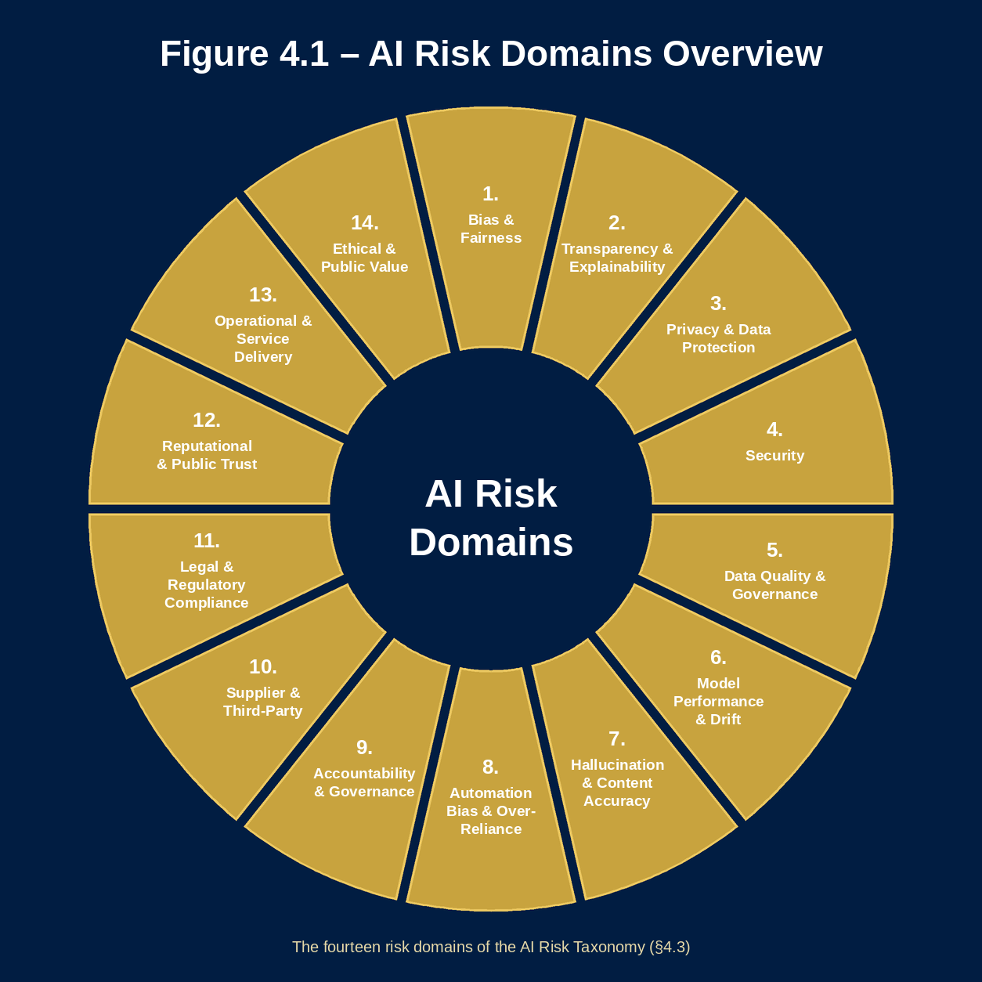
Figure 4.1: AI Risk Domains Overview — the fourteen risk domains of the AI Risk Taxonomy (§4.3)

4.1.1 Purpose
The AI Risk Management and Assurance Framework serves four core purposes:
- To provide a systematic methodology for identifying and assessing AI-related risks across The Council’s services and operations.
- To establish a common risk taxonomy and scoring methodology that enables consistent evaluation of each materially distinct UC-ID regardless of technical nature or service context, while reusing shared system evidence only with applicability checked.
- To define proportionate governance requirements — including delegated decision pathways, assurance activities and monitoring obligations — calibrated to each UC-ID’s risk classification.
- To create clear accountability structures and escalation pathways that ensure AI risks are owned, managed and reviewed by appropriately senior individuals and governance bodies.

4.1.2 Scope
This framework applies to all AI systems that The Council procures, develops, commissions, deploys or uses in any capacity. It encompasses:
- Commercial off-the-shelf AI products and platforms procured from third-party suppliers.
- AI capabilities embedded within broader enterprise software systems (including AI features integrated into existing line-of-business applications).
- Bespoke or custom-built AI systems developed internally or commissioned from external developers.
- Generative AI tools and platforms accessed directly by council staff.
- AI systems operated by commissioned service providers on The Council’s behalf.
- Pilot, proof-of-concept and experimental AI deployments.

4.1.3 Relationship to Other Governance Frameworks
The AI Risk Management and Assurance Framework operates as a component of The Council’s broader governance architecture. It does not replace existing risk, data protection or information security frameworks — it extends and supplements them to address AI-specific risks that conventional frameworks are not designed to capture. The framework is aligned with The Council’s Corporate Risk Management Framework, Information Governance Framework, Data Protection Policy, Information Security Policy, Equality Framework and Procurement Framework.
A full clause-by-clause mapping of this framework to ISO/IEC 42001 and the NIST AI Risk Management Framework is provided at Appendix D.

4.1.4 Guiding Objective
The objective of this framework is not to eliminate AI risk — some degree of risk is inherent in any decision to adopt new technology. Rather, the objective is to ensure that AI risks are: identified early, before AI systems are procured or deployed; assessed consistently, using a structured methodology; classified proportionately, so governance requirements are calibrated to actual risk; controlled effectively, with appropriate preventive, detective and corrective controls; and monitored continuously throughout the operational lifecycle.

4.2 AI Risk Management Principles
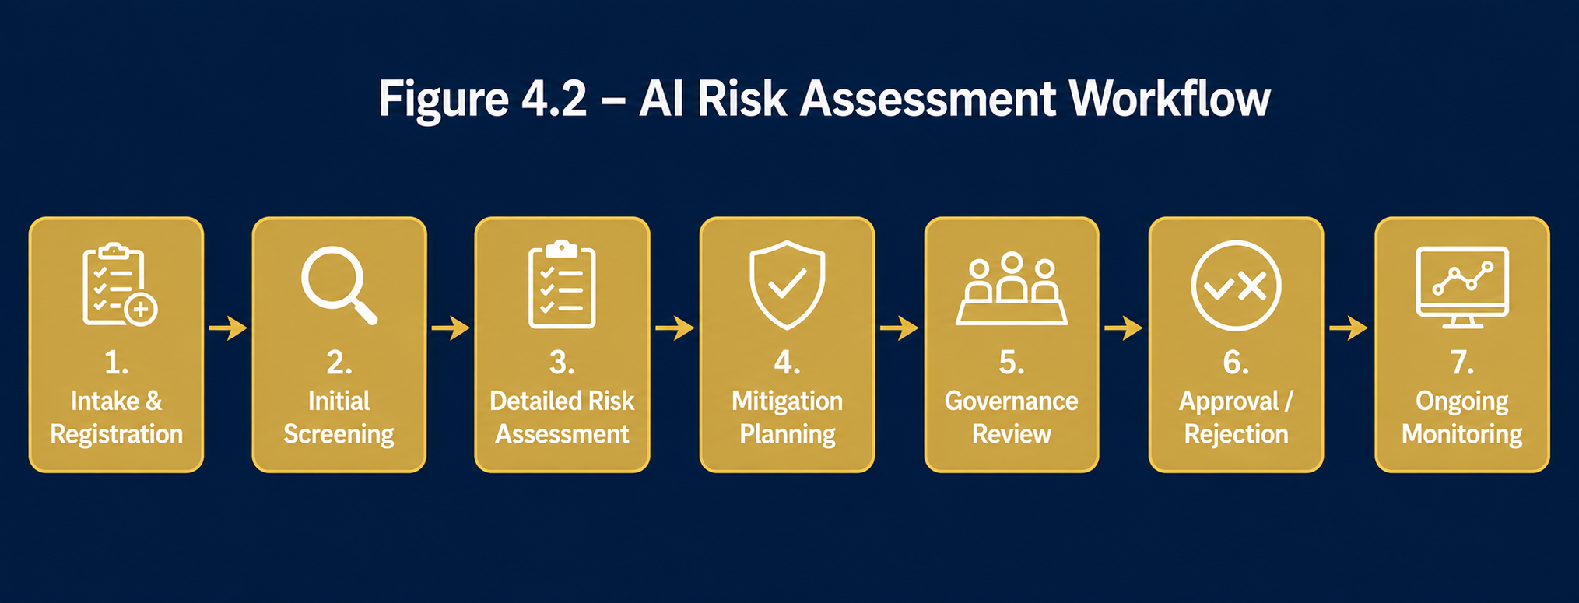
Figure 4.2: AI Risk Assessment and Governance Workflow
The framework is underpinned by ten risk management principles that reflect The Council’s obligations as a public authority. These ten risk management principles apply the eight Responsible AI principles in §3.2, which are The Council’s official set, to the management of AI risk: Principle 1 (Risk-Based Governance) through §4.2.1 and §4.2.2; Principle 2 (Human Accountability and Oversight) through §4.2.4; Principle 3 (Transparency and Explainability) through §4.2.5; Principle 4 (Fairness, Inclusion and Public Value) through §4.2.6; Principle 5 (Privacy, Security and Data Responsibility) through §4.2.7; Principle 6 (Accountability and Assurance) through §4.2.3 and §4.2.9; Principle 7 (Innovation with Responsibility) through §4.2.1 and §4.2.2; and Principle 8 (Continuous Improvement) through §4.2.8 and §4.2.10. These principles should inform every decision made under this framework, from the initial risk assessment of a proposed AI use to the ongoing monitoring of an operational deployment.
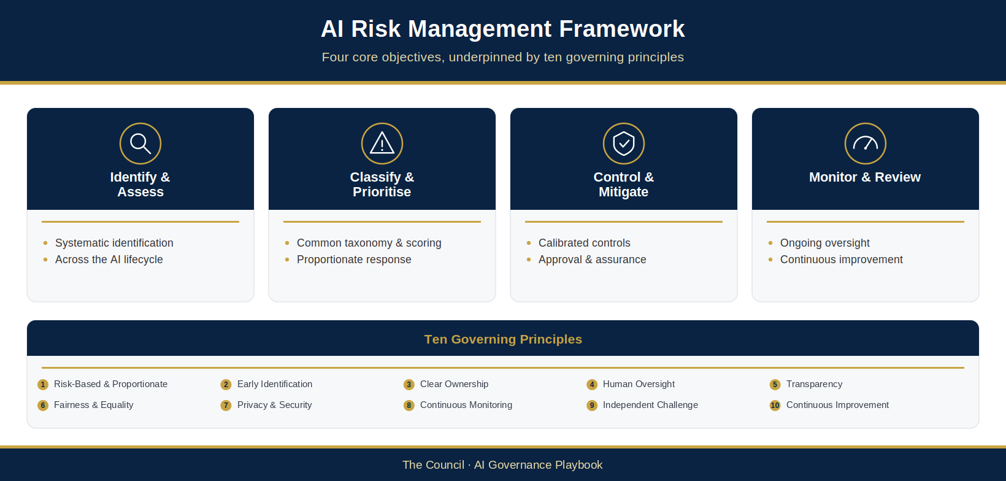
Figure 4.3: AI Risk Management Framework

4.2.1 Principle 1: Risk-Based and Proportionate
Governance requirements shall be calibrated to the actual risk profile of each materially distinct UC-ID. Higher-risk uses attract more comprehensive oversight and assurance and the required delegated decision; lower-risk uses receive proportionate controls. Shared system evidence may be reused only after applicability is checked. The framework shall not be applied in a one-size-fits-all manner.

4.2.2 Principle 2: Early Identification
AI risks shall be identified at the earliest practicable point in the AI lifecycle — ideally before procurement or development commences. Early identification enables risks to be addressed through system design, supplier selection, contractual protections and governance architecture rather than retrospective remediation after deployment.

4.2.3 Principle 3: Clear Ownership
Every AI system deployed by The Council shall have a clearly identified Service Owner who is accountable for the ongoing management of that system’s risk profile. Risk ownership shall not be diffused across teams or attributed to suppliers. Where a supplier operates an AI system on The Council’s behalf, the Service Owner remains accountable for ensuring appropriate controls, contractual protections and governance oversight are in place.

4.2.4 Principle 4: Human Oversight
The Council is committed to maintaining meaningful human oversight of AI systems, particularly where those systems inform, influence or produce decisions that affect residents’ access to services, entitlements or statutory determinations. Human oversight shall be substantive rather than nominal — decision-makers shall have access to the information, training and authority necessary to exercise genuine review and challenge of AI outputs.

4.2.5 Principle 5: Transparency
The Council shall maintain appropriate transparency about its use of AI, both internally and with residents and service users. Residents shall be informed when AI systems are used in ways that materially affect them. Transparency requirements shall be proportionate to the nature and impact of the AI system concerned.

4.2.6 Principle 6: Fairness and Equality
The Council shall actively assess and monitor AI systems for bias and discriminatory outcomes, recognising that AI systems trained on historical data may perpetuate or amplify existing inequalities. This principle is grounded in The Council’s obligations under the Public Sector Equality Duty. Equality Impact Assessments are required for High- and Critical-risk UC-IDs (governing risk score of 11 or above), and equality screening applies to every use (§4.6.2).

4.2.7 Principle 7: Privacy and Security
AI systems that process personal data shall comply with the UK General Data Protection Regulation and the Data Protection Act 2018, as amended by the Data (Use and Access) Act 2025. Data Protection Impact Assessments shall be completed where required by law or by The Council’s data protection policies. AI systems shall also be subject to appropriate information security controls, with cyber security requirements proportionate to the sensitivity of data processed.

4.2.8 Principle 8: Continuous Monitoring
AI risk management shall not be a one-time activity conducted at the point of decision. Each UC-ID shall be monitored throughout operation for use-specific performance, governance compliance, equality outcomes and incidents; genuinely shared system measures may be monitored at AIR-ID and linked to affected uses.

4.2.9 Principle 9: Independent Challenge
Critical-risk UC-ID conclusions shall receive independent governance challenge (§3.10.1), and High-risk conclusions where the AI Assurance Board recommends it, from individuals with appropriate expertise who are not directly involved in delivery or commercial operation. Independent challenge tests the use-specific assessment and controls; it is assurance, not the delegated decision.

4.2.10 Principle 10: Continuous Improvement
The Council shall continuously improve its AI risk management capabilities, drawing on operational experience, incident learning, audit recommendations, regulatory developments and emerging best practice. The framework itself shall be subject to periodic review, and governance bodies shall have a standing responsibility to identify and implement improvements.

4.3 AI Risk Taxonomy
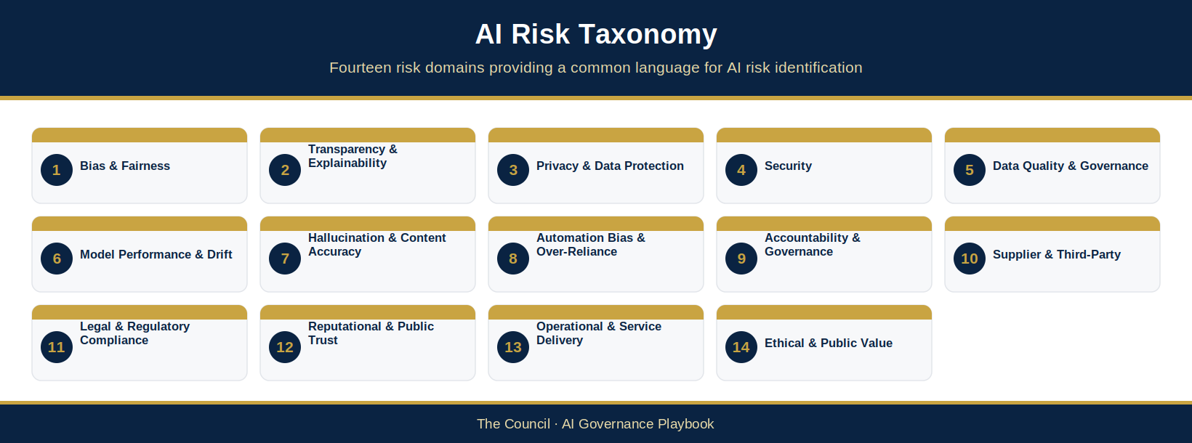
Figure 4.4: AI Risk Taxonomy
The Council’s AI Risk Taxonomy defines fourteen risk domains that collectively represent the full spectrum of risks that AI systems can present in a local authority context. The taxonomy provides a common language for risk identification and assessment, ensuring that all material risk categories are considered systematically whenever an AI system is evaluated.
AI systems typically present risks across multiple domains simultaneously. The taxonomy is not a classification system in which each AI system is assigned to a single risk category — each domain must be reviewed for every AI system use as a completeness check, and the use’s risk score is then calculated once by the method in §4.4.9.
During the AI Risk Assessment, the assessor reviews the use against each of the fourteen domains, documenting the relevant indicators and any existing controls, and records which domains were reviewed and any found elevated. The use then receives a single risk score (§4.4.9). AIG-AIMS-11 maps the fourteen domains to the risks in NIST AI 600-1, the Generative AI Profile of the NIST AI Risk Management Framework, and to the impact dimensions of ISO/IEC 42005 as a completeness prompt (Proposed — for Council confirmation).

4.3.1 Bias and Fairness Risk
Bias and fairness risk arises where an AI system produces outputs that systematically disadvantage particular groups defined by protected characteristics or socioeconomic factors. In a local authority context, this risk is particularly acute given The Council’s Public Sector Equality Duty obligations. Key indicators include: the use of variables that correlate with protected characteristics; differential accuracy rates across demographic groups; and outputs that vary systematically by postcode, language or other factors associated with protected characteristics.

4.3.2 Transparency and Explainability Risk
Transparency and explainability risk arises where an AI system operates in a manner that cannot be adequately understood, explained or scrutinised by the individuals who use it, are affected by it, or are responsible for governing it. The risk is heightened for complex machine learning models (particularly deep neural networks) where predictions cannot be readily decomposed into understandable contributing factors.

4.3.3 Privacy and Data Protection Risk
Privacy and data protection risk encompasses risks arising from the processing of personal data by AI systems in ways that may breach the UK GDPR or The Council’s data protection obligations. This includes: the processing of special category personal data without a lawful basis; the use of personal data for incompatible purposes; the creation of detailed profiles of individuals without consent; and inadequate data retention and deletion arrangements.

4.3.4 Security Risk
Security risk encompasses cyber security threats and vulnerabilities specific to AI systems, including adversarial attacks, prompt injection attacks against large language models, data poisoning attacks targeting training pipelines, and model extraction attacks. Security risks also include the potential for AI systems integrated with sensitive council data sources to become vectors for data exfiltration or system compromise. Where AI systems are granted the ability to take actions through connected tools, systems or interfaces, security risk further encompasses: the misuse of those action capabilities through injected or manipulated instructions; excessive permission scope, in which a system holds broader access than its approved use case requires; and cascading automated actions, in which an erroneous action propagates across connected systems before human intervention is possible. Where the system is an agent, these threats are assessed against the actor and its tools, memory, interfaces and sub-agents through the agentic layer (AIG-AGT-01 to AIG-AGT-06, with AIG-INV-02 for Fast-Track screening).

4.3.5 Data Quality and Governance Risk
Data quality and governance risk arises where the data used to train, validate or operate an AI system is of insufficient quality to support reliable, unbiased and accurate outputs. Key risk indicators include: incomplete or unrepresentative training datasets; data with poor lineage and provenance documentation; inconsistent variable definitions; and historical data that does not accurately reflect current service user populations.

4.3.6 Model Performance and Drift Risk
Model performance and drift risk arises where an AI system’s predictive accuracy or output quality degrades over time, typically because the real-world conditions the model was trained to reflect have changed. Without systematic performance monitoring and drift detection, AI systems may continue to be used despite delivering degraded or unreliable outputs.

4.3.7 Hallucination and Content Accuracy Risk
Hallucination and content accuracy risk is specific to generative AI systems. These systems can produce outputs that are factually incorrect, misleading or fabricated, while presenting those outputs with a confidence that may lead users to accept them uncritically. Without systematic human review, hallucinations can propagate into service delivery in ways that harm residents or expose The Council to legal or reputational risk.

4.3.8 Automation Bias and Over-Reliance Risk
Automation bias risk arises where human decision-makers place excessive weight on AI outputs, effectively deferring to the system rather than exercising independent professional judgement. This risk is heightened where AI systems are presented as highly accurate, where staff lack training to evaluate AI outputs critically, or where workload pressures create incentives to accept AI recommendations without scrutiny.

4.3.9 Accountability and Governance Risk
Accountability and governance risk arises where AI systems are deployed without clear ownership, registration, documented risk assessments or governance oversight — a phenomenon sometimes described as ‘shadow AI’. This risk includes AI tools adopted informally by individual teams without procurement oversight, and governance arrangements that have degraded over time as staff turnover erodes institutional knowledge.

4.3.10 Supplier and Third-Party Risk
Supplier and third-party risk arises from The Council’s dependence on external organisations for AI capabilities that it cannot directly control or audit. The Council’s use of AI will predominantly involve commercial AI products operated by third-party suppliers, creating risks relating to proprietary model opacity, supplier data processing practices, contractual arrangements, supplier business continuity, and limited rights to audit or challenge AI system behaviour.

4.3.11 Legal and Regulatory Compliance Risk
Legal and regulatory compliance risk encompasses the risk that AI systems are used in ways that breach applicable legal obligations. For The Council, the most significant legal frameworks include: the UK GDPR and Data Protection Act 2018, as amended by the Data (Use and Access) Act 2025; the Equality Act 2010 and Public Sector Equality Duty; the Human Rights Act 1998; the Freedom of Information Act 2000; sector-specific statutory frameworks; and the evolving landscape of AI-specific legislation.

4.3.12 Reputational and Public Trust Risk
Reputational and public trust risk arises where AI systems are used in ways that would damage public confidence in The Council if known to residents, the media or other stakeholders. This risk is particularly acute for AI systems used in sensitive service areas — housing, social care, benefits, enforcement — where residents may have concerns about the appropriateness of algorithmic decision-making.

4.3.13 Operational and Service Delivery Risk
Operational and service delivery risk arises where AI systems become embedded in critical service workflows in ways that create operational dependencies. If an AI system fails or produces unreliable outputs, service delivery may be significantly disrupted — particularly where manual fallback processes have been degraded through over-reliance on automation. Where the service is a prioritised activity in The Council’s business continuity plans under the Civil Contingencies Act 2004, the go-live plan records the plan reference and a consistent fallback (AIG-OPS-01 section 8; AIG-AIMS-05 REQ-054). Proposed — for Council confirmation.

4.3.14 Ethical and Public Value Risk
Ethical and public value risk arises where AI systems are used in ways that, while potentially lawful, are inconsistent with The Council’s values as a public authority. This includes: AI deployments that deliver limited or unclear public benefit; systems that disproportionately extend surveillance of residents; AI tools that have chilling effects on residents’ willingness to access services; and the progressive displacement of human engagement in ways that erode the quality of public services.

4.3.15 Environmental Impact Considerations
AI systems use energy, water and hardware, mostly in the data centres that host them, and the footprint varies widely. A large foundation model or a high-volume service can have a far greater environmental impact than a small, task-specific tool. The Council considers environmental impact for every AI use so that it chooses proportionate solutions and can explain its choices. Environmental impact is considered alongside the fourteen risk domains rather than scored as one of them: it does not change the risk tier, but it informs the choice of solution, supplier questions and monitoring (Proposed — for Council confirmation).
At triage, four questions are recorded against the AIR-ID: whether the use relies on a foundation model or another large general-purpose model; whether it runs on cloud infrastructure; its expected computational intensity (low, medium, high or very high); and whether the supplier has disclosed its environmental practices. The answers give an environmental flag:
Green: no foundation model, low or medium intensity, and the supplier has disclosed its environmental practices. The flag is recorded and no further action is needed.
Amber: a foundation model, high or very high intensity, or environmental practices not disclosed or unknown. The Service Owner records in the Responsible AI Assessment (AIG-ASS-04) whether a smaller, existing or non-AI option would meet the need, and procurement asks the supplier about its environmental practices (§5.5.2).
Red: a foundation model at very high intensity, where the supplier has not disclosed its environmental practices. The Amber steps apply, the decision record (AIG-DEC-03) notes why a lower-impact option was not chosen, and after go-live monitoring includes usage and, where the supplier can provide it, energy data (Appendix E.1).
This approach reflects the environmental sustainability principle of the Data and AI Ethics Framework (Government Digital Service, 2025): consider alternatives and reuse, measure impact where it matters, and check suppliers’ practices. Environmental questions in the Supplier AI Due-Diligence Questionnaire (AIG-ASS-08) and environmental fields in the Post-Deployment Monitoring & Review Log (AIG-OPS-02) are being added to those artefacts.

4.4 AI Risk Scoring Methodology
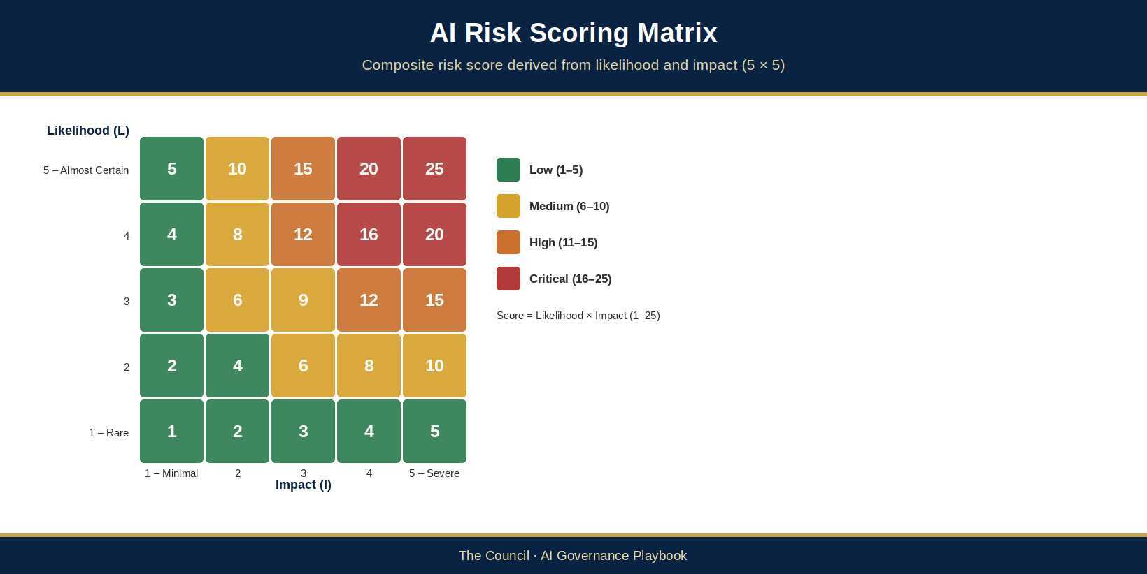
Figure 4.5: AI Risk Scoring Matrix
The Council’s AI Risk Scoring Methodology provides a structured, quantitative approach to evaluating the risk profile of AI systems. The methodology produces a composite risk score that reflects both the inherent risk of the AI system and the effectiveness of existing or planned controls. The residual score, read with the tier rule in §4.4.9, determines the UC-ID’s risk classification tier and associated governance requirements.

4.4.1 Scoring Components
The risk score is constructed from three components, each assessed on a 1–5 scale:
- Likelihood (L): The probability that the risk will materialise. Scores range from 1 (Rare) to 5 (Almost Certain).
- Impact (I): The severity of harm if the risk materialises, assessed across five impact dimensions. Scores range from 1 (Minimal) to 5 (Severe).
- Control Effectiveness (C): How effectively existing or planned controls reduce the inherent risk. Scores range from 1 (Very Strong) to 5 (Ineffective).

4.4.2 Inherent Risk Score
Inherent Risk Score = Likelihood (L) × Impact (I)
The inherent risk score ranges from 1 (lowest) to 25 (highest). This score represents the risk level before the application of any controls.

4.4.3 Residual Risk Score
Residual Risk Score = Inherent Risk Score × Control Effectiveness Factor
The Control Effectiveness Factor is the Control Effectiveness score (1–5) divided by 5. It ranges from 0.2 (Very Strong controls, CE score 1) to 1.0 (Ineffective controls, CE score 5). A factor of 1.0 makes no reduction to the inherent risk score; a factor of 0.2 reduces it to one-fifth. For example, an inherent score of 15 (High) and a CE score of 2 give a factor of 0.4 and a residual score of 6 (Medium). A lower residual score does not lower the tier until the controls are evidenced: the tier rule, including the floors that apply, is set out in §4.4.9.

4.4.4 Impact Assessment Dimensions
The Impact score is assessed across five dimensions:
- Resident Impact: Physical, psychological, financial or social harm to individuals or communities, including harm to vulnerable groups.
- Legal and Regulatory Impact: Regulatory sanctions, enforcement action, legal proceedings or breach of statutory obligations.
- Reputational Impact: Damage to public trust, media coverage, political scrutiny or damage to The Council’s standing.
- Operational Impact: Disruption to service delivery, operational failures, resource costs of remediation and impact on staff.
- Financial Impact: Direct financial costs including compensation, regulatory fines, remediation expenditure and lost efficiency.
The overall Impact score reflects the highest dimension score, rather than an average, so that a single severe impact dimension is not diluted by lower scores elsewhere. Impact floor (Proposed — for Council confirmation): a confirmed Impact score of 5 (Severe) on any impact dimension sets a minimum governing tier of Medium, whatever the likelihood; mandatory triggers can still raise it further. Above that floor the tier follows the Likelihood × Impact product. For example, Impact 5 × Likelihood 1 = 5, which falls in the Low band but is governed as Medium by the impact floor; Impact 5 gives 10 (Medium) at Likelihood 2, 15 (High) at Likelihood 3 and 20 or 25 (Critical) at Likelihood 4 or 5. A severe-impact use is raised to at least the High pathway where a §4.4.6 mandatory trigger applies (for example vulnerable residents, special category data or statutory decisions), and where likelihood is uncertain the higher classification applies (§3.10.1).

4.4.5 Likelihood Assessment
The Likelihood score is assessed by reference to: the maturity and track record of the AI technology; the complexity of the deployment environment; the quality and representativeness of training and operational data; the adequacy of testing and validation activities; known failure modes for comparable AI systems; and the nature of the operational environment.

4.4.6 Mandatory Escalation Triggers
Certain characteristics trigger mandatory escalation irrespective of the quantitative risk score:
- Processing of special category personal data as defined by the UK GDPR.
- AI systems used in relation to vulnerable residents, including children, adults with care and support needs, and individuals experiencing homelessness.
- AI systems that directly influence housing allocation, social care assessments or homelessness prevention decisions.
- Novel or first-of-type AI deployments for which The Council has no prior operational experience.
- AI systems that produce or directly inform statutory decisions.
- Significant AI supplier or model changes that materially alter the risk profile of an existing deployment.
- A materially distinct use/configuration that can execute actions autonomously — including initiating transactions, modifying records, sending communications or invoking other systems — without human review of each individual action. Apply this uplift to the affected UC-ID(s); do not automatically transfer it to non-action-capable uses under the same AIR-ID.
Minimum uplift rules apply to each affected UC-ID: any trigger requires at least the High pathway, an AI Assurance Board opinion/recommendation, and a decision by the competent delegated forum/officer under its confirmed delegation. A use producing or directly informing statutory decisions, or involving autonomous agentic action without review of each action, requires the Critical pathway and Executive Sponsor and Senior Responsible Owner (SRO) oversight; approval authority remains with whoever holds the relevant delegation. The worksheet must show the higher of that use’s calculated tier and trigger minimum. Record the uplift, rationale and use-specific decision before operation; professional judgement may raise, but must not reduce, the trigger minimum. Do not automatically uplift unrelated UC-IDs sharing the AIR-ID.

4.4.7 The Council AI Risk Matrix
Figure 4.5 (AI Risk Scoring Matrix) shows how the Likelihood and Impact scores for the UC-ID being assessed combine across the 25 possible combinations. The score bands are set out in §4.4.8.

4.4.8 Risk Thresholds and Classification Bands
The Council’s risk scoring methodology produces scores on a 1–25 scale corresponding to four classification bands. The minimum requirements for each tier are set out in the Governance Response Matrix (§4.5.9).
- Low Risk (1–5): a use with no resident-facing impact and no processing of special category data.
- Medium Risk (6–10): a use that informs, but does not directly determine, service delivery decisions.
- High Risk (11–15): a use that influences decisions affecting residents’ access to services.
- Critical Risk (16–25): a use that directly informs statutory decisions or processes special category data at scale.
Where the Control Effectiveness Factor produces a residual risk score for a UC-ID between classification bands, classify that use at the higher band, consistent with §3.10.1; do not infer the same classification for other uses without an applicability assessment.
Risk appetite and interim acceptance rule (Proposed — for Council confirmation). The framework does not set The Council’s AI risk appetite or financial thresholds. These are set by The Council’s leadership and plug into the scales (§4.4.1–§4.4.5), the bands above and the acceptance routes without changing the method, consistent with ISO 31000 and ISO/IEC 42001 clause 6.1, where the organisation sets its own risk criteria. Interim rule until the appetite is confirmed: a residual risk is accepted only as part of the recorded delegated decision for the UC-ID (AIG-DEC-03), by the officer or forum holding confirmed delegation for that tier (or the interim decision-maker in §3.10.1), and never by the assessor or Service Owner alone. A Critical residual risk is accepted only with executive oversight, as the §3.10.1 matrix requires. Acceptance lasts until the next scheduled review or a reassessment trigger (Appendix E.4) and never takes a use below a floor.

4.4.9 Calculating the Use’s Risk Score
The Council’s AI Risk Assessment scores each named UC-ID once, by the method the AI Risk Assessment Worksheet (AIG-ASS-02) calculates. The fourteen risk domains in §4.3 are reviewed as a completeness check, so that no material source of harm is missed; they are not scored or averaged separately. The assessor confirms: one score (1–5) for each of the five impact dimensions in §4.4.4, with the use’s Impact (I) taken as the highest of those five scores, not an average; one Likelihood (L) for the use (1–5, §4.4.5), assessed against the risks found in the domain review, with the higher score applied where likelihood is uncertain; and one Control Effectiveness score (C, 1–5). The inherent score is L × I (§4.4.2); the residual score is the inherent score × C ÷ 5 (§4.4.3); and a residual score falling between bands is classified at the higher band (§4.4.8). Tier rule: the tier of the UC-ID is the band of its residual score (a non-integer residual score is rounded up to the next whole number before banding). The tier never falls below the inherent band until controls are evidenced (and, for a reduction from High or Critical, independently verified), and never below any §4.4.6 trigger floor, the §4.4.4 impact floor (a confirmed Impact score of 5 on any dimension sets at least Medium) or, for action-capable uses, the agentic pathway floor. List the domains reviewed, and any found elevated, in the assessment rationale (AIG-ASS-02 Step 6); where several domains are elevated, consider whether a contextual uplift is justified (§4.5.5). Worked example: the domain review finds elevated privacy and bias risks; the confirmed impact scores are Resident 3, Legal and Regulatory 3, Reputational 2, Operational 2 and Financial 1, so I = 3; with L = 3 the inherent score is 9 (Medium); with C = 3 (factor 0.6) the residual score is 5.4, which falls between Low (1–5) and Medium (6–10) and is classified Medium. Separately record genuinely shared system-control evidence.
Assessor consistency (Proposed — for Council confirmation). Each quarter a second assessor rescores a small sample of Medium and Low assessments without seeing the original scores. Where the two differ by a whole band, the AI Governance Working Group reviews the difference and clarifies the scale anchors or guidance. The agreement rate is reported as measure M-17 (AIG-AIMS-10). This moderation is part of the second line’s challenge (§6.3.3.2) and does not replace independent verification of any reduction from High or Critical (tier rule above).

4.5 AI Risk Classification Framework
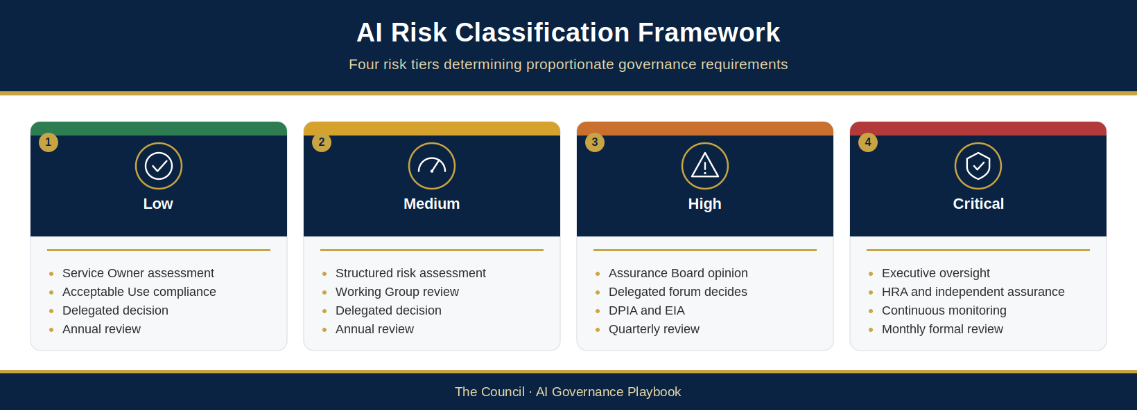
Figure 4.6: AI Risk Classification Framework
The AI Risk Classification Framework translates each UC-ID’s quantitative score into governance requirements. Each risk tier — Low, Medium, High and Critical — carries use-specific obligations for delegated decision authority, assurance, monitoring and impact assessment before operation. The minimum requirements for each tier are set out in the Governance Response Matrix (§4.5.9).

4.5.1 Tier 1: Low Risk (Score 1–5)
A Low-risk UC-ID has limited potential for harm, for example internal productivity, administrative automation or analysis that does not directly affect residents or process sensitive personal data. A use with any impact dimension scored 5 (Severe) cannot be Low (§4.4.4). Minimum requirements: §4.5.9.

4.5.2 Tier 2: Medium Risk (Score 6–10)
A Medium-risk UC-ID presents moderate potential for harm, for example processing personal data or informing (but not directly determining) service decisions where errors could cause material but recoverable harm. Examples include demand forecasting, workforce planning or business intelligence uses. Minimum requirements: §4.5.9.

4.5.3 Tier 3: High Risk (Score 11–15)
A High-risk UC-ID presents significant potential for harm, for example a use affecting residents’ access to services or processing substantial personal or special category data. Examples include housing prioritisation, homelessness prevention analytics, safeguarding indicators and public-facing services. A platform’s other UC-IDs are assessed separately. Minimum requirements: §4.5.9.

4.5.4 Tier 4: Critical Risk (Score 16–25)
A Critical-risk UC-ID presents severe potential for harm, for example a use involving highly automated decisions affecting access to services, statutory determinations or large-scale special category data. Executive involvement does not replace the delegated decision: the competent delegated authority decides the use. Minimum requirements: §4.5.9.

4.5.5 Contextual Uplift
Governance bodies — particularly the AI Assurance Board — may recommend a contextual uplift for the affected UC-ID or additional assurance where justified; apply it through triage/routing, and leave any resulting decision with the authority holding the relevant delegation. Uplift may be appropriate for high political/public sensitivity, novel technology or community concerns indicating greater risk than the internal assessment. Do not transfer the uplift to other UC-IDs without an applicability assessment.

4.5.6 Classification Review Triggers
UC-ID risk classifications are not static. Review affected uses when system functionality, deployment scope, datasets, supplier models, incidents, adverse outcomes, law or monitoring/audit/assurance findings materially change. Reassess other UC-IDs under the AIR-ID only where the change is applicable to them.

4.5.7 Decommissioning and Classification
AI system decommissioning is itself a risk event requiring governance attention. When AI systems are retired, Service Owners must ensure that data is appropriately deleted or archived; contractual termination obligations are fulfilled; the AI Register is updated; and any dependencies on the decommissioned system within wider service processes are managed.

4.5.8 Portfolio-Level Classification
The Council maintains a portfolio view of AI risk through the AI Register and the AI Assurance Board’s oversight function. This portfolio view enables governance bodies to identify concentration risk, cumulative risk from individually lower-risk AI deployments, and systemic risks from dependencies on a small number of AI suppliers or platforms. Concentration is measured through the Dependency concentration view in the Capabilities and System Map (AIG-INV-05) and measure M-16 (AIG-AIMS-10), and reported in the AI Assurance Board Report (AIG-OPS-05) (Proposed — for Council confirmation).

4.5.9 Governance Response Matrix
The Governance Response Matrix is the authoritative statement of the minimum use-specific requirements for each UC-ID risk tier: delegated decision authority, assurance, monitoring and mandatory impact assessments. Other sections that describe the tiers (§3.10.1, §3.10.2, §4.4.8 and §4.5.1 to §4.5.4) refer to it, and its monitoring requirements match the cadence in §6.4.4 (Proposed — for Council confirmation).
UC-ID risk tier | Decision authority and assurance | Minimum monitoring and review | Impact assessments
Low (1–5) | The officer or forum with confirmed delegation (Service Owner/Service Manager only if delegated); basic risk assessment by the Service Owner, with Acceptable Use Policy compliance confirmed (not self-approval); AI Governance Lead validates the route. | Routine operational monitoring; annual formal review (self-assessment by the AI System Owner, or Service Owner where none is named). | DPIA, equality and Convention-rights screening; fuller assessments only where screening indicates.
Medium (6–10) | AI Governance Working Group performs the detailed review; AI Assurance Board reviews and provides an assurance opinion/recommendation; the officer or forum with confirmed delegation decides; structured risk assessment; for resident-facing generative AI, a documented adversarial test (AIG-ASS-11 Section 7) before go-live (Gate 6) (Proposed — for Council confirmation). | Monthly operational monitoring; quarterly performance review; annual formal review (AI Governance Working Group). | Screening as for Low; DPIA where Article 35 applies; EIA considered; Responsible AI Assessment, completed before the Gate 3 decision.
High (11–15) | Competent delegated forum/officer, informed by an AI Assurance Board opinion; independent challenge where the Assurance Board recommends it; legal review and AI Security Review Checklist (AIG-ASS-11). | Continuous operational monitoring; monthly performance review; quarterly formal review with governance reporting to the AI Assurance Board; independent assurance review before deployment and periodically. | DPIA normally required; EIA; Responsible AI Assessment; Human Rights Assessment where Convention rights may be engaged.
Critical (16–25) | All High-tier requirements, plus: competent delegated forum/officer with SRO and Executive Sponsor oversight, informed by an AI Assurance Board opinion; involvement of the Executive Leadership Team and escalation to the relevant executive member or committee and the Audit and Risk Committee (or equivalent) (§3.10.1); independent challenge; comprehensive and independent assurance, including an annual independent assurance review with Internal Audit coverage. | Continuous monitoring; at least monthly performance review and formal review; reported to each AI Assurance Board meeting. | DPIA; EIA; Responsible AI Assessment; Human Rights Assessment (mandatory).
Any §4.4.6 trigger floor, the §4.4.4 impact floor and, for action-capable uses, the agency-tier minimum also apply; the highest governs (the governing tier). The AGPI priority (§3.9.5) sets urgency only, not the route. Screening for data protection, equality and Convention rights applies to every UC-ID whatever its tier (§4.6). Every UC-ID’s risk assessment is linked to its parent AIR-ID in the AI Register.

4.5.10 Conclusion
The AI Risk Classification Framework translates each UC-ID’s risk score into proportionate requirements for delegated decisions, assurance and monitoring, ensuring each use receives oversight commensurate with its risk. Shared system-control evidence may be reused after applicability is checked.

4.6 AI Impact Assessment Framework
The Council’s AI Impact Assessment Framework defines the structured assessments required before a UC-ID is authorised to operate. These assessments provide decision-makers with evidence for the use-specific delegated decision and create an audit trail of compliance with legal and governance obligations.
Screening by reference (Proposed — for Council confirmation). Equality, human-rights and data protection screening applies to every UC-ID at every tier. Where the system already has a current assessment that covers this kind of use, the screening for a new UC-ID may be done by reference, applying the rule that shared system evidence is reused only with its applicability checked. The cited assessment must be listed in the evidence index of the AI Register (AIG-INV-04) with its version or as-at date, owner and Accepted status, and must have been completed or last reviewed within the last 12 months, with its own review date not passed (an older one can be cited once its owner confirms it still holds and records that review). The new use must involve the same kind of data, the same people affected, the same type of purpose and the same decision impact, with no change to the model, configuration or controls since that assessment. Record a brief reasoned outcome naming the groups and rights considered, and carry the assessment’s conditions and mitigations into the new use’s decision record. Only what is new needs fresh screening; where no covering assessment exists, complete the short screening. The DPO confirms the privacy applicability, including purpose compatibility, lawful basis, records of processing and privacy information for the new purpose; Legal Services is consulted where Convention-rights engagement is possible or uncertain. The decision-maker sees the screening outcome before deciding and records in AIG-DEC-03 that it was considered, and the Gate Log (AIG-DEC-04) records that the screening was done and considered, which is required before an outcome of Progress, Progress with condition, Re-authorise or Resume. Record the Evidence ID so that every use relying on an assessment can be found and re-checked if the assessment changes or expires; the annual review re-confirms it. For a Light-touch use, record this in the Screening by reference box of the Fast-Track Screening (AIG-INV-02, Part C).
Proposed — Legal and DPO validation required. AIG-ASS-12 is a design crosswalk to potential evidence locations; it does not show that a Fundamental Rights Impact Assessment (FRIA) is complete or unnecessary. If the EU AI Act applies to a specific Council role, system and deployment, assess and document each Article 27 element against completed, versioned case evidence before deployment and meet any notification obligation. Where a Data Protection Impact Assessment (DPIA) is also required, Article 27(4) requires it to be complemented by the FRIA; combining work does not automatically discharge either duty. Record the case-specific Legal/DPO scope and sufficiency decision. This is not a blanket conclusion that The Council is in or out of EU scope.

4.6.1 Data Protection Impact Assessment
A DPIA is legally required under UK GDPR Article 35 where personal-data processing is likely to result in a high risk to individuals’ rights and freedoms. That statutory threshold is separate from The Council’s internal AI tier. Council policy requires DPIA screening for every AI use and normally a completed DPIA for High- and Critical-risk UC-IDs; where screening concludes Article 35 does not require one, record the reasons and DPO advice. The Service Owner completes the use-specific DPIA and the DPO provides independent advice, review and quality assurance; The Council, acting through the accountable Controller/SRO, remains responsible for deciding whether processing may proceed. If unmitigated high residual risk remains, The Council must consult the ICO under Article 36 before processing begins. For significant decisions based solely on automated processing, the DPIA must evidence the safeguards in Articles 22A to 22D, including information about the decision, representations, meaningful human intervention and contestability. Where special category data is used, Article 22B applies: such a significant decision may be taken based solely on automated processing only if it is based entirely on data for which the data subject has given explicit consent, or if it is necessary for entering into or performing a contract with the data subject, or required or authorised by law, and the substantial public interest condition in Article 9(2)(g) applies. Under Article 22B(4), no significant decision may be taken based solely on automated processing where the processing relies, entirely or partly, on the recognised legitimate interests basis in Article 6(1)(ea). DPO and Legal advice must be recorded. Indicative timescale: allow four to six weeks for systems of average complexity.
PROPOSED — legal review only; draft clarification, not an adopted or live Council policy change. The legal test is the law itself; an internal form, score or tier does not decide whether the law is met. The relevant law is UK GDPR Articles 35 and 36 (DPIA and prior consultation, which apply only where their statutory conditions are met), the Data Protection Act 2018, as amended, and section 80 of the Data (Use and Access) Act 2025 (automated decision-making). The ICO’s guidance on automated decision-making and profiling is also relevant.

4.6.2 Equality Impact Assessment
An EIA is required for each High- and Critical-risk UC-ID, and should be considered for a Medium-risk use where its outputs may differentially affect people sharing protected characteristics. The EIA must examine representational bias in training data, differential accuracy across protected groups and equality monitoring. The Service Owner completes it with the Equalities lead, who quality-checks it before the delegated decision is sought. Indicative timescale: three to four weeks to Equalities lead sign-off.
PROPOSED — legal review only; draft clarification, not an adopted or live Council policy change. The section 149 duty is a statutory due-regard duty, not a statutory requirement to use a particular EIA template or risk score. Case-level equality screening and a recorded, reasoned outcome are required as an internal governance control whenever an AI use may affect protected-characteristic equality, for every risk tier; escalation to the fuller EIA template under the stated High/Critical (and any other Council-set) threshold is a separate proposed internal requirement. Neither a low score nor a decision not to complete the full template discharges or determines the section 149 duty. Official text: https://www.legislation.gov.uk/ukpga/2010/15/section/149

4.6.3 Human Rights Assessment
A Human Rights Assessment is mandatory for a Critical-risk UC-ID and required for a High-risk use where it may engage Convention rights under the Human Rights Act 1998. Screen relevant Convention and Protocol rights, including life, freedom from inhuman or degrading treatment, liberty, Article 6 where civil rights/obligations or criminal charges are determined, privacy/family life, expression, association, non-discrimination, property and education. Do not use Article 6 as a general label for administrative fairness. Legal Services identifies engaged rights and whether each is absolute, limited, qualified, procedural or ancillary, then applies legality, legitimate aim, necessity, proportionality and safeguards. Legal Services leads and records independent legal advice; the competent delegated authority decides the UC-ID. Indicative timescale: three to five weeks depending on the rights engaged.
PROPOSED — legal review only; draft clarification, not an adopted or live Council policy change. Section 6 of the Human Rights Act 1998 makes it unlawful for a public authority to act incompatibly with a Convention right, subject to the statutory exception in section 6(2); it does not prescribe an HRA template or risk score. Screen each AI use case, case by case, for whether and how Convention rights may be engaged, record the rights considered and the reasoned outcome, and obtain legal analysis where engagement is possible or uncertain, irrespective of risk tier. The High/Critical criteria for completing this fuller HRA template are a separate proposed internal governance threshold, not the statutory trigger or a substitute for the section 6 duty. Official text: https://www.legislation.gov.uk/ukpga/1998/42/section/6

4.6.4 Responsible AI Assessment
The Responsible AI Assessment is required for each Medium-, High- and Critical-risk UC-ID. It covers purpose/public benefit, data quality, transparency, fairness, human oversight, accountability, privacy/security and supplier governance. The Service Owner completes the assessment and the AI Governance Lead quality-checks it. For a Medium-risk use it must be completed before the Gate 3 (Case for change / strategic alignment) decision; for High and Critical it must be completed before the use-specific delegated decision. Indicative timescale: two to three weeks to AI Governance Lead sign-off.

4.7 AI Control Framework
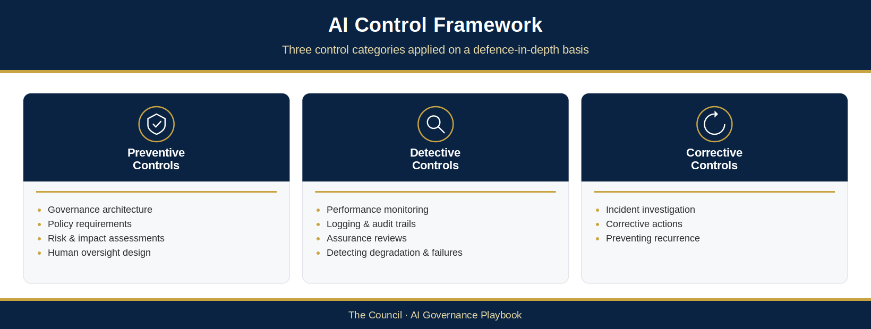
Figure 4.7: AI Control Framework
The Council’s AI Control Framework defines the controls that are applied to manage AI-related risks identified through the risk assessment and classification process. The control framework is designed on a defence-in-depth basis, with multiple layers of controls providing resilience against individual control failures.

4.7.1 Introduction to AI Controls
AI controls are the organisational, technical and process-based measures that The Council puts in place to manage AI-related risks. Controls range from governance structures (such as the AI Assurance Board and approval pathways) to technical measures (such as performance monitoring and logging) to human process controls (such as mandatory human review of AI outputs in high-stakes contexts).

4.7.2 Three-Category Control Architecture
The Council’s AI controls are organised into three categories:
- Preventive Controls are designed to prevent AI-related risks from materialising in the first place, operating before and during deployment through governance architecture, policy requirements and human oversight design.
- Detective Controls are designed to identify AI-related risks and incidents as they arise during operational deployment, providing the monitoring, logging and assurance capabilities necessary to detect performance degradation and governance failures.
- Corrective Controls are designed to remediate AI-related risks and incidents after they have been identified, providing the governance authority and operational capability to investigate incidents, implement corrective actions and prevent recurrence.

4.7.3 Governance Controls
The AI Assurance Board exercises strategic oversight, assurance, challenge and escalation for High- and Critical-risk uses. Defined pathways bring each UC-ID to its competent delegated decision-maker; the Board does not approve unless it holds that delegation. System registration ensures no system operates outside governance oversight but does not approve its uses. Service Owner accountability and escalation procedures remain clear.

4.7.4 Policy and Standards Controls
The Council’s suite of AI-specific policies and standards — the Level 2 corporate AI policies listed in §5.2.2 (including the Responsible AI Policy, AI Acceptable Use Policy, AI Procurement and Supplier Governance Policy and AI Data Governance Policy), the Level 3 standards in §5.2.3 and The Council’s existing Information Security Policy — provides the normative framework within which AI systems must operate. Together, these instruments ensure that AI governance requirements are embedded in The Council’s operational practice.

4.7.5 Risk Assessment Controls
Pre-deployment risk assessment controls — the AI Risk Assessment, DPIA, Equality Impact Assessment, Human Rights Assessment and Supplier Due Diligence — form the primary preventive control mechanism for new AI deployments. These assessments ensure risks are systematically identified before deployment decisions are made.

4.7.6 Procurement Controls
The Council’s AI procurement controls ensure commercial AI products are subject to governance scrutiny during procurement. AI-specific procurement questions, standard contractual AI clauses (including data protection, audit rights, change notification and performance standards) and data processing agreements are required for all AI-related contracts.

4.7.7 Human Oversight Controls
Human oversight controls include: requirements for human-in-the-loop review before AI outputs inform significant decisions; documented override capability; escalation routes for anomalous outputs; and manual review thresholds. These controls are most intensive for High- and Critical-risk systems, where the consequences of unreviewed AI errors are most severe.
For agentic AI systems — systems capable of planning and executing actions rather than solely producing outputs for human consideration — human oversight controls shall additionally include: a defined and documented action scope specifying the actions the system is authorised to take and the systems upon which it may act; least-privilege access arrangements granting no broader permissions than the approved use case requires; per-action human authorisation before any irreversible or high-consequence action is executed, unless an equivalent control has been formally authorised at the relevant Council gate (evidenced at Gate 2, Technical design review; re-confirmed at Gate 6, Deployment / go-live) and recorded in the Agent Record (Agentic System Bill of Materials, ASBOM; AIG-AGT-04), with post-action review or monitoring-only modes permitted only for non-consequential, reversible actions (where it is uncertain whether each action is reviewed, treat it as not reviewed); comprehensive logging of all actions taken, sufficient to reconstruct the sequence of events; and a documented suspension capability enabling the system’s action authority to be revoked without delay. These controls apply to the agent as a governed actor and to each consequential action; the full agent composition and authority envelope are recorded in the Agent Record (AIG-AGT-04) and the Agent Authority Graph (AIG-AGT-05), and agents are classified through the Agentic Triage (AIG-AGT-03). See Appendix F.

4.7.8 Training and Awareness Controls
The Council’s AI training and awareness programme includes: baseline AI Awareness Training, mandatory for all staff who use AI systems and available to all staff; the Responsible AI Training programme for Service Owners and staff involved in AI procurement, deployment or governance; the AI Governance for Managers module for managers with staff using AI systems (§5.9.1 and §7.4.3); and mandatory policy acknowledgement. Training content is reviewed annually.

4.7.9 Performance Monitoring Controls
Performance monitoring detective controls enable The Council to identify AI system performance degradation, drift and anomalies during operational deployment. Monitoring activities include: accuracy monitoring against ground truth data; drift monitoring; validation testing; trend analysis; and service impact monitoring.

4.7.10 Bias and Fairness Monitoring Controls
Bias and fairness monitoring controls provide systematic assurance that AI systems continue to operate equitably over time. These controls include: regular bias testing across protected characteristic groups; outcome analysis; equality monitoring; fairness reviews; and demographic impact analysis. Results are reported to the AI Assurance Board regularly.

4.7.11 Audit and Assurance Controls
The Council’s audit and assurance programme provides periodic independent verification that AI systems are operating as intended and governance requirements are being met. This includes: governance audits; internal audit reviews; compliance assessments; supplier assurance reviews; and independent assurance reviews required for High- and Critical-risk systems.

4.7.12 Logging and Incident Detection Controls
Comprehensive logging of AI system activity includes: decision logs capturing inputs, outputs and contextual information; user activity logs; system access logs; and incident reports. Log retention requirements are aligned with The Council’s information management policies. At High and Critical, inputs and outputs are logged for audit and investigation. The retention period is set in the DPIA where there is one; otherwise it is recorded in the security review (AIG-ASS-11, Section 4 Access, auditability and resilience) and agreed with the records manager in line with The Council’s records retention schedule. For action-capable AI it is also recorded in the Agent Record (AIG-AGT-04). Logs are kept long enough to investigate incidents and support audit and the next formal review, and no longer. Logging prompts and outputs triggers DPIA screening, because they often contain personal data. System prompts, configuration and logs are protected information assets: each has an owner and a version and is access-controlled, and a change to a system prompt or configuration is a change that triggers review (NCSC guidelines 2.2, 2.3 and 4.2; Proposed — for Council confirmation).

4.7.13 Complaints Monitoring
Service Owners are required to monitor complaint patterns for evidence of AI-related issues. Complaint patterns suggesting AI performance issues must be escalated to the AI Governance Working Group for assessment, and where appropriate, to the AI Assurance Board.

4.7.14 Incident Response Controls
The Council’s AI incident response framework provides structured processes for investigating and responding to AI-related incidents. The response process includes: immediate assessment and containment; formal investigation; root cause analysis; implementation of corrective actions; and, where required, notification to regulators and affected individuals.

4.7.15 Model Remediation Controls
Model remediation options include: model retraining on updated or corrected datasets; data quality improvement; rule adjustments; introduction of additional human oversight; and temporary system suspension. The choice of remediation approach is determined by the nature and severity of the identified problem.

4.7.16 Continuous Improvement Controls
The Council’s continuous improvement programme ensures that lessons learned from operational experience are systematically captured and applied. Improvement inputs include: lessons from AI incidents and near-misses; findings from audit and assurance activities; regulatory guidance; and the outputs of the AI Assurance Board’s maturity reviews.

4.7.17 Suspension and Withdrawal Controls
Protecting residents, staff and public trust takes precedence over keeping an AI system running. Suspension works at two levels: an immediate precautionary pause, which does not wait for a governance decision, and any longer suspension, resumption or withdrawal, which is decided by the competent delegated authority.
Immediate precautionary pause. The Service Owner or AI System Owner must pause or restrict an AI system, or the affected use (UC-ID), as soon as there is a real risk of harm, without waiting for a governance decision. Where neither can be reached, the AI Governance Lead may direct the pause, subject to confirmation of that authority in The Council’s Scheme of Delegation. A precautionary pause is a containment action, not a finding of fault. It is recorded on the AI Incident Report Form (AIG-OPS-03) and as a dated event in the Gate Log (AIG-DEC-04), and the AI Governance Lead is notified at once. Because the pause is not a decision, the Gate Log records it with the Event type “Precautionary pause (containment)” and the outcome “Paused — pending decision”, the AIG-OPS-03 incident reference and the date by which the delegated authority will decide; no AIG-DEC-03 reference is needed for the pause itself. Where the delegated authority lifts the pause with the use’s approval unchanged, the follow-up decision is recorded in AIG-DEC-03 (Approved, or Approved with conditions where new conditions are set) and in the Gate Log as a Decision with the outcome “Resume”, entered as the next event for that AIR-ID and UC-ID after the pause; where the use needs reassessment first, the outcome is “Re-authorise” instead (Proposed — for Council confirmation).
Incidents that must lead to immediate escalation (the same working day) and consideration of a precautionary pause are listed in §6.8.4.2 (Incident triggers for a precautionary pause).
Continued suspension, resumption and withdrawal. Any decision to continue a suspension beyond immediate containment, to resume use or to withdraw the system is made by the forum or officer holding confirmed delegated authority under The Council’s Constitution and Scheme of Delegation, and is recorded in the Governance Decision Record (AIG-DEC-03) and the Gate Log (AIG-DEC-04). Resumption requires the relevant conditions to be closed, or expressly accepted by that authority.
Role of the AI Assurance Board. The AI Assurance Board may call for a precautionary pause, reviews any suspension, and recommends continued suspension, resumption or withdrawal. It does not itself decide unless that authority has been formally delegated to it, consistent with the Terms of Reference (AIG-GOV-06) and the Gate Map (AIG-DEC-01). The named officers holding pause and resume authority are to be confirmed in the Scheme of Delegation before adoption.

4.8 AI Assurance Framework
Assurance gives governance bodies confidence that each AI use is operating as intended, that controls are effective and that governance requirements are being met. It is distinct from operational monitoring: it is a periodic, structured evaluation of the governance and control environment, proportionate to each UC-ID’s risk tier, independent where its credibility depends on it, and reported openly, including negative findings and control gaps. The Council’s AI Assurance Framework, including the Three Lines Model, is set out in §6.3, and the minimum assurance for each tier is in the Governance Response Matrix (§4.5.9).

4.9 Monitoring, Reporting and Escalation
Risk management does not end when a use is approved. Each UC-ID is monitored for its own thresholds, outcomes, incidents and approval conditions, at the frequency set by the UC-ID’s risk classification; genuinely shared measures are monitored at system level (AIR-ID) and linked to the affected uses. Reports show system counts by AIR-ID and the state of each use by UC-ID, and keep unknown or unverified states separate from approved or zero. Monitoring obligations and frequency are set out in §6.4, reporting to governance bodies in §6.9, governance measures in §3.11 and escalation triggers in §3.10.3, with incident escalation in §5.10 and §6.8.

4.10 Chapter Summary
This chapter has established The Council’s AI Risk Management and Assurance Framework — the structured approach by which AI-related risks are identified, assessed, classified, controlled and monitored across The Council’s AI portfolio.
The framework is built on ten risk management principles that apply the eight Responsible AI principles in §3.2. It employs a fourteen-domain risk taxonomy that provides a common language for risk identification, and a structured scoring methodology that produces consistent, comparable risk assessments across different AI systems and service contexts.
Risk scores are translated into one of four classification tiers — Low, Medium, High and Critical — each carrying proportionate governance requirements. A comprehensive control framework spanning preventive, detective and corrective controls ensures that classified risks are actively managed throughout the AI lifecycle. Impact assessments (§4.6) give decision-makers the evidence they need before a use operates, and assurance, monitoring and reporting (Chapter 6: §6.3, §6.4 and §6.9) keep each use under review once it is running.
Together, these elements constitute a governance framework that enables The Council to realise the benefits of AI while managing its risks responsibly — in the interests of residents, staff, and the broader public value that The Council exists to deliver.

Chapter 5 — AI Policy Framework, Standards and Operational Procedures

5.1 Introduction
The Council’s responsible use of artificial intelligence requires not only a governance framework and risk management methodology, but a coherent suite of policies, standards and operational procedures that translate governance principles into day-to-day operational practice. This chapter establishes The Council’s AI Policy Framework — the hierarchical structure of policy instruments through which The Council’s AI governance requirements are articulated, communicated and enforced.
This chapter describes The Council AI Policy Architecture, then sets out the content and requirements of each of the principal policy instruments within that architecture. It is intended as the authoritative reference for all Council staff, managers, Service Owners and governance bodies who have responsibilities in relation to The Council’s use of artificial intelligence.

5.1.1 Scope
The AI Policy Framework applies to all Council staff, elected members in their operational capacity, contractors, consultants and any other individuals who use AI systems on behalf of The Council or in the delivery of council services. Compliance with The Council’s AI policies is a condition of employment and contracting for all individuals within scope.

5.1.2 Policy Governance
The Council’s AI policies are owned collectively by the AI Governance Function. AI policies are subject to assurance and recommendation by the AI Assurance Board; formal adoption remains with the competent Council authority unless a separate confirmed delegation expressly assigns adoption authority. AI policies are subject to periodic review on a cycle of no longer than two years, or more frequently in response to significant regulatory or operational changes.

5.1.3 Relationship to Existing Policies
The Council’s AI policies do not replace The Council’s existing information governance, data protection, information security, procurement or employment policies. They extend and supplement those policies to address AI-specific requirements. Where AI policies impose requirements additional to those in existing policies, the more stringent requirement applies.

5.2 The Council AI Policy Architecture
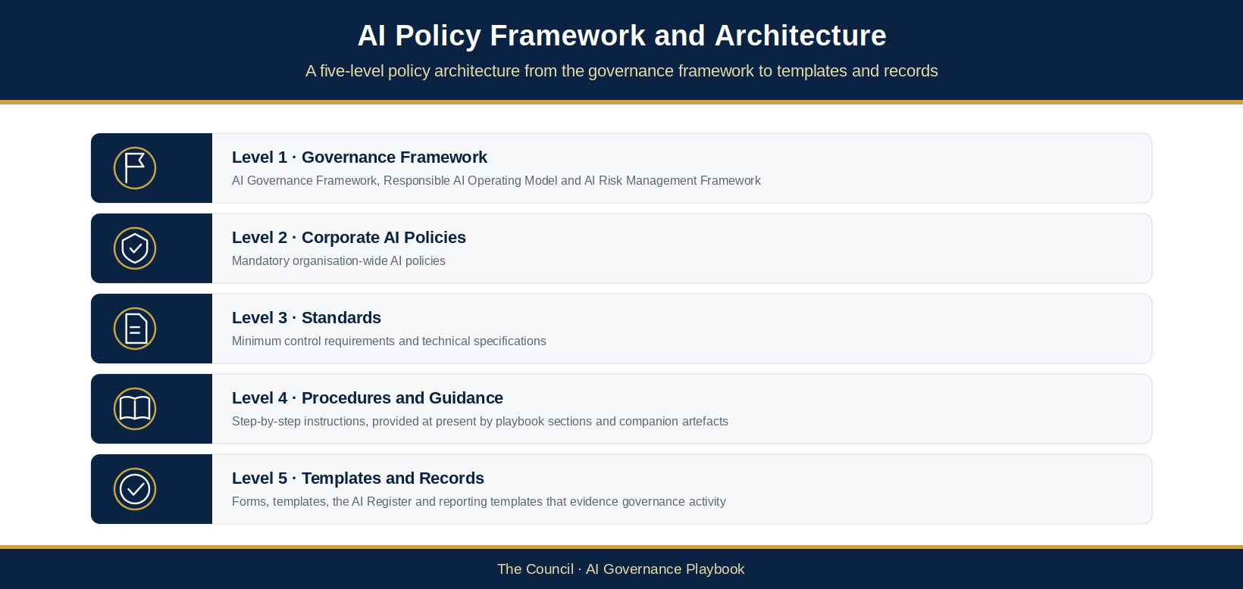
Figure 5.1: AI Policy Framework and Architecture
The Council’s AI Policy Architecture organises The Council’s AI-related policy instruments into a five-level hierarchy. This hierarchical structure ensures that policy instruments at each level are appropriately scoped, that requirements flow consistently from strategic principles to operational detail, and that the relationships between different policy instruments are clear to those responsible for implementing and complying with them.

5.2.1 Level 1: Governance Framework
The apex of The Council’s AI Policy Architecture is the AI Governance Framework — the top-level document that establishes The Council’s overall approach to AI governance, its governance structure, its accountability arrangements, and its high-level commitments in relation to responsible AI. Level 1 documents include: The Council AI Governance Framework; the Responsible AI Operating Model; and the AI Risk Management and Assurance Framework.

5.2.2 Level 2: Corporate AI Policies
Level 2 comprises The Council’s corporate AI policies — mandatory policy instruments that apply across the organisation and define the requirements that all AI activities must meet. The Council’s Level 2 corporate AI policies are the nine instruments set out in §5.3 to §5.11, which together form the policy register: the Responsible AI Policy (§5.3); the AI Acceptable Use Policy (§5.4); the AI Procurement and Supplier Governance Policy (§5.5); the AI Data Governance Policy (§5.6); the AI Transparency Policy (§5.7); the AI Register Policy (§5.8); the AI Skills, Awareness and Capability Development Policy (§5.9); the AI Incident Management Policy (§5.10); and the AI Ethics Review Process (§5.11). Each is owned by the AI Governance Function (§5.1.2) and adopted by the competent Council authority; these names are used throughout this playbook.

5.2.3 Level 3: Standards
Level 3 standards define minimum control requirements and technical specifications that translate corporate policy obligations into concrete, measurable requirements. The Council’s Level 3 AI standards are not yet separate documents; each is provided at present by the playbook section and companion artefacts named here: the AI Risk Assessment Standard (§4.4 to §4.5 and the AI Risk Assessment Worksheet AIG-ASS-02); the AI Supplier Assurance Standard (§5.5 and the Supplier AI Due-Diligence Questionnaire AIG-ASS-08); the AI Impact Assessment Standard (§4.6, the Responsible AI Assessment AIG-ASS-04, the DPIA AIG-ASS-05, the Equality Impact Assessment AIG-ASS-06 and the Human Rights Assessment AIG-ASS-07); the AI Register Standard (§3.7, §5.8 and the AI Register AIG-INV-04); and the AI Monitoring Standard (§6.4, Appendix E and the AI Post-Deployment Monitoring & Review Log AIG-OPS-02). Whether any of these should become a standalone standard is for The Council to decide.

5.2.4 Level 4: Procedures and Guidance
Level 4 procedures and guidance documents provide step-by-step instructions for carrying out specific AI governance activities. The Council’s Level 4 AI documents are not yet separate procedures; each is provided at present by the playbook section and companion artefacts named here: the AI Intake Procedure (§3.8, the AI Intake Form AIG-INV-03 and AI Fast-Track Screening AIG-INV-02); the AI Approval Procedure (§3.10, the AI Governance Gate Map AIG-DEC-01, the Decision-Ready Paper AIG-DEC-02 and the Governance Decision Record AIG-DEC-03); the AI Incident Management Procedure (§5.10, §6.8 and the AI Incident Report Form AIG-OPS-03); the AI Review Procedure (§3.10.5, Appendix E and the AI Post-Deployment Monitoring & Review Log AIG-OPS-02); and the Generative AI User Guidance (§5.4.4 and the Staff Guide AIG-INV-01). Whether any of these should become a standalone procedure is for The Council to decide.

5.2.5 Level 5: Templates and Records
Level 5 comprises the templates, forms and record-keeping instruments that provide evidence of governance activity. The Council’s Level 5 AI documents include: the AI Intake Form; the AI Risk Assessment Worksheet; the Responsible AI Assessment; the AI Register; and the suite of AI Governance Reporting Templates.

5.2.6 Policy Coherence
The Council’s AI Policy Architecture is designed to be internally coherent — each level is consistent with the levels above it, and no instrument contradicts another. The AI Governance Function is responsible for maintaining this coherence, including by reviewing the impact of changes at any level on the architecture as a whole.

5.3 Responsible AI Policy
The Council’s Responsible AI Policy is the cornerstone corporate policy instrument that establishes the mandatory principles governing all AI activity across The Council. It articulates The Council’s commitment to the responsible use of AI and restates, for policy purposes, the responsible AI principles that all AI deployments must embody. The principles are the eight design principles in §3.2, The Council’s official set; §5.3.2 states them for policy purposes.

5.3.1 Purpose and Scope
The Responsible AI Policy applies to all AI systems and activities within the scope of The Council’s AI Governance Framework. It establishes mandatory requirements that all staff and contractors must comply with when using, procuring, deploying or overseeing AI systems.

5.3.2 Eight Responsible AI Principles
- Risk-Based Governance: Governance activities and controls shall be proportionate to the risk each AI use presents, with higher-risk uses subject to greater scrutiny and oversight.
- Human Accountability and Oversight: Responsibility for decisions remains with people, not technology. Meaningful human oversight shall be maintained over AI systems, particularly where those systems inform decisions affecting residents.
- Transparency and Explainability: The Council shall be transparent about its use of AI. AI systems shall be explainable to the individuals responsible for using and overseeing them.
- Fairness, Inclusion and Public Value: AI shall be used only where there is a clear, demonstrable benefit to residents, service users or The Council’s ability to fulfil its public duties. AI systems shall be designed, tested and operated to produce fair and equitable outcomes. Bias shall be actively assessed before deployment and monitored throughout the operational lifecycle.
- Privacy, Security and Data Responsibility: AI systems shall comply with UK GDPR and The Council’s data protection policies. Personal data shall be processed only where there is a lawful basis and in accordance with data minimisation principles. AI systems shall be deployed and operated within The Council’s cyber security framework, and AI-specific security risks shall be assessed and addressed as part of the procurement and deployment process.
- Accountability and Assurance: Every AI system shall have a clearly identified Service Owner who is accountable for its governance and performance. Accountability shall not be delegated to AI systems or external suppliers.
- Innovation with Responsibility: The Council shall use AI to improve services where it can do so safely; governance shall enable responsible innovation rather than inhibit it.
- Continuous Improvement: The Council shall continuously improve its AI governance practices, drawing on operational experience, audit findings, regulatory developments and emerging best practice.

5.3.3 Core Obligations
The Responsible AI Policy establishes the following core obligations for all staff and contractors:
- All AI systems must be registered in The Council AI Register before operational deployment.
- Each materially distinct use (UC-ID) must undergo an appropriate risk assessment commensurate with its use-specific risk classification; shared system evidence may be reused only with applicability checked.
- Staff must complete The Council’s mandatory AI awareness training before first use of any approved AI tool; new starters complete it as part of their induction.
- AI-related incidents must be reported through The Council’s AI incident reporting process without delay.
- AI systems may not be used in ways that breach The Council’s data protection, equality or human rights obligations.
- Residents must be informed when AI systems are used in ways that materially affect them.

5.4 AI Acceptable Use Policy
The AI Acceptable Use Policy defines the boundaries of appropriate AI use by Council staff and contractors. It provides specific guidance on what constitutes acceptable and unacceptable use of AI systems, addressing both the use of council-approved AI tools and the use of publicly available AI services by staff in their professional capacity.

5.4.1 Approved AI Use
Council staff may use an AI tool only for the specific use (UC-ID), purpose, users, data, decision or action and conditions covered by a current delegated decision, and only after the required training and readiness conditions are met. Before use, staff check that the use is listed as approved in the Approved Tools view. A system shown as approved or active in the AI Register (AIG-INV-04) is not, on its own, permission for any particular use; Service Owners confirm the use-specific decision and its conditions from the Governance Decision Record (AIG-DEC-03) or approved minutes and the Gate Log (AIG-DEC-04). Any use that is not listed, has materially changed or cannot be confirmed must pause and enter intake or reassessment before operation.

5.4.2 Unapproved and Public AI Tools
The use of publicly available AI tools (including publicly accessible large language model interfaces, AI writing assistants, AI image generation tools and AI analysis platforms) for Council business is not permitted unless the exact intended UC-ID, scope and conditions have a current delegated decision through the AI governance process. Staff must submit each materially distinct use for intake before use. Staff already using an unapproved tool are encouraged to disclose it through the same route; in line with §2.4, disclosure brings the use into governance for assessment and is not a conduct matter.

5.4.3 Prohibited Uses
The following uses of AI are prohibited regardless of whether the AI system concerned is approved:
- Using AI systems to make final statutory decisions without appropriate human review and accountability.
- Inputting special category personal data or other highly sensitive council data into AI systems without explicit data protection approval.
- Using AI systems to generate content that will be communicated externally as factual without human verification.
- Using AI systems to surveil, profile or monitor residents in ways not authorised by The Council’s governance processes.
- Circumventing The Council’s AI registration and approval requirements.
- Using AI-generated content in formal legal proceedings or statutory processes without disclosing to the relevant decision-maker, court or statutory body, as appropriate, that AI tools were used in the preparation of that content.
- Using AI to generate obscene, degrading or abusive content, or information that could help create weapons capable of mass harm (Proposed — for Council confirmation).

5.4.4 Generative AI Specific Guidance
Generative AI tools present specific risks relating to hallucination of factually incorrect content, generation of content that appears authoritative but lacks evidential basis, and the potential for AI-generated content to pass into official outputs without adequate human review. Practical guidance on the responsible use of generative AI for drafting, summarisation, data analysis assistance and research support (the Generative AI User Guidance, Level 4, §5.2.4) is provided at present by this section and the Staff Guide (AIG-INV-01).
Labelling and disclosure (Proposed — for Council confirmation). Content produced wholly or substantially by AI that The Council publishes or sends to residents is checked by a person before release, and is labelled as AI-assisted where a reader would otherwise assume a person wrote it. Chatbots and virtual assistants tell users at the start that they are AI and how to reach a person. AI-generated images, audio or video showing real people, places or events are not published without clear labelling and approval by the Service Owner (and Communications where applicable).
Safeguarding (Proposed — for Council confirmation). A resident-facing chatbot or virtual assistant must not produce harmful content or advice when a user discloses self-harm, abuse, crisis or a safeguarding concern; it signposts appropriate help and hands over to a person in line with the service’s safeguarding route, and this is tested before go-live (AIG-ASS-11 Section 7).

5.5 AI Procurement and Supplier Governance Policy
The AI Procurement and Supplier Governance Policy establishes the requirements for the procurement of AI systems from external suppliers and the ongoing governance of AI-related supplier relationships. Given that the majority of The Council’s AI deployments will involve commercially supplied AI products, effective procurement governance is a critical component of The Council’s overall AI risk management approach.

5.5.1 Pre-Procurement AI Assessment
Before commencing any procurement process for a system with an AI component, the relevant Service Owner must complete a pre-procurement AI assessment. This assessment establishes: the nature and scope of AI capabilities involved; a preliminary risk assessment; the data protection implications; and the specific AI governance requirements that the procurement process and resulting contract must address.
Gate 4 and existing contracts (Proposed — for Council confirmation). Gate 4 (Procurement) in the Gate Map (AIG-DEC-01) applies wherever a procurement, new contract, licence change or contract variation is needed. For an AI feature enabled under an existing contract or licence, or a free public tool, Gate 4 is recorded in the Gate Plan (AIG-DEC-04) as “N/A — existing contract / free tool” with the rationale, and the supplier checks that still apply are completed: the data processing terms and the Supplier AI Due-Diligence Questionnaire (AIG-ASS-08) sections on data protection and security (section 5) and business continuity and exit (section 8).

5.5.2 AI-Specific Procurement Requirements
All procurement exercises for systems with an AI component must include AI-specific requirements in the specification and evaluation criteria. These requirements encompass:
- Transparency about AI models used, including training data, known limitations and performance characteristics.
- Alignment with The Council’s responsible AI principles, including commitments to bias testing, explainability and human oversight.
- Data processing arrangements that comply with UK GDPR and The Council’s data governance requirements.
- Audit rights enabling The Council to assess AI system performance, bias and compliance.
- Change notification obligations requiring suppliers to inform The Council of material changes to AI models, training data or functionality.
- Business continuity arrangements appropriate to the criticality of the AI system.
- Where the supplier, or any sub-processor, will process personal data outside the UK: the countries involved and the transfer safeguard relied on (for example UK adequacy regulations, the International Data Transfer Agreement or the UK Addendum to the EU standard contractual clauses), confirmed with the DPO before contract award (UK GDPR Chapter V) (Proposed — for Council confirmation).
- Information on the supplier’s environmental practices, such as energy sourcing, efficiency measures and environmental reporting, where the environmental flag is Amber or Red (§4.3.15) (Proposed — for Council confirmation).

5.5.3 Contractual AI Provisions
The Council’s standard AI contractual provisions are included in all contracts for systems with an AI component. Standard provisions include: AI-specific data processing clauses; requirements for regular performance and bias reporting; governance cooperation obligations; incident notification requirements; and termination provisions that protect The Council’s data and service continuity.

5.5.4 Ongoing Supplier Governance
The Council’s AI supplier governance arrangements extend beyond the procurement phase to cover the full operational lifecycle. Service Owners are responsible for: monitoring supplier compliance with contractual AI provisions; reviewing supplier performance data and audit outputs; escalating supplier governance concerns to the AI Governance Working Group; and managing contract renewal and termination in a manner that protects The Council’s governance interests.

5.6 AI Data Governance Policy
The AI Data Governance Policy establishes the requirements for the governance of data in the context of AI systems, addressing the data governance dimensions of AI risk that are not fully covered by The Council’s general data protection and information management frameworks.

5.6.1 Data Quality Requirements
The Council’s AI systems shall operate on data that meets defined quality requirements. Before deploying an AI system, Service Owners must assess the quality of the data the system will use, addressing: completeness and representativeness; accuracy and timeliness; consistency across data sources; and the potential for historical data to reflect past inequalities that the AI system should not perpetuate.

5.6.2 Personal Data in AI Systems
The processing of personal data by AI systems is subject to the full requirements of the UK GDPR and The Council’s Data Protection Policy, in addition to AI-specific requirements. Key requirements include: the application of data protection by design and by default in accordance with UK GDPR Article 25; identification of a lawful basis before any personal data is used; completion of a DPIA where processing is likely to present high risk; data minimisation; and purpose limitation.

5.6.3 AI Training Data Governance
Where The Council uses its own data to train or fine-tune AI models, specific governance requirements apply: provenance documentation; representativeness review; personal data minimisation in training (preferring synthetic or anonymised data); and retention of training datasets for a period sufficient to support model auditing and incident investigation.

5.6.4 Data Retention and Deletion
The Council’s AI systems shall be subject to defined data retention schedules covering: model training data; model validation and test data; operational data; AI decision logs; and monitoring and performance data. Retention schedules shall be documented as part of the AI system’s governance record and reviewed at each formal review cycle.

5.6.5 Records of Processing, Individual Rights and Complaints
Record of processing (Proposed — for Council confirmation). When a use that processes personal data is approved, the Service Owner asks the DPO or information governance team to add or update The Council’s record of processing activities (UK GDPR Article 30) and the privacy information given to residents before go-live. The AI Register entry records that this has been done.
Individual rights (Proposed — for Council confirmation). Requests to exercise UK GDPR rights, including access, rectification, erasure, restriction, objection and portability (Articles 15 to 21), apply to personal data held in AI systems: prompts, inputs, outputs, logs and, where personal data is retained, training data. For each use, the Service Owner records where that data is held, including with suppliers, so that The Council’s information rights team can find, provide, correct or delete it within the statutory time limits. Supplier contracts require suppliers to help The Council respond (§5.5.3). Where personal data cannot practically be removed from a trained model, the DPIA records this and the mitigation agreed with the DPO.
Data protection complaints (Proposed — for Council confirmation). Complaints from individuals about how their personal data is used by an AI system are handled under The Council’s data protection complaints procedure, in line with section 164A of the Data Protection Act 2018, and linked to the AI Contestability and Redress Control (AIG-OPS-04) where they also challenge an AI-influenced decision.

5.7 AI Transparency Policy
The Council’s AI Transparency Policy establishes The Council’s commitments and obligations in relation to transparency about its use of artificial intelligence. Transparency is an ethical imperative and, in specific circumstances, a legal requirement (for example UK GDPR transparency duties and the Article 22C safeguards for significant decisions based solely on automated processing). As Council policy, residents should be told when and how AI is used in ways that materially affect them.

5.7.1 Resident Transparency
The Council shall inform residents when AI systems are used in decision-making processes that materially affect them. This includes: communicating the nature and purpose of AI systems used in resident-facing services; providing information about how AI outputs are used and the role of human decision-makers; ensuring residents can request human review of AI-influenced decisions; and providing accessible explanations of AI-informed decisions where requested. Requests for human review and challenges are handled under the AI Contestability and Redress Control (AIG-OPS-04; see also §6.8.6.5) and, for significant decisions based solely on automated processing, the UK GDPR Article 22C safeguards.

5.7.2 Internal Transparency
The Council maintains internal transparency about its AI portfolio through the AI Register — a comprehensive record of all AI systems in operation. The AI Register is accessible to all governance bodies and to staff with a legitimate need to understand The Council’s AI capabilities. Internal transparency also encompasses governance reporting — regular reports to the AI Assurance Board providing a clear picture of The Council’s AI risk profile and governance compliance.

5.7.3 Public Transparency
The Council is committed to publishing appropriate information about its use of AI to enable public accountability. This includes: publishing a summary of the AI Register; publishing ATRS records (AIG-ASS-10) where required or adopted; reporting on AI governance arrangements in the Annual Governance Statement; responding to Freedom of Information requests about AI systems; and considering the publication of AI-specific impact assessments where appropriate.

5.7.4 Explainability Requirements
The Council’s AI systems shall meet explainability requirements appropriate to their function and risk classification. For AI systems used to inform decisions affecting residents, explainability requirements include: the ability for decision-makers to explain key factors contributing to an AI output; documentation of the AI system’s decision logic; and the ability to provide residents with meaningful explanations of AI-informed decisions where requested.

5.8 AI Register Policy
The Council’s AI Register is the authoritative inventory and current-state record of AI systems across The Council. This policy continues to govern; the architecture described here and in Proposed Annex G is a draft design and is not approved or adopted.

5.8.1 Registration Requirements
All AI systems within the scope of The Council’s AI Governance Framework must be registered before operational deployment. The Service Owner remains accountable for submission and accurate system information; the AI Governance Lead performs operational custody and register administration under the existing Intake Process. A permanent AIR-ID is issued only through Council governance and is not changed or reused. The AI Register holds each system’s identity and current state, with a summary of its latest risk assessment. Formal assessments and their evidence remain in their existing source records.

5.8.2 Register Maintenance
Service Owners are responsible for keeping information about their AI systems accurate and up to date; the AI Governance Lead administers the register as its operational custodian. Entries must be reviewed at each formal review cycle and updated immediately following: significant changes to AI system functionality; changes in risk classification; AI-related incidents; changes in Service Owner or governance arrangements; and decommissioning decisions. Giving a system new or wider access to other systems or tools is a material change that needs reassessment; the change, the reassessment evidence and the resulting Gate Log entry are recorded through the change process. Recording an access link is not approval of that access.

5.8.3 Register as Governance Tool
The AI Register enables the AI Assurance Board and Working Group to maintain a complete portfolio view, identify systems approaching review dates, monitor current priority and risk distributions, and identify patterns across AI deployments. Governance decisions, their conditions and progress through the gates are recorded in the Gate Log (AIG-DEC-04), which keeps a permanent history of events and a plan of the gates still to come, and tracks each approval condition separately. Gate Maps help reviewers but are not decisions. The AI Register shows each system’s current priority; a priority override is recorded in the Gate Log (§3.9.5). For an agent, the Register links to its Agent Record (AIG-AGT-04) rather than repeating the agent’s permissions. The permanent AIR-ID links the Register, the Gate Log and the decision records for each system.

5.9 AI Skills, Awareness and Capability Development Policy
Effective AI governance depends not only on robust policies and processes but on the knowledge, skills and awareness of the individuals responsible for using, managing and overseeing AI systems. The Council’s AI Skills, Awareness and Capability Development Policy establishes The Council’s commitments and requirements in relation to AI-related learning and development.

5.9.1 Mandatory Training Requirements
Council staff within the scope of the AI Governance Framework are subject to mandatory training requirements appropriate to their role:
- All staff who use AI systems as part of their work must complete The Council’s baseline AI Awareness Training programme.
- Staff who are Service Owners for AI systems, or who are directly involved in AI procurement, deployment or governance, must complete the Responsible AI Training programme.
- Managers with staff using AI systems must complete The Council’s AI Governance for Managers programme (§7.4.3).
Baseline AI Awareness Training must be completed before first use of any approved AI tool, and by new starters as part of their induction. Responsible AI Training and the AI Governance for Managers programme must be completed on appointment to the relevant role and before an AI system is deployed in that service area. Training completion is recorded in The Council’s learning management system.

5.9.2 Specialist Capability
The Council recognises the need to develop specialist AI capability within The Council, both to support the governance of increasingly complex AI deployments and to enable The Council to participate effectively in AI-related procurement, contract management and supplier negotiations. The AI Governance Function will develop a specialist capability development programme for staff in roles requiring deeper AI knowledge.

5.9.3 Governance Body Training
Members of The Council’s AI governance bodies must have sufficient knowledge of AI governance principles to exercise their oversight functions effectively. The Council will provide governance body members with appropriate briefing and development opportunities, including induction sessions for new members, regular updates on AI developments, and access to expert advice where the complexity of AI proposals requires specialist input.

5.10 AI Incident Management Policy
The Council’s AI Incident Management Policy establishes the requirements for the identification, reporting, investigation and resolution of AI-related incidents. Effective incident management is essential both to limiting harm caused by AI failures and to learning from incidents in a manner that improves governance practice.

5.10.1 Definition of AI Incidents
For the purposes of this policy, an AI incident is defined as any event involving an AI system that: causes harm to residents, staff or third parties; results in a data protection breach or security compromise; produces outputs that are materially inaccurate, biased or otherwise inconsistent with the AI system’s intended function; triggers a significant service failure; or represents a significant deviation from approved governance arrangements. The definition also includes near-misses.

5.10.2 Reporting Requirements
All AI incidents and near-misses must be reported by the identifying staff member to their Service Owner without delay, using Part A of the AI Incident Report Form (AIG-OPS-03). The Service Owner assesses provisional severity and notifies the AI Governance Lead the same working day, using the same Part A. A suspected personal data breach is referred to the Data Protection Officer immediately at Part A and handled through The Council’s data protection incident procedure. Where a personal data breach must be notified to the Information Commissioner’s Office under UK GDPR Article 33, The Council must notify without undue delay and, where feasible, not later than 72 hours after becoming aware of it; a notification made after 72 hours must be accompanied by the reasons for the delay. Where a breach is likely to result in a high risk to individuals’ rights and freedoms, the affected data subjects must also be told without undue delay (Article 34). These statutory requirements take precedence over all other escalation timelines. Internal escalation then follows the timescales in the severity matrix (§6.8.4.1).

5.10.3 Investigation and Resolution
All significant AI incidents must be subject to a formal investigation that identifies: the nature and cause of the incident; the harm caused; the control failures that contributed; and the corrective actions required to prevent recurrence. Investigation findings for High- and Critical-severity incidents are reported to the AI Governance Working Group; findings for Critical-severity incidents, and for High-severity incidents where the Working Group recommends escalation, are reported to the AI Assurance Board (§6.8.6.3 and §6.8.6.4).

5.11 AI Ethics Review Process
The Council’s AI Ethics Review Process provides a structured mechanism for assessing AI proposals that present significant ethical questions — questions that go beyond what conventional risk assessment tools are designed to address. Ethical review asks ‘is this use of AI consistent with The Council’s values and its obligations to the public interest?’

5.11.1 Triggers for Ethics Review
Ethics review is recommended, and the AI Assurance Board may advise that it is needed, for AI proposals that: involve novel or unprecedented applications of AI in a public service context; raise questions about the appropriate boundaries of automated decision-making; involve significant trade-offs between competing values; or have generated public concern warranting structured ethical analysis.

5.11.2 Ethics Review Process
The Council’s ethics review process involves: a structured analysis of the ethical dimensions of the AI proposal against The Council’s responsible AI principles; consideration of the perspectives of residents and communities likely to be affected; review by individuals with relevant expertise in AI ethics, public sector law and equality; and a structured report to the AI Assurance Board with recommendations. Ethics review findings inform but do not replace the standard risk assessment and governance approval process.

5.12 Chapter Summary
This chapter has established The Council’s AI Policy Framework — the hierarchical structure of policy instruments through which The Council’s AI governance commitments are translated into operational requirements that apply to all staff, contractors and governance bodies involved in AI activities.
The Council AI Policy Architecture organises these instruments into a five-level hierarchy: the Governance Framework at Level 1, Corporate AI Policies at Level 2, Standards at Level 3, Procedures and Guidance at Level 4, and Templates and Records at Level 5. This hierarchy ensures that strategic principles flow consistently to operational practice.
The chapter has described each of the principal Level 2 corporate AI policies: the Responsible AI Policy; the AI Acceptable Use Policy; the AI Procurement and Supplier Governance Policy; the AI Data Governance Policy; the AI Transparency Policy; the AI Register Policy; the AI Skills, Awareness and Capability Development Policy; the AI Incident Management Policy; and the AI Ethics Review Process.
The policies described in this chapter work in conjunction with The Council’s AI Risk Management and Assurance Framework (Chapter 4) and AI Governance Framework to provide a complete and coherent governance architecture for responsible AI. Their effectiveness depends on consistent implementation, active monitoring and ongoing improvement — responsibilities that are shared across Service Owners, the AI Governance Function, governance bodies and individual members of staff throughout The Council.

Chapter 6 — AI Assurance, Monitoring and Oversight

6.1 Introduction
The purpose of this chapter is to define the assurance, monitoring and oversight mechanisms required to support the responsible operation of Artificial Intelligence (AI) systems across The Council.
The preceding chapters established The Council’s AI Governance and Responsible AI Operating Model, defined governance structures and responsibilities, and introduced the risk management, lifecycle governance and operational controls required to support the safe adoption of AI. Together, these elements provide the foundation for responsible AI governance. AI systems can change after deployment (§6.5.1), so governance must continue after approval. Effective governance requires ongoing assurance that controls remain effective, risks remain understood and managed, and AI systems continue to operate in a manner consistent with The Council’s legal obligations, ethical responsibilities and public-service values.
Assurance provides confidence that governance arrangements are functioning as intended. It verifies that each use operates only within the scope and conditions of its current delegated decision, that shared system controls remain effective, and that compliance obligations are met. Assurance also provides transparency to senior leaders, elected members, regulators, auditors and residents.
Monitoring forms a critical component of this assurance capability. The Council must maintain visibility of how AI systems perform in practice, how risks evolve over time and whether expected benefits are being realised. Monitoring activities provide the evidence required to support governance decisions, identify emerging issues and trigger corrective action where necessary. Effective monitoring helps ensure that AI systems remain aligned with their intended purpose and continue to operate within The Council’s risk appetite (to be confirmed at adoption).
This chapter introduces a comprehensive framework for assurance and oversight that supports AI systems throughout their lifecycle. The framework incorporates performance monitoring, compliance assessment, independent review, audit activity, incident management, governance reporting and continuous improvement. Together, these mechanisms provide a structured approach to maintaining confidence in The Council’s use of AI while supporting accountability, transparency and responsible innovation.
The framework also recognises the importance of independent challenge. While AI system owners and operational teams remain responsible for day-to-day management and control effectiveness, governance maturity requires the ability to assess performance objectively and provide assurance independent of those directly responsible for delivery. Independent assurance activities provide confidence that governance arrangements remain robust, risks are appropriately managed and opportunities for improvement are identified and acted upon.
This chapter aligns with recognised good practice, including the National Institute of Standards and Technology (NIST) AI Risk Management Framework, ISO/IEC 42001 Artificial Intelligence Management Systems, and wider public-sector expectations relating to accountability, transparency and governance assurance. It has been designed to complement The Council’s existing corporate governance, audit, risk management and performance management arrangements rather than operate as a separate or standalone framework.
The objective is clear: to ensure that The Council maintains continuous visibility, effective oversight and demonstrable assurance over the AI systems it deploys. By embedding monitoring, assurance and continuous improvement throughout the AI lifecycle, The Council can support innovation with confidence, strengthen public trust and ensure that AI continues to deliver safe, lawful, ethical and effective outcomes for residents, communities and the organisation.

6.2 Why Assurance Matters
Artificial Intelligence introduces governance challenges that extend beyond those typically associated with traditional technology systems. While governance structures, policies and risk management processes provide the foundation for responsible AI adoption, they do not in themselves guarantee that AI systems will continue to operate as intended once deployed. Assurance provides the mechanism through which The Council can obtain confidence that governance arrangements remain effective, risks are being managed appropriately and AI systems continue to operate in accordance with approved objectives and organisational expectations.
In traditional technology environments, assurance activities often focus on validating compliance with established policies, standards and controls. While these activities remain important, AI systems introduce additional considerations that require a broader and more dynamic approach to oversight. AI systems produce probabilistic outputs and can influence decisions in ways that are not always fully predictable, so effective AI governance requires ongoing assurance throughout the lifecycle of the system.
The need for assurance is particularly important within The Council. The Council delivers services that directly affect residents, communities and service users, including individuals who may be vulnerable or require additional support. Decisions informed by AI may influence access to services, prioritisation of resources, operational activities or policy development. The Council must therefore be able to demonstrate that AI systems are operating fairly, transparently and consistently with its public-service responsibilities.
Assurance supports this objective by providing evidence that governance controls are functioning as intended. It enables The Council to verify that AI systems remain aligned with approved use cases, continue to operate within defined risk tolerances and comply with applicable legal, regulatory and policy requirements. Where issues are identified, assurance activities provide a structured mechanism for investigation, remediation and continuous improvement.
It is important to distinguish between governance, risk management and assurance, as each performs a different but complementary role within the AI Operating Model.
Governance establishes the structures, responsibilities, policies and decision-making arrangements through which AI activities are directed and controlled. Governance determines who is accountable, how decisions are made and what standards must be followed.
Risk management provides the processes through which AI-related risks are identified, assessed, monitored and treated. It supports informed decision-making by ensuring that potential harms, uncertainties and control requirements are understood and managed appropriately.
Assurance provides independent confidence that governance arrangements and risk management activities are operating effectively. It tests whether controls are functioning as intended, whether risks remain within acceptable levels and whether governance objectives are being achieved in practice.
Together, governance, risk management and assurance form an integrated system of oversight that supports responsible AI adoption across The Council.
The importance of assurance is further reinforced by the rapidly evolving nature of the AI landscape. Technologies continue to develop at pace, regulatory expectations are becoming more sophisticated and public scrutiny of AI-enabled decision-making is increasing. Governance arrangements that are effective today may require adaptation in the future as organisational requirements, regulatory obligations and technology capabilities change. Assurance activities provide the visibility necessary to identify these changes and ensure that governance arrangements remain fit for purpose.
Assurance also plays a critical role in maintaining public trust. Residents, elected members, regulators and oversight bodies increasingly expect organisations to demonstrate not only that governance policies exist, but that those policies are operating effectively in practice. Confidence in AI cannot be established through documentation alone. It must be supported by evidence that risks are being managed, controls are functioning and accountability arrangements are being applied consistently.
For The Council, assurance should therefore be viewed not as a compliance exercise but as an enabling capability. Effective assurance supports responsible innovation by providing confidence that AI systems can be deployed, monitored and improved within a structured governance framework. It allows The Council to embrace new technologies while maintaining appropriate oversight, protecting public trust and ensuring that AI adoption continues to deliver measurable public value.
The Council AI Assurance Framework described in the following section establishes the structures, processes and activities through which this confidence will be achieved. It provides a proportionate and risk-based approach to assurance that supports transparency, accountability and continuous improvement across the AI lifecycle.

6.3 The Council AI Assurance Framework
The Council AI Assurance Framework provides the structured approach through which The Council obtains confidence that Artificial Intelligence (AI) systems are operating in accordance with approved governance arrangements, risk management requirements and organisational objectives.
The Council AI Governance and Responsible AI Operating Model establishes the structures, policies, controls and responsibilities required to support responsible AI adoption. Assurance demonstrates that controls function in practice, each UC-ID remains within its approved scope and conditions, and shared system controls remain effective throughout the lifecycle.
The framework supports The Council’s risk-based approach to governance. Assurance activities shall be proportionate to the nature, complexity and potential impact of each AI use (UC-ID). Higher-risk uses are subject to enhanced assurance requirements, more frequent review and increased governance scrutiny, while lower-risk uses are governed through proportionate, lighter-touch monitoring and oversight. This focuses assurance resources where potential risks and impacts are greatest and avoids unnecessary barriers to innovation and service improvement.
Minimum assurance by risk tier follows the review cadence in §6.4.4. In addition, a High-risk use receives an independent assurance review as part of pre-deployment approval and periodically, and a Critical-risk use an annual independent assurance review that includes Internal Audit coverage.
Assurance findings, including negative findings and control gaps, must be reported to governance bodies in a timely and transparent way. The credibility of assurance depends on the independence of those who provide it (§6.3.3).
The framework supports five primary objectives, which also apply to the monitoring, compliance and independent assurance activities in §6.4 to §6.7:
- Provide confidence that AI governance arrangements are operating effectively.
- Verify that AI-related risks are being identified, assessed and managed appropriately.
- Demonstrate compliance with legal, regulatory and policy obligations.
- Monitor the ongoing performance, effectiveness and reliability of AI systems.
- Support transparency, accountability and continuous improvement across the AI lifecycle.
Together, these objectives help ensure that The Council can deploy AI confidently while maintaining appropriate oversight, public trust and organisational accountability.

6.3.1 The Council Assurance Model
The Council AI Assurance Framework is structured around five interconnected assurance domains. Collectively, these domains provide comprehensive oversight across governance, risk, compliance, operational performance and independent review activities.

6.3.1.1 Governance Assurance
Governance Assurance focuses on the effectiveness of The Council’s AI governance arrangements. It provides confidence that decision-making structures, accountability mechanisms, policies and oversight processes are operating as intended.
Key areas of review include:
- Governance structures and committee effectiveness
- Role clarity and accountability
- Policy implementation
- Decision-making processes
- Escalation and reporting arrangements
- Governance maturity and capability development
Governance Assurance helps ensure that AI activities remain aligned with The Council’s strategic objectives, Responsible AI principles and public-service responsibilities.

6.3.1.2 Risk Assurance
Risk Assurance focuses on the identification, assessment and management of AI-related risks.
Its purpose is to provide confidence that risks remain visible, understood and managed within The Council’s risk appetite (to be confirmed at adoption).
Key areas of review include:
- Risk assessments
- AI impact assessments
- Risk treatment plans
- Control effectiveness
- Emerging risk monitoring
- Risk reporting and escalation
Risk Assurance supports informed decision-making by ensuring that governance bodies have reliable information regarding the risk profile of AI systems operating across the organisation.

6.3.1.3 Compliance Assurance
Compliance Assurance provides confidence that AI systems operate in accordance with applicable legal, regulatory and policy requirements.
AI adoption occurs within an evolving regulatory environment that includes data protection obligations, equality duties, procurement requirements and wider public-sector governance expectations.
Key areas of review include:
- Data protection compliance
- Equality and fairness obligations
- Information governance requirements
- Procurement controls
- Transparency requirements
- Internal policy compliance
Compliance Assurance supports The Council’s ability to demonstrate lawful, ethical and accountable use of AI technologies.

6.3.1.4 Operational Assurance
Operational Assurance focuses on the day-to-day performance and effectiveness of AI systems once deployed.
The objective is to verify that AI systems continue to operate safely, reliably and in accordance with their approved purpose.
Key areas of review include:
- System performance
- Service reliability
- Model effectiveness
- Performance monitoring
- Model drift detection
- Change management controls
- Lifecycle governance activities
Operational Assurance provides visibility of how AI systems perform in practice and helps identify issues before they develop into material governance concerns.

6.3.1.5 Independent Assurance
Independent Assurance provides objective challenge and review of AI governance arrangements.
While governance and operational teams remain responsible for managing risks and controls, independent assurance activities provide additional confidence that governance arrangements remain effective and proportionate.
Independent Assurance may be delivered through:
- Internal Audit
- Independent assessments
- External specialist reviews
- Regulatory inspections
Independent challenge strengthens accountability and provides assurance to senior leadership, elected members and oversight bodies that AI governance controls are operating effectively.

6.3.2 Assurance Activities
The Council AI Assurance Framework incorporates multiple assurance activities operating at different levels of the organisation.

6.3.2.1 Self-Assessment
The AI System Owner (or Service Owner where no System Owner is named) and operational teams are responsible for conducting periodic self-assessments of governance controls, risk management activities and system performance.
Self-assessments provide the first level of assurance and support ongoing operational accountability.

6.3.2.2 Monitoring and Review
Continuous monitoring activities provide ongoing visibility of system performance, risk indicators and compliance status.
Monitoring activities may include performance metrics, risk dashboards, compliance reporting and operational reviews.

6.3.2.3 Governance Body Review
Governance bodies, including the AI Governance Working Group and AI Assurance Board, shall undertake periodic reviews of AI systems, governance performance and assurance findings.
Governance body review ensures that emerging issues are identified and addressed through established governance processes. This is distinct from the AIMS management review by top management (AIG-AIMS-09).

6.3.2.4 Independent Review
Independent reviews provide objective challenge and validation of governance arrangements.
Reviews may be targeted towards specific AI systems, governance processes or thematic risk areas.

6.3.2.5 Audit
Formal audit activities provide the highest level of assurance and evaluate the overall effectiveness of governance controls, compliance arrangements and risk management practices.
Audit findings shall be reported through The Council’s established governance and assurance processes.

6.3.3 The Three Lines Model
To support clear accountability and effective assurance, The Council adopts the Three Lines Model for AI governance and oversight. Each line is defined once below and the same definitions apply throughout this playbook.

6.3.3.1 First Line — Ownership and Operations
The first line is the AI System Owner (or Service Owner where no System Owner is named), supported by service managers, operational teams and project leads. The first line owns each AI use, operates its controls and carries out self-assessment.
These individuals are responsible for:
- Managing AI systems on a day-to-day basis
- Operating governance controls
- Monitoring performance
- Managing operational risks
- Maintaining compliance with policies and procedures
Accountability for AI outcomes remains within the first line.

6.3.3.2 Second Line — Governance, Risk and Compliance
The second line is the AI Governance Lead and the AI Governance Working Group, working with specialist functions. It provides oversight, guidance, challenge and quality assurance of first-line activities.
The second line includes:
- AI Governance Lead and AI Governance Working Group
- Information Governance
- Risk Management
- Data Protection
- Cyber Security
- Legal
- Procurement
Second-line functions support consistent implementation of governance requirements and provide oversight of risk and compliance activities, including the quarterly assessor consistency check (§4.4.9).

6.3.3.3 Third Line — Independent Assurance
The third line is Internal Audit and other independent assurance providers (§6.3.1.5). It provides independent assurance regarding the effectiveness of governance arrangements and control environments.
Third-line assurance provides objective confidence that governance controls are operating effectively and that significant risks are being managed appropriately.
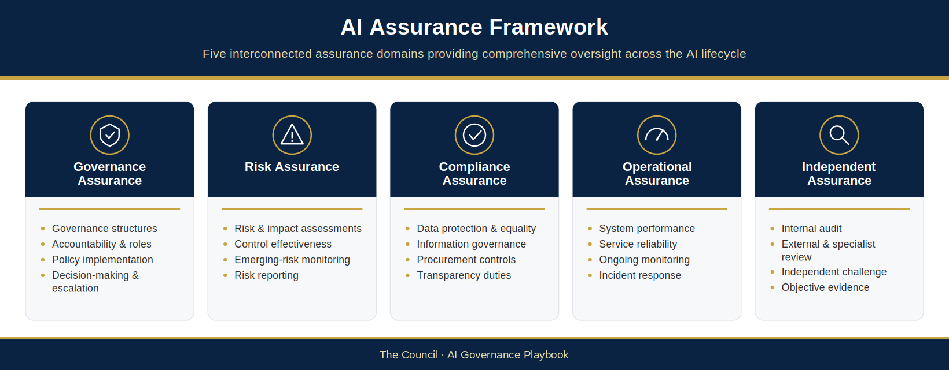
Figure 6.1: AI Assurance Framework
This figure illustrates the relationship between governance assurance, risk assurance, compliance assurance, operational assurance and independent assurance. It demonstrates how assurance activities operate across the Three Lines Model to provide continuous oversight of AI systems throughout their lifecycle.

6.3.4 Continuous Assurance Across the AI Lifecycle
Assurance is not a single event conducted at the point of approval or deployment. It is an ongoing activity that extends throughout the lifecycle of every AI system.
From initial assessment and implementation through operational use, monitoring, review and eventual retirement, assurance activities provide the visibility and evidence required to support responsible AI governance.
Whatever level of assurance applies to a use (§6.3), The Council must be able to demonstrate that AI systems are governed effectively, risks are managed appropriately and governance controls continue to operate as intended.
The health of the assurance framework itself is tracked through governance key performance indicators reported on the AI Governance Dashboard (§6.9.7): the proportion of uses with current risk assessments; the proportion meeting their monitoring obligations; the number and severity of AI incidents; the time to resolve identified control gaps; and governance body attendance and review completion rates.
By establishing a comprehensive and proportionate assurance framework, The Council can strengthen accountability, support transparency and create the confidence necessary to pursue innovation responsibly. The following sections describe the specific monitoring, review and oversight activities through which this framework is implemented in practice.

6.4 AI Performance Monitoring
Once operational, AI systems require ongoing monitoring to ensure that they continue to perform as intended, operate within approved risk tolerances and deliver the outcomes for which they were implemented. Performance monitoring forms a critical component of The Council’s AI Assurance Framework and provides the evidence required to support informed governance decisions throughout the AI lifecycle.
Monitoring gives The Council early visibility of the changes described in §6.5.1, so that corrective action can be taken before material impacts occur.
The objective of performance monitoring is not simply to measure technical effectiveness. It is to provide assurance that AI systems remain safe, lawful, ethical and aligned with The Council’s organisational objectives and public-service responsibilities. Monitoring therefore encompasses operational performance, model performance, Responsible AI outcomes and business value realisation.
By establishing consistent monitoring arrangements across the AI portfolio, The Council can strengthen accountability, support transparency and ensure that governance decisions are informed by reliable evidence rather than assumptions.
Thresholds, outcomes, incidents and approval conditions are monitored at the UC-ID where they are use-specific; only genuinely shared measures are recorded at system level. Reporting gives system counts by AIR-ID and use states by UC-ID, and keeps unknown or unverified states distinct from approved or zero. Monitoring results and each UC-ID’s Monitoring and Review Plan are recorded in the AI Post-Deployment Monitoring & Review Log (AIG-OPS-02). Appendices E.1 and E.2 set out the controlled rules for monitoring evidence and minimum cadence.

6.4.1 Monitoring Objectives
The Council AI Performance Monitoring Framework adds the following monitoring objectives to those in §6.3:
- Maintain ongoing visibility of AI system performance and operational effectiveness.
- Detect performance deterioration, emerging risks and control weaknesses at an early stage.
- Verify that AI systems continue to operate within approved governance and risk parameters.
- Measure whether expected organisational and service benefits are being realised.
Performance monitoring should be viewed as a continuous process rather than a periodic compliance exercise. Monitoring activities shall be integrated into the day-to-day management of AI systems and aligned with The Council’s broader governance, risk management and performance management arrangements.

6.4.2 Monitoring Categories
To support comprehensive oversight, The Council will monitor AI systems across four interconnected performance domains. At a minimum, monitoring of each UC-ID covers technical performance against defined thresholds; data quality and input data characteristics; equality and fairness metrics; incident and complaint patterns; and compliance with applicable governance requirements.

6.4.2.1 Operational Performance
Operational Performance Monitoring focuses on the reliability, availability and operational stability of AI systems.
The objective is to ensure that systems remain available, function as intended and support the services within which they operate.
Typical monitoring measures may include:
- System availability
- Service uptime
- Reliability and resilience
- Processing times
- Transaction volumes
- System failures and outages
- User-reported issues
- Incident frequency
Operational monitoring provides assurance that AI systems continue to support service delivery effectively and reliably.

6.4.2.2 Model Performance
Model Performance Monitoring focuses on the effectiveness and accuracy of AI models and decision-support mechanisms.
The objective is to determine whether AI outputs remain sufficiently accurate, reliable and aligned with the purpose for which the system was approved.
Monitoring measures may include:
- Accuracy rates
- Precision and recall
- Confidence scores
- Error rates
- False positive rates
- False negative rates
- Recommendation quality
- Output consistency
The specific measures used will vary according to the nature of the AI system and its intended use case. For example, monitoring requirements for a generative AI assistant may differ significantly from those applied to a predictive analytics model or automated classification system.
Where performance indicators demonstrate significant deterioration, further investigation and governance review may be required.

6.4.2.3 Responsible AI Performance
Technical performance alone is not sufficient to determine whether an AI system is operating responsibly.
Responsible AI Performance Monitoring focuses on the ethical, governance and accountability dimensions of AI operation.
Key areas of consideration include:
- Fairness and bias indicators
- Equality impacts
- Transparency requirements
- Human oversight effectiveness
- Explainability considerations
- User trust and confidence
- Complaints and concerns
- Adherence to Responsible AI principles
Monitoring these factors helps ensure that AI systems continue to align with The Council’s commitment to fairness, inclusion, accountability and public value.
Responsible AI monitoring is particularly important where AI systems influence decisions, recommendations or actions that may affect residents, employees or service users.

6.4.2.4 Business Performance and Benefits Realisation
AI systems should deliver measurable value to the organisation and the communities it serves.
Business Performance Monitoring focuses on whether expected benefits are being achieved and sustained over time.
Potential measures may include:
- Service efficiency improvements
- Productivity gains
- Cost avoidance
- Resource optimisation
- Service quality improvements
- User satisfaction
- Resident outcomes
- Strategic objective delivery
Monitoring benefits realisation helps ensure that AI investments continue to support The Council’s organisational priorities and deliver meaningful public value.

6.4.3 Monitoring Responsibilities
Performance monitoring requires collaboration between operational teams, governance functions and oversight bodies.

6.4.3.1 AI System Owners
The AI System Owner (or Service Owner where no System Owner is named) (§3.5) is responsible for day-to-day monitoring of each assigned UC-ID.
Responsibilities include:
- Reviewing performance indicators
- Investigating issues
- Maintaining monitoring records
- Escalating concerns
- Supporting governance reviews
The AI System Owner (or Service Owner where no System Owner is named) remains accountable for ensuring that monitoring activities are conducted appropriately and consistently.

6.4.3.2 Service Owners and Managers
Service Owners are responsible for assessing the operational impact of AI systems within their services.
This includes evaluating whether systems continue to support business objectives, deliver expected outcomes and operate within acceptable service parameters.

6.4.3.3 AI Governance Working Group
The AI Governance Working Group provides oversight of monitoring activities across the wider AI portfolio.
Responsibilities include:
- Reviewing monitoring reports
- Identifying emerging trends
- Assessing cross-organisational risks
- Coordinating remediation activities
- Escalating significant concerns

6.4.3.4 AI Assurance Board
The AI Assurance Board receives periodic reports regarding AI performance, assurance outcomes and emerging risks.
The AI Governance Working Group provides it with consolidated reporting. The Board seeks assurance and advises the delegated Council forum or officer (§6.9.6) on whether additional governance actions or interventions are required; it reports through The Council’s governance structures to the Executive Leadership Team and relevant scrutiny bodies.

6.4.4 Monitoring Frequency
Monitoring must be proportionate to the risk tier of each UC-ID. The table below is the controlled minimum cadence for each UC-ID (Appendix E.2). The Monitoring and Review Plan in AIG-OPS-02 may increase these frequencies but must not reduce them. Where an AI use can take actions itself (agentic AI, Appendix F), its monitoring cadence is increased, never reduced, by its agency tier.
UC-ID risk tier | Operational monitoring | Performance review | Minimum formal review of the UC-ID
Low (1–5) | Routine operational monitoring by the AI System Owner | Annual | Annual (AI System Owner; reported in the portfolio summary)
Medium (6–10) | Monthly | Quarterly | Annual (AI Governance Working Group)
High (11–15) | Continuous | Monthly | Quarterly, with governance reporting to the AI Assurance Board
Critical (16–25) | Continuous | At least monthly | Continuous monitoring with a formal review at least monthly, reported to each AI Assurance Board meeting
The schedule for each UC-ID must be set during the AI risk assessment and recorded in its Monitoring and Review Plan in AIG-OPS-02; the AI Register records only the next review date. AIG-OPS-02 records the review type of each result (operational monitoring, performance review or formal review) and checks it against the minimum for the tier and review type in this table; for a use that can take actions itself, it records whether the plan has increased the cadence. The size of this increase for each agency tier is to be set by The Council (Proposed — for Council confirmation). Where no AI System Owner is named, the Service Owner acts in that role.

6.4.5 Performance Thresholds and Escalation
Monitoring is only effective if clear thresholds and escalation pathways are established.
Each UC-ID should define performance indicators, acceptable operating thresholds and trigger points for investigation or intervention.
The Council will adopt a risk-based approach using the following performance status categories:
- Green: performance remains within the approved parameters for the named UC-ID; no material concerns have been identified.
- Amber: performance indicators suggest emerging concerns that require investigation, increased monitoring or management attention.
- Red: performance has deteriorated beyond acceptable limits, significant risks have emerged or governance intervention is required.
Where monitoring identifies significant issues, such as a Red status, they are escalated using the route set out in §3.10 and Appendix E.5.
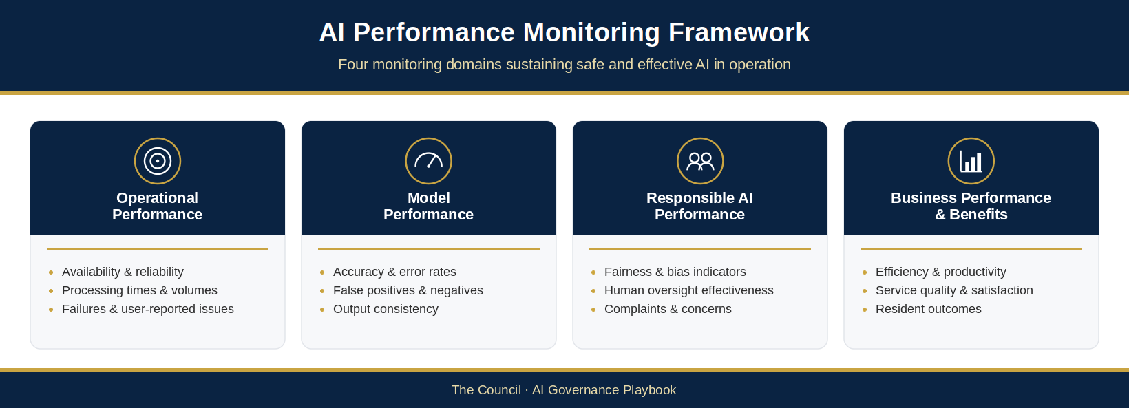
Figure 6.2: AI Performance Monitoring Framework
This figure illustrates the relationship between operational performance monitoring, model performance monitoring, Responsible AI monitoring and business performance monitoring. It demonstrates how monitoring activities provide evidence to support governance oversight, assurance reviews and continuous improvement across the AI lifecycle.

6.4.6 Monitoring as an Enabler of Assurance
Performance monitoring represents one of the most important sources of evidence within The Council’s AI Assurance Framework. It provides continuous visibility of how AI systems perform in practice, supports early identification of emerging risks and enables informed governance decision-making.
Monitoring should therefore be viewed as more than a technical activity. It is a governance capability that strengthens accountability, supports transparency and helps ensure that AI systems continue to operate safely, effectively and in accordance with The Council’s Responsible AI principles.
The following section examines one of the most significant challenges associated with long-term AI operation: model drift, performance degradation and the governance responses required when AI systems no longer perform as expected.

6.5 Model Drift and Performance Degradation
Monitoring alone is not enough. The Council must also maintain the capability to identify, assess and respond to model drift, performance degradation and other forms of operational deterioration that may emerge throughout the AI lifecycle.
The ability to detect and manage these issues is a fundamental component of responsible AI governance. It helps ensure that AI systems remain aligned with their intended purpose, continue to operate within approved risk tolerances and maintain the confidence of residents, employees and decision-makers.

6.5.1 Understanding Model Drift
Model drift occurs when the performance of an AI system changes over time due to changes in the conditions under which it operates.
While a system may perform effectively when initially deployed, shifts in underlying data, operating environments, user behaviour or external circumstances can gradually reduce its effectiveness. New risks may also emerge that were not identified when the use was assessed and approved, and regulatory expectations may develop. As a result, outputs that were previously accurate, reliable or appropriate may become less dependable.
Model drift is a recognised challenge across both predictive and generative AI systems and should be considered a normal operational risk rather than an exceptional event.
Effective governance therefore requires mechanisms for identifying drift before it creates material operational, ethical or governance concerns.

6.5.2 Types of Drift and Degradation
Several forms of drift may affect AI systems operating within The Council.

6.5.2.1 Data Drift
Data drift occurs when the characteristics of input data change over time.
Examples may include:
- Changes in resident demographics
- Changes in service demand patterns
- Changes in operational processes
- New data sources
- Deterioration in data quality
Where input data differs significantly from the conditions under which a model was originally developed or configured, performance may decline.

6.5.2.2 Concept Drift
Concept drift occurs when the relationship between inputs and outcomes changes over time.
For example, patterns that were previously reliable indicators of a particular outcome may no longer be valid due to changing circumstances, policy changes or external events.
Concept drift can be particularly difficult to detect because system performance may decline gradually rather than suddenly.

6.5.2.3 Operational Drift
Operational drift occurs when changes are made to the surrounding environment in which an AI system operates.
Examples may include:
- Changes to business processes
- Changes to source systems
- Changes to user workflows
- Integration changes
- Configuration updates
Although the underlying AI model may remain unchanged, operational modifications can still affect performance and outcomes.

6.5.2.4 Generative AI Degradation
Generative AI systems may experience deterioration in output quality due to changing prompts, user behaviour, configuration settings or evolving operational requirements.
Potential indicators may include:
- Reduced output quality
- Increased hallucinations
- Inconsistent responses
- Reduced relevance
- Increased user complaints
These risks should be monitored alongside traditional performance measures.

6.5.3 Detecting Performance Deterioration
Early identification of drift and degradation is essential to maintaining effective governance.
The Council will utilise a combination of monitoring techniques to identify potential issues, including:
- Performance trend analysis: reviewing performance indicators over time to identify gradual deterioration.
- Quality assurance reviews: periodic sampling and review of AI outputs to assess accuracy, relevance and appropriateness.
- User feedback: monitoring complaints, concerns and operational feedback from employees, residents and service users.
- Incident reporting: reviewing operational incidents that may indicate emerging performance issues.
- Governance reviews: periodic governance assessments designed to identify changes in risk profile, operational context or system effectiveness.
No single monitoring mechanism should be relied upon in isolation. Effective detection requires multiple sources of evidence and ongoing governance oversight.

6.5.4 Governance Response to Drift
Not all instances of performance deterioration require immediate intervention. Governance responses should be proportionate to the nature of the issue, the level of risk involved and the potential impact on residents, employees and service delivery.
Where deterioration is identified, The Council may adopt one or more of the following responses.

6.5.4.1 Enhanced Monitoring
Where issues are emerging but remain within acceptable tolerances, monitoring frequency may be increased to provide greater visibility and support further assessment.

6.5.4.2 Corrective Action
Operational adjustments may be implemented to address identified weaknesses or control deficiencies.
Examples may include:
- Process changes
- Configuration adjustments
- Additional human oversight
- Enhanced quality assurance activities

6.5.4.3 Model Review and Revalidation
Where material deterioration is identified, a formal review may be required to determine whether the system remains suitable for its intended purpose.
This may include:
- Reassessment of risks
- Revalidation of performance
- Review of governance controls
- Review of Responsible AI considerations

6.5.4.4 Retraining or Redevelopment
Where appropriate, models may require retraining, recalibration or redevelopment to restore performance and effectiveness.
Any significant modification should be subject to The Council’s established AI lifecycle governance and change control procedures.

6.5.4.5 Suspension or Withdrawal
Where risks cannot be adequately controlled, the AI system or affected use may be suspended, restricted or withdrawn under §4.7.17: the Service Owner or AI System Owner applies an immediate precautionary pause where there is a real risk of harm, and any continued suspension, resumption or withdrawal is decided by the officer or forum with confirmed delegation and recorded in AIG-DEC-03 and AIG-DEC-04.
The protection of residents, employees and public trust shall take precedence over continued operation.

6.5.5 Escalation and Decision-Making
Significant performance deterioration should be escalated through The Council’s established governance structure.
Factors that may trigger escalation include:
- Material reduction in performance
- Increased risk exposure
- Significant fairness or bias concerns
- Regulatory compliance issues
- Adverse resident impacts
- Reputational concerns
The objective of escalation is not simply to report problems but to ensure that appropriate decisions are made at the correct level of organisational authority. Material drift or a breached threshold triggers reassessment of the affected UC-IDs (§3.10.5, §4.5.6 and Appendix E.4); the escalation route, governance re-entry and decision records follow §3.10, Appendix E.5 and AIG-DEC-03.
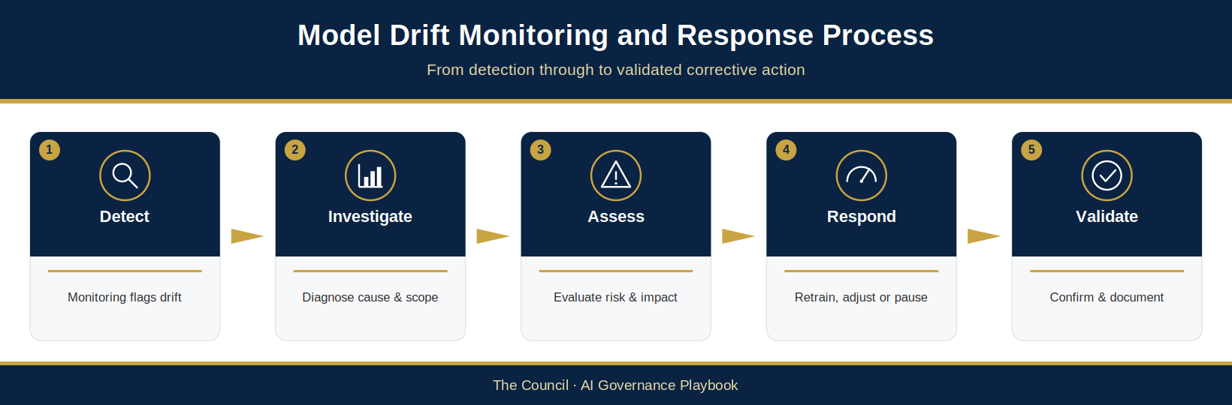
Figure 6.3: Model Drift Monitoring and Response Process
This figure illustrates The Council’s approach to detecting, assessing and responding to model drift and performance degradation. It demonstrates how monitoring activities, governance reviews and escalation processes interact to support effective lifecycle oversight.

6.5.6 Maintaining Confidence Over Time
By establishing structured processes for detecting drift, assessing performance deterioration and implementing proportionate responses, The Council can ensure that AI systems remain effective, trustworthy and aligned with organisational objectives. These arrangements strengthen assurance, support accountability and help maintain public confidence in The Council’s use of AI.
The following section examines how The Council will monitor compliance with legal, regulatory and policy obligations to ensure that AI systems continue to operate within an appropriate governance and control environment.

6.6 Compliance Monitoring
Artificial Intelligence (AI) systems operate within a complex framework of legal, regulatory and organisational obligations. While performance monitoring provides assurance that systems are functioning effectively, The Council must also ensure that AI systems continue to operate in compliance with applicable legislation, regulatory expectations and internal governance requirements throughout their lifecycle.
Compliance cannot be viewed as a one-time assessment conducted during procurement, development or implementation. Legal obligations, regulatory expectations and operational circumstances may change over time, requiring ongoing oversight to ensure that AI systems remain compliant and continue to support lawful, ethical and accountable decision-making.
Compliance Monitoring forms a core component of The Council’s AI Assurance Framework. It provides the mechanisms through which The Council verifies that AI systems continue to meet required standards, identifies potential areas of non-compliance and supports timely corrective action where issues are identified.
The objective is not simply to avoid regulatory breaches. Effective compliance monitoring strengthens public trust, supports organisational accountability and ensures that AI systems continue to operate in a manner consistent with The Council’s public-service responsibilities and Responsible AI principles.

6.6.1 Compliance Monitoring Objectives
The Council’s Compliance Monitoring Framework adds the following compliance objectives to those in §6.3:
- Verify ongoing compliance with legal and regulatory obligations.
- Ensure adherence to The Council’s AI governance policies, standards and procedures.
- Identify emerging compliance risks and control weaknesses.
- Maintain regulatory readiness.
Compliance monitoring should be integrated into normal governance activities and aligned with The Council’s wider corporate compliance, risk management and assurance arrangements.

6.6.2 Key Compliance Areas
AI systems may be subject to a range of obligations depending upon their purpose, risk profile and operational context.
The following areas represent the primary focus of The Council’s compliance monitoring activities.

6.6.2.1 Data Protection and Privacy
AI systems frequently process information that falls within the scope of data protection legislation and information governance requirements.
Compliance monitoring should therefore consider:
- Lawful basis for processing
- Data minimisation
- Purpose limitation
- Data quality and accuracy
- Retention requirements
- Security controls
- Individual rights
- Data Protection Impact Assessment requirements
Monitoring activities should verify that AI systems continue to operate in accordance with established data protection obligations and that changes to systems, data sources or operational processes do not introduce unmanaged privacy risks.

6.6.2.2 Equality, Fairness and Inclusion
As a public authority, The Council has legal and ethical responsibilities to promote fairness and avoid discriminatory outcomes.
Compliance monitoring should assess whether AI systems continue to support equitable outcomes and whether potential bias or disproportionate impacts are emerging over time.
Areas of review may include:
- Equality impact assessments
- Fairness indicators
- Protected characteristic considerations
- Disproportionate outcomes
- Accessibility requirements
- Inclusion considerations
Where concerns are identified, appropriate governance review and corrective action should be undertaken.

6.6.2.3 Transparency and Accountability
Transparency is fundamental to maintaining public trust in AI-enabled services.
Compliance monitoring should assess whether The Council continues to meet its transparency obligations and whether governance arrangements provide sufficient accountability for AI-related activities.
Areas of review may include:
- AI Register maintenance
- Public transparency requirements
- Decision documentation
- Governance records
- Audit trails
- Accountability arrangements
The Council should be able to demonstrate how AI systems are governed, who is accountable and how decisions regarding deployment and oversight are made.

6.6.2.4 Procurement and Supplier Compliance
Many AI capabilities are introduced through third-party suppliers, software platforms and technology partners.
Compliance monitoring should therefore extend beyond internally managed systems and include oversight of supplier obligations and contractual requirements.
Areas of review may include:
- Supplier assurance commitments
- Contractual obligations
- Security requirements
- Data handling arrangements
- Performance obligations
- Regulatory compliance assurances
- Change notifications
Ongoing monitoring helps ensure that supplier-related risks remain visible and appropriately managed throughout the relationship lifecycle.

6.6.2.5 Internal Policy Compliance
All AI systems operating within The Council should comply with the policies, standards and governance requirements established through the AI Governance and Responsible AI Operating Model.
Areas of review may include:
- AI Acceptable Use Policy compliance
- AI Register requirements
- Risk assessment completion
- Governance approvals
- Monitoring obligations
- Assurance requirements
- Documentation standards
Policy compliance monitoring provides confidence that governance arrangements are being applied consistently across the organisation.

6.6.3 Compliance Monitoring Activities
The Council’s approach to compliance monitoring incorporates a range of complementary activities designed to provide ongoing visibility and assurance.

6.6.3.1 Periodic Compliance Reviews
Periodic reviews should be conducted to assess whether AI systems remain compliant with applicable requirements.
Reviews may be risk-based and proportionate to the significance of the system.

6.6.3.2 Documentation Reviews
Governance documentation should be reviewed periodically to ensure that records remain complete, accurate and current.
This may include:
- Risk assessments
- Impact assessments
- Governance approvals
- Supplier documentation
- Monitoring records
- Assurance reports

6.6.3.3 Control Testing
Compliance monitoring should include testing of governance controls to verify that required processes are operating effectively.
Examples may include:
- Approval process testing
- Access control reviews
- Audit trail verification
- Policy compliance checks

6.6.3.4 Thematic Reviews
The Council may undertake thematic reviews focusing on specific risk areas, technologies or governance requirements.
Examples may include:
- Generative AI usage
- Data governance controls
- Supplier assurance arrangements
- Equality and fairness considerations
Thematic reviews support organisational learning and provide visibility of systemic risks across the AI portfolio.

6.6.4 Compliance Reporting and Escalation
Compliance monitoring activities should be supported by clear reporting and escalation arrangements.
Where monitoring identifies non-compliance, governance bodies should be informed in accordance with The Council’s established escalation pathways.
Factors that may require escalation include:
- Regulatory breaches
- Significant policy non-compliance
- Data protection concerns
- Equality-related issues
- Supplier compliance failures
- Transparency or accountability concerns
Matters are escalated using the route set out in §3.10 and Appendix E.5.
Corrective actions should be tracked to completion and subject to appropriate management oversight.

6.6.5 Regulatory Change and Horizon Scanning
The regulatory environment for AI continues to evolve rapidly.
New legislation, guidance, standards and regulatory expectations are likely to emerge as AI adoption increases across both the public and private sectors.
The Council maintains processes for monitoring regulatory developments and assessing their potential impact on governance arrangements.
This may include consideration of:
- UK Government guidance
- Regulatory authority publications
- Emerging standards and frameworks
- Public-sector best practice
- International developments relevant to supplier ecosystems
Horizon scanning supports proactive governance and helps ensure that The Council remains prepared for future compliance requirements.
The Council maintains a controlled record of these sources and their mapping to the framework in the AI Source Assurance and Traceability Register (AIG-AIMS-13), which is verified on a scheduled cadence. Applicable requirements, horizon scanning and change control are recorded in the AIMS Applicable Requirements and Change Register (AIG-AIMS-05). An automated horizon-scanning tool may be used as an input, but the controlled record (AIG-AIMS-13) is the authoritative source.
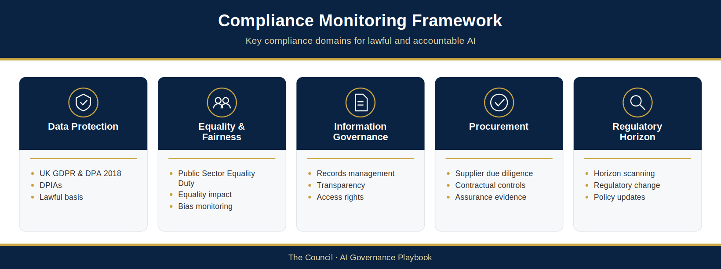
Figure 6.4: Compliance Monitoring Framework
This figure illustrates the relationship between legal obligations, regulatory expectations, internal governance requirements and compliance monitoring activities. It demonstrates how ongoing compliance monitoring supports assurance, accountability and responsible AI adoption across The Council.

6.6.6 Compliance as a Continuous Governance Activity
Compliance monitoring is not solely a regulatory requirement. It is an essential governance activity that supports transparency, accountability and public confidence in The Council’s use of AI.
By maintaining ongoing oversight of legal obligations, policy requirements and regulatory expectations, The Council can identify emerging issues early, respond to changing requirements and demonstrate that AI systems continue to operate within an appropriate governance framework.
Effective compliance monitoring provides assurance that AI adoption remains lawful, ethical and aligned with The Council’s public-service responsibilities. It also strengthens The Council’s ability to adapt to an evolving regulatory landscape while continuing to pursue innovation responsibly and confidently.
The following section examines the role of Internal Audit and independent assurance in providing objective challenge and validating the effectiveness of The Council’s AI governance arrangements.

6.7 Internal Audit and Independent Assurance
The Council AI Governance and Responsible AI Operating Model establishes governance structures, risk management processes and monitoring arrangements designed to support the responsible adoption of Artificial Intelligence (AI). While these mechanisms provide important oversight and control, effective governance also requires independent challenge and objective assessment.
Independent assurance provides confidence that governance arrangements are operating as intended, risks are being managed appropriately and controls remain effective over time. It strengthens organisational accountability by providing an impartial assessment of governance performance and helps identify opportunities for improvement that may not be visible through routine operational monitoring.
Within the public sector, independent assurance plays a particularly important role: it provides the objective evidence that residents, elected members, regulators and oversight bodies expect (§6.2).
The purpose of this section is to define The Council’s approach to Internal Audit and independent assurance activities and to establish how objective review contributes to the ongoing effectiveness of AI governance arrangements. The internal audit programme and audit records are held in AIG-AIMS-07, nonconformities and corrective actions in AIG-AIMS-08, and management review in AIG-AIMS-09.

6.7.1 The Role of Independent Assurance
Independent assurance provides objective evaluation of governance structures, risk management processes and control effectiveness.
Unlike operational monitoring, which focuses on day-to-day management activities, independent assurance provides a broader assessment of whether governance arrangements are functioning as intended and achieving their objectives.
In addition to the objectives in §6.3, independent assurance aims to:
- Validate the operation of governance controls and oversight mechanisms.
- Identify weaknesses, gaps and improvement opportunities.
Independent assurance should be viewed as a constructive governance activity that strengthens decision-making and supports continuous improvement rather than a mechanism for assigning blame or restricting innovation.

6.7.2 Assurance Principles
The Council’s approach to independent assurance is founded upon several core principles.

6.7.2.1 Independence
Assurance activities should be conducted by individuals or functions that are sufficiently independent from the systems, processes or activities being reviewed.
Independence helps ensure that findings are objective, evidence-based and free from operational bias.

6.7.2.2 Proportionality
Assurance activities follow the proportionality principle set out in §6.3.

6.7.2.3 Evidence-Based Assessment
Assurance conclusions should be supported by documented evidence, monitoring data, governance records and verifiable observations.
Assessments should focus on demonstrable control effectiveness rather than assumptions or informal assurances.

6.7.2.4 Continuous Improvement
The objective of assurance is not solely to identify deficiencies but to support governance maturity and organisational learning.
Findings should inform improvements to governance structures, policies, controls and operating practices.

6.7.3 Sources of Independent Assurance
The sources of independent assurance are listed in §6.3.1.5. This section describes how each is used, and how second-line functions contribute.

6.7.3.1 Internal Audit
Internal Audit represents the primary source of formal independent assurance.
Internal Audit provides objective review and evaluation of governance, risk management and control arrangements and may undertake specific reviews relating to AI governance and Responsible AI practices.
Potential areas of Internal Audit review include:
- Governance structures and oversight arrangements
- AI risk management processes
- Compliance monitoring effectiveness
- AI Register management
- Lifecycle governance controls
- Supplier assurance processes
- Monitoring and reporting arrangements
- Incident management procedures
Internal Audit findings provide valuable insight into the effectiveness of governance arrangements and support continuous improvement activities.

6.7.3.2 Corporate Assurance Functions
The second-line functions listed in §6.3.3.2 provide challenge, review and specialist oversight. They do not operate with the same independence as Internal Audit, so their work is second-line assurance rather than independent assurance.

6.7.3.3 Independent Specialist Reviews
In some circumstances, The Council may commission independent specialist reviews to assess specific AI systems, technologies or governance arrangements.
This may be particularly appropriate where:
- Systems are highly complex.
- Significant risks are present.
- Specialist expertise is required.
- Independent validation would provide additional confidence.
Specialist reviews may focus on technical, ethical, operational or governance considerations depending upon the nature of the system being assessed.

6.7.3.4 External Oversight and Regulatory Review
The Council may also be subject to external scrutiny through regulatory reviews, inspections, audits or investigations.
External oversight may provide additional assurance regarding:
- Compliance obligations
- Governance effectiveness
- Transparency arrangements
- Public-sector accountability requirements
The Council should maintain governance arrangements capable of supporting external review and demonstrating responsible AI practices.

6.7.4 Internal Audit Approach to AI Governance
As The Council’s use of AI matures, Internal Audit may adopt a risk-based programme of AI governance reviews.
The scope and frequency of reviews should be informed by factors such as:
- Organisational risk exposure
- Number of AI systems in operation
- Risk classification of AI use cases
- Regulatory developments
- Previous assurance findings
- Emerging technology trends
Reviews may examine both individual AI systems and broader governance capabilities.
Potential review questions may include:
- Are governance responsibilities clearly defined?
- Are AI systems appropriately recorded and monitored?
- Are risk assessments completed and maintained?
- Are Responsible AI principles being applied consistently?
- Are assurance arrangements operating effectively?
- Are significant risks appropriately escalated?
These reviews provide confidence that governance arrangements remain effective as AI adoption expands across the organisation.

6.7.5 Assurance Findings and Management Actions
The value of assurance is realised through action.
All assurance findings should be assessed, prioritised and managed through established governance processes.
Findings may be categorised according to:
- Risk significance
- Control effectiveness
- Compliance implications
- Potential organisational impact
Management actions should be assigned to appropriate owners and monitored until completion.
Governance bodies should maintain visibility of significant findings and regularly review progress against agreed remediation plans.
The objective is not simply to identify issues but to ensure that governance arrangements continue to improve over time.

6.7.6 Reporting Assurance Findings
Assurance outcomes, including significant findings, control weaknesses and outstanding actions, are reported through The Council’s governance structures. The reporting routes, frequency and the roles of the AI Governance Working Group and AI Assurance Board are set out in §6.9.
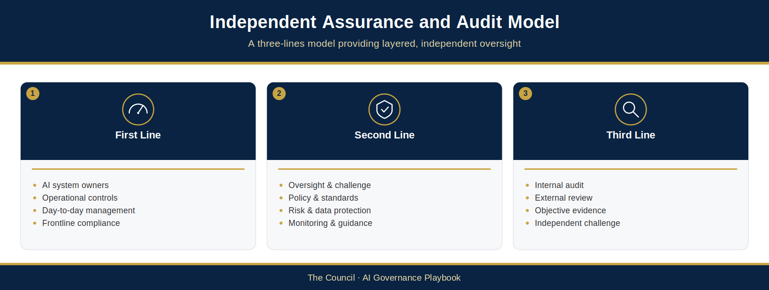
Figure 6.5: Independent Assurance and Audit Model
This figure illustrates how Internal Audit, specialist reviews and external oversight activities, supported by second-line corporate assurance functions, interact to provide independent assurance across The Council’s AI governance framework. It demonstrates the relationship between operational management, governance oversight and independent challenge.

6.7.7 Independent Assurance as a Driver of Governance Maturity
Independent assurance represents a critical component of The Council’s Responsible AI Operating Model. It provides objective confidence that governance arrangements are functioning effectively, supports organisational accountability and strengthens public trust in The Council’s use of AI.
As The Council’s AI capabilities continue to develop, independent assurance will play an increasingly important role in validating governance effectiveness, identifying emerging risks and supporting continuous improvement. By embedding robust assurance arrangements within its governance framework, The Council can ensure that AI adoption remains safe, lawful, ethical and aligned with its public-service responsibilities.
The following section defines The Council’s approach to AI incident management and escalation, establishing the processes through which significant issues, failures and emerging risks will be identified, investigated and addressed.

6.8 AI Incident Management and Escalation
While effective governance, monitoring and assurance arrangements significantly reduce risk, no control environment can eliminate risk entirely. Artificial Intelligence (AI) systems may experience operational failures, produce unexpected outcomes, create compliance concerns or contribute to incidents that require investigation and management. As The Council’s adoption of AI expands, it is essential that The Council maintains clear processes for identifying, reporting, investigating and responding to AI-related incidents.
AI incidents can arise from a variety of sources, including technical failures, data quality issues, governance weaknesses, supplier failures, security events or unintended consequences associated with AI outputs. In some circumstances, incidents may affect service delivery, resident outcomes, regulatory compliance or public trust. Effective incident management ensures that these issues are addressed promptly, proportionately and transparently.
The purpose of AI incident management is not solely to respond to failures. It is also to support organisational learning, strengthen governance controls and improve the long-term safety and effectiveness of AI systems. Every incident provides an opportunity to better understand risks, refine governance arrangements and improve future decision-making.
This section establishes The Council’s approach to AI incident management and defines the escalation pathways through which significant issues will be reviewed and addressed.

6.8.1 Defining an AI Incident
An AI incident is any event, outcome or circumstance associated with an AI system that results in, or has the potential to result in, harm, significant operational disruption, governance concern, regulatory non-compliance or reputational impact. It also includes near-misses (§5.10.1).
Not all incidents will require the same level of response. Some may represent minor operational issues that can be addressed through routine management processes, while others may require formal investigation and escalation through governance structures.
Examples of AI-related incidents may include:
- Significant inaccuracies or erroneous outputs
- Bias or discriminatory outcomes
- Unauthorised or inappropriate use of AI systems
- Data protection breaches
- Security incidents involving AI technologies
- Failure of governance controls
- Material model performance deterioration
- Significant service disruption
- Supplier-related failures
- Transparency or accountability concerns
- Adverse resident impacts
The identification of an incident does not necessarily indicate governance failure. Rather, it demonstrates that monitoring, reporting and oversight mechanisms are functioning as intended.

6.8.2 Incident Management Objectives
The Council’s AI Incident Management Framework is designed to achieve the following objectives:
- Ensure timely identification and reporting of AI-related incidents.
- Protect residents, employees and service users from harm.
- Support effective investigation and remediation.
- Maintain compliance with legal and regulatory obligations.
- Facilitate transparent governance oversight.
- Promote organisational learning and continuous improvement.
These objectives align with The Council’s broader risk management, information governance and corporate incident management arrangements.

6.8.3 Incident Identification and Reporting
The effective management of incidents begins with early identification and reporting.
All employees, contractors, suppliers and stakeholders involved in the operation or management of AI systems should be encouraged to report concerns, anomalies or unexpected outcomes.
Potential sources of incident identification may include:
- Performance monitoring activities
- User feedback
- Service complaints
- Internal reviews
- Assurance activities
- Audit findings
- Security monitoring
- Supplier notifications
- Regulatory enquiries
The Council should promote a culture in which issues can be reported openly and constructively without discouraging innovation or responsible experimentation.
Early reporting enables The Council to assess risks quickly and implement appropriate mitigation measures before issues escalate. Reports follow §5.10.2: staff report to their Service Owner using Part A of the AI Incident Report Form (AIG-OPS-03), the Service Owner notifies the AI Governance Lead within the timescale in §6.8.4.1, and a suspected personal data breach is referred to the Data Protection Officer immediately.

6.8.4 Incident Classification

AI-related incidents shall be classified according to their nature, severity, impact and potential consequences. Consistent classification supports proportionate governance responses, effective escalation, appropriate oversight and timely remediation activities.
Incident classification should consider:
- Impact on residents, service users, employees and stakeholders.
- Legal and regulatory implications.
- Data protection and information security impacts.
- Operational disruption.
- Reputational consequences.
- Ethical and Responsible AI considerations.
- Scale of affected individuals, services or business processes.
- Likelihood of recurrence.

6.8.4.1 Incident Severity Matrix
The following severity classifications shall be applied when assessing AI-related incidents.
Severity Level | Description | Examples | Escalation Requirement
Low | Limited operational impact with no significant legal, ethical or service consequences. | Minor output inaccuracies, isolated user complaints, documentation errors, non-material process failures. | Service Owner review and local remediation; Part A to the AI Governance Lead the same working day; recorded in the incident record (AIG-OPS-03) and summarised in the AIG-OPS-02 monitoring log within ten working days (the AI Register holds only a link or status).
Medium | Moderate impact requiring management attention and corrective action. | Repeated inaccurate outputs, policy non-compliance, control failures, minor service disruption or recurring user complaints. | AI Governance Lead notified the same working day (Part A); documented remediation plan agreed within five working days.
High | Significant operational, legal, ethical or reputational impact requiring formal governance oversight. | Material bias findings, significant model drift, operational disruption, security weaknesses, repeated control failures or significant service impacts. | AI Governance Lead notified the same working day (Part A); escalation to the AI Governance Working Group within two working days, and formal governance review.
Critical | Actual or potential harm to individuals, significant legal exposure, major reputational impact or breach of statutory obligations. | Data breaches, unlawful automated decision-making, significant impacts on vulnerable individuals, major regulatory concerns, widespread service failure or substantial media scrutiny. | AI Governance Lead notified immediately (Part A); immediate escalation, and in any event within 24 hours, to the AI Assurance Board, Executive Sponsor and relevant Executive Leadership.

6.8.4.2 Severity Assessment
Incident severity shall be determined using both actual and potential impact.
Where uncertainty exists regarding classification, the higher severity category shall be applied until sufficient information is available to support reassessment.
Multiple lower-severity incidents may be aggregated and treated as a higher-severity incident where they indicate a systemic governance weakness, recurring control failure or emerging operational risk.
Incident triggers for a precautionary pause (Proposed — for Council confirmation). Significant bias resulting in adverse outcomes, a data protection breach involving AI-processed data, a security incident affecting AI system integrity, or a governance failure indicating an inadequate control environment is classified at least High, whatever the provisional severity. It is escalated to the AI Governance Lead immediately with consideration of a precautionary pause; the escalation timing for the confirmed severity (§6.8.4.1) then also applies.

6.8.4.3 Recording Requirements
All incidents shall be formally recorded: Low severity incidents in the incident record (AIG-OPS-03) and the AIG-OPS-02 monitoring log, and Medium, High and Critical severity incidents also within The Council’s governance records.
High and Critical incidents shall be reviewed as part of governance reporting and oversight activities.
Lessons learned from Medium, High and Critical incidents shall be incorporated into The Council’s continuous improvement, governance effectiveness and assurance activities.

6.8.5 Incident Investigation
All significant incidents should be subject to appropriate investigation.
The objective of investigation is to establish:
- What occurred
- Why it occurred
- Which controls were affected
- What impacts resulted
- What corrective actions are required
Investigations should be proportionate to the severity and complexity of the incident.
Depending on the nature of the issue, investigations may involve:
- Service teams
- AI System Owners
- Information Governance
- Data Protection Officer
- Cyber Security teams
- Procurement representatives
- Legal Services
- Independent assurance functions
Investigation findings should be documented and retained in accordance with The Council’s governance requirements.

6.8.6 Escalation Framework

Effective escalation ensures that AI-related incidents receive appropriate management attention, governance oversight and timely remediation. Escalation arrangements should be proportionate to the nature, severity and potential impact of the incident and should align with The Council’s broader governance, risk management and incident management arrangements.
Incidents should be escalated where they involve:
- Significant resident or service-user impact.
- Legal, regulatory or compliance concerns.
- Data protection breaches or information governance issues.
- Cyber security incidents or vulnerabilities.
- Material service disruption.
- Significant fairness, bias or discrimination concerns.
- Incidents affecting uses (UC-IDs) at High or Critical risk tier.
- Reputational risk or adverse media attention.
- Persistent or systemic control failures.
- Repeated incidents indicating an emerging governance weakness.
Escalation decisions should take account of the incident severity classification defined in §6.8.4 and any actual or potential impacts on residents, services, employees, stakeholders or The Council’s statutory obligations.

6.8.6.1 Low Severity Incidents
Low severity incidents are notified to the AI Governance Lead within the timescale in §6.8.4.1 (Part A, §5.10.2) and should normally be managed by the relevant AI System Owner or Service Owner through routine operational processes. They are recorded as set out in §6.8.4.1 and §6.8.4.3.
Where appropriate, corrective actions should be documented and monitored to completion. Escalation beyond operational management is not normally required unless recurring issues indicate a broader governance concern.

6.8.6.2 Medium Severity Incidents
Medium severity incidents are notified to the AI Governance Lead within the timescale in §6.8.4.1 (as are all incidents, §5.10.2) and recorded within The Council’s governance records.
The AI Governance Lead should review the incident, assess whether additional governance oversight is required, and ensure that a documented remediation plan is agreed within the timescale in §6.8.4.1, implemented and monitored.

6.8.6.3 High Severity Incidents
High severity incidents shall be escalated to the AI Governance Working Group for formal governance review within the timescale in §6.8.4.1.
The Working Group should consider:
- Root causes and contributing factors.
- Impacts on services, residents and stakeholders.
- Adequacy of existing controls.
- Additional mitigation requirements.
- Whether reassessment of the risk classification of affected uses (UC-IDs) is required.
- Organisational lessons learned.
The Working Group may recommend additional oversight, assurance activities or escalation to the AI Assurance Board where appropriate.

6.8.6.4 Critical Severity Incidents
Critical severity incidents shall be escalated to the AI Assurance Board, Executive Sponsor and relevant Executive Leadership representatives within the timescale in §6.8.4.1.
Critical incidents shall trigger immediate consideration of:
- Immediate suspension or restriction of the AI system.
- Enhanced monitoring arrangements.
- Regulatory notification obligations.
- Independent assurance or investigation activities.
- Emergency risk mitigation measures.
- Public communications or stakeholder engagement activities.
- Reassessment of governance controls and approval status.
- Reassessment of the risk classification of affected uses (UC-IDs), and additional governance controls and mitigations.
The AI Assurance Board shall seek assurance on incident resolution and recommend corrective and preventative actions; the decision rests with the forum or officer holding delegated authority (§6.9.6).

6.8.6.5 Escalation to Corporate Governance Structures
Where appropriate, AI-related incidents may also be escalated through The Council’s existing corporate governance, risk management, information governance, cyber security, legal or incident management arrangements.
Escalation pathways should ensure that AI-related incidents receive the same level of scrutiny, oversight and accountability as other significant organisational risks and incidents.
Many AI incidents will also fall within an existing Council process. Where they do, the specialist route leads on its own duties and timescales, and the AI incident record runs alongside it, linked by the AIR-ID and affected UC-ID(s). Raising an AI incident must never delay a statutory or specialist route.
- Personal data breach: the Data Protection Officer and The Council’s data breach procedure lead, including the ICO notification decision, which must be made without undue delay and, where feasible, within 72 hours of becoming aware of the breach (§5.10.2).
- Cyber security incident: Information and Cyber Security lead, under The Council’s security incident procedure.
- Safeguarding concern about a child or an adult at risk: The Council’s safeguarding procedures take priority and apply without delay.
- Complaint or challenge from a resident: The Council’s complaints procedure leads, with the AI Contestability and Redress Control (AIG-OPS-04; see also §5.7.1) applied where AI made or materially influenced the decision.
- Supplier failure: contract management and Procurement, under the relevant contract terms.
- Significant organisational risk: the corporate risk register and The Council’s corporate risk management arrangements.
The AI Governance Lead records which specialist routes were engaged, and when, on the AI Incident Report Form (AIG-OPS-03). Named contacts for each route are to be confirmed before adoption.

6.8.7 Incident Roles

6.8.7.1 AI System Owners
Responsible for operational management and immediate response activities, including an immediate precautionary pause where there is a real risk of harm (§4.7.17).

6.8.7.2 Service Owners
Responsible for service-level decision-making and remediation activities.

6.8.7.3 AI Governance Working Group
Responsible for reviewing governance implications, emerging risks and cross-organisational lessons.

6.8.7.4 AI Assurance Board
Responsible for strategic oversight and review of significant incidents. The Board may recommend major remediation actions, suspension, resumption or withdrawal; the decision rests with the forum or officer holding delegated authority (§4.7.17).
Where appropriate, escalation may also involve existing corporate governance, risk management or incident management structures.

6.8.8 Corrective and Preventative Actions
The objective of incident management is not merely to resolve individual events but to reduce the likelihood of recurrence.
Corrective actions may include:
- Process improvements
- Additional monitoring
- Governance control enhancements
- Additional human oversight
- Training and awareness activities
- Supplier engagement
- System modification
- Model retraining
- Risk reassessment
Where necessary, The Council may determine that a system should be restricted, suspended or withdrawn from service until appropriate controls are restored.
All corrective actions should be assigned to accountable owners and monitored through governance processes until completion.

6.8.9 Incident Reporting and Governance Oversight
Significant incidents, investigation outcomes, root causes, corrective action status, emerging trends and lessons learned are reported through the governance reporting arrangements in §6.9. The AI Governance Working Group maintains visibility of incident activity across the AI portfolio (§6.9.5), and the AI Assurance Board receives periodic reporting on significant incidents (§6.9.6).

6.8.10 Organisational Learning and Continuous Improvement
Every incident provides an opportunity to strengthen governance capability.
Lessons learned should be incorporated into:
- Policies and standards
- Risk management processes
- Monitoring arrangements
- Training programmes
- Procurement practices
- Governance controls
- Assurance activities
Organisational learning helps ensure that incidents contribute to improved resilience rather than repeated failures.
Incident response arrangements should also be tested before they are needed. The Council should conduct periodic tabletop exercises, at least annually, simulating plausible AI failure scenarios such as an AI system producing harmful or discriminatory outputs, a data breach involving an AI tool, or the failure of a supplier-hosted service. These structured rehearsals test roles, escalation thresholds and communication pathways while the stakes are low. Gaps identified through exercises should be addressed through the corrective and preventative action process described in §6.8.8.
By systematically reviewing incidents and implementing improvements, The Council can continuously strengthen its Responsible AI Operating Model.
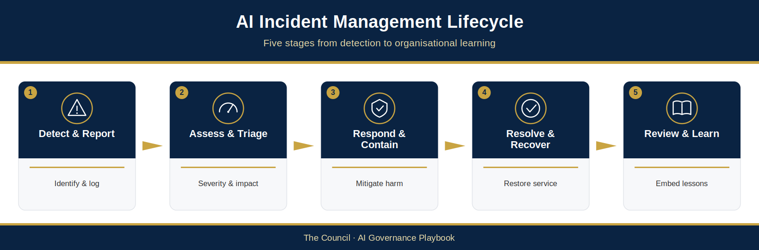
Figure 6.6: AI Incident Management Lifecycle
This figure illustrates the end-to-end AI incident management process, including identification, reporting, assessment, investigation, escalation, remediation and organisational learning. It demonstrates how incident management supports governance oversight and continuous improvement throughout the AI lifecycle.

6.8.11 Building Resilience Through Effective Incident Management
The successful governance of AI requires the ability to respond effectively when issues arise. Robust incident management arrangements provide The Council with the mechanisms needed to identify problems quickly, protect residents and services, maintain regulatory compliance and preserve public trust.
By establishing clear reporting pathways, proportionate escalation processes and structured learning mechanisms, The Council can ensure that AI-related incidents are managed consistently and transparently. These arrangements strengthen organisational resilience and provide confidence that AI systems can be operated responsibly even in the presence of uncertainty and change.
The following section defines The Council’s reporting and governance oversight arrangements, establishing how monitoring information, assurance findings and risk intelligence are consolidated to support effective decision-making across the AI governance framework.

6.9 Reporting and Governance Oversight
Effective AI governance depends upon timely, accurate and meaningful information. Monitoring activities, assurance reviews, compliance assessments and incident investigations generate valuable intelligence regarding the operation of AI systems across the organisation. However, governance can only function effectively when this information is consolidated, reported and reviewed through appropriate oversight mechanisms.
Reporting provides the means through which The Council maintains visibility of AI activities, understands emerging risks, evaluates governance effectiveness and supports informed decision-making. Governance oversight ensures that leadership remains aware of significant developments, that accountability is maintained and that appropriate action is taken where concerns are identified.
The purpose of this section is to establish The Council’s approach to AI reporting and governance oversight and to define how information will flow through the governance framework to support effective management of AI-related opportunities and risks.

6.9.1 Reporting Principles
The Council’s reporting approach is founded upon several key principles designed to support transparency, accountability and effective decision-making.

6.9.1.1 Accuracy
Reporting should be based on reliable and verifiable information. Governance decisions must be supported by evidence rather than assumptions or anecdotal observations.

6.9.1.2 Proportionality
Reporting requirements should reflect the risk profile, complexity and significance of each AI use. Higher-risk uses may require more detailed and frequent reporting than lower-risk use cases.

6.9.1.3 Transparency
Reporting should provide sufficient visibility of performance, risks, incidents and governance activities to enable informed oversight and accountability.

6.9.1.4 Timeliness
Information should be reported at appropriate intervals and escalated promptly where significant concerns arise.

6.9.1.5 Actionability
Reports should focus on information that supports governance decisions and enables appropriate management action where required.
Together, these principles help ensure that reporting contributes meaningfully to governance effectiveness rather than becoming an administrative exercise.

6.9.2 Governance Reporting Framework
The Council’s reporting framework consolidates information from multiple assurance and monitoring activities.
Key reporting inputs may include:
- AI Register information
- Risk assessments and risk profiles
- Performance monitoring results
- Compliance monitoring outcomes
- Assurance findings
- Audit reports
- Incident reporting
- Benefits realisation measures
- Emerging technology and regulatory developments
These inputs provide a comprehensive view of The Council’s AI landscape and support both operational and strategic oversight. Reports are prepared using the AI Governance Reporting Templates (AIG-OPS-05), and the measures reported are defined in the AIMS Monitoring and Measurement Plan (AIG-AIMS-10).

6.9.3 Operational Reporting
Operational reporting supports the day-to-day management of AI systems and services.
Reports may include:
- System performance indicators
- Service availability
- Operational incidents
- User feedback
- Monitoring results
- Emerging risks
Operational reporting should be reviewed regularly by AI System Owners and Service Owners (or Service Managers acting for them) to ensure that issues are identified and addressed promptly.
The frequency and level of detail should be proportionate to the nature and risk profile of the AI system.

6.9.4 Governance Reporting
Governance reporting provides a broader view of AI performance, risk and assurance across the organisation.
The objective is to provide governance bodies with sufficient information to assess whether each UC-ID continues to operate within its approved scope and conditions, whether shared system controls remain effective, and whether governance arrangements need reassessment.
Governance reports may include:
- AI portfolio overview
- Risk profile summaries
- Compliance status
- Significant incidents
- Assurance outcomes
- Outstanding actions
- Emerging governance concerns
- Strategic developments
Reporting should focus on trends, material risks and issues requiring management attention rather than operational detail alone.

6.9.5 AI Governance Working Group Oversight
The AI Governance Working Group plays a key role in reviewing governance information and coordinating oversight activities.
The Working Group should receive regular reporting regarding:
- New AI use cases
- Risk assessment outcomes
- Monitoring results
- Compliance activities
- Incident trends
- Assurance findings
- Policy implementation progress
The Working Group is responsible for identifying emerging themes, reviewing governance effectiveness and escalating significant issues where necessary.
It also serves as a forum for cross-organisational coordination and knowledge sharing.

6.9.6 AI Assurance Board Oversight
The AI Assurance Board provides strategic oversight of The Council’s AI governance framework.
The Board should receive periodic reporting that enables it to:
- Understand the overall AI risk landscape.
- Review governance performance.
- Monitor assurance outcomes.
- Consider significant incidents and emerging risks.
- Review implementation of Responsible AI principles.
- Assess governance maturity and capability development.
- Recommend strategic interventions where needed.
Reporting to the Board should be concise, evidence-based and focused on matters requiring strategic attention.
The Board’s role is to provide oversight, challenge and advice rather than operational management. The Board is advisory: it recommends and seeks assurance, and decisions rest with the Council forum or officer holding delegated authority, as Figure 6.7 shows.

6.9.7 AI Governance Dashboard
To support effective oversight, The Council maintains an AI Governance Dashboard (AIG-OPS-06) that provides a consolidated view of governance performance across the AI portfolio.
The dashboard may include indicators such as:
- Number of AI systems in operation
- UC-ID risk classification distribution
- UC-IDs awaiting a delegated decision
- Open incidents
- Assurance activities completed
- Compliance status
- Outstanding governance actions
- Benefits realisation measures
- Training and capability indicators
Dashboard reporting supports transparency and enables governance bodies to identify trends and emerging issues more effectively.

6.9.8 Escalation and Exception Reporting
Routine reporting should be complemented by exception reporting arrangements that ensure significant issues receive immediate attention.
Examples of matters that may require escalation include:
- Significant incidents
- Material compliance failures
- Emerging high-risk issues
- Major performance deterioration
- Significant assurance findings
- Reputational concerns
- Regulatory enquiries
The objective is to ensure that significant matters are reviewed by the appropriate governance body at the appropriate time.

6.9.9 Reporting for Continuous Improvement
Reporting should not focus solely on identifying problems. It should also support organisational learning and continuous improvement.
Governance reports should provide insight into:
- Recurring issues
- Emerging trends
- Areas of good practice
- Lessons learned
- Improvement opportunities
This information supports governance maturity and helps ensure that The Council continues to evolve its AI governance capability as technologies, risks and organisational requirements change.
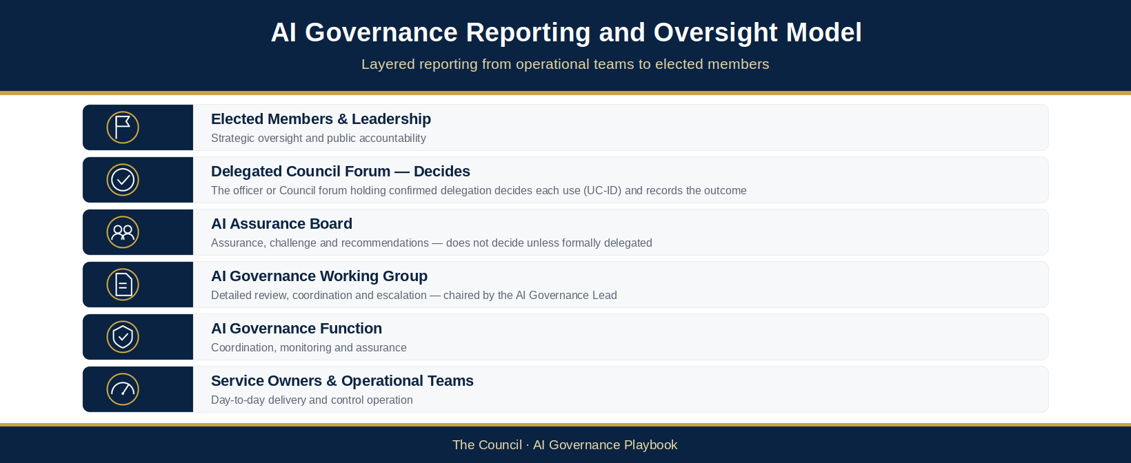
Figure 6.7: AI Governance Reporting and Oversight Model
This figure illustrates the flow of information between operational teams, assurance functions, governance groups and leadership bodies. It demonstrates how monitoring, compliance, assurance and incident management activities contribute to informed governance oversight and decision-making.

6.9.10 Supporting Informed Decision-Making
Reporting and governance oversight provide the mechanism through which The Council maintains visibility and control across its AI portfolio. By consolidating information from multiple sources and ensuring that it is reviewed through appropriate governance structures, The Council can identify emerging risks, monitor performance and support accountable decision-making.
Effective reporting strengthens transparency, supports assurance activities and enables leadership to make informed decisions regarding the deployment, operation and future development of AI capabilities. It is therefore a critical component of The Council’s Responsible AI Operating Model and a key enabler of sustainable governance maturity.
The following section examines how The Council will periodically review the effectiveness of its AI governance framework to ensure that governance arrangements remain appropriate, proportionate and fit for purpose as AI adoption continues to evolve.

6.10 Governance Effectiveness Reviews
The successful governance of Artificial Intelligence (AI) requires more than the implementation of policies, controls and oversight mechanisms. Governance arrangements must also be periodically reviewed to ensure that they remain effective, proportionate and aligned with The Council’s strategic objectives, regulatory obligations and evolving risk landscape.
As AI technologies continue to develop and organisational use cases become more sophisticated, governance frameworks must adapt accordingly. Structures and processes that are appropriate today may become less effective as technology capabilities mature, regulatory expectations evolve and organisational reliance on AI increases. Regular governance effectiveness reviews provide the mechanism through which The Council can assess whether its AI Governance and Responsible AI Operating Model continues to meet organisational needs and support responsible AI adoption.
The purpose of governance effectiveness reviews is not simply to evaluate compliance with existing arrangements. Rather, they provide an opportunity to assess whether governance structures are achieving their intended outcomes, supporting informed decision-making and enabling the organisation to manage AI-related opportunities and risks effectively.
This section establishes The Council’s approach to reviewing governance effectiveness and defines how these reviews contribute to continuous governance maturity.

6.10.1 Objectives of Governance Effectiveness Reviews
Governance effectiveness reviews are designed to provide assurance that The Council’s AI governance arrangements remain fit for purpose.
The primary objectives are to:
- Assess the effectiveness of governance structures and decision-making arrangements.
- Evaluate whether governance responsibilities remain clear and appropriate.
- Determine whether governance controls are operating as intended.
- Review the effectiveness of risk management and assurance activities.
- Identify opportunities to improve governance capability and maturity.
- Ensure continued alignment with organisational priorities and regulatory expectations.
Governance reviews should support both accountability and continuous improvement by providing an evidence-based assessment of governance performance.

6.10.2 Scope of Governance Reviews
Governance effectiveness reviews should consider the operation of the AI Governance and Responsible AI Operating Model as a whole.
Areas of review may include:

6.10.2.1 Governance Structures
Assessment of whether governance bodies continue to operate effectively and provide appropriate oversight.
Considerations may include:
- Committee effectiveness
- Decision-making processes
- Terms of reference
- Escalation arrangements
- Reporting structures

6.10.2.2 Roles and Responsibilities
Assessment of whether accountability arrangements remain clear and consistently applied.
Considerations may include:
- Ownership of AI systems
- Governance responsibilities
- Decision-making authority
- Accountability for risk management
- Oversight responsibilities

6.10.2.3 Policy and Standards Framework
Assessment of whether policies, standards and guidance remain current, relevant and effective.
Considerations may include:
- Policy coverage
- Alignment with emerging requirements
- Ease of implementation
- Policy compliance levels

6.10.2.4 Risk Management Arrangements
Assessment of whether AI-related risks are being effectively identified, assessed and managed.
Considerations may include:
- Risk assessment processes
- Risk reporting
- Risk treatment effectiveness
- Emerging risk identification

6.10.2.5 Assurance and Monitoring Activities
Assessment of whether assurance mechanisms provide sufficient visibility and confidence regarding governance effectiveness.
Considerations may include:
- Monitoring arrangements
- Compliance activities
- Audit outcomes
- Assurance coverage
- Incident management effectiveness
The review should provide a holistic assessment of governance performance rather than focusing solely on individual controls or processes.

6.10.3 Indicators of Governance Effectiveness
The Council may utilise a range of qualitative and quantitative indicators when assessing governance effectiveness.
Examples may include:
- Compliance levels
- Audit findings
- Assurance outcomes
- Incident trends
- Risk management performance
- Policy adoption rates
- Training completion rates
- Stakeholder feedback
- Governance action completion rates
- Benefits realisation outcomes
These indicators provide evidence regarding whether governance arrangements are functioning as intended and delivering expected outcomes.

6.10.4 Governance Maturity Assessment
As part of periodic reviews, The Council should assess the maturity of its AI governance capability.
Governance maturity assessment helps the organisation understand its current state, identify improvement opportunities and monitor progress over time.
Areas of maturity assessment may include:
- Governance and oversight
- Risk management
- Responsible AI implementation
- Assurance capability
- Compliance management
- Monitoring and reporting
- Organisational capability and culture
- Supplier governance
Maturity assessments should focus on both governance effectiveness and the organisation’s ability to sustain and scale responsible AI adoption.
The AI Governance Maturity Framework (§7.6) provides the structure through which these assessments can be conducted.

6.10.5 Review Frequency
Governance effectiveness reviews should be conducted periodically to ensure that governance arrangements remain current and effective.
As a minimum, The Council should undertake a formal review of the AI Governance and Responsible AI Operating Model on an annual basis.
Additional reviews may be triggered by:
- Significant regulatory developments
- Major organisational changes
- Material governance incidents
- Significant assurance findings
- Introduction of high-risk AI systems
- Changes in organisational risk appetite
- Emerging technology developments
This approach ensures that governance arrangements remain responsive to changing circumstances and emerging risks.

6.10.6 Review Outcomes and Improvement Planning
The output of a governance effectiveness review should include a clear assessment of strengths, weaknesses and improvement opportunities.
Review outcomes may include:
- Governance observations
- Areas of effective practice
- Identified gaps
- Emerging risks
- Maturity assessment findings
- Recommendations for improvement
Where improvement actions are identified, these should be documented, prioritised and assigned to accountable owners.
Progress against improvement plans should be monitored through established governance arrangements.
The objective is to ensure that review findings lead to measurable governance improvements rather than remaining as standalone assessments.

6.10.7 Reporting and Oversight
The results of governance effectiveness reviews should be reported through The Council’s governance framework.
Reporting should provide visibility of:
- Overall governance effectiveness
- Significant findings
- Maturity assessment outcomes
- Improvement priorities
- Progress against previous review recommendations
The AI Governance Working Group should review findings and coordinate improvement activities.
The AI Assurance Board should receive periodic reports regarding governance effectiveness and make recommendations on future governance development.
This oversight ensures that governance performance remains visible at the appropriate levels of organisational leadership.
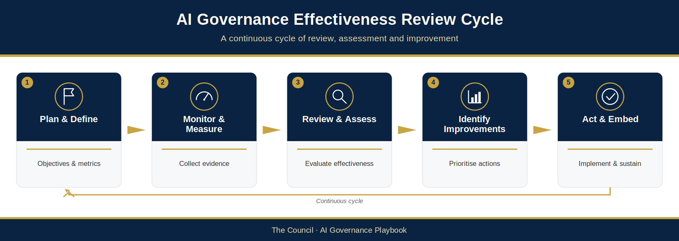
Figure 6.8: AI Governance Effectiveness Review Cycle
This figure illustrates The Council’s governance review process, demonstrating how monitoring, assurance, audit findings, incident management and maturity assessments contribute to periodic governance reviews and continuous improvement activities.

6.10.8 Governance Review Cycle
Effective AI governance requires regular oversight, assurance and review activities to ensure that governance arrangements remain proportionate, effective and aligned with The Council’s strategic objectives, legal obligations and Responsible AI principles.
The following governance cycle establishes the minimum review and oversight activities required under The Council’s AI Governance Framework.
Activity | Frequency | Owner
AI Register Review | Quarterly | AI Governance Lead
AI Governance Working Group Meeting | Quarterly | Chair, AI Governance Working Group
AI Assurance Board Meeting | Quarterly | Chair, AI Assurance Board
Low-Risk Use Review | As §6.4.4 | AI System Owner (or Service Owner where none is named)
Medium-Risk Use Review | As §6.4.4 | AI Governance Working Group
High-Risk Use Review | As §6.4.4 | AI Governance Lead
Critical-Risk Use Review | As §6.4.4 | AI Governance Lead (reported to each AI Assurance Board meeting)
Governance Performance Reporting | Quarterly | AI Governance Lead
Governance Effectiveness Review | Annually | AI Governance Lead
AI Governance Maturity Assessment | Annually | AI Governance Lead
Framework and Policy Review | Framework annually; each policy at least every two years (§5.1.2) | AI Governance Lead (AI Assurance Board assurance; adoption by the competent Council authority)
Training and Awareness Review | Annually | AI Governance Lead
Incident Response Tabletop Exercise | Annually | AI Governance Lead
Governance reviews may be conducted more frequently where risk levels, incidents, regulatory developments or organisational priorities require additional oversight.
Outputs from governance reviews should be incorporated into The Council’s continuous improvement activities, governance roadmap, capability development initiatives and future maturity assessments.

6.10.9 Ensuring Governance Remains Fit for Purpose
Governance effectiveness reviews provide The Council with a structured mechanism for evaluating and strengthening its AI governance arrangements over time. They help ensure that governance structures remain aligned with organisational priorities, capable of addressing emerging risks and responsive to an evolving regulatory and technological landscape.
By embedding periodic review into the AI Governance and Responsible AI Operating Model, The Council can maintain confidence that its governance arrangements continue to support safe, lawful, ethical and effective AI adoption. These reviews also provide a critical bridge between assurance activities and continuous improvement, ensuring that lessons learned are translated into meaningful governance enhancements.
Chapter 7, and in particular the AI Governance Maturity Framework (§7.6), explores how The Council will embed continuous improvement across its AI governance framework and support the long-term evolution of Responsible AI capability throughout the organisation.

6.11 Chapter Summary
This chapter has established The Council’s approach to AI assurance, monitoring and continuous oversight, providing the mechanisms through which The Council can maintain confidence in the safe, lawful and effective operation of AI systems throughout their lifecycle.
The preceding chapters defined The Council’s AI Governance and Responsible AI Operating Model, established governance structures and responsibilities, and introduced the controls required to support responsible AI adoption. This chapter has built upon those foundations by defining how governance effectiveness will be monitored, assessed and continuously improved over time.
A central theme of this chapter is that AI governance does not end at deployment. AI systems operate within dynamic environments where data, user behaviour, operational requirements and regulatory expectations may change. As a result, governance must extend beyond initial approval and incorporate ongoing assurance activities that provide visibility of performance, risk and compliance throughout the operational life of an AI system.
The Council AI Assurance Framework provides the structure through which this oversight is achieved. By integrating governance, risk, compliance, operational and independent assurance, it enables The Council to verify that each approved use (UC-ID) stays within its approved scope and conditions and that shared controls continue to work.
Performance monitoring plays a critical role within this framework. Continuous monitoring enables The Council to assess operational effectiveness, identify emerging risks, evaluate Responsible AI outcomes and measure the realisation of expected benefits. Through proportionate monitoring arrangements, The Council can maintain visibility of AI performance and respond appropriately when issues arise.
The chapter has also highlighted the importance of managing model drift and performance degradation. As AI systems evolve over time, governance arrangements must provide mechanisms for detecting deterioration, assessing impacts and implementing corrective actions where necessary. These activities help ensure that AI systems remain aligned with their intended purpose and continue to support organisational objectives.
Compliance monitoring represents another essential component of responsible AI governance. Ongoing oversight of legal, regulatory and policy obligations helps ensure that AI systems continue to operate lawfully, ethically and in accordance with The Council’s public-service responsibilities. By maintaining visibility of compliance requirements and emerging regulatory developments, The Council can strengthen accountability and maintain public confidence in its use of AI.
Independent assurance and Internal Audit provide an additional layer of confidence by offering objective challenge and review of governance arrangements. These activities support transparency, validate control effectiveness and identify opportunities for governance improvement. Independent assurance is a key component of governance maturity and an important mechanism for demonstrating accountability to leadership, elected members, regulators and residents.
The chapter has further established The Council’s approach to AI incident management, recognising that issues may arise despite robust governance controls. Through structured reporting, investigation, escalation and remediation processes, The Council can respond effectively to incidents, minimise potential harm and ensure that lessons learned contribute to stronger governance practices in the future.
Effective reporting and governance oversight bring together information from monitoring, assurance, compliance and incident management activities to support informed decision-making. By providing leadership with clear visibility of risks, performance and governance effectiveness, The Council can maintain strategic oversight of its AI portfolio and ensure that governance remains aligned with organisational objectives.
Finally, this chapter has emphasised the importance of governance effectiveness reviews and continuous improvement. Responsible AI governance must remain adaptive and responsive to changing circumstances. By embedding regular review, organisational learning and structured improvement activities within its governance framework, The Council can strengthen governance maturity and ensure that its Responsible AI Operating Model continues to evolve alongside technology, regulation and organisational need.
Together, the assurance, monitoring and oversight arrangements described in this chapter provide the foundation for maintaining confidence in The Council’s use of AI. They support transparency, accountability and public trust while enabling The Council to pursue innovation in a responsible and controlled manner.
The final chapter of this playbook focuses on the people, skills, culture and organisational capabilities required to sustain Responsible AI adoption over the long term. It explores how The Council can build governance maturity, strengthen AI capability and create the cultural foundations necessary to support the successful and responsible use of AI across the organisation.

Chapter 7 — People, Capability and Governance Maturity

7.1 Introduction
The governance effectiveness reviews, assurance activities and continuous improvement processes described in Chapter 6 provide The Council with mechanisms for evaluating the effectiveness of its Artificial Intelligence (AI) governance arrangements. However, understanding whether governance activities are functioning effectively is only one component of long-term governance success. The Council must also assess the maturity of its AI governance capability, identify areas for improvement and establish a structured pathway for capability development.
The successful adoption of AI depends on more than technology, governance frameworks and risk management processes. Those structures, set out in earlier chapters, cannot ensure good outcomes on their own. Effective AI governance needs employees who understand how AI should be used, leaders who can provide informed oversight and a culture that promotes accountability, transparency and responsible innovation. Human judgement remains essential, and accountability for outcomes rests with individuals and governance bodies, not with the technology. Building this capability is therefore a core part of The Council’s AI Governance and Responsible AI Operating Model.
As AI technologies become increasingly embedded within public services, the skills required to govern, deploy and use AI effectively will continue to evolve. Employees will need to develop new capabilities, managers will need to understand emerging risks and opportunities, and governance bodies will need to make decisions in an environment characterised by rapid technological change. Building these capabilities requires a structured and sustained organisational approach.
The public sector faces a particular challenge in this regard. Local authorities must balance innovation and service improvement with public accountability, regulatory obligations and the need to maintain public trust. AI governance is therefore not solely a technical discipline. It is an organisational capability that requires collaboration between service teams, governance functions, technology specialists, leadership teams and elected representatives.
This chapter focuses on the people, skills and cultural foundations required to sustain responsible AI adoption over the long term. It establishes The Council’s approach to capability development, training and awareness, leadership accountability, organisational change and governance maturity. It also introduces The Council’s AI Governance Maturity Framework, which provides a structured approach for assessing governance capability, measuring progress over time and prioritising improvement activities.
The objective is not simply to increase awareness of AI technologies. Rather, it is to build an organisation that can confidently adopt, govern and utilise AI in a manner that aligns with The Council’s values, supports public trust and delivers meaningful benefits for residents and communities.
By investing in capability, fostering a culture of responsible innovation and continuously strengthening governance maturity, The Council can position itself to realise the opportunities presented by AI while maintaining the high standards of accountability, transparency and public service that underpin its mission. The maturity framework and implementation roadmap presented in this chapter should be used alongside governance effectiveness reviews, assurance activities and strategic planning processes to support the continued evolution of The Council’s AI governance capability.

7.2 The Human Dimension of AI Governance
Despite rapid advances in AI capability, responsibility for governance, decision-making and accountability remains human.
A common misconception surrounding AI is that responsibility can be delegated to technology. In reality, AI systems do not possess accountability, judgement, ethical reasoning or legal responsibility. They generate outputs, recommendations and predictions based upon data and algorithms, but they do not assume responsibility for the consequences of those outputs. Accountability remains with the individuals, teams and governance bodies that design, procure, deploy, oversee and use AI systems.
For The Council, this principle is fundamental to the Responsible AI Operating Model. AI should support and enhance human decision-making, not replace accountability for decisions that affect residents, communities, employees or public services. The Council’s approach to AI governance is therefore founded on the principle that humans remain responsible for outcomes, irrespective of the level of automation involved.
This principle becomes increasingly important as AI capabilities become more sophisticated and integrated into operational processes. The more capable AI systems become, the greater the need for effective human oversight, informed governance and responsible organisational culture.

7.2.1 Human Accountability in AI Governance
Accountability is one of the core principles underpinning The Council’s Responsible AI approach.
Regardless of whether an AI system is developed internally, procured from a supplier or accessed through a third-party platform, responsibility for its use remains with The Council.
This means that individuals responsible for AI systems must be able to:
- Understand the purpose of the system.
- Understand the associated risks.
- Monitor system performance.
- Challenge outputs where appropriate.
- Escalate concerns.
- Ensure compliance with governance requirements.
- Take corrective action when required.
Governance arrangements should therefore be designed to ensure that accountability is always clearly assigned and understood.
The principle of accountability applies across all levels of the organisation, from operational users through to senior leadership and governance bodies.

7.2.2 Human Oversight and Decision-Making
Human oversight is a critical safeguard within responsible AI governance.
While AI can support analysis, automate routine activities and assist decision-making, there must remain an appropriate level of human involvement in the operation and oversight of AI systems.
The extent of human oversight should be proportionate to the nature, complexity and risk tier of the use.
For Low- and Medium-risk uses, oversight may involve periodic review of outputs and monitoring activities.
For High- and Critical-risk uses, the human oversight requirements in §4.2.4 and §4.7.7 apply.
The objective is to ensure that human judgement remains present where decisions may have significant operational, legal, financial or societal consequences.
Human oversight also provides an important mechanism for identifying unexpected outcomes, emerging risks and circumstances where AI outputs may not be appropriate.

7.2.3 Professional Judgement and Critical Thinking
Responsible AI governance requires more than compliance with policies and procedures. It also requires individuals to exercise professional judgement and critical thinking.
Users should not assume that AI outputs are always accurate, complete or appropriate.
Instead, individuals should be encouraged to:
- Question outputs where necessary.
- Consider context and professional expertise.
- Assess whether recommendations are reasonable.
- Challenge unexpected results.
- Escalate concerns when confidence is low.
AI should support informed decision-making rather than replace professional judgement.
Maintaining this balance is particularly important within public services, where decisions may affect vulnerable individuals, community outcomes and public trust.

7.2.4 Trust, Confidence and Responsible Use
The successful adoption of AI depends upon trust.
Employees must have confidence that AI systems are governed appropriately and can be used safely and responsibly. Similarly, residents and service users must have confidence that AI is being deployed in a manner that respects fairness, transparency and accountability.
Trust should not be based on assumptions regarding technology capability. Rather, it should be built through:
- Effective governance.
- Transparent decision-making.
- Clear accountability.
- Robust assurance.
- Responsible operational practices.
- Open communication.
Trust is strengthened when people understand both the opportunities and limitations of AI technologies.
For this reason, The Council’s approach emphasises education, awareness and informed use rather than blind reliance on automation.

7.2.5 The Relationship Between Technology, Governance and Culture
Responsible AI adoption requires the interaction of three interconnected elements:

7.2.5.1 Technology
The AI systems, tools and platforms used to support organisational objectives.

7.2.5.2 Governance
The policies, controls, accountability arrangements and oversight mechanisms that guide AI adoption.

7.2.5.3 Culture
The behaviours, values and attitudes that influence how individuals use and govern AI in practice.
All three elements are required for successful AI adoption.
Technology without governance may create unmanaged risk.
Governance without organisational capability may create compliance obligations that are difficult to implement.
Technology and governance without an appropriate culture may lead to inconsistent behaviours, poor decision-making and reduced trust.
Sustainable AI adoption therefore requires a balanced approach that integrates technology, governance and organisational culture.

7.2.6 People at the Centre of Responsible AI
The Council’s Responsible AI Operating Model places people at the centre of AI governance.
Employees remain responsible for the decisions they make, leaders remain accountable for organisational outcomes and governance bodies remain responsible for oversight and assurance.
AI should be viewed as a tool that supports human capability rather than a replacement for human responsibility.
This principle informs all aspects of The Council’s approach to AI governance, including capability development, leadership accountability, risk management, assurance and organisational culture.
By maintaining a people-centred approach to AI adoption, The Council can ensure that innovation remains aligned with public-service values and that accountability remains clear as AI technologies continue to evolve.
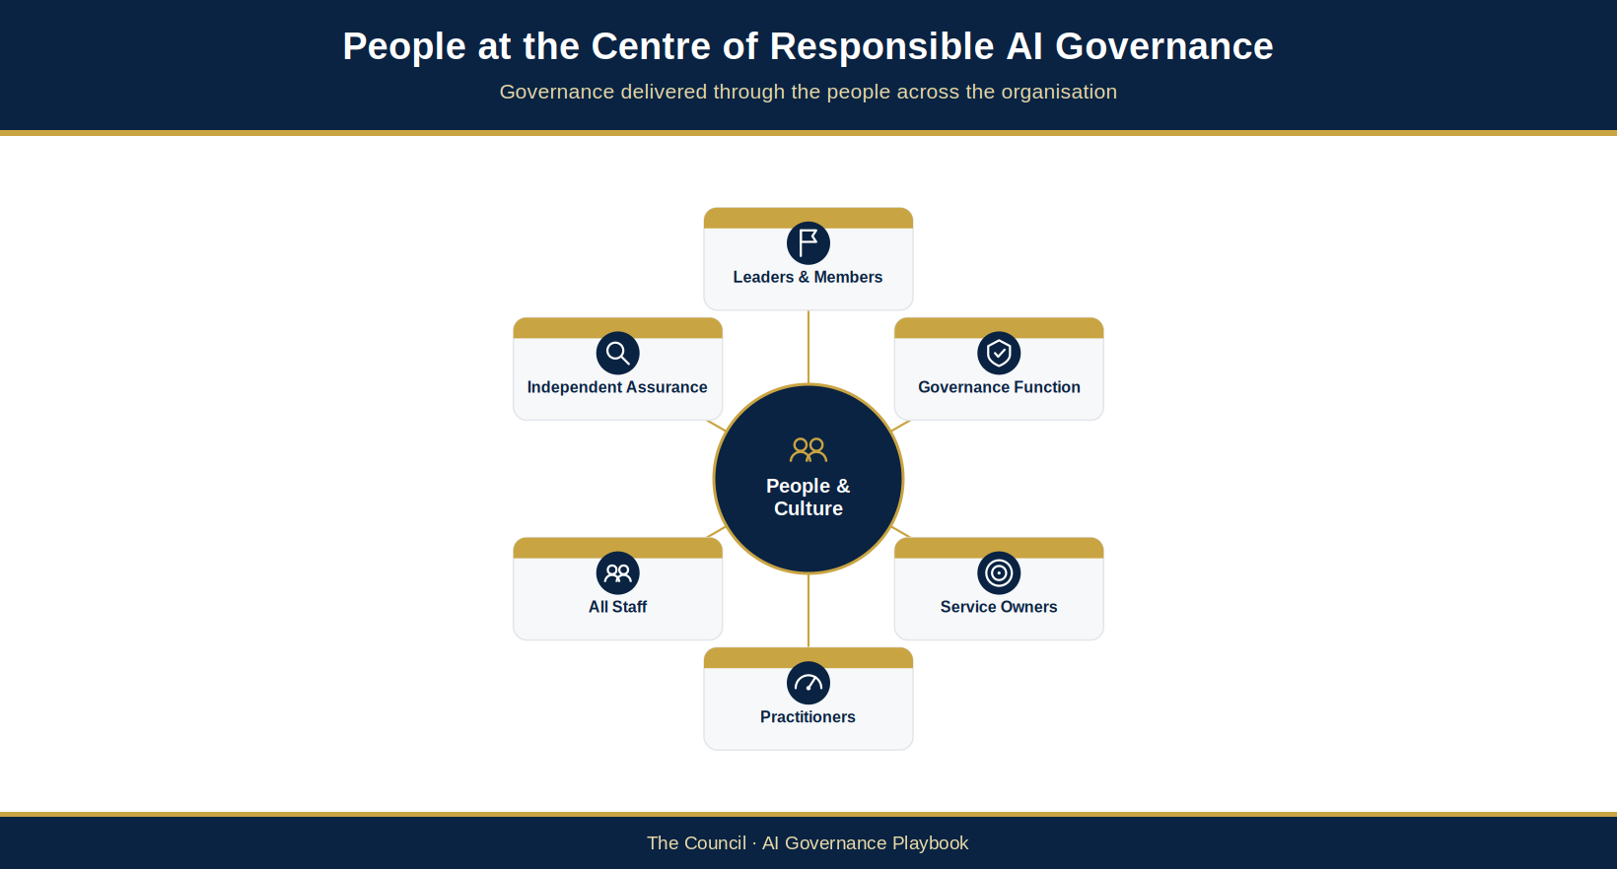
Figure 7.1: People at the Centre of Responsible AI Governance
This figure illustrates the relationship between people, governance and technology, demonstrating how human accountability, oversight and decision-making remain central to The Council’s Responsible AI Operating Model.

7.2.7 Establishing the Foundations for Capability Development
Recognising the central role of people in AI governance creates the foundation for developing organisational capability. To govern AI effectively, employees, managers and leaders must possess the knowledge, skills and confidence required to fulfil their responsibilities.
The following section introduces The Council’s AI Skills and Competency Framework and defines the capabilities required across different roles and levels of the organisation to support the successful adoption and governance of AI.

7.3 AI Skills and Competency Framework
As AI becomes increasingly integrated into service delivery, operational processes and decision-making activities, The Council must ensure that employees possess the capabilities necessary to use AI responsibly and effectively. Different roles within the organisation require different levels of understanding, ranging from general awareness of AI opportunities and risks through to specialist expertise in governance, risk management and technical implementation.
The purpose of The Council AI Skills and Competency Framework is to establish a structured and proportionate approach to capability development. The framework defines the competencies required across different roles and levels of responsibility and provides a foundation for training, professional development and governance maturity.
By establishing clear expectations regarding AI capability, The Council can strengthen accountability, improve governance effectiveness and support the safe and responsible adoption of AI across the organisation.

7.3.1 Principles of the Competency Framework
The Council AI Skills and Competency Framework is founded upon five key principles.

7.3.1.1 Proportionality
Capability requirements should be proportionate to an individual’s role, responsibilities and level of involvement with AI systems.
Not all employees require specialist technical expertise. However, all employees should possess an appropriate level of awareness regarding the opportunities, risks and governance expectations associated with AI.

7.3.1.2 Role-Based Capability
Competencies should reflect the responsibilities associated with different organisational roles.
The capabilities required by an occasional user of generative AI will differ significantly from those required by an AI System Owner, governance lead or technical specialist.

7.3.1.3 Continuous Learning
AI technologies continue to evolve rapidly. Competency development should therefore be viewed as an ongoing process rather than a one-time training activity.

7.3.1.4 Responsible AI by Design
Responsible AI principles should be embedded throughout capability development activities.
Training should address not only technical considerations but also governance, ethics, accountability, transparency and risk management.

7.3.1.5 Practical Application
Capability development should focus on the practical application of knowledge within The Council’s operational environment.
Employees should understand how governance requirements apply to their day-to-day responsibilities and decision-making activities.

7.3.2 The Council AI Competency Levels
The framework establishes five competency levels aligned to organisational roles and responsibilities.

7.3.2.1 Level 1 – AI Awareness
This level applies to all employees.
Individuals operating at this level should possess a basic understanding of:
- What AI is and how it may be used within The Council.
- The opportunities and benefits associated with AI.
- Key risks and limitations.
- Responsible AI principles.
- Acceptable use requirements.
- Escalation pathways for concerns or incidents.
The objective is to ensure that all employees can engage with AI technologies safely and responsibly.

7.3.2.2 Level 2 – AI User and Practitioner
This level applies to employees who regularly interact with AI tools or incorporate AI into operational activities.
Competencies may include:
- Effective use of approved AI tools.
- Understanding AI outputs and limitations.
- Prompt design and interaction techniques.
- Data protection and information handling requirements.
- Responsible use considerations.
- Identification and escalation of risks.
Individuals operating at this level should be able to use AI confidently while recognising when additional oversight or support may be required.

7.3.2.3 Level 3 – AI Owner and Manager
This level applies to Service Owners, AI System Owners, Service Managers and individuals responsible for overseeing AI-enabled services.
Competencies may include:
- AI governance requirements.
- Risk assessment processes.
- Performance monitoring responsibilities.
- Compliance obligations.
- Supplier management considerations.
- Incident management and escalation.
- Benefits realisation monitoring.
Individuals operating at this level should be capable of managing AI systems within The Council’s governance framework and ensuring that appropriate controls remain in place.

7.3.2.4 Level 4 – AI Specialist
This level applies to technical specialists and subject matter experts involved in the design, implementation, integration or governance of AI systems.
Competencies may include:
- AI technologies and architectures.
- Model performance considerations.
- Data governance requirements.
- Responsible AI implementation.
- Technical risk assessment.
- Assurance and monitoring methodologies.
- Supplier evaluation and technical due diligence.
Specialists provide expertise that supports governance decision-making and the effective implementation of AI solutions.

7.3.2.5 Level 5 – Strategic AI Leadership
This level applies to senior leaders, governance leads and individuals responsible for strategic oversight of AI adoption.
Competencies may include:
- Strategic AI governance.
- Organisational risk management.
- Regulatory developments.
- Responsible AI leadership.
- Governance maturity assessment.
- Assurance and accountability frameworks.
- AI strategy and transformation.
Individuals operating at this level should be capable of providing leadership, oversight and direction regarding The Council’s AI ambitions and governance priorities.

7.3.3 Competency Areas
The competency framework incorporates several common capability domains that may apply across multiple levels.

7.3.3.1 AI Literacy
Understanding fundamental AI concepts, terminology, opportunities and limitations.

7.3.3.2 Governance and Accountability
Understanding governance structures, responsibilities and decision-making requirements.

7.3.3.3 Risk Management
Understanding AI-related risks and the mechanisms used to manage them.

7.3.3.4 Responsible AI
Understanding fairness, transparency, accountability, explainability and ethical considerations.

7.3.3.5 Data and Information Governance
Understanding data protection obligations, information governance requirements and responsible data practices.

7.3.3.6 Security and Resilience
Understanding cyber security risks, operational resilience and control requirements.

7.3.3.7 Operational Application
Understanding how AI can be applied effectively within service delivery and organisational processes.
The depth of knowledge required within each competency area should vary according to role and responsibility.

7.3.4 Competency Assessment
The Council should establish mechanisms for assessing and maintaining AI capability across the organisation.
Assessment approaches may include:
- Training completion records.
- Self-assessments.
- Knowledge assessments.
- Professional development reviews.
- Role-specific accreditation requirements.
- Governance capability reviews.
Competency assessment helps ensure that individuals possess the knowledge required to fulfil their responsibilities effectively.
It also supports workforce planning and identifies areas where additional training or support may be required.

7.3.5 Embedding Capability Across the Organisation
Capability development should not be limited to technology teams or governance specialists.
AI adoption affects a wide range of functions across the organisation, including operational services, corporate functions, leadership teams and governance bodies.
The Council should therefore seek to embed AI capability across all parts of the organisation through:
- Awareness initiatives.
- Role-specific learning pathways.
- Leadership development programmes.
- Continuous professional development.
This approach helps create a shared understanding of AI governance and supports consistent application of Responsible AI principles across the organisation. Figure 7.2 shows the five capability themes of the framework. These themes group the competency areas in §7.3.3 and apply at each of the five levels in §7.3.2.
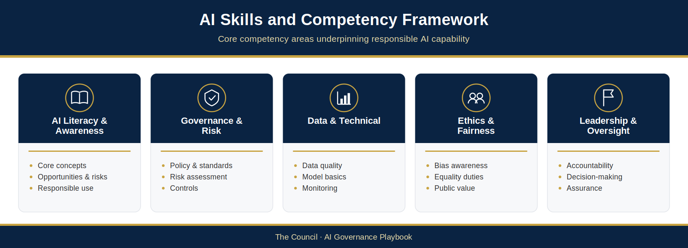
Figure 7.2: The five capability themes of the AI Skills and Competency Framework
The themes are AI Literacy & Awareness, Governance & Risk, Data & Technical, Ethics & Fairness, and Leadership & Oversight. The depth of knowledge needed in each theme increases with role, accountability and involvement in AI-related activities.

7.4 Training and Awareness Programme
While the AI Skills and Competency Framework (§7.3) defines the capabilities each role needs, the training and awareness programme is how The Council develops and maintains them.
Training is a critical component of The Council’s Responsible AI Operating Model. It helps ensure that individuals understand their responsibilities, recognise potential risks, comply with governance requirements and apply AI technologies appropriately within their areas of work. Effective training also supports organisational confidence by helping employees understand both the opportunities and limitations associated with AI-enabled tools and services.
As AI technologies continue to evolve, capability development cannot be treated as a one-time activity. The Council’s approach therefore emphasises continuous learning, practical application and ongoing awareness to ensure that knowledge remains current and relevant.
The purpose of this section is to establish The Council’s approach to AI training and awareness and define how capability development will support responsible AI adoption across the organisation.

7.4.1 Objectives of the Training and Awareness Programme
The Council’s AI Training and Awareness Programme is designed to achieve several key objectives:
- Develop organisational understanding of AI technologies.
- Support compliance with governance and policy requirements.
- Promote responsible and ethical AI use.
- Strengthen accountability and risk awareness.
- Build confidence in the use of approved AI tools and services.
- Support governance maturity and organisational capability development.
The programme should ensure that employees are equipped not only to use AI technologies effectively but also to understand when additional oversight, review or escalation may be required.

7.4.2 Training Principles
The design and delivery of training activities should be guided by several core principles.

7.4.2.1 Role-Based Learning
Training should be aligned with the responsibilities and competency requirements associated with specific roles.
Different learning pathways should be developed for:
- General employees
- Operational users
- Managers and supervisors
- AI System Owners
- Service Owners
- Governance and assurance professionals
- Technical specialists
- Senior leaders
This approach ensures that training remains relevant, practical and proportionate.

7.4.2.2 Continuous Learning
Given the pace of technological change, AI capability development should be viewed as an ongoing process.
Training programmes should be reviewed and updated regularly to reflect:
- Emerging technologies
- Regulatory developments
- Organisational learning
- New governance requirements
- Changes in The Council’s AI portfolio

7.4.2.3 Practical Application
Training should focus on real-world scenarios and practical application within The Council’s operational context.
Employees should understand how governance principles, policies and controls apply to their day-to-day responsibilities.

7.4.2.4 Accessibility and Inclusion
Training should be accessible to all employees and designed to accommodate different learning styles, experience levels and professional backgrounds.
Capability development should support inclusive participation in The Council’s AI transformation journey.

7.4.3 Core Training Modules
The Council will provide the following core training modules, aligned to organisational needs and competency levels. They deliver the mandatory programmes in §5.9.1: modules 7.4.3.1, 7.4.3.3 and 7.4.3.4 form the baseline AI Awareness Training (mandatory for all staff who use AI systems and available to all staff); module 7.4.3.2 with 7.4.3.5 forms the Responsible AI Training programme (mandatory for Service Owners and staff involved in AI procurement, deployment or governance); and modules 7.4.3.5 and 7.4.3.6 form the AI Governance for Managers programme (mandatory for managers with staff using AI systems). Module 7.4.3.6 also provides the governance body training in §5.9.3. Training completion is recorded in The Council’s learning management system. Required competence is set out in the AIMS Roles, Competence, Awareness and Communications Plan (AIG-AIMS-04).

7.4.3.1 Introduction to Artificial Intelligence
This foundational module should provide an overview of:
- What AI is
- Common AI technologies
- Opportunities and limitations
- AI within The Council
- The Council’s AI strategy and governance approach
This module should be available to all employees.

7.4.3.2 Responsible AI and Governance
This module should introduce:
- Responsible AI principles
- Accountability requirements
- Transparency considerations
- Fairness and inclusion
- Governance structures
- Escalation pathways
The objective is to ensure that employees understand how AI is governed within The Council.

7.4.3.3 AI Acceptable Use
This module should focus on:
- Approved AI tools
- Acceptable use requirements
- Information handling expectations
- Security considerations
- Risk awareness
- Reporting responsibilities
Completion of this training may be required before access to certain AI tools is granted.

7.4.3.4 Data Protection and Information Governance
This module should reinforce:
- Data protection obligations
- Privacy considerations
- Data classification requirements
- Secure information handling
- Information governance controls
The module should emphasise the specific risks associated with using AI technologies in data-rich environments.

7.4.3.5 AI Risk Management
This module should be targeted at managers, system owners and governance professionals.
Topics may include:
- Risk identification
- Risk assessment
- Risk treatment
- Monitoring requirements
- Incident management
- Governance controls

7.4.3.6 Leadership and Strategic Oversight
This module should support senior leaders and governance bodies in understanding:
- Strategic AI opportunities
- Organisational risks
- Governance responsibilities
- Assurance requirements
- Regulatory developments
- Governance maturity considerations
Leadership understanding is essential to ensuring informed oversight and effective decision-making.

7.4.4 Awareness and Engagement Activities
Formal training should be complemented by broader awareness and engagement initiatives.
Examples may include:
- Awareness campaigns
- Internal communications
- Workshops and seminars
- Learning events
- Guest speakers and expert sessions
These activities help maintain organisational awareness and encourage ongoing engagement with responsible AI practices.

7.4.5 Training for High- and Critical-Risk Uses
Where employees are involved in the operation, oversight or governance of High- or Critical-risk uses (see §4.2.4 and §4.7.7 for the oversight requirements), additional role-specific training may be required.
This may include:
- Enhanced governance requirements
- Advanced risk management practices
- Monitoring and assurance activities
- Incident management procedures
- Responsible AI assessments
- Regulatory obligations
The depth and frequency of training should be proportionate to the risk tier of the use.

7.4.6 Measuring Training Effectiveness
Training activities should be evaluated to ensure that they are achieving intended outcomes.
Measures may include:
- Completion rates
- Assessment results
- Employee feedback
- Confidence indicators
- Incident trends
- Compliance outcomes
- Governance maturity assessments
Monitoring effectiveness helps identify capability gaps and supports continuous improvement of the training programme.

7.4.7 Leadership Responsibility for Capability Development
Capability development is a shared organisational responsibility.
Managers and leaders should support employees to develop the knowledge and skills their roles need. The leadership responsibilities for capability development are set out in §7.5.2.
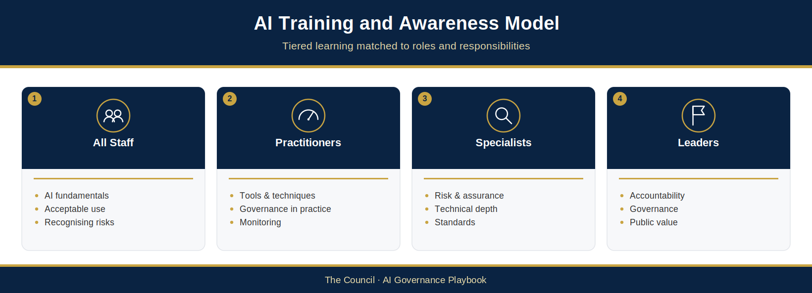
Figure 7.3: The four broad audiences for AI training (all staff, practitioners, specialists and leaders); the detailed pathways are listed in §7.4.2.1
Each audience follows the learning pathways and core modules suited to its role (§7.4.2.1 and §7.4.3).

7.5 Leadership, Culture and Responsible AI Behaviours
Governance frameworks define responsibilities and controls, but culture shapes how people apply them in practice.
A strong governance framework can be undermined by poor behaviours, unclear accountability or a lack of leadership engagement. Conversely, a positive organisational culture can strengthen governance effectiveness by encouraging responsible decision-making, transparency, collaboration and continuous learning.
As The Council expands its use of AI, leadership and organisational culture will play a critical role in ensuring that AI technologies are adopted in a manner that aligns with The Council’s values, supports public trust and delivers positive outcomes for residents and communities.
The purpose of this section is to establish The Council’s approach to leadership, culture and responsible AI behaviours and to define the organisational characteristics required to sustain effective AI governance over time.

7.5.1 The Importance of Culture in AI Governance
Governance frameworks provide structure, but culture determines how governance operates in practice.
Organisational culture influences:
- How risks are identified and managed.
- How governance requirements are applied.
- How individuals respond to ethical concerns.
- How incidents and mistakes are reported.
- How innovation is encouraged and managed.
- How accountability is exercised.
AI governance therefore depends upon creating an environment in which responsible behaviours are consistently encouraged, recognised and reinforced.
A strong Responsible AI culture helps ensure that governance principles become embedded within everyday decision-making rather than being viewed solely as compliance obligations.

7.5.2 Leadership Responsibility
Leadership commitment is essential to the successful implementation of The Council’s Responsible AI Operating Model.
Leaders set expectations, influence organisational priorities and play a critical role in establishing the behaviours that shape governance culture.
Senior leaders should:
- Demonstrate visible commitment to Responsible AI principles.
- Promote accountability and transparency.
- Support responsible innovation.
- Encourage informed risk management.
- Provide resources for capability development.
- Promote participation in training, professional development and opportunities for practical learning.
- Champion continuous improvement.
Leadership behaviours send important signals regarding organisational expectations and can significantly influence how governance requirements are interpreted and applied.
Effective leadership helps ensure that Responsible AI is viewed as a strategic organisational priority rather than a purely technical or compliance-related activity.

7.5.3 Creating a Culture of Responsible Innovation
Innovation and governance are often incorrectly presented as competing objectives.
In reality, effective governance enables innovation by providing the confidence, controls and accountability required to adopt new technologies responsibly.
The Council should foster a culture in which employees are encouraged to explore AI opportunities while remaining mindful of governance obligations and potential risks.
A culture of responsible innovation should encourage:
- Curiosity and learning.
- Experimentation within approved boundaries.
- Open discussion of risks and opportunities.
- Collaboration across services and functions.
- Evidence-based decision-making.
- Continuous improvement.
Employees should feel confident exploring innovative ideas while understanding that innovation must occur within an appropriate governance framework.

7.5.4 Psychological Safety and Open Reporting
Responsible governance relies on the willingness of individuals to raise concerns, report incidents and challenge decisions where appropriate.
The Council should seek to create an environment in which employees feel able to:
- Report issues without fear of blame.
- Escalate concerns regarding AI systems.
- Challenge outputs that appear inappropriate.
- Discuss governance weaknesses openly.
- Share lessons learned from mistakes.
This concept, often referred to as psychological safety, is an important enabler of effective governance.
When employees feel comfortable reporting concerns, risks are more likely to be identified early and addressed before they result in significant harm or organisational impact.
A culture that discourages challenge or suppresses concerns may increase governance risk and reduce organisational resilience.

7.5.5 Ethical Decision-Making and Professional Responsibility
The use of AI frequently requires individuals to exercise judgement in situations where there may not be a clear or straightforward answer.
Employees and managers should therefore be encouraged to consider:
- The potential impact of decisions.
- Fairness and inclusion implications.
- Transparency expectations.
- Public trust considerations.
- Organisational values.
- Professional obligations.
Responsible AI governance requires individuals to think critically about how technology is being applied and whether outcomes align with The Council’s responsibilities as a public authority.
Ethical decision-making should complement governance controls rather than replace them.
Together, they provide a balanced approach to responsible AI adoption.

7.5.6 Encouraging Cross-Functional Collaboration
AI governance is inherently multidisciplinary.
Effective oversight requires collaboration between:
- Service teams
- Technology teams
- Information Governance
- Data Protection
- Legal Services
- Procurement
- Risk Management
- Internal Audit
- Corporate Governance functions
No single team possesses all the expertise required to govern AI effectively.
The Council should therefore promote collaboration and knowledge sharing across organisational boundaries.
Cross-functional engagement helps ensure that governance decisions reflect a broad range of perspectives and expertise.
It also supports more effective identification of risks, opportunities and unintended consequences.

7.5.7 Embedding Responsible AI Behaviours
Responsible AI principles should be reflected in day-to-day organisational behaviours.
Examples of desired behaviours include:

7.5.7.1 Accountability
Taking ownership of decisions, actions and outcomes.

7.5.7.2 Transparency
Being open about how AI is used and how decisions are made.

7.5.7.3 Curiosity
Seeking to understand AI technologies, opportunities and limitations.

7.5.7.4 Challenge
Questioning assumptions and escalating concerns when appropriate.

7.5.7.5 Collaboration
Working across teams to support responsible AI adoption.

7.5.7.6 Learning
Sharing knowledge and continuously improving governance practices.
These behaviours help translate governance principles into practical actions across the organisation.

7.5.8 Recognising and Reinforcing Positive Behaviours
Organisational culture is strengthened when desired behaviours are recognised and reinforced.
The Council may encourage responsible AI behaviours through:
- Leadership communications.
- Recognition programmes.
- Communities of practice.
- Knowledge-sharing activities.
- Professional development opportunities.
- Inclusion within governance and performance discussions.
Recognising positive behaviours helps reinforce organisational expectations and supports long-term cultural change.
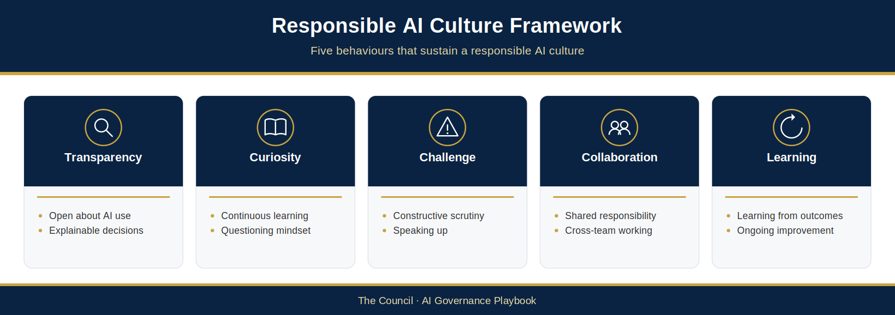
Figure 7.4: Responsible AI Culture Framework
This figure illustrates the relationship between leadership, culture, behaviours and governance outcomes. It demonstrates how leadership commitment, organisational values and responsible behaviours contribute to effective AI governance and sustained public trust.

7.6 AI Governance Maturity Framework
AI governance is not a one-time activity: as The Council’s use of AI grows, its governance arrangements must mature with it.
Governance maturity reflects an organisation’s ability to consistently govern AI in a structured, effective and sustainable manner. Mature organisations move beyond basic compliance activities and develop integrated governance capabilities that support strategic decision-making, organisational learning and responsible innovation.
The purpose of The Council AI Governance Maturity Framework is to provide a structured mechanism for assessing governance capability, identifying areas for improvement and supporting long-term capability development. The framework enables The Council to understand its current level of maturity, establish future aspirations and prioritise investment in governance, skills and organisational capability.
The framework is intended to support continuous improvement rather than compliance alone. It provides a practical tool for measuring progress and ensuring that governance arrangements remain aligned with The Council’s strategic ambitions and public-service responsibilities.

7.6.1 Objectives of the Maturity Framework
The Council AI Governance Maturity Framework is designed to:
- Assess the effectiveness of AI governance capabilities.
- Identify strengths and improvement opportunities.
- Support governance planning and prioritisation.
- Inform capability development activities.
- Measure governance progress over time.
- Support continuous improvement and organisational learning.
- Provide evidence of governance capability to stakeholders and assurance functions.
The framework should be used as a management tool rather than an audit checklist.
Its purpose is to enable improvement and strategic planning rather than to assign scores for compliance purposes.

7.6.2 Governance Maturity Levels
The framework defines five levels of governance maturity.
Each level represents an increasing degree of organisational capability, consistency and integration.

7.6.2.1 Level 1 – Initial
AI activities are largely informal and decentralised.
Characteristics may include:
- Limited governance arrangements.
- Ad hoc use of AI technologies.
- Minimal oversight.
- Inconsistent documentation.
- Limited awareness of AI-related risks.
- Reactive management of issues.
At this stage, governance relies heavily on individual initiative and informal practices.

7.6.2.2 Level 2 – Developing
Foundational governance arrangements have been established.
Characteristics may include:
- Basic policies and guidance.
- Initial governance structures.
- Emerging risk management processes.
- Early training and awareness activities.
- Initial AI inventory or register.
- Increasing leadership awareness.
Governance activities are becoming more structured but may still be applied inconsistently across the organisation.

7.6.2.3 Level 3 – Defined
Governance processes are documented, implemented and operating consistently.
Characteristics may include:
- Formal governance framework.
- Defined roles and responsibilities.
- Risk-based decision-making.
- Established assurance activities.
- Structured monitoring and reporting.
- Consistent application of Responsible AI principles.
At this level, governance is embedded within organisational processes and supported by clear accountability arrangements.

7.6.2.4 Level 4 – Managed
Governance effectiveness is actively measured and managed.
Characteristics may include:
- Performance metrics and governance indicators.
- Integrated assurance activities.
- Governance effectiveness reviews.
- Advanced monitoring capabilities.
- Organisational learning mechanisms.
- Mature supplier governance.
- Data-driven governance decision-making.
Governance becomes increasingly proactive and evidence-based.

7.6.2.5 Level 5 – Optimised
AI governance is fully integrated into organisational strategy, culture and decision-making.
Characteristics may include:
- Continuous governance improvement.
- Advanced organisational capability.
- Strong Responsible AI culture.
- Predictive risk management approaches.
- Strategic use of governance intelligence.
- High levels of transparency and accountability.
- Sector-leading governance practices.
At this level, governance supports innovation while maintaining robust accountability and public trust.

7.6.3 Governance Capability Domains
Governance maturity should be assessed across seven capability domains.

7.6.3.1 Governance and Oversight
Assessment of governance structures, accountability arrangements and decision-making processes.
Areas may include:
- Governance bodies
- Roles and responsibilities
- Escalation pathways
- Strategic oversight

7.6.3.2 Policy and Standards
Assessment of governance documentation and organisational guidance.
Areas may include:
- Policy framework
- Standards and procedures
- Responsible AI requirements
- Documentation quality

7.6.3.3 Risk Management
Assessment of AI risk management capability.
Areas may include:
- Risk identification
- Risk assessment
- Risk treatment
- Risk reporting

7.6.3.4 Assurance and Compliance
Assessment of oversight and assurance activities.
Areas may include:
- Monitoring
- Compliance activities
- Internal Audit
- Independent assurance

7.6.3.5 People and Capability
Assessment of workforce capability and governance knowledge.
Areas may include:
- Skills and competencies
- Training and awareness
- Leadership capability
- Knowledge sharing

7.6.3.6 Culture and Responsible AI
Assessment of organisational behaviours and governance culture.
Areas may include:
- Accountability
- Transparency
- Ethical decision-making
- Responsible innovation

7.6.3.7 Technology and Operational Controls
Assessment of operational governance capabilities.
Areas may include:
- System monitoring
- Lifecycle management
- Supplier governance
- Incident management
Evaluating maturity across multiple domains provides a more balanced understanding of governance capability than focusing on a single area.

7.6.4 Conducting Maturity Assessments
Governance maturity assessments should be conducted annually (§6.10.5) to evaluate progress and identify future priorities.
Assessments may utilise:
- Self-assessment questionnaires.
- Governance reviews.
- Internal Audit findings.
- Assurance outcomes.
- Stakeholder interviews.
- Performance metrics.
- Benchmarking exercises.
Assessments should be evidence-based and supported by documented observations wherever possible.
The objective is to establish a realistic understanding of current capability rather than to achieve a particular maturity score.

7.6.5 Using Maturity Assessment Results
The value of maturity assessment lies in how the results are used.
Assessment findings should inform:
- Governance improvement plans.
- Capability development initiatives.
- Resource allocation decisions.
- Policy enhancements.
- Assurance planning.
- Strategic AI planning activities.
Results should also help The Council identify dependencies and prioritise activities that will have the greatest impact on governance effectiveness.

7.6.5.1 Governance Improvement Ownership
Responsibility for coordinating governance maturity assessments, governance improvement planning and capability development activities rests with the AI Governance Lead, supported by the AI Governance Working Group and overseen by the AI Assurance Board.
Improvement actions arising from maturity assessments should be documented, prioritised, assigned to accountable owners and tracked through The Council’s governance reporting arrangements. Progress against improvement plans should be reviewed periodically by the AI Governance Working Group and reported to the AI Assurance Board as part of The Council’s continuous improvement activities.

7.6.6 Benchmarking and External Comparison
Where appropriate, The Council may compare its governance maturity against recognised frameworks, peer organisations and public-sector good practice.
Benchmarking can help:
- Identify leading practices.
- Validate improvement priorities.
- Inform strategic planning.
- Demonstrate governance progress.
External comparison should be used to support learning and improvement rather than to create unnecessary competition or compliance burdens.
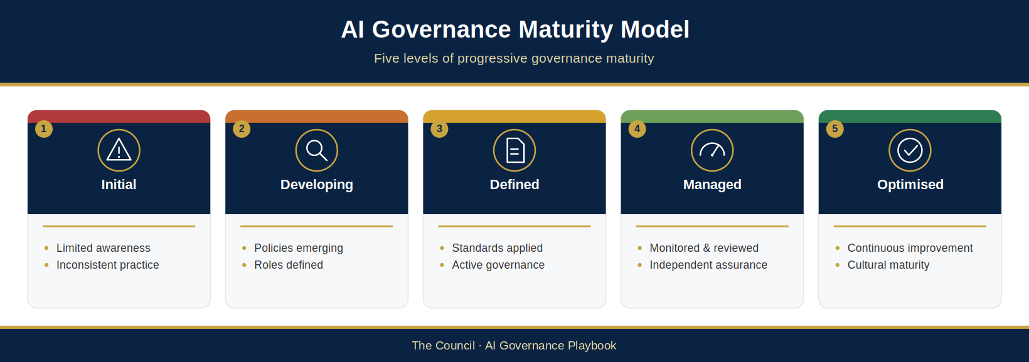
Figure 7.5: AI Governance Maturity Model
This figure illustrates the five maturity levels. It provides a visual representation of how governance capability develops from initial adoption through to optimised and continuously improving governance practices.

7.7 AI Governance Implementation Roadmap
Governance capability must be embedded across the organisation progressively, not simply published as policies and guidance.
The Council AI Governance and Responsible AI Operating Model establishes the governance foundations required to support the responsible adoption of AI. However, achieving governance maturity requires sustained organisational commitment, leadership support and investment in people, processes and oversight capabilities.
The purpose of this implementation roadmap is to provide a practical framework through which The Council can strengthen its AI governance capability over time. It translates the principles, structures and controls described throughout this Operating Model into a series of phased activities that support the gradual development of a mature, sustainable and scalable Responsible AI capability.
The roadmap is not intended to prescribe a rigid sequence of activities. Rather, it provides a strategic framework that can be adapted in response to organisational priorities, resource availability, regulatory developments and emerging technology trends.

7.7.1 Roadmap Objectives
The implementation roadmap is designed to support The Council in achieving several strategic objectives:
- Establish consistent governance arrangements across the organisation.
- Build organisational capability and awareness.
- Strengthen oversight and accountability.
- Improve risk management and assurance capability.
- Support responsible innovation.
- Enhance governance maturity.
- Maintain compliance with evolving regulatory expectations.
The roadmap should be reviewed at least annually as part of The Council’s governance effectiveness review process and updated to reflect changes in organisational priorities, governance maturity assessment outcomes, regulatory developments and emerging AI-related risks.

7.7.2 Implementation Principles
Several principles should guide implementation activities.

7.7.2.1 Proportionality
Implementation activities should be proportionate to The Council’s AI adoption profile, organisational priorities and risk environment.

7.7.2.2 Practicality
Governance arrangements should be implementable within operational environments and aligned with existing organisational processes wherever possible.

7.7.2.3 Continuous Improvement
Implementation should be viewed as an ongoing journey rather than a finite programme of work.

7.7.2.4 Collaboration
Successful implementation requires engagement across services, governance functions, technology teams and leadership groups.

7.7.2.5 Value Focus
Governance activities should support organisational objectives and responsible innovation while managing risk appropriately.
These principles help ensure that governance remains effective, sustainable and aligned with organisational needs.

7.7.3 Phase 1 – Foundation
The initial phase focuses on establishing the core governance capability required to support responsible AI adoption.
Key activities may include:

7.7.3.1 Governance Establishment
- Establish governance structures and accountability arrangements.
- Confirm governance roles and responsibilities.
- Approve governance policies and standards.
- Define decision-making and escalation processes.

7.7.3.2 AI Inventory and Visibility
- Establish and maintain the AI Register.
- Identify existing AI systems and use cases.
- Develop classification and risk assessment processes.

7.7.3.3 Policy and Guidance Development
- Publish Responsible AI principles.
- Implement AI Acceptable Use requirements.
- Establish governance procedures and templates.

7.7.3.4 Awareness and Communication
- Launch organisational awareness activities.
- Communicate governance expectations.
- Promote leadership engagement.
The objective of this phase is to establish the foundational governance capability required to manage AI consistently across the organisation.

7.7.4 Phase 2 – Operationalisation
Once foundational governance arrangements are established, the focus shifts towards embedding governance into operational activities.
Key activities may include:

7.7.4.1 Risk Management Integration
- Implement AI risk assessment processes.
- Integrate AI risks into corporate risk management activities.
- Establish risk reporting arrangements.

7.7.4.2 Lifecycle Governance
- Embed governance checkpoints within AI lifecycle processes.
- Introduce governance review and approval activities.
- Establish monitoring and assurance requirements.

7.7.4.3 Capability Development
- Deliver role-based training programmes.
- Develop governance communities of practice.
- Support knowledge sharing and learning.

7.7.4.4 Supplier Governance
- Strengthen procurement controls.
- Introduce supplier assurance requirements.
- Enhance contract management arrangements.
This phase focuses on ensuring that governance becomes part of normal organisational practice rather than a standalone initiative.
The first 100 days (Appendix C) deliver Phase 1 (Foundation) and begin Phase 2 (Operationalisation).

7.7.5 Phase 3 – Assurance and Optimisation
As governance capability matures, The Council should strengthen assurance, measurement and continuous improvement activities.
Key activities may include:

7.7.5.1 Assurance Framework Maturity
- Expand monitoring and compliance activities.
- Embed the annual governance effectiveness review.
- Strengthen Internal Audit engagement.
- Enhance independent assurance capability.

7.7.5.2 Governance Metrics and Reporting
- Develop governance dashboards.
- Establish performance indicators.
- Improve governance reporting and oversight.

7.7.5.3 Incident Management and Learning
- Mature incident reporting processes.
- Formalise lessons-learned activities.
- Improve organisational learning mechanisms.

7.7.5.4 Continuous Improvement
- Review governance effectiveness.
- Update policies and standards.
- Incorporate emerging good practice.
This phase supports a more evidence-based and proactive approach to governance management.

7.7.6 Phase 4 – Strategic Integration
The final phase focuses on embedding AI governance as a strategic organisational capability.
Key activities may include:

7.7.6.1 Governance as a Strategic Capability
- Integrate AI governance into strategic planning activities.
- Align governance objectives with organisational priorities.
- Strengthen executive oversight.

7.7.6.2 Advanced Governance Maturity
- Use the annual maturity assessment to track progress.
- Benchmark against sector-leading practices.
- Develop predictive and forward-looking governance capabilities.

7.7.6.3 Responsible Innovation
- Establish governance mechanisms that support innovation at scale.
- Improve governance support for experimentation and emerging technologies.
- Enhance organisational agility.

7.7.6.4 Sector Leadership
- Share lessons learned and good practice.
- Contribute to public-sector governance initiatives.
- Support wider Responsible AI collaboration.
At this stage, governance becomes fully integrated into The Council’s broader organisational capability and transformation agenda.

7.7.7 Success Factors
Several factors are likely to influence the success of implementation activities.
These include:
- Leadership commitment
- Clear accountability
- Adequate resources
- Effective communication
- Workforce capability
- Strong governance culture
- Cross-functional collaboration
- Continuous improvement
These success factors should be considered throughout all phases of implementation.

7.7.8 Monitoring Roadmap Progress
Progress against the implementation roadmap should be reviewed periodically through The Council’s governance structures.
Measures may include:
- Completion of governance initiatives
- Capability development indicators
- Maturity assessment outcomes
- Assurance findings
- Risk management effectiveness
- Compliance performance
- Stakeholder feedback
Monitoring progress helps ensure that implementation activities remain aligned with organisational objectives and governance priorities.
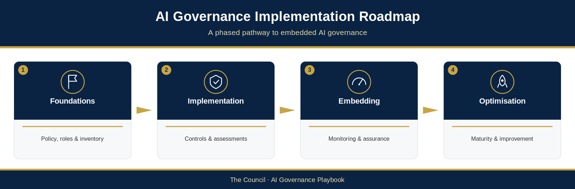
Figure 7.6: AI Governance Implementation Roadmap
This figure illustrates the phased implementation approach across Foundation, Operationalisation, Assurance and Optimisation, and Strategic Integration. It demonstrates how governance capability develops progressively over time and how each phase contributes to overall governance maturity.

7.8 Future Outlook and Evolving Governance
AI, and the rules and expectations around it, continue to change quickly, so The Council’s governance must be ready to adapt.
The AI Governance and Responsible AI Operating Model described throughout this document provides a robust foundation for responsible AI adoption. However, governance cannot remain static. The technologies, risks and opportunities that The Council will encounter in the coming years are unlikely to be identical to those that exist today. Effective governance therefore requires adaptability, foresight and a commitment to continuous evolution.
This section considers the future of AI governance within The Council and outlines the principles that should guide the continued development of governance capability as AI technologies mature.

7.8.1 The Evolving AI Landscape
The pace of AI innovation continues to accelerate.
Advances in areas such as:
- Generative AI
- Agentic AI systems (already governed by §4.7.7 and Appendix F)
- Autonomous decision-support tools
- Multimodal AI
- Predictive analytics
- Intelligent automation
- Digital assistants
- Synthetic data technologies
are creating new opportunities for public-sector organisations while simultaneously introducing new governance challenges.
As these technologies become increasingly accessible, The Council can expect AI to become more deeply embedded within service delivery, operational processes and decision-making activities.
Governance arrangements must therefore remain capable of responding to both technological advancement and changing expectations regarding accountability, transparency, fairness and public trust.

7.8.2 An Increasingly Dynamic Regulatory Environment
AI law and regulation continue to develop in the United Kingdom and internationally. The Council tracks these changes through regulatory change management and horizon scanning (§6.6.5) and builds them into governance planning.

7.8.3 The Growing Importance of Responsible AI
As AI adoption expands, public expectations regarding the responsible use of technology are likely to increase.
Residents, employees, elected members and oversight bodies will expect organisations to demonstrate that AI systems are:
- Safe
- Transparent
- Fair
- Accountable
- Secure
- Human-centred
Responsible AI will therefore become an increasingly important component of organisational trust and legitimacy.
The Council’s commitment to Responsible AI principles provides a strong foundation for meeting these expectations. However, maintaining trust will require ongoing investment in governance capability, assurance activities and transparent engagement with stakeholders.
The Council should continue to view Responsible AI as a strategic capability rather than a compliance requirement.

7.8.4 Governance as an Enabler of Innovation
As AI technologies become more sophisticated, governance will play an increasingly important role in enabling innovation.
Effective governance should not be viewed as a barrier to progress. Rather, it should provide the confidence, structure and accountability required to support responsible experimentation and adoption.
Future governance arrangements should continue to:
- Enable innovation within defined risk tolerances.
- Support responsible experimentation.
- Encourage learning and improvement.
- Facilitate informed decision-making.
- Protect residents and public interests.
The most successful organisations will be those that can balance innovation and governance effectively rather than prioritising one at the expense of the other.

7.8.5 Strengthening Organisational Capability
The future success of AI governance will depend heavily upon organisational capability.
Technology will continue to evolve, but the need for informed leadership, skilled employees and effective governance oversight will remain constant.
The Council should continue to invest in:
- AI literacy
- Governance capability
- Leadership development
- Responsible AI expertise
- Assurance and risk management skills
- Organisational learning
Capability development should be viewed as a long-term strategic investment that enables The Council to respond confidently to future technological change.

7.8.6 Building a Learning Organisation
The organisations most likely to succeed in an AI-enabled future will be those that can learn and adapt continuously.
The Council should seek to strengthen its ability to:
- Learn from experience.
- Respond to incidents and emerging risks.
- Share knowledge across services.
- Evaluate governance effectiveness.
- Adapt governance arrangements as required.
- Incorporate lessons from external developments.
A learning-oriented approach helps ensure that governance remains relevant and effective even as technologies and operating environments evolve.

7.8.7 Collaboration and Public-Sector Leadership
The challenges and opportunities associated with AI are not unique to The Council.
Many public-sector organisations are confronting similar governance questions regarding risk, accountability, transparency and responsible innovation.
The Council should continue to engage with:
- Local government partners
- Professional bodies
- Academic institutions
- Government organisations
- Industry experts
- Standards and assurance communities
Collaboration enables the sharing of knowledge, good practice and lessons learned while helping to strengthen governance capability across the wider public sector.
It also provides opportunities for The Council to contribute to the development of emerging approaches to Responsible AI governance.

7.8.8 Preparing for the Next Generation of AI
While it is impossible to predict precisely how AI technologies will develop, it is clear that future systems are likely to become more capable, more autonomous and more integrated into everyday organisational activities.
The Council already governs agentic and autonomous AI through §4.7.7 and Appendix F. Future governance frameworks may need to go further to address:
- Greater autonomy
- Complex human-AI collaboration
- Wider use of AI agents
- Enhanced transparency requirements
- New assurance methodologies
- Emerging ethical considerations
- Novel regulatory obligations
The Council’s governance framework should therefore be designed with flexibility in mind, enabling the organisation to adapt as new technologies emerge and governance expectations evolve.
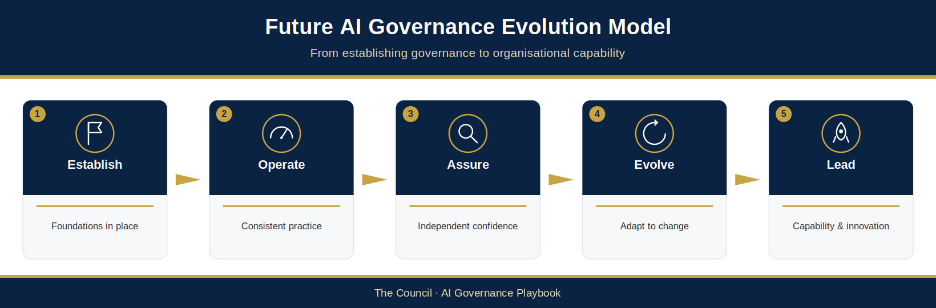
Figure 7.7: Future AI Governance Evolution Model
This figure illustrates how technological innovation, regulatory developments, organisational capability and Responsible AI principles interact to shape the future evolution of The Council’s governance framework. It demonstrates how continuous improvement and governance maturity enable The Council to adapt confidently to future AI developments.

Chapter 7 Summary
This chapter has focused on the people, leadership, culture and organisational capabilities required to sustain the responsible adoption of AI across The Council. While governance frameworks, policies and controls provide the structural foundations for Responsible AI, their effectiveness ultimately depends upon the individuals and organisational behaviours that bring them to life.
The chapter began by establishing the principle that AI governance is fundamentally human-centred. Regardless of technological capability, accountability for decisions, outcomes and governance remains with the individuals, teams and governance bodies responsible for the design, procurement, deployment and oversight of AI systems. Human judgement, professional responsibility and effective oversight therefore remain essential components of The Council’s Responsible AI Operating Model.
Recognising the importance of organisational capability, the chapter introduced The Council AI Skills and Competency Framework. The framework provides a structured approach to capability development, ensuring that employees, managers, technical specialists and governance leaders possess the knowledge and skills required to fulfil their responsibilities effectively. By defining role-based competency expectations and supporting continuous learning, The Council can strengthen governance effectiveness while enabling the safe and confident use of AI technologies.
The chapter also established The Council’s approach to training and awareness. A comprehensive programme of education, communication and capability development helps ensure that employees understand both the opportunities and risks associated with AI and can apply governance requirements consistently within their areas of responsibility. Continuous learning was identified as a critical enabler of governance maturity in an environment characterised by rapid technological change.
Leadership and organisational culture were recognised as equally important contributors to governance success. Effective governance depends upon a culture that promotes accountability, transparency, collaboration, learning and responsible innovation. Leadership commitment plays a critical role in reinforcing these values, setting expectations and ensuring that Responsible AI principles are embedded throughout organisational decision-making. A positive governance culture helps transform policies and controls from compliance requirements into everyday organisational behaviours.
To support continuous development, the chapter introduced The Council AI Governance Maturity Framework. The framework provides a structured mechanism for assessing governance capability across multiple domains, identifying strengths and improvement opportunities and measuring progress over time. Governance maturity was presented not as an end state but as an ongoing journey of capability development, organisational learning and continuous improvement.
Building on this foundation, the chapter outlined a phased implementation roadmap that translates governance principles into practical organisational action. Through the progressive development of governance structures, risk management processes, assurance activities, capability programmes and strategic oversight mechanisms, The Council can strengthen its ability to govern AI effectively while maintaining flexibility to respond to changing organisational needs and technological developments.
Finally, the chapter considered the future of AI governance. As AI technologies continue to evolve, governance arrangements must remain adaptable, responsive and forward-looking. By investing in capability, fostering collaboration, embracing continuous improvement and maintaining a commitment to Responsible AI principles, The Council can position itself to respond confidently to future opportunities and challenges.
Taken together, the themes explored throughout this chapter reinforce the idea that effective AI governance is not solely a matter of technology or compliance. It is an organisational capability that depends upon skilled people, informed leadership, strong culture and a commitment to learning and improvement. These elements enable The Council to govern AI responsibly while supporting innovation, service transformation and public value creation.

Document Conclusion
The Council AI Governance and Responsible AI Operating Model provides a comprehensive framework for the responsible adoption, governance and assurance of Artificial Intelligence across The Council. It establishes the structures, principles, processes and capabilities required to ensure that AI technologies are used in a manner that is lawful, ethical, transparent, accountable and aligned with The Council’s public-service mission.
The Operating Model recognises that AI presents significant opportunities to improve services, enhance operational efficiency, support decision-making and deliver better outcomes for residents and communities. At the same time, it acknowledges that these opportunities must be balanced against potential risks relating to fairness, transparency, privacy, security, accountability and public trust.
By adopting a lifecycle-based approach to governance, supported by clear accountability arrangements, risk management processes, assurance mechanisms and capability development activities, The Council can create an environment in which innovation and governance operate together rather than in opposition. Responsible AI becomes not simply a compliance objective, but a strategic capability that supports sustainable and trustworthy adoption of emerging technologies.
The future success of AI within The Council will depend upon The Council’s ability to maintain this balance. Governance frameworks will need to evolve, organisational capabilities will need to grow and leadership commitment will need to remain strong. Through continuous improvement, ongoing learning and a steadfast commitment to Responsible AI principles, The Council can ensure that its use of AI remains aligned with its values, its responsibilities and the expectations of the communities it serves.
This Operating Model provides the foundation for that journey. It establishes the governance capability required not only for today’s AI technologies, but also for the opportunities and challenges that will emerge in the years ahead.
Governance is not a one-time exercise but an ongoing organisational commitment. Through regular review, continuous improvement, capability development and effective oversight, The Council will continue to strengthen its ability to adopt and govern AI responsibly. By embedding Responsible AI principles into decision-making, culture and operational practice, The Council can realise the benefits of AI while maintaining public trust, accountability and confidence in the services it delivers.
This concludes the main body of the AI Governance Playbook. The appendices follow: Appendices A to F, which form part of the controlled framework; Proposed Annex G, a draft design for Council review; and the Standards and Legal Applicability cross-reference.

Appendix A: Technical Implementation Standards
This appendix sets out the technical controls and standards that underpin the governance framework described in the preceding chapters. Where the main body of this document defines what The Council requires from a governance perspective, this appendix describes how those requirements are realised in technical practice. It is intended primarily for the data, engineering, architecture and machine-learning operations teams responsible for building, deploying and maintaining AI systems, and it should be read alongside the AI lifecycle governance requirements set out in Chapter 3 and the assurance and monitoring expectations set out elsewhere in this document.

A.1 Model Lifecycle and Versioning
Every AI model used by The Council shall be uniquely identified, versioned and recorded, so that the exact model in operation at any point in time can be established. Technical teams shall maintain a model registry recording each model version together with its associated training code, configuration and parameters, and the approval status of that version. Versioning shall extend to the model artefact, the data used to train it and the code used to produce it, so that any given result can in principle be reproduced. A documented rollback capability shall be maintained so that a previously approved version can be restored quickly if a newly deployed version behaves unexpectedly. Each registered model version shall be linked to its corresponding entry in the AI Register.

A.2 Data Lineage and Provenance
The Council shall be able to trace the data on which each AI system depends. For every model, technical teams shall record the provenance of training, validation and test datasets, including their source, the date of extraction and any transformations, cleaning or labelling applied. Where personal data or special category data is involved, this shall be clearly flagged and cross-referenced to the relevant Data Protection Impact Assessment. Maintaining clear data lineage supports reproducibility, enables bias and fairness to be investigated at source, and allows The Council to respond accurately if the quality, legality or representativeness of training data is later questioned.

A.3 Audit Logging and Traceability
AI systems that inform or influence decisions shall generate audit logs sufficient to reconstruct, after the event, what the system did and on what basis. Logging shall capture the model version in operation, the salient inputs and outputs (recorded proportionately and in line with data protection requirements), the identity of any human reviewer, and any material configuration changes. Logs shall be tamper-evident and retained for a period consistent with The Council’s records-management and data protection obligations. Effective audit logging is what makes the right to challenge an AI-assisted decision meaningful, and it is a prerequisite for credible incident investigation.

A.4 Model Documentation (Model Cards)
Each AI model shall be accompanied by structured documentation, commonly referred to as a model card. A model card records, in a consistent format, the model’s intended purpose, the data on which it was trained, its measured performance, the results of bias and fairness testing, its known limitations, and the uses for which it is explicitly not suitable. It also records the responsible owner and the date of the next scheduled review. Model cards make a model’s capabilities and boundaries legible to non-technical stakeholders, support the transparency and explainability principles set out in this document, and give assurance teams a consistent basis for review. For agentic AI systems, the model card shall additionally record the tools, systems and actions available to the model, the approved action scope, and the level of human control applied to each action capability. Where The Council builds an AI system in-house, the team also records and manages technical debt (NCSC guideline 2.4) alongside the model documentation (Proposed — for Council confirmation).

A.5 Integration with the Delivery Lifecycle
Technical governance is most effective when embedded in the delivery pipeline rather than applied retrospectively. Governance checkpoints shall be integrated into The Council’s software development and machine-learning operations (MLOps) lifecycle, so that the governance stage gates described in Chapter 3 correspond to concrete technical controls: triage and registration at intake, impact and risk assessment before build, governance approval before deployment, and continuous monitoring once a system is live. Where automated deployment pipelines are used, pre-deployment validation checks covering performance, fairness and the presence of required documentation shall be enforced as a condition of release. This ensures that governance becomes a continuous and enforceable property of the delivery process rather than a manual gate that can be bypassed under delivery pressure.
The following table summarises how each technical control in A.1 to A.5 supports the governance requirements established in this document.
Technical Control | Governance Requirement Supported
Model lifecycle and versioning | Reproducibility, rollback and a verifiable record of the model in operation at any given time.
Data lineage and provenance | Evidence for Data Protection Impact Assessments, investigation of bias, and assurance of data quality and legality.
Audit logging and traceability | Transparency, the right to challenge AI-assisted decisions, and credible incident investigation.
Model documentation (model cards) | Transparency, explainability and a consistent basis for assurance review.
Integration with the delivery lifecycle | Continuous, enforceable lifecycle governance that cannot be bypassed under delivery pressure.

A.6 Technical Evidence Intake and Reconciliation
Technical evidence from a model registry, pipeline, metadata store or monitoring service may populate existing governance records when available and useful. Automated metadata ingestion is optional; systems may use controlled manual records or supplier evidence instead. The evidence needed for a governance decision remains proportionate to the system and its risk. The AI Register AIR-ID is the stable key: the source resource identifier, exact model or configuration version, originating project and region, event time and ingestion time must remain traceable to that key. Keep a reference to a controlled snapshot or retained export and its digest where available. Cite an Evidence ID where the proposed Register Evidence index (Annex G) provides one; if none exists yet, retain the source reference and do not invent an ID (Annex G.3). A live URL alone is insufficient when the source may change or expire.
If The Council chooses to enable a technical evidence feed, the receiving process should use a documented, provider-neutral evidence exchange format agreed by the AI Governance Lead (no exchange schema is supplied with this suite). A connector may pull through read-only access or receive an authorised push. Validate required identifiers, UTC timestamps, allowed evidence type, source location, AIR-ID and schema version; reject or quarantine missing, malformed, duplicate or unmatched records. Restrict access, minimise personal data, log ingestion and corrections, and check the source against the retained snapshot before marking evidence Verified. Imported, Pending review, Verified, Stale and Rejected are evidence states; none constitutes a governance decision.
Where imported technical evidence supports a gate, the accountable reviewer selects a dated snapshot and records its ID in the Gate Log (AIG-DEC-04). Otherwise the existing evidence and decision references remain sufficient when they meet the gate requirements. Where used, the Model Card (AIG-ASS-09) points to the same verified evidence for model versions, lineage and evaluation. For imported evidence, the Monitoring Log (AIG-OPS-02) cites the Evidence ID in its Evidence Location and records actual results, sample basis and threshold assessment; missing or stale technical evidence prompts a review, never an automatic pass. Update the Register current state only after the authorised decision. A changed model version, data source, deployment, material drift or breached threshold triggers reassessment through the existing routes. The Agent Record (AIG-AGT-04) can reference model evidence for agent components, but authority and runtime actions remain governed separately by AIG-AGT-05 and AIG-AGT-06.
A cloud machine-learning metadata service is one possible source of artefact, execution, context and lineage identifiers. A source adapter may also obtain model version information from a registry and monitoring observations from a monitoring service: do not infer that metadata alone contains all three. Check capture coverage, retention, permissions and source-specific semantics before relying on an automated feed. A human assurance reviewer remains responsible for evidence sufficiency, interpretation, conditions and approval.

Appendix B: Glossary and Abbreviations
This glossary defines the key terms and abbreviations used in this playbook. It is provided for reference and does not override the fuller explanations given in the main text.
Term / Abbreviation | Definition
Action-capable use | A use (UC-ID) whose “can it act?” screen answer is Yes (“Unsure” is treated as Yes until confirmed), at any agency tier including T0. Every action-capable use receives Agentic Triage (AIG-AGT-03), and rules R1–R3 apply (F.2).
ADM | Automated decision-making; under UK GDPR Articles 22A to 22D, a significant decision based solely on automated processing.
AG-ID | Agent identifier; the stable identifier of an agent in the Agent Record (ASBOM, AIG-AGT-04), always linked to the parent AIR-ID.
Agency tier (T0–T5) | The agentic tier assigned by the Agentic Triage (AIG-AGT-03) from the five-dimension agency profile; it sets a minimum risk-tier pathway for an action-capable agent (Appendix F.2; AIG-DEC-01 Agentic pathway). The higher of that minimum and the risk-tier pathway governs (see Governing tier).
Agentic AI | An AI system capable of planning and executing actions in pursuit of a goal — such as invoking tools, modifying records or initiating communications — with limited or no human review of each individual action.
AGPI | AI Governance Priority Index; the weighted 0–100 score used at triage to set the applicable UC-ID’s governance priority.
AI | Artificial Intelligence.
AI Assurance Board | The Council’s AI assurance and oversight body; provides assurance, challenge and escalation; decision rights and accountability remain with the relevant delegated authority. The Board does not itself approve higher-priority or higher-risk AI initiatives unless a separate confirmed delegation expressly grants that authority.
AI Governance Lead | The role accountable for running the AI governance function day to day; chairs the Working Group.
AI Governance Working Group | The operational governance body, chaired by the AI Governance Lead; confirms triage priorities proposed by the AI Governance Lead, performs detailed review of Medium-risk uses, oversees the AI Register and prepares recommendations for the AI Assurance Board.
AI Register | The authoritative current-state record of AI systems (AIG-INV-04): one row per AIR-ID with linked UC-IDs, ownership, priority, risk and review information. It is not a monitoring history, incident log or decision record.
AI System Owner | The officer to whom a Service Owner assigns day-to-day operation and monitoring of a specific AI system (§3.5). The Service Owner remains accountable; where no AI System Owner is named, the Service Owner performs the role.
AIMS | Artificial Intelligence Management System; the management system structured to align with ISO/IEC 42001 (§3.12).
AIR-ID | AI Register identifier; the permanent, never-reused identifier of one governed AI system, issued only through Council governance in the AI Register (AIG-INV-04).
ASBOM | Agentic System Bill of Materials; the Agent Record (AIG-AGT-04), the authoritative agentic master record (Appendix E.3 and F.3).
ATRS | Algorithmic Transparency Recording Standard; the UK Government standard for publishing information about algorithmic tools used in the public sector.
Autonomy level (A0–A5) | The degree of independent operation permitted to an agent; the permitted level is granted at Gate 6 (F.2); never inferred from model capability.
CAP-ID | Capability identifier; identifies a reusable atomic capability in the Capabilities and System Map (AIG-INV-05).
Competent delegated forum/officer | The Council officer or forum holding confirmed delegated authority, under the Constitution and Scheme of Delegation, to decide a UC-ID. Also referred to in this playbook as the delegated Council forum or the delegated authority.
Computer Vision | AI that interprets images or video.
Control Effectiveness | A 1–5 assessment of how strongly existing controls mitigate a risk (1 = very strong, 5 = ineffective).
DDQ | Due-diligence questionnaire; the Supplier AI Due-Diligence Questionnaire (AIG-ASS-08).
DPA 2018 | Data Protection Act 2018 (c.12), as amended.
DPIA | Data Protection Impact Assessment; an assessment of the data protection risks of a processing activity, required under UK GDPR Article 35 where processing is likely to result in a high risk to individuals’ rights and freedoms.
DPO | Data Protection Officer; the statutory role responsible for data protection oversight.
Data poisoning | An attack that corrupts an AI model by tampering with its training data.
DUAA | Data (Use and Access) Act 2025 (c.18).
EIA | Equality Impact Assessment; an assessment of a system’s effect on people with protected characteristics.
EU AI Act | Regulation (EU) 2024/1689 laying down harmonised rules on artificial intelligence, as amended by Regulation (EU) 2026/1744.
Executive Sponsor | The senior leader providing executive sponsorship and accountability for AI governance.
Fast-Track Screening | The Yes / No / Unsure screen within AI Intake (AIG-INV-02) that tests eligibility for the Light-touch route; it never replaces intake facts, never creates an AIR-ID and never authorises use.
FRIA | Fundamental Rights Impact Assessment under Article 27 of the EU AI Act, where that Act applies.
Gate Log / Gate Event | The AI Governance Gate Log (AIG-DEC-04) records gate plans, dated Gate Events and conditions, and points to the decision; it is never the decision record.
Generative AI | AI that produces new content such as text, images or code.
Governance Investigation | The pathway applied to an AI system discovered with insufficient visibility (for example through Shadow AI monitoring) until ownership and purpose are established.
Governance Priority (1–5) | The five-level scale (Critical, High, Standard, Routine, Observe) that sets the urgency and sequencing of governance attention (how soon and in what order); it does not set the route, which follows the governing tier. Resident Impact or Legal & Regulatory Exposure scored 5 sets at least Priority 2 – High (§3.9.6).
Governance secretariat | The AI Governance Lead or a governance secretariat acting for them; maintains the AI Register and Gate Log.
Governing tier | The tier that sets a UC-ID’s route (decision forum, assessments, gates and review cadence): the highest of the §4.4 risk tier, any §4.4.6 trigger floor, the §4.4.4 impact floor (a confirmed Impact score of 5 sets at least Medium) and, for action-capable uses, the agency-tier minimum (Appendix F.2). The AGPI priority does not change it, and nothing lowers it (§3.10.1).
Hallucination | A confident but factually incorrect output from a generative AI model.
HRA | Human Rights Assessment (AIG-ASS-07). The Human Rights Act 1998 (c.42) is written in full in this playbook.
Human oversight | Meaningful human review of, and the ability to challenge, AI-assisted decisions.
ICO | Information Commissioner’s Office; the UK data protection regulator.
Inherent Risk | The level of risk before controls are applied, scored as Impact × Likelihood (1–25).
ISO/IEC 42001 | The international management-system standard for Artificial Intelligence.
Lifecycle stage (governance) | The governance lifecycle stage of an AI system: §3.6 Stages 1 to 7 (Idea and Innovation to Retirement and Decommissioning). Recorded in the AI Register (AIG-INV-04) Lifecycle stage field. Distinct from Operational status (Not live, Active, Suspended, Decommissioned).
Light-touch route | The lowest governance route, for a routine, low-impact UC-ID that passes Fast-Track Screening and is validated by the AI Governance Lead; a proportionate delegated decision is still recorded before operation (§3.8.1).
MCP | Model Context Protocol; a protocol by which AI agents connect to tools and data sources.
Model Card | Structured documentation of an AI model’s purpose, data, performance, limitations and review status.
Model drift | The gradual degradation of a model’s performance as real-world conditions diverge from its training data.
NIST | The US National Institute of Standards and Technology, referenced for its AI Risk Management Framework.
Operational status | The system-baseline operational state recorded in the AI Register (AIG-INV-04) Operational Status field: Not live, Active, Suspended or Decommissioned. It is not permission for any use (each UC-ID needs its own delegated decision). Distinct from Lifecycle stage, which records the governance stage (§3.6 Stages 1 to 7); pilot or testing activity is shown by the Lifecycle stage, not by Operational status.
OWASP | Open Worldwide Application Security Project; publisher of the agentic security guidance referenced in Appendix F.
Prompt injection | An attack that manipulates a large language model through crafted input.
PSED | Public Sector Equality Duty under section 149 of the Equality Act 2010 (c.15).
RACI | Responsible, Accountable, Consulted, Informed; the responsibility matrix in §3.5.1.
RAG | Red, Amber, Green status rating (§6.4.5).
RAIA | Responsible AI Assessment (AIG-ASS-04).
Residual Risk | The level of risk remaining after controls are applied (Inherent × Control Effectiveness ÷ 5).
Responsible AI Operating Model | The Council’s model for embedding responsible AI across the AI lifecycle.
Risk appetite | The amount and type of risk The Council is willing to accept in pursuit of its objectives; set by The Council’s leadership; to be confirmed at adoption (interim acceptance rule: §4.4.8).
Service Manager | The manager responsible for a service area in which an AI system is used; decides on a use only where delegated.
Service Owner | The role accountable for an AI system and its safe operation within a service.
Shadow AI | AI used without formal approval, governance or organisational visibility.
SIRO | Senior Information Risk Owner; the senior role accountable for information risk.
SRO | Senior Responsible Owner; the senior officer accountable for delivering a specific AI-enabled programme or project (§3.5).
Triage | The step after intake and registration in which the AI Governance Lead scores the AGPI and proposes each UC-ID’s governance priority, and records its provisional governing tier and route, confirmed by the AI Governance Working Group.
UC-ID | Use-case identifier; identifies one materially distinct use (purpose, workflow and outcome) of a governed system. Priority, risk tier, decision, scope and conditions are recorded per UC-ID.
UK GDPR | The United Kingdom General Data Protection Regulation.

Appendix C: The First 100 Days
An implementation sequence for The Council AI Governance Framework
This appendix sequences the framework set out in this playbook into a practical first 100 days for the AI Governance Lead. The first 100 days deliver Phase 1 (Foundation) of the implementation roadmap in §7.7 and begin Phase 2 (Operationalisation). This appendix introduces no new requirements. Every activity below draws on an artefact or process already defined in Chapters 2 to 7 and the supporting templates; this appendix simply orders them so that visibility comes before policy, quick wins come before structure, and structure comes before full operationalisation. Timescales are indicative and should be adapted to organisational context and capacity.
The sequencing follows a simple principle: in the early weeks, the priority is to see what already exists and prevent imminent harm; only then is it productive to formalise policy, and only after that to operationalise risk management in full. Attempting these in the reverse order produces governance on paper that does not reflect reality on the ground.

C.1 Days 1 to 15: Discovery and Visibility
Objective: Establish an accurate picture of AI already in use before designing anything further.
- Stand up The Council AI Register (§3.7) as the single source of truth, seeded with all known AI systems, embedded AI capabilities and procurements in flight.
- Work with IT, cyber security and information governance colleagues to identify shadow AI (§2.4), including AI features embedded in existing platforms such as office productivity suites.
- Assign discovered systems with no clear owner to the Governance Investigation pathway (§3.9.5) and begin tracing ownership. Frame discovery as bringing work into the light, not as an audit of individuals.
- Apply governance triage and AGPI scoring (§3.9.4 to §3.9.6) to identify the highest-priority systems, including any imminent deployment or procurement that requires review before it proceeds. In Days 1 to 15 the AI Governance Lead performs this triage provisionally; the AI Governance Working Group confirms it when it is convened (C.2).
Milestone: A populated AI Register and a prioritised list of systems requiring urgent governance attention.

C.2 Days 16 to 30: Coalition and Mandate
Objective: Put the people and the authority in place. Governance cannot be run from a single desk.
- Confirm the Executive Sponsor and agree the governance mandate (§3.4 and §3.5).
- Convene the AI Assurance Board and Working Group as set out in §3.4, with membership drawn from legal, procurement, cyber security, information governance, digital and technology, the DPO, the SIRO and service areas, so that governance is designed with practitioners rather than imposed on them. The Working Group’s first task is to confirm the provisional triage from C.1.
- Hold a kick-off session that frames the mission as accelerating responsible AI adoption, not restricting it.
- Brief senior leadership on discovery findings, presented as opportunity and manageable risk rather than blame.
Milestone: First AI Assurance Board meeting held and the mandate communicated across the organisation.

C.3 Days 31 to 45: Quick Wins and Interim Guardrails
Objective: Deliver visible, proportionate protections while the foundations are still being built.
- Publish the AI Acceptable Use Policy (§5.4) in plain English, stating clearly what staff may do as well as what they must not.
- Open the disclosure route described in §2.4 and §5.4.2 so staff can bring existing uses into governance without sanction. The staff-facing Approved Tools view may list only systems whose current governance/operational state is eligible for use, and must display the specific approved UC-ID(s), purpose, scope and conditions supported by the authoritative delegated decision and relevant AIG-DEC-04 event. An ‘Approved’ entry in the AI Register is not permission for an unlisted use (see §5.4.2). The full AI Register remains the portfolio record and must not be presented as a use-approval list.
- Open the AI intake route (§3.8) with a stated five-working-day screening commitment, so that asking permission is faster and easier than working around the rules.
- Complete rapid reviews of the highest AGPI-scored systems and of any supplier contract about to be signed (§3.10 and §5.5).
Milestone: Staff know what they may use, how to ask about anything new, and how quickly they will receive an answer.

C.4 Days 46 to 70: Governance Foundations
Objective: Formalise policy and accountability now that the framework reflects observed reality.
- Secure ratification of the Responsible AI Policy and the supporting policy architecture (§5.2 and §5.3).
- Formalise roles and decision rights, including Service Owner accountability and the Approval Authority Matrix (§3.5 and §3.10.1).
- Embed AI checkpoints into existing corporate machinery rather than alongside it: procurement gateways (§5.5), DPIA screening reflecting the Data (Use and Access) Act 2025, project stage gates and the corporate risk register (§4.1.3 and §5.1.3).
Milestone: A ratified policy framework, clear decision rights, and AI governance operating inside existing corporate processes.

C.5 Days 71 to 100: Operational Risk and Assurance
Objective: Move from framework to demonstrated practice.
- Pilot the full risk and impact assessment pathway (Chapter 4 and the supporting templates) on one or two high-priority systems identified at triage, and refine the process based on what the pilot teaches.
- Agree monitoring plans, thresholds and RAG escalation criteria for live higher-risk systems (§6.4).
- Stand up AI incident reporting and escalation (§6.8), and run a tabletop exercise simulating an AI failure scenario (§6.8.10) to test roles, thresholds and communication before a real incident does.
- Deliver the first AI governance dashboard and report to the AI Assurance Board (§6.9).
Milestone: Risk management demonstrated end to end on real systems, incident response rehearsed, and the first oversight report delivered.

C.6 Throughout: Culture and Capability
Culture is not a phase; it runs through all five. From day one, launch awareness communications and initial training (§7.4), model the psychological safety and open reporting behaviours described in §7.5.4, and publicly recognise teams that raise concerns or delay a launch to fix a problem. The measure of success at day 100 is not the volume of documentation produced but whether people across the organisation know the rules, trust the process and feel safe to speak up.

C.7 The Day 100 Checkpoint
By day 100 the organisation should be able to evidence: a populated and maintained AI Register with no unowned high-priority systems; a functioning AI Assurance Board and Working Group; a published Acceptable Use Policy with open disclosure and intake routes; a ratified Responsible AI Policy embedded in corporate processes; at least one risk assessment completed end to end; a rehearsed incident response; and a first governance report to the Board. The 100 days that follow are about refining, scaling and deepening what has been built.
Days | Phase | Headline Milestone | Key Sections
1 to 15 | Discovery and visibility | AI Register populated; prioritised list of systems needing urgent attention | 2.4, 3.7, 3.9
16 to 30 | Coalition and mandate | AI Assurance Board and Working Group convened; mandate communicated | 3.4, 3.5
31 to 45 | Quick wins and interim guardrails | Acceptable Use Policy live; disclosure and intake routes open with stated turnaround | 2.4, 3.8, 3.10, 5.4, 5.4.2, 5.5
46 to 70 | Governance foundations | Responsible AI Policy ratified; roles, decision rights and corporate embedding in place | 3.5, 3.10, 3.10.1, 4.1.3, 5.1.3, 5.2, 5.3, 5.5
71 to 100 | Operational risk and assurance | Risk pathway piloted end to end; incident response rehearsed; first Board report delivered | Ch. 4, 6.4, 6.8, 6.8.10, 6.9
Table C.1: The first 100 days at a glance, mapped to the sections of this playbook that define each activity.

Appendix D: Framework Alignment Mapping
This appendix maps the playbook’s designed coverage to ISO/IEC 42001, the international management-system standard for artificial intelligence, and the NIST AI Risk Management Framework. It identifies the playbook sections and companion artefacts intended to address each requirement; D.1 sets out the status of this mapping. References such as §4.6 are to the playbook’s own numbering. Three further references support specific controls: the NCSC Guidelines for Secure AI System Development (AI security; AIG-ASS-11 and AIG-ASS-08), ISO/IEC 42005:2025 AI system impact assessment (AIG-AIMS-11) and NIST AI 600-1, the Generative AI Profile of the NIST AI RMF (July 2024), for generative AI risks. AIG-AIMS-11 maps the fourteen risk domains (§4.3) to NIST AI 600-1 and ISO/IEC 42005 (Proposed — for Council confirmation).

D.1 Status and Scope
The playbook provides designed coverage against ISO/IEC 42001 and the NIST AI RMF. It is not certified, conformant or evidenced by live operation. The accurate claim is ‘structured to align with’ and ‘designed against’. The status columns in D.2 and D.3 distinguish mapped design from approval, implementation, evidence and operating effectiveness; all non-design states remain open until The Council completes and records them.

D.2 ISO/IEC 42001 — Management System Clauses (4 to 10)
Clauses 4 to 10 are the auditable requirements. Annex A (D.3) is the reference control set.
Clause | What it requires (in brief) | Where met in the playbook | Companion artefacts | NIST AI RMF | Design / approval / implementation / evidence / effectiveness
4 Context | Understand the organisation and its context, the needs of interested parties, and define the scope of the AI management system. | §1.1–1.7 strategic context and executive assessment; §2.1–2.6 risk landscape, regulatory expectations and current-maturity assessment; scope at §4.1.2 and §5.1.1; interested parties across §3.4 governance layers and §3.5 roles. | AI Register (AIG-INV-04); AIMS Scope, Context and Interested Parties (AIG-AIMS-01); AIMS Applicable Requirements and Change Register (AIG-AIMS-05) | MAP — context and scope established | Design: mapped; Approved: no; Implemented: no; Evidenced: no; Effective: not tested
5 Leadership | Top-management commitment, a documented AI policy, and assigned roles, responsibilities and authorities. | §3.2 design principles; §3.3 operating model (Pillar 2); §3.4 governance structure; §3.5 and §3.5.1 roles and responsibilities matrix; §5.3 Responsible AI Policy; §7.5 leadership and culture. | AIMS Leadership Commitment Statement (AIG-GOV-04); AI Policy Statement (AIG-GOV-05); AI Governance Terms of Reference (AIG-GOV-06); AIMS Roles, Competence, Awareness and Communications Plan (AIG-AIMS-04); AI Governance Reporting Templates (AIG-OPS-05) | GOVERN — leadership, policy and accountability | Design: mapped; Approved: no; Implemented: no; Evidenced: no; Effective: not tested
6 Planning | Address risks and opportunities: AI risk assessment, risk treatment, AI system impact assessment, and AI objectives. | §3.9 triage and AGPI; §4.3–4.5 taxonomy, scoring and classification; §4.6 impact assessments (the 42001-distinctive requirement); §3.11 success measures; §7.7 roadmap. | AI Governance Priority Index (AGPI) Triage Tool (AIG-ASS-01); AI Risk Assessment Worksheet (AIG-ASS-02); Responsible AI Assessment (AIG-ASS-04); Data Protection Impact Assessment (AIG-ASS-05); Equality Impact Assessment (AIG-ASS-06); Human Rights Assessment (AIG-ASS-07); AIMS Statement of Applicability (AIG-AIMS-02); AIMS Objectives, Risk Treatment and Improvement Plan (AIG-AIMS-03); AI System Impact Assessment: Coverage Mapping (AIG-AIMS-11) | GOVERN & MAP — risk, impact and objectives | Design: mapped; Approved: no; Implemented: no; Evidenced: no; Effective: not tested
7 Support | Resources, competence, awareness, communication and documented information. | §7.3 competency framework; §7.4 training and awareness; §5.9 skills policy; §3.11 governance reporting; the register and records set as documented information. | AIMS Roles, Competence, Awareness and Communications Plan (AIG-AIMS-04); AI Intake Form (AIG-INV-03); AI Register (AIG-INV-04); AI Model Card (AIG-ASS-09); Governance Decision Record (AIG-DEC-03); ATRS Record Template (AIG-ASS-10) | GOVERN — resources, competence, awareness, communication and documentation | Design: mapped; Approved: no; Implemented: no; Evidenced: no; Effective: not tested
8 Operation | Operational planning and control; run risk assessment, treatment and impact assessment in operation. | §3.6 seven-stage lifecycle; §3.8 intake and approval; §3.10 risk-based approval; §4.7 control framework; §5.5 procurement; §5.6 data governance. | AI Deployment and Rollout Plan (AIG-OPS-01); AI Governance Checklist (AIG-ASS-03); AI Security Review Checklist (AIG-ASS-11); Supplier AI Due-Diligence Questionnaire (AIG-ASS-08) | MANAGE, with MAP / MEASURE — operational control, risk and impact | Design: mapped; Approved: no; Implemented: no; Evidenced: no; Effective: not tested
9 Performance evaluation | Monitoring, measurement, analysis and evaluation; internal audit; management review. | Chapter 6, esp. §6.4 performance monitoring and §6.6 compliance monitoring; §6.3 assurance and the Three Lines Model; §3.11 measures; governance reporting as the management-review input. | AI Governance Dashboard (AIG-OPS-06); AI Governance Reporting Templates (AIG-OPS-05); AI Post-Deployment Monitoring & Review Log (AIG-OPS-02); AIMS Internal Audit Programme and Procedure (AIG-AIMS-07); AIMS Management Review (AIG-AIMS-09); AIMS Monitoring and Measurement Plan (AIG-AIMS-10); AIMS Clause Conformity Register (AIG-AIMS-06) | MEASURE — monitoring, internal audit and management review | Design: mapped; Approved: no; Implemented: no; Evidenced: no; Effective: not tested
10 Improvement | Continual improvement; nonconformity and corrective action. | Design Principle 8; §4.7.15–4.7.16 remediation and continuous-improvement controls; §5.10 incident management; §7.6 maturity framework. | AIMS Objectives, Risk Treatment and Improvement Plan (AIG-AIMS-03); AIMS Nonconformity and Corrective Action (AIG-AIMS-08); AI Incident Report Form (AIG-OPS-03) | MANAGE — continual improvement and corrective action | Design: mapped; Approved: no; Implemented: no; Evidenced: no; Effective: not tested
The NIST AI RMF column is given at function level. A detailed sub-clause-level crosswalk of this mapping against the NIST AI RMF is maintained separately as AIG-AIMS-12 (AIMS Clause-Level Crosswalk).

D.3 ISO/IEC 42001 — Annex A Reference Controls
Annex A groups the reference controls under control objectives A.2 to A.10. The Council must approve the control design, determine applicability in a Statement of Applicability, implement the controls, retain evidence and test operating effectiveness before claiming implementation or conformity (see D.6).
Annex A control theme | Intent | Where met in the playbook | Design / approval / implementation / evidence / effectiveness
A.2 Policies related to AI | A documented, maintained set of AI policies. | §5.2 policy architecture; §5.3 Responsible AI Policy; §5.4 Acceptable Use Policy; §5.6–5.8 data, transparency and register policies. | Design: mapped; Approved: no; Implemented: no; Evidenced: no; Effective: not tested
A.3 Internal organisation | AI roles and responsibilities; a route to report concerns. | §3.4 structure; §3.5 roles; §5.10 incident reporting; §7.5.4 psychological safety and open reporting. | Design: mapped; Approved: no; Implemented: no; Evidenced: no; Effective: not tested
A.4 Resources for AI systems | Documented data, tooling, compute and human resources. | §7.3 competency; Appendix A technical implementation standards; §5.6 data governance. | Design: mapped; Approved: no; Implemented: no; Evidenced: no; Effective: not tested
A.5 Assessing impacts of AI systems | A process to assess impacts on individuals, groups and society. | §4.6 impact assessment framework (Data Protection Impact Assessment (DPIA), Equality Impact Assessment (EIA), Human Rights Assessment (HRA) and Responsible AI Assessment (RAIA)); §3.9 governance lens and triage. | Design: mapped; Approved: no; Implemented: no; Evidenced: no; Effective: not tested
A.6 AI system life cycle | Responsible development, deployment, operation and logging across the life cycle. | §3.6 lifecycle governance; Appendix A.1 model lifecycle and versioning; §4.7 controls (incl. logging and incident detection §4.7.12). | Design: mapped; Approved: no; Implemented: no; Evidenced: no; Effective: not tested
A.7 Data for AI systems | Data quality, provenance and preparation. | §5.6 data governance policy; §4.3.5 data quality and governance risk. | Design: mapped; Approved: no; Implemented: no; Evidenced: no; Effective: not tested
A.8 Information for interested parties of AI systems | Transparency to users and the public; incident communication. | §5.7 transparency policy; §3.7 register transparency and ATRS reporting; §5.10 incident management. | Design: mapped; Approved: no; Implemented: no; Evidenced: no; Effective: not tested
A.9 Use of AI systems | Defined intended use and processes for responsible use. | §5.4 Acceptable Use Policy; §5.11 ethics review; §7.2 human oversight and accountability. | Design: mapped; Approved: no; Implemented: no; Evidenced: no; Effective: not tested
A.10 Third-party and customer relationships | Allocated responsibilities across suppliers and customers. | §5.5 procurement and supplier governance policy; Supplier AI Due-Diligence Questionnaire (AIG-ASS-08). | Design: mapped; Approved: no; Implemented: no; Evidenced: no; Effective: not tested

D.4 NIST AI Risk Management Framework — The Four Functions
The NIST AI RMF organises risk work into four functions. It is voluntary and not certifiable. The mapping covers all four functions, with Govern the strongest design fit.
Function | What it requires | Where met in the playbook | Fit
GOVERN | Cultivate a risk culture with accountability structures, policies, roles and third-party oversight. Cross-cutting. | The whole of Chapter 3 operating model; §3.4/§3.5 structure and roles; the Chapter 5 policy stack; §7.5 culture and leadership; §5.5 supplier oversight. | Strong / primary
MAP | Establish context; categorise the system; identify capabilities, intended use, benefits and impacts. | §3.6 stages 1–2 (idea, registration); §3.9 triage; §4.3 risk taxonomy; §4.6 impact assessments; §3.7 the AI Register. | Strong
MEASURE | Analyse, benchmark and track identified risks over time using appropriate metrics. | §4.4 scoring methodology and AGPI; §4.4.8 classification bands; §6.4 performance monitoring; §6.5 drift detection; §4.7.10 bias and fairness monitoring; §3.11 measures. | Designed; evidence prospective
MANAGE | Prioritise, respond to, treat and recover from risks; document and communicate. | §3.10 escalation and decision authority; §4.5 tiers and governance response matrix; §4.7 controls incl. §4.7.17 suspension and withdrawal; §5.10 incident management; §6.5.4 drift response. | Strong

D.5 NIST AI RMF — Characteristics of Trustworthy AI
The RMF names seven characteristics of trustworthy AI. Each is mapped to an intended home in the playbook’s risk taxonomy, principles and controls; the mapping is not evidence that outcomes have been achieved.
Trustworthy-AI characteristic | Where addressed in the playbook
Valid and reliable | §4.3.6 model performance and drift risk; §6.4 performance monitoring; §6.5 model drift and degradation.
Safe | §4.5 classification tiers and governance response; §4.4.6 mandatory escalation triggers; §4.7.17 suspension and withdrawal controls.
Secure and resilient | §4.3.4 security risk; §4.7.12 logging and incident detection controls; AI Security Review Checklist (AIG-ASS-11).
Accountable and transparent | §3.5 roles and accountability; §5.7 transparency policy; §3.7 register and ATRS reporting.
Explainable and interpretable | §4.3.2 transparency and explainability risk; §5.7.4 explainability requirements.
Privacy-enhanced | §4.3.3 privacy and data protection risk; §4.6.1 DPIA; §5.6 data governance policy.
Fair, with harmful bias managed | §4.3.1 bias and fairness risk; §4.6.2 Equality Impact Assessment; §4.7.10 bias and fairness monitoring.

D.6 What Full ISO/IEC 42001 Conformity Would Additionally Require
ISO/IEC 42001 conformity requires an established, implemented, maintained and continually improved management system that produces evidence over time. The following gaps must be closed and evidenced before any conformity or implementation claim is made:
Statement of Applicability. A draft Statement of Applicability exists (AIG-AIMS-02), but the Annex A controls are mapped in design only. The Council must determine each control’s applicability, record exclusions and justifications, assign owners and approval, then track implementation, evidence and effectiveness.
Internal audit programme. §6.3 and the Three Lines Model (§6.3.3) describe internal audit, and a draft audit programme exists (AIG-AIMS-07); what is missing is its approval and an audit programme actually executed, with audit records held over time.
Management review. Governance reporting (§3.11) is the vehicle and a draft management review record exists (AIG-AIMS-09); what is missing is approval and management reviews actually held on a defined cadence with minuted inputs and outputs, closing the review loop.
Nonconformity and corrective action. Incident management (§5.10) covers part of this, and a draft nonconformity and corrective-action log exists (AIG-AIMS-08); what is missing is its approval and operating evidence that makes the Clause 10 requirement auditable.
Live monitoring evidence. With no live deployments yet, the MEASURE and Clause 9 outputs (drift metrics, monitoring records) are prospective. They become real evidence once systems are in operation.
NIST AI RMF is voluntary and non-certifiable; operational evidence, review and effectiveness testing remain necessary before The Council describes the practices as implemented.

Appendix E: Post-Deployment Monitoring Evidence and Closed-Loop Risk Control
This controlled clarification strengthens Stages 6 and 7 of the lifecycle and the assurance arrangements in Chapter 6. It shall be read with the AI Register (AIG-INV-04), AI Risk Assessment Worksheet (AIG-ASS-02), Incident Report Form (AIG-OPS-03), Deployment and Rollout Plan (AIG-OPS-01), AIMS Monitoring and Measurement Plan (AIG-AIMS-10), Gate Log (AIG-DEC-04) and AI Post-Deployment Monitoring & Review Log (AIG-OPS-02).

E.1 System-Level Monitoring Evidence
For every live AI system, record actual monitoring results in AIG-OPS-02 under its AIR-ID and link results to each affected UC-ID where performance, fairness/bias, drift, error/failure, human oversight, complaints, privacy/security or outcome evidence is use-specific. Genuinely shared measures may be recorded at system level with applicability shown. The Register is the current-state portfolio record, not the detailed monitoring history.
Environmental monitoring (Proposed — for Council confirmation). For a system with a Red environmental flag (§4.3.15), the Monitoring and Review Plan also records usage volume and, where the supplier can provide it, energy consumption, with a baseline at go-live and the trend at each review.

E.2 Monitoring Cadence (Controlled Minimum Rule)
Each UC-ID’s risk tier establishes its minimum monitoring cadence. The Monitoring and Review Plan in AIG-OPS-02 may increase frequency where impact, volatility, incident history or that use’s agentic capability warrants it, but may not reduce it below the tier minimum. The minimum cadence for each tier is set in §6.4.4. Where a use can act, agentic capability raises, and never lowers, its cadence.

E.3 Controlled Definitions
The following controlled definitions apply throughout this playbook and the supporting artefacts. Autonomy, agency and risk tier are distinct classifications and are not interchangeable. Appendix B is the master glossary; AGPI, autonomy level and ASBOM are defined there in the same terms, and the other definitions below apply to post-deployment and agentic control.
Monitoring: Ongoing collection and review of system-level and, where relevant, UC-ID-specific evidence about operation, performance, impact and control effectiveness.
Review: A structured assessment of whether each relevant UC-ID remains within its approved scope, conditions and governance requirements, alongside shared system controls.
Reassessment: A renewed risk, impact and agency assessment triggered by material change, incident, drift, new evidence or another defined trigger.
Reauthorisation: A decision by the appropriate delegated authority to continue operation following reassessment or material change.
AGPI (AI Governance Priority Index): The weighted 0–100 score used at triage to set the applicable UC-ID’s governance priority: the urgency and sequencing of attention. It does not set the route, which follows the governing tier (§3.10.1). It does not replace the substantive AI Risk Assessment and does not determine legal risk.
Autonomy level (A0–A5): The degree of independent operation permitted to an agent; the permitted level is granted at Gate 6 (F.2); never inferred from model capability.
Agency: The breadth and consequence of the system’s ability to act within its permitted autonomy.
Risk tier: The use-specific governance risk classification for a UC-ID, derived through the approved methodology and applicable mandatory triggers/uplifts; shared evidence is reused only after applicability is checked.
ASBOM: Agentic System Bill of Materials; the Agent Record (AIG-AGT-04), the authoritative agentic master record. It covers the agent’s identity, capabilities, authority, relationships, tools, memory and controls.
Agent Authority Graph: A derived view of authority and delegation relationships; it is not a separate manually maintained master record.
Action / Decision Record: Runtime evidence of consequential agentic actions, normally generated by the control plane rather than manually reconstructed.

E.4 Mandatory Reassessment Triggers
Documented consideration of risk reassessment is required where monitoring identifies an approved UC-ID threshold breach; material change to the model, data, supplier, purpose, user population or autonomous authority; a significant complaint/challenge pattern; a material incident or near miss; adverse human-override trends; control failure; or a legal/regulatory change affecting a use. Do not close a breach solely as operational remediation without considering affected uses and whether their residual risk, tier, controls, conditions or delegated decision need review.

E.5 Escalation and Governance Re-Entry
Where reassessment is required, update the affected UC-ID risk assessment and recalculate its residual risk; reflect current system state in AIG-INV-04 and link each use’s decision/status reference. Record delegated decisions, conditions, suspension, enhanced monitoring, remediation, reauthorisation or resumption after a precautionary pause (Outcome “Resume”) by UC-ID in AIG-DEC-04. Use AIG-OPS-03 and AIG-AIMS-08 for incidents/nonconformities. Monitoring continues until actions are evidenced and formally closed.

E.6 Portfolio Oversight
Governance reporting shall include, at minimum: UC-IDs with overdue reviews; High/Critical UC-IDs without current monitoring evidence; uses outside approved performance, fairness or drift thresholds; uses requiring reassessment after breach or material change; and open High/Critical post-deployment risks. Report system-level shared controls separately and link affected UC-IDs. These indicators feed the dashboard, AIMS monitoring and management review.

E.7 Retirement and Closure
Retirement evidence shall confirm that the relevant capability or UC-ID has been withdrawn or disabled; interfaces and access addressed; supplier access reviewed; model/data/log retention decided; open incidents and actions closed or transferred; the UC-ID closure and current AI Register system state recorded; final governance review completed; and lessons learned captured. Do not retire the parent AIR-ID until all its governed uses are closed or retired.

E.8 Post-Deployment Control Flow
Deploy → Monitor → Detect → Record in AIG-OPS-02 → Assess → Reassess risk where triggered → Remediate / Escalate → Governance decision in AIG-DEC-04 → Update AIG-INV-04 → Continue monitoring or retire.

Appendix F: Agentic AI Governance Layer
This section introduces the agentic layer added to the framework (controlled artefacts AIG-AGT-01 to AIG-AGT-06, with AIG-INV-02 for Fast-Track screening). It reflects the shift from governing a model to governing a delegated actor operating in an environment: the governing question becomes who or what is acting, with what authority, using which models, memory, data and tools, towards which objective, through which interfaces, with what autonomy, under whose responsibility, and with what ability to observe, constrain, interrupt and reverse its actions.

F.1 Core Principle and Invariants
No autonomous AI system may possess authority that cannot be attributed, bounded, monitored, interrupted, revoked and, where technically feasible, reversed. No agent may acquire additional authority merely through its own reasoning, memory, persuasion, delegation, tool discovery, model selection or interaction with another agent. Every transfer of authority must be explicitly governed and auditable. Five invariants hold for every agent at every autonomy level: attribution, authority, observability, controllability and accountability. These are set out in F.7.2.

F.2 Triage: Two Functions, One Route
Intake keeps one route and one AIR-ID. Every AI system receives an initial route screen (the Light-touch rule is in §3.8.1). Standard and enhanced cases receive governance priority and risk assessment (AGPI and the Risk Worksheet). A screen question (“can it act?”) then asks whether the system can act; if it can (“Unsure” is treated as Yes until confirmed), the use is action-capable (Glossary) and a distinct Agentic Triage (AIG-AGT-03) additionally assesses agency across five dimensions (consequence, autonomy, authority, reach and controllability), records the capability vector and the agency multipliers, runs the worst-plausible-chain, the boundary tests and the kill-switch test, and assigns an agency tier (T0 to T5) that sets a minimum governance pathway. Agentic assessment is dynamic: system, action and authority risk are assessed separately, and action risk is re-evaluated at runtime. Combination rule: the governing pathway is the higher of (a) the §4.4 risk-tier pathway, including the §4.4.6 trigger floors and the §4.4.4 impact floor (a confirmed Impact score of 5 sets at least Medium), and (b) the minimum risk-tier pathway set by the agency tier (table below); neither lowers the other.
Agentic pathway (Proposed — for Council confirmation). No new board is created. Each agency tier sets a minimum on the existing risk-tier pathway scale; the existing forums, gates and records then apply unchanged for the governing pathway. The Gate Map (AIG-DEC-01, Agentic pathway) sets out the gates, decision-makers and agentic evidence for each tier; AIG-AGT-03 §6 holds the same table.
Agency tier | Minimum risk-tier pathway | Agentic requirement
T0 informational | None | Normal route; no minimum pathway; Gate 2 and Gate 6 still apply as an action-capable use (R1, R2); recorded on the Agent Record (AIG-AGT-04)
T1 assisted | None | Normal route; Gate 2 and Gate 6 apply (R1, R2); recorded on the Agent Record (AIG-AGT-04; core record, plus the sheets its features need)
T2 bounded agent | Medium | Agentic controls review at Gate 2 (Technical design review), by the Technical design authority with AI Governance Working Group input; the forum for the governing tier decides; core Agent Record plus the sheets its features need
T3 consequential agent | High | As T2, plus a formal AI Assurance Board recommendation before the decision; full ASBOM (AIG-AGT-04) and Agent Authority Graph (AIG-AGT-05)
T4 high-agency | High (Critical where actions run without evidenced per-action human review — §4.4.6) | As T3; AIG-ASS-11 security review against the OWASP Top 10 for Agentic Applications (ASI01–ASI10) complete before the Gate 2 decision
T5 exceptional / high-consequence | Critical | Executive and safety escalation (SRO and Executive Sponsor oversight, independent challenge); no consequential production use until resolved
Rules for every action-capable use (any agency tier, including T0), except personal and approved-pattern agents on an approved platform, which are covered once at platform level (F.8). R1: Gate 2 (Technical design review) is mandatory; the agentic control checkpoints (memory control, tool/interface authority, delegation chain, containment/kill switch, identity/credentials, rollback) are evidenced there and re-confirmed at Gate 6. R2: Gate 6 (go-live) grants the permitted autonomy level for each UC-ID; the go-live decision-maker records it in AIG-DEC-03 and it is written to AIG-AGT-04 (permitted autonomy level and decision reference); it may be lower than requested. R3: the §4.4.6 Critical floor (actions without evidenced per-action human review; “Unsure” is treated as “No”) is unchanged and applies to every action-capable use, T0 included. R4: agentic triage is a routing and evidence mechanism, not an approval layer; decisions stay with the delegated officer or forum (AIG-DEC-03 or approved minutes), with dated events in AIG-DEC-04. The routing in the Gate Map is extended, not replaced.

F.3 The Record and the Graph
Each agent that can act has an Agent Record (Agentic System Bill of Materials, AIG-AGT-04), completed to the level its agency tier and features require (Proposed — for Council confirmation). Every such agent has the core record: identity, approved purpose, owner and platform, agency tier and the agency profile behind it (Agency Profile sheet), what it can act on and do, whose credentials it uses, human oversight mode, how to stop it, how to undo what it did, the permitted autonomy level and its decision, and the review date. Features add their own sheets: persistence adds runtime controls for stopping and containing it; memory beyond the current context adds Memory Controls; tool discovery or credential access adds the Tool Authority Registry and Interface Register; delegation adds Authority & Delegations and Multi-Agent Controls, and with them the Agent Authority Graph. At T3 and above, where the agent has financial authority, or while its agency tier is unassessed (fail safe), the full ASBOM is required: capability vector, components (models, datasets, interfaces, tools, sub-agents and credentials), authority delegations and all ten runtime controls. The Agent Record shows which record level applies. For a bought-in agent, supplier-side detail the supplier will not give may be recorded as “Not disclosed by supplier”, with the gap recorded as a risk in AIG-ASS-02 and AIG-ASS-08; the core fields are about how The Council has set the agent up, so they must always be answered. Where delegations are recorded, the Agent Authority Graph (AIG-AGT-05) renders them, so attribution, blast radius, authority ceilings and revocation can be read directly. The AI Register (AIG-INV-04) indexes the agent records; the Agentic Classification Reference (AIG-AGT-02) fixes the shared vocabulary.

F.4 Relationship to the Existing Controls
The existing controls are retained and re-expressed for agents. The human-oversight and agentic controls at §4.7.7, the escalation triggers at §4.4.6 and the agent threats at §4.3.4 apply to the agent as an actor and to each consequential action. The framework owns the documentation controls; the runtime controls (a control plane, continuous authorisation, per-action locks, memory enforcement and kill-switch and rollback enforcement) must be provided by The Council’s platform and security functions and are assured through this framework (F.7.8).

F.5 Status
The agentic layer is a working draft, pre-adoption; nothing in it is evidenced until operated, and adoption of the layer is a Council decision not yet taken. It aligns with the OWASP 2026 agentic guidance (the Top 10 for Agentic Applications 2026 and the Agent Control Standard) and ISO/IEC 42001.

F.6 Proportionate Light-Touch Path
Fast-Track Screening (AIG-INV-02) holds the ten factual eligibility questions, answered Yes / No / Unsure for each UC-ID; the AI Intake Form (AIG-INV-03) records its reference and result rather than repeating the questions. The screen covers action capability, personal/special-category/confidential data, influence on individual decisions, resident/statutory impact, direct/public interaction, live-system or tool access, novelty/material change/agentic capability, plausible material harm, procurement/supplier dependency and unknowns. The Light-touch rule, including validation by the AI Governance Lead, how the result is recorded and re-entry to full triage, is in §3.8.1; screening by reference for a Light-touch use is in §4.6.

F.7 Agentic AI Governance Operating Requirements
This section is a controlled extension of the lifecycle governance model for AI systems that can act, transact, communicate, delegate, persist, discover tools, or otherwise exercise authority. It does not create a separate approval authority. The existing delegated decision-maker remains accountable; the AI governance function provides the assurance and continuity layer.

F.7.1 Governance Object and Front Door
- Every AI use enters through the existing AI Intake and receives one permanent AIR-ID.
- The standard AI triage remains the first classification point. A positive “can it act?” trigger invokes the Agentic Triage Function and the agentic controls below.
- The governed object is the deployed agent configuration and authority envelope, not merely the underlying model. Where an agent routes between models, the governed record must capture model selection, routing, fallback and switching logic.

F.7.2 Agent Authority Invariants
- Attribution: every consequential action must be attributable to an agent identity, version/configuration and initiating context.
- Authority: an agent may act only within explicitly delegated authority. Delegation cannot create authority that the delegator did not possess.
- Observability: consequential actions, tool calls, authority decisions, overrides and containment events must be reconstructable without relying on private chain-of-thought.
- Controllability: required suspension, credential revocation, tool disablement, termination and containment controls must be technically or operationally demonstrable.
- Accountability: a named accountable owner and decision authority must remain identifiable throughout the lifecycle.
Authority inheritance rule: a delegatee must never receive a greater authority ceiling than its delegator, and no memory, retrieved content, tool output or agent-to-agent message may silently create or increase authority.

F.7.3 Capability, Autonomy and Agency
- Record capability as a vector (read, write, execute, communicate, purchase, delegate, persuade, code, discover, persist, replicate, learn and escalate), with each capability explicitly permitted, prohibited or scoped.
- Autonomy A0–A5 is a permissioned control; it must never be inferred from model sophistication. Triage records only the assessed or requested autonomy level; the permitted level is granted at Gate 6 (F.2).
- Agency T0–T5 is assigned from a multi-dimensional profile. The highest applicable trigger or mandatory minimum tier governs; tiers are not reduced by averaging away a high-consequence dimension.
- “Frontier model” is a separate characteristic and must not be used as a synonym for high-impact or high-agency use.

F.7.4 Deterministic Agentic Triage
- Consequence: assess the worst plausible external consequence of an erroneous or malicious action.
- Controllability: assess how hard it is to stop, contain or reverse the agent’s authority and actions. It is scored in reverse to its name: 0 = instant stop with full rollback, 5 = effectively irreversible or hardest to stop (AIG-AGT-02).
- Autonomy: assess the extent of independent, permissioned action without a person approving each step.
- Authority: assess delegated permissions, privilege and maximum permitted effect.
- Reach: assess the number and sensitivity of external systems, people, data and physical environments affected.
Canonical profile: consequence, autonomy, authority, reach and controllability are each scored 0–5 under AIG-AGT-02 and AIG-AGT-03. Persistence, delegation, memory, tool discovery and other agency multipliers are separate flags and may set a mandatory tier floor. Record the five dimension scores, rationale, evidence and any tier floor applied in the Agent Record (AIG-AGT-04) under the AIR-ID; never replace a dimension with a multiplier.
Minimum routing rule: any dimension that meets a defined escalation threshold sets a floor for the agency tier. The per-dimension thresholds, the floors set by multiplier flags, the T0/T1 criterion and the tie-break (the highest floor wins) are set out in the tier-assignment table of the Agentic Classification Reference (AIG-AGT-02, Tables A and B; Proposed — for Council confirmation), which the Agentic Triage (AIG-AGT-03) applies. A governance decision record must document any exception or upward adjustment and its authority basis. The computed tier is the highest applicable floor, so no adjustment may take the agency tier below it; adjustments may only raise the tier, recorded in AIG-DEC-03 with their rationale.
Routing to the Council gates: see F.2 for how the agentic minimum and the risk tier combine.

F.7.5 Memory Governance
- Classify context, working memory, retrieved knowledge and persistent memory separately.
- For each memory type record read/write authority, provenance, retention, deletion, user/tenant isolation, cross-agent sharing, poisoning controls and monitoring.
- Persistent or shared memory requires an explicit owner, retention/deletion control and tested containment path.
- Memory may inform an action but can never itself constitute permission or delegated authority.

F.7.6 Tool and Interface Authority
- Each tool, API, MCP server, browser, shell, messaging channel, SaaS integration and agent-to-agent interface is treated as a boundary crossing.
- A Tool Authority Registry and Interface Register must identify owner, function, data, permissions, environment, maximum impact, transaction limits, reversibility, monitoring, approval requirements, failure mode and disablement mechanism.
- The governing question at every interface is: what authority and what data cross this boundary?

F.7.7 Multi-Agent Governance
- Model parent-child relationships and every delegation edge in the Agent Authority Graph.
- Enforce authority ceilings at every delegation step.
- Define maximum delegation depth and prohibit unbounded recursion unless separately authorised.
- Define limits for concurrent sub-agents, transaction volume, financial exposure, runtime and other relevant budgets.
- Authenticate agent-to-agent communication and define termination behaviour for the whole chain.
- Agent creation, replication or self-modification is a separately governed capability and cannot be assumed from general delegation permission.

F.7.8 Runtime Controls: Designed versus Implemented
The playbook distinguishes governance requirements from technical enforcement. A documented control is not an implemented control. Each agentic control is tracked through four states: Designed; Specified; Implemented; Evidenced.
- An agent must not be represented as operationally controlled solely because its intended behaviour, policy or documentation says it should behave safely.
- A design-only or supervised pilot may test proposed controls only within the exact UC-ID scope authorised by a delegated decision; it is not production approval. A system-level move to Approved/Active is not a production decision. Consequential autonomy may operate for a UC-ID only when each required runtime control is Implemented and Evidenced, or a time-bounded compensating control has been expressly accepted for that use by the relevant delegated authority, with owner, expiry, residual risk and evidence in AIG-DEC-03 and AIG-DEC-04. A deferred platform phase is not a waiver.
Action-capable agent security coverage: Information and Cyber Security records the applicability, control owner, expected and actual state, test result and evidence for OWASP ASI01–ASI10 in AIG-ASS-11, with the implemented controls and technical evidence referenced in AIG-AGT-04. This applies to action-capable agents at every risk tier; the review depth follows the consequence and actual authority, and the Runtime Controls sheet holds the controls the review marks Required (all ten, each Required or Not applicable, at T3 and above). A Not applicable result needs a rationale. Open required control gaps follow the production requirement above (checked at Gate 6).

F.7.9 Kill-Switch and Containment Acceptance
- Stop initiation of new actions.
- Revoke or disable relevant credentials and tool permissions.
- Stop queued work where technically possible.
- Address in-flight actions and record residual exposure.
- Contain child/sub-agents and delegated chains.
- Prevent automatic restart or reauthorisation.
- Preserve audit evidence.
- Record time-to-containment and any external side effects.
- Test rollback or compensating action where reversal is possible.

F.7.10 Action-Level Evidence and Human Oversight
For consequential actions, retain an Agentic Action / Decision Record (AIG-AGT-06) containing at minimum the controlled field list of AIG-AGT-06, in this order: Action ID; AIR-ID; AG-ID; UC-ID; ASBOM version/revision (the exact AIG-AGT-04 record version and snapshot against which authority was evaluated); source Edge ID(s) (from the ASBOM Authority & Delegations sheet, shown in the Agent Authority Graph); agent identity/version; timestamp; authority invoked; objective/context; action/tool; policy decision; approval/override; outcome; reversibility; evidence reference; runtime control state (where a runtime control applies); and exception/incident reference (where relevant). This is a runtime evidence record, normally generated by the platform or runtime control plane rather than manually completed by the Service Owner; it must be retrievable against the AIR-ID. Do not require private chain-of-thought.
Human oversight is selected by consequence, reversibility, uncertainty and authority. Oversight modes include pre-action approval, bounded execution with intervention, post-action review and monitoring-only operation; the selected mode and rationale are recorded in the Agent Record (AIG-AGT-04). Per-action human authorisation (pre-action approval) is required before any irreversible or high-consequence action unless an equivalent control has been formally authorised at the relevant Council gate (evidenced at Gate 2; re-confirmed at Gate 6) and recorded in AIG-AGT-04 (§4.7.7). Post-action review and monitoring-only operation are permitted only for non-consequential, reversible actions. Where it is unclear whether each action is reviewed, treat it as not reviewed.
Agentic monitoring: before go-live, the Service Owner and operating/security teams agree thresholds and owners in AIG-OPS-02 for denied tool calls, authority changes, persistent or shared memory writes, looping and delegation, new external destinations, human overrides and time to containment where applicable. Each breach links the AIG-AGT-06 action evidence, incident AIG-OPS-03 where required, and decision/event AIG-DEC-04; monitoring is not evidence that a runtime control is implemented.

F.7.11 Data Through the Agentic Loop
- Trace material data through input, context, retrieval, reasoning support, memory, tool invocation and external output.
- Record classification, provenance, retention, onward disclosure and combination risk at relevant stages.
- The DPIA and Responsible AI Assessment must explicitly consider agentic data combination and cross-boundary exposure.

F.7.12 Model Routing and Supply Chain
- An agent may reference multiple model records. Record routing criteria, fallback models, provider changes, version changes, evaluation evidence and reauthorisation triggers.
- Third-party agents, tools, models, MCP servers and connectors are components of the governed supply chain and require ownership, versioning and assurance.

F.7.13 Reversibility and Consequence
- Classify actions as fully reversible, partly reversible, difficult to reverse, or irreversible.
- Where an external side effect cannot be technically rolled back, define compensating action, owner and escalation route before approval.

F.7.14 Paper-Compliance Prohibition
Documented permissions, policies and containment claims do not constitute evidence of control unless the corresponding technical or operational control has been implemented and tested. This principle applies to autonomy, credentials, memory, tools, delegation, kill-switches and rollback.

F.7.15 Transparency and Legal Currency
The ATRS is mandatory for organisations within the applicable central-government scope and is recommended for the wider public sector, including local authorities. For The Council, record the outcome as Mandatory, Recommended or Not applicable; The Council may adopt the standard voluntarily where it is not mandatory. Applicability must be reassessed when government policy changes.
Most Data (Use and Access) Act 2025 data-protection amendments, including section 80 (UK GDPR Articles 22A to 22D), have been in force since 5 February 2026 (SI 2026/82). The data-subject complaints provisions (section 103, inserting section 164A of the Data Protection Act 2018) have been in force since 19 June 2026. Some provisions commence later; check current commencement status with the DPO. The suite must use current ICO guidance. Where an agent materially affects an individual, the governance record must identify the route for human review, challenge and appropriate redress where required, under the AI Contestability and Redress Control (AIG-OPS-04; §5.7.1, §6.8.6.5).

F.7.16 Release Readiness
Before an agent moves to production, the decision record must confirm: correct AIR-ID; Agent Record complete to the level its agency tier and features require (the Agent Record’s completeness check passes); authority graph complete where delegations exist or at T3 and above; capability vector approved at T3 and above; agency/autonomy route justified; memory controls evidenced where the agent has memory beyond the current context; tool/interface authority evidenced where it has tool discovery or credential access; identity/credential controls evidenced; multi-agent constraints tested where applicable; action logging available; containment tested; reversibility/compensation understood; legal/data-protection assessments complete; monitoring and reauthorisation dates set.
Agentic control checkpoints (memory control, tool/interface authority, delegation chain, containment/kill switch, identity/credentials and rollback) are not decision gates; when their evidence is received and when the permitted autonomy level is granted are set out in F.2. “Gate 0” to “Gate 8” refer only to the decision gates in AIG-DEC-01.
Controlled routing rule: the Light-touch route and Fast-Track Screening (AIG-INV-02) follow §3.8.1; Fast-Track Screening never bypasses Agentic Triage (AIG-AGT-03) where the system can act.
Assurance-opinion currency rule. The AI Assurance Board maintains a current assurance opinion; material changes to risk, authority, capability, model, tooling, memory, delegation or operating environment trigger review and, where required, re-triage and reauthorisation.

F.8 Agents Built on an Approved Platform
Some platforms already on the AI Register, such as Microsoft 365 Copilot, let staff build and share their own agents. Triaging each of those agents individually would not scale and would not be proportionate. This section sets how they are governed: the platform once, then agents by pattern and by impact. It is consistent with the LGA’s playbook for agentic AI in local government (October 2026), including its three governance tiers and its rule that impact on decisions, not location, sets the tier (Proposed — for Council confirmation).
Switching on agents is a material change. Enabling agent creation, sharing, connectors or actions on a platform already on the Register is a material change to that platform’s entry (AIR-ID). Before it is enabled, the platform use is reassessed (§3.10.5), its DPIA is updated, and the platform guardrails below are set, recorded on the platform’s Agent Record (AIG-AGT-04) and evidenced once at Gate 2 and Gate 6.
Platform guardrails. The platform owner and the AI Governance Lead record, once for the platform:
- who may build agents, and who may share them and to what audience;
- which knowledge sources and connectors agents may use, and which actions are allowed, including whether each action needs the user to confirm it;
- publishing approval for any agent shared beyond a team;
- an agent inventory in which every shared agent has a named owner, with ownerless agents removed;
- audit logging of agent use and actions; and
- permissions hygiene before agents are grounded on shared data, because an agent can see whatever its user can see.
Three classes of agent. Every agent built on the platform falls into one class:
- Personal agents (LGA Tier 1). Built by a member of staff for their own use, using data they can already access, that only retrieve, summarise or draft, or whose actions run only when the user confirms each one within their own mailbox and files. Covered by the platform’s Register entry and the AI Acceptable Use Policy (§5.4). No individual intake; the user checks every output.
- Approved-pattern agents (LGA Tier 2). Team or service agents that match a pattern approved by the AI Governance Lead, for example a team knowledge assistant over the team’s own SharePoint library. Each pattern is one UC-ID under the platform’s AIR-ID and follows the Light-touch or Standard route (§3.8.1); each shared instance is listed in the platform’s agent inventory with a named Service Owner.
- Individually governed agents (LGA Tier 3). Any agent that meets a trigger below. It becomes its own UC-ID and follows the full route: intake, triage, Agentic Triage (AIG-AGT-03), its own Agent Record and Gates 2 and 6 (F.2).
Triggers for individual governance. An agent leaves the personal or pattern class and comes through intake if it: takes actions without the user confirming each one; changes records in line-of-business systems, sends communications outside The Council or spends money; is resident-facing; uses special category data or data its users could not otherwise access; influences decisions on eligibility, enforcement, prioritisation or safeguarding; is shared across the whole organisation; or calls another agent. “Unsure” is treated as yes.
How this fits the “can it act?” screen. For personal and approved-pattern agents the screen is answered once, at platform level: actions the user confirms one at a time within their own scope are treated as assisted (T1) and are covered by the platform’s Gate 2 and Gate 6 evidence. Rules R1 and R2 (F.2) apply agent by agent only to individually governed agents.
Monitoring. Every agent built on the platform is recorded, with its class, named owner and any pattern UC-ID, on the Platform Agent Inventory sheet of the Agent Record (AIG-AGT-04). The AI Governance Lead reviews that inventory, with the platform’s own admin inventory, at least quarterly for new shared agents, agents without an owner, and agents with new connectors or actions. Any agent that now meets a trigger is brought through intake. Usage, incidents and inventory findings feed the platform’s Monitoring and Review Plan (AIG-OPS-02).

Proposed Annex G — Register and Gate Operating Architecture (Draft; Not Adopted)

Status and Scope
Annex G is a proposal for a future design, not part of the current operating model, which is why it is an annex rather than an appendix. This annex proposes how proposed revisions of the AI Register (AIG-INV-04) and Gate Log (AIG-DEC-04) could support the existing governance policies, and introduces a distinct proposed AIG-INV-05 Capabilities and System Map. It is explanatory design text only: it does not approve a system, change a delegation, replace a controlled artefact, establish that any draft workbook has been adopted, or establish facts about live systems. Until formal approval and controlled migration, the current controlled AIG-INV-04 Register, AIG-DEC-04 Gate Log, AIG-DEC-01 Gate Map and AIG-AGT-04 Agent Record remain authoritative for their respective purposes.

G.1 Identity, Current State and Assurance
The permanent AIR-ID is the stable join key for one governed system across the lifecycle. Only Council governance may issue it; it is immutable and never reused. The AIG-INV-04 AI Register worksheet is the system master for identity, system-level purpose/boundary, Service Owner, lifecycle and current governance/operational state (Governance Approval Status (system baseline; not use approval); Operational Status (system baseline)). These are portfolio summary fields, not permission for any use: record the exact authorised scope, delegated outcome and conditions by UC-ID in the current Governance Decision Record/minutes. The separate Assessment summary worksheet is a one-to-one current view of risk, priority, assessments and evidence references and is not a substitute for the use-specific assessment. Gate Events retain event-time stage and, where available, a technical snapshot/as-at reference.
Capabilities and System Map (proposed AIG-INV-05)
AIG-INV-05 is a controlled descriptive map in this proposed catalogue, separate from AIG-INV-04 Register and AIG-DEC-01 Governance Gate Map. It connects outcome-led use cases (UC-ID) to reusable atomic capabilities (CAP-ID), then to governed systems via the AIR-ID issued and maintained by AIG-INV-04. UC-to-CAP relationships may be drafted before an AIR-ID exists; system/component edges require a reconciled AIR-ID and source/version, owner, confidence and verification date. The map does not create IDs, duplicate intake or evidence, determine legal applicability or risk, grant access, prove controls, record a gate, or confer approval.
Use AIG-INV-03 as the canonical intake/source reference; do not re-enter the same use case in the map as a second intake. Reconcile the system label and current state to AIG-INV-04 as a dated snapshot. Use exact component source references from the authoritative Model Card, Agent Record/ASBOM, Authority Graph and approved catalogues; AIG-INV-05 does not copy model evidence, agent permissions or delegation edges. AIG-DEC-04 remains separate: Gate Plan is prospective, Gate Event is a dated occurrence, and each Condition is linked to an Event. AIG-DEC-03 and/or approved forum minutes remain the authoritative decision record.
The proposed operational flow is: Service Owner supplies outcome, workflow and source reference through AIG-INV-03; governance validates the UC/CAP definitions and any relationships; the AI Governance Lead (or delegated governance secretariat) issues/reconciles the AIR-ID in AIG-INV-04; map records are marked Proposed/Unverified until sourced; changes to system purpose, components or access trigger existing intake/reassessment and, when required, a prospective AIG-DEC-04 plan and an actual AIG-DEC-04 Event only after the relevant forum acts. A confirmed map edge is descriptive evidence of a stated relationship, not permission to use the system. The map’s owners, data-quality controls, review cadence and catalogue ID require Council confirmation before adoption.
The AI Governance Lead provides operational custody: administers the register, identifier continuity, record linkage and reconciliation. The Service Owner remains accountable for the accuracy and timely updating of service/system facts. The AI Assurance Board maintains portfolio oversight under existing arrangements; oversight is distinct from routine register administration. Existing statutory, delegated and forum responsibilities are not displaced.

G.2 Gate Plan, Append-Only Events and Conditions
The proposed Gate Plan is prospective: maintain at most one active requirement per AIR-ID and gate/forum, with a basis/triage reference for a required gate; close or supersede an earlier plan before opening a repeat cycle. A plan is not a decision and does not establish approval. Gate Events are the dated, append-only history: one event row per decision/event, joined by AIR-ID and optionally by Plan ID. Preserve stable Event IDs and event-time details. Do not overwrite event history when the current AI Register or Assessment summary changes.
Conditions are separate from both plans and event narrative: create one row per distinct condition, linked to exactly one Event ID, with its own action, owner, due date, state, resolution/waiver date and evidence or authority reference. AIR-ID is inherited from the parent event. Overdue is derived from the condition state and due date rather than silently typed over history. A final decision of “progress with conditions” requires complete condition rows and owners for open conditions; conditions may also hang off a Re-authorise or Resume decision. Legacy “Overdue” states whose due-date/as-at history cannot be reconstructed require owner review; do not silently recast them.
AIG-DEC-01 is the governance Gate Map: a forum/gate routing configuration, not a capabilities/system inventory and not evidence of a decision. AIG-INV-05 is a separate descriptive relationship map. Compare current approval state in AIG-INV-04 to the latest applicable final Gate Event in AIG-DEC-04; record a mismatch for human review rather than treating any formula or summary label as a decision.

G.3 Decision Authority, Minutes and Evidence References
Decision authority remains with the competent forum/officer under the Council Constitution, Scheme of Delegation and applicable terms of reference. The formal forum minutes and/or Governance Decision Record are the authoritative decision record; AIG-DEC-04 is the append-only cross-forum log and locator, not an alternate approval authority. Each event should preserve the decision-maker/role, decision date, next gate, and a stable reference to the relevant minutes/decision record, assurance opinion and any technical snapshot as-at.
Use the existing AIG-INV-04 Evidence index as the proposed evidence-pointer spine: cite a stable Evidence ID where the controlled index provides one, linked to AIR-ID and the relevant Event ID or Condition ID, with source/location and version or as-at information sufficient to retrieve the evidence. If no approved Evidence ID exists yet, retain the current source reference/URI and do not invent an ID. Evidence is created and retained at its authoritative source; Register, Assurance and Gate records point to it rather than duplicating the evidence or mistaking a reference for the evidence itself.

G.4 Material Access Changes, Priority Overrides and Agent Records
Every new or expanded system/tool access relationship is a material change requiring reassessment under existing AIG-INV-04 guidance. The proposed Map Change Log records AIR-ID, affected edge, previous and new access, change date/owner, reassessment evidence reference, and a Gate Event ID when the reassessment requires a gate. An added map edge is not access approval. A spreadsheet cannot detect an unrecorded access-edge change; completeness therefore requires a Council process or audit control outside the spreadsheet.
A final priority override is logged in AIG-DEC-04 as a dated Gate Event with Event type “Priority override”. The event points to the AIG-DEC-03 record (or approved minutes) that states the priority before and after the override, the reason and the Assurance update reference; the Gate Log holds the dated pointer, not the values. The current priority remains in the AIG-INV-04 Assessment summary; the Gate Log (AIG-DEC-04) prompts a reviewer to reconcile the latest historical override with that current value. The workbook does not automatically prove that the event and current snapshot agree.
For an agentic system, retain the permanent AIR-ID in the AIG-INV-04 AI Register worksheet and link its Agent Record reference to the exact applicable AIG-AGT-04 Agent Record (ASBOM) row/component. A proposed AG alias in the relationship map must resolve to that matched record for the same AIR-ID. Agent permissions and authority remain in the ASBOM/related authority artefacts, not copied into the Register, map or Gate Log; AIG-AGT-05 remains the derived authority graph.

G.5 Migration and Open Items Before Any Adoption
The AIG-INV-04 Register and AIG-DEC-04 Gate Log are separate proposed designs; their field-level migration dispositions must be reviewed independently. Preserve original source versions and stable identifiers, reconcile current AIG-INV-04 state against dated AIG-DEC-04 Events/Conditions, validate controlled values and workbook formulas, and record source/as-at metadata. AIG-INV-05 requires a separate decision on proposed IDs, canonical capability definitions, relationship confidence and source validation. No factual correctness of live records is inferred from any prototype; no migration or adoption is authorised by this annex.
Before any replacement, Council owners must approve field dispositions and controlled values, test representative migrated records (including material access expansion, priority override and legacy conditions), verify permissions and outcomes in Excel, and approve the revised guidance and migration procedure.
Open controls/decisions: (1) confirm each forum’s actual delegated authority and required minute/decision-record reference; (2) formally define and approve the Evidence ID/index fields and owner; (3) set a reliable process/audit trail to ensure every access-edge change is captured; (4) specify the reviewer and evidence for priority-override reconciliation; (5) reconcile legacy “Overdue” rows with owners; and (6) complete AIG-AGT-04/AG-ID crosswalk conventions, including any shared-agent join. These are adoption blockers, not statements that the existing policies have been changed.

G.6 Authority to Amend the Suite After Adoption (Open Item)
A decision to adopt this edition does not automatically delegate power to amend it later. Before adoption, The Council must identify the person or forum with confirmed authority under its current Constitution, Scheme of Delegation and document-control rules to approve future controlled changes to policy text, artefact catalogue/identifiers, workbook schemas, gate configuration and source mapping (AIG-AIMS-05 and AIG-AIMS-13). AIG-DEC-01 routes decisions on individual AI initiatives; it does not itself confer authority to revise the suite. The AI Governance Lead coordinates proposals, service and specialist owners validate affected facts and duties, and the AI Assurance Board may give an assurance recommendation; none is an amendment approval unless separately delegated. The controlling authority must define which editorial versus material changes it may delegate, escalation and consultation thresholds, the authoritative written/minuted decision record, version and effective date, publication, notification, retention of superseded editions, and migration of existing records or tool references. No automatic editorial, emergency or source-update exception is inferred by this draft. Until the authority and route are confirmed, amendments remain proposed and existing controlled records retain their status.

G.7 Identifier Formats (Proposed)
Proposed — for Council confirmation. The formats below are those the proposed workbooks use (AIG-INV-04 READ ME, AIG-INV-05 ‘ID and source rules’, AIG-DEC-04 and AIG-AGT-04); n is a digit. Enter one ID per cell wherever a join is needed; a list of IDs is allowed only in a column explicitly labelled as multi-value (for example ‘UC-ID scope(s)’). IDs are never reused or renumbered.
Table G.1: Proposed identifier formats
Identifier | Format (proposed) | Issued by / held in
AIR-ID | AIR-nnnn (e.g. AIR-0001) | Issued only by governance in the AI Register (AIG-INV-04); permanent, never reused; the stable join key for one governed system.
UC-ID | UC-nnnn (e.g. UC-0001) | Unique across The Council, not per AIR-ID; recorded in the AI Intake Form (AIG-INV-03) and referenced in the Capabilities and System Map (AIG-INV-05); linked to the AIR-ID in AIG-INV-04.
CAP-ID | CAP-nnnn | Reusable capability in AIG-INV-05 (Capabilities sheet), or the approved capability catalogue.
AG-ID | AG-nnnn (e.g. AG-0001) | Stable, unique per-agent key under the parent AIR-ID in the Agent Record / ASBOM (AIG-AGT-04); carried with the AIR-ID on every child sheet.
Plan ID | PLN-nnnn | Gate plan row in the Gate Log (AIG-DEC-04).
Event ID | EVT-nnnn; suffix -a, -b… where one meeting decides several UC-IDs (e.g. EVT-0012-a) | Gate event row in AIG-DEC-04, one row per UC-ID; points to the AIG-DEC-03 record or approved minutes.
Condition ID | CND-nnnn | Conditions sheet in AIG-DEC-04; each condition is linked to exactly one Event ID.
Evidence ID | EV-nnnn | Evidence index in AIG-INV-04; do not invent one where the controlled index has none (G.3).
Change ID | RCH-nnnn (Register Change ID); MCH-nnnn (Map Change ID) | Register change log in AIG-INV-04; Map changes sheet in AIG-INV-05. Kept as separate namespaces.
Edge ID | MED-nnnn (Map Edge ID); Authority Edge ID in AIG-AGT-04 | Relationships in AIG-INV-05; delegation and access edges in AIG-AGT-04 Authority & Delegations. A map edge is not a delegation or permission.

Standards and Legal Applicability — Proposed Cross-Reference
Proposed cross-reference index — not approved legal advice or evidence of compliance. The listed instruments may be relevant to this playbook, but applicability depends on the case, service and Council delegation. Legislation, official guidance, Council policy and voluntary standards are different authority classes. The full 58-entry requirement inventory, authoritative URLs, validation owners and current versions are in AIG-AIMS-05; source checks are in AIG-AIMS-13. Do not treat a template, plan or cross-reference as completed assessment, adopted policy, ISO conformity or legal sign-off. Identifiers not in the REQ-nnn series (NIST-AI-100-1 and OWASP-ACS-2026) are standard references cited directly.
Requirement / instrument | Why check it here | Source
REQ-001 — UK General Data Protection Regulation (UK GDPR), as amended | Where personal data is processed; test each UK GDPR provision separately. | https://www.legislation.gov.uk/eur/2016/679/contents
REQ-002 — Data Protection Act 2018, as amended | Where DPA 2018 processing/rights rules are engaged; DPO to validate. | https://www.legislation.gov.uk/ukpga/2018/12/contents
REQ-003 — Data (Use and Access) Act 2025 (DUAA) | Where DUAA-amended UK GDPR/DPA provisions are engaged, including ADM safeguards. | https://ico.org.uk/about-the-ico/what-we-do/legislation-we-cover/data-use-and-access-act-2025/
REQ-005 — Equality Act 2010, including Public Sector Equality Duty section 149 | Public authority due regard under s.149; case-level equality screening is not risk-tier gated. | https://www.legislation.gov.uk/ukpga/2010/15/section/149
REQ-006 — Human Rights Act 1998 | Public-authority compatibility under s.6; assess Convention rights engaged by the case. | https://www.legislation.gov.uk/ukpga/1998/42/contents
REQ-013 — Local Government Act 1972 (including section 101) and The Council’s Constitution and Scheme of Delegation | For actual Council decision/approval, verify the current Constitution and delegation. | https://www.legislation.gov.uk/ukpga/1972/70/contents
REQ-032 — Regulation (EU) 2024/1689 (EU AI Act), consolidated and amended by enacted Regulation (EU) 2026/1744 | Only after case-specific EU territorial, actor-role and material scope assessment. | https://eur-lex.europa.eu/legal-content/EN/TXT/HTML?uri=CELEX:02024R1689-20260727 ; amending Regulation (EU) 2026/1744: https://eur-lex.europa.eu/legal-content/EN/TXT/HTML/?uri=CELEX:32026R1744
REQ-036 — Algorithmic Transparency Recording Standard (ATRS) | Central-government mandatory scope is distinct from proposed local-authority adoption. | https://www.gov.uk/government/publications/guidance-for-organisations-using-the-algorithmic-transparency-recording-standard/algorithmic-transparency-recording-standard-guidance-for-public-sector-bodies
REQ-039 — NCSC Guidelines for Secure AI System Development | Government security guidance: threat model, secure configuration, logging and supplier security (AIG-ASS-11, AIG-ASS-08). | https://www.ncsc.gov.uk/collection/guidelines-secure-ai-system-development/introduction
REQ-040 — ISO/IEC 42001:2023 Artificial intelligence management system | Proposed management-system design mapping; licensed clause review and adoption needed. | https://www.iso.org/standard/42001
REQ-041 — ISO/IEC 23894:2023 AI — Guidance on risk management | Voluntary risk-management guidance; proposed alignment, not statutory conformity. | https://www.iso.org/standard/77304.html
REQ-042 — ISO/IEC 42005:2025 AI system impact assessment | Guidance for AI impact-assessment design; validate edition and selected use (AIG-AIMS-11). | https://www.iso.org/standard/42005
NIST-AI-100-1 — NIST AI Risk Management Framework 1.0 (NIST AI 100-1, January 2023) | Voluntary alignment reference; not certification or statutory conformity. | https://www.nist.gov/publications/artificial-intelligence-risk-management-framework-ai-rmf-10
REQ-055 — NIST AI 600-1 Artificial Intelligence Risk Management Framework: Generative Artificial Intelligence Profile (July 2024) | Voluntary guidance (US); generative AI risk prompts and actions (§4.3, §5.4.4; AIG-AIMS-11 crosswalk). Reference only, not statutory. | https://doi.org/10.6028/NIST.AI.600-1
REQ-056 — The Data Protection Act 2018 (Code of Practice on Artificial Intelligence and Automated Decision-Making) Regulations 2026 (SI 2026/425), and the ICO statutory code of practice on AI and automated decision-making that it requires | Statutory code in development; the ICO code on AI and automated decision-making, including children’s data, once issued (§4.6.1; AIG-ASS-05 section 5). | https://www.legislation.gov.uk/uksi/2026/425/made
OWASP-ACS-2026 — OWASP Agent Control Standard (OWASP GenAI Security Project, published 1 September 2026) | Technical design guidance; verify operational tests. | https://genai.owasp.org/resource/agent-control-standard-acs/

Document Control
Administrative control record. This artefact remains a working draft until formally approved.
Field | Controlled value
Document ID | AIG-GOV-02
Author | Kim Abercromby
AI assistance | Drafted with AI assistance; structured, directed and verified by the author.
Version | 19.9.23 draft
Status | Draft for Council review
Document owner | AI Governance Lead
Approving body | Pending confirmation — Competent Council authority under Constitution and Scheme of Delegation; AI Assurance Board provides assurance where applicable; exact delegation and publication authority to be verified by Monitoring Officer.
Approval date | Not yet approved
Effective date | Not yet effective
Next review date | To be set on approval: 12 months after the effective date, or sooner following material change
Classification | OFFICIAL

Change History
Drafts up to version 19.9.19 are summarised in one row; the detailed history is held in the earlier versions.
Version | Date | Change summary | Owner
Up to 19.9.19 draft | 6 August to 12 October 2026 | Earlier drafts: development of the operating model, risk framework, policies, assurance and people chapters; agentic AI layer (Appendix F); register and gate architecture (Annex G); alignment with ISO/IEC 42001, NIST AI RMF and UK law. Detailed history is held in the earlier versions. | AI Governance Lead
19.9.20 draft | 13 October 2026 | Editorial and publication pass for external circulation: copy-edits, consistent quotation marks, hyphenation and term capitalisation, and tidied draft-status markers; no change to requirements. Added §4.3.15 Environmental Impact Considerations, with cross-references in §5.5.2 and Appendix E.1, aligning the playbook with the environmental sustainability principle of the Data and AI Ethics Framework. Author and AI-assistance statement added to the cover and document control. Proposed — for Council confirmation. | AI Governance Lead
19.9.21 draft | 13 October 2026 | UK GDPR completeness: §5.5.2 adds international transfer safeguards for suppliers and sub-processors (UK GDPR Chapter V); new §5.6.5 Records of Processing, Individual Rights and Complaints covers the record of processing (Article 30), individual rights requests reaching data held in AI systems and by suppliers (Articles 15 to 21), and data protection complaints (Data Protection Act 2018 section 164A). Proposed — for Council confirmation. | AI Governance Lead
19.9.22 draft | 14 October 2026 | Currency: references to the UK AI Regulation White Paper (March 2023) removed from §1.1 and §2.5, as it is no longer current; the regulatory context now anchors on the AI Playbook for the UK Government (February 2025) and the Data and AI Ethics Framework (December 2025). Formatting: paragraphs added without the playbook styling (§3.8.1, §3.8.2, Chapter 4 legal notes, §6.6.5, Appendices F and G) brought into the body style, with typed bullets converted to list bullets. Clarity: §3.8 restructured (AIR-ID and UC-ID explained up front; the three routes described once in §3.8.1; design principles stated once in §3.8.2; retrospective intake and public AI tools moved to new §3.8.3); repetition removed from §3.9.1 and §3.9.2; unstyled “Start here” block removed from the front matter (the same route is in the README and §3.8). Independent review: the findings of a fresh read-through of the whole playbook applied (repetition removed so each rule is stated once and referenced elsewhere; tier requirements consolidated in §4.5.9; assurance consolidated in Chapter 6; incident timescales in §6.8.4.1; shorthand explained; figure captions corrected; earlier change history summarised in one row). Consistency: remaining unstyled paragraphs styled, section references standardised to §, double spaces removed and headings set in Title Case throughout. Decisions applied (Proposed — for Council confirmation): the AI Assurance Board is advisory throughout; an AI Assurance Board opinion is required for every High-risk use; the Responsible AI Assessment is required for Medium-risk uses before Gate 3; mandatory AI training is completed before first use and at induction; Executive Sponsor oversight applies to Critical-risk uses; Critical-tier examples revised; maturity target set at Level 3 moving towards Level 4. | AI Governance Lead
19.9.23 draft | 16 October 2026 | New Appendix F.8 Agents Built on an Approved Platform: staff-built agents on a platform already on the AI Register (for example Microsoft 365 Copilot) are governed through platform guardrails set once, approved patterns, and triggers that bring higher-impact agents through individual intake, aligned with the LGA’s playbook for agentic AI in local government (9 October 2026). Rule R1 (F.2) and the Enhanced route (§3.8.1) cross-refer to it. Each agent is recorded on the new Platform Agent Inventory sheet of the Agent Record (AIG-AGT-04 v0.7). Proposed — for Council confirmation. | AI Governance Lead

