Home page
 | 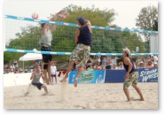 | 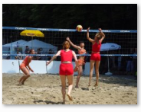

<p>We are very proud to server you the fun, safe, family sport, Beach volleyball in Marakson since 2007. We offer a wide range of services from social volleyball, competitive volleyball tournaments, socializing, licensed bar with daily happy hour from 6-7pm to leasing spaces fo fun and fitness.</p>

<p>Our players are of all ages, both men and women. We are encouraging young people, high school students to join us. It will be a lot of fun, and help to keep your body in good shape and healthy as well.</p>

1. Who Can Play?

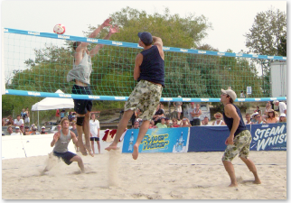  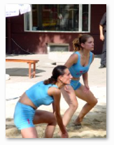 | <h4>Such a safe and fun sport, volleyball attracts millions of people worldwide to play at least once a week.</h4>  <ol>  <li>Suitable for people of all ages and both genders to keep us active and healthy.</li>  <li>Great for those wish a low-impact sport but keep body in good shape.</li>  <li>Fantastic for those want competitive, exciting, intense games. Don't worrry, the net there keeps you guys obey rules.</li>  <li?We advise you to consult doctors before taking any sport if needed</li>  </ol>

2. About Volleyball

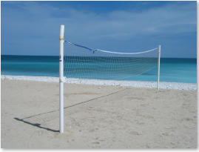 | 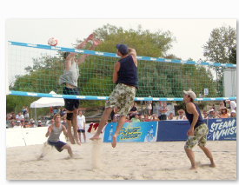

<h1>Overview</h1>
<p>Volleyball is a team sport played with one ball and a middle net. One team try to hit the ball over the net, land it on the opponent's court. Another team must send the ball back over the net within 3 tries, without letting it touch the ground. A player is not allowed to hit the ball twice consecutively except when attempting a block. </p>

<p>The ball is put into the play when the right back-row player serve it to the other team. The game keeps going until the ball touches the ground, or goes out the court, or a team fails to return it to other side, or commits a fault.</p>

<h4>When to get a point?</h4>
<p>The team winning a rally scores a point. When the receiving team wins a rally, it gains a point and the right to serve, and its players rotate one position clockwise.<p>

<h4>Who is the winner?</h4>
<ul>
<li>The best of three or best of five games will win matches. </li>
<li>In a non-deciding game, the team first scores 25 points with a minimum two-point advantage.</li>
<li>In a deciding game, team that first scores 15 points with a minimum two-point advantage.</li>

<h2>Brief history</h2>
<p>The sport originally invented in the United States, and is now popular all other the world. It ranks behind only soccer among participation sports. There are two kinds of competitive volleyball. Team volleyball is played indoors on a hard court with 6 people per team. Beach volleyball is played outdoors on the sand with 2 players per team. <p>

<p>Reproduced from http://www.volleyball.org/whatis.html </p>

3. Contact
Phone: 07 4774 1234
Fax: 07-4774 1235
Add: 14 Beach Avenue, Marakson
Email: diggers@ gmail.com

4. Announcements
Some cool things are gonna happen that we want you to know about.

In April, you can buy 2 get 3 drinks at the bar.

Get 10% discount registration fees for the next season starting April 21st if signing up before 10th

Tournament on April 18/19: Nominations close April 14 for this 4-a-side weekend competition.

5. Links
http://www.volleyball.org/ - Volleyball worldwide
http://www.fivb.ch/en/beachvolleyball/ - FIVB International Federation of Volleyball, Beach
asianvolleyball.net - Asian Volleyball Confederation

6. Sign-Up

We would like an online sign-up form so people can register their team on the site.
Data we need would be:
- Contact person name
- Phone number
- Email address
- Competition day (choose Monday – Saturday)
- Tick-box for whether they have read and agree with our playing guidelines (below)

Playing Guidelines
Participants in Diggers Beach Volleyball play at their own risk and are responsible for their own safety and should only play if they are capable. Check with your doctor before you begin.

Game fees must be paid prior to the start of the game.

Games may be cancelled up to 4 hours beforehand to get a refund. Without 4 hours' notice, participants will forfeit the game and be charged 50% of the game fee.

