PlantScope Requirements

Important

Analysis
Analysis requirements what data should be gathered and use in analysis and feel free to correct the data on what system collects
- Field assessment
Description: Field assessment onsite inspector use phone to collect the 4 parts that are Meta data, Safety, Survivability, and boundary verification use in analysis
Currently the system collects:
- Meta Data
- Assessment date
- Permits
- Security concerns
- General safety
- Accessibility
- Community support
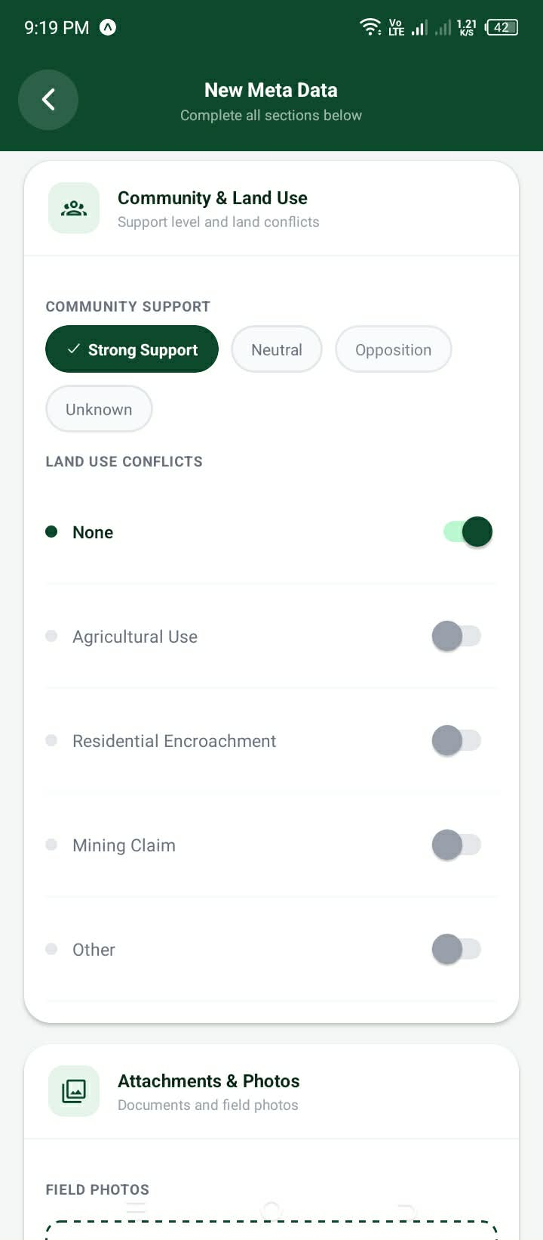
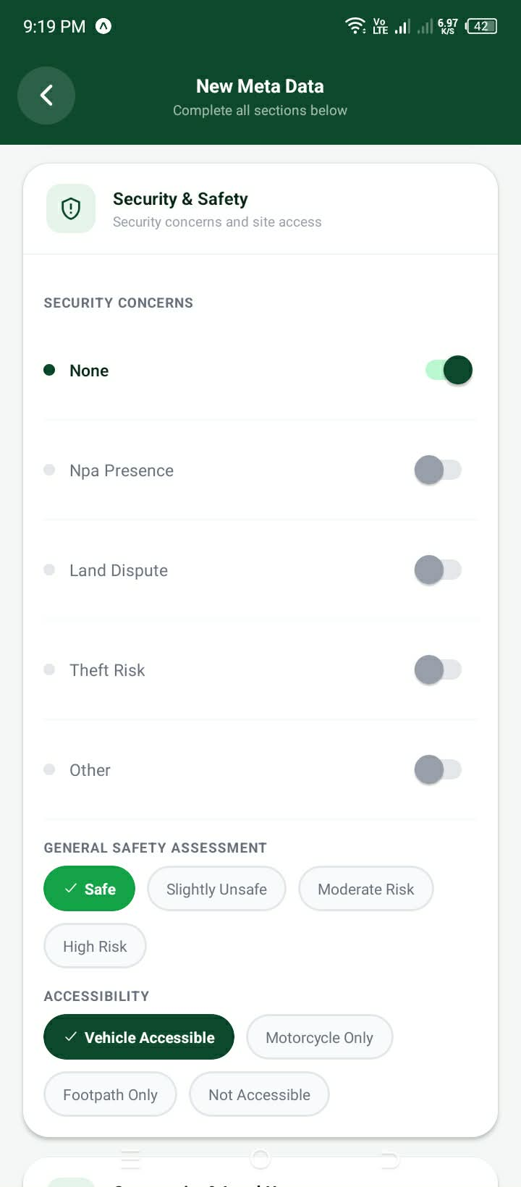
- Land use conflicts
- Attachment photos
Mobile application phots:
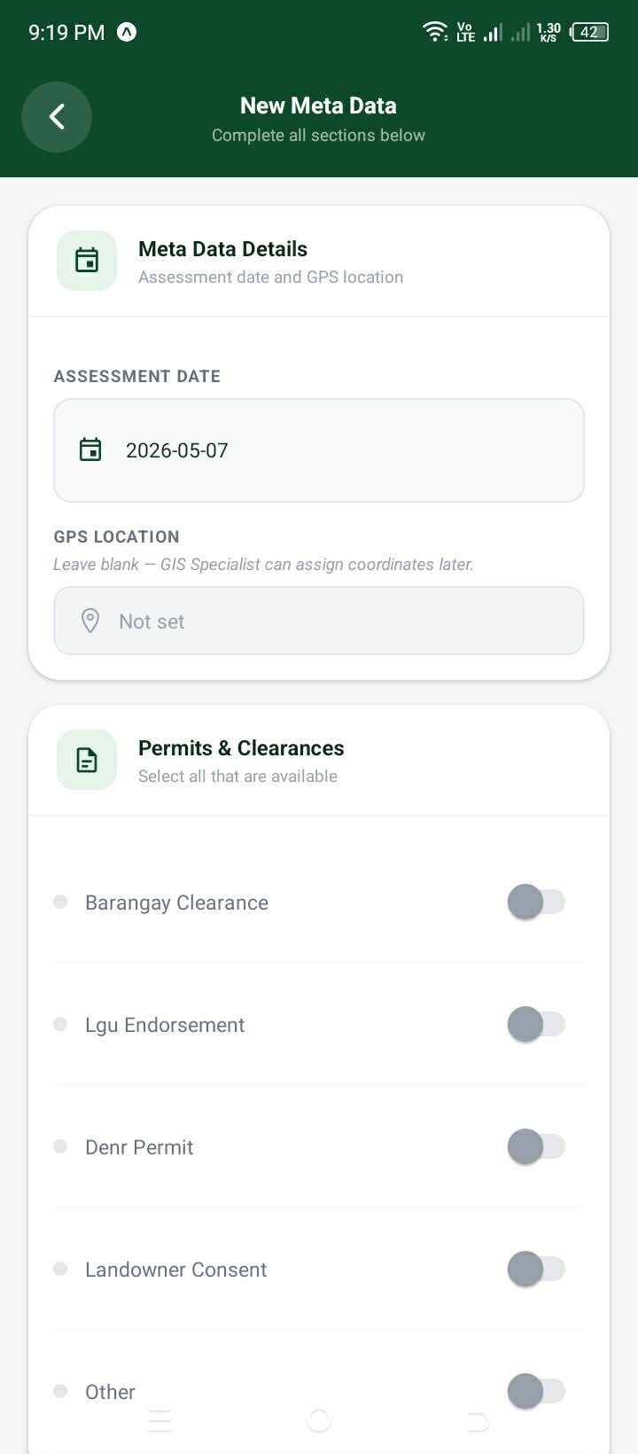
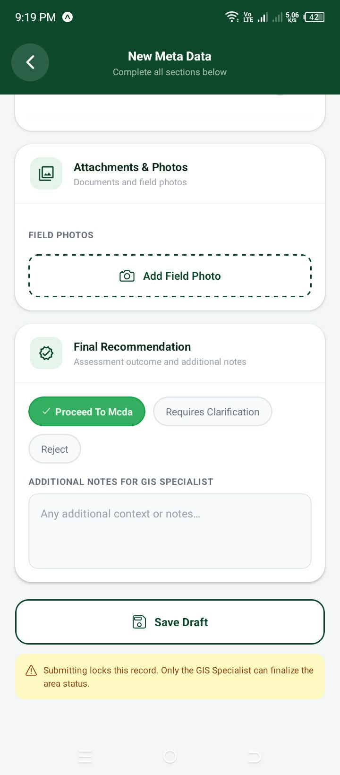

- Safety
- Land slide indicators
- Flood Evidence
- Erosion Assessment
- Assessment location
- Notes
- Photo evidence
Mobile application phots:
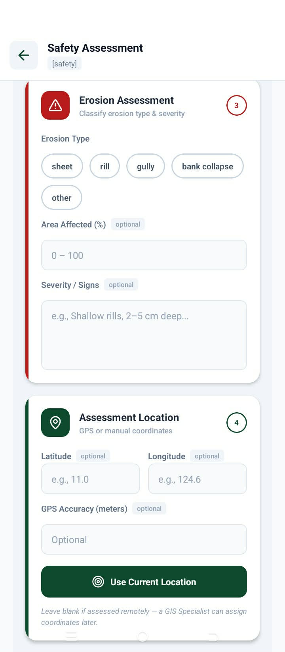
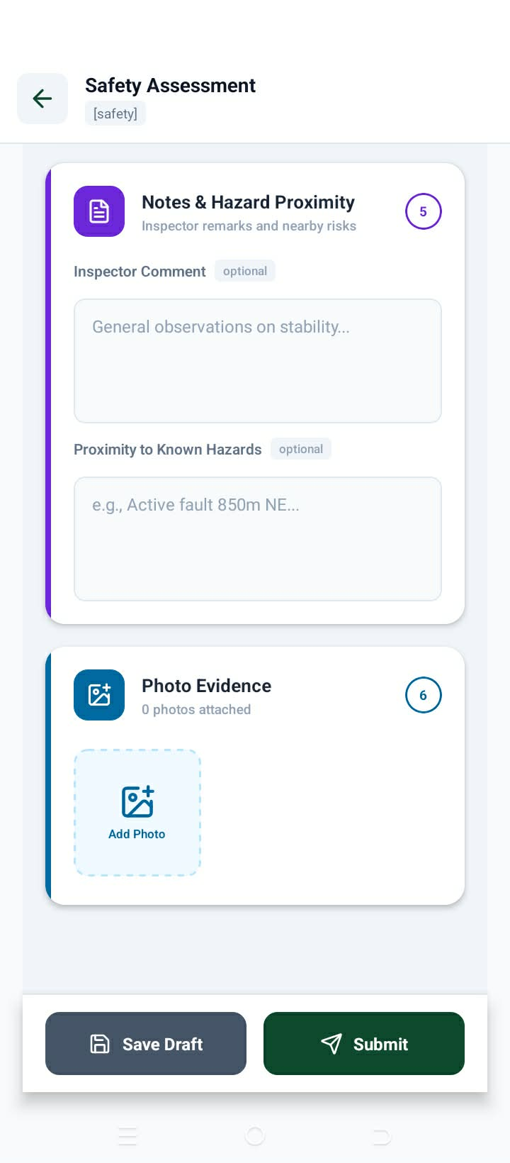
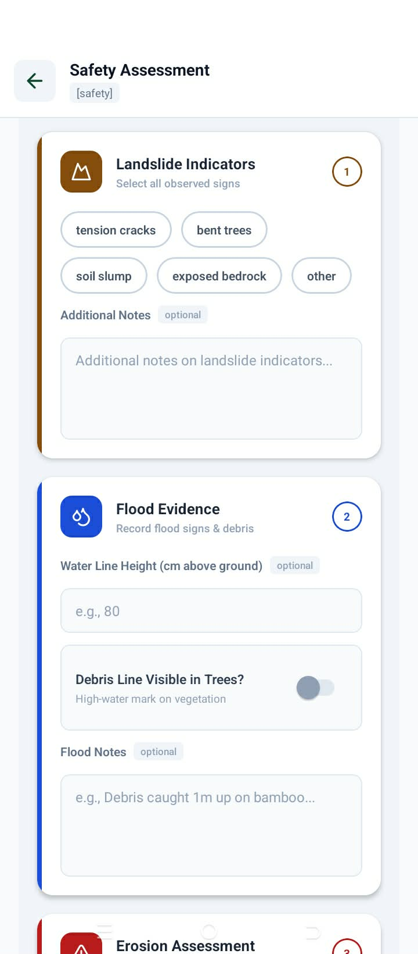

- Survivability
- Soil
- Continue lang ni nya e adjust ang uban e specific

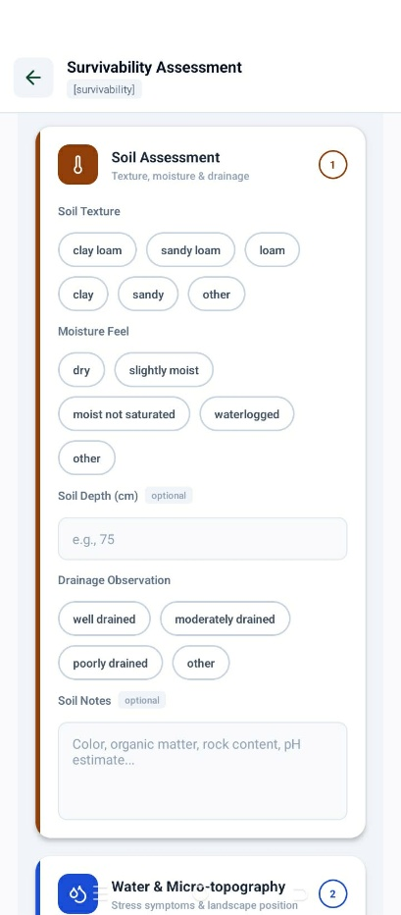
Mobile application phots:
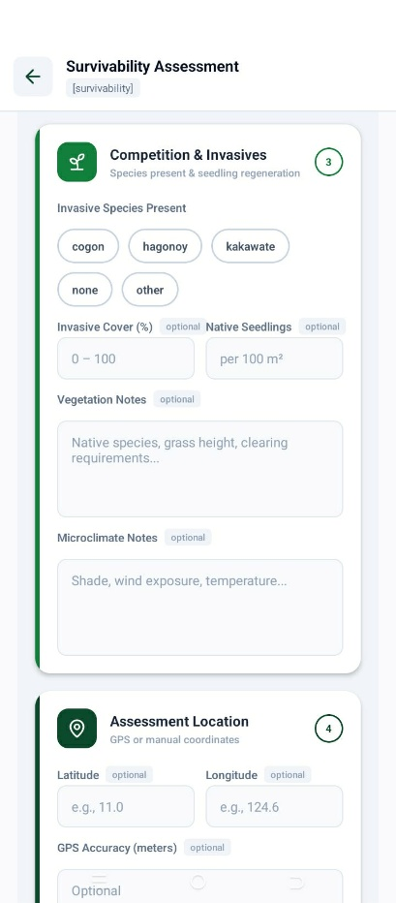
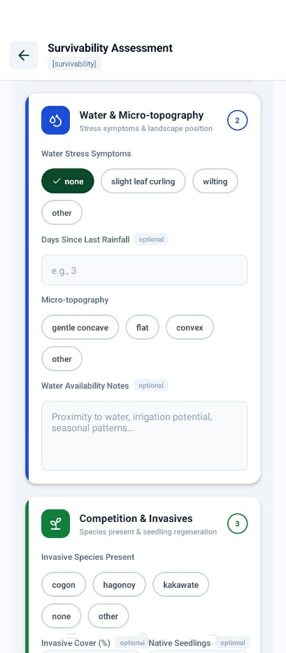

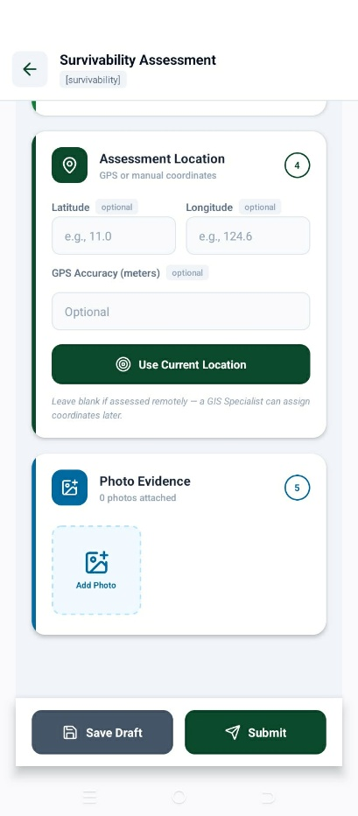

- Boundary verification
- Boundary markers
- Spail compliance
- …. Continue nya e specific

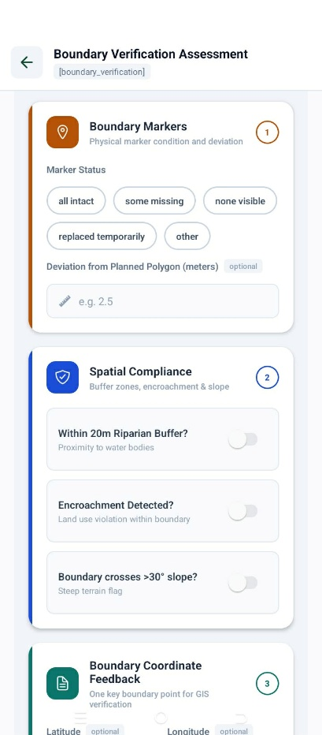
Mobile application phots:
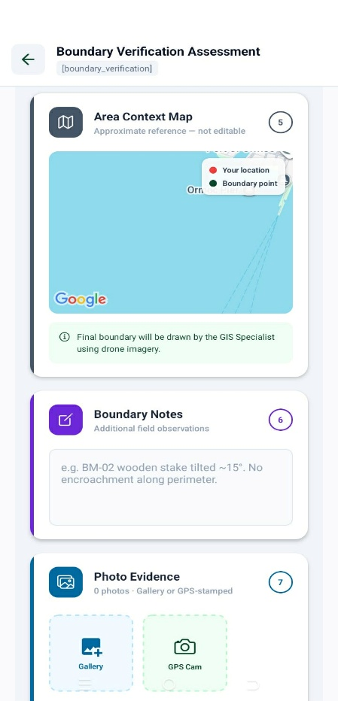
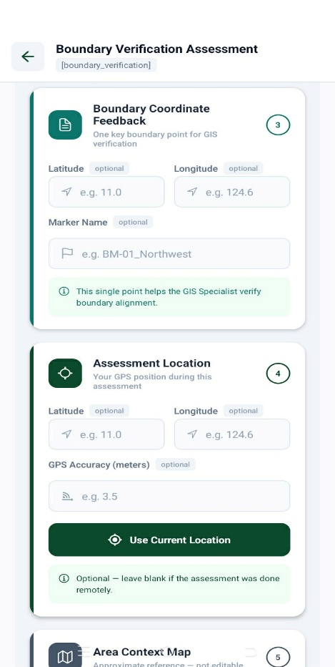

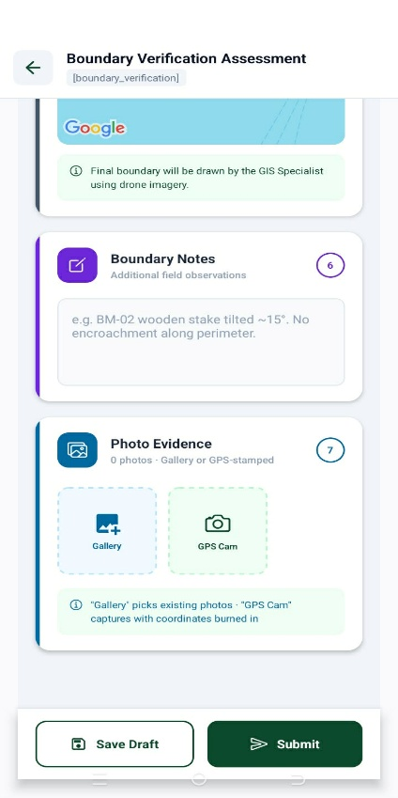

Enro corrections or adjustment:
(Enro corrections)

- Meta Data verification
Description: With the field assessments of meta data verification, now it use on verifying the finalize information about reforestation area. If, the land classification overall safety and is it legal and finalization overall.
Currently the system use in verification are:
- Permits upload photo and permit number
- Verified Safety Level (Safe, slight, moderate, and high)
- Land Classification
- Legal Status Decision
- Meta Data Status final decision (accept/rejected)

Web application photos:
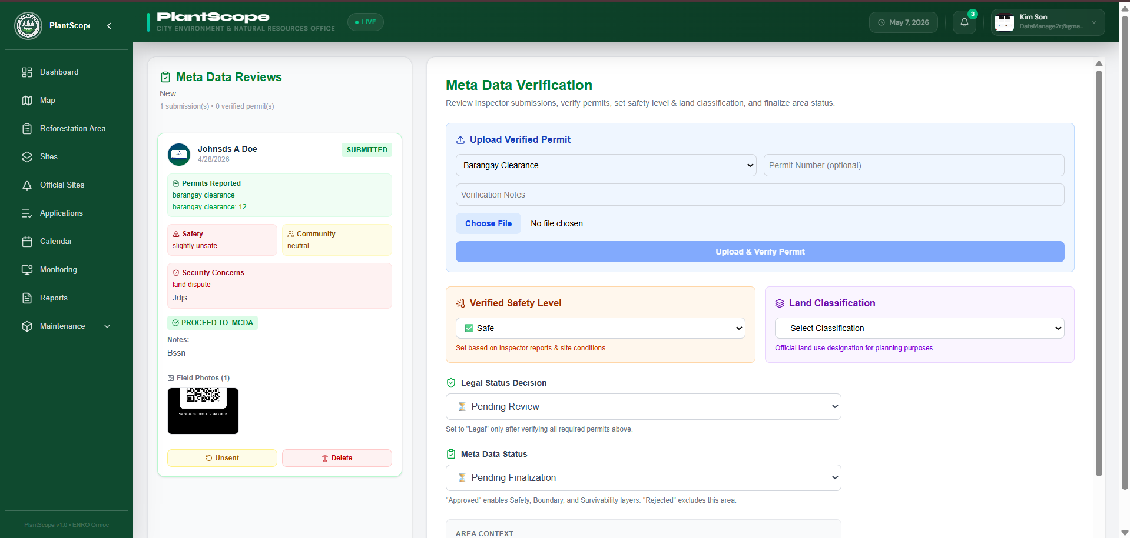

Enro corrections or adjustment:

- Multicriteria analysis (MCDA)
Description: This page is dedicated to analyze the reforestation area if suitable for planting also here with the analysis we can get the sites (polygons) using the field assessment of onsite inspector that are safety, survivability and boundary verification (3 layers). Now to finalize if the site is suitable with the 3 layers for finalize decision its need to be adjusted.
Currently the system use on final decision are:
- Safety
- Safety risk level
- ……Continue
Web application phots:
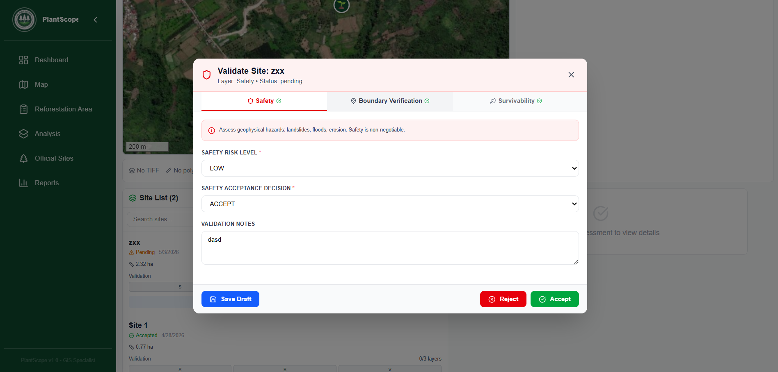

- Survivability
- Soil Suitability
- ……Continue
Web application phots:
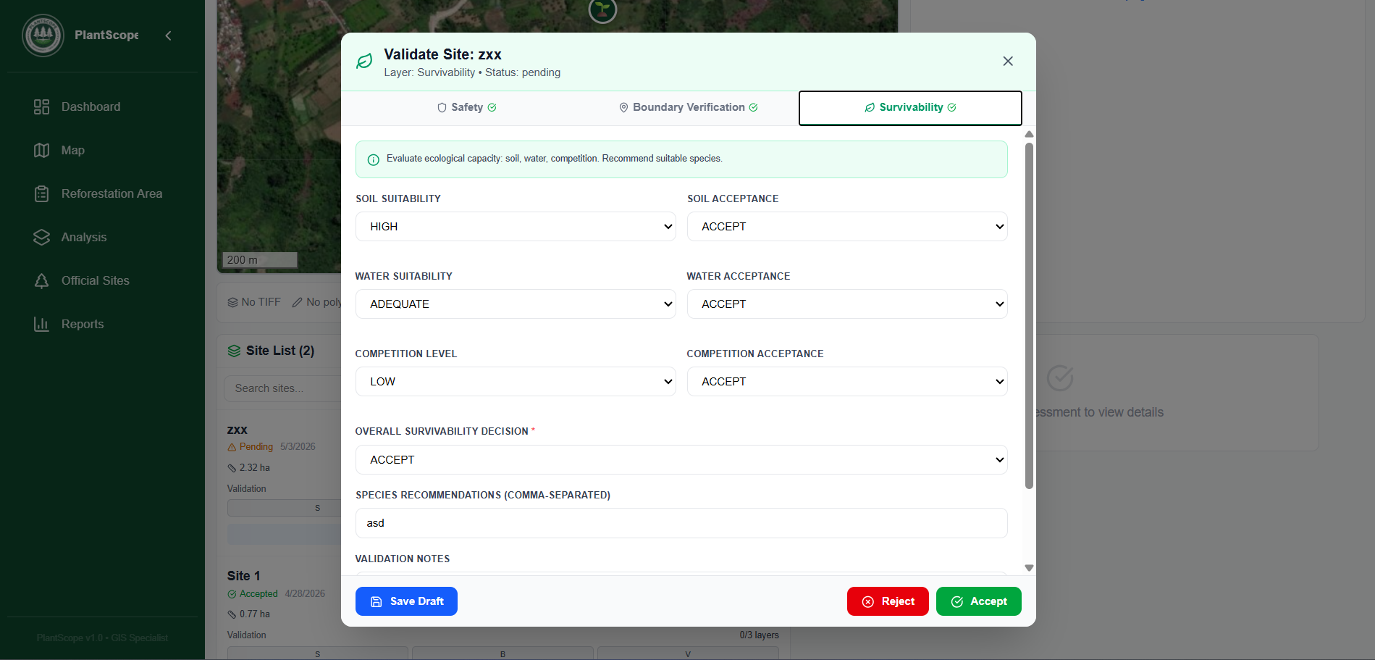
- Boundary verification
- Boundary Compliance
- ….Continue
Web application phots:
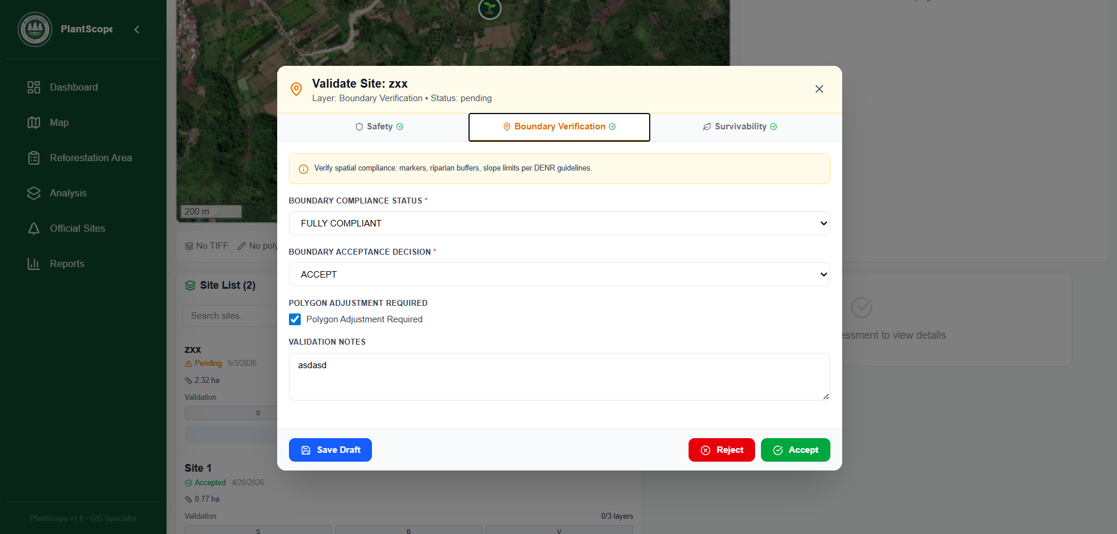

Testing and Integrating the NDVI
Description: We would like to have a real-world data to test how well our feature performs so we can adjust to strengthen it more.

Least important (needs actual discussion)

Testing and Integrating the NDVI
Description: We would like to have a real-world data to test how well our feature performs so we can adjust to strengthen it more

Seedling related questions
- Do you own the seedling you provide or is there another organization in partner?

Monitoring
Description: Currently we are confused of the data have been provided on motoring the progress of the tree growers. On the next meeting we would like to discuss the process from tracking how much the treegrowers plant and how much it survived and when and how will you record the progress.

Wildfire, flooding, landslide, and other hazard tracking
Description: Ikaw na bhala ani gica
Note: The effort will be appreciated, if the data is sent early just how much you can provide but it is not required because if it needs further more clarification and should be discuss on actual

