Marc Xyver L. Gica BSIT-3201
Laboratory Activity 3
File Permissions
Folder Structure Created

Gica_Marc_Xyver/
└── CICTE/
├── BSIT/
│ ├── BSIT3201/
│ │ ├── file1.txt
│ │ └── file2.txt
│ └── BSIT3202/
│ ├── file3.txt
│ └── file4.txt
└── BSCS/
└── file5.txt

Commands Used
Step 1: Create Main Folder

Command:
mkdir Gica_Marc_Xyver
cd Gica_Marc_Xyver

Screenshot:
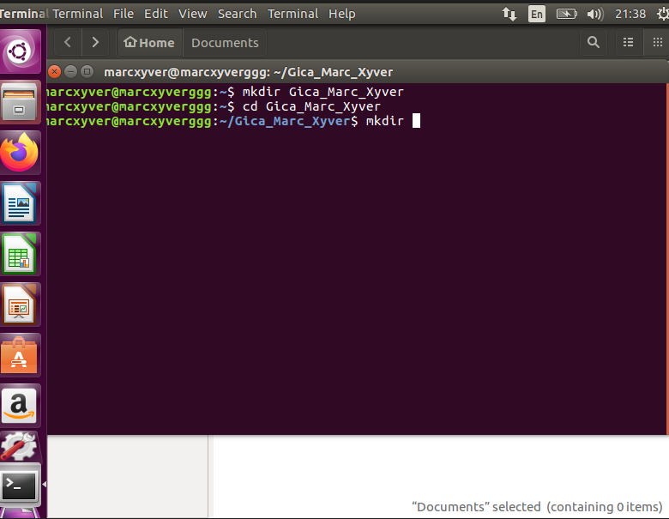

Step 2: Create Folder Structure

Command:
mkdir CICTE
cd CICTE
mkdir BSIT BSCS
mkdir BSIT/BSIT3201 BSIT/BSIT3202

Screenshot:
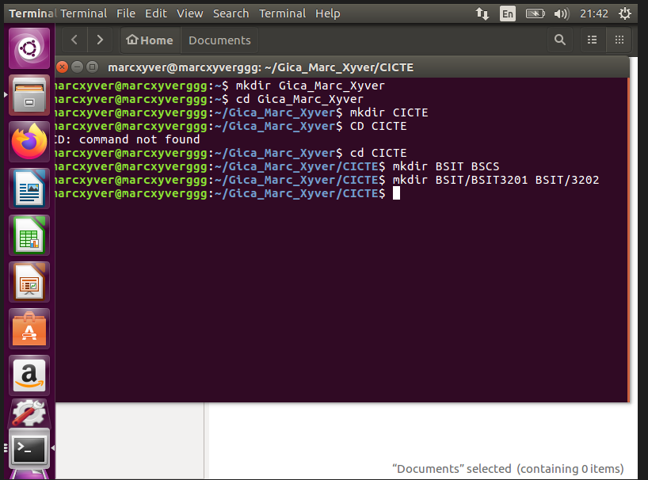

Step 3: Create Files

Command:
touch BSIT/BSIT3201/file1.txt
touch BSIT/BSIT3201/file2.txt
touch BSIT/BSIT3202/file3.txt
touch BSIT/BSIT3202/file4.txt
touch BSCS/file5.txt

Screenshot:
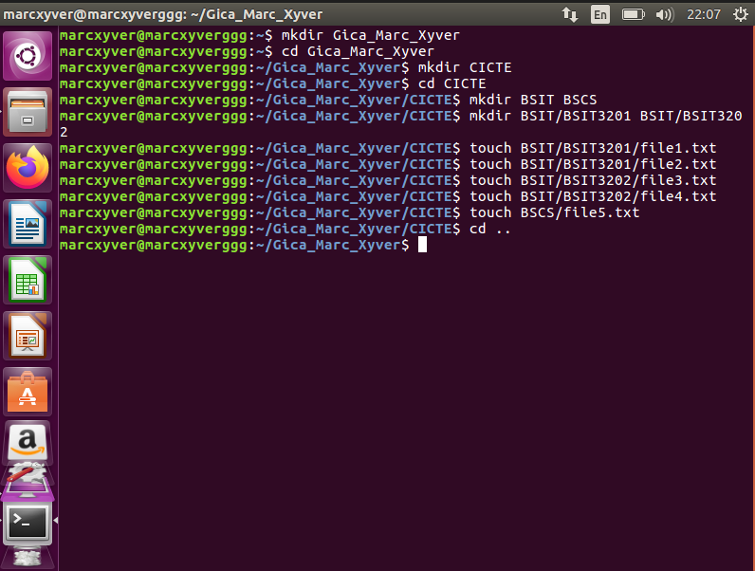

Step 4: Set Permissions

Command:
cd ..
chmod 700 CICTE
chmod 755 CICTE/BSIT
chmod 755 CICTE/BSCS
chmod 777 CICTE/BSIT/BSIT3201
chmod 777 CICTE/BSIT/BSIT3202
chmod 600 CICTE/BSIT/BSIT3201/file1.txt
chmod 644 CICTE/BSIT/BSIT3201/file2.txt
chmod 666 CICTE/BSIT/BSIT3202/file3.txt
chmod 700 CICTE/BSIT/BSIT3202/file4.txt
chmod 755 CICTE/BSCS/file5.txt

Screenshot:
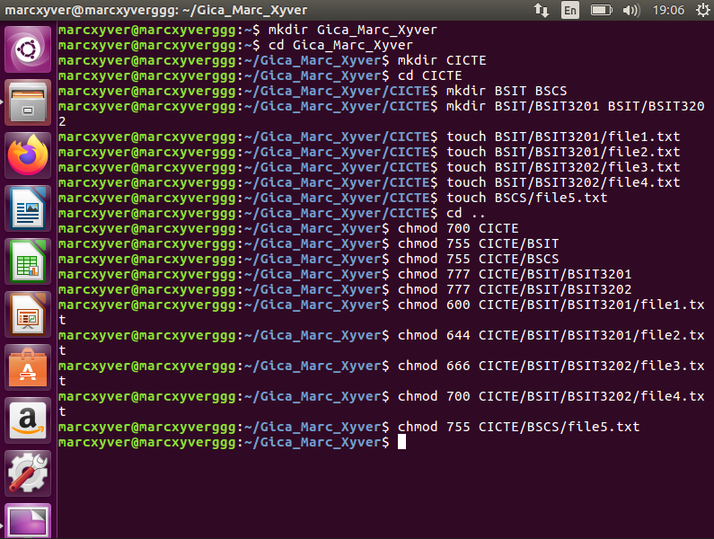
Screenshots
1. CICTE Folder Contents

Command:
ls -ld CICTE/

ls -l CICTE/
Screenshot:
Screenshot:
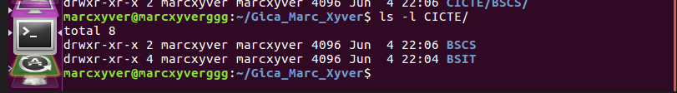

2. BSIT Folder Contents

Command:
ls -ld CICTE/BSIT

ls -l CICTE/BSIT/

Screenshot:

Screenshot:
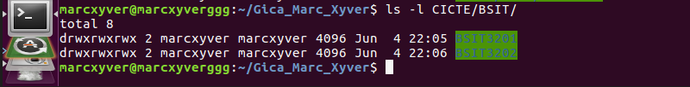

3. BSCS Folder Contents

Command:
ls -ld CICTE/BSCS/

ls -l CICTE/BSCS/

Screenshot:

Screenshot:
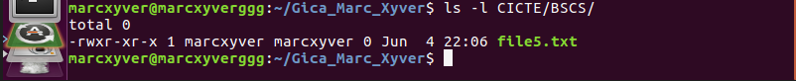

4. BSIT3201 Folder Contents

Command:
ls -ld CICTE/BSIT/BSIT3201
ls -l CICTE/BSIT/BSIT3201

Screenshot:
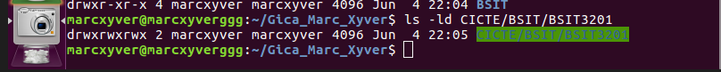

Screenshot:
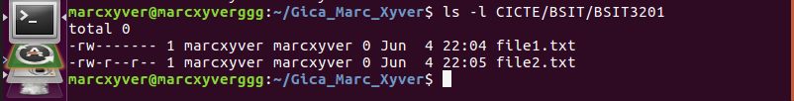

5. BSIT3202 Folder Contents

Command:
ls -ld CICTE/BSIT/BSIT-3202
ls -l CICTE/BSIT/BSIT-3202
Screenshot:

Screenshot:
