PlantScope: A GIS-Enabled Site Identification and Prioritization System for Data-Driven Reforestation in Ormoc City, Leyte

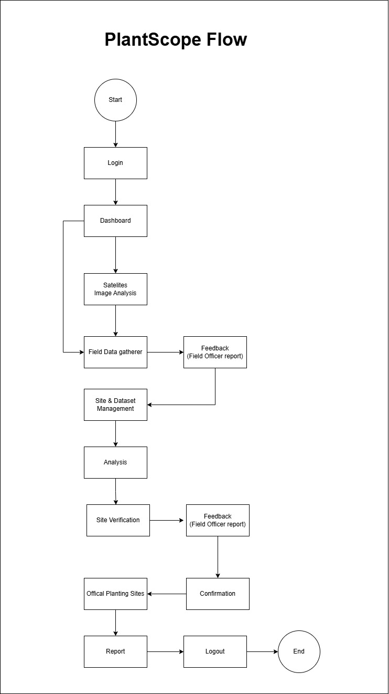

Module | Description (2 Sentences)
Login | Allows both admins and field officers to securely access the system. Ensures that only authorized users can manage and view reforestation data.
Dashboard | Displays an overview of reforestation activities, datasets, and ongoing site updates. It serves as the main control center for system insights.
Satellites Image Analysis | Uses satellite imagery to detect and identify potential reforestation areas based on land and vegetation conditions. The system analyzes imagery to highlight degraded or suitable sites.
Field Data Gatherer | Assigns field officers to collect on-site information such as soil type, moisture, and vegetation health. The data gathered supports the validation of satellite findings.
Feedback (Field Officer Report) | Field officers submit their collected data and on-ground observations to the system. This feedback helps improve analysis accuracy and decision-making.
Site & Dataset Management | Manages and organizes all site-related data from both satellite and field sources. Ensures data consistency and accessibility for analysis.
Analysis | Processes and evaluates all gathered data to identify and prioritize areas suitable for reforestation. It uses defined environmental criteria for ranking sites.
Site Verification | After analysis, identified areas are assigned to field officers for on-site verification. Their findings are sent back to the admin for review and confirmation.
Confirmation | Admin reviews field verification results and decides which areas will become official planting sites. This final step ensures accuracy and accountability.
Official Planting Sites | Displays all verified and approved areas designated for reforestation. These sites serve as the basis for actual planting operations.
Report | Generates detailed reports summarizing analysis results, feedback, and confirmed planting sites. These reports support transparency and planning for future reforestation efforts.
Logout | Safely ends the user’s session and returns to the login screen. This helps maintain security and data privacy.

Interview Guide for ENRO – DENR Ormoc City
Research Title: PlantScope: A GIS-Enabled Site Identification and Prioritization System for Data-Driven Reforestation in Ormoc City, Leyte
Purpose: To gather insights on the current methods, challenges, and criteria used by ENRO–DENR Ormoc City in identifying and prioritizing reforestation sites.
Confidentiality: All answers will be treated confidentially and used only for academic research.

A. Respondent Information
1. Can you please state your name and position in the office?
2. How many years have you been working in ENRO/DENR?
3. Which division or area are you assigned to?
4. What is your educational background or training relevant to environmental management or GIS?
5. Can you briefly describe your involvement in reforestation or environmental programs?

B. Site Identification Practices
6. How does your office currently identify potential sites for reforestation? Can you describe the
process?
7. What factors or criteria do you consider when selecting reforestation sites (e.g., slope, soil type,
land use, accessibility, proximity to water sources)?
8. Who are usually involved in the site identification process (e.g., LGU staff, community members,
technical staff)?
9. How often does your office reassess or update identified reforestation sites?

C. Site Prioritization Process
10. How do you determine which areas should be prioritized for reforestation?
11. What factors make a site more urgent or important to rehabilitate compared to others?
12. Do you use any tools, maps, or data systems to support prioritization decisions (e.g., GIS maps,
land classification data)?
13. What challenges or limitations do you face in prioritizing reforestation sites?

D. Technology and Decision Support
14. Are you currently using any digital tools or mapping systems for identifying and prioritizing sites?
If yes, which ones?
15. What kind of technological support or data would make your site identification and prioritization
work easier or more accurate?
16. Would your office consider adopting a GIS-based system like PlantScope to enhance decisionmaking? Why or why not?
E. Program Insights
17. In your experience, what are the main reasons some reforestation projects succeed or fail in
Ormoc City?
18. What recommendations can you suggest to improve how reforestation sites are identified and
prioritized?

