CTD Data Report for Aurora Australis Marine Science Cruise AU0404, V4 2003/2004 ("HIPPIES" Heard Is. Fishing Voyage)

MARK ROSENBERG
ACE CRC, Hobart, Australia
August, 2004

1 INTRODUCTION

Oceanographic data were collected on Aurora Australis Voyage 4 2003/2004, from December 2003 to February 2004, and a calibrated data set was created. A total of 42 CTD vertical profile stations were taken, most to within 5 m of the bottom. Over 450 Niskin bottle salinity samples were collected and analysed on board, for calibration of the CTD conductivity sensors. Nutrient samples were also collected, but not analysed. Near surface current data were collected using a ship mounted ADCP. Data from the array of ship's underway sensors are included in the data set.

This report describes the processing/calibration of the CTD and ADCP data, and details the data quality. An offset correction is derived for the underway sea surface temperature and salinity data, by comparison with near surface CTD data. Note that the data processor was not a cruise participant, thus this report does not describe in detail the shipboard field data collection or any problems encountered. CTD station positions are shown in Figure 1, while CTD station information is summarised in Table 4.

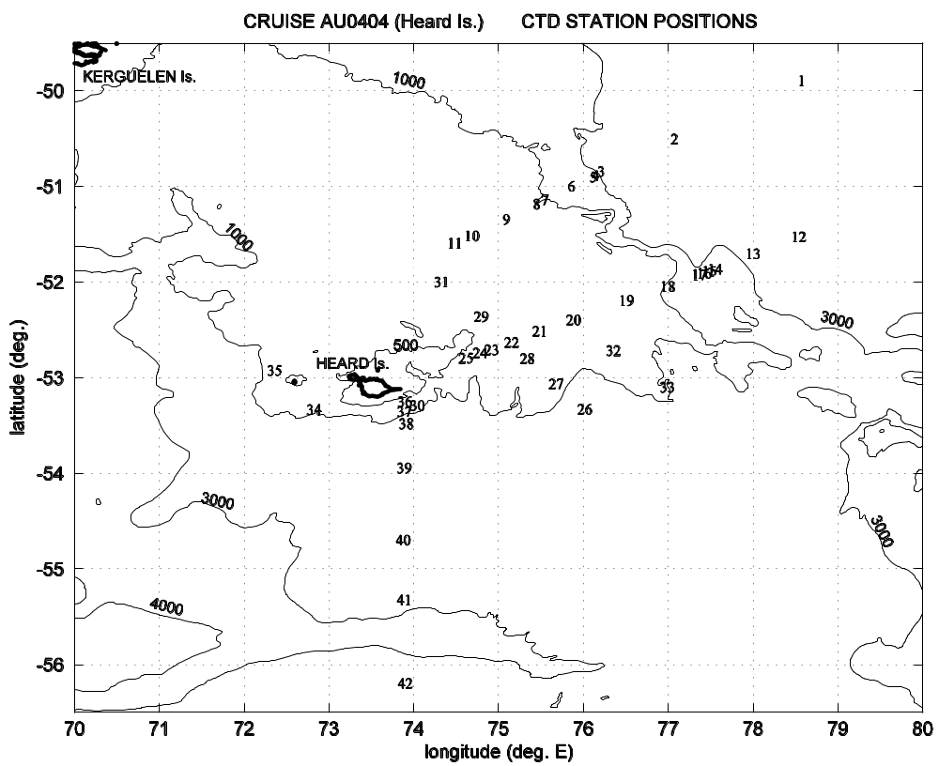

Figure 1: CTD station positions for cruise AU0404, including GEBCO2003 bathymetry at contours 4000, 3000, 1000 and 500 m.

2 CTD INSTRUMENTATION, LABORATORY CALIBRATION AND ACCURACY

A SeaBird SBE9plus CTD, serial 703, was used for the entire cruise, including the following sensors:

dual temperature (model SBE3plus) and conductivity (model 4C) sensors
submersible pump system for each sensor pair
dissolved oxygen (model SBE43) sensor
Digiquartz pressure sensor
Wetlabs fluorometer
Benthos altimeter

The instrument was mounted on a 24 bottle rosette frame, together with a SeaBird 24 position rosette pylon (model SBE32) and 18 x 10 litre OTE Niskin bottles. A camera system took the place of 6 Niskin bottles. Data were transmitted up a 6 mm sea cable to a SeaBird SBE11plusV2 deck unit, at a data rate of 24 Hz.

Sensor calibrations were as provided by the manufacturer, with the following calibration dates:
primary temperature 18/09/2002
primary conductivity 18/09/2002
pressure 22/03/2002
secondary temperature 04/09/2002
secondary conductivity 24/09/2002
oxygen 24/09/2002
fluorometer 27/11/2002

Under normal circumstances, new sensor calibrations would be obtained prior to an oceanography cruise. For the case of cruise au0404, CTD's were not a cruise determining program, and the instrument was not recalibrated prior to the voyage. For temperature data, sensor calibration drift occurs over time, and thus there is some degradation to the temperature data accuracy. Specifically, the manufacturer quotes typical temperature sensor stability as ~0.0002ºC per month. Thus temperature data for the cruise can at best be considered accurate to only ~0.003ºC. Typical pressure sensor drift quoted by the manufacturer is 0.0015% of full scale per month, thus at 4000 dbar there may be a pressure calibration drift error of the order ~0.8 dbar. For conductivity/salinity data, final calibrations are obtained from the in situ salinity Niskin bottle measurements, and thus the age of the sensor calibrations is not considered significant (as long as the temperature and pressure data are no more degraded than discussed above).

3 CTD DATA PROCESSING AND CALIBRATION

CTD data were processed in Hobart. The first step is application of a suite of the SeaBird "Seasoft" processing programs to the raw data, in order to:
* convert raw data signals to engineering units
* remove the surface pressure offset for each station
* realign the oxygen sensor with respect to time (note that conductivity sensor alignment is done by the deck unit at the time of data logging)
* remove conductivity cell thermal mass effects
* apply a low pass filter to the pressure data
* flag out pressure reversals
* search for bad data (e.g. due to sensor fouling)

Further processing and data calibration were done in a UNIX environment, using a suite of fortran programs. Processing steps here include:
* forming upcast burst CTD data for calibration against bottle data, where each upcast burst is the average of 10 seconds of data prior to each Niskin bottle firing
* merging bottle and CTD data, and deriving CTD conductivity calibration coefficients by comparing upcast CTD burst average conductivity data with calculated equivalent bottle sample conductivities
* forming pressure monotonically increasing data, and from there calculating 2 dbar averaged downcast CTD data
* calculating calibrated 2 dbar averaged salinity from the 2 dbar pressure, temperature and conductivity values

Final station header information, including station positions and sounder depths at the start, bottom and end of each CTD cast, were obtained from 1 minute underway data for the cruise (downloaded from the AADC underway data website - see the Antarctic Division "dotzapper" report referenced at the end of this report). Note the following for the station header information:
* All times are UTC.
* Sounder depths are calculated at a sound speed of 1475 m/s, with a ship's draught of 7.3 m added.
* After initial CTD deployment, the instrument is held a few metres below the surface until confirmation of pump operation. The instrument is then brought back up to as near the surface as conditions allow, then the downcast proper commences. "Start of cast" information is at this commencement of the downcast.
* "Bottom of cast" information is at the maximum pressure value.
* "End of cast" information is when the CTD leaves the water at the end of the cast, as indicated by a drop in salinity values.

Lastly, data were converted to MATLAB format, and final data quality checking was done within MATLAB.

4 RESULTS AND DATA QUALITY

During calibration of the CTD conductivity data, the primary sensor data was found to give a better comparison with bottle values. Thus data from the primary CTD sensor pair (temperature and conductivity) were used for this cruise.

Comparing primary and secondary temperature data (T_{p} and T_{s} respectively), overall T_{s} < T_{p} by ~0.001ºC. This lies well within the calibration drift error already discussed above, thus there is no further degradation of the temperature accuracy already discussed i.e. ~0.003ºC.

Conductivity and salinity calibration results are shown in Figures 2 and 3 respectively, for primary sensor data. The conductivity calibration methodology is described in detail in Rosenberg et al. (1995). From the figures, several significant "steps" occur in the CTD/bottle comparison, most noticeably before station 9, before station 12, and before station 30. These apparent calibration shifts are most likely due to the following 2 problems. Firstly, large laboratory temperature fluctuations were experienced on the ship during salinity sample analyses, causing salinometer calibration shifts, most notably prior to stations 12 and 30. And secondly, throughout the cruise close approaches to the sea floor were required for camera work, and as a result CTD sensor fouling occurred on several occasions after contact with the bottom. This fouling is most noticeable for primary sensor data for stations 9 to 14 (not evident in the secondary sensor data). Conclusive evidence of the main cause of these calibration steps would usually be provided by salinity data comparisons between series of stations for both CTD and bottle data within the Southern Ocean deep water mass. However CTD measurements for the cruise were taken mostly over shallower bathymetry, thus there is insufficient deep water data available. So the evidence remains largely circumstantial i.e. attributing calibration steps to salinometer problems caused by laboratory temperature fluctuations. With this assumption of unstable salinometer readings, a station dependent correction term was not considered appropriate for the conductivity calibration, and all stations were grouped together for a single calibration fit. More refined station grouping was not possible as the salinometer and CTD sensor fouling problems were intermingled. The resulting conductivity calibration coefficients are:

slope = 1.0008392e-03
offset = -5.3388926e-03

where calibrated CTD conductivity c_{cal} is obtained from uncalibrated CTD conductivity c_{uncal} by the equation

c_{cal} = c_{uncal} x 1000 x slope + offset

The degradation of data accuracy due to the assumed salinometer problems means that salinity for the cruise can only be considered accurate to ~0.003 (PSS78). Furthermore, for stations 9 to 14 the CTD salinity may be low by up to 0.005 (PSS78) (Figure 3), due to assumed sensor fouling.

No dissolved oxygen Niskin bottle samples were collected, thus the CTD dissolved oxygen data for the cruise were unusable. All oxygen data have been replaced by null values in the data files.

Further processing/calibration notes are listed as follows:

* For station 42, raw data files from the right hand CTD logging PC were corrupt. Data files from the lefthand CTD logging PC were used.

* Surface pressure offset corrections are listed in Table 1.

* Table 2 lists the bad 24 hz data scans flagged out - mostly due to sensor fouling.

* Bad out of water data had to be removed from the end of the raw data file for station 40.

* Niskin bottle firing time files were manually created for station 10 and 42, as the original files were corrupt. Niskin firing times for these stations were estimated from the firing times noted on the CTD sheets.

* Fluorescence data for station 2 were suspiciously high, and have been removed.

Summary of data accuracy:

temperature: 0.003ºC
salinity: 0.003 (PSS78), except for stations 9-14 where salinity may be low by up to 0.005 (PSS78)
pressure: 0.035% of full scale (e.g. 0.35 dbar at 1000 dbar depth, 1.4 dbar at 4000 dbar depth),
incorporating both initial sensor accuracy and calibration drift quoted by manufacturer

5 ADCP

The hull mounted ADCP unit is a high power 150 kHz narrow band ADCP produced by RD Instruments. The four transducer heads are mounted in a concave Janus configuration, with the beams 30 degrees off vertical, and with the transducers aligned at 45º to fore and aft. The transducers are mounted in a seachest ~7 m below the water surface, behind a 81 mm thick low density polyethylene window, with the window flush to the ship’s hull. The inside of the seachest is lined with acoustic tiles (polyurethane with barytes and air microsphere fillers), and filled with hypersaline water.

ADCP data are logged on a Sparc 5 Sun workstation, using software developed by CSIRO Division of Marine Research, Hobart (J. Dunn and H. Beggs). GPS data are obtained from an Ashtech 3DF GPS system, logged by the workstation every second. Raw ADCP ping data are averaged into 3 minute ensembles at the time of logging. Pitch/roll corrections, derived from 3D GPS attitude, are also applied to the data at this time. During post-cruise data processing, these ship-relative ADCP data are converted to earth coordinates using the 3D GPS position, velocity and heading data. The final data set is averaged into 30 minute ensembles. Data processing is discussed in more detail in Dunn (a and b, unpublished reports). ADCP logging and calibration parameters are summarised in Table 3, and current vectors for the cruise are plotted in Figures 4a and b.

In general, ADCP data are contaminated by ship's motion when the ship accelerates i.e. changes direction or speed. Noise and turbulence often diminish ADCP data quality when the ship travels at speeds greater than ~13 knots, or during rough sea states. Thus the best quality ADCP data is when the ship is steaming in a straight line at a suitable constant speed, and during milder sea conditions. The most reliable data are collected when the ship is "on station" (on station data is defined here as data where ship speed ≤ 0.35 m/s).

An erroneous vertical ADCP current shear occurs when the ship is underway. This shear has a magnitude for this cruise of up to ~0.11 m/s over the ADCP current profile (Figure 5). A likely cause for this error is acoustic ringing against a small air/water interface inside the transducer seachest. From Figure 5, when the ship is underway the effect is most significant over bins 1 to 10, and data from these bins should be treated with caution. Also from the figure, when the ship is travelling at ≤ 1 m/s the effect is no longer significant.

Data backup problems during the cruise resulted in some corrupted data files, and as a result there are no ADCP data from ~18th January to 3rd February.

6 UNDERWAY DATA

Underway data, including bathymetry, sea surface temperature/salinity/fluorescence, and meteorological parameters, were logged to an Oracle database on the ship. Data were dumped from the AADC (Antarctic Division Data Centre) website. For more information, see the AADC website, and the cruise dotzapper report (Lunstedt, 2004).

12 kHz bathymetry data were logged at a sound speed of 1500 m/s. In the final data set presented here, bathymetry values are recalculated at a sound speed of 1475 m/s, an average value for the fishing survey area calculated from CTD profile data. Ship's draught of 7.3 m is also added to the data.

A correction was applied to the underway sea surface temperature and salinity data, derived by comparing the underway data with CTD temperature and salinity data at 8 dbar (Figure 6). The following corrections were applied:

T = T_{dls} - 0.033
S = S_{dls} + 0.029

for corrected underway sea surface temperature and salinity T and S respectively, and uncorrected values T_{dls} and S_{dls}. A simple offset rather than a higher order correction was selected, as follows. From Figure 7, which shows the entire time series of underway T and S from the cruise, CTD's were only taken over a narrow range of all the underway T and S values encountered - specifically, during the fishing survey in the vicinity of Heard Island. Thus the correction values above have only been calculated over the range of underway T and S values during the survey. No data are available from this cruise to refine the correction for the higher (and lower) underway T and S values encountered over the first ~10 and last ~15 days of the cruise (Figure 7). As the corrections have been applied to the whole cruise underway T and S data, higher order corrections are not suitable as they may introduce a significant error.

7 DATA FORMATS

The data are available in the following files:

CTD data
* 2 dbar averaged downcast CTD files, including header information
* station information summary file
* bottle data file, including Niskin bottle salinity data, and CTD upcast averaged data bursts
* MATLAB versions of the CTD data and bottle data
* a README_au0404 file, detailing the file names and file formats

ADCP data
* 30 minute ensemble averaged data for the whole cruise, both ASCII and MATLAB versions
* same as above, but for "on station" data only (i.e. ship speed ≤ 0.35 m/s)
* a READMEdop0404 file, detailing file names and file formats

underway data
* 1 min.instantaneous values, text format: hippies.ora
* 1 min. instantaneous values, matlab format: hippiesora.mat

REFERENCES

Dunn, J., 1995a. ADCP processing system. CSIRO Division of Oceanography (unpublished report).

Dunn, J., 1995b. Processing of ADCP data at CSIRO Marine Laboratories. CSIRO Division of Oceanography (unpublished report).

Lunstedt, E. (2004) Marine Science Support Data Quality Report. RSV Aurora Australis Voyage 4 2003-2004 (HIPPIES). Avaliable at http://aadc.maps.aad.gov.au/metadata/mar_sci/Dz200304040.html

Rosenberg, M., Eriksen, R., Bell, S., Bindoff, N. and Rintoul, S., 1995. Aurora Australis marine science cruise AU9407 - oceanographic field measurements and analysis. Antarctic Cooperative Research Centre, Research Report No. 6, July 1995. 97 pp.

ACKNOWLEDGEMENTS

Thanks to all scientific personnel who participated in the cruise, and to the crew of the RSV Aurora Australis. Thanks also to Guy Williams for leading the oceanographic data collection on the cruise, and for providing the CTD and ADCP data, and to Bryan Scott for providing underway data.

Table 1: Surface pressure offsets.

station surface P offset station surface P offset station surface P offset
number (dbar) number (dbar) number (dbar)
------------------------------------ ------------------------------------ ------------------------------------
1 -0.35 15 -0.56 29 -0.29
2 -0.45 16 -0.78 30 -0.09
3 -0.48 17 -0.83 31 -0.30
4 -0.45 18 -0.74 32 -0.08
5 -0.56 19 -0.76 33 -0.35
6 -0.49 20 -0.32 34 -0.28
7 -0.40 21 -0.50 35 -0.43
8 -0.58 22 -0.55 36 -0.45
9 -0.35 23 -0.45 37 -0.48
10 -0.51 24 -0.52 38 -0.58
11 -0.58 25 -0.56 39 -0.49
12 -0.24 26 -0.25 40 -0.51
13 -0.43 27 -0.46 41 -0.60
14 -0.51 28 -0.47 42 -0.48

Table 2: Raw data scans flagged as bad, mostly due to sensor fouling.

station raw scan station raw scan station raw scan
number range number range number range
---------------------------------- ---------------------------------- ----------------------------------
1 44565-7 12 36792-5 29 30671-4
1 44674-6 15 33256-8 31 29115-7
1 45914-5 17 14507-9 32 31014-6
1 46596-46600 24 13458-13460 32 33828-30
2 84366-8 25 22792-6 35 19948-19952
6 42316-9 25 23133-5 35 19955-7
8 14966-8 25 23194-6 35 20137-9
9 43231-5 25 23221-3 41 20144-6
11 38336-8 25 23291-3 42 46466-7
12 33238-9 26 18026-8 42 52476-8

Table 3: ADCP logging and calibration parameters for cruise au0404. For calibration parameters: α=alignment angle between ADCP transducers and GPS heading; 1+β=scaling factor.

ping parameters bottom track ping parameters
no. of bins: 60 no. of bins: 128
bin length: 8 m bin length: 4 m
pulse length: 8 m pulse length: 32 m
delay: 4 m
ping interval: minimum ping interval: same as profiling pings

reference layer averaging: bins 8 to 20
XROT: 822
ensemble averaging duration: 3 min. (for logged data)
30 min. (for final processed data)

calibration
α (± standard deviation) 1+β (± standard deviation) number of 'calibration' sites
2.381 ± 0.566 1.0672 ± 0.010 217

Table 4: CTD station information for cruise au0404. Note: altimeter is the minimum altimeter reading in metres; maxp is the maximum pressure (dbar) for the cast.

--------------------------start of CTD------------------------------- ----------------bottom of CTD------------------ -------------------end of CTD-------------------
stn date time latitude longitude depth time latitude longitude depth time latitude longitude depth altimeter maxp

001 16 Dec 2003 074246 49 53.56 S 078 34.38 E 3597 085000 49 54.34 S 078 34.55 E 3589 101725 49 55.33 S 078 34.64 E 3569 0.0 3676
002 16 Dec 2003 215823 50 30.24 S 077 04.47 E 3284 223657 50 30.38 S 077 04.73 E 3336 235723 50 30.44 S 077 05.71 E 3350 0.0 3353
003 17 Dec 2003 054917 50 50.64 S 076 12.63 E 3044 072038 50 50.65 S 076 13.42 E 3014 084154 50 50.54 S 076 14.36 E 3087 0.0 3065
004 17 Dec 2003 131810 50 53.36 S 076 08.78 E 2574 141009 50 53.43 S 076 09.22 E 2548 151815 50 53.41 S 076 09.83 E 2550 - 2505
005 17 Dec 2003 175010 50 54.14 S 076 07.10 E 2049 183054 50 54.14 S 076 07.54 E 2090 193116 50 54.22 S 076 07.94 E 2153 11.1 2093
006 17 Dec 2003 222255 50 59.89 S 075 51.70 E 1496 233445 50 59.84 S 075 51.97 E 1527 002940 50 59.83 S 075 52.58 E 1656 0.0 1596
007 18 Dec 2003 045406 51 08.41 S 075 32.92 E 1138 053202 51 08.41 S 075 33.26 E 1259 061731 51 08.56 S 075 33.82 E 1274 - 1172
008 18 Dec 2003 081301 51 11.05 S 075 27.05 E 604 082800 51 11.14 S 075 27.19 E 596 090302 51 11.37 S 075 27.55 E 590 14.6 579
009 18 Dec 2003 125337 51 20.67 S 075 05.68 E 628 131040 51 20.68 S 075 05.89 E 629 134733 51 20.74 S 075 06.49 E 622 0.0 632
010 18 Dec 2003 175641 51 31.02 S 074 41.24 E 521 180610 51 30.98 S 074 41.29 E 524 184458 51 30.66 S 074 41.72 E 539 5.5 520
011 18 Dec 2003 211147 51 35.70 S 074 29.17 E 363 213012 51 35.68 S 074 29.27 E 368 215739 51 35.72 S 074 29.52 E 368 0.0 368
012 25 Dec 2003 170126 51 31.60 S 078 32.38 E 3532 180450 51 31.66 S 078 32.75 E 3533 190538 51 31.64 S 078 33.23 E 3532 - 3483
013 25 Dec 2003 222126 51 42.23 S 078 00.12 E 3263 234707 51 41.84 S 078 00.88 E 3295 010745 51 41.51 S 078 01.77 E 3308 - 3242
014 26 Dec 2003 033222 51 51.83 S 077 33.20 E 2998 043143 51 52.11 S 077 33.25 E 2988 055351 51 52.27 S 077 33.05 E 2957 - 2955
015 26 Dec 2003 172029 51 53.30 S 077 29.32 E 1612 175424 51 53.15 S 077 29.32 E 1540 184953 51 52.86 S 077 29.50 E 1645 - 1532
016 26 Dec 2003 202654 51 54.43 S 077 25.56 E 998 205215 51 54.40 S 077 25.67 E 1060 213548 51 54.49 S 077 25.85 E 1024 - 1004
017 26 Dec 2003 231336 51 55.40 S 077 22.01 E 396 232554 51 55.42 S 077 22.12 E 396 000007 51 55.38 S 077 22.68 E 428 20.1 410
018 27 Dec 2003 032402 52 02.83 S 076 59.86 E 1776 040518 52 02.92 S 076 59.70 E 1782 050121 52 03.25 S 076 59.68 E 1789 18.4 1785
019 27 Dec 2003 083946 52 11.56 S 076 30.60 E 294 084827 52 11.47 S 076 30.64 E 293 091629 52 11.20 S 076 30.92 E 282 4.3 292
020 28 Dec 2003 064953 52 23.77 S 075 53.12 E 761 071057 - - 768 074633 52 23.01 S 075 53.60 E 760 0.0 781
021 28 Dec 2003 110810 52 30.79 S 075 29.25 E 466 112213 52 30.50 S 075 29.37 E 468 115710 52 30.01 S 075 29.51 E 468 0.0 476
022 28 Dec 2003 154149 52 37.88 S 075 09.34 E 251 155035 52 37.81 S 075 09.42 E 251 161640 52 37.59 S 075 09.70 E 251 3.7 252
023 28 Dec 2003 192452 52 42.44 S 074 55.19 E 560 194845 52 42.43 S 074 55.42 E 588 202536 52 42.36 S 074 55.54 E 602 3.0 597
024 28 Dec 2003 222506 52 44.44 S 074 47.04 E 500 224123 52 44.15 S 074 47.07 E 513 231444 52 43.60 S 074 47.03 E 507 1.4 535
025 29 Dec 2003 012153 52 47.74 S 074 37.15 E 305 013407 52 47.58 S 074 36.91 E 301 020027 52 47.26 S 074 36.53 E 296 2.7 299
026 29 Dec 2003 201838 53 19.84 S 076 01.14 E 1203 205026 53 19.85 S 076 01.14 E 1205 214945 53 19.74 S 076 01.31 E 1212 4.0 1212
027 30 Dec 2003 005200 53 03.91 S 075 40.87 E 838 012011 53 03.77 S 075 40.91 E 838 021146 53 03.49 S 075 40.78 E 831 0.0 840
028 30 Dec 2003 054321 52 48.05 S 075 20.42 E 506 055908 52 48.01 S 075 20.46 E 506 063425 52 48.07 S 075 20.52 E 506 0.0 512
029 30 Dec 2003 141734 52 21.65 S 074 47.89 E 200 142442 52 21.61 S 074 47.93 E 200 144924 52 21.44 S 074 47.98 E 205 3.2 212
030 01 Jan 2004 013951 53 17.44 S 074 02.67 E 1076 021035 53 17.39 S 074 02.75 E 1044 025304 53 17.35 S 074 02.97 E 1003 0.0 1096
031 14 Jan 2004 232504 51 59.91 S 074 19.74 E 284 233440 51 59.89 S 074 19.74 E 284 001234 51 59.86 S 074 19.68 E 284 0.0 280
032 17 Jan 2004 010323 52 43.00 S 076 21.42 E 767 012843 52 43.04 S 076 21.50 E 769 020708 52 43.02 S 076 21.75 E 770 2.8 769

Table 4: (continued)

--------------------------start of CTD------------------------------- ----------------bottom of CTD------------------ -------------------end of CTD-------------------
stn date time latitude longitude depth time latitude longitude depth time latitude longitude depth altimeter maxp

033 19 Jan 2004 021533 53 05.94 S 076 59.48 E 938 024109 53 05.99 S 076 59.41 E 943 034031 53 05.74 S 076 59.37 E 932 3.9 942
034 22 Jan 2004 082451 53 19.98 S 072 49.58 E 713 084554 53 20.11 S 072 49.91 E 775 092624 53 20.12 S 072 50.25 E 833 2.6 793
035 22 Jan 2004 135021 52 55.46 S 072 21.72 E 436 140344 52 55.49 S 072 21.76 E 445 143616 52 55.57 S 072 21.86 E 451 1.8 448
036 25 Jan 2004 011728 53 15.10 S 073 53.82 E 426 012559 53 15.07 S 073 53.94 E 426 015923 53 14.98 S 073 54.41 E 427 0.5 426
037 25 Jan 2004 030415 53 21.19 S 073 53.48 E 767 032413 53 21.17 S 073 53.56 E 777 040321 53 21.01 S 073 53.92 E 791 0.0 782
038 25 Jan 2004 055537 53 28.84 S 073 54.88 E 1467 061943 53 28.86 S 073 54.91 E 1470 071551 53 28.78 S 073 55.38 E 1453 11.3 1469
039 25 Jan 2004 132748 53 56.58 S 073 53.41 E 2245 141722 53 56.55 S 073 53.82 E 2258 151603 53 56.51 S 073 54.34 E 2265 4.0 2291
040 25 Jan 2004 215245 54 41.85 S 073 52.69 E 1661 221848 54 41.83 S 073 52.72 E 1664 231341 54 41.70 S 073 52.73 E 1662 3.1 1675
041 26 Jan 2004 032712 55 19.47 S 073 53.45 E 2541 042902 55 19.40 S 073 53.83 E 2537 060418 55 19.12 S 073 54.23 E 2546 0.0 2574
042 26 Jan 2004 125114 56 11.91 S 073 54.07 E 2762 135805 56 11.68 S 073 54.35 E 2755 150129 56 11.59 S 073 54.49 E 2737 3.9 2800

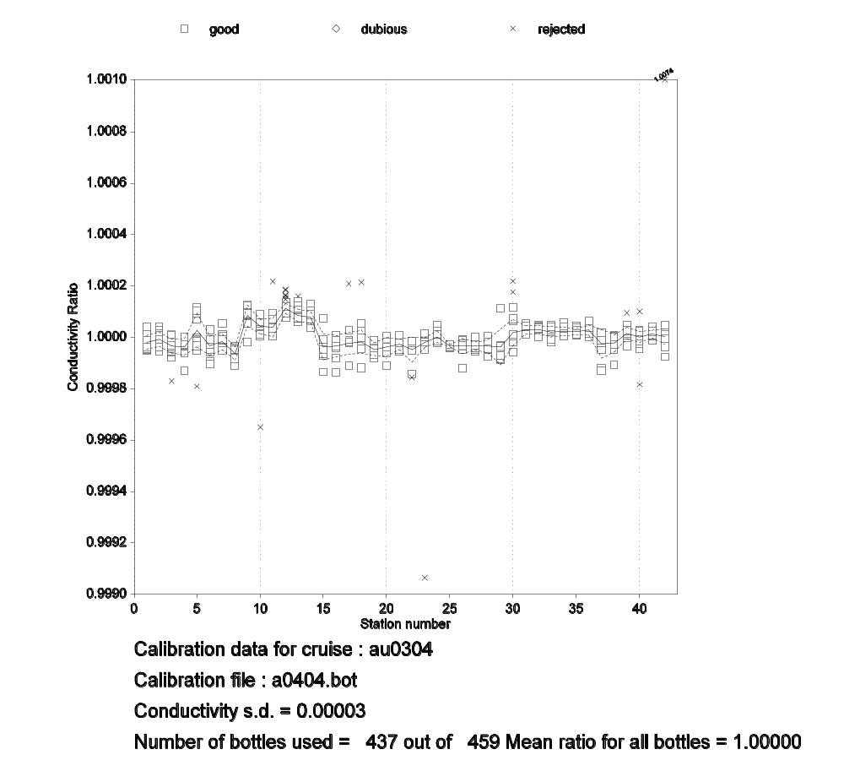
Figure 2: Conductivity ratio c_{btl}/c_{cal} (i.e. for bottle conductivity c_{btl} and calibrated CTD conductivity c_{cal}) versus station number for cruise au0404. The solid line follows the mean of the ratios, and the broken lines are ± the standard deviation of the ratios, for each station.

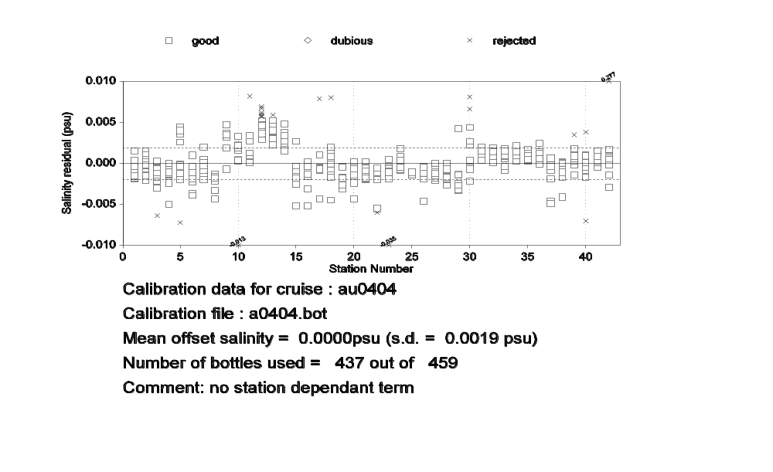
Figure 3: Salinity residual (bottles - calibrated CTD) versus station number for cruise au0404. The solid line is the mean of all the residuals; the broken lines are ± the standard deviation of all the residuals.

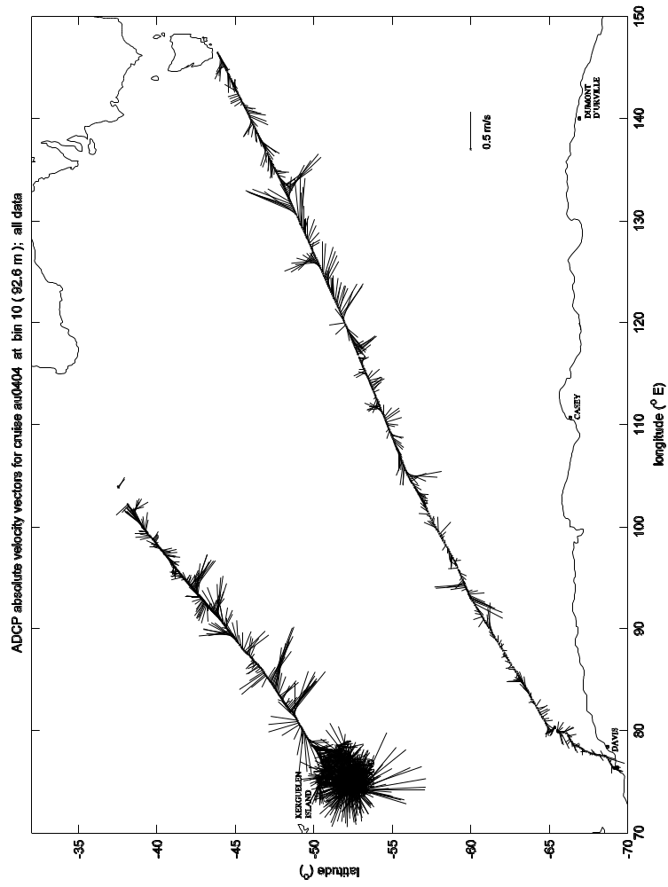

Figure 4a: ADCP 30 minute ensemble data for cruise au0404, at vertical bin 10 - data from the whole cruise.

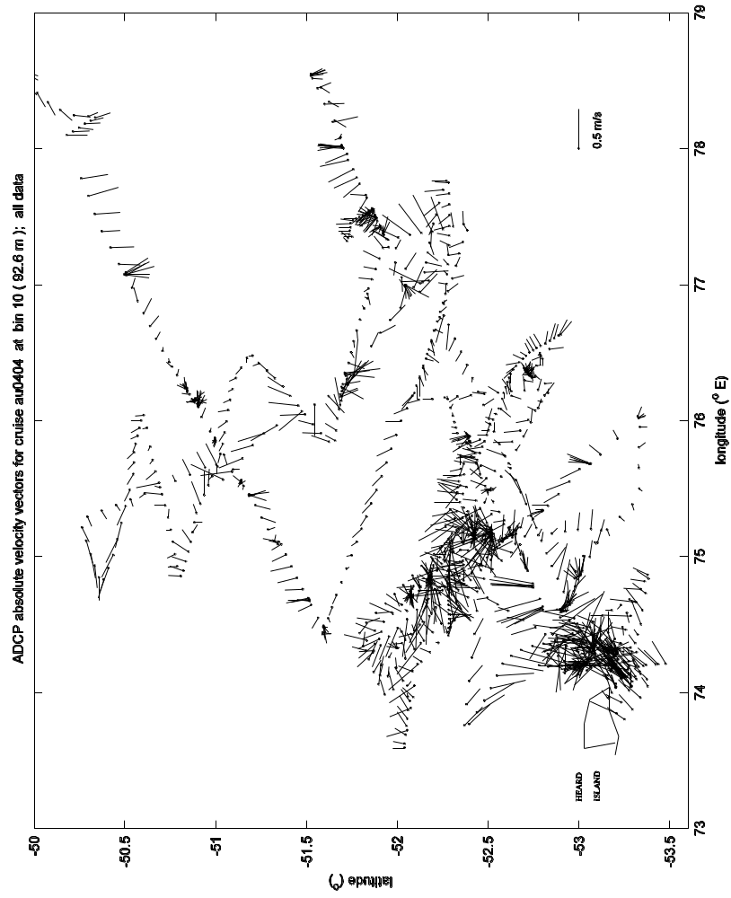

Figure 4b: ADCP 30 minute ensemble data for cruise au0404, at vertical bin 10 - data from the fishing survey area in the vicinity of Heard Island.

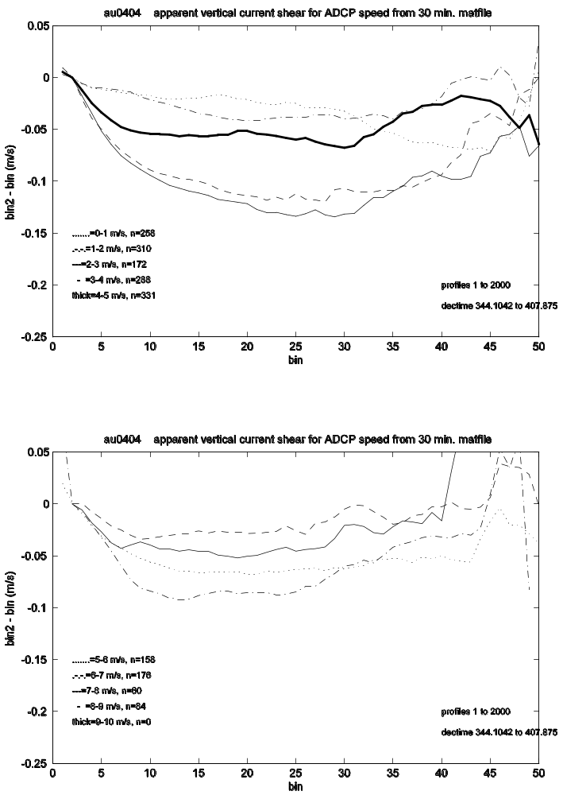

Figure 5: Apparent vertical current shear calculated from uncorrected (i.e. ship speed included) ADCP velocities for cruise au0404. Data are divided up into distinct speed classes (i.e. ship speed), shown by the different lines. The top panel shows data for ship speed classes from 0 to 5 m/s; the bottom panel is for 5 to 10 m/s. The horizontal axis is vertical profile bin, while the vertical axis is the speed difference between bin 2 and all other vertical bins.
(a)
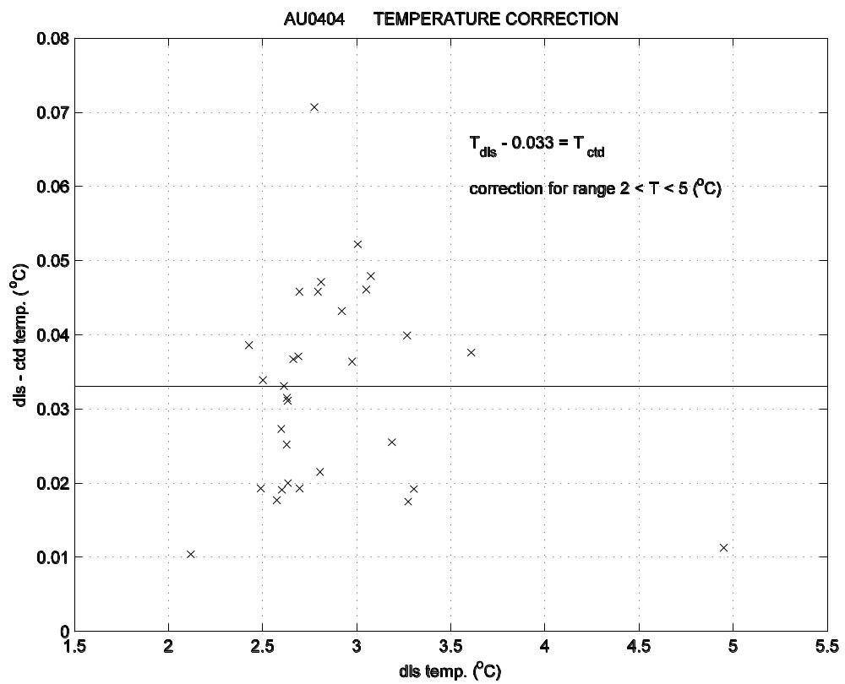
(b)
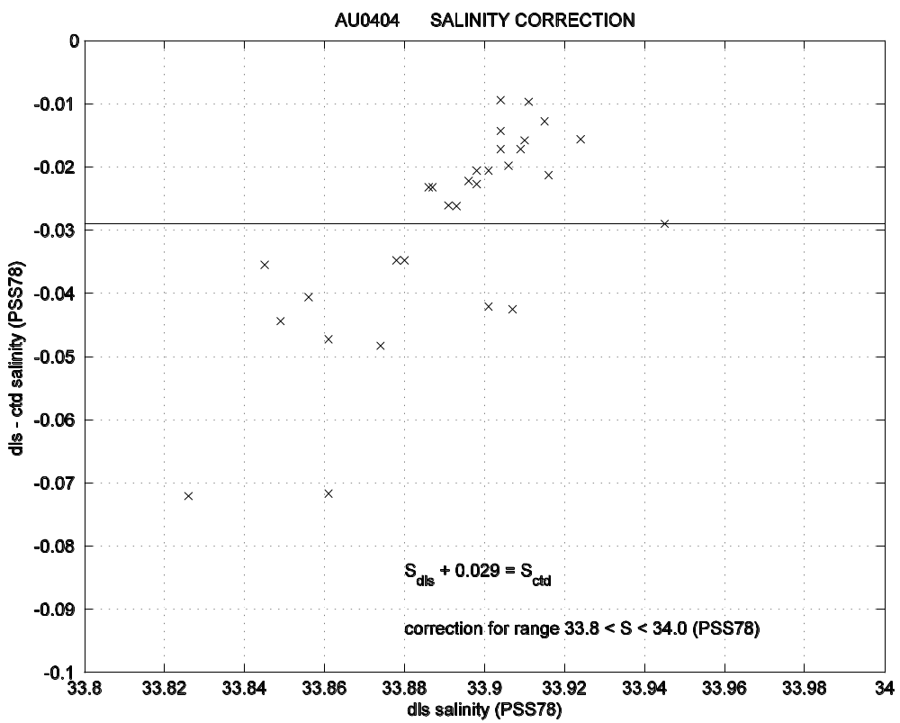

Figure 6a and b: Comparison between CTD and underway data, for (a) sea surface temperature, and (b) sea surface salinity. Mean offset value is also shown.
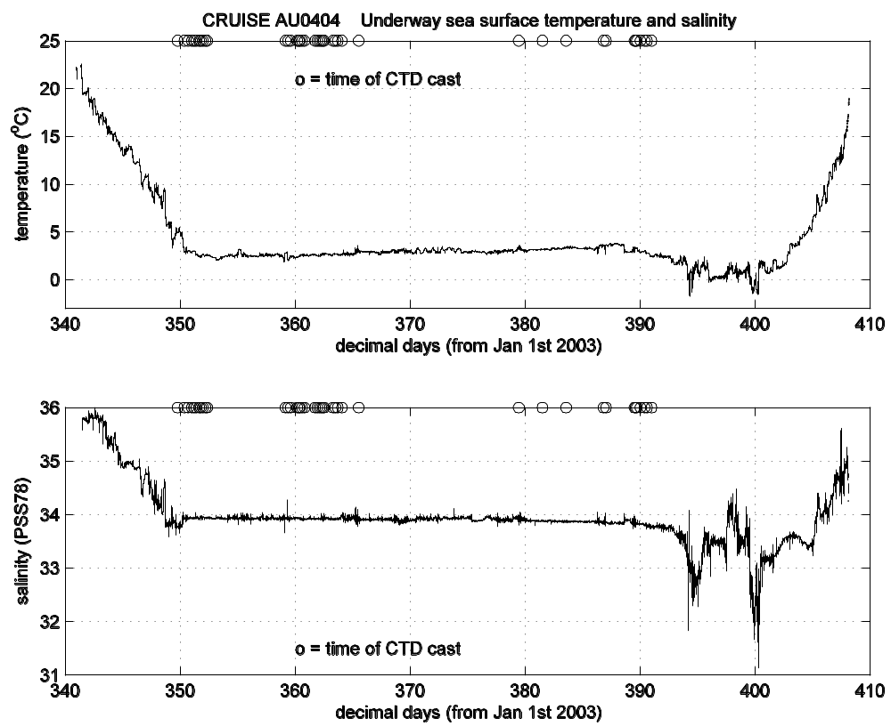

Figure 7: Underway sea surface temperature and salinity data for the whole cruise, showing times at which CTD casts were taken.

