2

1

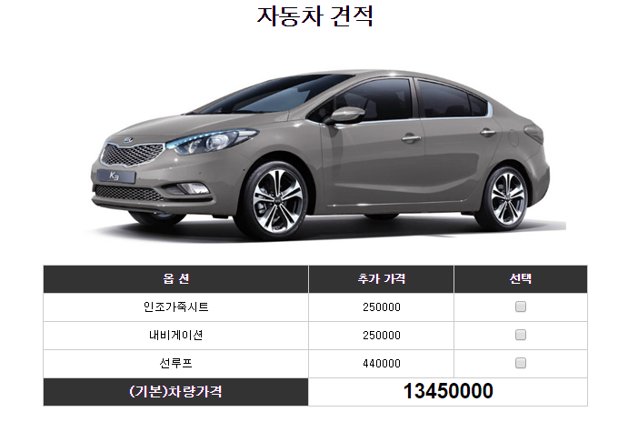

|  |  |
| --- | --- |
| **화면번호** | 1 |
| **화면명** | TITLE |
| **기능명** | SHOW |
| **업무명** | SHOW TITLE & IMAGE |

|  |  |
| --- | --- |
| **화면번호** | 2 |
| **화면명** | MAIN |
| **기능명** | CAL |
| **업무명** | CALCULATE |