ETL FLIGHT DATA Practice  
(이삭엔지니어링 인턴 김형근, fnfn9087@gmail.com)  
(CDH 5.15, Oracle DB를 사용하여 실습하였음.)

**1. Download the flight Data**

링크 : [Research and Innovative Technology Administration, Bureau of Transportation Statistics](http://www.transtats.bts.gov/DL_SelectFields.asp?Table_ID=236&DB_Short_Name=On-Time).

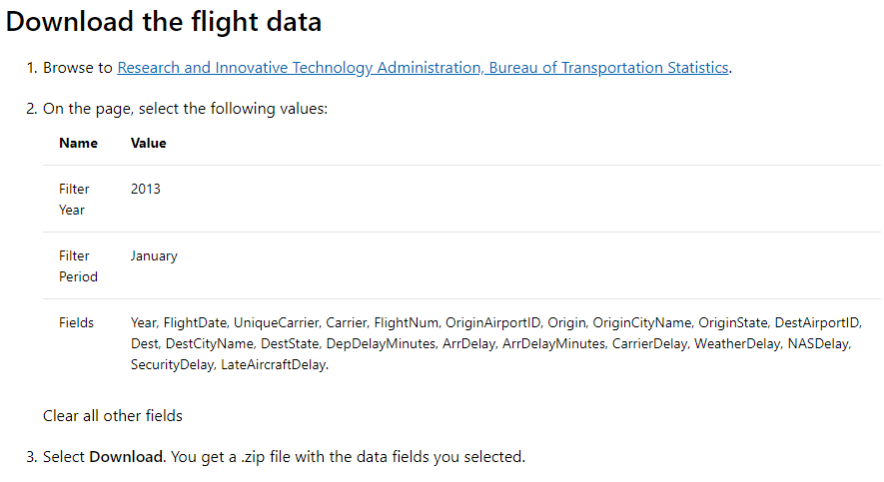  
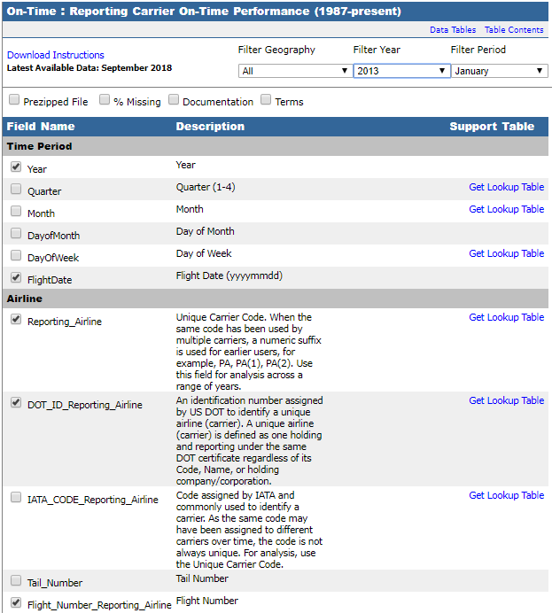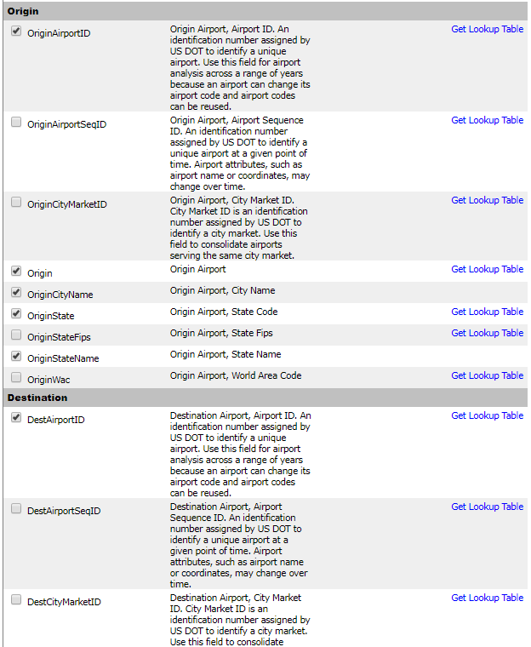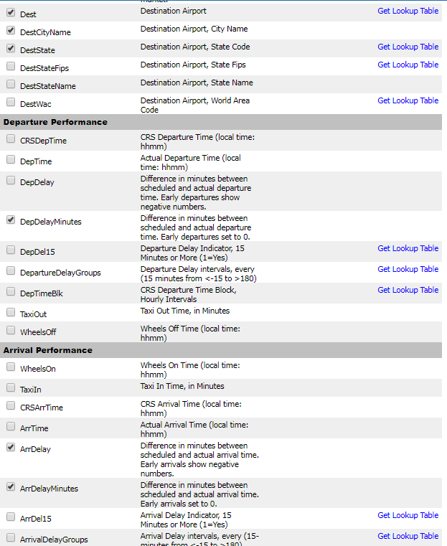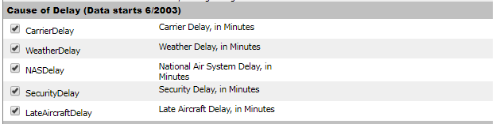

**2. Use the following commands to create a directory, and copy the .csv file to the directory**

hdfs dfs -mkdir -p hdfs://iseHA1/user/hkkim/tutorials/flightdelays/data

hdfs dfs -put <FILE_NAME>.csv hdfs://iseHA1/user/hkkim/tutorials/flightdelays/data/

**3. In the Hue interface(10.100.3.211:8888), enter the following queries in Hive Query Interface  
(You must proceed “edx_hkkim” database.)**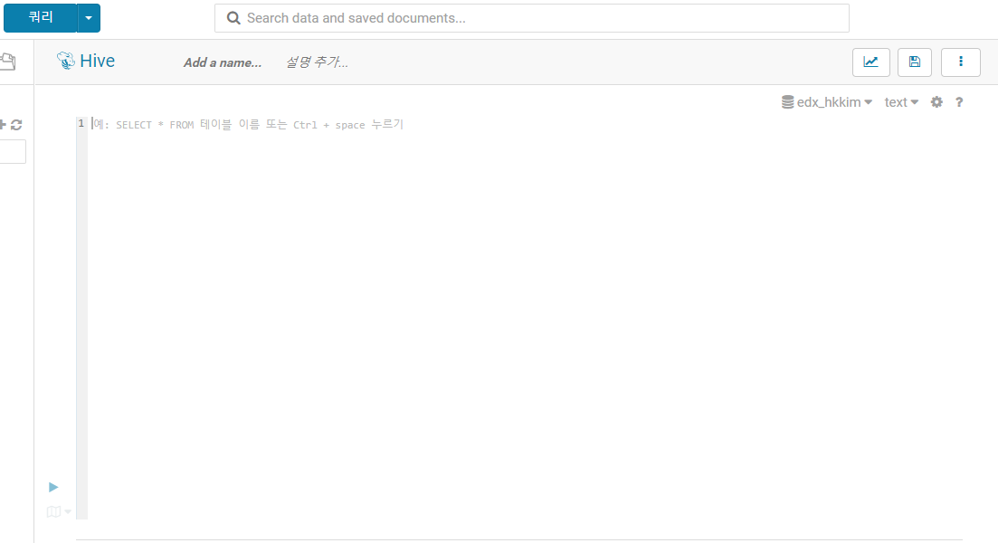  
DROP TABLE delays_raw;

-- Creates an external table over the csv file

CREATE EXTERNAL TABLE delays_raw (  
YEAR string,  
FL_DATE string,  
UNIQUE_CARRIER string,  
CARRIER string,  
FL_NUM string,  
ORIGIN_AIRPORT_ID string,  
ORIGIN string,  
ORIGIN_CITY_NAME string,  
ORIGIN_CITY_NAME_TEMP string,  
ORIGIN_STATE_ABR string,  
DEST_AIRPORT_ID string,  
DEST string,  
DEST_CITY_NAME string,  
DEST_CITY_NAME_TEMP string,  
DEST_STATE_ABR string,  
DEP_DELAY_NEW float,  
ARR_DELAY_NEW float,  
CARRIER_DELAY float,  
WEATHER_DELAY float,  
NAS_DELAY float,  
SECURITY_DELAY float,  
LATE_AIRCRAFT_DELAY float)

-- The following lines describe the format and location of the file  
ROW FORMAT DELIMITED FIELDS TERMINATED BY ','  
LINES TERMINATED BY '\n'  
STORED AS TEXTFILE  
LOCATION *‘user/hkkim/tutorials/flightdelays/data';*

-- Drop the delays table if it exists

DROP TABLE delays;  
-- Create the delays table and populate it with data  
-- pulled in from the CSV file (via the external table defined previously)  
CREATE TABLE delays  
LOCATION ‘user/hkkim/tutorials/flightdelays/processed’

AS  
SELECT YEAR AS year,  
FL_DATE AS flight_date,  
substring(UNIQUE_CARRIER, 2, length(UNIQUE_CARRIER) -1) AS unique_carrier,  
substring(CARRIER, 2, length(CARRIER) -1) AS carrier,  
substring(FL_NUM, 2, length(FL_NUM) -1) AS flight_num,  
ORIGIN_AIRPORT_ID AS origin_airport_id,  
substring(ORIGIN, 2, length(ORIGIN) -1) AS origin_airport_code,  
substring(ORIGIN_CITY_NAME, 2) AS origin_city_name,  
substring(ORIGIN_STATE_ABR, 2, length(ORIGIN_STATE_ABR) -1) AS origin_state_abr,  
DEST_AIRPORT_ID AS dest_airport_id,  
substring(DEST, 2, length(DEST) -1) AS dest_airport_code,  
substring(DEST_CITY_NAME,2) AS dest_city_name,  
substring(DEST_STATE_ABR, 2, length(DEST_STATE_ABR) -1) AS dest_state_abr,  
DEP_DELAY_NEW AS dep_delay_new,  
ARR_DELAY_NEW AS arr_delay_new,  
CARRIER_DELAY AS carrier_delay,  
WEATHER_DELAY AS weather_delay,  
NAS_DELAY AS nas_delay,  
SECURITY_DELAY AS security_delay,  
LATE_AIRCRAFT_DELAY AS late_aircraft_delay

FROM delays_raw;

**4. After finish “3.” , enter the following queries.**  
INSERT OVERWRITE DIRECTORY *'/user/hkkim/tutorials/flightdelays/output'*  
ROW FORMAT DELIMITED FIELDS TERMINATED BY '\t'  
SELECT regexp_replace(origin_city_name, '''', ''),  
avg(weather_delay)  
FROM delays  
WHERE weather_delay IS NOT NULL  
GROUP BY origin_city_name;

**5. In Oracle DB, login to “username = sys as sysdba, password = sys”. DB’s name is “dwd”  
And, Go to user named “SELECTONLY”, and Create Tables.**CREATE TABLE SELECTONLY.DELAY

( ORIGIN_CITY_NAME NVARCHAR2(50) NOT NULL,   
WEATHER_DELAY FLOAT,   
CONSTRAINT DELAY_PK PRIMARY KEY ( ORIGIN_CITY_NAME ) ENABLE );  
  
원문은 아래이나, CONSTRAINT [PK_delays] PRIMARY KEY CLUSTERED 구문이 Oracle에서 문법 오류가 계속 발생. 그래서 Oracle에서 위 구문으로만 진행.   
([origin_city_name] ASC)  
“CREATE TABLE [dbo].[delays](  
[origin_city_name] [nvarchar](50) NOT NULL,  
[weather_delay] float,  
CONSTRAINT [PK_delays] PRIMARY KEY CLUSTERED   
([origin_city_name] ASC))”

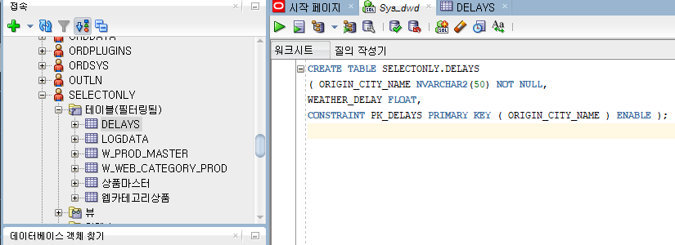  
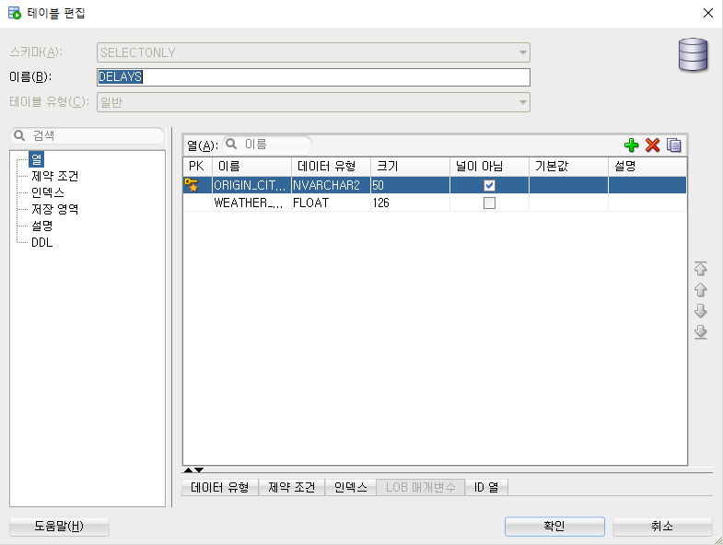

**6. Use Sqoop export, and insert data to “DELAYS” tables.**  
sqoop export   
--connect jdbc:oracle:thin:@10.100.3.152:1521:dwd   
--username selectonly --password ise1212   
--direct   
--export-dir /user/hkkim/tutorials/flightdelays/output   
--table DELAYS --fields-terminated-by '\t' --m 1   
  
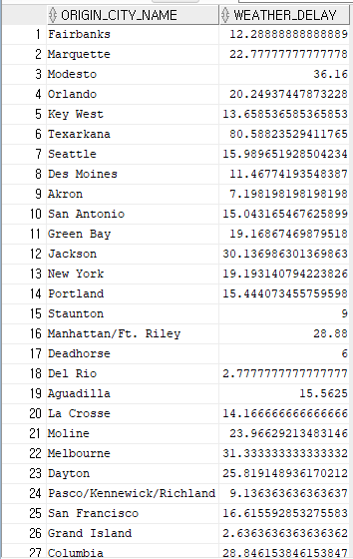

Reference:  
<https://docs.microsoft.com/en-us/azure/storage/data-lake-storage/tutorial-extract-transform-load-hive>