

|  |
| --- |
| HW 04 Simple File Transfer using TCP |
|  |



|  |  |  |  |  |
| --- | --- | --- | --- | --- |
| Date | 2015, 06, 14 |  | Major | Computer Science |
| Subject | Computer Network |  | Team Number | 1 |
| Professor | Yongsoo Joo |  | Name | Jungchul Kim Heetae Kim Gyeungmin Min Doona Lee Gisung Lim |

1. Description about implementation

We accomplished Mandatory and Option A.

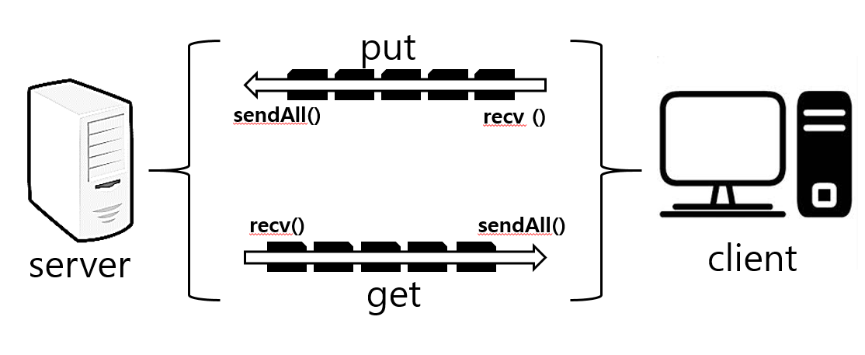When you run this program, you have to position the server and client program to a different directory.

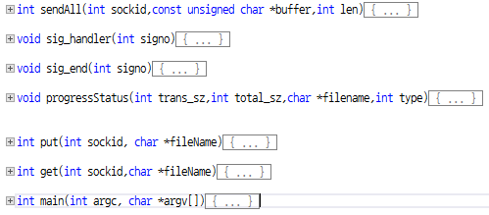1-1 server.c

We made main function and additional three function ( progressStatus, put, get, sendAll, sig_handler, sig_end).

First, main function connect between the server and the client using the socket () and the bind () function, also it read the messages received on the client, you can call the corresponding function according to the command line.

Second, in the put function, server received the file sent by the client through the recv function. If the size that client transfer correspond the size received send a message by using the send function to the client. It creates a file, and writes the content that is received in the buffer. It will call the progressStatus function during processing.

Third, in the get function, server received via the message file name on the client. And then, it send a message to the client using the send function. It reads only the size of the file and run the while statement to transfer files. During transferring of data, it call the progressStatus function.

Fifth, in the sig_handler function, it control of speed and transfer output per second. If it receive Sig alarm, it fill resource and then, set alarm one second.

Sixth, in the sig_end function, it finished the alarm when it completed transferring.

Fourth, in the progressStatus function, it looks visually by comparing the transfer amount and file amount.

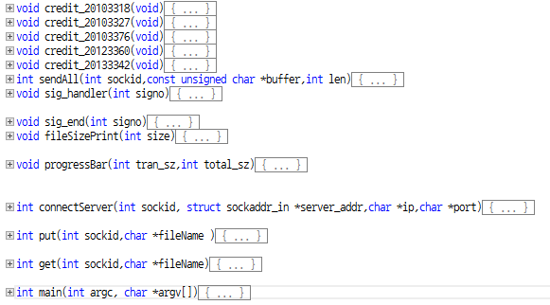1-3 client.c

Client code is similar to the server code. It has main function and additional thirteen function ( credit 5, sendAll, sig_handler(), sigend(), progressBar, fileSizePrint, connectServer, put, get). First, main function connect between the server and the client using the socket () and the bind () function. It receives a command from the user and call the function according to the command. If command is “connect”, it connects server and calls the connectServer function. And if command is “put”, it will call the put function which purpose of transferring the file. And if command is “get”, it will call the get function which purpose of receiving the file. If command is “ratecurr”, it show the receive rate and send rate. And also we set of receive and send rate using command sendrate, recvrate. If command is “close”, it will close the connection to the server. If 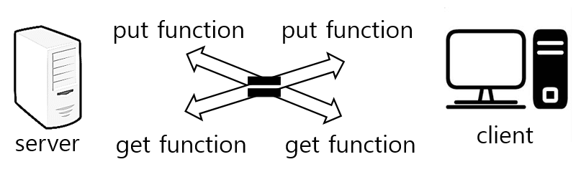command is “quit”, it will exit the program.

Second, in the put function, it is same get function in the server program.

Third, in the get function, it is same put function in the server program.

Fourth, in the progressBar function, it looks visually by comparing the transfer amount and file amount. It calls fileSizePrint function.

Fifth, in the fileSizePrint function, it calculates byte amount.

Sixth, ConnectServer function is confirmed by exchanging messages about checking connection.

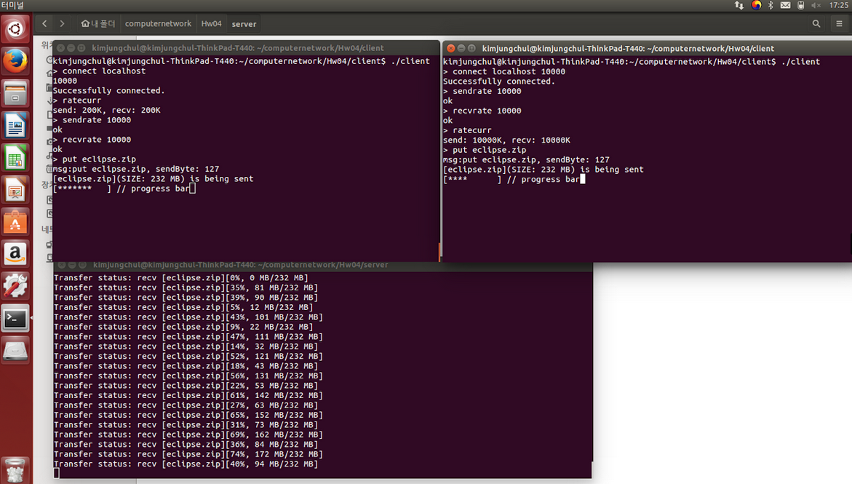1-4 result window

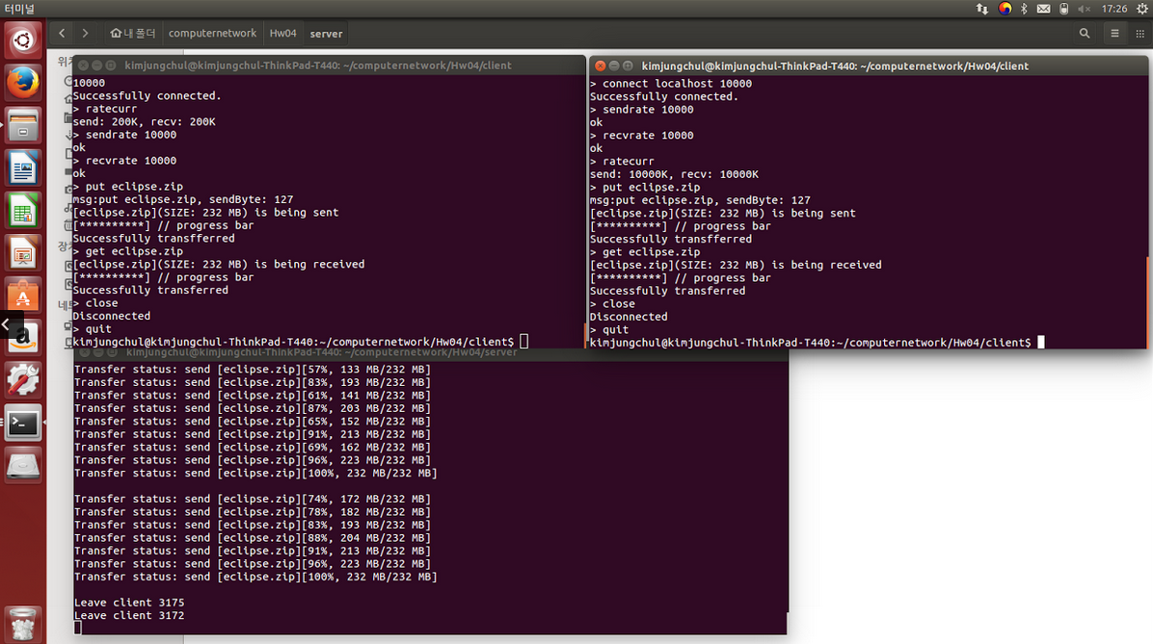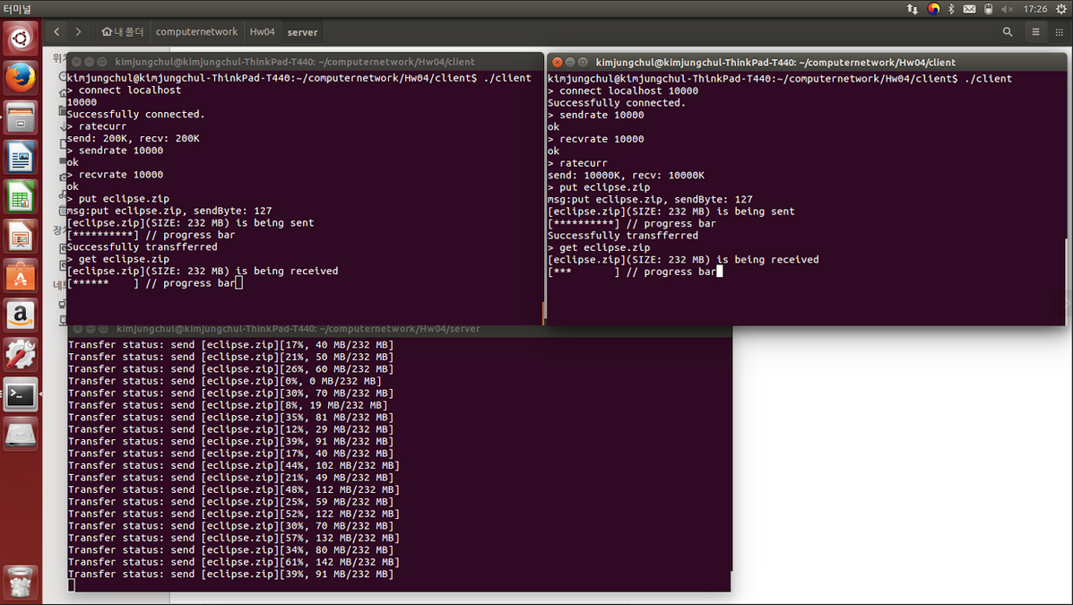

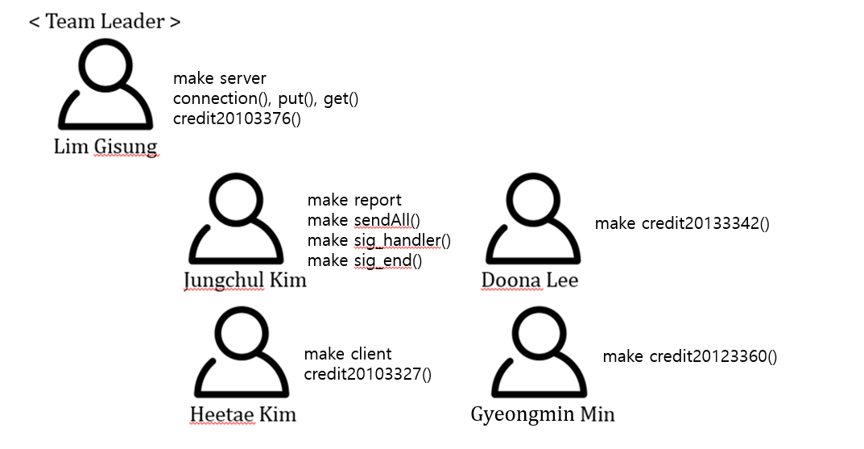2. The contribution of each member

-- Thank you for reading! --