Mssql

날짜변환 : <https://ndolson.com/1219>

<https://ji80903.tistory.com/entry/mssql-DATETIME-%EB%B3%80%ED%99%98>

<https://rohsstory.tistory.com/276>

http://egloos.zum.com/aslike/v/1627250

datediff : https://mirwebma.tistory.com/178

인덱스 : <http://blog.naver.com/PostView.nhn?blogId=webwizard83&logNo=60171496664>

복합인덱스와 성능 : https://burning-dba.tistory.com/79

select한거 바로 insert하기 : <http://www.webmadang.net/database/database.do?action=read&boardid=4001&page=1&seq=25>

case when, if : https://coding-factory.tistory.com/113

ISNULL : http://www.webmadang.net/database/database.do?action=read&boardid=4001&page=2&seq=14

Nchar vs char

Nvarchar vs varchar

<http://blog.naver.com/PostView.nhn?blogId=newcomsa&logNo=30081390512>

커서 : <https://coding-factory.tistory.com/96>

커서가 성능이안좋다하네.. 대체로 rownum() over()있다는데.. : https://m.blog.naver.com/PostView.nhn?blogId=feelydh&logNo=220650122922&proxyReferer=https%3A%2F%2Fwww.google.com%2F

테이블변수 : <https://rocabilly.tistory.com/214>

Exists :

STUFF : http://godwo.blogspot.com/2017/09/blog-post.html

sp_helpindex

MSSQL에서 행을 열로 바꾸기(Mysql.docx 참고!)

select EqpID, EqpType, State, sum(DATEDIFF(Second, StartTime, Endtime)) as Times, Sum(case when SetState = 'Y' then 1 else 0 end) as Cnt

from SUMMARY_EQPSTATUS

where BDate = '2019-01-01' and Hours = 0

group by EqpID, EqpType, State

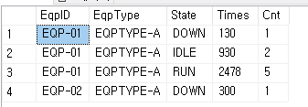

EqpID | EqpType | Run_Times | Run_Cnt | Idle_Times | Idle_Cnt | Down_Times | Down_Cnt …

이런식의 컬럼으로 바꾸고싶으면..?

select

tab.eqpid,

tab.eqptype,

isnull(max(case when tab.State='DOWN' then tab.Times end),0) as 'DOWN',

isnull(max(case when tab.State='DOWN' then tab.Cnt end),0) as 'DOWN_CNT',

isnull(max(case when tab.State='IDLE' then tab.Times end),0) as 'IDLE',

isnull(max(case when tab.State='IDLE' then tab.Cnt end),0) as 'IDLE_CNT',

isnull(max(case when tab.State='RUN' then tab.Times end),0) as 'RUN',

isnull(max(case when tab.State='RUN' then tab.Cnt end),0) as 'RUN_CNT',

isnull(max(case when tab.State='PM' then tab.Times end),0) as 'PM',

isnull(max(case when tab.State='PM' then tab.Cnt end),0) as 'PM_CNT'

from (select EqpID, EqpType, State, sum(DATEDIFF(Second, StartTime, Endtime)) as Times, Sum(case when SetState = 'Y' then 1 else 0 end) as Cnt

from SUMMARY_EQPSTATUS

where BDate = '2019-01-01' and Hours = 0

group by EqpID, EqpType, State) tab

group by eqpid, eqptype

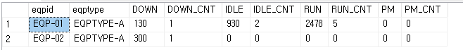

완성..!

*Group by 로 다시 묶어줬으니 max값으로 잡아줘야함..

Max없으면 아래와 같은 에러뜸..

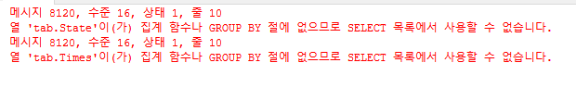

Groupby를 했는데 무슨값을 내어놓아야할지 모르니깐.. 당연히 에러나겟지.. sum써도됨..