20171019 구현시험 답

2017-10-19

이승진

**목차**

1. 프로젝트 생성 2

1) pom.xml 4

2) application.properties 5

2. DTO 6

1) District.java 6

2) City.java 6

3. mybatis mapper 7

1) DistrictMapper.java 7

2) DistrictMapper.xml 7

3) CityMapper.java 9

4) CityMapper.xml 9

4. Controller 10

1) CityController.java 10

5. view 12

1) city/list.jsp 12

2) city/edit.jsp 13

3) city/list2.jsp 14

6. 정적 파일 15

1) common.css 15

2) common.js 15

3) index.jsp 16

# 프로젝트 생성

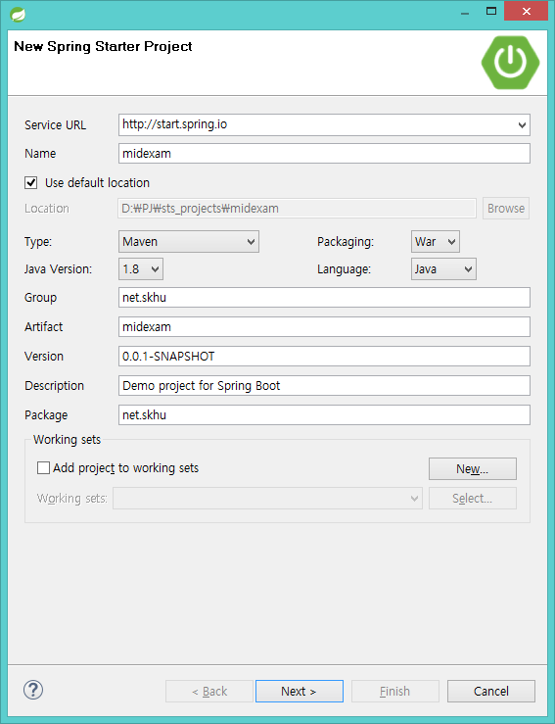

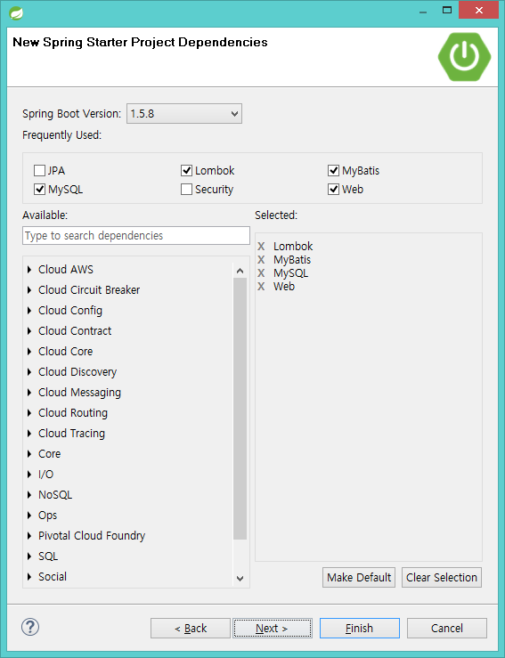

## pom.xml

|  |
| --- |
| <?xml version="1.0" encoding="UTF-8"?>  <project xmlns="http://maven.apache.org/POM/4.0.0" xmlns:xsi="http://www.w3.org/2001/XMLSchema-instance" xsi:schemaLocation="http://maven.apache.org/POM/4.0.0 http://maven.apache.org/xsd/maven-4.0.0.xsd">  <modelVersion>4.0.0</modelVersion>  <groupId>net.skhu</groupId>  <artifactId>midexam</artifactId>  <version>0.0.1-SNAPSHOT</version>  <packaging>war</packaging>  <name>midexam</name>  <description>Demo project for Spring Boot</description>  <parent>  <groupId>org.springframework.boot</groupId>  <artifactId>spring-boot-starter-parent</artifactId>  <version>1.5.8.RELEASE</version>  <relativePath /> <!-- lookup parent from repository -->  </parent>  <properties>  <project.build.sourceEncoding>UTF-8</project.build.sourceEncoding>  <project.reporting.outputEncoding>UTF-8</project.reporting.outputEncoding>  <java.version>1.8</java.version>  </properties>  <dependencies>  <dependency>  <groupId>org.mybatis.spring.boot</groupId>  <artifactId>mybatis-spring-boot-starter</artifactId>  <version>1.3.1</version>  </dependency>  <dependency>  <groupId>org.springframework.boot</groupId>  <artifactId>spring-boot-starter-web</artifactId>  </dependency>  <dependency>  <groupId>mysql</groupId>  <artifactId>mysql-connector-java</artifactId>  <scope>runtime</scope>  </dependency>  <dependency>  <groupId>org.projectlombok</groupId>  <artifactId>lombok</artifactId>  <optional>true</optional>  </dependency>  <dependency>  <groupId>org.springframework.boot</groupId>  <artifactId>spring-boot-starter-tomcat</artifactId>  <scope>provided</scope>  </dependency>  <dependency>  <groupId>org.springframework.boot</groupId>  <artifactId>spring-boot-starter-test</artifactId>  <scope>test</scope>  </dependency>  <dependency>  <groupId>javax.servlet</groupId>  <artifactId>jstl</artifactId>  </dependency>  </dependencies>  <build>  <plugins>  <plugin>  <groupId>org.springframework.boot</groupId>  <artifactId>spring-boot-maven-plugin</artifactId>  </plugin>  </plugins>  </build>  </project> |

## application.properties

|  |
| --- |
| spring.mvc.view.prefix=/WEB-INF/views/  spring.mvc.view.suffix=.jsp  spring.datasource.driver-class-name=com.mysql.jdbc.Driver  spring.datasource.url=jdbc:mysql://localhost:3306/cities?allowMultiQueries=true  spring.datasource.username=user1  spring.datasource.password=test123  mybatis.type-aliases-package=net.skhu.dto |

# DTO

## District.java

src/main/java/net/skhu/dto/District.java

|  |
| --- |
| package net.skhu.dto;  import java.util.List;  import lombok.Data;  @Data  public class District {  int id;  String districtName;  List<City> cities;  } |

## City.java

src/main/java/net/skhu/dto/City.java

|  |
| --- |
| package net.skhu.dto;  import lombok.Data;  @Data  public class City {  int id;  int districtId;  String name;  int population;  String districtName;  } |

# mybatis mapper

## DistrictMapper.java

src/main/java/net/skhu/mapper/DistrictMapper.java

|  |
| --- |
| package net.skhu.mapper;  import java.util.List;  import org.apache.ibatis.annotations.Mapper;  import net.skhu.dto.District;  @Mapper  public interface DistrictMapper {  List<District> findAll();  List<District> findAllWithCities();  } |

## DistrictMapper.xml

src/main/java/net/skhu/mapper/DistrictMapper.xml

|  |
| --- |
| <?xml version="1.0" encoding="UTF-8" ?>  <!DOCTYPE mapper PUBLIC "-//mybatis.org//DTD Mapper 3.0//EN"  "http://mybatis.org/dtd/mybatis-3-mapper.dtd">  <mapper namespace="net.skhu.mapper.DistrictMapper">  <select id="findAll" resultType="District">  SELECT * FROM district  </select>    <select id="findAllWithCities" resultMap="resultMap1">  SELECT d.*,  c.id cityId, c.name, c.population  FROM district d LEFT JOIN city c ON d.id = c.districtId  </select>  <resultMap id="resultMap1" type="District">  <id property="id" column="id" />  <result property="districtName" column="districtName" />  <collection property="cities" ofType="City">  <id property="id" column="cityId" />  <result property="name" column="name"/>  <result property="population" column="population"/>  </collection>  </resultMap>  </mapper> |

SELECT d.*,

c.id cityId, c.name, c.population

FROM district d LEFT JOIN city c ON d.id = c.districtId

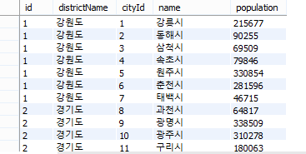

위 SQL 명령과 조회 결과 컬럼명에 주목하자

city 테이블의 id 필드의 조회 결과 컬럼명은 cityId 로 변경되었다.

## CityMapper.java

src/main/java/net/skhu/mapper/CityMapper.java

|  |
| --- |
| package net.skhu.mapper;  import java.util.List;  import org.apache.ibatis.annotations.Mapper;  import org.apache.ibatis.annotations.Param;  import net.skhu.dto.City;  @Mapper  public interface CityMapper {  City findOne(int id);  List<City> findAllOrderBy(@Param("orderBy") String orderBy);  void insert(City city);  void update(City city);  void delete(int id);  } |

List<City> findAllOrderBy(@Param("orderBy") String orderBy);

보통 mapper 메소드의 파라미터가 한 개뿐일 때는, @Param("...") 어노테이션을 붙여줄 필요가 없다.

그런데, mybatis dynamic SQL 기능에 사용될 파라미터에는,

반드시 @Param("....") 어노테이션을 붙여주어야 한다.

## CityMapper.xml

src/main/java/net/skhu/mapper/CityMapper.xml

|  |
| --- |
| <?xml version="1.0" encoding="UTF-8" ?>  <!DOCTYPE mapper PUBLIC "-//mybatis.org//DTD Mapper 3.0//EN"  "http://mybatis.org/dtd/mybatis-3-mapper.dtd">  <mapper namespace="net.skhu.mapper.CityMapper">  <select id="findOne" resultType="City">  SELECT * FROM city WHERE id = #{id}  </select>    <select id="findAllOrderBy" resultType="City">  SELECT c.*, d.districtName  FROM city c LEFT JOIN district d ON c.districtId = d.id  ORDER BY ${orderBy}  </select>    <update id="update">  UPDATE city  SET name = #{name}, districtId = #{districtId}, population = #{population}  WHERE id = #{id}  </update>    <insert id="insert" useGeneratedKeys="true" keyProperty="id">  INSERT city (name, districtId, population)  VALUES (#{name}, #{districtId}, #{population})  </insert>    <delete id="delete">  DELETE FROM city WHERE id = #{id}  </delete>  </mapper> |

# Controller

## CityController.java

src/main/java/net/skhu/controller/CityController.java

|  |
| --- |
| package net.skhu.controller;  import org.springframework.beans.factory.annotation.Autowired;  import org.springframework.stereotype.Controller;  import org.springframework.ui.Model;  import org.springframework.web.bind.annotation.RequestMapping;  import org.springframework.web.bind.annotation.RequestMethod;  import org.springframework.web.bind.annotation.RequestParam;  import net.skhu.dto.City;  import net.skhu.mapper.CityMapper;  import net.skhu.mapper.DistrictMapper;  @Controller  @RequestMapping("city")  public class CityController {  @Autowired CityMapper cityMapper;  @Autowired DistrictMapper districtMapper;  @RequestMapping("list")  public String list(@RequestParam("order") int order, Model model) {  String[] a = { "name", "districtName", "population DESC" };  model.addAttribute("list", cityMapper.findAllOrderBy(a[order]));  return "city/list";  }  @RequestMapping(value="edit", method=RequestMethod.GET)  public String edit(@RequestParam("id") int id, Model model) {  model.addAttribute("city", cityMapper.findOne(id));  model.addAttribute("districts", districtMapper.findAll());  return "city/edit";  }  @RequestMapping(value="edit", method=RequestMethod.POST)  public String edit(City city, @RequestParam("order") int order, Model model) {  cityMapper.update(city);  return "redirect:list?order=" + order;  }  @RequestMapping(value="create", method=RequestMethod.GET)  public String create(Model model) {  model.addAttribute("city", new City());  model.addAttribute("districts", districtMapper.findAll());  return "city/edit";  }  @RequestMapping(value="create", method=RequestMethod.POST)  public String create(City city, @RequestParam("order") int order, Model model) {  cityMapper.insert(city);  return "redirect:list?order=" + order;  }  @RequestMapping("delete")  public String delete(Model model, @RequestParam("id") int id, @RequestParam("order") int order) {  cityMapper.delete(id);  return "redirect:list?order=" + order;  }  @RequestMapping("list2")  public String list2(Model model) {  model.addAttribute("list", districtMapper.findAllWithCities());  return "city/list2";  }  } |

@RequestMapping(value="edit", method=RequestMethod.POST)

public String edit(City city, @RequestParam("order") int order, Model model) {

cityMapper.update(city);

return "redirect:list?order=" + order;

}

수정 페이지에서 저장 버튼을 클릭했을 때, 서버에서 실행되는 액션 메소드이다.

이 액션 메소드를 요청하는 URL 에는 order 쿼리 스트링이 들어있다. (예: edit?id=3&order=1 )

쿼리 스트링의 id 값은, city 파리미터 객체의 id 속성에 채워지고,

쿼리 스트링의 order 값은, order 파라미터 변수에 채워져 있다.

return "redirect:list?order=" + order;

액션 메소드가 "redirect:...." 형태의 문자열을 리턴하면,

리다이렉트 메타 태그가 웹브라우저로 출력된다.

"redirect:" 뒷 부분은 URL 이다.

웹브라우저가 리다이렉트 메타 태그를 받으면, 그 URL을 서버에 즉시 요청하게 된다.

즉 웹브라우저 창은 그 URL로 이동하게 된다.

예를 들어 order 변수 값이 1 이라면, 위 리턴 문은 "redirect:list?order=1" 문자열을 리턴한다.

이 문자열에서, list?order=1 부분이 URL 이다.

서버로부터 리다이렉트 메타 태그를 받은 웹브라우저 창은, 이 URL 로 즉시 이동하게 된다.

즉 웹브라우저 창은 목록 페이지로 즉시 이동하게 된다.

# view

## city/list.jsp

src/main/webapp/WEB-INF/views/city/list.jsp

|  |
| --- |
| <%@ page language="java" contentType="text/html; charset=UTF-8" pageEncoding="UTF-8"%>  <%@ taglib uri="http://java.sun.com/jsp/jstl/core" prefix="c" %>  <c:url var="R" value="/" />  <!DOCTYPE html>  <html>  <head>  <meta http-equiv="Content-Type" content="text/html; charset=UTF-8">  <link href="http://maxcdn.bootstrapcdn.com/bootstrap/3.3.7/css/bootstrap.min.css"  rel="stylesheet" media="screen">  <script src="http://ajax.googleapis.com/ajax/libs/jquery/1.12.4/jquery.min.js"></script>  <script src="https://maxcdn.bootstrapcdn.com/bootstrap/3.3.7/js/bootstrap.min.js"></script>  <script src="${R}res/common.js"></script>  <link rel="stylesheet" href="${R}res/common.css">  </head>  <body>  <div class="container">  <h1>도시목록</h1>  <div class="pull-right">  <a class="btn btn-default" href="create?order=${param.order}">도시 등록</a>  </div>  <form class="form-inline">  <select class="form-control" name="order">  <option value="0" ${ param.order == 0 ? "selected" : "" }>시 이름 순서</option>  <option value="1" ${ param.order == 1 ? "selected" : "" }>도 이름 순서</option>  <option value="2" ${ param.order == 2 ? "selected" : "" }>인구 순서</option>  </select>  <button type="submit" class="btn btn-default">검색</button>  </form>  <table class="table table-bordered mt5">  <thead>  <tr>  <th>id</th>  <th>시 이름</th>  <th>도 이름</th>  <th class="text-right">인구</th>  </tr>  </thead>  <tbody>  <c:forEach var="city" items="${ list }">  <tr data-url="edit?id=${city.id}&order=${param.order}">  <td>${ city.id }</td>  <td>${ city.name }</td>  <td>${ city.districtName }</td>  <td class="text-right">${ city.population }</td>  </tr>  </c:forEach>  </tbody>  </table>  </div>  </body>  </html> |

${ param.order }

현재 URL의 query string 중에서 order 값을 출력한다.

${ param.order == 0 ? "selected" : "" }

현재 URL의 query string 중에서 order 값이 0 이면 selected 문자열을 출력하고,

그렇지 않으면 빈 문자열을 출력한다.

<select class="form-control" name="order">

<option value="0" ${ param.order == 0 ? "selected" : "" }>시 이름 순서</option>

<option value="1" ${ param.order == 1 ? "selected" : "" }>도 이름 순서</option>

<option value="2" ${ param.order == 2 ? "selected" : "" }>인구 순서</option>

</select>

order 쿼리 스트링 값은, 목록 페이지의 순서이다.

서버에 요청된 URL 에서 order 쿼리 스트링 값이 1 이라면,

위 코드가 서버에서 실행된 후 웹브라우저로 출력되는 태그는 아래와 같다.

<select class="form-control" name="order">

<option value="0" >시 이름 순서</option>

<option value="1" selected>도 이름 순서</option>

<option value="2" >인구 순서</option>

</select>

<tr data-url="edit?id=${city.id}&order=${param.order}">

이 tr 태그를 클릭하면, 웹브라우저가 edit?id=${city.id}&order=${param.order} URL 로 넘어간다.

이 기능은 common.js 파일의 자바스크립트 코드로 구현되어 있다.

$("[data-url]").click(function() {

var url = $(this).attr("data-url");

location.href = url;

})

위 코드는 common.js 파일에 들어있다.

data-url 애트리뷰트가 있는 태그를 클릭하면,

data-url 애트리뷰트 값 URL 로, 웹브라우저가 이동하는 자바스크립트 코드이다.

edit?id=${city.id}&order=${param.order}

시 수정 페이지로 넘어가는 URL 이다.

id 쿼리 스트링 값은, 수정할 시의 id 값이다.

order 쿼리 스트링 값은, 목록 페이지의 순서이다.

## city/edit.jsp

src/main/webapp/WEB-INF/views/city/list.jsp

|  |
| --- |
| <%@ page language="java" contentType="text/html; charset=UTF-8" pageEncoding="UTF-8"%>  <%@ taglib uri="http://java.sun.com/jsp/jstl/core" prefix="c" %>  <%@ taglib uri="http://www.springframework.org/tags/form" prefix="form" %>  <c:url var="R" value="/" />  <!DOCTYPE html>  <html>  <head>  <meta http-equiv="Content-Type" content="text/html; charset=UTF-8">  <link href="http://maxcdn.bootstrapcdn.com/bootstrap/3.3.7/css/bootstrap.min.css"  rel="stylesheet" media="screen">  <script src="http://ajax.googleapis.com/ajax/libs/jquery/1.12.4/jquery.min.js"></script>  <script src="https://maxcdn.bootstrapcdn.com/bootstrap/3.3.7/js/bootstrap.min.js"></script>  <script src="${R}res/common.js"></script>  <link rel="stylesheet" href="${R}res/common.css">  </head>  <body>  <div class="container">  <h1>시 ${ city.id > 0 ? "수정" : "등록" }</h1>  <hr />  <form:form method="post" modelAttribute="city">  <div class="form-group">  <label>이름:</label>  <form:input path="name" class="form-control w200" />  </div>  <div class="form-group">  <label>도</label>  <form:select path="districtId" class="form-control w200"  itemValue="id" itemLabel="districtName" items="${ districts }" />  </div>  <div class="form-group">  <label>인구:</label>  <form:input path="population" class="form-control w200" />  </div>  <hr />  <div>  <button type="submit" class="btn btn-primary">  <span class="glyphicon glyphicon-ok"></span> 저장</button>  <c:if test="${ city.id > 0 }">  <a href="delete?id=${ city.id }&order=${ param.order }" class="btn btn-danger"  data-confirm-delete>  <i class="glyphicon glyphicon-remove"></i> 삭제</a>  </c:if>  <a href="list?order=${ param.order }" class="btn btn-info">목록으로</a>  </div>  </form:form>  </div>  </body>  </html> |

## city/list2.jsp

src/main/webapp/WEB-INF/views/city/list.jsp

|  |
| --- |
| <%@ page language="java" contentType="text/html; charset=UTF-8" pageEncoding="UTF-8"%>  <%@ taglib uri="http://java.sun.com/jsp/jstl/core" prefix="c" %>  <c:url var="R" value="/" />  <!DOCTYPE html>  <html>  <head>  <meta http-equiv="Content-Type" content="text/html; charset=UTF-8">  <link href="http://maxcdn.bootstrapcdn.com/bootstrap/3.3.7/css/bootstrap.min.css"  rel="stylesheet" media="screen">  <script src="http://ajax.googleapis.com/ajax/libs/jquery/1.12.4/jquery.min.js"></script>  <script src="https://maxcdn.bootstrapcdn.com/bootstrap/3.3.7/js/bootstrap.min.js"></script>  <script src="${R}res/common.js"></script>  <link rel="stylesheet" href="${R}res/common.css">  </head>  <body>  <div class="container">  <h1>도시목록</h1>  <c:forEach var="district" items="${ list }">  <h1>${ district.districtName }</h1>  <table class="table table-bordered mt5">  <thead>  <tr>  <th>id</th>  <th>시 이름</th>  <th class="text-right">인구</th>  </tr>  </thead>  <tbody>  <c:forEach var="city" items="${ district.cities }">  <tr>  <td>${ city.id }</td>  <td>${ city.name }</td>  <td class="text-right">${ city.population }</td>  </tr>  </c:forEach>  </tbody>  </table>  </c:forEach>  </div>  </body>  </html> |

# 정적 파일

## common.css

src/main/webapp/res/common.css

|  |
| --- |
| body { font-family: 굴림체; }  thead th { background-color: #eee; }  tr:hover td { background-color: #ffe; cursor: pointer; }  input.form-control.w100 { width: 100px; }  input.form-control.w200 { width: 200px; }  input.form-control.w300 { width: 300px; }  input.form-control.w400 { width: 400px; }  select.form-control.w100 { width: 100px; }  select.form-control.w200 { width: 200px; }  select.form-control.w300 { width: 300px; }  select.form-control.w400 { width: 400px; }  .mt5 { margin-top: 5px; }  .mb5 { margin-bottom: 5px; }  .mr20 { margin-right: 20px; }  .ml20 { margin-left: 20px; } |

## common.js

src/main/webapp/res/common.js

|  |
| --- |
| $(function() {  $("[data-url]").click(function() {  var url = $(this).attr("data-url");  location.href = url;  })  $("[data-confirm-delete]").click(function() {  return confirm("삭제하시겠습니까?");  })  }) |

## index.jsp

src/main/webapp/index.jsp

|  |
| --- |
| <%@ page language="java" contentType="text/html; charset=UTF-8" pageEncoding="UTF-8"%>  <!DOCTYPE html>  <html>  <head>  <meta http-equiv="Content-Type" content="text/html; charset=UTF-8">  </head>  <body>  <h1>중간고사</h1>  <a href="city/list?order=0">도시목록1</a> <br />  <a href="city/list2">도시목록2</a> <br />  </body>  </html> |