|  |
| --- |
| Faculty of Information Technology – Major in Computer Vision |
| **PROJECT 2** |
| **WRITING AN ADD-IN FOR AUTOCAD** |

|  |
| --- |
| GROUP 2  04/07/2022 |

NATIONAL UNIVERSITY OF HO CHI MINH CITY

**UNIVERSITY OF SCIENCE**

**Table of Contents**

I. Group Information 2

II. Introduction 2

III. Instructions for Setting Up AutoCAD Projects on Visual Studio 2

IV. Reference 2

# Group Information

|  |  |  |  |
| --- | --- | --- | --- |
| STUDENT ID | FULL NAME | MAIL | WORK ASSIGNMENT |
| **19127644** | **Chung Kim Khánh** | **ckkhanh19@clc.fitus.edu.vn** | * Planning project * Setting up project files/code * Finding references * Write mini report * Write main report * Code drawing sharp in to AutoCAD |
| 19127263 | Nguyễn Hoàng Sơn | nhson19@clc.fitus.edu.vn | * Code read file .STL * Create Test sample |
| 19127524 | Phạm Nguyễn Anh Quốc | pnaquoc19@clc.fitus.edu.vn |  |

# Introduction

This is a plug-in of AutoCAD software that supports users to import .STL files (SketchUp software) into AutoCAD. This project we did while studying Applied Graphics course at VNUHCM-University of Science. The project is written in C# language on Visual Studio 2019 and AutoCAD 2020 software. We decode the .skp file from binary to the necessary information and program the command to ask AutoCad to perform the redraw. The project stops at the basic geometry level.

# Instructions for Setting Up AutoCAD Projects on Visual Studio

There are 2 ways to create an Add-in programming project for AutoCAD. Method 1 we use directly to install AutoCAD programming support available on Visual Studio. Method 2 will be more complicated, but it is the foundation for plug-in programming for other software.

**Step 1:**

Create a “New Project” using “Class Library”. Choosing library .Net Framework (newest).

**Step 2:**

Insert API library of AutoCAD into Visual Studio. Change “Copy local” into “False”.

**Step 3:**

Change name of Visual’s default class (Pressing “Yes” if asked)

Add the initial code as following:

* Insert reference library (using keyword)

using Autodesk.AutoCAD.ApplicationServices;

using Autodesk.AutoCAD.DatabaseServices;

using Autodesk.AutoCAD.EditorInput;

using Autodesk.AutoCAD.Geometry;

using Autodesk.AutoCAD.Runtime;

using AcAp = Autodesk.AutoCAD.ApplicationServices.Application;

* Create Test method

public class Commands

{

[CommandMethod("TEST")]

public void Test()

{

var doc = AcAp.DocumentManager.MdiActiveDocument;

var db = doc.Database;

var ed = doc.Editor;

using (var tr = db.TransactionManager.StartTransaction())

{

tr.Commit();

}

}

}

**Step 4:**

Create a script to load the application when starting AutoCAD

* Create a file of type Text File named "start.scr"
* Insert the following line of code into the file "start.scr" and save it:

netload “<name of project>.dll”

* In the Properties section of the "start.scr" file, change the "Copy in the Output Directory" property to "Always Copy"

**Step 5:**

Change the MSBuild file (.csproj) to run AutoCAd in Debug mode

* Find the .csproj file of the current project and open it with notepad
* Insert the following line of code in the PropertyGroup section (2nd - the Debug section). Change the AutoCAD path if necessary

<StartAction>Program</StartAction>

<StartProgram>C:\Program Files\Autodesk\AutoCAD 2021\acad.exe</StartProgram>

<StartArguments>/nlogo /b "start.scr"</StartArguments>

* The entire PropertyGroup node will look like this:

<PropertyGroup Condition=" '$(Configuration)|$(Platform)' == 'Debug|AnyCPU' ">

<DebugSymbols>true</DebugSymbols>

<DebugType>full</DebugType>

<Optimize>false</Optimize>

<OutputPath>bin\Debug\</OutputPath>

<DefineConstants>DEBUG;TRACE</DefineConstants>

<ErrorReport>prompt</ErrorReport>

<WarningLevel>4</WarningLevel>

<StartAction>Program</StartAction>

<StartProgram>C:\Program Files\Autodesk\AutoCAD 2021\acad.exe</StartProgram>

<StartArguments>/nlogo /b "start.scr"</StartArguments>

</PropertyGroup>

* In the ItemGroup node you may need to change the path of the reference files (if necessary)

<Reference Include="accoremgd">

<HintPath>..\..\..\..\..\..\..\..\Program Files\Autodesk\AutoCAD 2021\accoremgd.dll</HintPath>

<Private>False</Private>

</Reference>

<Reference Include="acdbmgd">

<HintPath>..\..\..\..\..\..\..\..\Program Files\Autodesk\AutoCAD 2021\acdbmgd.dll</HintPath>

<Private>False</Private>

</Reference>

<Reference Include="acmgd">

<HintPath>..\..\..\..\..\..\..\..\Program Files\Autodesk\AutoCAD 2021\acmgd.dll</HintPath>

<Private>False</Private>

</Reference>

* Save this file again. The above changes will appear in Visual Studio. The Debug tab of the Properties panel

**Step 6:**

Export template

* Với With AutoCAD 2016 and later, the “LEGACYCODESEARCH” variable value must be changed to 1 (done in AutoCAD software)
* Open the project in Visual Studio and try debugging (F5)
* Go to menu Project -> Export Template
* Select Project Template -> Continue
* Enter the parameters then finish

# About .STL file

STL is a file format native to the stereolithography CAD software created by 3D Systems. STL has several backronyms such as "Standard Triangle Language" and "Standard Tessellation Language". This file format is supported by many other software packages; it is widely used for rapid prototyping, 3D printing and computer-aided manufacturing. STL files describe only the surface geometry of a three-dimensional object without any representation of color, texture or other common CAD model attributes. The STL format specifies both ASCII and binary representations. Binary files are more common, since they are more compact. [2]

An STL file describes a raw, unstructured triangulated surface by the unit normal and vertices (ordered by the right-hand rule) of the triangles using a three-dimensional Cartesian coordinate system. In the original specification, all STL coordinates were required to be positive numbers, but this restriction is no longer enforced and negative coordinates are commonly encountered in STL files today. STL files contain no scale information, and the units are arbitrary. [2]

An ASCII STL file begins with the line

solid *name*

where *name* is an optional string (though if *name* is omitted there must still be a space after solid). The file continues with any number of triangles, each represented as follows:

facet normal *ni nj nk*

outer loop

vertex *v*1*x* *v*1*y* *v*1*z*

vertex *v*2*x* *v*2*y* *v*2*z*

vertex *v*3*x* *v*3*y* *v*3*z*

endloop

endfacet

where each *n* or *v* is a floating-point number in sign-mantissa-"e"-sign-exponent format, e.g., "2.648000e-002". The file concludes with

endsolid *name*

The structure of the format suggests that other possibilities exist (e.g., facets with more than one "loop", or loops with more than three vertices). In practice, however, all facets are simple triangles. [2]

White space (spaces, tabs, newlines) may be used anywhere in the file except within numbers or words. The spaces between "facet" and "normal" and between "outer" and "loop" are required. [2]

# Test and Result

The sample dataset "Untiled1.stl" is given initially:

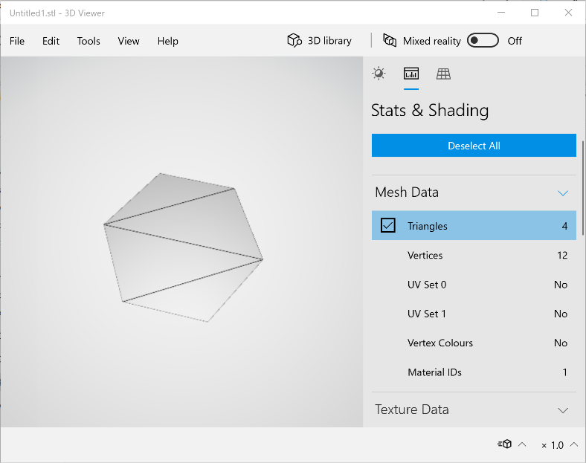

Results after running the plug-in

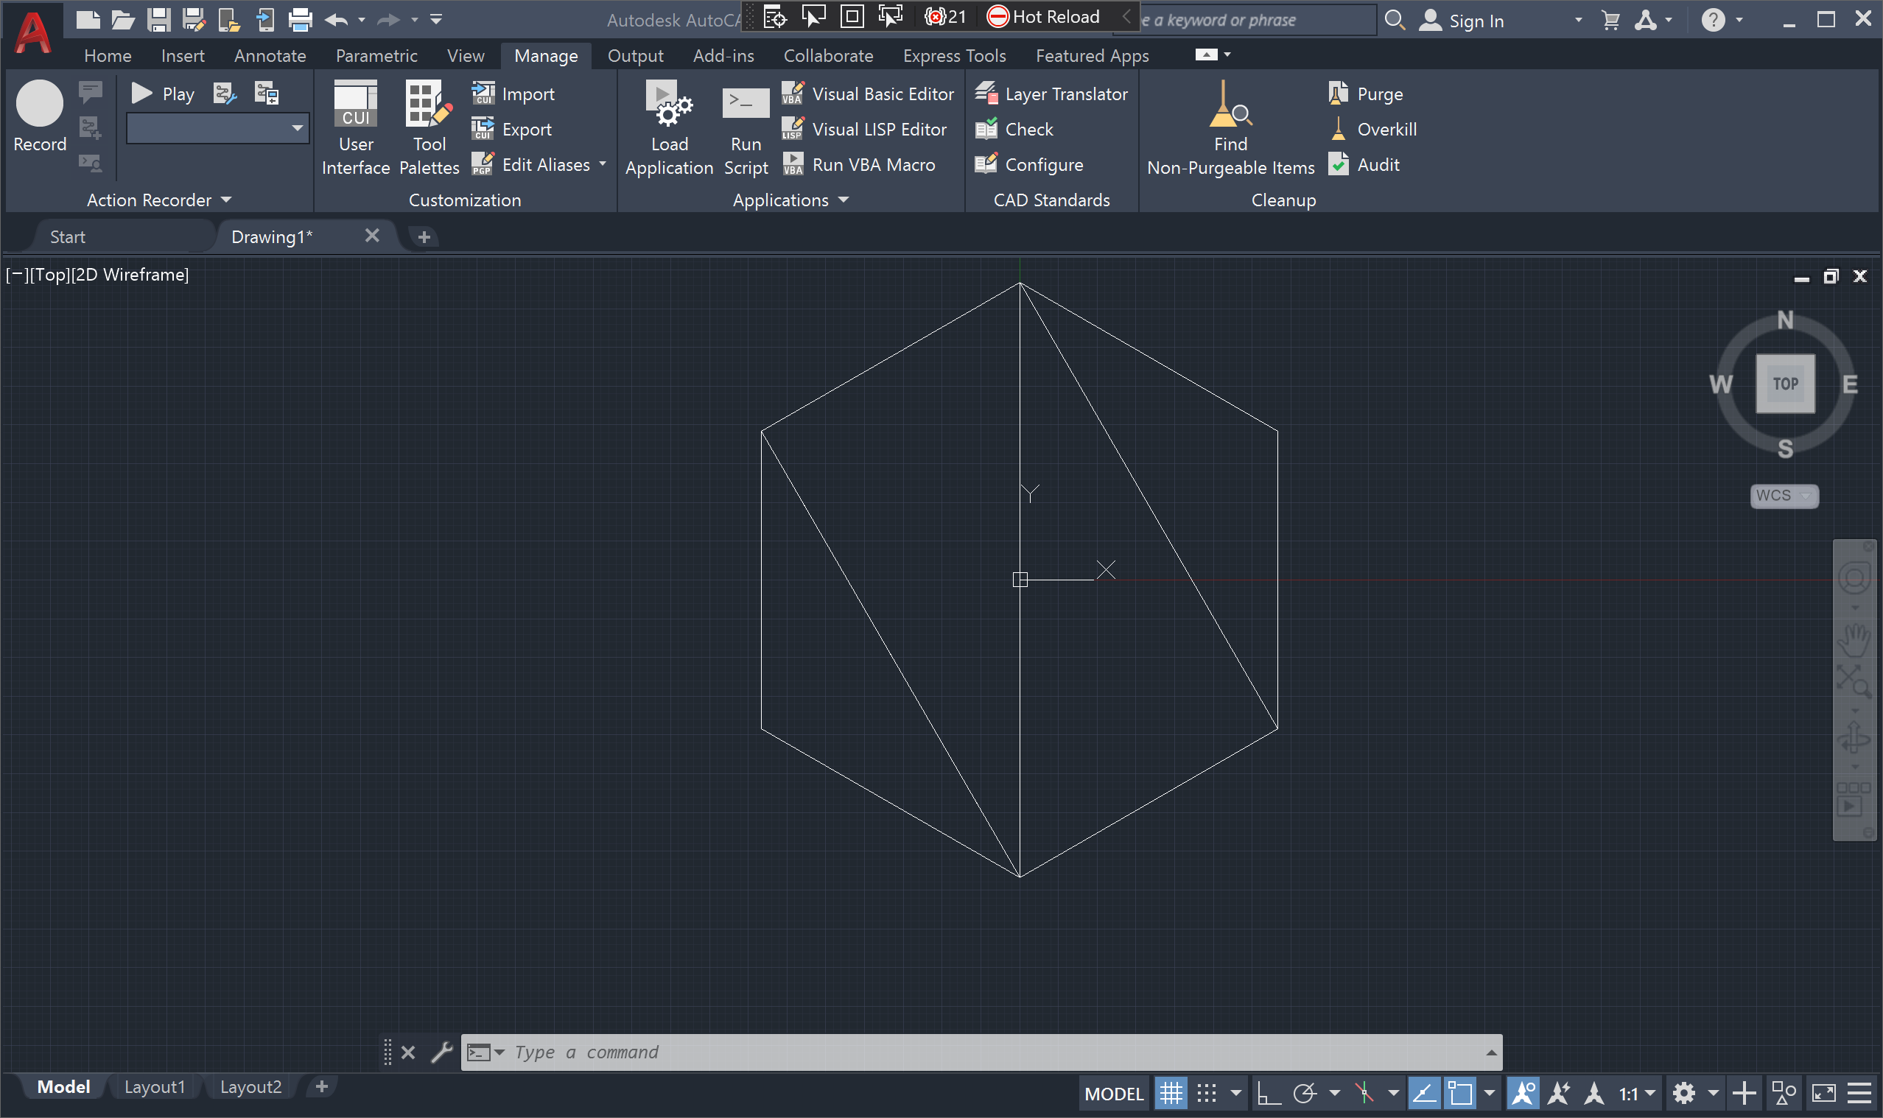

# Reference

1. [eRSVN](https://www.youtube.com/playlist?list=PLcUq_rc1Vk1LZ4QyasX-2zVr6O56Ouzc8)
2. [STL (file format), Wikipedia](https://en.wikipedia.org/wiki/STL_(file_format))