**로고학습일지**

**kt ds University 자바 기반의 데이터 사이언티스트 양성과정**

|  |  |  |  |  |  |
| --- | --- | --- | --- | --- | --- |
| 학습일시 | 2018. 08. 16 (목) | 장소 | kt ds University B관 201호 | **시 간** | 09:00~18:00 |
| 학습범위 | UI/UX | | | | |
| 작 성 자 |  | | | **강 사** | 장민창 강사 |

|  |  |
| --- | --- |
| 학습안건 | BOARD |

|  |  |
| --- | --- |
| 학습내용 | 내용 |

★ **BOARD**

**SEQUENCE**

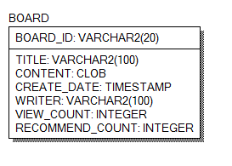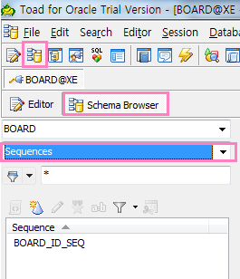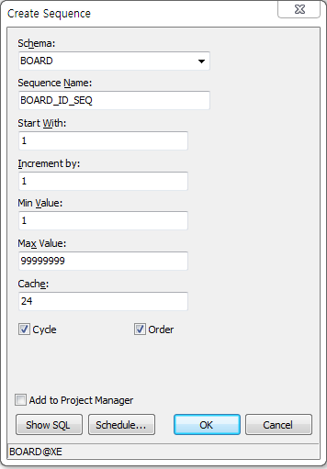

-- BD-2018081613-000001

SELECT 'BD-' || TO_CHAR(SYSDATE, 'YYYYMMDDHH24') || '-'

|| '000001'

FROM DUAL

**;**

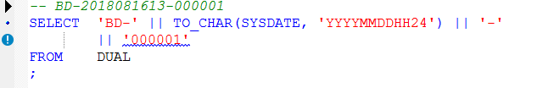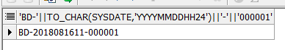

SELECT BOARD_ID_SEO.NEXTVAL

FROM DUAL;

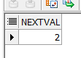

**\*INSERT\***

INSERT INTO BOARD (

BOARD_ID

,TITLE

,CONTENT

,CREATE_DATE

,WRITER

,VIEW_COUNT

,RECOMMEND_COUNT

)

VALUES

(

'BD-' || TO_CHAR(SYSDATE, 'YYYYMMDDHH24') || '-' || LPAD(BOARD_ID_SEQ.NEXTVAL,6,'0')

,'TITLE'

,'CONTENT'

,SYSDATE

,'WRITER'

,0

,0

)

;

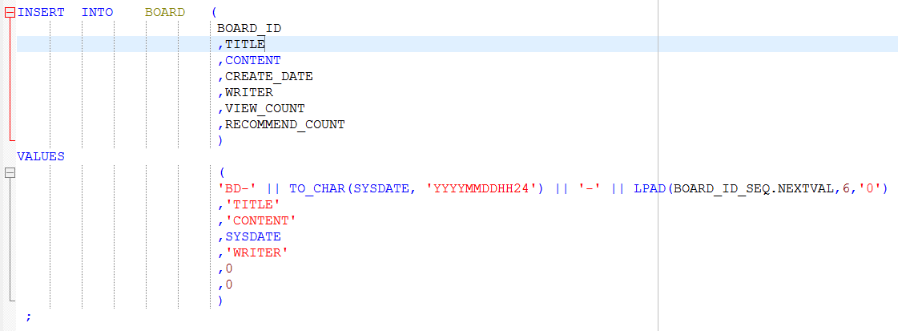

**/*삭제*/**

**DELETE**

**FROM BOARD ;** 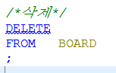

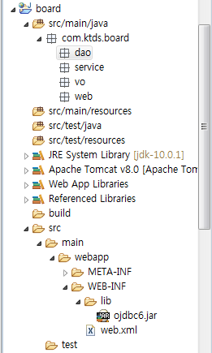

**Vo : 테이블에 있는대로 만들어준다.**

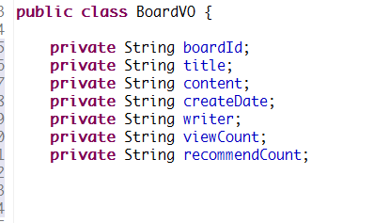

**Dao**

**public** **interface** BoardDao {

//C.R.U.D

//Create => insert

// void ->int : insert 된 것의 갯수

**public** **int** insertNewBoard(BoardVO boardVO);

// Read -> select

// void -> List

**public** List<BoardVO> selectAllBoards();

// void ->BoardVO (하나니까)

**public** BoardVO selectOneBoard(String boardId);

//Update

// public void updateOneBoard(String boardId, BoardVO boardVO); 이렇게 써도 됨

**public** **void** updateOneBoard(BoardVO boardVO);

// Delete

**public** **int** deleteOneBoard(String boardId);

**service**

**public** **interface** BoardService {

//c

**public** **boolean** createOneBoard(BoardVO boardVO);

//R

**public** List<BoardVO> readAllBoards();

**public** BoardVO readOneBoard(String boardId);

//U

**public** **boolean** updateOneBoard(BoardVO boardVO);

//D

**public** **boolean** deleteOneBoard(String boardID);

}

Web Flow

