**BrightPathRetail Report**

This project was completed as part of the BrightPath Consulting case study. The goal was to simulate a real-world data analytics scenario where a retail consulting firm analyzes store performance, product sales, and regional revenue trends using relational databases and dashboards.

The project involved creating a SQLite database (BrightPathRetail.db) containing three key datasets: Stores, Products, and Sales. The data was imported from CSV files and structured with primary and foreign key relationships. SQL queries were then used to extract insights, which were exported to Excel for visualization.

The final output includes:

* A normalized database (BrightPathRetail.db)
* An interactive Excel dashboard showing KPIs and visual trends
* This written report summarizing the SQL queries, results, and business interpretations

Each query was written and executed using DB Browser for SQLite.  
The following section presents the SQL code, sample output, and an interpretation explaining the business value of each result.

**Q1: List all stores located in the West region**

This query identifies all stores operating in the West region, providing their IDs, names, and opening dates. The results show that six stores have been active since 2015–2016, giving the business insight into the age and distribution of stores in that region — useful for assessing regional coverage, performance trends, and potential expansion planning.

**Q2: Find all products in the “Electronics” category with a unit price greater than $500, showing ProductID, ProductName, and UnitPrice.**

This query identifies high-value products within the *Electronics* category, each priced above $500. The results highlight key premium items — such as laptops, TVs, and monitors — which likely contribute most to overall revenue and should be prioritized for targeted promotions or inventory optimization.

**Q3: Total Revenue joining the Sales and Products tables. Show StoreID, StoreName, and Total Revenue, sorted from highest to lowest.**

This query ranks all stores by their total sales revenue. The results show that Store H-33 generates the highest revenue, indicating strong performance and potentially larger customer traffic or higher-priced product sales — valuable insights for benchmarking and identifying top-performing locations.

**Q4: Identify the top 5 products by revenue across all stores. Show ProductID, ProductName, and Revenue.**

This query highlights the five highest-grossing products, revealing that Electronics Monitor 45 and TV 44 are the top revenue drivers. These insights help the business identify which items generate the most profit, guiding inventory focus and promotional strategies toward high-performing electronics.

**Q5: Find stores that opened before January 1, 2020, and have sold more than 500 total units across all products. Show StoreID, StoreName, OpeningDate, and TotalUnitsSold**

This query identifies well-established stores that have been operational since 2015–2016 and continue to maintain strong sales performance with 500+ units sold. These results help management recognize consistently high-performing, mature locations that contribute significantly to overall sales stability.

**Combined Query for Dashboard Export**

This comprehensive dataset merges sales, product, and store information. It was exported to Combined_Sales_Data.csv and used in Excel to create an interactive dashboard with KPI cards, slicers, and visual charts (Monthly Revenue Trend, Store Revenue, Category Mix by Region).

**DASHBOARD OVERVIEW**

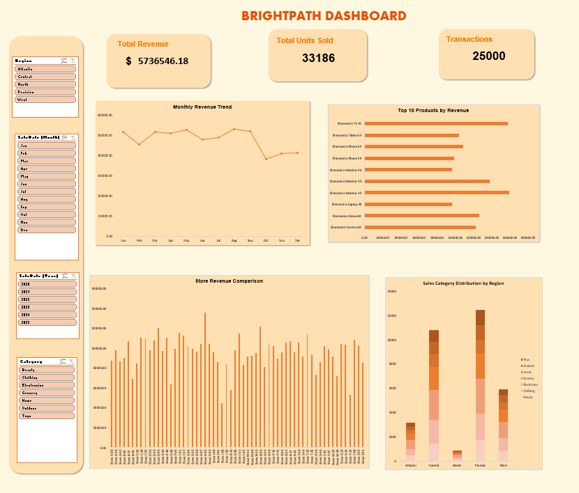

The dashboard provides an interactive summary of key business metrics. Users can filter by region or category to quickly identify trends and high-performing areas. It enables data-driven decisions to optimize product mix and store management.

The BrightPathRetail project demonstrates how structured data, SQL querying, and visualization tools can transform raw sales data into meaningful insights. Through database creation, analytical queries, and dashboard design, this analysis provides a clear overview of store performance and product profitability — skills that are essential for data-driven business decision-making.