**RESEARCH PROPOSAL**

Kim López Güell, Albert Prats Uribe, Daniel Prieto-Alhambra

**Background/Rationale**

Non-pharmaceutical interventions (NPI) constitute one of the strongest tools to control the spread of the ongoing SARS-CoV-2 (COVID) pandemic. Understanding their effectiveness is crucial, especially given their adverse socioeconomical impact. A proper study of their combined effect on reducing the incidence of the virus is required to correctly assess the best protocol for future interventions. There are many studies available on some combinations of NPIs in different regions, but none includes the application of a COVID passport measure to control the access to certain social events, which has been in vigour in some European countries only recently. The current analysis intends to determine the effectiveness of this intervention.

**Research Aims**

As stated, we would like to assess the usefulness of the COVID passport intervention in different countries.

**Methods**

**Data sources**

See “Data_sources” document for links to the downloadable data of deaths, cases, hospital admissions and vaccinations per country.

See “NPI_data” document for the selected NPIs and countries.

For the robustness check:

* Australia weekly data of Strokes, Diabetes, Heart conditions, etc. Not by age nor sex: https://www.abs.gov.au/statistics/health/causes-death/provisional-mortality-statistics/latest-release

**Study population/s and stratification/s**

As written in the previous section, depending on the outcome, the study will account for stratification for different countries, sex and/or age blocks.

**Intervention/exposure variables**

The variables accounted for will include:

* COVID passport
* Restrictions on unvaccinated people

Information on these variables can be found in the supplementary “NPI_data” document.

**Outcome/s of interest**

The same model will be run to evaluate different COVID incidence measures. For all of them, a certain lag after the application of all NPIs will be accounted for, measured in days, if applicable. The values in the specified range will be tested for robustness, and the value for the main model detailed as follows:

* Confirmed cases (LAG 2-7): LAG 5
* Admissions in hospital: LAG 7
* Mortality attributed to the pandemic (LAG 17-21): LAG 19
* Vaccinated people ( LAG 7-14): LAG 11

Ideally we will separate 1-dose from 2-dose vaccinations.

Vaccination lag might change, as there is the anticipation factor to be taken into account.

Daily or weekly analysis must be decided.

**Data analysis**

As we will perform all methods on data stratified on country, age and sex (if applicable, if not the stratification is void), from now on we will say CAS data when referring to the data separated into country, age and sex blocks.

Moreover, all analyses will be done for raw data, for the logarithm or hyperbolic sine to minimize the influence of extreme data counts, and for moving average means to increase smoothness. The most well-behaved model will be selected.

Firstly, segmented linear regression (SLR) assessment on CAS data will be performed as an initial inspection of the effect. It will be done for all populations and stratifications mentioned but will only take the COVID passport NPI covariate into account. The procedure will consist in the following:

1. Select a timepoint t* when the intervention was officially formalised by the government for each country, if applicable.
2. Initial visualization of the data to select the timeline of the intervention. We will restrict the regression to the particular wave of the NPI, to minimize the effect of other confounding covariates, for instance weather conditions. Therefore we will select the maximal interval containing t* that is strictly concave or convex.
3. Create a categorical variable quantifying the application of the COVID passport NPI.
4. Select the SLR model with coefficients b0, b1, b2, b3 and b4. We will have two timepoints, t* and t*+LAG. We would expect a change in slope or step on the second one but not on the first.
5. Perform a Durbin-Watson test on the residuals of the model. If negative, go to step 6. If not, do step 4 again transforming the model, for instance, to a Cochranne-Orcutt autocorrelated linear model.
6. Perform a test to see the validity of the hypothesis b3=0.

Then, the main models will be created using ARIMAX methodology. For all CAS data, the procedure is the following:

1. Create categorical variables for all NPIs as specified above.
2. Select a triple (p,d,q) to build the model ARIMAX(p,d,q). This will be done in different ways: both by letting the built function select the most optimal model by itself, and also by looking at the stationarity, ACF and PCF plots of the data ourselves. A sensible criteria should be applied, as for the lag we would expect for different outcomes (ranges written in Outcome/s of interest section). Seasonality should probably be included as well. Stationarity should be checked with Dickey-Fueller test.
3. Check the residuals of the model by looking at their ACF plot and performing normality (Shaphiro-Wilk), heteroskedasticity (Breusch-Pagan) and randomness (Ljung-Box) tests on them. Check also for significance of coefficients. If they do not look like white noise then we should modify the model.
4. Determine the effect of the NPI of the model by looking at its coefficient. This is not exactly accurate but I believe this is how it is usually assessed in other papers. Moreover, the absolute reduction in outcomes might also be interesting to measure.
5. Compare all models for different stratifications. Aggregate the results with inverse-variance weighted average or other Mantel-Haenzel methods.

To check for multicollinearity and for the robustness of the model, we will also do the following, both for the ARIMAX and the SLR when applicable:

* Run the model dropping all covariates one by one to see which coefficient varies the most in absence or presence of other covariates. This check will enable us to further asses which countries deliver the most reliable effect information.
* Let interventions have a longer impact after they are lifted.
* Let the windows for the moving average take larger or smaller values.
* Perturb the lags slightly. For instance, for cases data, we could allow for 2-7 days of lag instead of 5.
* Change the data slightly, particularly for not very reliable values like cases (allowing for a uniformly at random addition or subtraction of weekly data taken from a Binomial with probability (average new cases)/(population), in the latter situation).
* Run the model with data for a seemingly random outcome, like strokes, for which we would expect no effect whatsoever.
* Permute data within and between countries to ensure the results are not due to spurious effects.
* For one case in which we have daily and weekly data, run the model with both to see how it behaves for different time units.

**Mock tables and figures**

Let N=#countries·#age factors·#sex factors=C·A·S, and O=#outcomes. We expect to produce the following results after our analyses:

* Initial C·S plots of behaviour for the data of all outcomes factored by A
* Initial C plots of NPI timeline
* Possibly other summary data plots

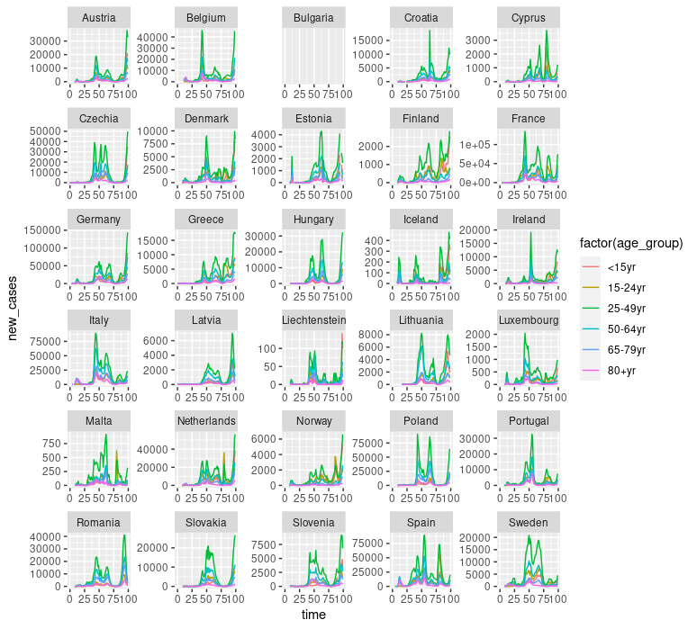

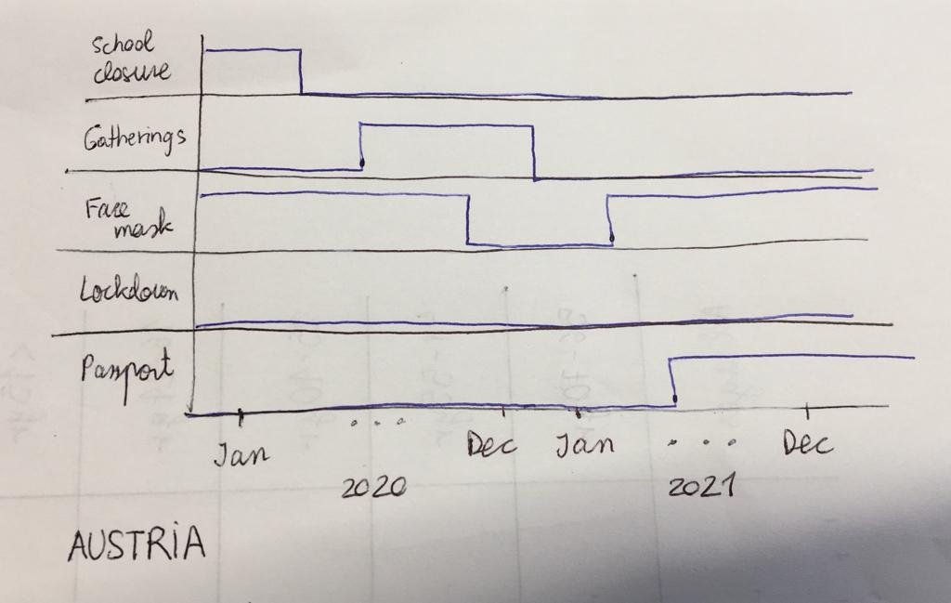

* SLR: N plots for all outcomes with regression lines for the pre-intervention period, lag period and post-lag period.
* SLR: O tables with C columns, A rows and S-divided entries with the results of the b3=0 tests.

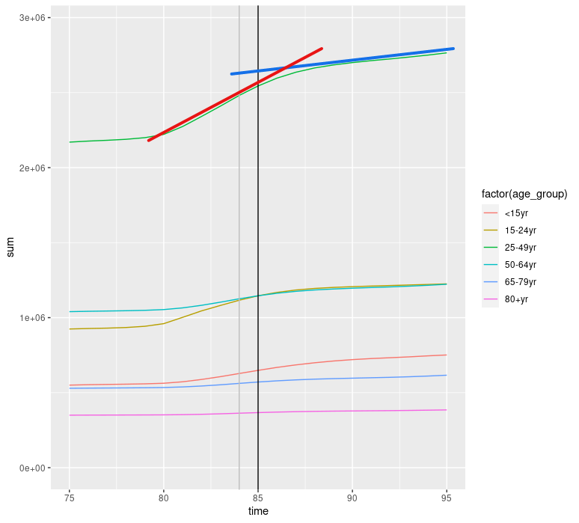

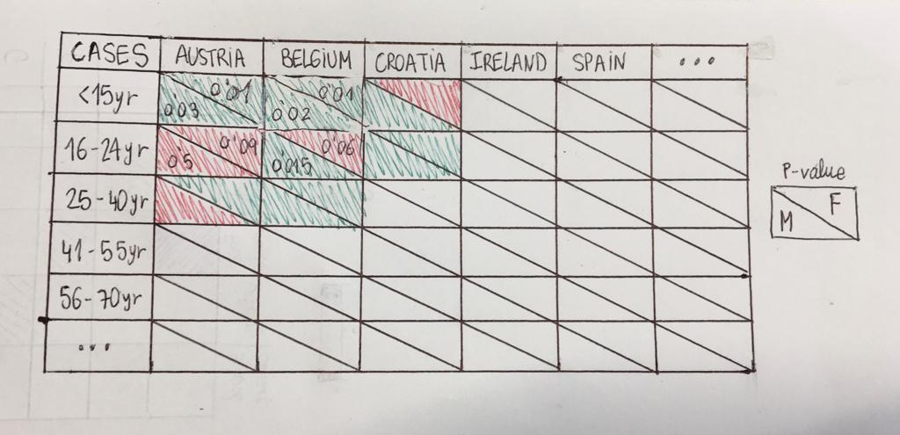

* ARIMAX: Plot with the effect computed by the model by A (rows) and S (columns) with its uncertainty.

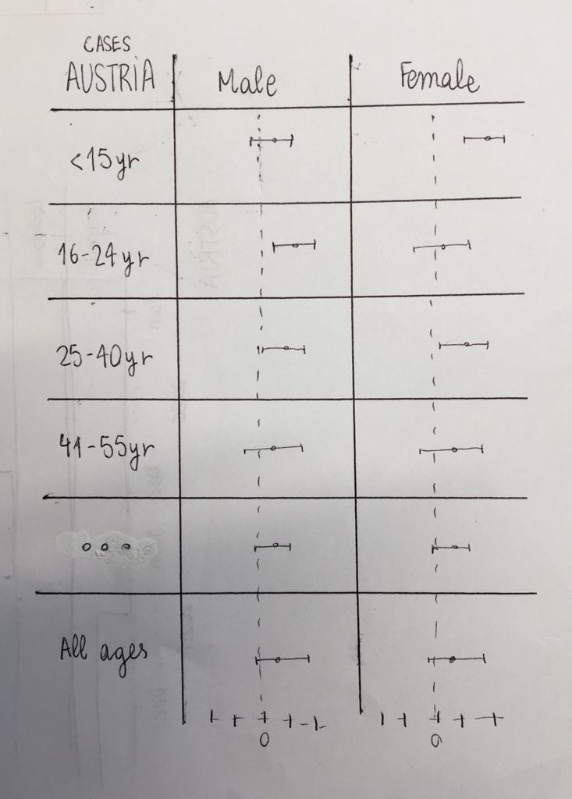

* ARIMAX: More graphics summarizing information by aggregating the previous plots for C, A, S or a combination of them.
* Double entry tables of effe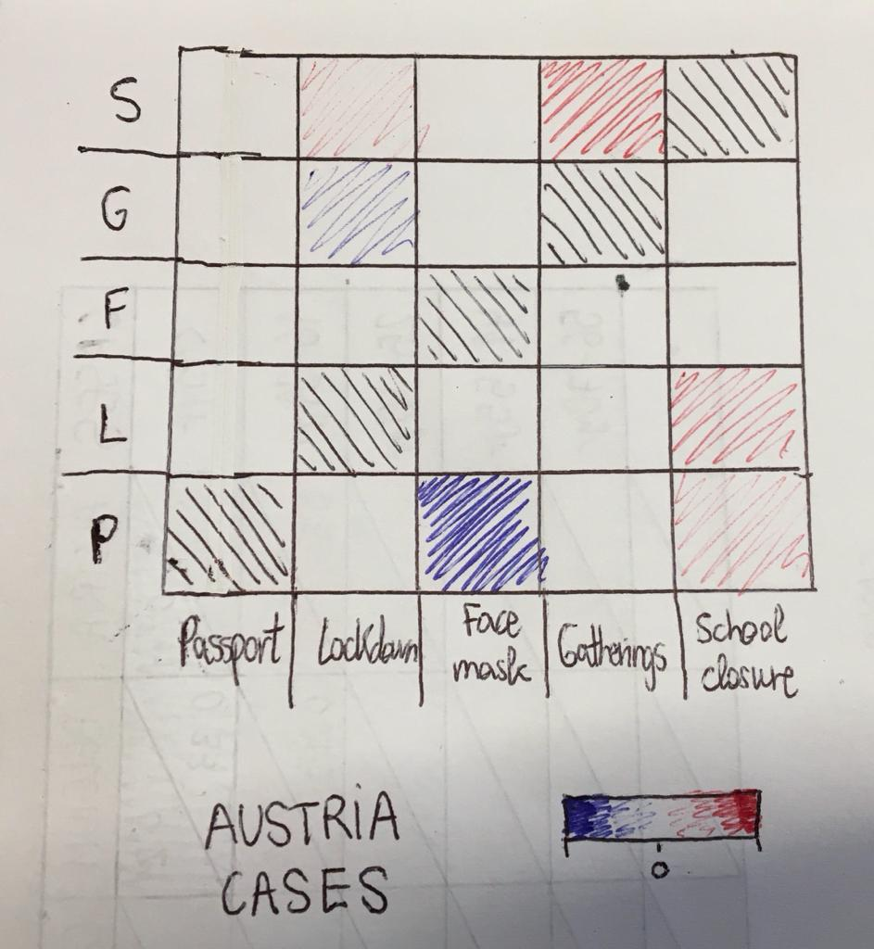ct change when dropping one covariate