**MID Q2 [10 points]**: You are given **Q2.html**, **Q2.css**, **profile.jpg** in this **Question2** folder. Your task is to modify the **Q2.css** file to display the HTML page in **Q2.html** on **Chrome** browser as seen below.

* **[– 20 points]** if at least a filename is changed
* **[– 20 points]** if the content of **m1.html** is changed
* **[40 points]** CSS properties for margin, text, and background colour on the first screenshot
* **[25 points]** CSS properties for margin, image, and button for mouse hover
* **[25 points]** CSS classes modifications and proper positioning of content

See the screenshots on the next pages.

**Hint**

* Background color is still white
* H1 color is black
* H2-h6 color is lightgray
* Text margin top and bottom is 4%
* Text font: Verdana, 40px
* Container padding will be 15% from left to right and 2% from top to bottom
* Icon to be used will be font icon
* Icon and button color is darkorange

Color: lightgray

15% padding

15% padding

6% padding

6% padding

4% padding

4% padding

Q2.html loaded on Chrome browser

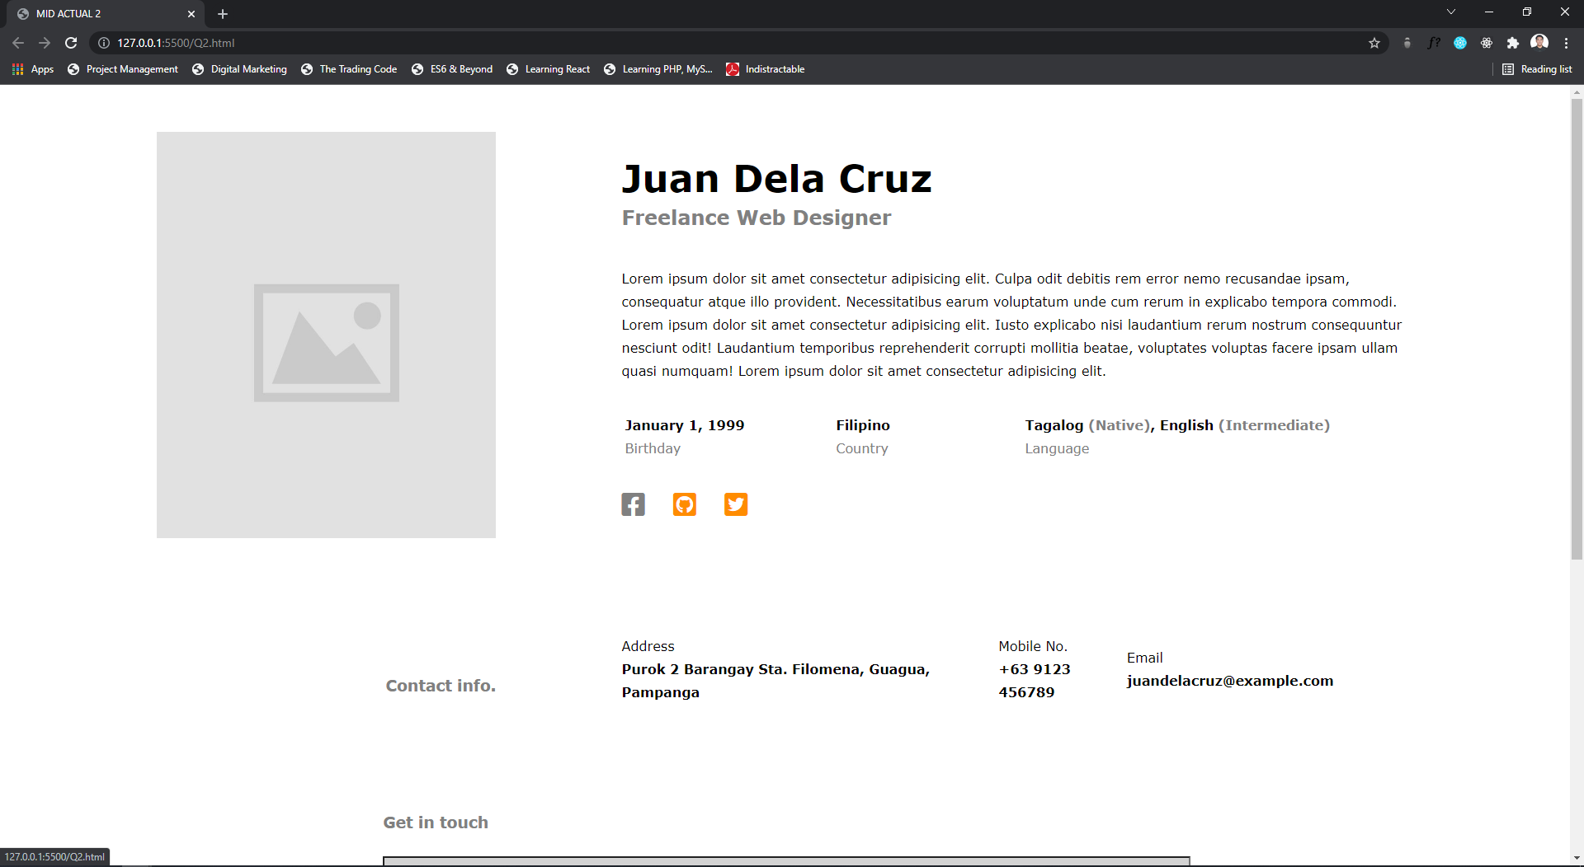

Color: lightgray

Color: darkorange

Link Mouse hover

Color: lightgray

Color: darkorange

18% padding

18% padding

3% padding

6% padding

Contact section

Color: gray

Button Mouse hover

See the full page

