Creating new Scenes and Levels

• We’ll create a new Start, Win, Game and Lose scene in a new 2D project

• Scenes and Levels are the same

• That’s it :-)

Create three new scenes

• In the same way as we created the Start scene create the Game, Lose, and Win scenes

씬의 구성.

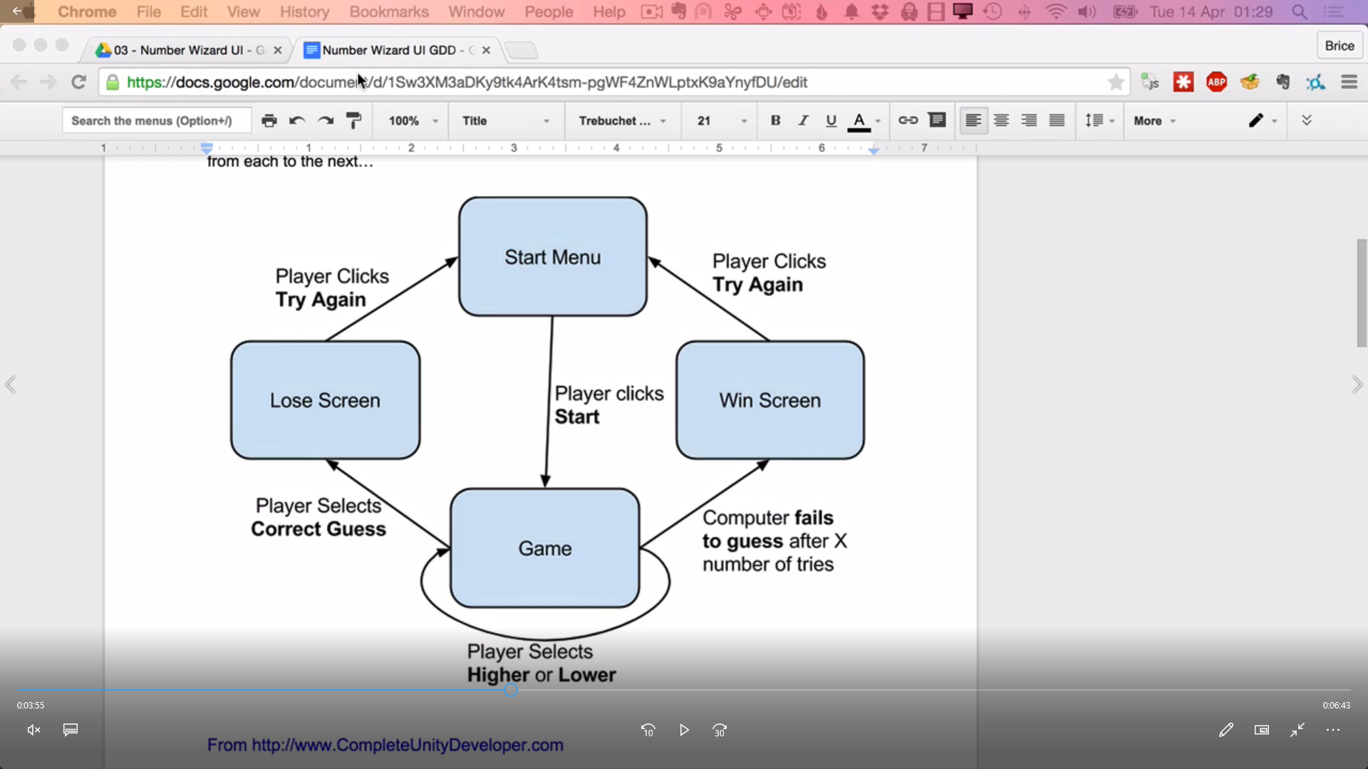

일단 4개의 씬 생성

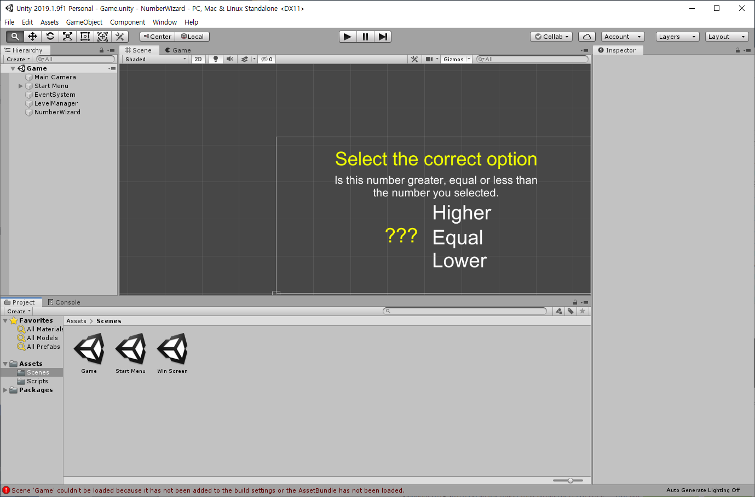

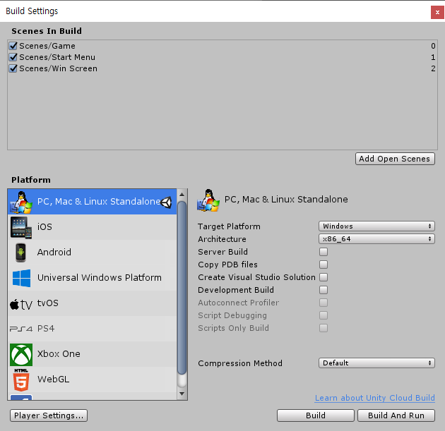

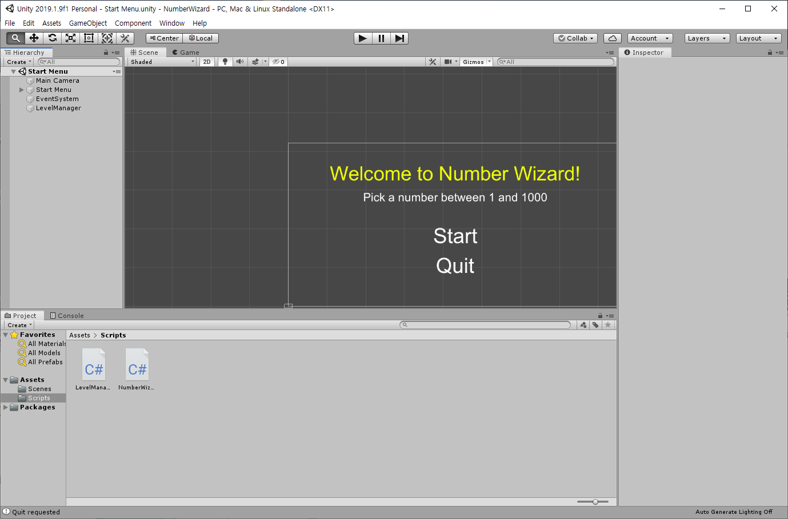여기 LevelManager이름으로 Empty Object 추가.

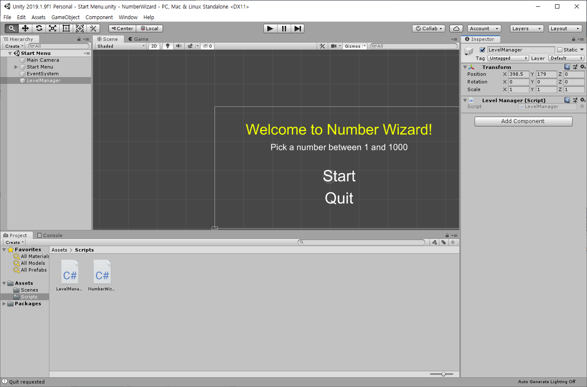

|  |
| --- |
| public class LevelManager : *MonoBehaviour* {  public void LoadLevel(string name){  *Debug*.*Log* ("New Level load: " + name);  *Application*.LoadLevel (name);  }  public void QuitRequest(){  *Debug*.*Log* ("Quit requested");  *Application*.*Quit* ();  }  } |

On Click()에 LevelManager 오브젝트를 가져다가 놓는다.

