Asian Journal of Economic Modelling  ISSN(e): 2312-3656  ISSN(p): 2313-2884  DOI:  Vol. x, No.x, xx-xx  © 2017 AESS Publications. All Rights Reserved.  URL: www.aessweb.com | 

REMITTANCE AND INFLATION – AN EMPIRICAL STUDY FOR VIETNAM

Nguyen Thi Hong Hai¹  Thang, Doan² | ^{1,2}International Business Faculty Banking Academy of Vietnam | (+ Corresponding author)
 | ABSTRACT
Article History  Keywords  Macroeconomic  Inflation  Remittance  VAR  Reduced-form | Remittances have recently received such a great attention as private monetary flows that its monetary nature seems to be disregarded. The issue that whether remittance flows are inflationary, resulting in a change in relative price, remains controversial. This study utilizes a reduced-form VAR model to investigate the inflation’s response to a positive shock to the remittance based on ’s study. We use a quarterly data from 1st quarter 1996 to 3rd quarter 2012. The main findings are that first, there exists a positive effect of remittance on inflation in Vietnam and this effects prolong up to three quarters; second others main macroeconomic factors also affect inflation but at a lower magnitude compared with remittances.
Contribution/ Originality: This study is one of very few studies which have investigated the impact of remittance on inflation in Vietnam. We found that remittance is a key driving factor of inflation during the past twenty years. This finding suggests that Vietnam’s government should manage remittance to fight inflation.

1. INTRODUCTION
The remittance flows play an important role in many developing countries due to the positive effects. However, these flows, simultaneously, have the negative impact on economies, say, increasing the inflation. This paper will use the VAR method to analyze the impact of remittance on inflation in Vietnam from 1996 to 2012.
Economists are interested in the impacts of remittance flow on inflation. Theoretically, these impacts lead to three different results: an appreciation of local currency, an increase in money supply and a change in BOP. Salter-Swan-Corden-Dornbusch model explains the relationship between the inflow (remittance in this case), price level, and real exchange rate in developing countries. The remittance will affect the consumption, leading the price increase, then home currency appreciates. However, the final impacts depend on the exchange rate regime. In fixed exchange rate regime, the inflows will cause inflation and the nominal money supply increase. It causes the home currency appreciate. In the float exchange rate regime, the remittance seems not to impact the inflation as well as nominal money supply.
An increase in remittance flow will rise the foreign currency supply, leading home currency appreciation and foreign currency depreciation. In fixed exchange rate regime, central bank must intervene the market by buying foreign currency to prevent home currency from appreciation. This intervention increases the nominal supply. At the same time, central bank, normally, sterilize the increase of money supply through the open market. However, this sterilization is not as efficient as desired, which causes inflation. By contrast, central bank does not intervene the foreign market, therefore both nominal money supply and inflation remain unchanged.
In theory, used the money model to prove the above conclusions about the impact of the remittance on inflation. He also found out the empirical evidence for these conclusions when using the data in Brazil, Colombia, Costa Rica, Dominica Republic, Ecuador, El Salvador and Mexico from 1980 to 2006. Before that, indicated that large remittance flow caused inflation in El Salvador increase while this country seeks the fixed exchange rate regime. Others findings conducted by ; ; show the same results about the effects of the remittance on inflation under the fixed exchange rate regime. However, the empirical evidence of those effects under the float exchange rate regime is not clear.
There is no official research about the impact of the remittance on inflation in Vietnam. Previous research only focused on the effect of the remittance on economy under microeconomic view. For example, Viet (2008) investigated the impact of remittances on poverty and inequality. Pfau and Giang (2009) studied the effects of remittance on household welfare in Vietnam. Niimi and Reilly (2011) analyzed how the gender affect the remittance behavior. Therefore, this paper is new at this time.

1.1. Overview on Vietnam’s Remittance
With about 5 million Vietnamese living and working in around 90 different nations and territories, Vietnam is one of the world’s top 10 remittance-receiving countries, with remittances from overseas Vietnamese in 2013 recorded at US$10.6 billion that is equivalent to about 6.5 per cent compared with previous year, according to the World Bank.
Remittance is one of two foreign inflow capitals (the other is FDI) which accounts for the largest share in Vietnam and tends to increase over years. In period 2003-2006, the value of remittance exceeded the FDI’s. Compared to ODA, remittance always surpasses. (Figure 1, 2, and 3, see Appendix)

1.2. Variables and Data Description
Our VAR model uses four endogenous variables, which are adequate in explain the remittance framework of a small open economy like Vietnam. We choose variables based on the variables used by . In their model, they use quarterly data for the CPI, nominal money supply (M2), real GDP, real exchange rate (RER) and remittances (REM). In our VAR model, we use the consumer price index (CPI), nominal money supply (M2), real effective exchange rate (REER) and remittances (REM). The data set is obtained from several various sources. The data of Vietnam’s CPI, Vietnam’s money supply is obtained from the International Financial Statistics (IFS). Remittance (REM) is obtained from General Statistics Office of Vietnam (GSO) and International Financial Statistics (IFS). The REER is calculated as a weighted average of real exchange rates of the Vietnamese currency to the currencies of Vietnam’s main trading partners. The original data is adjusted seasonally by Census 11 method and then, transformed into logarithms. The period considered is 1996:1 to 2012:3.
A preliminary investigation of the variables demonstrates that all of our variables are non-stationary. Hence, our analysis focuses on the continuously compounded growth rates of CPI, M2, REER, and REM. The quarterly percentage changes reported are annualized percentage changes (Table 2, see Appendix).

2. METHODOLOGY
The empirical behavior of the variables is modeled using the Vector Autoregressive approach.
The initial econometric model has the reduced form as following:
Y_{i,t} = Γ(L)Y_{it} + u_{it} (1)
where Y_{it} is the 41 dependent and endogenous vector of variables with Y_{i,t} = [Δln(REM)_{it}, Δln(M2)_{it}, Δln(CPI)_{it}, Δln(REER)_{it}]’. Γ(L) is matrix polynomial in the lag operator (with Γ(L)= Γ₁(L) + Γ₂(L)² + Γ₃(L)³ + …). u_{it} is the error term.
We then derive the impulse response functions from equation (1) relying on the Cholesky decomposition to orthogonalize the residuals. For this purpose, “the variables must be ordered such that variables placed higher in the ordering have a contemporaneous impact on all variables lower in the ordering” . Hence, the first variables should be the most exogenous. A careful ordering of the variables allows identifying the response of inflation to a positive shock on remittances.
The theoretical model considers remittances as the most independent of the internal conditions of a country while it has an impact on other variables. Empirical studies, such as Schiantarelli (2005) corroborate this assumption and show that remittances respond to external factors such as a reduction in transaction costs in the country where migrants live. Hence, remittances are the first variable, while ordering the remaining variables differs depending on the exchange rate regime considered.
Under fix exchange rate regime, the central bank must intervene to keep the nominal exchange rate stable. Hence, a change in remittance leads to a change real money demand and in the nominal money demand, then in inflation and, finally, in the REER. The resulting orderings are written as following:
Model: Δln(REM)_{it}, Δln(M2)_{it}, Δln(CPI)_{it}, Δln(REER)_{it}

2.1. Results of the Unit Root Tests and the Optimal Lag
We basically employ the Augmented Dickey-Fuller (ADF) test to exam whether the times series have a unit root. The null hypothesis is that there is a unit root in our series. In this paper, 1% is chosen to be the significance level. Thus, if test statistic reported by the ADF test is greater than critical value at 1%, the series is said to have no unit root; otherwise, it has a unit root. Accordingly, the ADF test shows that all of the series, except real GDP, have no unit test at 1% significance level. The Johansen cointegration test shows that there is no cointegration, therefore we can use the VAR model (Table 4, see Appendix).

Table-3. Unit roots test results
Variables | Critical values |  |  | Test-stat | Decision
 | 1% | 5% | 10% | Test-stat | Decision
lnCPI | -3.5366 | -2.9077 | -2.5914 | 1.5822 | Accept H0
D(lnCPI) | -3.5366 | -2.9077 | -2.5914 | -3.8478*** | Reject H0
lnGDP | -3.5482 | -2.9126 | -2.5940 | -0.6694 | Accept H0
D(lnGDP) | -3.5482 | -2.9126 | -2.5940 | -2.7604 | Accept H0
lnM2 | -3.5441 | -2.9109 | -2.5931 | -1.8209 | Accept H0
d(lnM2) | -3.5441 | -2.9109 | -2.5931 | -7.6493*** | Reject H0
lnREER | -3.5441 | -2.9109 | -2.5931 | 0.6446 | Accept H0
d(lnREER) | -3.5441 | -2.9109 | -2.5931 | -6.0257*** | Reject H0
lnREM | -3.5441 | -2.9109 | -2.5931 | -2.2778 | Accept H0
d(lnREM) | -3.5441 | -2.9109 | -2.5931 | -6.2965*** | Reject H0
Note: (***) reject null hypothesis (H0) at 1% level of significance.

There are couple of information criteria for selecting the optimal lag number. LR, FPE, AIC, and HQ criteria select one lag as an optimal lag (Table 6, see Appendix). Thus, we choose one lag to estimate the VAR. To double check the optimal lag and stability of the VAR, we test for autocorrelation among residuals and examine the roots of characteristic polynomial. The autocorrelation LM test shows that there is no autocorrelation among residuals (Table 7, see Appendix). All inverse roots of characteristic are less than 1, which implies that the VAR satisfies the stability condition (Table 5, see Appendix). In addition, the Residual Heteroskedasticity. Tests shows that model variance is homoscedasticity (Table 8, see Appendix). Thus, we are highly confident to run the VAR model with one lag. In the following parts, we will discuss the impulse response functions of inflation with respect to positive shocks of other endogenous variables, specially focusing on the positive shock of remittance.

2.2. Responses of the Inflation to Positive Shocks
Figure 4 (see Appendix) shows that, the inflow of remittance causes inflation in Vietnam increase immediately and it lasts 2-3 quarters. It means that an increase in inflow remittance lead inflation tend to increase and vice versa. This phenomenon derives from following reason:
First, although State Bank of Vietnam (SBV) announced that Vietnam has pursued the managed floating exchange rate regime, the actual regime (de facto) is the exchange rate peg regime with dollars with relatively little volatility, especially after the world financial crisis 2007-2009 . There was a huge remittance flowing in (with FDI and FII flow) in the second half of 2007 caused VND appreciate. In order to prevent an appreciation of local currency, SBV bought USD to raise foreign exchange reserves up to 26 billion USD (about 9 billion USD only in 2007). Despite selling a large amount of bills and bonds through open market operations to collect money from circulation, this neutralizing activity was not as effective as desired making a total means of payment in 2007 increased to 47, 2%, pushing inflation higher. As the central bank pursues a stable exchange rate policy (applicable exchange rate peg regime), the strong remittance inflows plus the ineffectiveness of neutralization interventions (sterilization) has led to Vietnam's inflation increase. This conclusion is entirely consistent with the previous studies as ; ; ; .
Secondly, research also indicates that M2 money supply has a positive impact on inflation in Vietnam. More specifically, the impact persists for 7-8 quarters after the shock with an impact remaining positive.
Thirdly, real effective exchange rate has a positive impact on inflation in Vietnam. The impact becomes more clearly after quarter 2th. In theory, the real exchange rate increases (foreign currency revaluation and local currency devaluation) will make the price of exports cheaper and of imports more expensive, which causes the price level increase. This effect becomes greater because Vietnam has a large import demand. Hence, even though the price of imported goods is quite expensive, it is difficult to reduce the import volumes.
Briefly, remittance, money supply and real effective exchange rate have positive impacts on inflation in Vietnam. It means that positive shocks of these variables will lead an increase in inflation with different lags. However, from Table 9 (see Appendix) we can see that the expectation of inflation contributes about 90% of change in inflation in Vietnam.

3. CONCLUSION
With the quarterly data from 1996 to 2012 and VAR model, this paper investigates the impact of remittance on inflation in Vietnam. There are two main findings:
First, remittance inflows increase inflation in Vietnam. Empirical evidence has contributed to reinforce the theory of the impact of remittances on inflation in the peg exchange rate regime. It suggests for the policy makers that to minimize the negative impact of remittances on inflation, the central bank should reconsider the exchange rate regime.
Second, both money supply and real effective exchange rate affect inflation, however, they account for mere 2-3%. Inflation expectations is a major factor explaining the volatility of inflation in Vietnam.

REFERENCES
Amuedo-Dorantes, C., & Pozo, S. (2004). Workers' remittances and the real exchange rate: a paradox of
gifts. World development, 32(8), 1407-1417.
Ball, C. P., Lopez, C., & Reyes, J. (2013). Remittances, Inflation and Exchange Rate Regimes in Small
Open Economies1. The World Economy, 36(4), 487-507.
Bourdet, Y., & Falck, H. (2006). Emigrants' remittances and Dutch disease in Cape Verde. International
Economic Journal, 20(3), 267-284.
Caceres, L. R., & Saca, N. N. (2006). What do remittances do? Analyzing the private remittance
transmission mechanism in El Salvador (No. 6-250). International Monetary Fund.
Lopez, H., M. Luis and B. Maurizio, 2007. Remittances and the real exchange rate. World Bank Policy Research
Working Paper, No. WPS 4213, April.
Niimi, Y., & Reilly, B. (2011). Gender differences in remittance behavior: Evidence from Vietnam. The
Singapore Economic Review, 56(02), 215-237.
Pfau, W. D., & Giang, L. T. (2009). Determinants and impacts of international remittances on household
welfare in Vietnam. International Social Science Journal, 60(197‐198), 431-443.
Schiantarelli, F. (2005). Global economic prospects 2006: economic implications of remittances and
migration. The World Bank.
Takagi, S. and T.H.A. Pham, 2011. Responding to the global financial crisis: Vietnamese exchange rate policy, 2008-2009. Journal of Asian Economics, 22(6): 507-517.
Viet, C. N. (2008). Do foreign remittances matter to poverty and inequality? Evidence from
Vietnam. Economics Bulletin, 15(1), 1-11.

APPENDIX

Table-1. Definition of variables and their data sources
Variable | Abbreviation | Source
Real Effective Exchange Rate | REER | IFS
Money supply | M2 | IFS
Remittance | REM | IFS
Cosumer Price Index | CPI | IFS
Source: IFS

Table-2. Statistics Summary of Data
 | DREER | DM2 | DREM | DCPI
Mean | -3.603162 | 25.35545 | 19.54856 | 6.822710
Median | -4.647274 | 22.99552 | 5.650192 | 5.582550
Maximum | 94.11329 | 1640.010 | 761.2623 | 32.81905
Minimum | -70.69736 | -1587.045 | -365.2880 | -4.937537
Std. Dev. | 23.65260 | 283.7081 | 143.3583 | 7.293665
Skewness | 0.647255 | 0.012450 | 1.932423 | 1.446797
Kurtosis | 7.135314 | 32.68668 | 12.81422 | 5.581355
Jarque-Bera | 51.63560 | 2423.574 | 305.9537 | 41.34976
Probability | 0.000000 | 0.000000 | 0.000000 | 0.000000
Sum | -237.8087 | 1673.460 | 1290.205 | 450.2988
Sum Sq. Dev. | 36363.95 | 5231869. | 1335854. | 3457.841
Observations | 66 | 66 | 66 | 66
Source:

Table-4. Johansen Cointegration Test
 | Sample (adjusted): 1996Q4 2012Q3
 | Included observations: 64 after adjustments
 | Trend assumption: Linear deterministic trend
 | Series: M2 REM REER CPI
 | Lags interval (in first differences): 1 to 2
 | Unrestricted Cointegration Rank Test (Trace)
 | Hypothesized |  | Trace | 0.05
 | No. of CE(s) | Eigenvalue | Statistic | Critical Value | Prob.**
 | None | 0.317296 | 42.77958 | 47.85613 | 0.1380
 | At most 1 | 0.150702 | 18.35120 | 29.79707 | 0.5402
 | At most 2 | 0.103833 | 7.897106 | 15.49471 | 0.4765
 | At most 3 | 0.013670 | 0.880901 | 3.841466 | 0.3480
Trace test indicates no cointegration at the 0.05 level
* denotes rejection of the hypothesis at the 0.05 level
** p-values

Table-5. Stability Condition Test
 | Roots of Characteristic Polynomial
 | Endogenous variables: DCPI DM2 DREER DREM
 | Exogenous variables: C
 | Lag specification: 1 2
 | Root | Modulus
 | 0.556190 | 0.556190
 | 0.439750 - 0.326563i | 0.547744
 | 0.439750 + 0.326563i | 0.547744
 | -0.225662 - 0.320733i | 0.392165
 | -0.225662 + 0.320733i | 0.392165
 | -0.362606 | 0.362606
 | 0.065382 - 0.331338i | 0.337727
 | 0.065382 + 0.331338i | 0.337727
No root lies outside the unit circle.
VAR satisfies the stability condition.

Table-6. Lag length criteria
Lag | LogL | LR | FPE | AIC | SC | HQ
0 | -1277.170 | NA | 2.06e+13 | 42.00556 | 42.14398* | 42.05981
1 | -1245.050 | 58.97331* | 1.21e+13* | 41.47706* | 42.16915 | 41.74829*
2 | -1231.718 | 22.73018 | 1.33e+13 | 41.56453 | 42.81029 | 42.05275
3 | -1219.083 | 19.88451 | 1.52e+13 | 41.67486 | 43.47429 | 42.38007
4 | -1207.403 | 16.84974 | 1.81e+13 | 41.81650 | 44.16961 | 42.73870
5 | -1188.080 | 25.34247 | 1.72e+13 | 41.70753 | 44.61431 | 42.84672
Source: self-calculation
Table-7. Autocorrelation LM test for the residuals
Lags | LM-Stat | Prob
1 | 21.94030 | 0.1451
2 | 21.33813 | 0.1659
3 | 17.95584 | 0.3265
4 | 21.55757 | 0.1581
5 | 8.346023 | 0.9379
Source: self-calculation

Table-8. Residual Heteroskedasticiy Tests
Joint test:
Chi-sq | df | Prob.
152.7234 | 160 | 0.6464
Source: self-calculation

Table-9. Variance decomposition of the inflation
Period | S.E. | DCPI | DM2 | DREER | DREM
1 | 4.957282 | 90.58073 | 3.306284 | 0.000000 | 6.112983
2 | 6.909789 | 94.76969 | 1.767298 | 0.032429 | 3.430583
3 | 7.635258 | 95.28564 | 1.758565 | 0.128192 | 2.827607
4 | 7.802627 | 95.07912 | 2.085975 | 0.126613 | 2.708292
5 | 7.826235 | 94.95705 | 2.220200 | 0.126380 | 2.696368
6 | 7.828152 | 94.92278 | 2.252631 | 0.128404 | 2.696182
7 | 7.828545 | 94.91628 | 2.257494 | 0.129765 | 2.696456
8 | 7.828697 | 94.91561 | 2.257682 | 0.130271 | 2.696441
9 | 7.828712 | 94.91547 | 2.257673 | 0.130430 | 2.696430
10 | 7.828719 | 94.91544 | 2.257671 | 0.130463 | 2.696429
Source: Regression Results

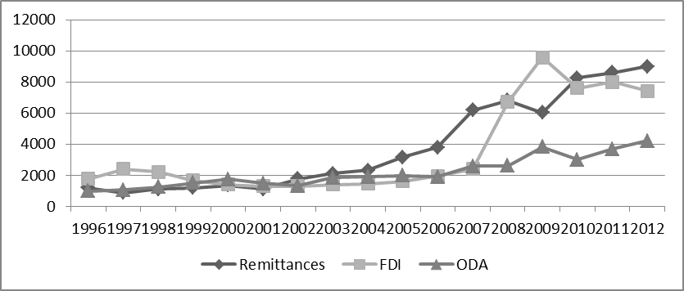
Figure-1. Inflow capital in Vietnam (million USD)
(Sources: World Bank database)

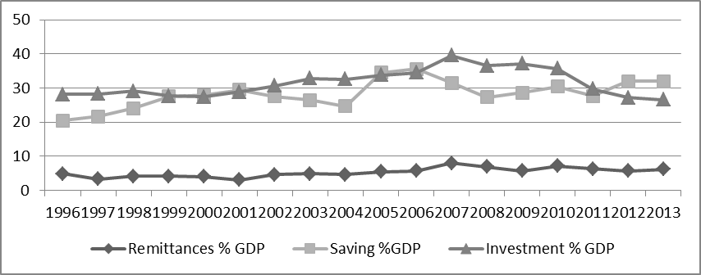
Figure-2. Remittance, Saving and Investment in Vietnam 1996-2013
(Sources: World Bank database)

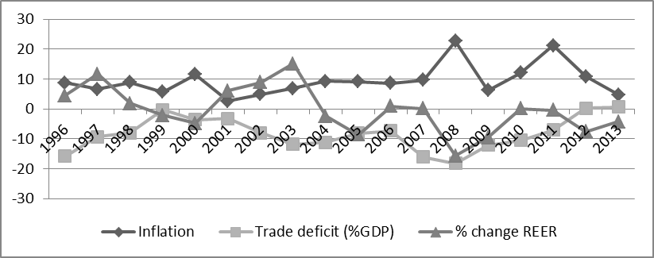
Figure-3. Vietnam macroeconomic indicator 1996-2013
(Sources: IMF and self-calculation)

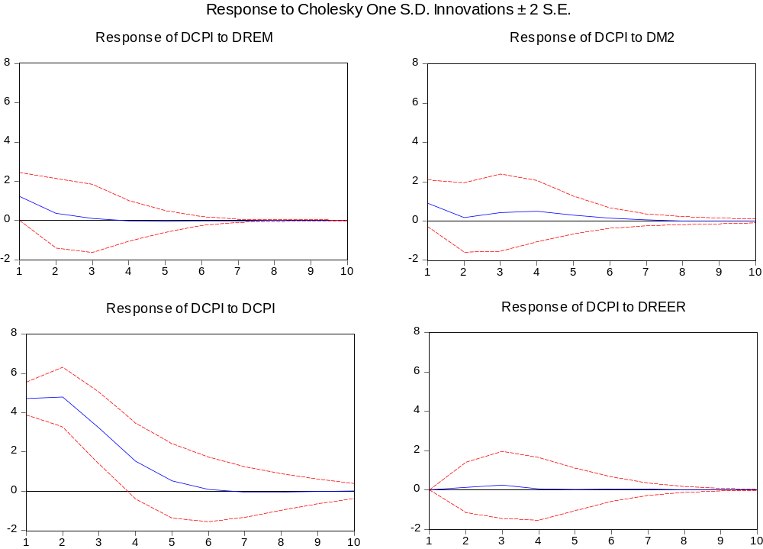
Figure-4. Impulse responses of inflation (Cholesky ordering: DREM, DM2, DCPI, DREER)
Sources: Regression Results

