# LCD library (Source: )

1. ***//i2c-2004.h***
2. **#include "stm32f4xx_hal.h"**
4. **void lcd_init (void); *// initialize lcd***
5. **void lcd_send_cmd (char cmd); *// send command to the lcd***
6. **void lcd_send_data (char data); *// send data to the lcd***
7. **void lcd_send_string (char *str); *// send string to the lcd***
8. **void lcd_clear (void);**
10. ***//i2c-2004.c***
11. ***/** Put this in the src folder **/***
12. **#include "i2c-2004.h"**
13. **extern I2C_HandleTypeDef hi2c1; *// change your handler here accordingly***
14. **#define SLAVE_ADDRESS_LCD 0x7E//0x4E // change this according to ur setup**
16. **void lcd_send_cmd (char cmd)**
17. **{**
18. **char data_u, data_l;**
19. **uint8_t data_t[4];**
20. **data_u = (cmd&0xf0);**
21. **data_l = ((cmd<<4)&0xf0);**
22. **data_t[0] = data_u|0x0C; *//en=1, rs=0***
23. **data_t[1] = data_u|0x08; *//en=0, rs=0***
24. **data_t[2] = data_l|0x0C; *//en=1, rs=0***
25. **data_t[3] = data_l|0x08; *//en=0, rs=0***
26. **HAL_I2C_Master_Transmit (&hi2c1, SLAVE_ADDRESS_LCD,(uint8_t *) data_t, 4, 100);**
27. **}**
29. **void lcd_send_data (char data)**
30. **{**
31. **char data_u, data_l;**
32. **uint8_t data_t[4];**
33. **data_u = (data&0xf0);**
34. **data_l = ((data<<4)&0xf0);**
35. **data_t[0] = data_u|0x0D; *//en=1, rs=1***
36. **data_t[1] = data_u|0x09; *//en=0, rs=1***
37. **data_t[2] = data_l|0x0D; *//en=1, rs=1***
38. **data_t[3] = data_l|0x09; *//en=0, rs=1***
39. **HAL_I2C_Master_Transmit (&hi2c1, SLAVE_ADDRESS_LCD,(uint8_t *) data_t, 4, 100);**
40. **}**
42. **void lcd_clear (void)**
43. **{**
44. **lcd_send_cmd (0x00);**
45. **for (int i=0; i<100; i++)**
46. **{**
47. **lcd_send_data (' ');**
48. **}**
49. **}**
51. **void lcd_init (void)**
52. **{**
53. ***// 4 bit initialisation***
54. **HAL_Delay(50); *// wait for >40ms***
55. **lcd_send_cmd (0x30);**
56. **HAL_Delay(5); *// wait for >4.1ms***
57. **lcd_send_cmd (0x30);**
58. **HAL_Delay(1); *// wait for >100us***
59. **lcd_send_cmd (0x30);**
60. **HAL_Delay(10);**
61. **lcd_send_cmd (0x20); *// 4bit mode***
62. **HAL_Delay(10);**
64. ***// dislay initialisation***
65. **lcd_send_cmd (0x28); *// Function set --> DL=0 (4 bit mode), N = 1 (2 line display) F = 0 (5x8 characters)***
66. **HAL_Delay(1);**
67. **lcd_send_cmd (0x08); *//Display on/off control --> D=0,C=0, B=0 ---> display off***
68. **HAL_Delay(1);**
69. **lcd_send_cmd (0x01); *// clear display***
70. **HAL_Delay(1);**
71. **HAL_Delay(1);**
72. **lcd_send_cmd (0x06); *//Entry mode set --> I/D = 1 (increment cursor) & S = 0 (no shift)***
73. **HAL_Delay(1);**
74. **lcd_send_cmd (0x0C); *//Display on/off control --> D = 1, C and B = 0. (Cursor and blink, last two bits)***
75. **}**
77. **void lcd_send_string (char *str)**
78. **{**
79. **while (*str) lcd_send_data (*str++);**
80. **}**

# DHT22 library (Source: )

1. ***//DHT_22.h***
2. **#include "stm32f4xx_hal.h"**
3. ***//Pin read/Write Data from DHT11 Sensor***
4. **#define DHT11_PORT GPIOA**
5. **#define DHT11_PIN GPIO_PIN_1**
7. ***//Add in main() (Note: before while(1))***
8. **void init_DHT22(void);**
9. **void delayus(uint16_t time); *//Delay in microsec.***
10. **void Set_Pin_Output (GPIO_TypeDef *GPIOx, uint16_t GPIO_Pin);**
11. **void Set_Pin_Input (GPIO_TypeDef *GPIOx, uint16_t GPIO_Pin);**
12. ***//Read 1 byte (in 5 bytes transmission)***
13. **uint8_t DHT22_Read (void);**
14. ***//Check DHT connection and data valid???***
15. **uint8_t DHT22_Check_Response(uint8_t d[5]);**
17. ***//DHT_22.c***
18. **#include "DHT_22.h"**
19. **extern TIM_HandleTypeDef htim6;**
21. **void init_DHT22(void)**
22. **{**
23. **HAL_TIM_Base_Start(&htim6);**
24. **}**
26. **void delayus(uint16_t time) *//Code 1: Timer 6***
27. **{**
28. ***//change your code here for the delay in microseconds***
29. **__HAL_TIM_SET_COUNTER(&htim6, 0);**
30. **while ((__HAL_TIM_GET_COUNTER(&htim6))<time);**
31. **}**
33. **void Set_Pin_Output (GPIO_TypeDef *GPIOx, uint16_t GPIO_Pin)**
34. **{**
35. **GPIO_InitTypeDef GPIO_InitStruct = {0};**
36. **GPIO_InitStruct.Pin = GPIO_Pin;**
37. **GPIO_InitStruct.Mode = GPIO_MODE_OUTPUT_PP;**
38. **GPIO_InitStruct.Speed = GPIO_SPEED_FREQ_VERY_HIGH;**
39. **HAL_GPIO_Init(GPIOx, &GPIO_InitStruct);**
40. **}**
42. **void Set_Pin_Input (GPIO_TypeDef *GPIOx, uint16_t GPIO_Pin)**
43. **{**
44. **GPIO_InitTypeDef GPIO_InitStruct = {0};**
45. **GPIO_InitStruct.Pin = GPIO_Pin;**
46. **GPIO_InitStruct.Mode = GPIO_MODE_INPUT;**
47. **GPIO_InitStruct.Speed = GPIO_SPEED_FREQ_VERY_HIGH;**
48. **HAL_GPIO_Init(GPIOx, &GPIO_InitStruct);**
49. **}**
51. **uint8_t DHT22_Read (void)**
52. **{**
53. **uint8_t i,j;**
54. **for (j=0;j<8;j++)**
55. **{**
56. **while (!(HAL_GPIO_ReadPin (DHT11_PORT, DHT11_PIN)));**
57. **delayus(30); *//Same as DHT11 and DHT22***
58. **if ((HAL_GPIO_ReadPin (DHT11_PORT, DHT11_PIN)))**
59. **{**
60. **while (HAL_GPIO_ReadPin (DHT11_PORT, DHT11_PIN));**
61. **i |= (1<<(7-j));**
62. **}**
63. **else i &= ~(1<<(7-j));**
64. **}**
65. **return i;**
66. **}**
68. **uint8_t DHT22_Check_Response(uint8_t d[])**
69. **{**
70. **HAL_GPIO_WritePin (DHT11_PORT, DHT11_PIN, GPIO_PIN_RESET);**
71. **delayus(1000); *//For DHT22, DHT11 takes 20000us***
72. **HAL_GPIO_WritePin (DHT11_PORT, DHT11_PIN, GPIO_PIN_SET);**
73. **Set_Pin_Input(DHT11_PORT, DHT11_PIN);**
74. **delayus(40);**
75. **if (!(HAL_GPIO_ReadPin (DHT11_PORT, DHT11_PIN)))**
76. **{**
77. **while (!(HAL_GPIO_ReadPin (DHT11_PORT, DHT11_PIN)));**
78. **while ((HAL_GPIO_ReadPin (DHT11_PORT, DHT11_PIN)));**
79. **d[0] = DHT22_Read();**
80. **d[1] = DHT22_Read();**
81. **d[2] = DHT22_Read();**
82. **d[3] = DHT22_Read();**
83. **d[4] = DHT22_Read();**
84. **Set_Pin_Output(DHT11_PORT, DHT11_PIN);**
85. **HAL_GPIO_WritePin (DHT11_PORT, DHT11_PIN, GPIO_PIN_SET);**
86. **if(d[4] == d[3]+d[2]+d[1]+d[0])**
87. **return 1;**
88. **else return 0;**
89. **}**
90. **else**
91. **{**
92. **Set_Pin_Output(DHT11_PORT, DHT11_PIN);**
93. **HAL_GPIO_WritePin (DHT11_PORT, DHT11_PIN, GPIO_PIN_SET);**
94. **return 0;**
95. **}**
96. **}**

# Main.c:

1. ***//main.c***
2. **#include "main.h"**
3. **#include "DHT_22.h" //Get temp, rh**
4. **#include "i2c-2004.h" //LCD2004**
5. **#include "stdio.h" //For sprintf**
6. **I2C_HandleTypeDef hi2c1;**
8. **TIM_HandleTypeDef htim6;**
9. **void SystemClock_Config(void);**
10. **static void MX_GPIO_Init(void);**
11. **static void MX_I2C1_Init(void);**
12. **static void MX_TIM6_Init(void);**
14. ***//Add in while(1) of main()***
15. **void readDHT22(uint8_t d[5]);**
16. **uint8_t d[5]; *//data byte from DHT22***
17. **char buffer[10];**
18. **uint16_t cal;**
19. **float f;**
21. **int main(void)**
22. **{**
23. **HAL_Init();**
24. **SystemClock_Config();**
25. **MX_GPIO_Init();**
26. **MX_I2C1_Init();**
27. **MX_TIM6_Init();**
28. **if (SysTick_Config(SystemCoreClock / 1000)) *//1ms***
29. **while (1); *//No need***
31. **lcd_init();**
32. **init_DHT22();**
33. **lcd_send_cmd(0x80|0x00);**
34. **lcd_send_string("T= ");**
35. **lcd_send_cmd(0x80|0x0A);**
36. **lcd_send_string("RH= ");**
37. **while (1)**
38. **{**
39. **readDHT22(d);**
40. **}**
41. **}**
43. ***/\*\****
44. ***\* @brief System Clock Configuration***
45. ***\* @retval None***
46. ***\*/***
47. **void SystemClock_Config(void)**
48. **{**
49. **RCC_OscInitTypeDef RCC_OscInitStruct = {0};**
50. **RCC_ClkInitTypeDef RCC_ClkInitStruct = {0};**
52. ***/** Configure the main internal regulator output voltage***
53. ***\*/***
54. **__HAL_RCC_PWR_CLK_ENABLE();**
55. **__HAL_PWR_VOLTAGESCALING_CONFIG(PWR_REGULATOR_VOLTAGE_SCALE1);**
56. ***/** Initializes the RCC Oscillators according to the specified parameters***
57. ***\* in the RCC_OscInitTypeDef structure.***
58. ***\*/***
59. **RCC_OscInitStruct.OscillatorType = RCC_OSCILLATORTYPE_HSE;**
60. **RCC_OscInitStruct.HSEState = RCC_HSE_ON;**
61. **RCC_OscInitStruct.PLL.PLLState = RCC_PLL_ON;**
62. **RCC_OscInitStruct.PLL.PLLSource = RCC_PLLSOURCE_HSE;**
63. **RCC_OscInitStruct.PLL.PLLM = 8;**
64. **RCC_OscInitStruct.PLL.PLLN = 336;**
65. **RCC_OscInitStruct.PLL.PLLP = RCC_PLLP_DIV2;**
66. **RCC_OscInitStruct.PLL.PLLQ = 4;**
67. **if (HAL_RCC_OscConfig(&RCC_OscInitStruct) != HAL_OK)**
68. **{**
69. **Error_Handler();**
70. **}**
71. ***/** Initializes the CPU, AHB and APB buses clocks***
72. ***\*/***
73. **RCC_ClkInitStruct.ClockType = RCC_CLOCKTYPE_HCLK|RCC_CLOCKTYPE_SYSCLK**
74. **|RCC_CLOCKTYPE_PCLK1|RCC_CLOCKTYPE_PCLK2;**
75. **RCC_ClkInitStruct.SYSCLKSource = RCC_SYSCLKSOURCE_PLLCLK;**
76. **RCC_ClkInitStruct.AHBCLKDivider = RCC_SYSCLK_DIV1;**
77. **RCC_ClkInitStruct.APB1CLKDivider = RCC_HCLK_DIV4;**
78. **RCC_ClkInitStruct.APB2CLKDivider = RCC_HCLK_DIV2;**
80. **if (HAL_RCC_ClockConfig(&RCC_ClkInitStruct, FLASH_LATENCY_5) != HAL_OK)**
81. **{**
82. **Error_Handler();**
83. **}**
84. **}**
86. ***/\*\****
87. ***\* @brief I2C1 Initialization Function***
88. ***\* @param None***
89. ***\* @retval None***
90. ***\*/***
91. **static void MX_I2C1_Init(void)**
92. **{**
94. ***/* USER CODE BEGIN I2C1_Init 0 */***
96. ***/* USER CODE END I2C1_Init 0 */***
98. ***/* USER CODE BEGIN I2C1_Init 1 */***
100. ***/* USER CODE END I2C1_Init 1 */***
101. **hi2c1.Instance = I2C1;**
102. **hi2c1.Init.ClockSpeed = 100000;**
103. **hi2c1.Init.DutyCycle = I2C_DUTYCYCLE_2;**
104. **hi2c1.Init.OwnAddress1 = 0;**
105. **hi2c1.Init.AddressingMode = I2C_ADDRESSINGMODE_7BIT;**
106. **hi2c1.Init.DualAddressMode = I2C_DUALADDRESS_DISABLE;**
107. **hi2c1.Init.OwnAddress2 = 0;**
108. **hi2c1.Init.GeneralCallMode = I2C_GENERALCALL_DISABLE;**
109. **hi2c1.Init.NoStretchMode = I2C_NOSTRETCH_DISABLE;**
110. **if (HAL_I2C_Init(&hi2c1) != HAL_OK)**
111. **{**
112. **Error_Handler();**
113. **}**
114. ***/* USER CODE BEGIN I2C1_Init 2 */***
116. ***/* USER CODE END I2C1_Init 2 */***
118. **}**
120. ***/\*\****
121. ***\* @brief TIM6 Initialization Function***
122. ***\* @param None***
123. ***\* @retval None***
124. ***\*/***
125. **static void MX_TIM6_Init(void)**
126. **{**
128. ***/* USER CODE BEGIN TIM6_Init 0 */***
130. ***/* USER CODE END TIM6_Init 0 */***
132. **TIM_MasterConfigTypeDef sMasterConfig = {0};**
134. ***/* USER CODE BEGIN TIM6_Init 1 */***
136. ***/* USER CODE END TIM6_Init 1 */***
137. **htim6.Instance = TIM6;**
138. **htim6.Init.Prescaler = 168-1;**
139. **htim6.Init.CounterMode = TIM_COUNTERMODE_UP;**
140. **htim6.Init.Period = 0xFFFF;**
141. **htim6.Init.AutoReloadPreload = TIM_AUTORELOAD_PRELOAD_DISABLE;**
142. **if (HAL_TIM_Base_Init(&htim6) != HAL_OK)**
143. **{**
144. **Error_Handler();**
145. **}**
146. **sMasterConfig.MasterOutputTrigger = TIM_TRGO_RESET;**
147. **sMasterConfig.MasterSlaveMode = TIM_MASTERSLAVEMODE_DISABLE;**
148. **if (HAL_TIMEx_MasterConfigSynchronization(&htim6, &sMasterConfig) != HAL_OK)**
149. **{**
150. **Error_Handler();**
151. **}**
152. ***/* USER CODE BEGIN TIM6_Init 2 */***
154. ***/* USER CODE END TIM6_Init 2 */***
156. **}**
158. ***/\*\****
159. ***\* @brief GPIO Initialization Function***
160. ***\* @param None***
161. ***\* @retval None***
162. ***\*/***
163. **static void MX_GPIO_Init(void)**
164. **{**
165. **GPIO_InitTypeDef GPIO_InitStruct = {0};**
167. ***/* GPIO Ports Clock Enable */***
168. **__HAL_RCC_GPIOH_CLK_ENABLE();**
169. **__HAL_RCC_GPIOA_CLK_ENABLE();**
170. **__HAL_RCC_GPIOB_CLK_ENABLE();**
172. ***/*Configure GPIO pin Output Level */***
173. **HAL_GPIO_WritePin(GPIOA, GPIO_PIN_1, GPIO_PIN_SET);*//RESET);***
175. ***/*Configure GPIO pin : PA1 */***
176. **GPIO_InitStruct.Pin = GPIO_PIN_1;**
177. **GPIO_InitStruct.Mode = GPIO_MODE_OUTPUT_PP;**
178. **GPIO_InitStruct.Pull = GPIO_PULLUP;**
179. **GPIO_InitStruct.Speed = GPIO_SPEED_FREQ_LOW;**
180. **HAL_GPIO_Init(GPIOA, &GPIO_InitStruct);**
182. **}**
184. ***/* USER CODE BEGIN 4 */***
185. **void readDHT22(uint8_t d[])**
186. **{**
187. **static uint32_t lastRead = 0;**
188. **uint32_t now = HAL_GetTick();**
189. **if((uint32_t)(now - lastRead) > 2000) *//DHT11 - 1000ms***
190. **{**
191. **lcd_send_cmd(0x80|0x03);**
192. **lcd_send_string(" ");**
194. **lcd_send_cmd(0x80|0x0E);**
195. **lcd_send_string(" ");**
196. **if(DHT22_Check_Response(d)){**
198. **cal = d[2]&0x7F; cal*=256;**
199. **cal += d[3]; f = cal*0.1;**
200. **if(d[2] & 0x80) f*=-1;**
202. **sprintf(buffer, "%0.1f", f);**
203. **lcd_send_cmd(0x80|0x03);**
204. **lcd_send_string(buffer);**
205. **lcd_send_string("*C");**
207. **cal = d[0]; cal*=256;**
208. **cal += d[1]; f = cal*0.1;**
210. **sprintf(buffer, "%0.1f", f);**
211. **lcd_send_cmd(0x80|0x0E);**
212. **lcd_send_string(buffer);**
213. **lcd_send_string("%");**
214. **}**
215. **else {**
216. **lcd_send_cmd(0x80|0x03);**
217. **lcd_send_string("ERROR");**
218. **lcd_send_cmd(0x80|0x0E);**
219. **lcd_send_string("ERROR");**
220. **}**
221. **lastRead = HAL_GetTick();**
222. **}**
223. **}**
225. ***/* USER CODE END 4 */***
227. ***/\*\****
228. ***\* @brief This function is executed in case of error occurrence.***
229. ***\* @retval None***
230. ***\*/***
231. **void Error_Handler(void)**
232. **{**
233. ***/* USER CODE BEGIN Error_Handler_Debug */***
234. ***/* User can add his own implementation to report the HAL error return state */***
235. **while(1)**
236. **{**
237. **}**
238. ***/* USER CODE END Error_Handler_Debug */***
239. **}**
241. **#ifdef USE_FULL_ASSERT**
242. ***/\*\****
243. ***\* @brief Reports the name of the source file and the source line number***
244. ***\* where the assert_param error has occurred.***
245. ***\* @param file: pointer to the source file name***
246. ***\* @param line: assert_param error line source number***
247. ***\* @retval None***
248. ***\*/***
249. **void assert_failed(uint8_t *file, uint32_t line)**
250. **{**
251. ***/* USER CODE BEGIN 6 */***
252. ***/* User can add his own implementation to report the file name and line number,***
253. ***tex: printf("Wrong parameters value: file %s on line %d\r\n", file, line) */***
254. ***/* USER CODE END 6 */***
255. **}**
256. **#endif /* USE_FULL_ASSERT */**
258. ***/************************ (C) COPYRIGHT STMicroelectronics *****END OF FILE****/***

Comments:

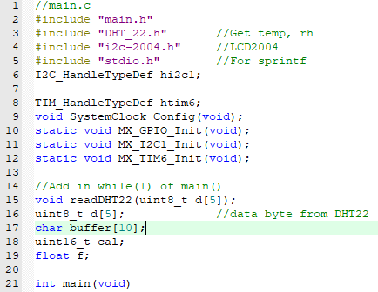

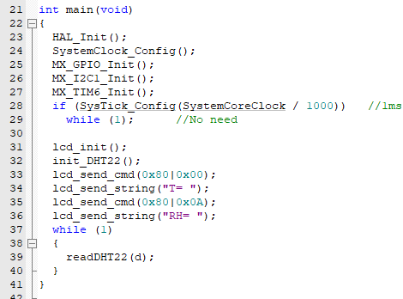

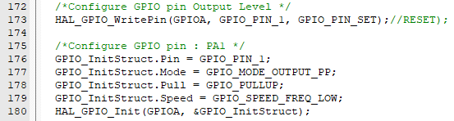

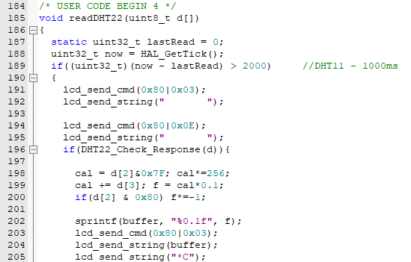

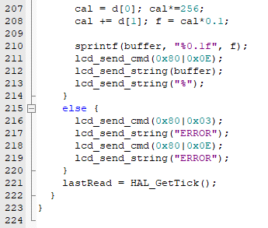

System clk là 168Mhz -> APB1,2 cũng là 168Mhz (xem trong Cube)

Timer_6: Prescaler – (168-1), Mode – Up, Period – (0xFFFF-1)