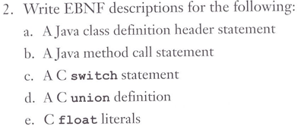

**a.**

**<class_head> {<modifier>} class <id> [extends class_name] [implements<interface_name> {, <interface_name>}]**

**<modifier> public | abstract | final**

**<class_head> {<modifier>} class <id> [extends class_name] [implements<interface_name> {, <interface_name>}] <modifier> public | abstract | final**

**<method_header> -> {<modifier>} class <id> [extends <id>]**

**[implements <id> {,<id>}]**

**<modifier> -> public | abstract | final**

**c.**

**<switch> ->**

**switch ( <expr> ) {**

**case <literal> : { <stmt> ; }**

**{ case <literal> : { <stmt>; }}**

**[ default : { <stmt> ; } ]**

**}**

**e.**

**<float-literal> –> <real> <suffix> | <real> <exponent> <suffix>**

**| <integer> <exponent> <suffix>**

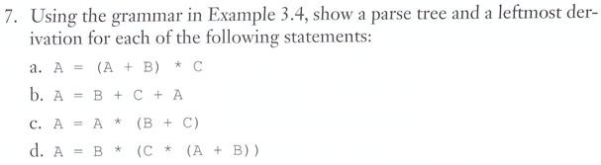

|  |  |  |
| --- | --- | --- |
| **b.**  **<assign>=><id>=<expr>**  **A=<id>+<expr>**  **A=B+<id>+<expr>**  **A=B+C+<id>**  **A=B+C+A** | **d.**  **<assign>=><id>=<expr>**  **A = <expr>**  **A = <id> * <expr>**  **A = B * <expr>**  **A = B * ( <expr> )**  **A = B * ( <id> * <expr> )**  **A = B * ( C * <expr> )**  **A = B * ( C * ( <expr> ) )**  **A = B * ( C * ( <id> + <expr> ) )**  **A = B * ( C * ( A + <expr> ) )**  **A = B * ( C * ( A + <id> ) )**  **A = B * ( C * ( A + B ) )** | |
|  | |

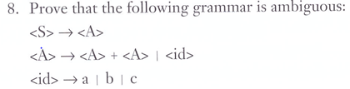

**S S**

**| |**

**A A**

**/ | ＼ / | ＼**

**A + A A + A**

**| / | ＼ / | ＼ |**

**<id> A + A A + A <id>**

**| | | | | |**

**a <id> <id> <id> <id> c**

**| | | |**

**b c a b**



**<assign> -> <id> = <expr>**

**<id> -> A | B | C**

**<expr> -> <expr> + <term> | <term>**

**<term> -> <term> * <factor> | <factor>**

**<factor> -> ( <expr> ) | <id> | – <id>**

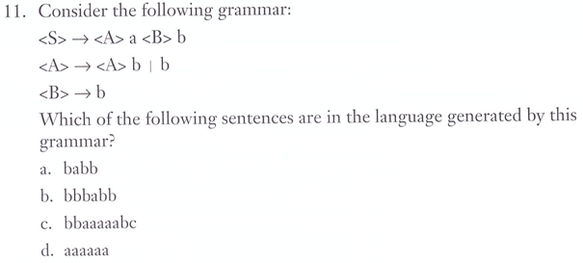

**a. babb: <S> -> <A>a<B>b -> ba<B>b -> babb**

**b. bbbabb: <S> -> <A>a<B>b -> <A>ba<B>b -> <A>bba<B>b -> bbba<B>b -> bbbabb**

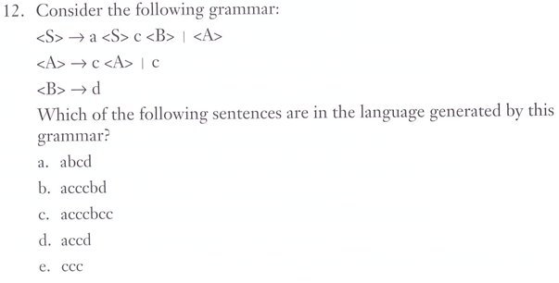

**d. accd: <S> -> a<S>c<B> -> a<S>cd -> a<A>cd -> accd**

**e. ccc: <S> -> <A> -> c<A> -> cc<A> -> ccc**

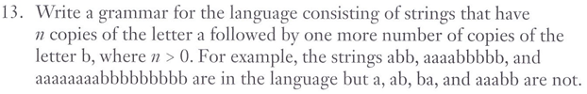

**<S> = b | a<S>b**

**ex) <S> -> a<S>b -> aa<S>bb -> aaa<S>bbb -> aaaa<S>bbbb -> aaaabbbbb**



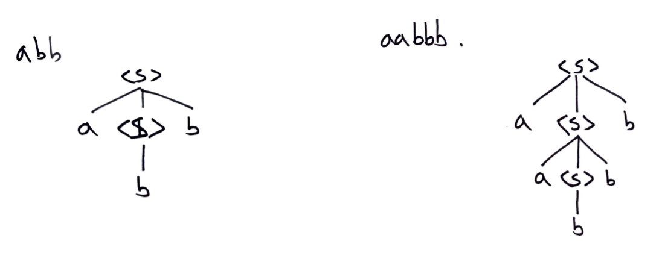



**<program> -> begin <stmt_list> end**

**<stmt_list> -> <stmt> [<stmt_list>]**

**<stmt> -> <var> = <expression>**

**<var> -> A | B | C**

**<expression> -> <var> { ( + | – ) <var> }**



**<assign> -> <id> = <expr>**

**<id> -> A | B | C**

**<expr> -> <id> (+ | *) <expr> | ( <expr> ) | <id>**

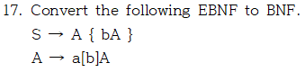

**S -> A | A B**

**B -> b A | b A B**

**A -> a A | a b A**