**Play the thrilling new game Balloon Blast! Exciting gameplay including:**

* *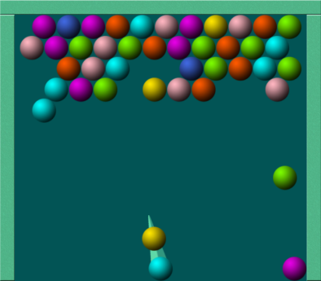***Get three balls of the same colour in a sequence to explode them!**
* **Leave balls hanging and see them jump off the board!**
* **Beat the time – shoot balls and explode all the stationary balls before a new row is added!**



**© *Kim Restad 2012***

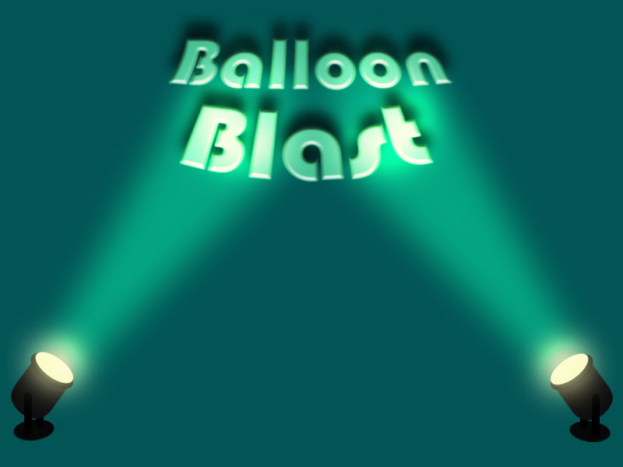

A Kim Restad

production