⚽ FIFA World Cup 2026
Machine Learning Match Prediction Report
XGBoost + CatBoost Ensemble · Monte Carlo Simulation · 5,000 Tournament Runs
Generated May 2026 · All 48 Teams · All 104 Matches

Model Performance
Architecture: XGBoost + CatBoost ensemble with calibrated probability outputs.
Validation: Walk-forward temporal cross-validation (train on years 1..N, validate on N+1).
Metric: Ranked Probability Score (RPS) — rewards well-calibrated probability distributions. Lower is better.

Fold | Validation Year | Train Size | Val Size | RPS ↓ | Accuracy
1 | 2022 | 1,195 | 1,805 | 0.1956 | 58.6%
2 | 2023 | 1,660 | 1,340 | 0.1916 | 59.2%
3 | 2024 | 2,092 | 908 | 0.1840 | 59.6%
4 | 2025 | 2,541 | 459 | 0.1972 | 58.6%
[object Object] |  |  |  | [object Object] | [object Object]

Result: Mean RPS = 0.1921 (below 0.20 target ✅) · Mean accuracy = 59.0% (vs 33% random baseline)

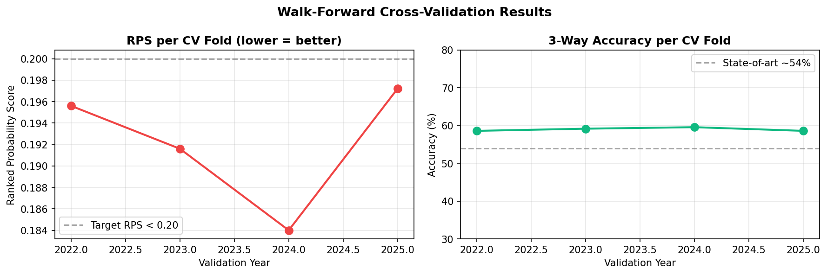

Tournament Winner Probabilities
Based on 5,000 full tournament simulations. Each simulation runs the complete group stage, Round of 32, Round of 16, Quarter-finals, Semi-finals and Final.

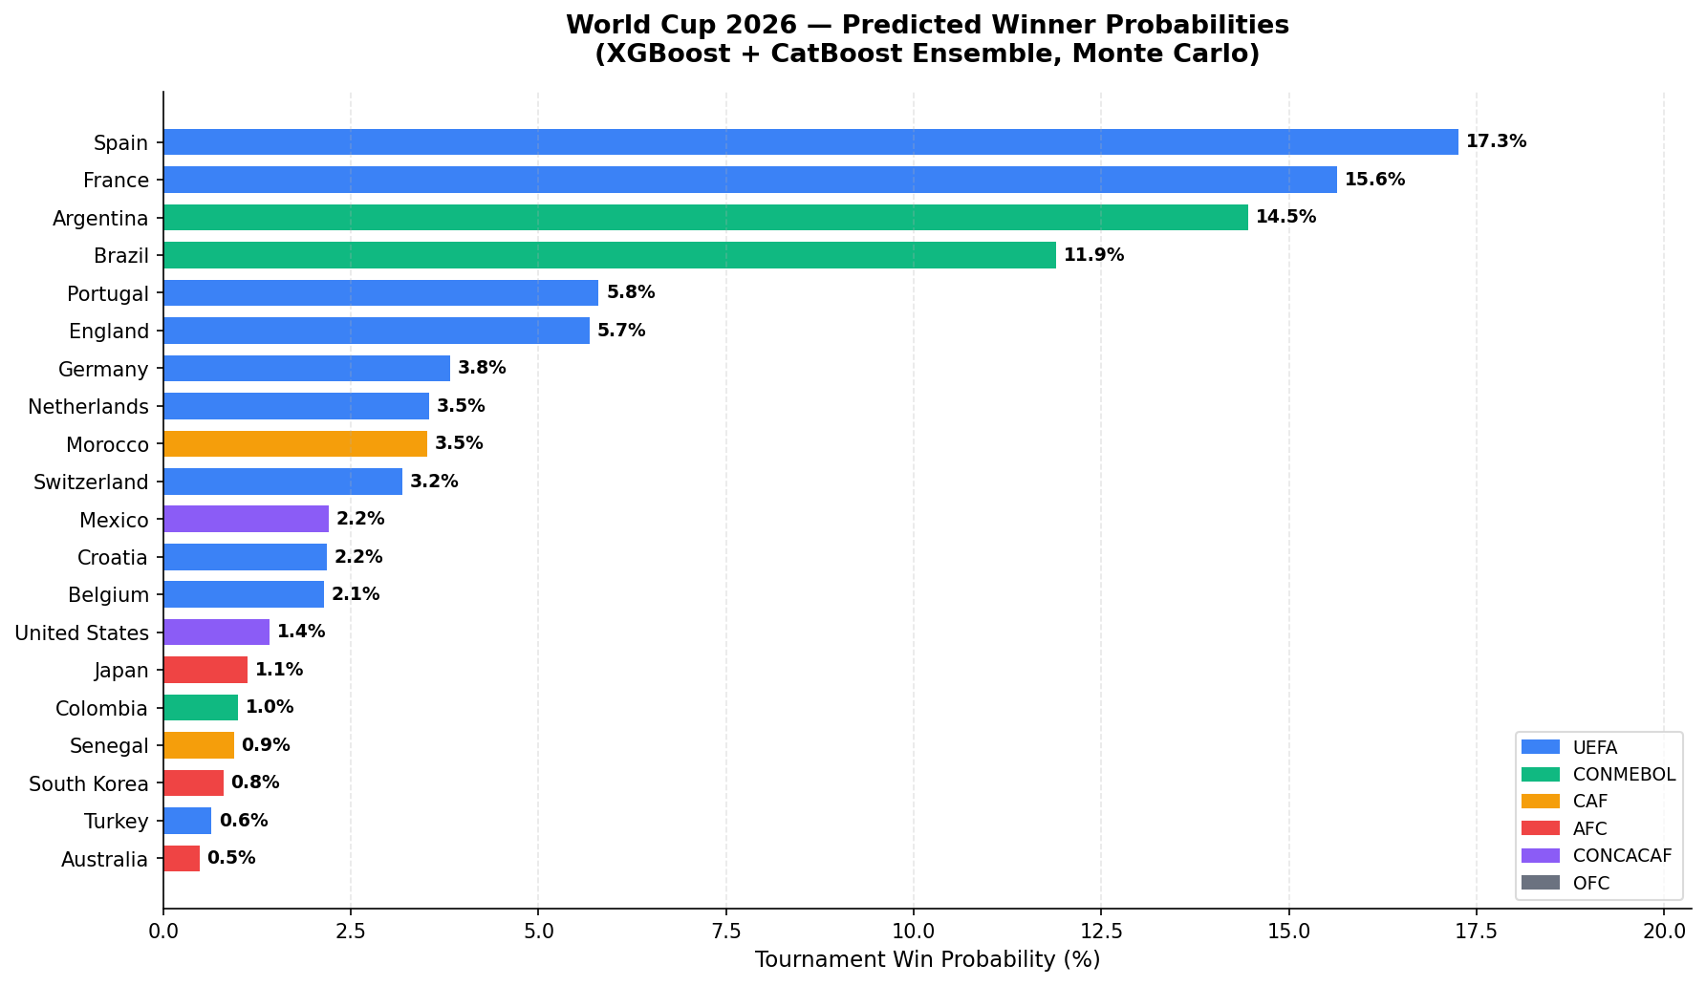

Rank | Team | Win Probability | Probability Bar | Simulated Wins
1 🥇 | Spain | 17.3% | ███░░░░░░░░░░░░░░░░░ 17% | 863
2 🥈 | France | 15.6% | ███░░░░░░░░░░░░░░░░░ 16% | 782
3 🥉 | Argentina | 14.5% | ███░░░░░░░░░░░░░░░░░ 14% | 723
4 | Brazil | 11.9% | ██░░░░░░░░░░░░░░░░░░ 12% | 595
5 | Portugal | 5.8% | █░░░░░░░░░░░░░░░░░░░ 6% | 290
6 | England | 5.7% | █░░░░░░░░░░░░░░░░░░░ 6% | 284
7 | Germany | 3.8% | █░░░░░░░░░░░░░░░░░░░ 4% | 191
8 | Netherlands | 3.5% | █░░░░░░░░░░░░░░░░░░░ 4% | 177
9 | Morocco | 3.5% | █░░░░░░░░░░░░░░░░░░░ 4% | 176
10 | Switzerland | 3.2% | █░░░░░░░░░░░░░░░░░░░ 3% | 159
11 | Mexico | 2.2% | ░░░░░░░░░░░░░░░░░░░░ 2% | 110
12 | Croatia | 2.2% | ░░░░░░░░░░░░░░░░░░░░ 2% | 109
13 | Belgium | 2.1% | ░░░░░░░░░░░░░░░░░░░░ 2% | 107
14 | United States | 1.4% | ░░░░░░░░░░░░░░░░░░░░ 1% | 71
15 | Japan | 1.1% | ░░░░░░░░░░░░░░░░░░░░ 1% | 56
16 | Colombia | 1.0% | ░░░░░░░░░░░░░░░░░░░░ 1% | 50
17 | Senegal | 0.9% | ░░░░░░░░░░░░░░░░░░░░ 1% | 47
18 | South Korea | 0.8% | ░░░░░░░░░░░░░░░░░░░░ 1% | 40
19 | Turkey | 0.6% | ░░░░░░░░░░░░░░░░░░░░ 1% | 32
20 | Australia | 0.5% | ░░░░░░░░░░░░░░░░░░░░ 0% | 24

Group Stage Match Predictions
All 72 group stage matches with predicted home win / draw / away win probabilities. The model outputs calibrated three-way probabilities.

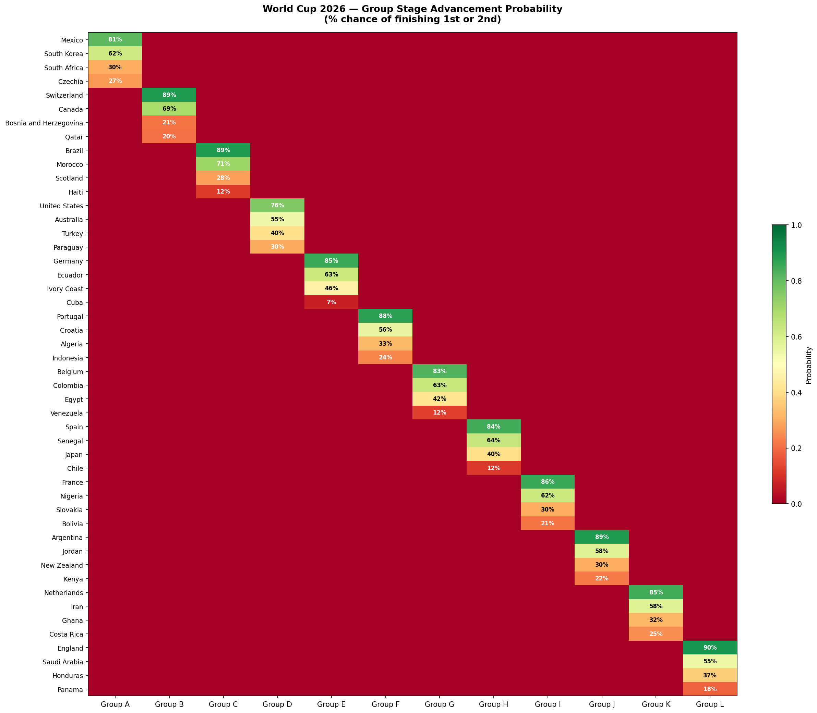

Group A
Team | P(1st) | P(2nd) | P(3rd) | P(4th) | P(Advance)
Mexico | 52.9% | 28.2% | 12.3% | 6.5% | 81.2%
South Korea | 27.4% | 34.7% | 24.0% | 13.9% | 62.1%
South Africa | 10.4% | 19.8% | 32.4% | 37.5% | 30.1%
Czechia | 9.3% | 17.3% | 31.3% | 42.1% | 26.6%

Match | Home Team | Draw | Away Team | Prediction
1 | Mexico 59% | 25% | South Africa 16% | Home Win
2 | Mexico 52% | 25% | South Korea 23% | Home Win
3 | Mexico 62% | 21% | Czechia 17% | Home Win
4 | South Africa 24% | 26% | South Korea 50% | Away Win
5 | South Africa 38% | 21% | Czechia 41% | Away Win
6 | South Korea 66% | 13% | Czechia 22% | Home Win

Group B
Team | P(1st) | P(2nd) | P(3rd) | P(4th) | P(Advance)
Switzerland | 60.4% | 28.3% | 8.4% | 2.9% | 88.7%
Canada | 28.6% | 40.8% | 20.2% | 10.4% | 69.4%
Bosnia and Herzegovina | 5.6% | 15.9% | 36.7% | 41.8% | 21.4%
Qatar | 5.4% | 15.0% | 34.7% | 44.8% | 20.4%

Match | Home Team | Draw | Away Team | Prediction
7 | Canada 60% | 21% | Bosnia and Herzegovina 20% | Home Win
8 | Canada 57% | 25% | Qatar 18% | Home Win
9 | Canada 26% | 25% | Switzerland 49% | Away Win
10 | Bosnia and Herzegovina 38% | 21% | Qatar 41% | Away Win
11 | Bosnia and Herzegovina 10% | 10% | Switzerland 79% | Away Win
12 | Qatar 11% | 9% | Switzerland 81% | Away Win

Group C
Team | P(1st) | P(2nd) | P(3rd) | P(4th) | P(Advance)
Brazil | 64.4% | 24.6% | 8.9% | 2.1% | 89.0%
Morocco | 25.7% | 45.3% | 21.1% | 7.9% | 71.0%
Scotland | 7.2% | 20.7% | 47.4% | 24.6% | 28.0%
Haiti | 2.6% | 9.3% | 22.6% | 65.4% | 12.0%

Match | Home Team | Draw | Away Team | Prediction
13 | Brazil 60% | 20% | Morocco 20% | Home Win
14 | Brazil 74% | 15% | Haiti 11% | Home Win
15 | Brazil 70% | 20% | Scotland 10% | Home Win
16 | Morocco 62% | 27% | Haiti 11% | Home Win
17 | Morocco 62% | 27% | Scotland 11% | Home Win
18 | Haiti 20% | 8% | Scotland 72% | Away Win

Group D
Team | P(1st) | P(2nd) | P(3rd) | P(4th) | P(Advance)
United States | 48.8% | 26.7% | 14.9% | 9.6% | 75.5%
Australia | 23.4% | 31.1% | 25.5% | 20.0% | 54.5%
Turkey | 16.8% | 23.5% | 31.9% | 27.9% | 40.3%
Paraguay | 11.1% | 18.6% | 27.8% | 42.5% | 29.7%

Match | Home Team | Draw | Away Team | Prediction
19 | United States 58% | 20% | Paraguay 22% | Home Win
20 | United States 52% | 25% | Australia 23% | Home Win
21 | United States 52% | 25% | Turkey 23% | Home Win
22 | Paraguay 26% | 25% | Australia 49% | Away Win
23 | Paraguay 26% | 25% | Turkey 49% | Away Win
24 | Australia 49% | 27% | Turkey 24% | Home Win

Group E
Team | P(1st) | P(2nd) | P(3rd) | P(4th) | P(Advance)
Germany | 57.8% | 27.4% | 11.5% | 3.4% | 85.2%
Ecuador | 24.4% | 38.3% | 28.0% | 9.3% | 62.7%
Ivory Coast | 15.7% | 29.7% | 42.8% | 11.7% | 45.5%
Cuba | 2.1% | 4.5% | 17.7% | 75.5% | 6.7%

Match | Home Team | Draw | Away Team | Prediction
25 | Germany 74% | 15% | Cuba 11% | Home Win
26 | Germany 57% | 25% | Ivory Coast 19% | Home Win
27 | Germany 57% | 25% | Ecuador 19% | Home Win
28 | Cuba 11% | 9% | Ivory Coast 81% | Away Win
29 | Cuba 11% | 9% | Ecuador 81% | Away Win
30 | Ivory Coast 26% | 25% | Ecuador 49% | Away Win

Group F
Team | P(1st) | P(2nd) | P(3rd) | P(4th) | P(Advance)
Portugal | 65.8% | 21.6% | 9.7% | 2.9% | 87.5%
Croatia | 20.2% | 35.7% | 27.1% | 17.1% | 55.8%
Algeria | 8.1% | 24.6% | 35.3% | 32.0% | 32.7%
Indonesia | 5.9% | 18.0% | 28.0% | 48.0% | 24.0%

Match | Home Team | Draw | Away Team | Prediction
31 | Portugal 70% | 20% | Indonesia 10% | Home Win
32 | Portugal 70% | 20% | Algeria 10% | Home Win
33 | Portugal 60% | 20% | Croatia 20% | Home Win
34 | Indonesia 26% | 25% | Algeria 49% | Away Win
35 | Indonesia 25% | 22% | Croatia 53% | Away Win
36 | Algeria 24% | 26% | Croatia 50% | Away Win

Group G
Team | P(1st) | P(2nd) | P(3rd) | P(4th) | P(Advance)
Belgium | 55.5% | 27.0% | 13.0% | 4.4% | 82.6%
Colombia | 26.6% | 36.4% | 26.2% | 10.8% | 62.9%
Egypt | 14.6% | 27.4% | 36.8% | 21.2% | 42.0%
Venezuela | 3.3% | 9.2% | 24.0% | 63.5% | 12.5%

Match | Home Team | Draw | Away Team | Prediction
37 | Belgium 64% | 16% | Egypt 21% | Home Win
38 | Belgium 70% | 20% | Venezuela 10% | Home Win
39 | Belgium 55% | 24% | Colombia 22% | Home Win
40 | Egypt 57% | 25% | Venezuela 19% | Home Win
41 | Egypt 26% | 25% | Colombia 49% | Away Win
42 | Venezuela 10% | 23% | Colombia 67% | Away Win

Group H
Team | P(1st) | P(2nd) | P(3rd) | P(4th) | P(Advance)
Spain | 59.7% | 24.6% | 11.9% | 3.7% | 84.4%
Senegal | 23.5% | 40.3% | 24.6% | 11.7% | 63.7%
Japan | 14.1% | 26.1% | 40.0% | 19.9% | 40.2%
Chile | 2.8% | 9.0% | 23.4% | 64.8% | 11.7%

Match | Home Team | Draw | Away Team | Prediction
43 | Spain 59% | 25% | Senegal 16% | Home Win
44 | Spain 67% | 24% | Chile 10% | Home Win
45 | Spain 59% | 25% | Japan 16% | Home Win
46 | Senegal 66% | 18% | Chile 15% | Home Win
47 | Senegal 52% | 25% | Japan 23% | Home Win
48 | Chile 19% | 12% | Japan 69% | Away Win

Group I
Team | P(1st) | P(2nd) | P(3rd) | P(4th) | P(Advance)
France | 60.4% | 25.5% | 10.5% | 3.6% | 85.9%
Nigeria | 24.1% | 38.4% | 24.6% | 12.9% | 62.5%
Slovakia | 9.4% | 21.0% | 36.4% | 33.2% | 30.4%
Bolivia | 6.1% | 15.1% | 28.4% | 50.3% | 21.2%

Match | Home Team | Draw | Away Team | Prediction
49 | France 59% | 25% | Nigeria 16% | Home Win
50 | France 62% | 27% | Bolivia 11% | Home Win
51 | France 62% | 27% | Slovakia 11% | Home Win
52 | Nigeria 57% | 25% | Bolivia 18% | Home Win
53 | Nigeria 58% | 20% | Slovakia 22% | Home Win
54 | Bolivia 26% | 25% | Slovakia 49% | Away Win

Group J
Team | P(1st) | P(2nd) | P(3rd) | P(4th) | P(Advance)
Argentina | 66.3% | 23.1% | 7.8% | 2.9% | 89.3%
Jordan | 19.7% | 38.5% | 25.4% | 16.5% | 58.1%
New Zealand | 8.6% | 21.7% | 38.1% | 31.6% | 30.3%
Kenya | 5.4% | 16.8% | 28.7% | 49.1% | 22.2%

Match | Home Team | Draw | Away Team | Prediction
55 | Argentina 59% | 25% | Jordan 16% | Home Win
56 | Argentina 70% | 20% | Kenya 10% | Home Win
57 | Argentina 70% | 20% | New Zealand 10% | Home Win
58 | Jordan 53% | 25% | Kenya 22% | Home Win
59 | Jordan 52% | 25% | New Zealand 23% | Home Win
60 | Kenya 24% | 26% | New Zealand 50% | Away Win

Group K
Team | P(1st) | P(2nd) | P(3rd) | P(4th) | P(Advance)
Netherlands | 62.5% | 22.3% | 11.7% | 3.6% | 84.7%
Iran | 21.7% | 36.5% | 25.3% | 16.5% | 58.3%
Ghana | 9.6% | 22.2% | 34.5% | 33.8% | 31.8%
Costa Rica | 6.2% | 19.1% | 28.6% | 46.2% | 25.3%

Match | Home Team | Draw | Away Team | Prediction
61 | Netherlands 62% | 27% | Costa Rica 11% | Home Win
62 | Netherlands 61% | 20% | Iran 19% | Home Win
63 | Netherlands 70% | 14% | Ghana 16% | Home Win
64 | Costa Rica 24% | 26% | Iran 50% | Away Win
65 | Costa Rica 27% | 21% | Ghana 52% | Away Win
66 | Iran 58% | 19% | Ghana 23% | Home Win

Group L
Team | P(1st) | P(2nd) | P(3rd) | P(4th) | P(Advance)
England | 69.7% | 20.6% | 7.2% | 2.5% | 90.3%
Saudi Arabia | 16.4% | 38.6% | 29.3% | 15.8% | 54.9%
Honduras | 9.5% | 27.2% | 36.8% | 26.6% | 36.6%
Panama | 4.5% | 13.7% | 26.7% | 55.1% | 18.1%

Match | Home Team | Draw | Away Team | Prediction
67 | England 67% | 24% | Honduras 10% | Home Win
68 | England 62% | 27% | Saudi Arabia 11% | Home Win
69 | England 74% | 15% | Panama 11% | Home Win
70 | Honduras 26% | 25% | Saudi Arabia 49% | Away Win
71 | Honduras 55% | 21% | Panama 24% | Home Win
72 | Saudi Arabia 64% | 16% | Panama 21% | Home Win

Feature Importance Analysis
The XGBoost model's feature importances reveal which variables have the greatest impact on match outcome prediction.

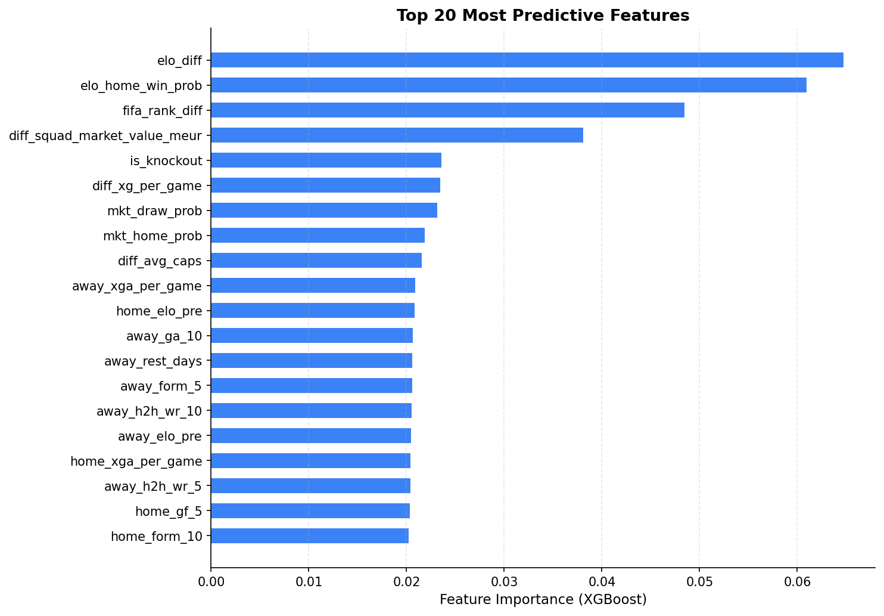

Top predictors: Elo rating differential and Elo-implied win probability are the single strongest features, confirming that team strength ratings are the most reliable signal. FIFA ranking differential, squad market value, and xG statistics provide additional signal, while contextual features (altitude, travel distance) contribute meaningful but smaller effects.

Methodology

Data Sources
• Historical international match results (1872–2025) — 12,000 training matches
• World Football Elo ratings — per-match strength ratings for all 48 teams
• FIFA/Coca-Cola World Rankings — monthly snapshots since 2000
• Squad statistics — xG, possession %, market value, average caps
• Betting odds — historical 1X2 odds from Bet365 and Pinnacle (implied probabilities)
• Contextual features — venue altitude, travel distance, rest days between matches

Feature Engineering
Rolling form windows (last 5 and 10 matches), head-to-head win rates, Elo differential, FIFA rank differential, squad strength proxies, and tournament importance weights. Booking market implied probabilities used as calibrated priors.

Model
XGBoost and CatBoost classifiers trained independently, averaged at the probability level. Multi-class softmax output (Home Win / Draw / Away Win). Post-hoc calibration via isotonic regression on held-out calibration set. Evaluation metric: Ranked Probability Score (RPS).

Simulation
Monte Carlo simulation: 5,000 full tournament runs. Each run simulates every group match using sampled outcomes from the model's probability distributions, then plays the knockout bracket using the same match probability model. The Round of 32 field includes all 12 group winners, 12 runners-up, and the 8 best third-placed teams ranked by points, goal difference, and goals scored.

