FLUTTER INTEGRATED PROJECT · 2026

Software Architecture
SaveAMeal

Contents
- About This Document
- Conceptual Architecture (Diagram)
- Conceptual Architecture — Narrative
- Implementation Architecture (Diagram)
- Implementation Architecture — Narrative
- Firestore Data Model (Diagram)
- Data Model — Narrative
- End-to-End Data Flow
- Security & Quality Considerations

1. About This Document
This document describes the software architecture of SaveAMeal at two levels:
• Conceptual architecture — the business model expressed as a software system. Shows the three user roles, the platform between them, and the flows of information and physical food.
• Implementation architecture — the actual technology layers we will build with: Flutter client structure, Firebase backend services, and external APIs.
• Firestore data model — the document shapes that connect everything.
The architecture deliberately keeps complexity low. The team has five members and ten build days; every decision in this document trades sophistication for build speed. Where the long-term SaveAMeal vision would call for a more elaborate solution (smart routing, microservices, etc.), this document calls out the simpler choice and notes the future direction.

2. Conceptual Architecture
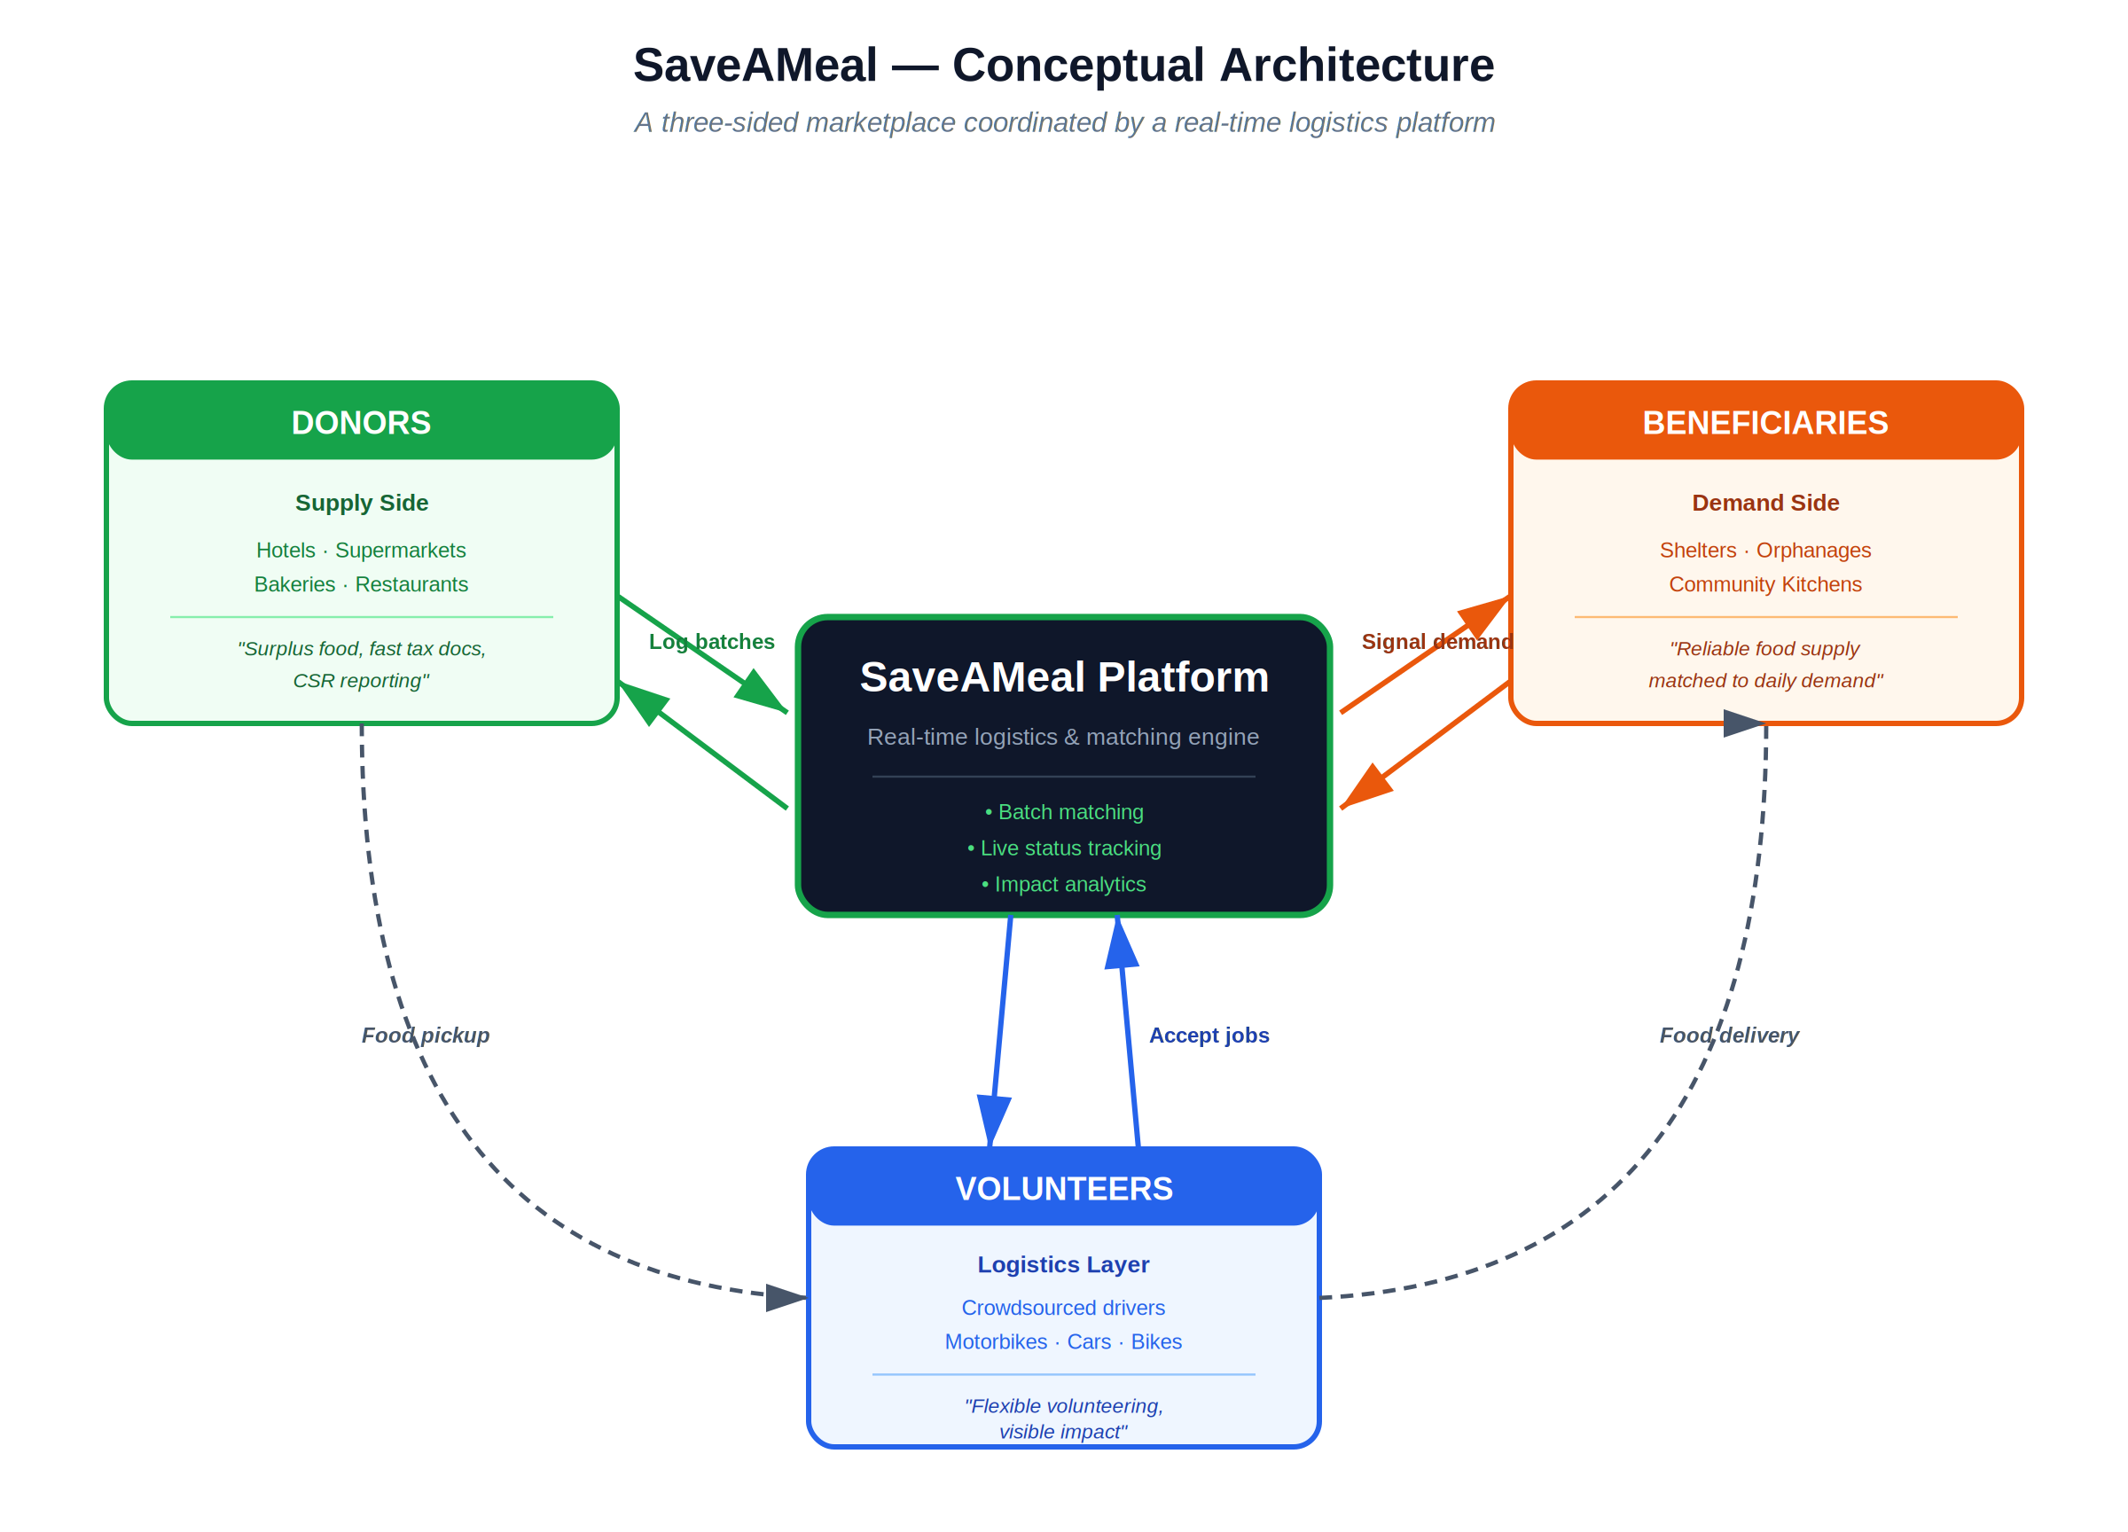
The three-sided marketplace: Donors supply surplus food, Beneficiaries signal demand, and Volunteers connect them through the platform. Solid arrows are information flows; dashed arrows are the physical food path.

3. Conceptual Architecture — Narrative
SaveAMeal is a three-sided marketplace. Each side has different motivations, but all three sides converge on the same transaction: rescuing surplus food before it goes to waste.

The Three Sides
Side | Who | What they bring · What they get
Donors (Supply) | Hotels, supermarkets, bakeries, restaurants | Bring: surplus food. Get: easy disposal, CSR/ESG reporting, tax-incentive documentation.
Beneficiaries (Demand) | Shelters, orphanages, community kitchens | Bring: distribution capacity and verified need. Get: reliable food supply matched to daily demand.
Volunteers (Logistics) | Crowdsourced drivers — motorbikes, cars, bicycles | Bring: their time and transportation. Get: meaningful, flexible volunteering; gamified recognition.

Why a Marketplace Model
NGOs like SOS Thailand solve this same problem but scale linearly with staff — they hire drivers, sort food in a warehouse, deliver themselves. SaveAMeal replaces that linear model with a coordination layer:
• The platform does not transport food itself. Volunteers do that.
• The platform does not store food. Donors hold it until pickup; beneficiaries consume on receipt.
• The platform's job is matching — connect a surplus batch to the right beneficiary via the closest available volunteer — and tracking — keep all three sides informed in real time.

Two Flows, Not One
The diagram intentionally shows two distinct flows:
- Information flow (solid arrows) — runs through the platform. Donors log batches into SaveAMeal; SaveAMeal broadcasts to volunteers; volunteers signal acceptance; SaveAMeal alerts beneficiaries.
- Physical food flow (dashed arrows) — runs around the platform. Food moves directly from donor → volunteer → beneficiary; the platform never touches it.
This separation is what lets SaveAMeal scale faster than an NGO: the platform handles only data, which is cheap; the people handle the physical work, which is distributed.

4. Implementation Architecture
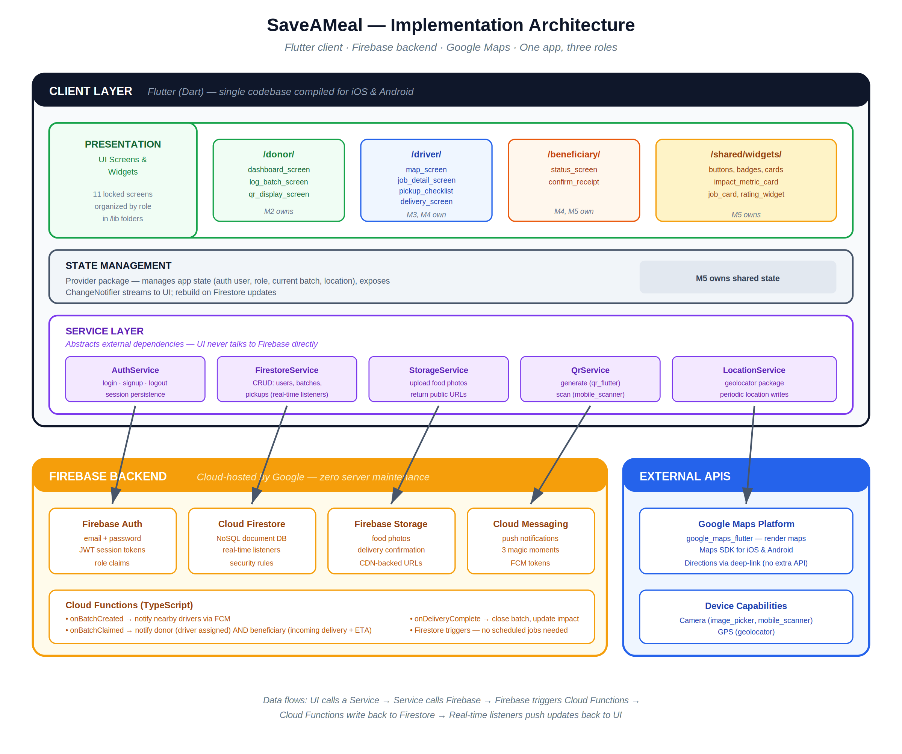
The Flutter client is split into four layers (Presentation, State Management, Service, and dependency layer). The Firebase backend provides Auth, Firestore, Storage, Cloud Messaging, and Cloud Functions. External APIs are limited to Google Maps and device capabilities.

5. Implementation Architecture — Narrative
The implementation is a client-heavy, server-light architecture: most of SaveAMeal's logic lives in the Flutter app and Firebase's managed services; we write very little custom backend code (only Cloud Functions for the three notification triggers).

Client Layer (Flutter)

Presentation
The Flutter UI is organized into role-based folders (/donor, /driver, /beneficiary) plus /shared/widgets. This structure maps directly to team ownership — Member 2 owns the /donor folder, Member 3 and 4 share /driver, Member 4 and 5 share /beneficiary, and Member 5 owns /shared/widgets. Each team member can work in isolation, reducing Git merge conflicts.

State Management
We use the Provider package for state management. State is exposed through ChangeNotifier classes that the UI listens to. When Firestore documents update via real-time listeners, the relevant state class notifies its UI subscribers, and the screens rebuild automatically.
We considered Riverpod (more powerful) and BLoC (more structured) but chose Provider because it has the simplest learning curve and is officially recommended by the Flutter team — important when we have 10 days and not everyone is fluent in advanced state management.

Service Layer
The Service Layer is the boundary between the app and external systems. Every external dependency has a single corresponding service class:
Service | Responsibility
AuthService | Wraps Firebase Auth — login, signup, logout, session persistence, current user.
FirestoreService | All reads and writes to Firestore — users, batches, pickups. Exposes real-time listeners (Streams).
StorageService | Uploads photos to Firebase Storage and returns public URLs.
QrService | Generates QR codes from batch IDs and scans QR codes via the device camera.
LocationService | Wraps the geolocator package. Periodically writes the driver's location to Firestore while a job is active.
Why this matters: UI code never directly calls Firebase. If we ever migrate to a different backend (e.g. Supabase post-graduation), only the Service Layer changes.

Firebase Backend
We chose Firebase over Supabase because the team has zero SQL experience and 10 days is not enough time to learn a new backend ecosystem. Firebase gives us five managed services we'd otherwise have to build ourselves:
- Firebase Auth — email/password authentication with JWT tokens; role information stored as a custom claim or in the user document.
- Cloud Firestore — NoSQL document database with real-time listeners (snapshots()). This is the killer feature: when a driver updates their location, every beneficiary's map updates automatically — no polling.
- Firebase Storage — CDN-backed photo storage. Returns public URLs we save in Firestore documents.
- Cloud Messaging (FCM) — push notifications. Three notification events drive SaveAMeal's "magic moments" (driver assigned, incoming delivery, etc.).
- Cloud Functions — serverless functions written in TypeScript. We use them as Firestore triggers: when a document changes, run a function. No HTTP endpoints needed.

The Four Cloud Functions
Function | Trigger | What it does
onBatchCreated | batches new doc | Send FCM to nearby drivers about the new pickup opportunity.
onBatchClaimed | status → "claimed" | Send FCM to donor ("driver assigned"). Also notify the matched beneficiary of incoming delivery + ETA.
onDeliveryComplete | status → "delivered" | Atomically update impactMetrics aggregates (kg, meals, CO₂e).
cleanupLocations | Scheduled (daily) | Remove driverLocations docs older than 24h.

External Dependencies
We minimize external APIs to two:
- Google Maps Platform — embedded maps for the driver and beneficiary screens. We use google_maps_flutter to render maps and delegate directions to the Google Maps app via deep-link (no Directions API call, no extra cost).
- Device capabilities — camera (for photos and QR scanning) and GPS (for driver location). Both wrapped by Flutter packages.

6. Firestore Data Model
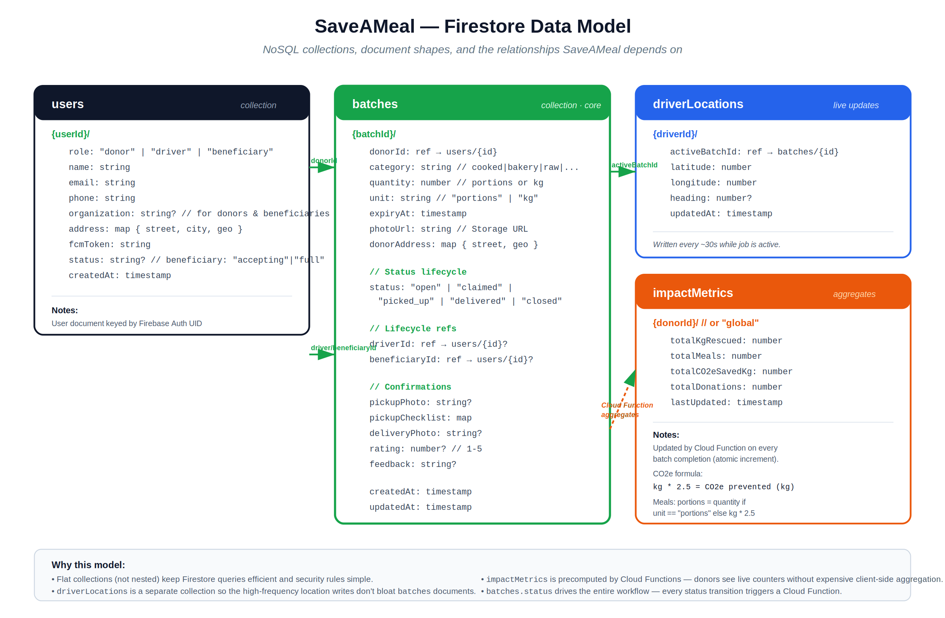
Four flat collections: users, batches (the core entity), driverLocations (high-frequency writes), and impactMetrics (pre-aggregated counters). Foreign-key style references (green arrows) connect them; the orange dashed arrow shows the Cloud Function aggregation.

7. Data Model — Narrative
Firestore is schemaless, but discipline early saves rework later. SaveAMeal uses four flat collections — no nested subcollections — chosen for query simplicity and security rule clarity.

users
One document per registered user, keyed by Firebase Auth UID. The role field is the most important — it drives the Role Router on login and determines which UI the user sees. Beneficiaries also store a status field ("accepting" or "full") for the toggle on Screen 10.

batches
The core entity — one document per donated batch of food. Every batch progresses through a status lifecycle:
open → claimed → picked_up → delivered → closed
Each transition triggers a Cloud Function (see section 5). The status field is the single source of truth for where a batch is in its lifecycle.
Reference fields (donorId, driverId, beneficiaryId) link a batch to the three users involved. These are stored as document references for easy joining client-side.

driverLocations
Live driver positions, written every ~30 seconds while a job is active. Kept separate from batches because:
- High write frequency would bloat batch documents and waste real-time listener bandwidth.
- Once a job is complete, the location data is no longer needed (cleaned up daily by Cloud Function).
- Privacy: location is only readable when a beneficiary has a matching active batches document.

impactMetrics
Pre-aggregated counters so the donor dashboard can render instantly without scanning all batch documents. Each donor has their own metrics document; a separate global document tracks platform-wide totals.
Updated atomically by the onDeliveryComplete Cloud Function using Firestore's FieldValue.increment() — concurrent updates are safe.
Impact formulas (for the report):
meals = portions (if unit is portions) or kg × 2.5 (if unit is kg)
CO2e prevented (kg) = kg of food rescued × 2.5 (industry-standard factor for mixed-food waste)

8. End-to-End Data Flow
Walking through a single complete transaction shows how all the pieces fit together:
1. Donor logs surplus — Khun Siriporn fills Screen 4 (Log Batch). The Donor Workflow code calls FirestoreService.createBatch(), which writes a new batches doc with status: "open". The photo goes to Firebase Storage via StorageService; the returned URL is saved in the batch doc.
2. QR generated & displayed — Screen 5 renders a QR code from the new batch ID using QrService.generate(batchId). The donor screenshots it for the food trays.
3. Cloud Function fires — onBatchCreated triggers automatically when the new doc is written. It queries nearby drivers and sends FCM push notifications.
4. Driver discovers job — Nattapong's Screen 6 has a real-time listener on batches.where('status', '==', 'open'). The new batch appears as a pin on his map immediately, no refresh needed.
5. Driver accepts — Tapping "Accept" on Screen 7 runs an atomic Firestore transaction: read the batch, verify status is still "open" (race-condition guard), update status: "claimed", driverId, and beneficiaryId (matched by Cloud Function later or pre-assigned). If two drivers tap "Accept" simultaneously, the transaction ensures only one wins.
6. Two notifications fire — onBatchClaimed Cloud Function sends an FCM to Khun Siriporn ("Driver assigned, ETA 22 min") and another to Sister Maria ("Incoming delivery, 38 portions, ETA 22 min"). These are the two "magic moments" of the system.
7. Live tracking begins — Nattapong's app starts writing to driverLocations/{driverId} every 30 seconds via LocationService. Sister Maria's Screen 10 has a real-time listener on that document; the pin on her map moves automatically.
8. Pickup confirmed — Nattapong scans the QR at the hotel (Screen 8), completes the 3-item checklist, uploads a confirmation photo. The Driver Workflow code updates status: "picked_up".
9. Delivery confirmed — Nattapong scans the beneficiary's QR (Screen 9), uploads a delivery photo. Status moves to "delivered".
10. Beneficiary closes the loop — Sister Maria's Screen 11 lets her rate 1–5 stars and optionally comment. This writes rating and feedback fields and moves status to "closed".
11. Impact aggregates update — onDeliveryComplete Cloud Function fires (triggered on status change to "delivered" or "closed"), calculates kg → meals → CO₂e, and atomically increments impactMetrics/{donorId} and impactMetrics/global.
12. Donor dashboard reflects the impact — Khun Siriporn's Screen 3 has a real-time listener on her impactMetrics doc. The numbers update on her screen within seconds of delivery completion.
This entire flow involves only one custom HTTP endpoint: zero. Everything is driven by Firestore document writes triggering Cloud Functions, which in turn write more documents. The architecture is "event-driven by data change" — much simpler than building a REST API.

9. Security & Quality Considerations

Authentication & Authorization
- Firebase Auth handles credential storage, password hashing, and session management — we never see passwords.
- Firestore Security Rules enforce role-based access. Examples:
  - Donors can read/write only batches where donorId == request.auth.uid.
  - Drivers can read all batches.status == "open" docs, but can only update a batch to "claimed" if it has no driverId yet (prevents stealing other drivers' jobs).
  - Beneficiaries can read batches where beneficiaryId == request.auth.uid and update only the rating fields.

Race Conditions
The "two drivers accept the same job" problem is handled by a Firestore transaction on the Accept Job button. The transaction reads the current batch state, checks status is still "open", and only then writes the claim. If another driver beat them to it, the transaction fails and the UI shows "Already taken."

Data Quality
- Required fields validated client-side AND in Firestore security rules — never trust the client alone.
- Photo uploads capped at reasonable file sizes; Firebase Storage rules reject oversized files.
- QR fallback — if scanning fails, drivers can manually enter the batch ID. Reduces failure modes.

Performance
- Firestore real-time listeners are scoped tightly — drivers see only status == "open"; beneficiaries see only their own incoming batch. Bandwidth stays low.
- impactMetrics is precomputed by Cloud Functions; the donor dashboard reads one document instead of scanning thousands.
- Photos are CDN-cached by Firebase Storage — fast even on slow networks.

Privacy
- Driver location is written only while a job is active and is readable only by the matched beneficiary.
- Location history is auto-deleted by the cleanupLocations Cloud Function after 24 hours.
- Beneficiary addresses are visible only to the assigned driver, not to other drivers browsing the map.

Things Deliberately Out of Scope
The locked scope explicitly omits the following — flagged here so they don't show up unexpectedly in the build:
• Smart route pooling (multi-stop optimization)
• Offline mode & data sync conflict resolution
• Admin/NGO web backoffice — manage demo data via Firebase Console live
• Multilingual UI — English only for the locked scope
• Tax-deduction document PDF generation
• Beneficiary distribution logging (how many people served)
• Driver verification / background checks
Architecture design principle: every choice in this document optimizes for the 10-day build window. Sophistication can be added after graduation; first we ship.

