SQL: PHÂN KHÚC SẢN PHẨM & HÀNH VI KHÁCH HÀNG E-COMMERCE
Table Name: my_buyer_profile
Description: Table records all buyer details
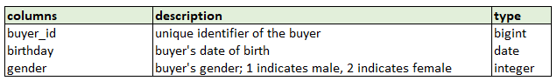
Table Name: my_order_trans
Description: Table records all orders/transactions at product variation level from the beginning of time
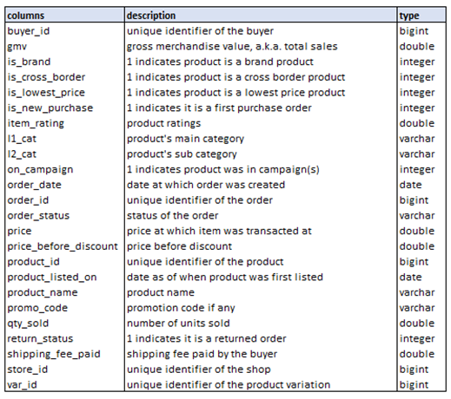
Q1. Find the lifetime total orders, total spent (gmv), unique items bought, earliest purchase date, last purchased date, average amount spent per order and average purchase price for the following buyer IDs and their purchased products’ main categories:
● 576123
● 123152

SELECT buyer_id,
i1_cat AS Main_Category,
COUNT(DISTINCT order_id) AS Total_Orders,
SUM(gmv) AS Total_Spent,
COUNT(DISTINCT product_id) AS Unique_Items_Bought,
MIN(order_date) AS Earliest_Purchase_Date,
MAX(order_date) AS Last_Purchase_Date,
SUM(gmv) / COUNT(DISTINCT order_id) AS Avg_Spending_per_Order,
AVG(price) AS Avg_Purchase_Price
FROM my_order_trans
WHERE buyer_id IN ('576123', '123152')
AND return_status <> 1
GROUP BY buyer_id, i1_cat;
Q2. Find out the top 10 cross border items with the highest quantity sold last month, together with their tier **, minimum selling price, total spent (gmv) and total orders.
** Tier is a user-defined item attribute dimension with 3 unique values:
● Short Tail (> 20 average daily orders)
● Mid Tail (between 10 - 20 average daily orders)
● Long Tail (< 10 average daily orders)

WITH cross_border_items AS (
SELECT product_id,
product_name,
SUM(qty_sold) AS Total_Qty,
MIN(price) AS Min_Selling_Price,
SUM(gmv) AS Total_GMV,
COUNT(DISTINCT order_id) AS Total_Orders,
CAST(COUNT(DISTINCT order_id) AS FLOAT)
/COUNT(DISTINCT order_date) AS Avg_Daily_Orders
FROM my_order_trans
WHERE FORMAT(order_date, 'yyyy-MM')
= FORMAT(DATEADD(month, -1, GETDATE()), 'yyyy-MM')
AND is_cross_border = 1
AND return_status <> 1
GROUP BY product_id, product_name
)
SELECT TOP 10
*,
CASE
WHEN Avg_Daily_Orders > 20 THEN 'Short Tail'
WHEN Avg_Daily_Orders < 10 THEN 'Long Tail'
ELSE 'Mid Tail'
END AS Tier
FROM cross_border_items
ORDER BY Total_Qty DESC;
Q3. The following buyers purchased on Shopee on separate days and several occasions:
● 123456
● 987654
● 34567
Find the average time (in hours) between their first and second checkout in the last 120 days.

WITH rank_order_date AS (
SELECT buyer_id,
order_date,
ROW_NUMBER() OVER (
PARTITION BY buyer_id
ORDER BY order_date) AS rank_date
FROM my_order_trans
WHERE buyer_id IN ('123456', '987654', '34567')
AND order_date >= DATEADD(day, -120, GETDATE())
),

hrs_interval AS (
SELECT buyer_id,
MIN(order_date) AS [1st_checkout],
MAX(order_date) AS [2nd_checkout],
DATEDIFF(hour, MIN(order_date), MAX(order_date)) AS in_hours
FROM rank_order_date
WHERE rank_date IN (1, 2)
GROUP BY buyer_id
)

SELECT AVG(in_hours) AS [Average time between 1st and 2nd purchase (hour)]
FROM hrs_interval;
Q4: Write an SQL query to find the main product categories (i1_cat) with a total GMV greater than 1000, along with the number of male and female buyers (based on gender from my_buyer_profile). Sort the results by total GMV in descending order.

WITH gmv_gender AS (
SELECT o.i1_cat,
o.gmv,
b.gender
FROM my_order_trans as o
JOIN my_buyer_profile as b
ON o.buyer_id = b.buyer_id
WHERE return_status <> 1
)

SELECT i1_cat AS main_category,
SUM(gmv) AS total_gmv,
(SELECT COUNT(gender) AS male_buyer
FROM gmv_gender
WHERE gender = 1),
(SELECT COUNT(gender) AS female_buyer
FROM gmv_gender
WHERE gender = 2)
FROM gmv_gender
GROUP BY i1_cat
HAVING total_gmv > 1000
ORDER BY total_gmv DESC;

