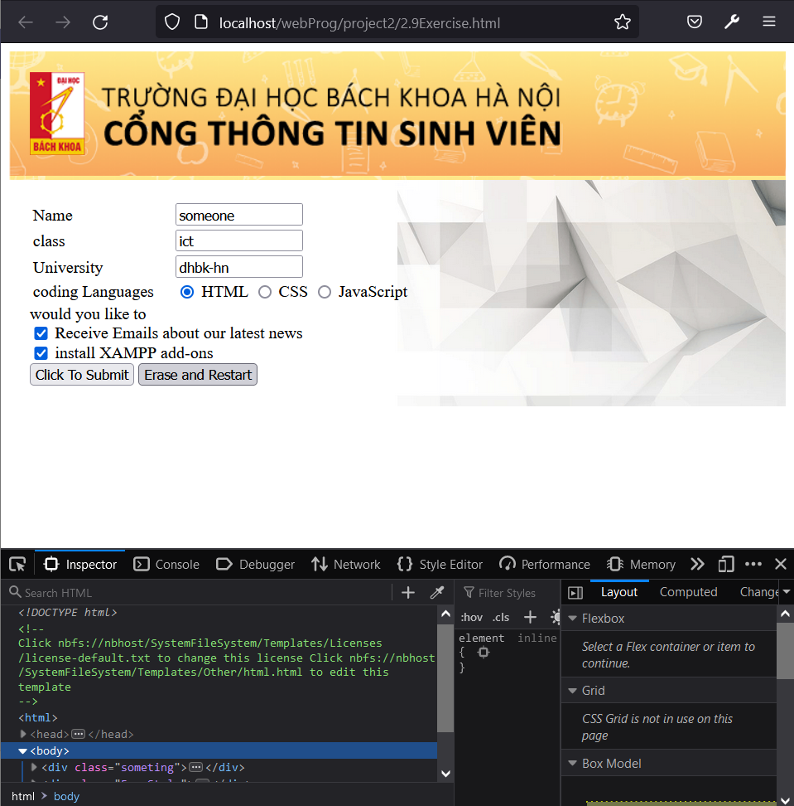  
- this is the form with a little background taken from the ctt web of hust.

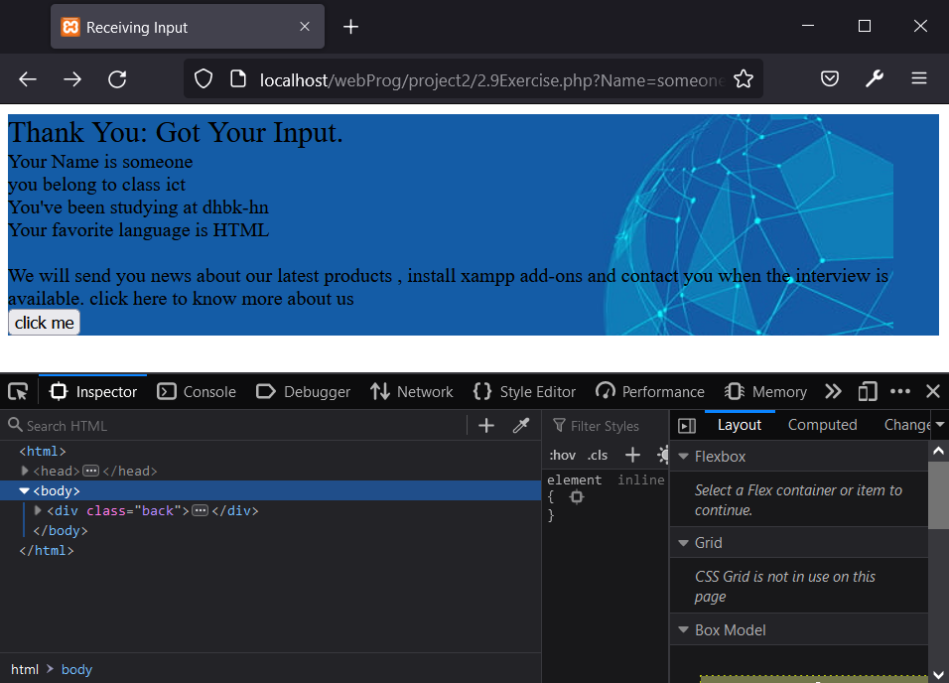

the php file in which the form would be processed, the “click me” button is just a bonus.  
just in case someone touchs the button, they’ll redirected to:  
