Teacher: NGUYEN DANG KHOA

ASSIGNMENT 1

sTUDENT nAME: vuong KHANG MINH (104179690)

# Description

* The music player circuit contains 4 main parts
  + The ON/OFF mode
  + The PLAY/PAUSE mode
  + The volume control
  + The track skipping

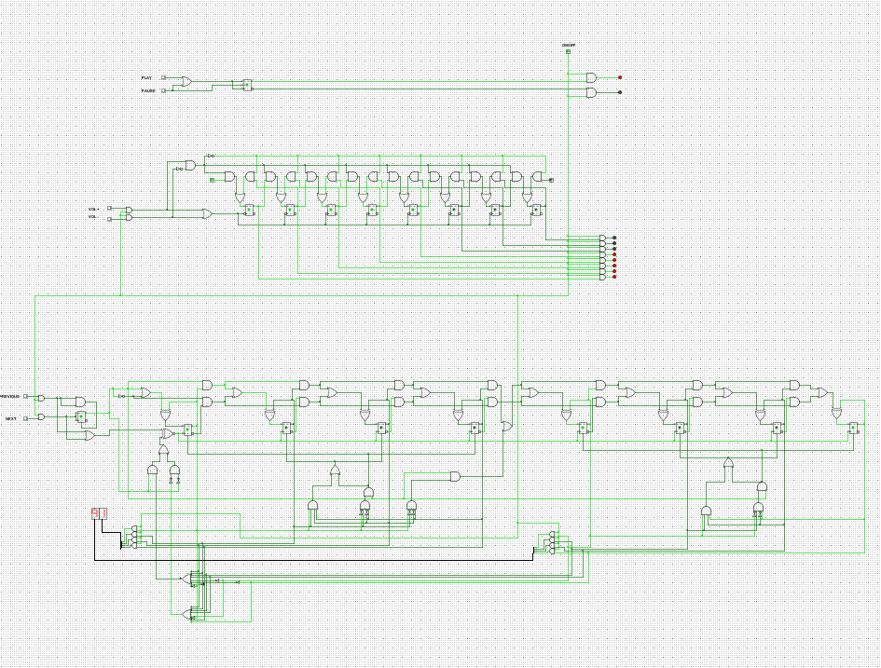

# Outline of the circuit

1. The ON/OFF and PLAY/PAUSE mode

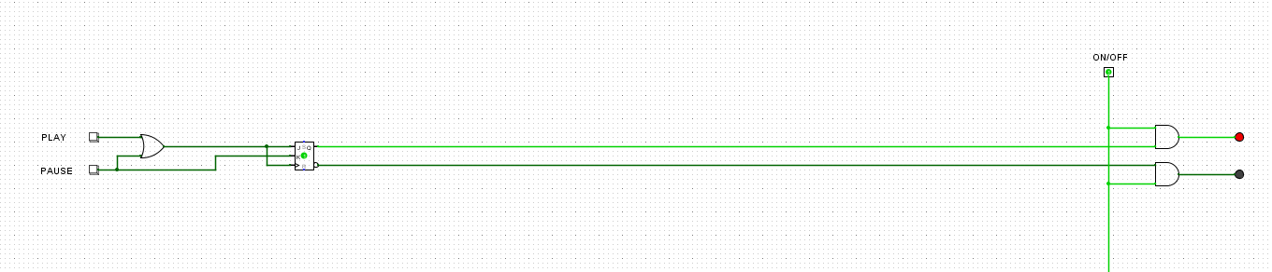

* + In the first part, JK Flip Flop and an OR gate are used to make the PLAY/PAUSE mode. When the play button is pressed, the PLAY LED will be turned on, which is also true for the PAUSE button. However, if the PAUSE button is pressed the second times, it will return to the PLAY state
  + There is one ON/OFF button at the top of the circuit, which confirms that all the LEDs on display should be turned off and stop changing the circuit when it is in an OFF state.

2. The volume control

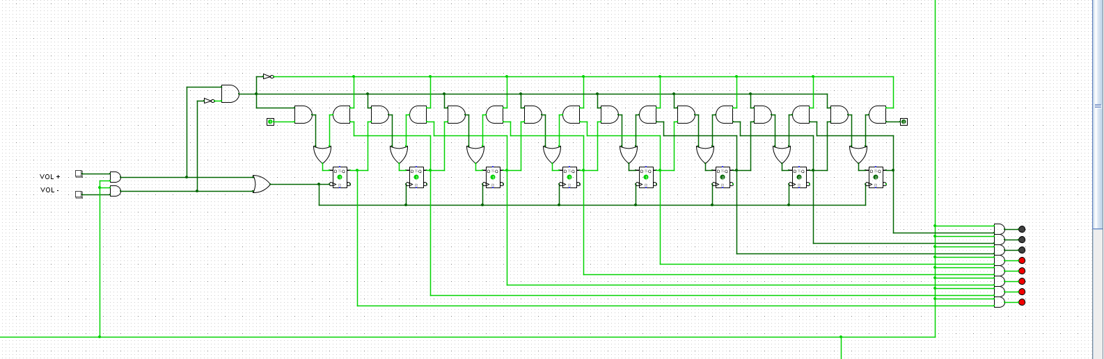

* + In the volume control part, D Flip Flop (Falling Edge), AND gates, OR gates, and NOT gates are the essential components. For this to work, the first pin on the circuit’s left must be in a high state (1).
  + Whenever VOL + but the VOL + button is pressed, it will send a pulse to clocks in 8 D Flip Flops and the D inputs, enabling the output of the Flip Flops to be high. In contrast, if the VOL – button is pressed, the output of the Flip Flops will be low sequencely.

3. The track skipping

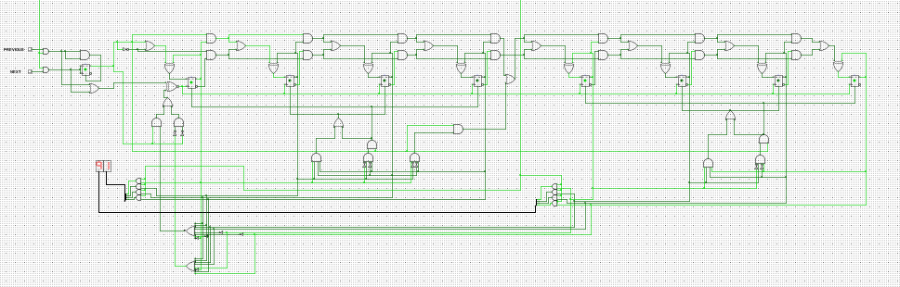

* + In this part, every 4 Flip Flops represent a HEX digit. The 4 Flip Flops are used for counting all the numbers from 0 to f.
* Block of gates (count from 0 to 9)

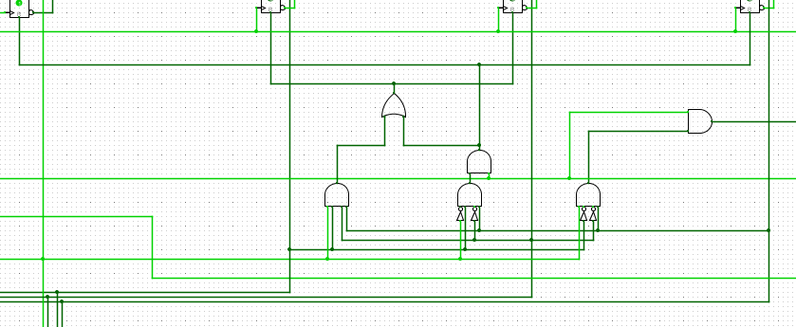

- Using this block of gates allows the circuit to reset to 0 whenever it increases to 10 and reset to 9 whenever it decreases to f.

* Block of gates ( count from 01 to 99)

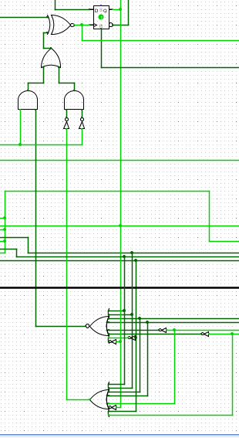

* + Finally, this block is used to bring the counter back to 01 if we press the next button from track 99 and back to 99 if we press the previous button from track 01.