***Scenario***

*You were just hired as head of the IT department for an existing company that has been*

*just managing their computers in a work-group. Due to the inefficiency of this you*

*recommend setting up a domain and everything that goes with it. You have two servers*

*and one workstation to work with.*

*Renaming The machine:*

Server I Server II

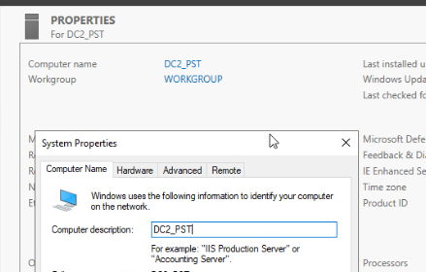

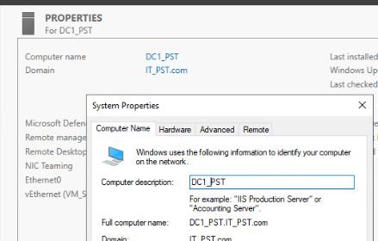

Workstation

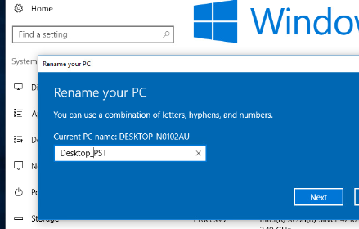

Setting the static IP address

Server I Server II

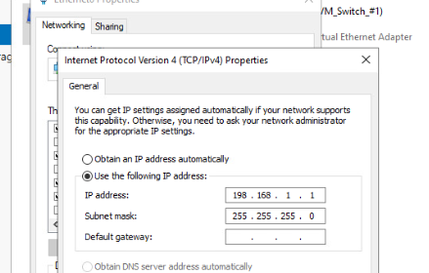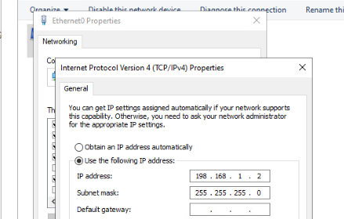  
  
  
Workstation

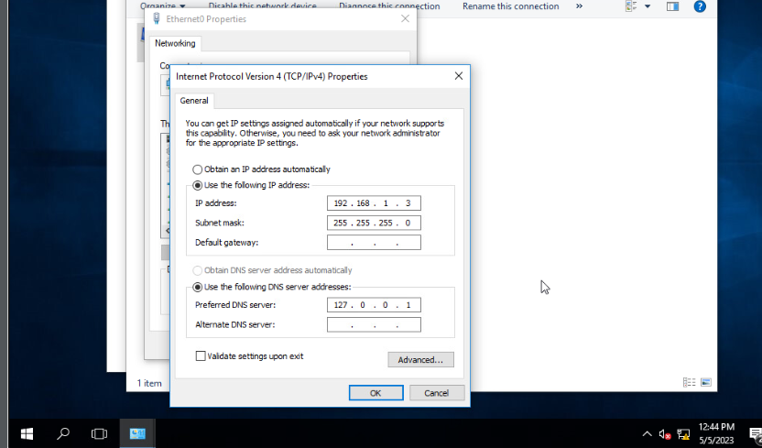  
  
  
  
  
  
  
  
Creating a domain:

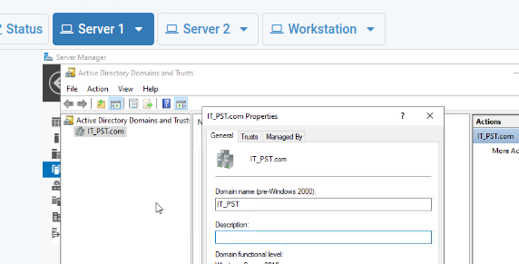

Creating Users:

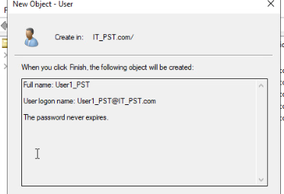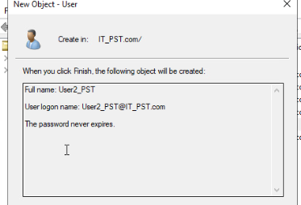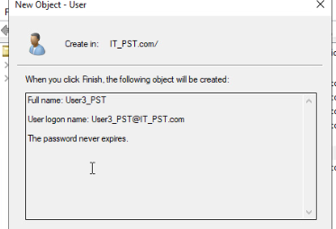

Creating a RAID-5 Array:

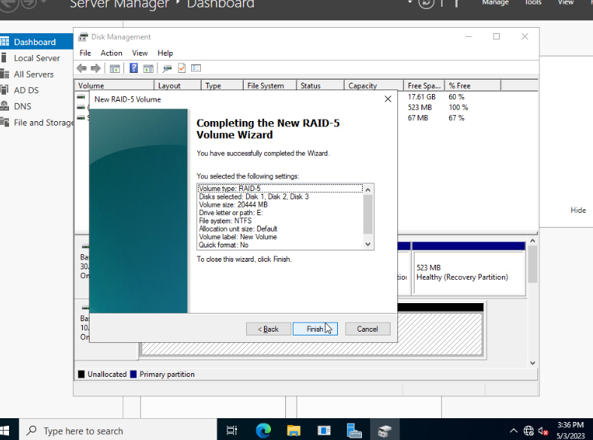

Creating Organizational Units:

* Miami(PST)
* New York(PST)
* Seattle(PST)

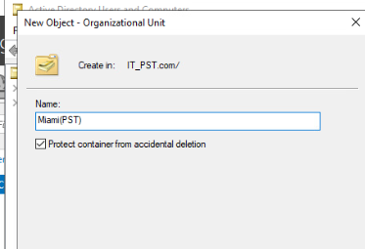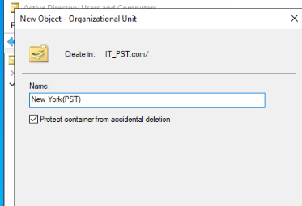

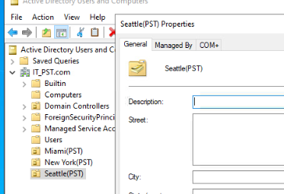  
  
  
  
  
  
Creating Security Groups:

* Miami Sales(PST)
* New York Sales(PST)
* Seattle(PST)

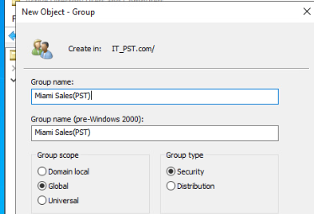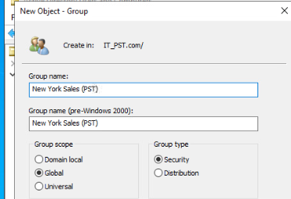  
  
  
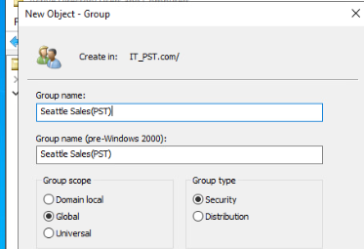  
  
  
  
  
  
  
  
  
  
  
  
Adding User1, 2 & 3 to Miami Sales Group:

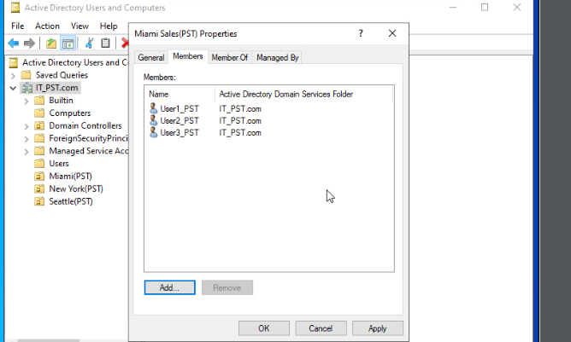  
  
  
Creating a SMB share: Miami Sales Home Drive

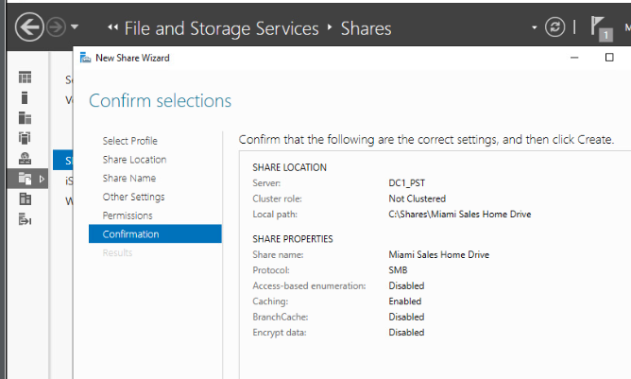  
Installing DFS Namespaces & Replication:

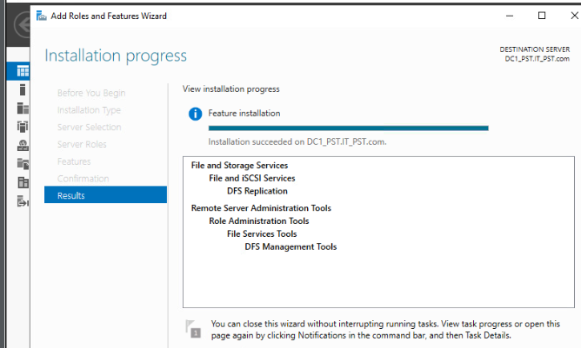  
  
  
  
Creating a DFS Namespace: Miami

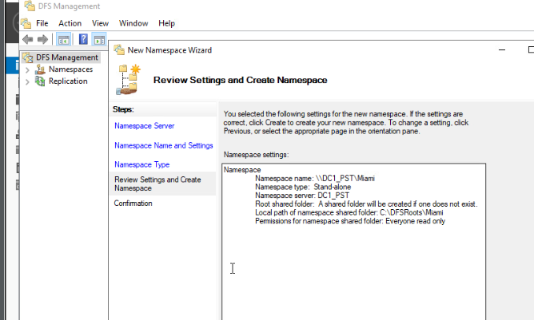  
  
Adding a target to the namespace: Miami sales Home Drive

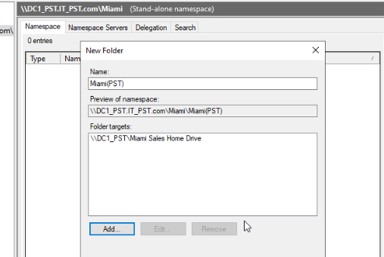

Creating a replication group:

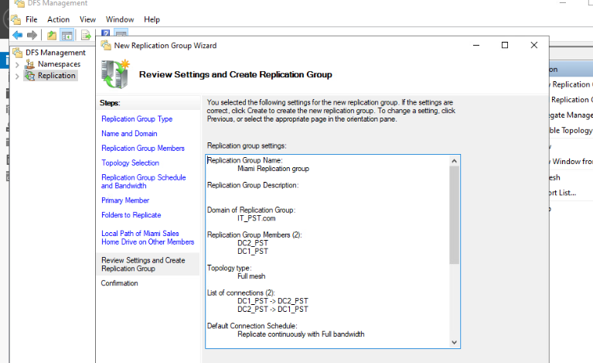

Setting a 2GB folder quota on the Miami sales Home drive:

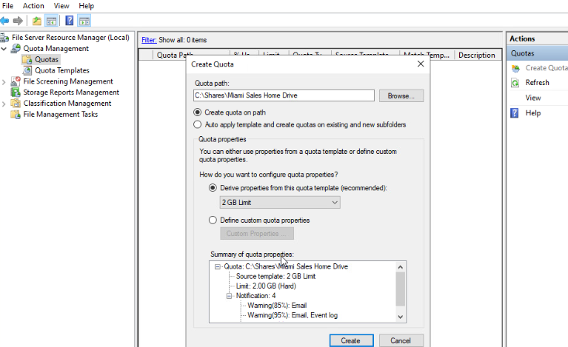  
  
  
Setting a file screen to block the ability to save audio and video files:

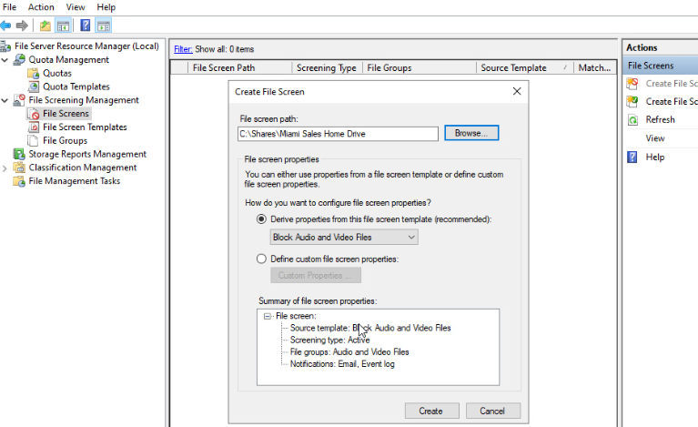  
  
Installing the print server role:

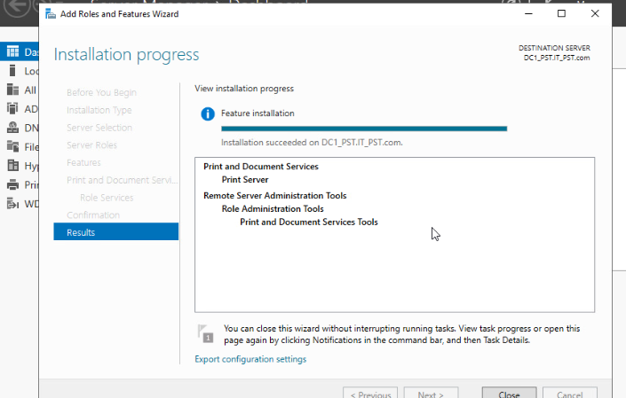  
  
  
Adding a network printer:

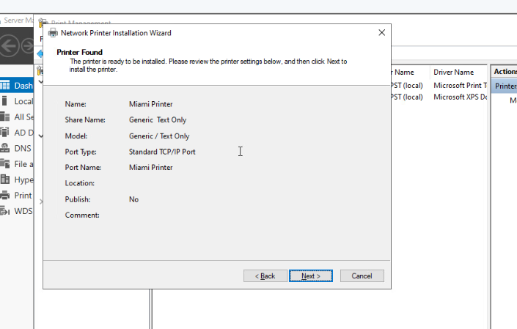  
  
Deploying the printer via the default domain policy:

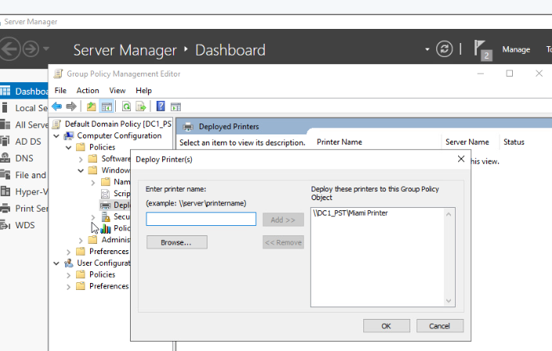

Creating a new volume via service manager on server II:

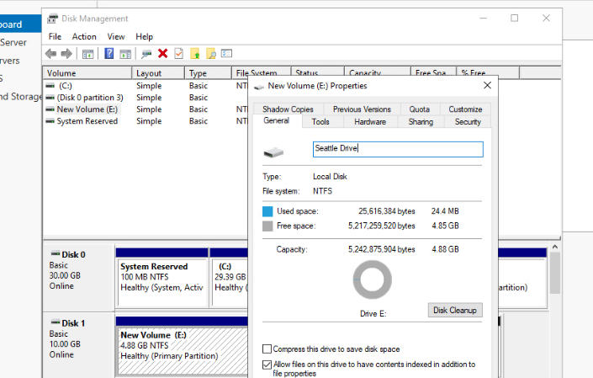  
Creating a new storage pool: Sales Storage Pool

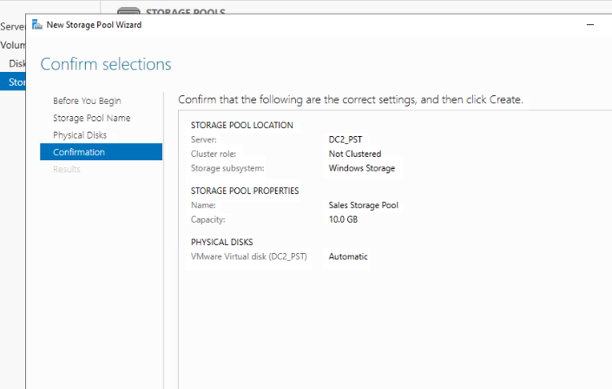

Enabling data de-duplication and throughput optimization on Seattle drive:

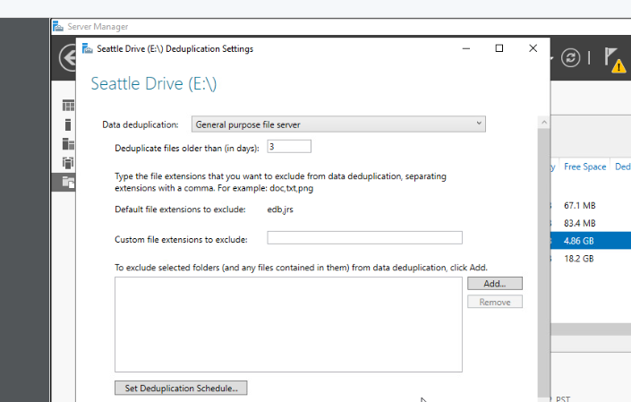

Scheduling windows backup 6 pm everyday for to the Miami sales home drive:  
  
  
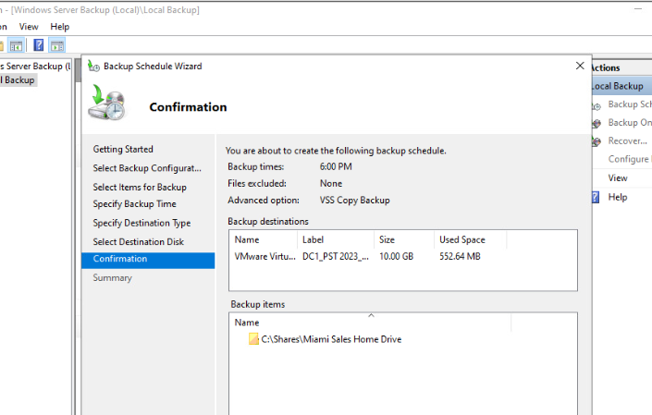  
  
  
  
  
  
  
  
  
  
  
  
  
  
  
  
  
  
  
  
  
  
DNS configuration:

1. Creating a forward lookup zone:

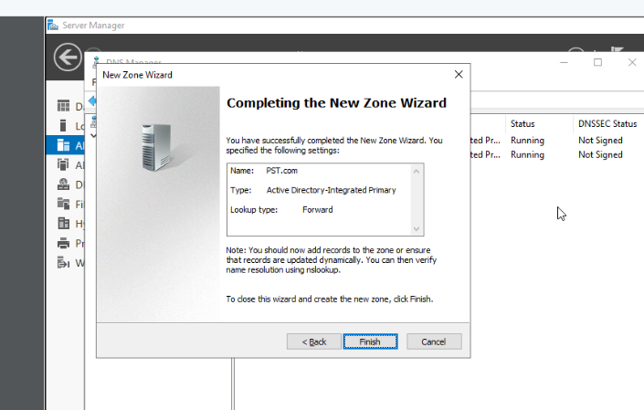  
Creating a host record: 192.168.1.20:

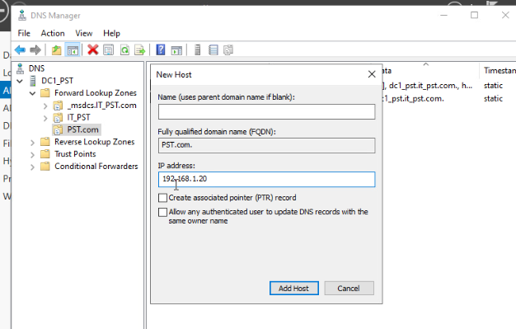  
  
  
Adjust the Zone properties’ SOA’s TTL to 2 hours & allow zone transfers to Server II:

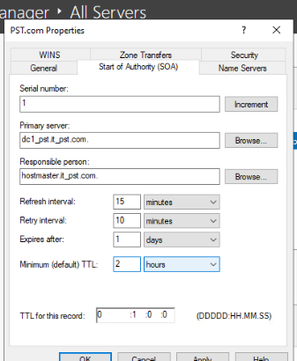 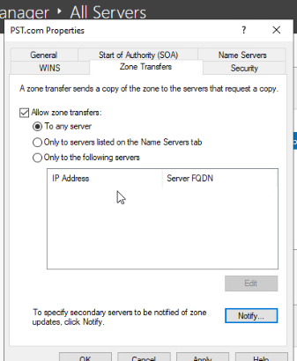  
  
  
DHCP configuration: Installing DHCP on Server I &II:

Server I:

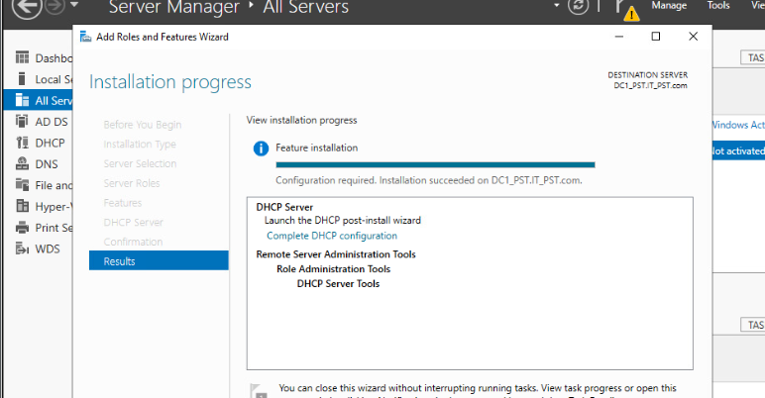   
  
  
Server II:

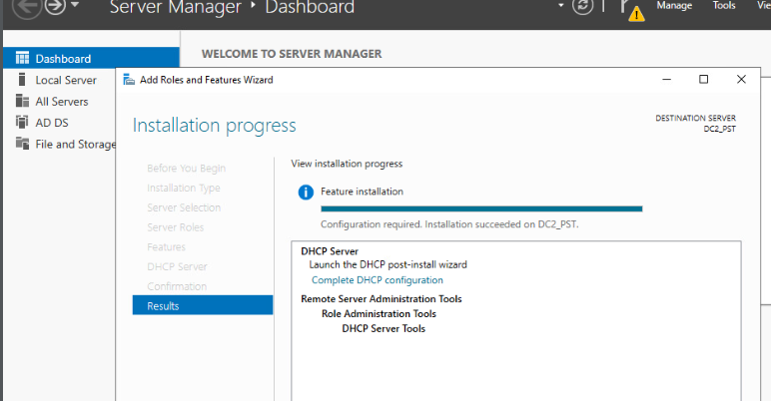  
  
  
Creating an IPv4 Scope: 198.168.1.30 ~.60 and exclusion of .40 ~ .45:

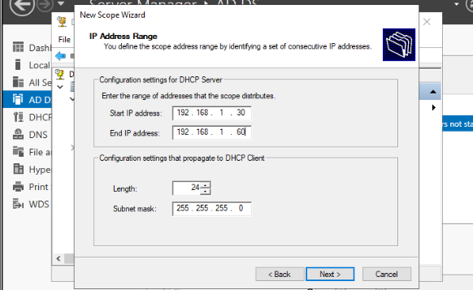  
  
  
  
  
  
  
  
  
  
  
  
  
  
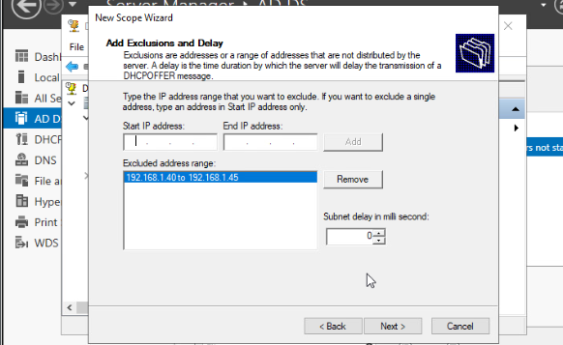  
  
Creating a reservation for a printer:

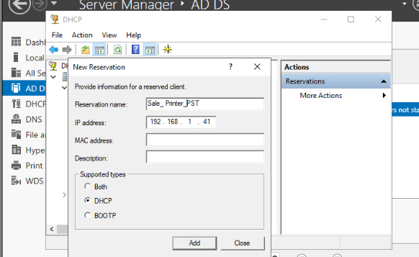  
  
  
DHCP fault tolerance: Configure load balancing with Server 2 w/ a max client lead time of 3 hours:

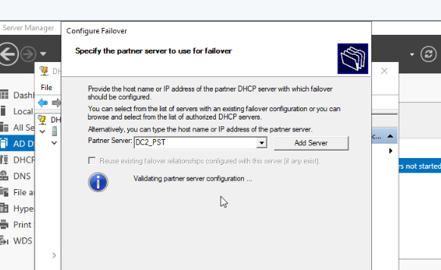  
  
  
  
  
  
  
  
Configuring remote server: Installing Remote Access and Network Policy & Access Services

role & Enabling VPN Access:

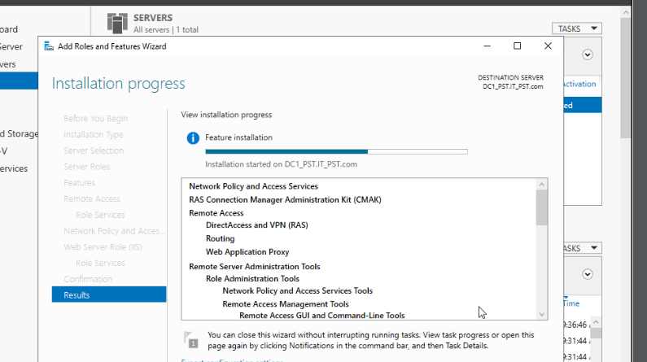  
  
Enabling VPN access:

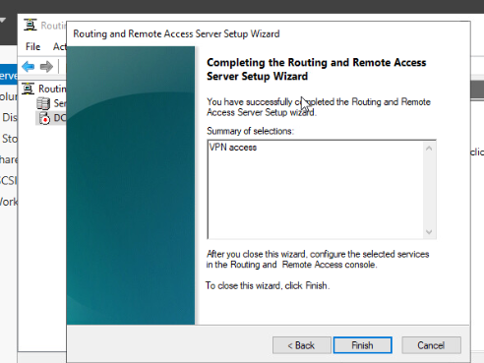  
  
  
  
  
  
  
Enabling RADIUS Authentication:

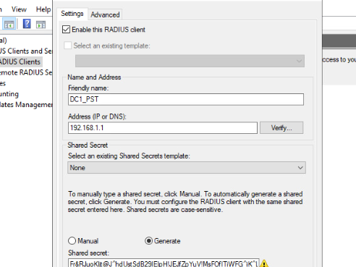  
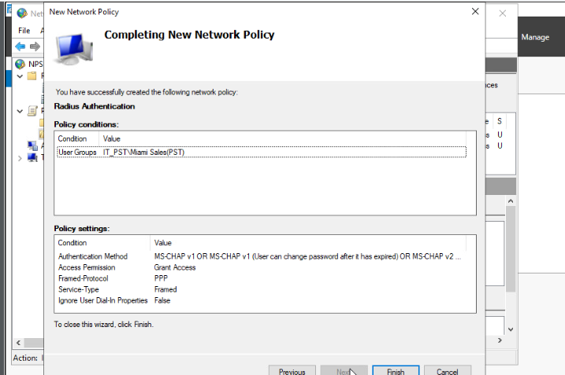  
  
Creating a network Policy:

Creating a GPO: New York GPO

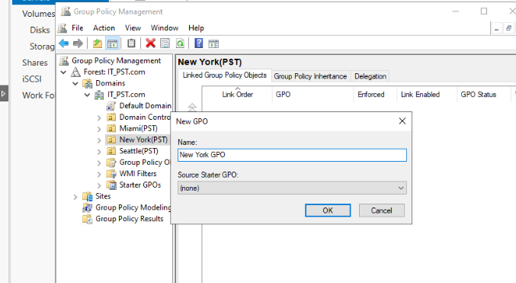

Removing authenticated users group & Adding users to the GPO:

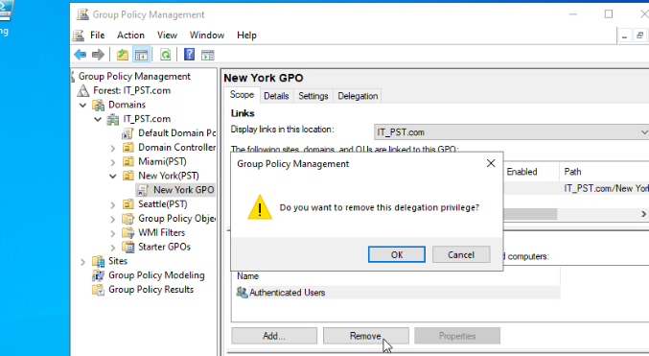

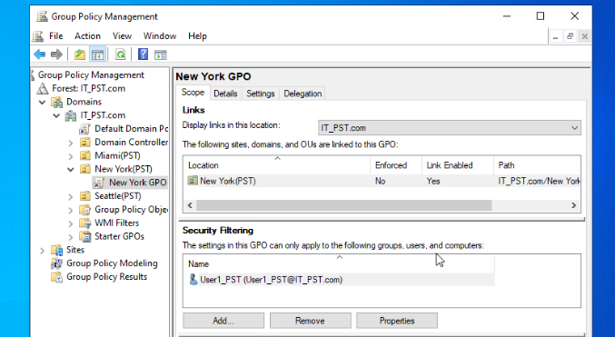  
  
Enabling Password settings on the GPO:

