**Week 6 : Lab 4**

**PART I: An outline format of the Tasks**

**I. Introduction**

* The company has recently merged with a small tech company and needs to incorporate them with the existing domain.
* Four departments need to be created (R&D, Engineering, Biometrics, and Informatics), and a separate OU should be created for each of them.
* There is a list of users with their departments and permissions.

**II. User Management**

* Create a separate OU for each department (R&D, Engineering, Biometrics, and Informatics).
* Put the users in their respective departments and assign them the correct permissions.
* Josie Carpen - R&D - Account Operator & Backup Operator
* Riley Trandel - Biometrics - Account Operator & Backup Operator
* Bailey Manprisio - Informatics - Domain Admin
* Penny Manprisio - Engineering - Domain Admin

**III. Shared Folders**

* Create four new shares using the following naming conventions:

1. R&D_Share_NAM
2. Engineering_Share_NAM
3. Biometrics_Share_NAM
4. Informatics_Share_NAM

* Publish a shared folder for Riley via AD and call it NAM.
* Create a namespace for the Informatics department called Informatics_NAM.

1. Set the folder target to the existing Marketing Home Drive.

* Perform file screening to ensure that Biometrics_Share_NAM cannot store any audio and video files. Notify us via email if they try to save them.

**IV. Printer Management**

* Set up printers for the four departments on the existing print server.

1. R&D_NAM - 192.168.1.60

2. Engineering_NAM - 192.168.1.61

3. Biometrics_NAM - 192.168.1.62

4. Informatics_NAM - 192.168.1.63

* Add all four printers to the default domain policy to deploy them for the new users.

**V. Testing**

* Sign in as one of the new users to ensure that they can see all the newly created printers.

**VI. Documentation**

* Take key screenshots of the work done for CIO (Rich) to provide a summary of all the work done.

**PART II: SCREENSHOTS OF MY WORK**

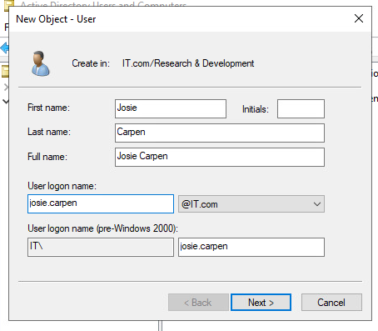**1. User management.**

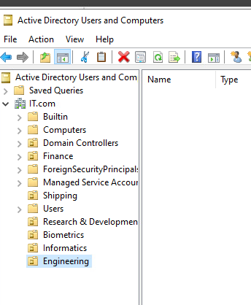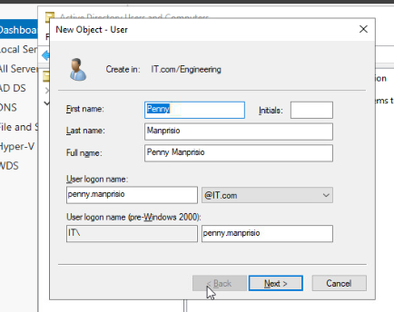

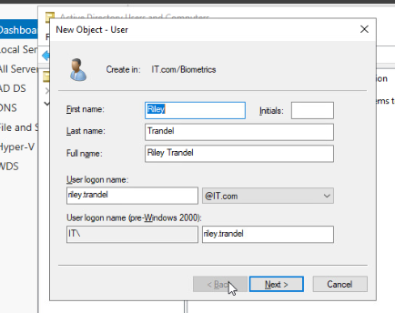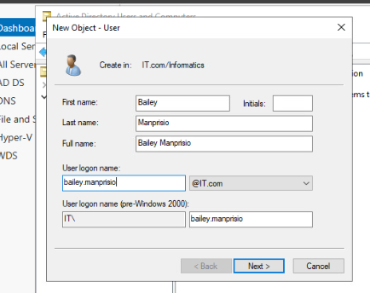**Assigned roles**

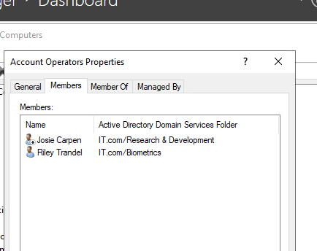 **Created Shared folders**

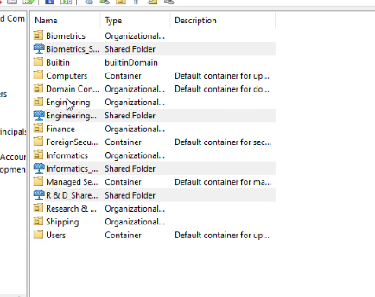 **Published a folder for Riley**

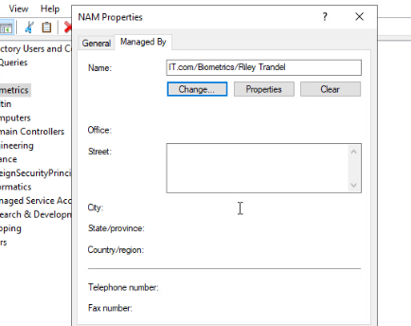

**Created** a namespace for the Informatics department called Informatics_XXX and set the folder target to the existing Marketing Home Drive

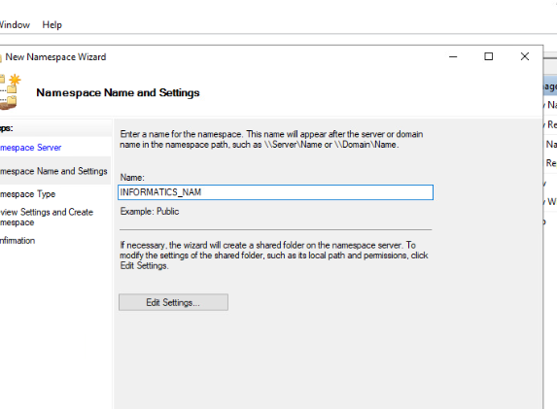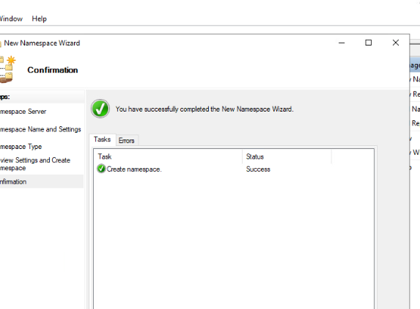  
  
  
  
  
  
  
  
  
  
  
  
  
  
  
  
  
  
  
  
  
Setting the folder target to the existing Marketing Home Drive.  
  
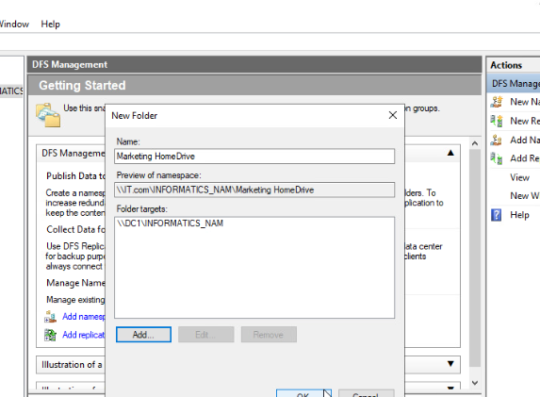  
  
  
  
Performing file screening to ensure that Biometrics_Share_XXX cannot store any audio and video files. Notify us via email if they try to save them.

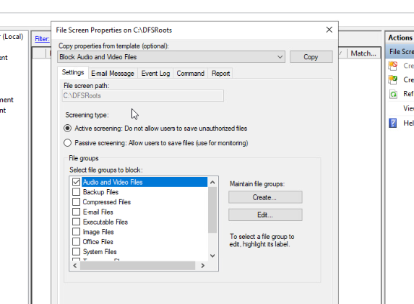  
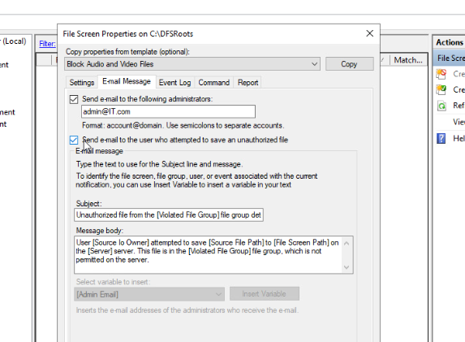  
  
  
  
  
  
  
  
  
  
  
  
  
  
  
  
  
  
  
  
  
  
Setting Up Printers

