S.M.A.R.T.
USER MANUAL
Student Management and Academic Records Tracking
Administrator and Instructor Guides
Use this guide to sign in, navigate your workspace, and complete common academic record tasks.

Getting Started
S.M.A.R.T. has separate Administrator and Instructor workspaces. Sign in with the account provided to you; the screens and available actions depend on your role. Use the navigation menu to switch between features, and use Sign Out when you finish.

Sign In
Enter your username and password, optionally select Show password to check the entry, then choose Sign in. If access is denied, check your credentials or contact the administrator. Instructor accounts that have been disabled must be re-enabled by an administrator.
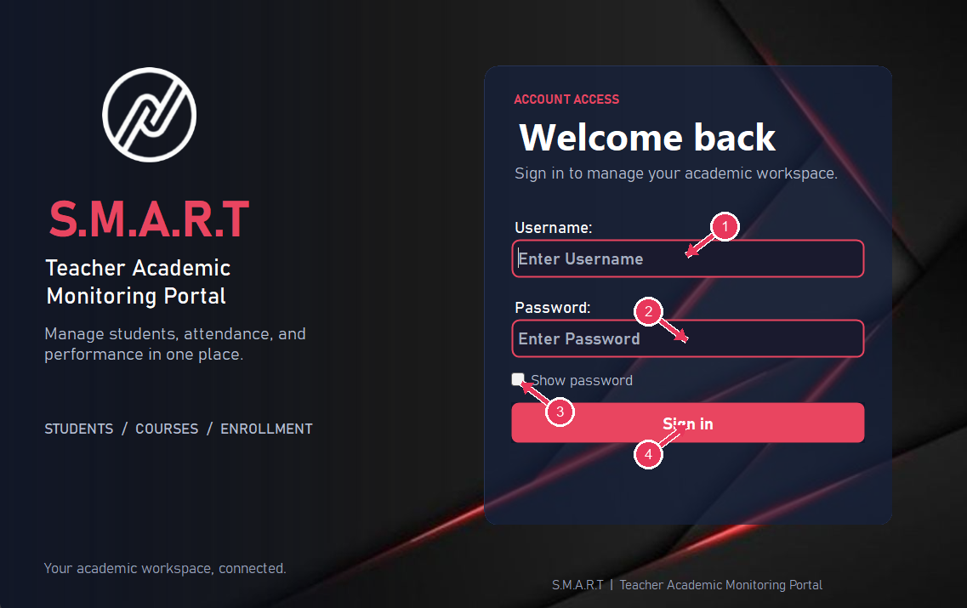
Figure 1. S.M.A.R.T. sign-in screen
1. Username field: Enter the username for your assigned account.
2. Password field: Enter your password; use Show password if you need to check it.
3. Show password: Toggle password visibility while entering your credentials.
4. Sign in: Submit the credentials and open the workspace for your account role.

Administrator Guide
The Administrator workspace is used to maintain the institution’s student, instructor, course, and enrollment records and to communicate with instructors.

Administrator Dashboard
The dashboard summarizes student, instructor, course, and active-student totals.
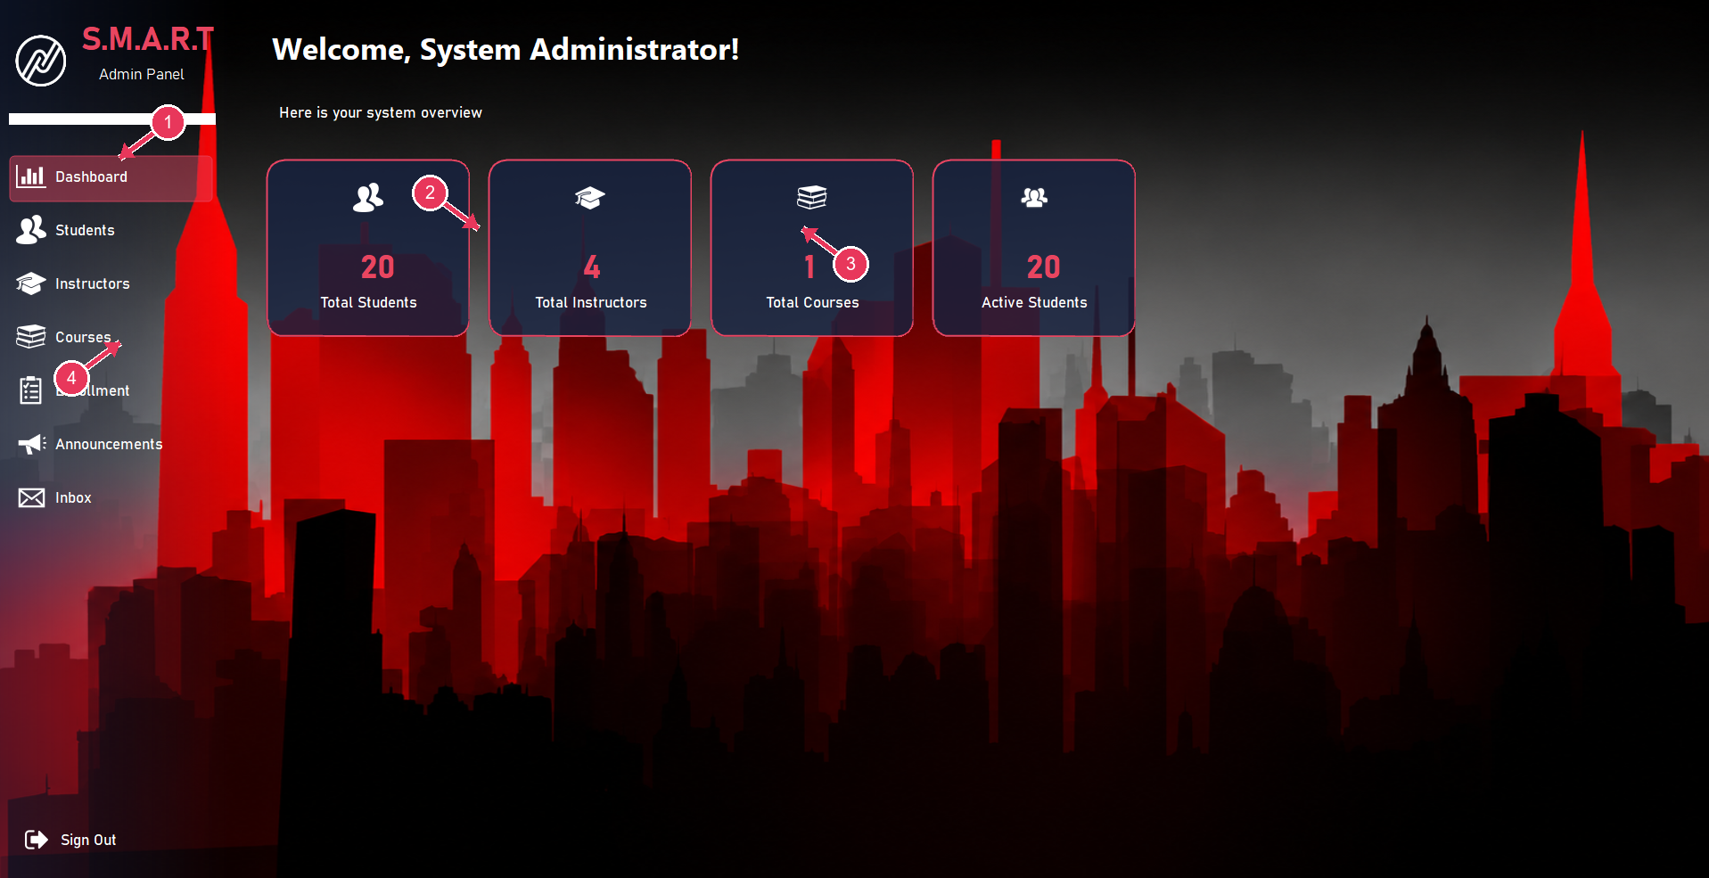
Figure 2. Administrator dashboard
1. Dashboard navigation: Return to the administrator overview.
2. Student and instructor totals: Review current record counts.
3. Course total: Check the number of courses in the system.
4. Management navigation: Open Students, Instructors, Courses, Enrollment, Announcements, or Inbox.
- Use the left navigation to open a management area.
- Use Sign Out at the bottom of the menu to end the session.

Student Management
Use this screen to add, find, update, and maintain student records.
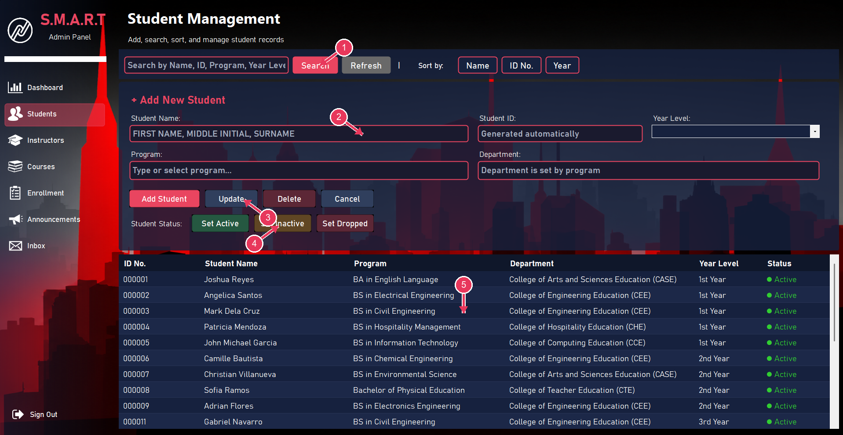
Figure 3. Student management
1. Search and sort: Find students by name, ID, program, or year level; choose a sort order.
2. Student details: Enter the student name, program, and year level; ID is generated automatically.
3. Record actions: Add, update, delete, or cancel the selected student record.
4. Student status: Set the selected student as Active, Inactive, or Dropped.
5. Student list: Select a row to review or manage that student.
- To add a student, enter the full name, program, and year level; the department follows the selected program and the student ID is generated automatically.
- Choose Add Student to save. Select a row before using Update, Delete, Cancel, or a status action.
- Search by name, ID, program, or year level; use the sort buttons to reorder the list.

Instructor Management
Use this screen to create instructor records and manage their login accounts.
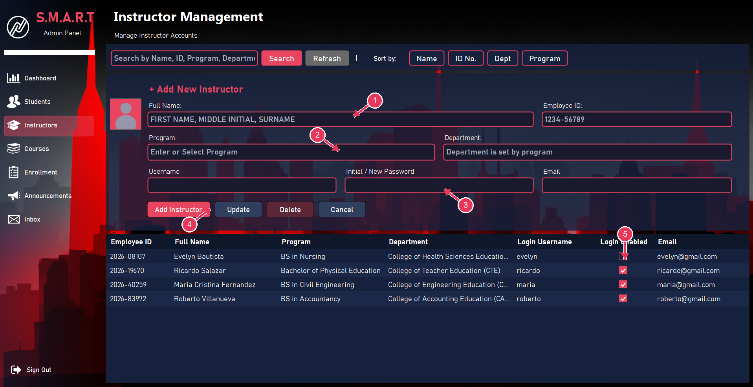
Figure 4. Instructor management
1. Instructor identity: Enter the instructor name and employee ID.
2. Program and department: Choose or enter the program; department is associated with the program.
3. Account and email: Set username and initial password; email uses the instructor first name.
4. Add or update instructor: Save a new instructor or update the selected record.
5. Login Enabled: A checked box allows the instructor to sign in; unchecked means disabled.
- Enter the instructor name, program, account username and initial password; select or enter a program to populate its department.
- Employee IDs follow the year-and-number format shown on the form, and the email address is generated from the instructor’s first name.
- Choose Add Instructor to save. Select a row before updating or deleting it; use Login Enabled to enable or disable the account.
- An instructor whose account is disabled cannot sign in until an administrator enables it again.

Course Management
Courses connect a course code and academic schedule to a program and assigned instructor.
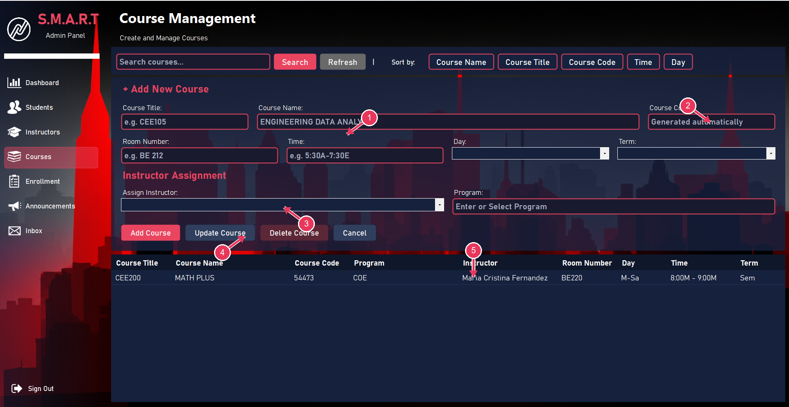
Figure 5. Course management
1. Course details: Enter course title, name, room, time, day, term, and program.
2. Course code: The application generates the course code for the new record.
3. Instructor assignment: Choose the instructor responsible for this course.
4. Save course: Add a course or update/delete the selected course.
5. Course list: Review saved instructor, room, day, time, and term information.
- Enter the course title and name, room, time, day, term, and program; choose an instructor from Assign Instructor.
- The course code is generated automatically. Confirm the day and time notation before saving (M means morning and A means afternoon).
- Choose Add Course to save. Select an existing course before updating or deleting it.
- Use the search box and sort buttons to locate course records.

Enrollment Management
Enrollment connects students to a selected course.
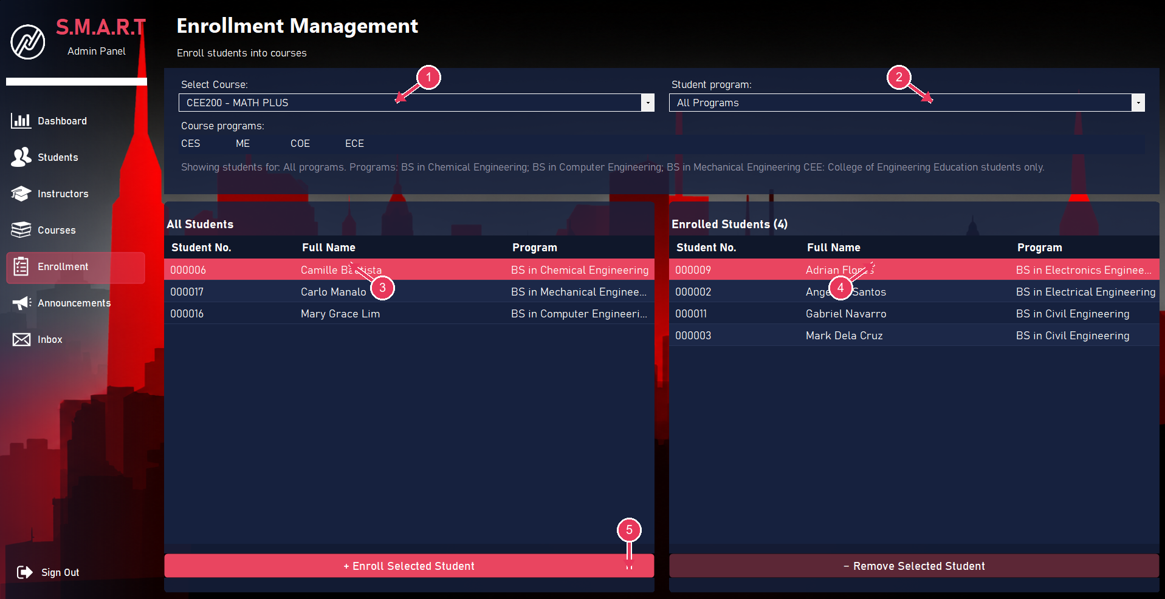
Figure 6. Enrollment management
1. Course selector: Choose which course you are managing.
2. Program filter: Limit the available students by student program.
3. Available students: Select a student here to add them to the course.
4. Enrolled students: Review students already enrolled in the selected course.
5. Enroll or remove: Use the bottom buttons to add or remove the selected enrollment.
- Choose a course and, if needed, filter the available student list by program.
- Select a student in All Students and choose Enroll Selected Student.
- To remove an enrollment, select the student in Enrolled Students and choose Remove Selected Student.

Announcements
Administrators can post notices for instructors and choose the audience and priority.
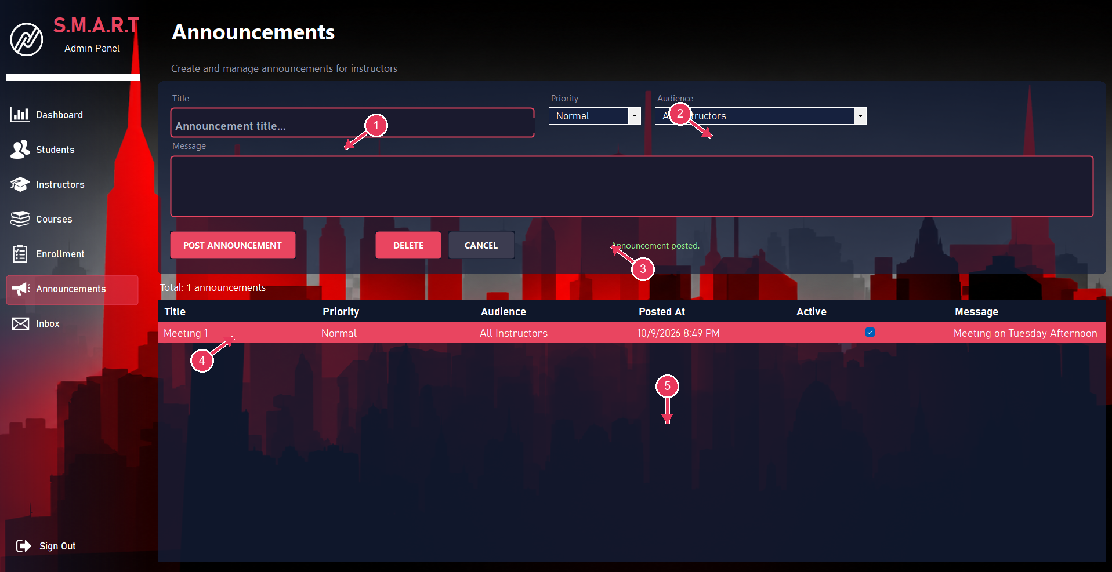
Figure 7. Administrator announcements
1. Announcement title: Enter a short title for the notice.
2. Priority and audience: Choose the announcement priority and instructor audience.
3. Message: Write the announcement details.
4. Post announcement: Publish the announcement to the selected audience.
5. Announcement list: Review posted items, active status, audience, and date.
- Enter a title and message, then set the priority and audience.
- Choose Post Announcement. Confirm the new item appears in the list and is marked active.
- Select an announcement and use Delete when it should be removed.

Instructor Inbox
The inbox collects messages sent by instructors through Assist.
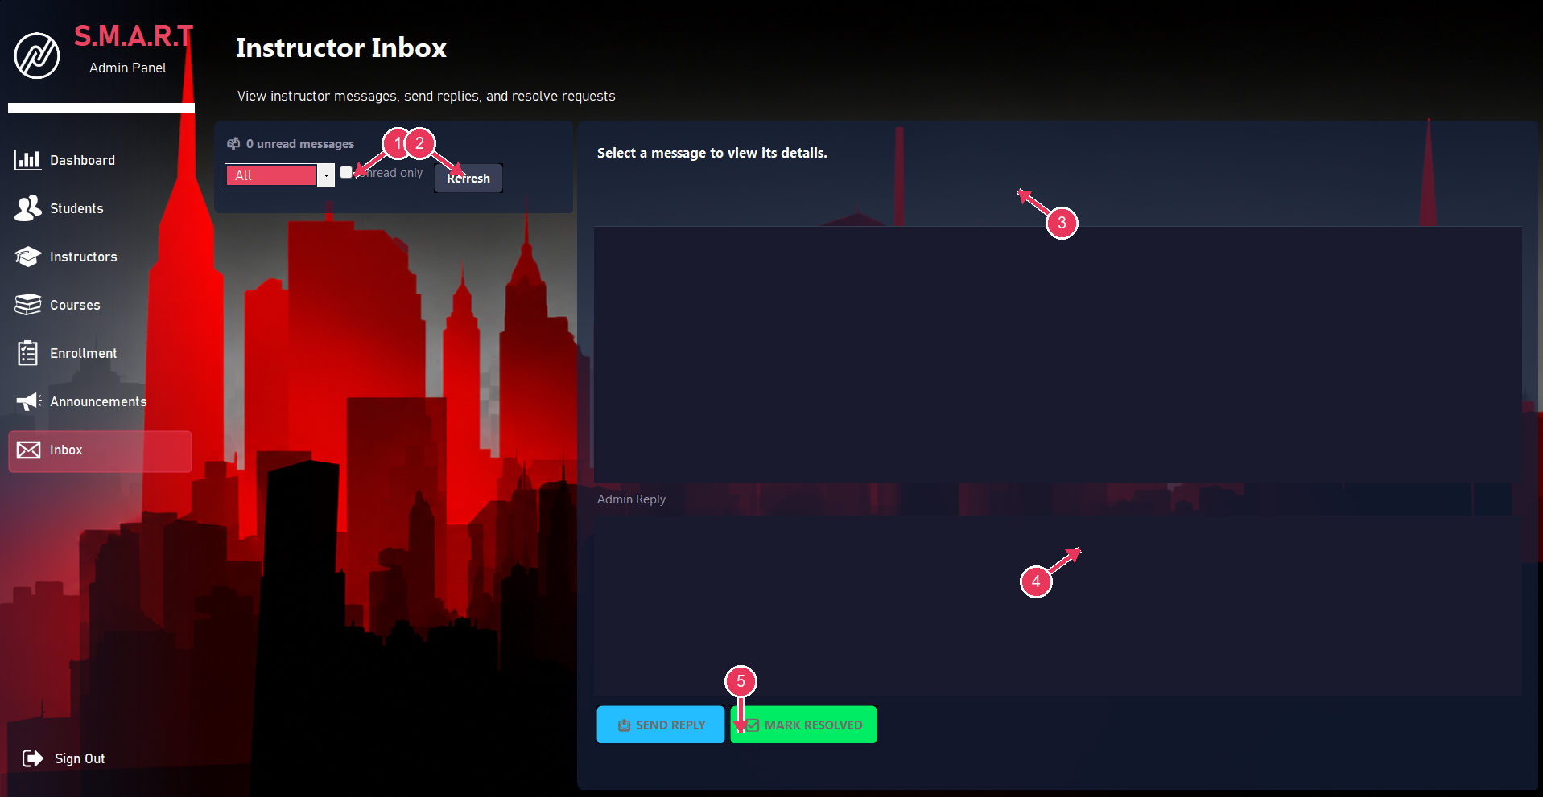
Figure 8. Instructor inbox
1. Inbox filters: Filter messages by status or show unread messages only.
2. Refresh: Reload the inbox message list.
3. Message details: Select a message to read the instructor request.
4. Admin reply: Enter a response to the selected instructor message.
5. Send reply or resolve: Send your response or mark the request as handled.
- Use the status filter, Unread only, and Refresh to find messages.
- Select a message to view its details, enter a reply, and choose Send Reply.
- Choose Mark Resolved when the request has been handled.

Instructor Guide
The Instructor workspace shows the signed-in instructor’s assigned courses and provides course records, schedule, announcements, calendar, notes, Assist, and account settings.

Instructor Dashboard
The dashboard displays assigned course cards with course code, room, term, day, time, and enrolled student count.

Figure 9. Instructor dashboard
1. Instructor dashboard: The dashboard welcomes the signed-in instructor.
2. Course card: Review course code, schedule, room, term, program, and enrollment count.
3. Instructor navigation: Open Schedule, Announcements, Calendar, Notes, Assist, or Settings.
- Choose a course card to open its course workspace.
- Use the left menu to open Schedule, Announcements, Calendar, Notes, Assist, or Settings.

Class Schedule
The schedule places assigned classes into weekday and time slots.
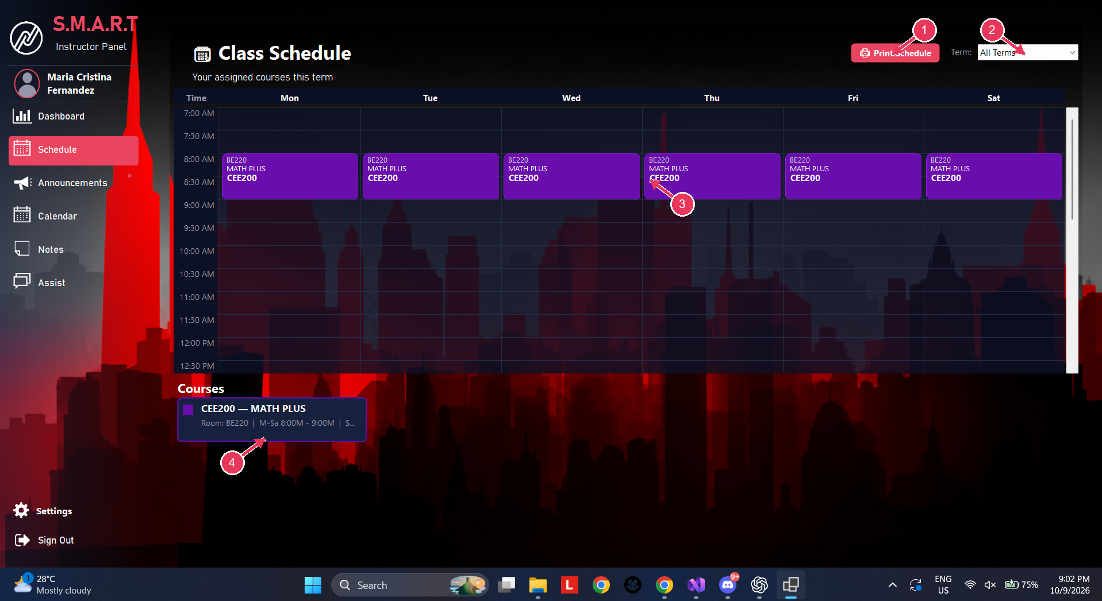
Figure 10. Weekly class schedule
1. Print schedule: Print the displayed schedule.
2. Term filter: Choose a term to filter assigned courses.
3. Weekly calendar grid: Read assigned class blocks by weekday and time.
4. Course details: Check the course room, days, and time below the grid.
- Choose a term in the term list to filter the displayed courses.
- Use the course details below the calendar to check room, meeting days, and time; choose Print Schedule for a paper copy.
- The schedule uses Monday through Saturday. M in a course time means morning; A means afternoon.

Announcements
This screen displays active announcements published by administration.
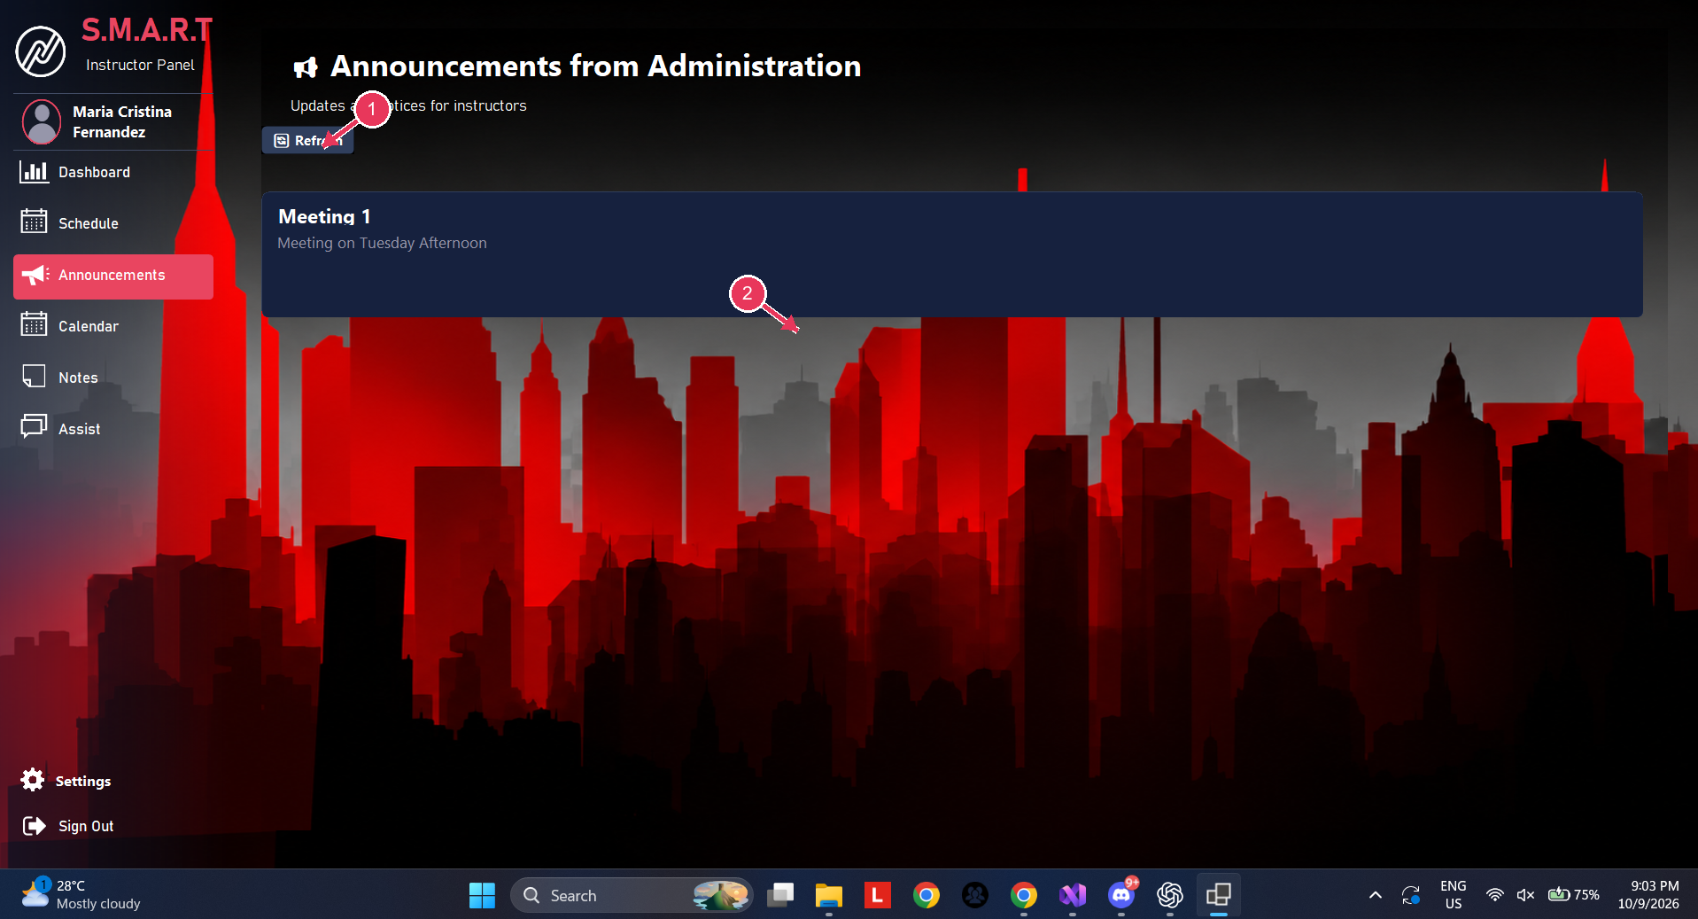
Figure 11. Instructor announcements
1. Refresh announcements: Load the latest active notices from administration.
2. Announcement card: Read the announcement title and message.
- Review the announcement title and message.
- Choose Refresh to load the latest notices.

Calendar
The calendar shows holidays and academic items by date.
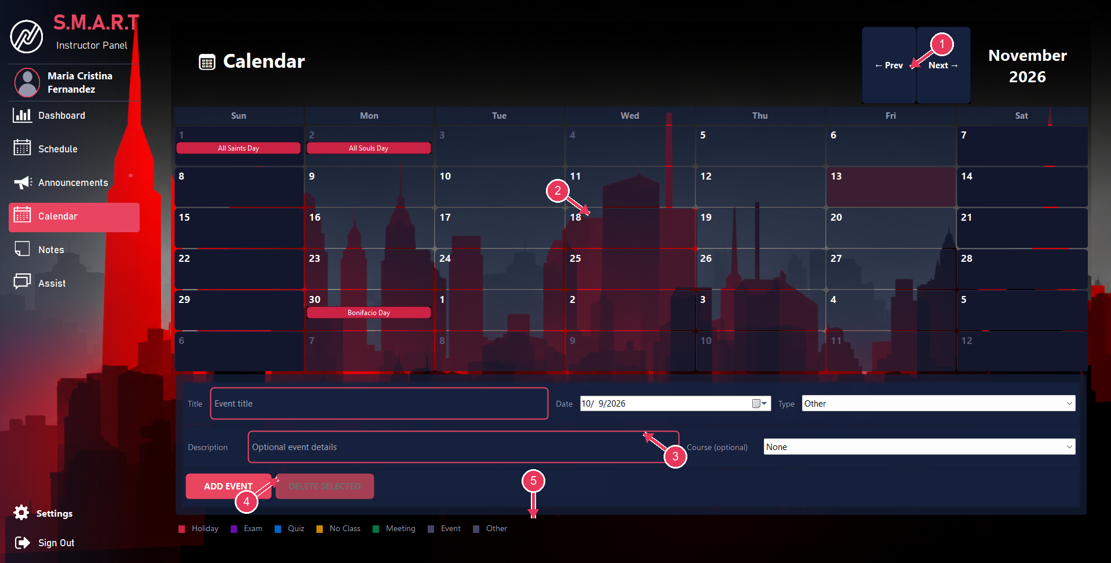
Figure 12. Instructor calendar
1. Month navigation: Move to the previous or next month.
2. Calendar events: Select a date or review the event labels shown on the calendar.
3. Event details: Enter title, date, type, description, and optional course.
4. Add or delete event: Save an event or remove the selected event.
5. Event legend: Identify the event category by its color.
- Use Prev and Next to move between months.
- To add an event, enter its title and date, choose a type, and optionally add a description or course; then choose Add Event.
- Select an event before choosing Delete Selected. The legend identifies event types by color.

My Notes
Notes are personal to the signed-in instructor.
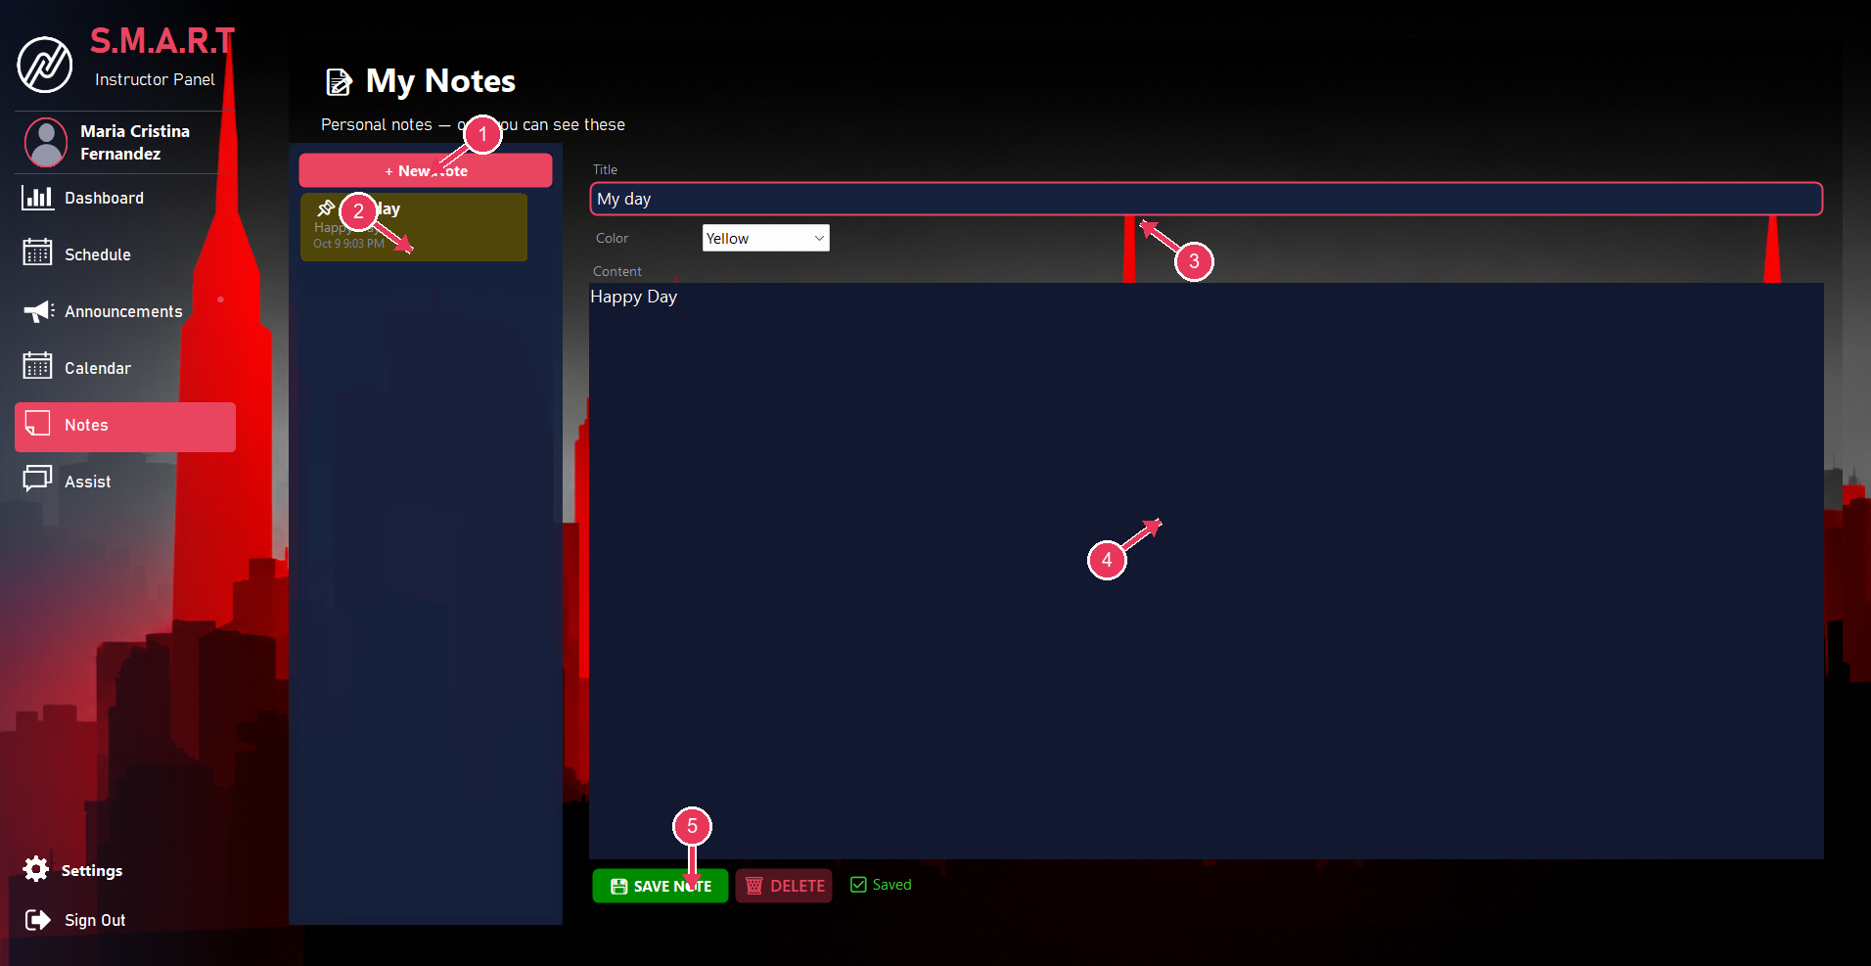
Figure 13. Instructor notes
1. New note: Create a personal note.
2. Note list: Select an existing note to edit it.
3. Title and color: Set the note title and choose a color.
4. Note content: Write or edit the note text.
5. Save or delete: Save changes or delete the selected note.
- Choose New Note, then enter a title and content and select a color.
- Choose Save Note to keep changes. Select a note from the list to reopen it; choose Delete to remove it.

Assist
Assist sends a request or message to the administrator and tracks its status.
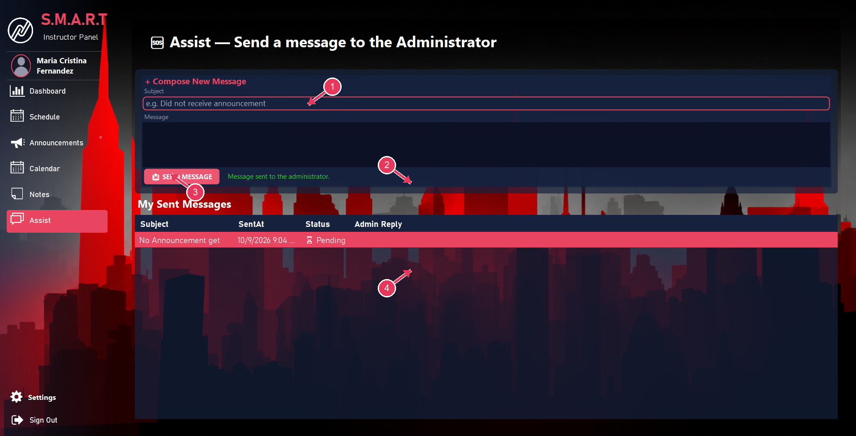
Figure 14. Assist message form
1. Subject: Enter a short subject describing your request.
2. Message: Describe the issue or question for the administrator.
3. Send message: Send the request to the administrator.
4. Sent messages: Track sent requests, their status, and administrator replies.
- Enter a short subject and describe the request in the message box.
- Choose Send Message. Your sent messages appear below with status and any administrator reply.

Profile Settings
Profile settings show account information and allow profile-photo and password updates.
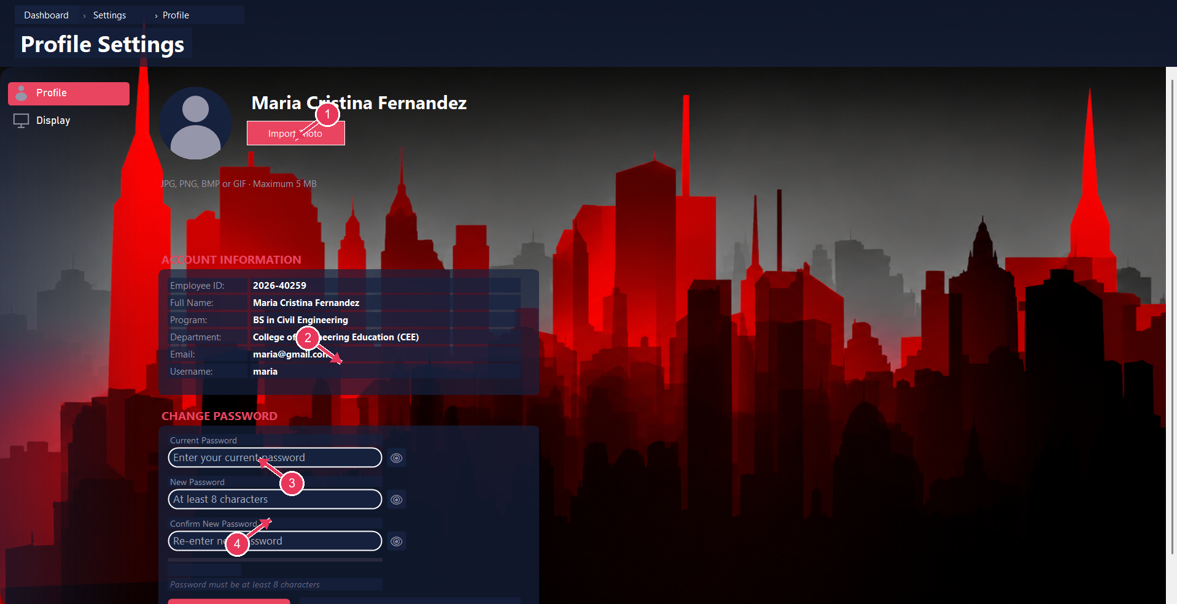
Figure 15. Profile settings
1. Import photo: Choose a JPG, PNG, BMP, or GIF profile image within the displayed limit.
2. Account information: Review your employee ID, name, program, department, email, and username.
3. Current password: Enter the existing password before changing it.
4. New and confirm password: Enter the new password twice to confirm it.
- Choose Import Photo to select a JPG, PNG, BMP, or GIF image within the displayed size limit.
- To change your password, enter the current password, enter and confirm the new password, then use the save/change control lower on the page.

Display Settings
The Display page controls the interface appearance.

Figure 16. Dark display setting
1. Appearance selector: Choose an available display theme.
2. Settings navigation: Switch between Profile and Display settings.
- Open the Appearance list and choose the desired theme.
- The selected appearance is applied to the interface.

Display Settings Light Theme
This screenshot shows the same Display page after choosing the Light appearance.

Figure 17. Light display setting
1. Appearance selector: Choose Light or another available display theme.
2. Settings navigation: Switch between Profile and Display settings.
- Use the same Appearance list to switch between available themes.

Course Workspace
Open a course card on the dashboard to access the roster and academic tools for that course. Use Back to return to the instructor dashboard.

Course Students
The Students tab lists students enrolled in the selected course, including program, year level, and status.
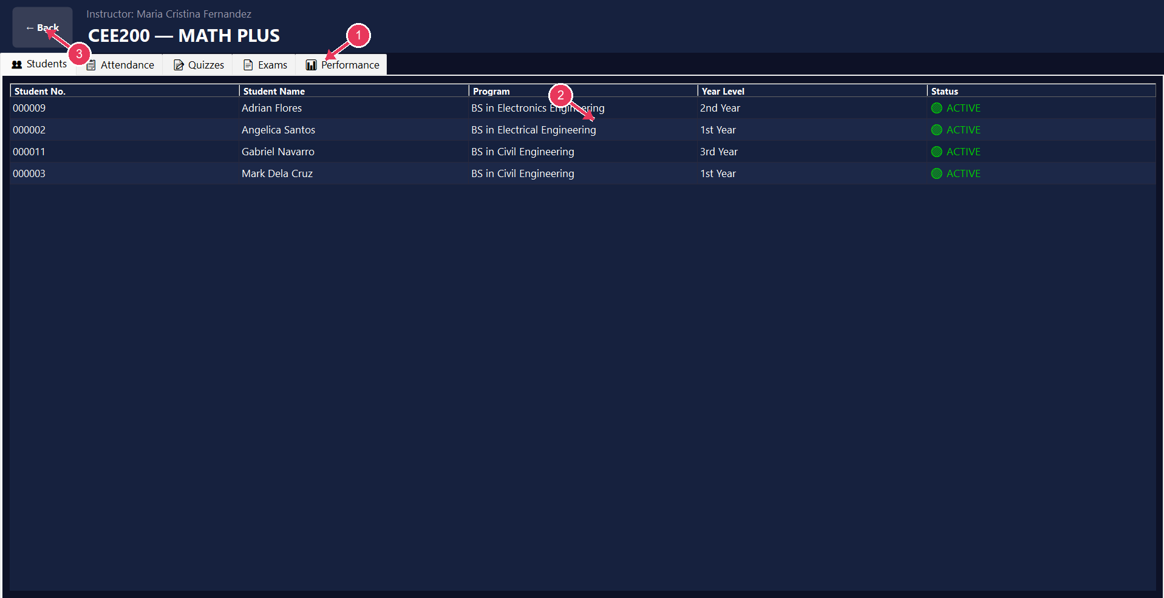
Figure 18. Course student roster
1. Course navigation tabs: Open Students, Attendance, Quizzes, Exams, or Performance.
2. Enrolled student roster: Review each student’s name, program, year level, and status.
3. Back: Return to the instructor dashboard.
- Review the roster before taking attendance or entering assessment scores.
- Use the tabs at the top to move between Students, Attendance, Quizzes, Exams, and Performance.

Course Attendance
Attendance records are entered for a selected class date.
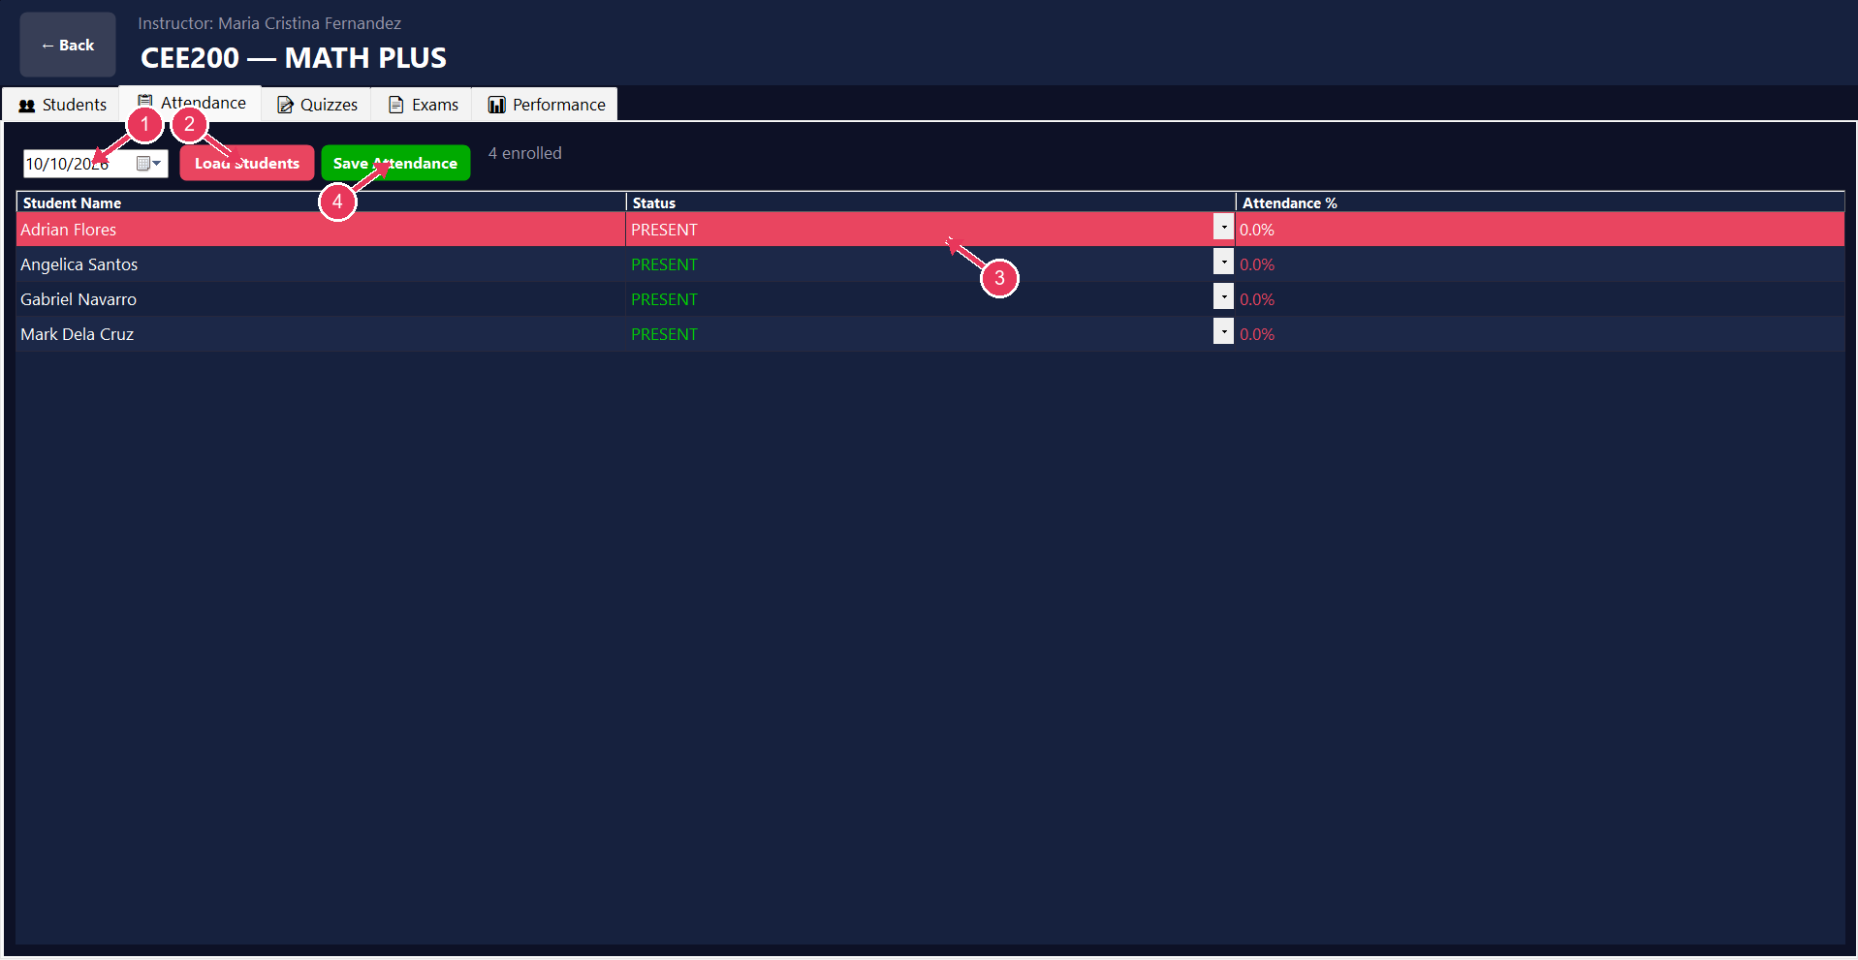
Figure 19. Course attendance
1. Attendance date: Choose the date for which attendance will be recorded.
2. Load students: Load the selected course roster for the chosen date.
3. Attendance status: Set each student’s attendance status.
4. Save attendance: Save the displayed attendance records.
- Choose the date and select Load Students.
- Set each student’s status, then choose Save Attendance.

Course Quizzes
The Quizzes tab creates quizzes and stores student scores.
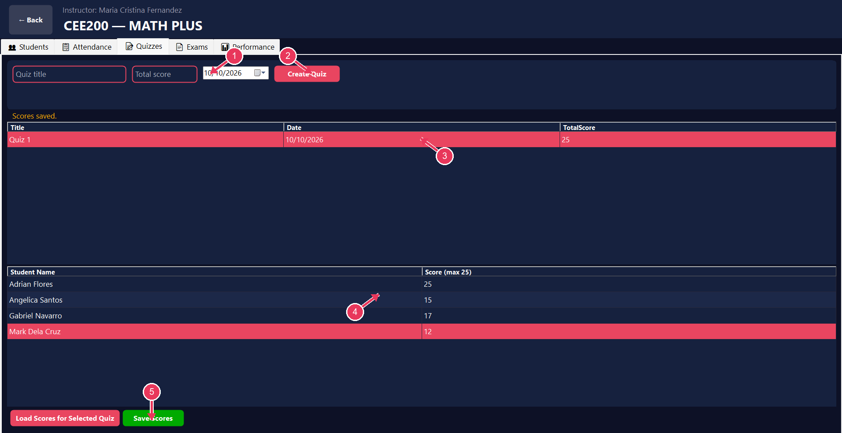
Figure 20. Quiz setup and scores
1. Quiz setup: Enter a quiz title, maximum score, and date.
2. Create quiz: Create the quiz for the selected course.
3. Quiz list: Select an existing quiz to load its student scores.
4. Student score entry: Enter each student’s score up to the quiz maximum.
5. Load or save scores: Load scores for the selected quiz and save changes.
- Enter a quiz title, maximum score, and date, then choose Create Quiz.
- Select a quiz and choose Load Scores for Selected Quiz, enter scores within the maximum, and choose Save Scores.

Course Exams
The Exams tab manages grading-period exam structure and exam scores.
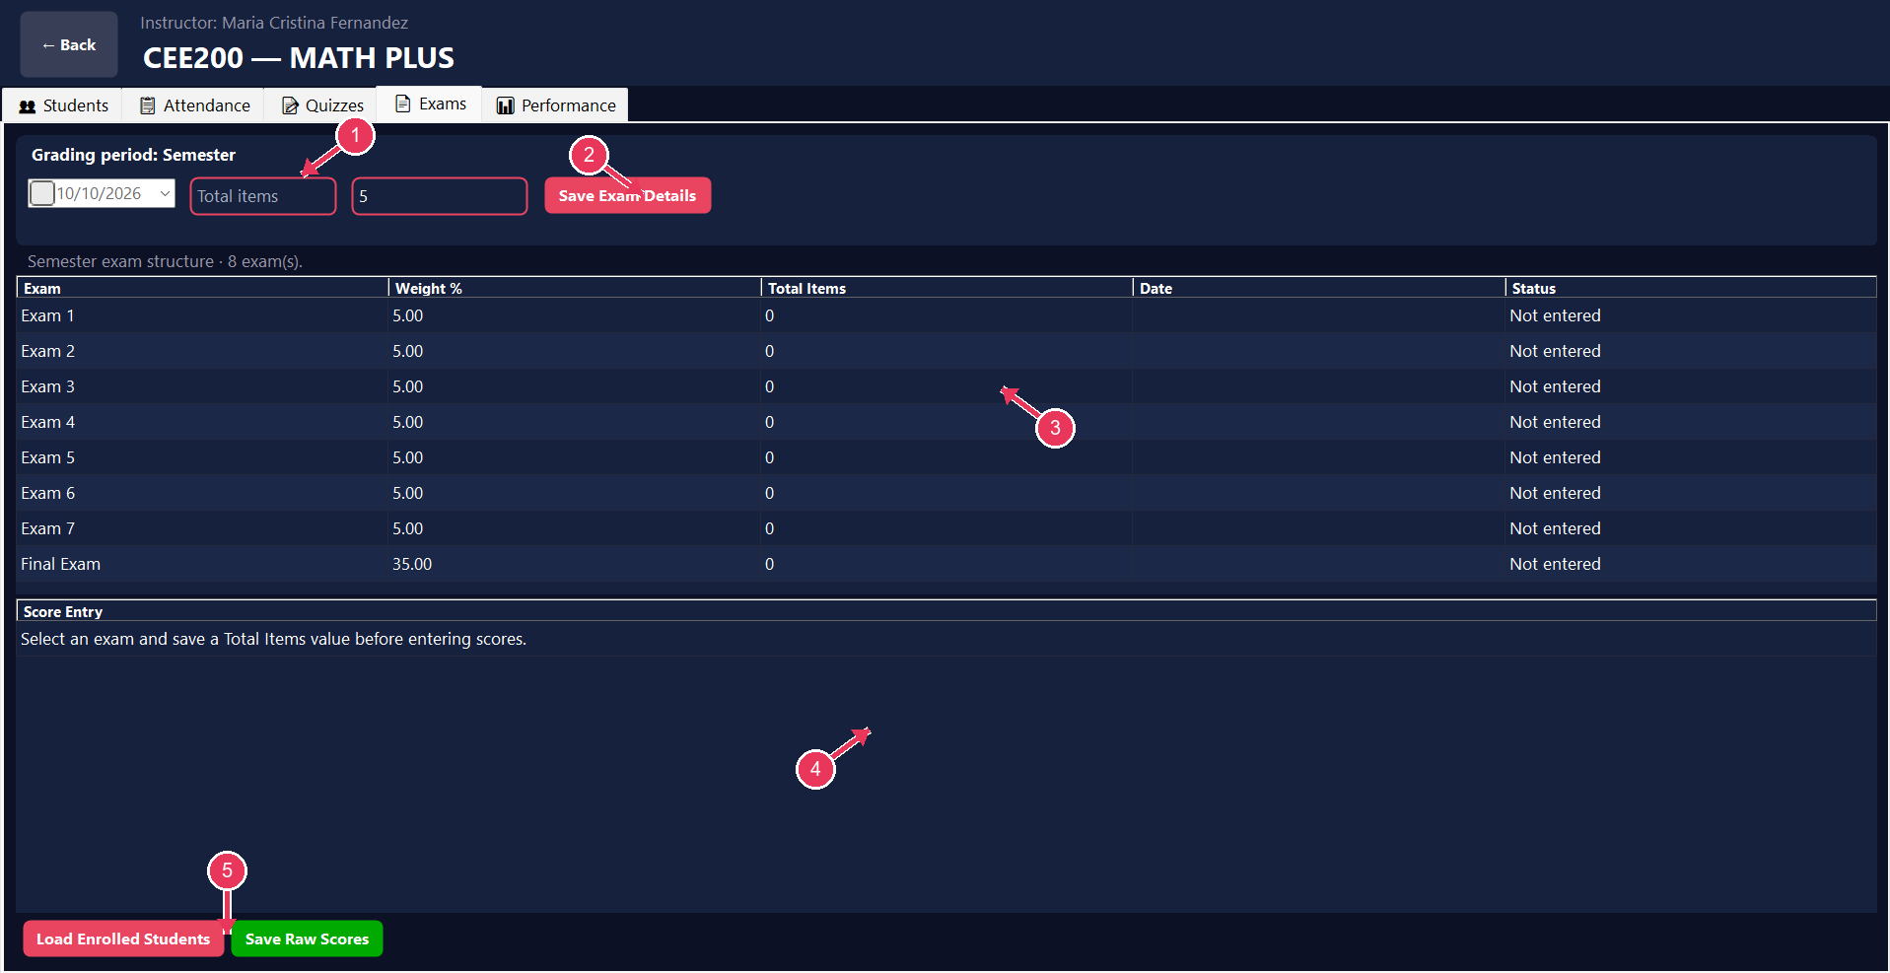
Figure 21. Exam structure and score entry
1. Grading period and exam details: Select grading period/date and enter total items or exam values.
2. Save exam details: Save the selected exam configuration.
3. Exam structure: Review exam names, weights, item totals, dates, and status.
4. Score entry: Select an exam and load enrolled students before recording scores.
5. Load or save scores: Load students for the exam and save their raw scores.
- Choose the grading period and exam, enter the total items and other requested details, then choose Save Exam Details.
- Load enrolled students to enter scores and save the raw scores. Save the exam’s total-item value before entering student scores.

Course Performance
The Performance tab summarizes attendance, quiz averages, weighted exam contribution, and overall results.
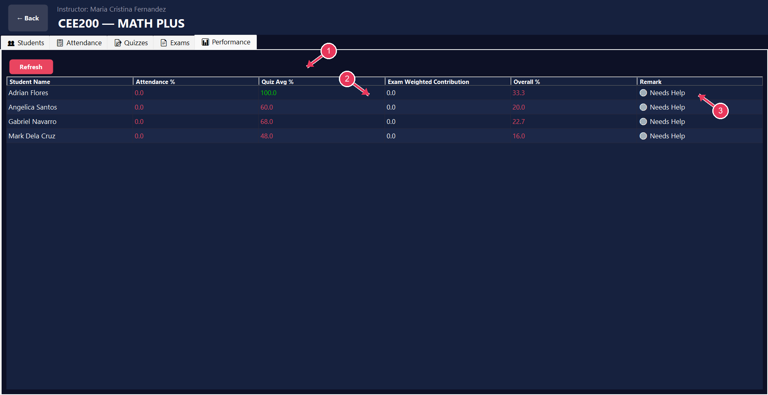
Figure 22. Course performance summary
1. Refresh performance: Reload the calculated course performance summary.
2. Performance measures: Compare attendance, quiz average, exam contribution, and overall percentage.
3. Remark: Use the remark to identify students who may need review or support.
- Choose Refresh to recalculate or reload the summary after updating attendance or assessment scores.
- Use the displayed remarks as a prompt to review student records; confirm grading policies with your institution.

Troubleshooting
- Sign-in fails: recheck the username and password; contact the administrator if the instructor account is disabled.
- A course or schedule is missing: confirm that the course is assigned to your instructor account, the term filter is correct, and the course days and time were saved correctly.
- A student is missing from a course: ask the administrator to confirm the enrollment and the selected course/program filters.
- A change does not appear: use the screen’s Refresh control or reopen the relevant page, then confirm the database is available.
- Need access or correction: send the administrator a message through Assist, including the affected course or record and a clear description.

