**WEBSITE: AUTOMATION EXERCISE**

**Test Plan, Design and Strategy**

**Content**

1. Introduction 3

2. Scope 3

2.1 Automatable Functionalities 3

2.2 Non-Automatable Functionalities 4

2.3 User Flow 4

3. Roles and Responsibilities 4

4. Risks Management y Emergency Preparedness 5

5. Test Environment and Testing Tools 5

5.1 Environment 5

5.2 Testing Tools 5

6. Automation Software Architecture 6

7. Acceptance Criteria 6

7.1 Entry Criteria 6

7.2 Exit Criteria 6

8. Automated Tests Planning 7

8.1 Timeline 7

8.2 Automation Sprint Planning 7

9. Test Results 8

9.1 Test Matrix 8

9.2 Test Report 8

# **Introduction**

This document describes the test automation strategy will be implemented as part of the “Automation Exercise” Project. Among the special points, the following stand out: scope, risks and emergency preparedness, environment and testing tools, design pattern, acceptance criteria, design and test execution; and test report.

# **Scope**

The type of testing will be implemented, it will be black box (tests based on functionalities). It will manage the following techniques:

* Equivalence partitioning -> the idea behind the technique is to divide a set of test conditions into groups or sets that can be considered as same. Partitioning usually happens for test objects, which includes inputs, outputs, internal values, time-related values, and for interface parameters.
* Boundary value analysis (BVA) -> consisting of numeric or sequential data. The minimum and maximum values of a partition are its boundary values.

On the other hand, the test cases covered will be automated for desktop and mobile versions.

## **Automatable Functionalities**

* Home Screen
* Product Details
* Cart and Cart Summary
* Check Out
* Account Creation / Sign Up
* Sign In
* Address
* Payment
* Order Confirmation
* Contact Us

## **Non-Automatable Functionalities**

Accessibility is not included.

## **User Flow**

1. User lands on the page and scroll to the middle.
2. User chooses a product and clicks on “View product” at the bottom of the image.
3. User enters the value 30 in the quantity field.
4. User clicks on “Add to cart” and after clicking on “View cart”.
5. User clicks on “Proceed to checkout”.
6. User enters an email and clicks on “Register/Log in”.
7. User enters a name and email in “New User Sign up”.
8. User enters the rest of the information and clicks on “Create Account’.
9. User clicks on “Continue” ubicated below of the title “Account Created!”.
10. User clicks on the shopping cart ubicated on the header.
11. User clicks on “Proceed to checkout”.
12. User enters a comment and clicks on “Place Order”.
13. User enters the information about fake credit card and clicks on “Pay and Confirm Order”.
14. User clicks on the continue button.
15. User clicks on “Log out” at the top on the header.
16. User enters the previously created account in “Log in your account”.
17. User clicks on the “Contact Us” ubicated on the header.
18. User fills out the form and clicks on the submit button.
19. User clicks on ”OK” button localized on the pop-up.
20. User clicks on the “Log out” button on the header.

# **Roles and Responsibilities**

|  |  |
| --- | --- |
| Roles | Responsibilities |
| QA Leader | Automation Testing planning and control  Report the testing progress |
| Automation Engineer / QA Analyst | Automation Test analysis and test design  Automated test execution  Report defects/bugs  Reporting the tests results |
| Product Owner / Stakeholders | Decisions making |

# **Risks Management y Emergency Preparedness**

# 

|  |  |  |  |  |  |
| --- | --- | --- | --- | --- | --- |
| N | Risk | Probability (1-5) | Impact (1-5) | Severity  (Pro * Imp) | Emergency Preparedness |
| 1 | Changes request in the automated test cases. | 3 | 4 | 12 | Prioritize the changed functionalities list for the next sprint. |

# **Test Environment and Testing Tools**

## **Environment**

The testing environment is “Automation Exercise website”: <https://www.automationexercise.com/>

## **Testing Tools**

|  |  |
| --- | --- |
| Tools | Description |
| Cypress (JavaScript) | Framework in order to automate the test cases of the project. |
| Viewport (Desktop and Mobile) | Desktop -> 1920 x 1080  Mobile -> 390 x 844 |
| Cypress Test Runner | **It is a graphical user interface (GUI) that allows you to easily visualize and debug your tests. Also, shows the test results (failed, passed and skip test cases).** |
| Browsers: Chrome and Electron. | Instances where the tests will be run. |
| Operating Systems | Windows and Mac |

# **Automation Software Architecture**

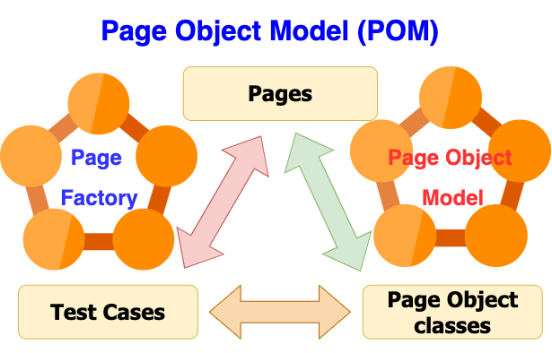

The project architecture is based on the **POM** (Page Object Model), which is a trending technique used in test automation in the Quality Engineering world. Simply put, the Page Object Model refers to using the Objects/Classes to depict and represent all the locators and functions (Components used for the automation) related to that particular page in a web application.

With the Page Object Model, you can simply break down a whole web application into multiple pages and use classes to depict those pages. In this way, each page in the web application corresponds to a particular class in the Page Object.  Also sometimes a single page in the application can be used across multiple classes in the Page Object, according to the functionalities of the page.

# **Acceptance Criteria**

## **Entry Criteria**

* The environment should be ready for testing previously.
* The website should have been tested manually.
* The high and blockers bugs should have been tested and closed previously.
* The Cypress framework should be installed and ready.
* The website pages should have some **data-qa** **data-testid**, **id** or **class** (not recommended) in order to localize the elements of the pages.

## **Exit Criteria**

* The most functionalities have been automated (>90%).
* The test cases have been executed successfully.
* There are not high and several open bugs.

# **Automated Tests Planning**

## **Timeline**

|  |  |  |  |
| --- | --- | --- | --- |
| Sprint | Functionalities (Pages) | Days | Commentaries |
| 1 | Home Screen | 1 |  |
| Product Details | 0,5 |  |
| Cart and Cart Summary | 1 |  |
| Check Out | 1,5 |  |
| Account Creation / Sign Up | 2 |  |
| Sign In | 0,5 |  |
| Address | 1 |  |
| Payment | 0,5 |  |
| Order Confirmation | 0,5 |  |
| Contact Us | 1,5 |  |
| Total | 10 | Sprint every 2 weeks |
| N |  |  |  |

## **Automation Sprint Planning**

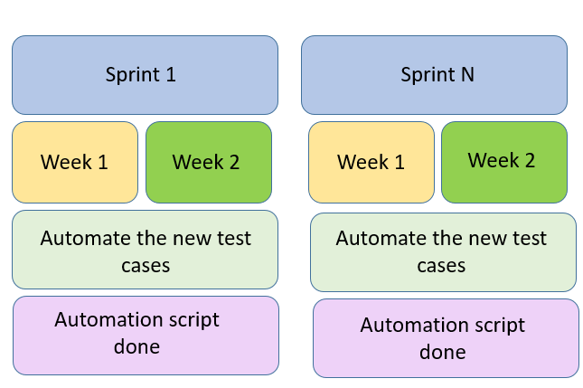

The automation tasks should start after the manual tests have finished. The sprint will be 2 every weeks, the automation team should begin the development of the automation scripts by pages or functionalities. The team will do continuous deliveries during the sprint and at the end of the sprint should be done all planned automation scripts.

# **Test Results**

## **Test Matrix**



## **Test Report**

|  |  |  |  |
| --- | --- | --- | --- |
| **Devices** | **Total Test Cases** | **Passed Test Cases** | **Failed Test Cases** |
| Desktop (1920 x 1080) | 26 | 26 | 0 |
| Mobile (390 x 844) | 26 | 26 | 0 |

The test report will be shown with some screenshots of the Cypress Test Runner for all automated modules.

* Home Screen (Desktop and Mobile)

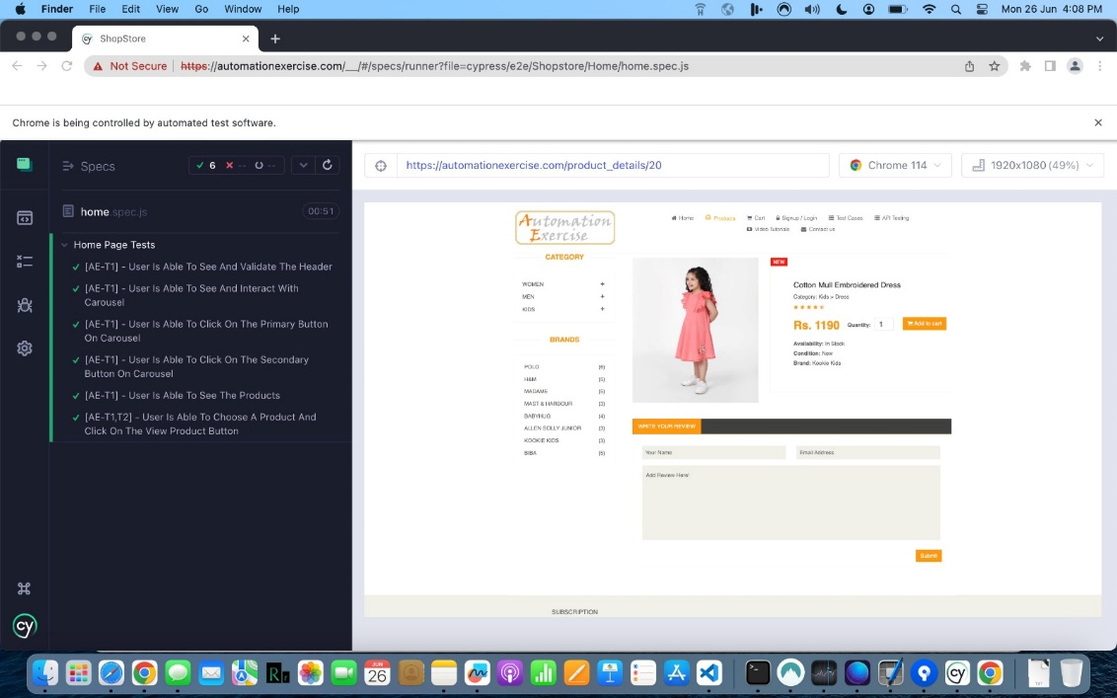

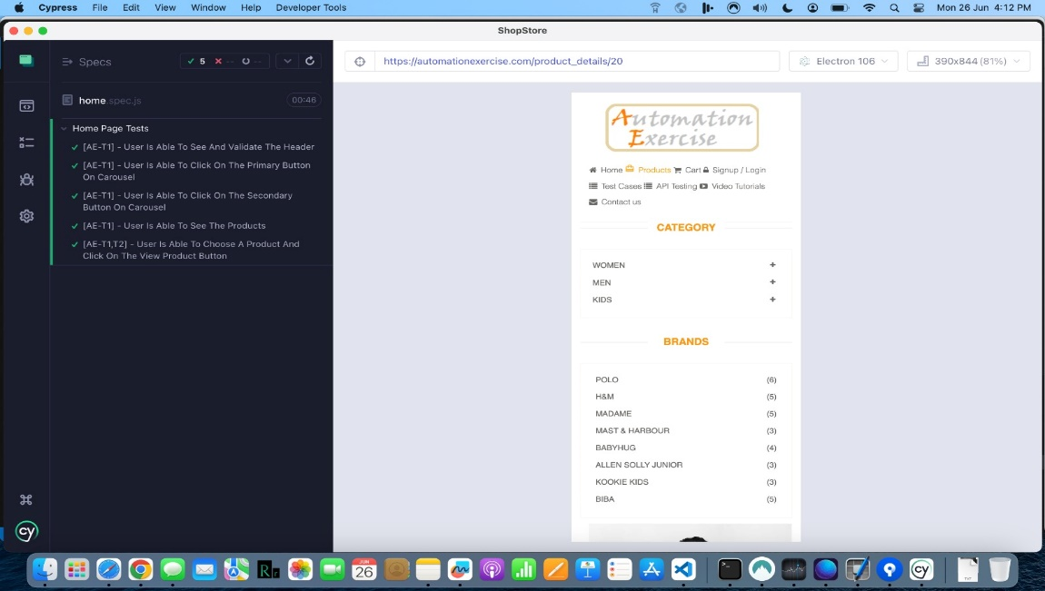

* Product Details (Desktop and Mobile)

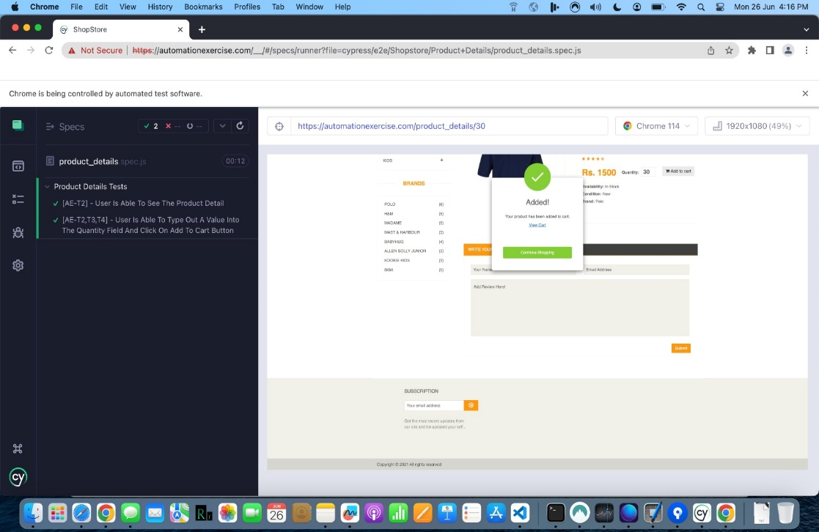

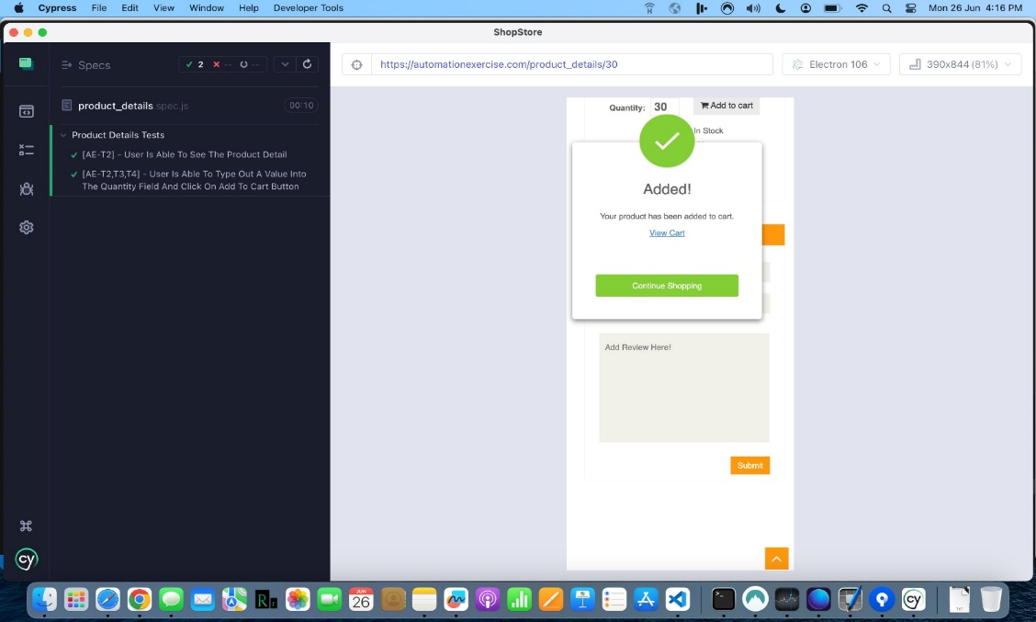

* Cart and Cart Summary (Desktop and Mobile)

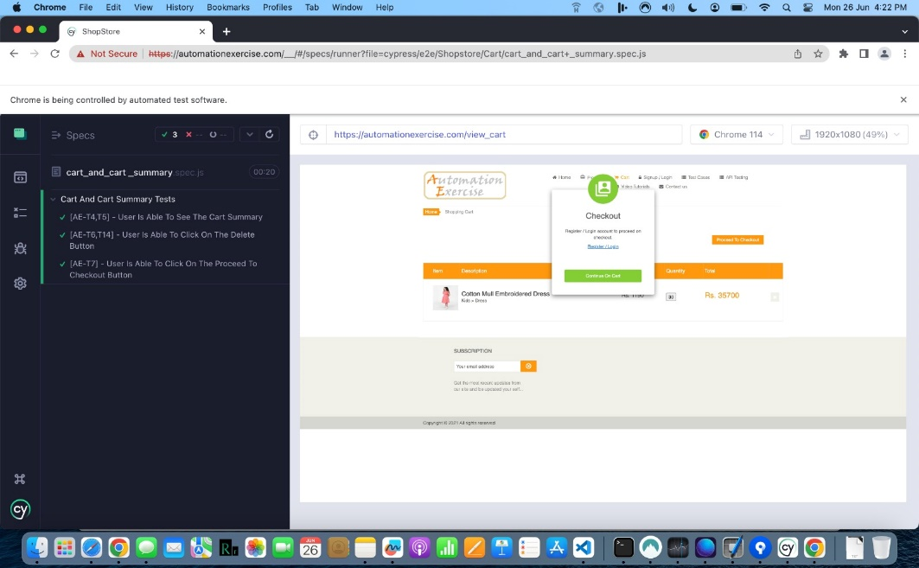

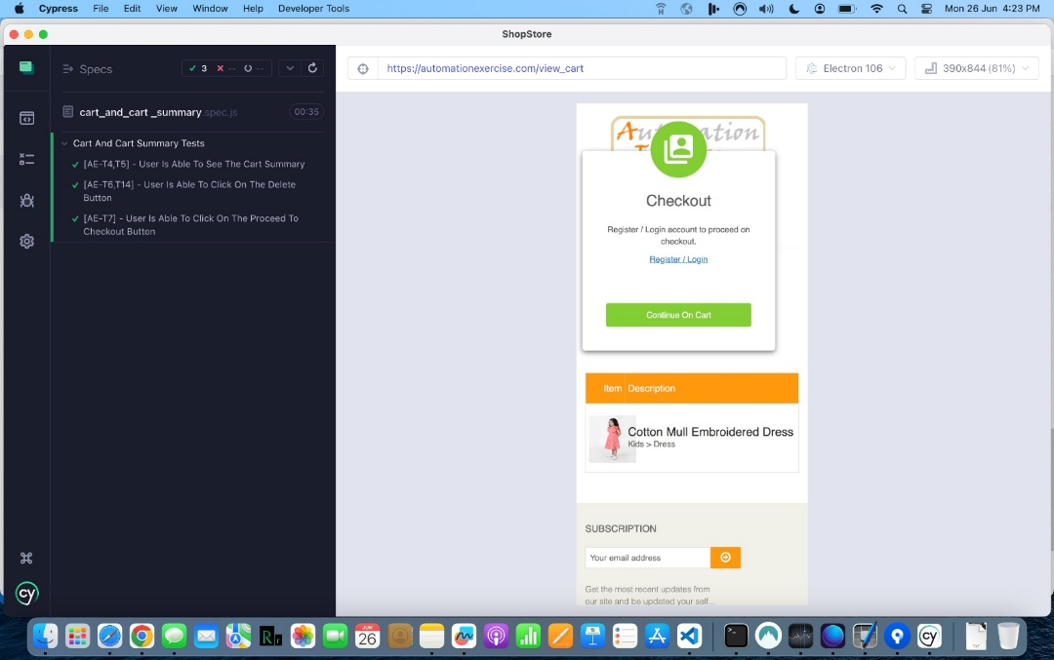

* Check Out (Desktop and Mobile)

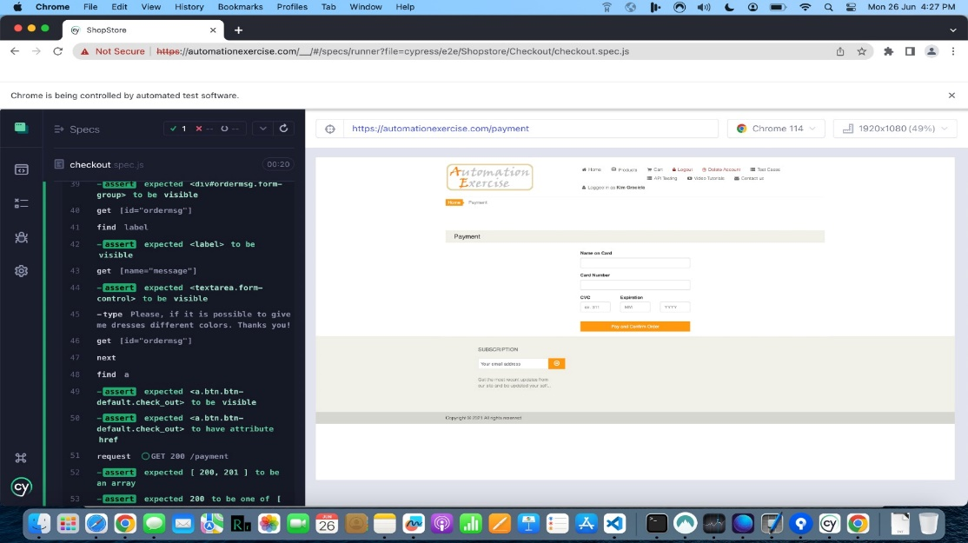

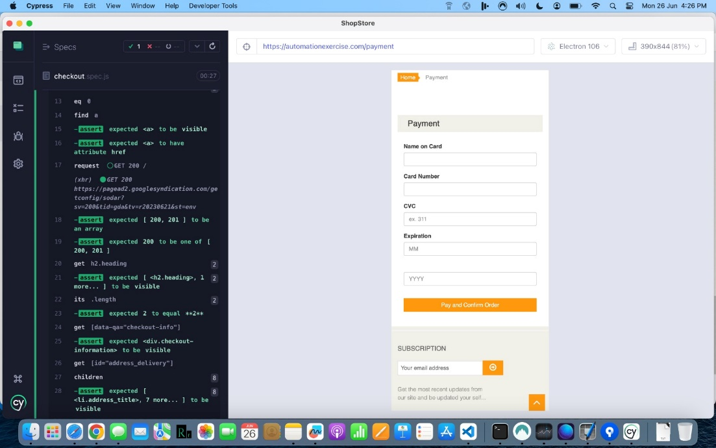

* Account Creation / Sign Up (Desktop and Mobile)

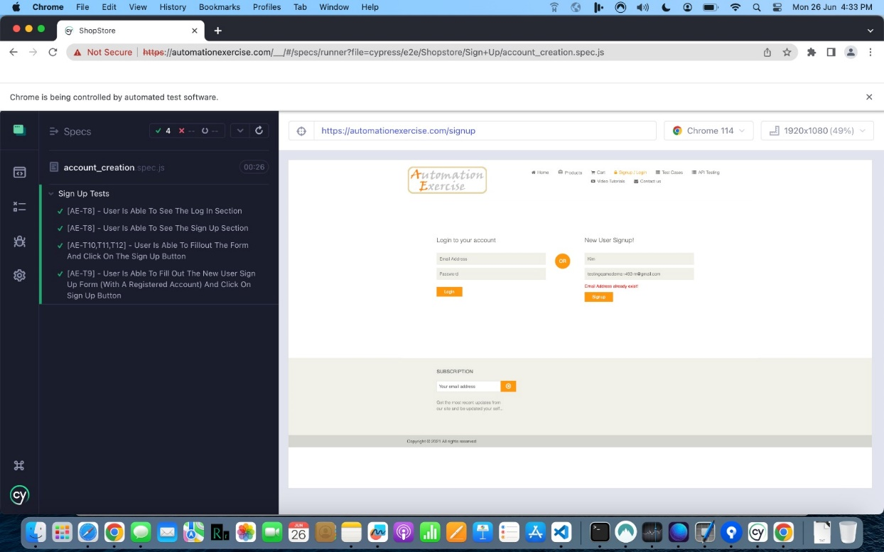

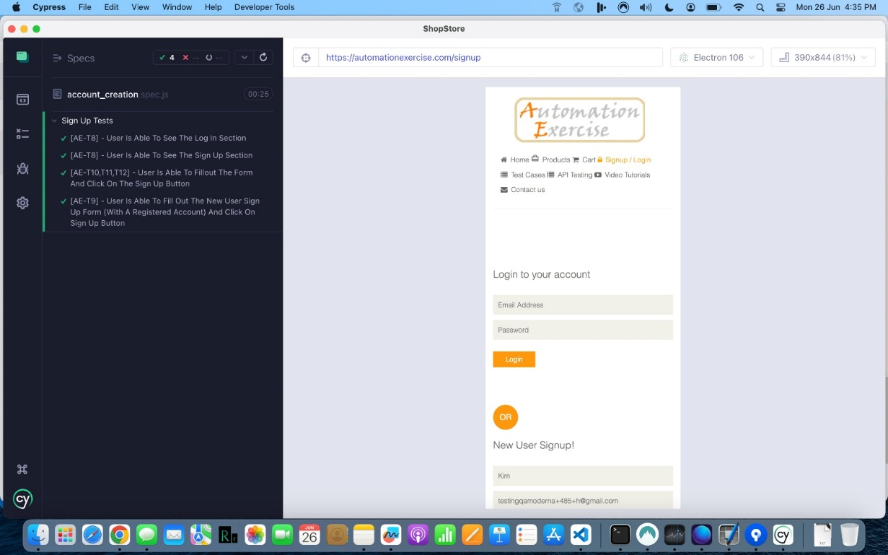

* Sign In (Desktop and Mobile)

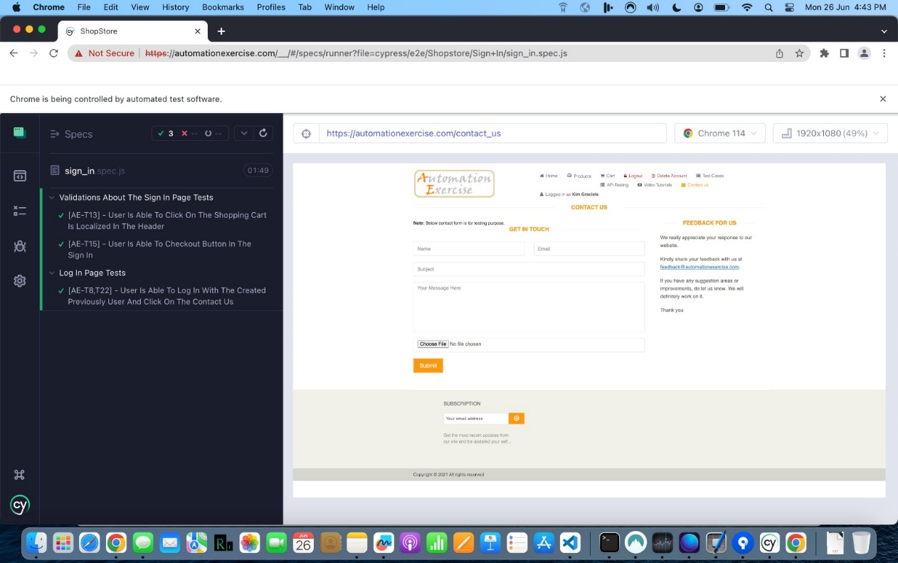

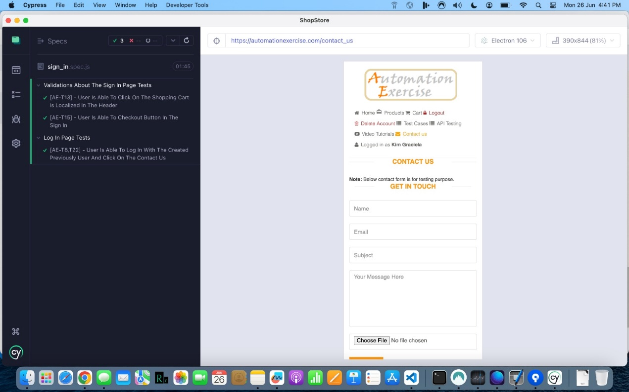

* Payment (Desktop and Mobile)

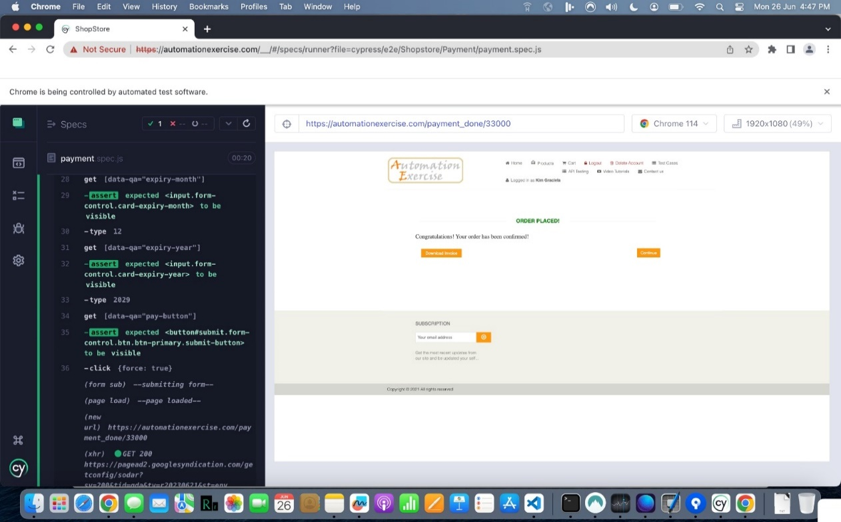

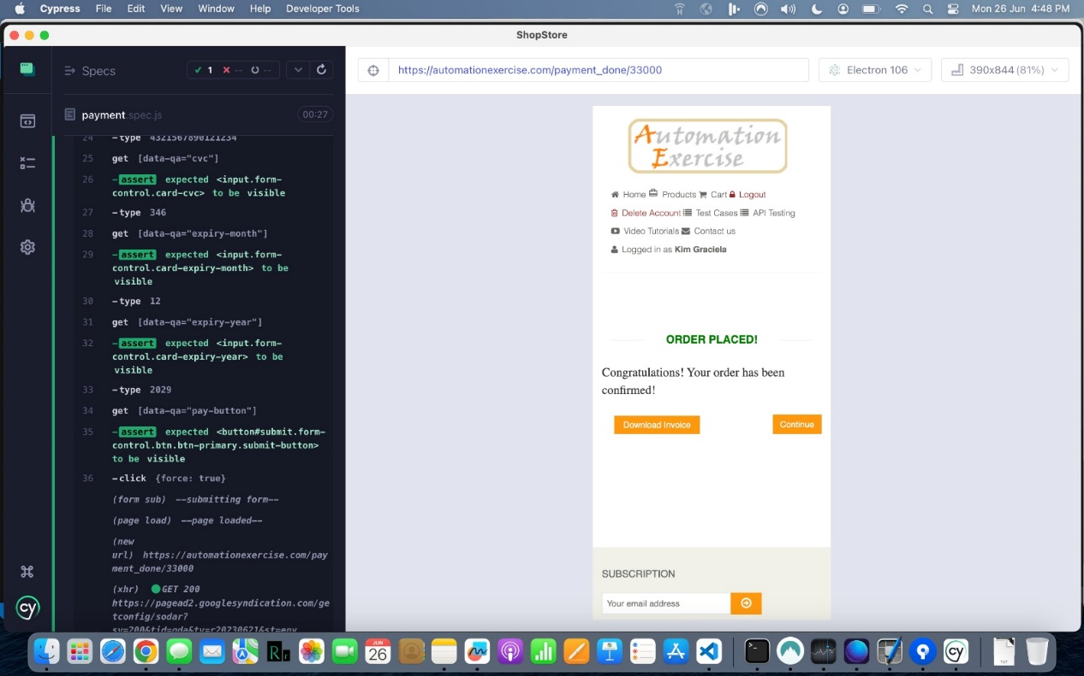

* Order Confirmation (Desktop and Mobile)

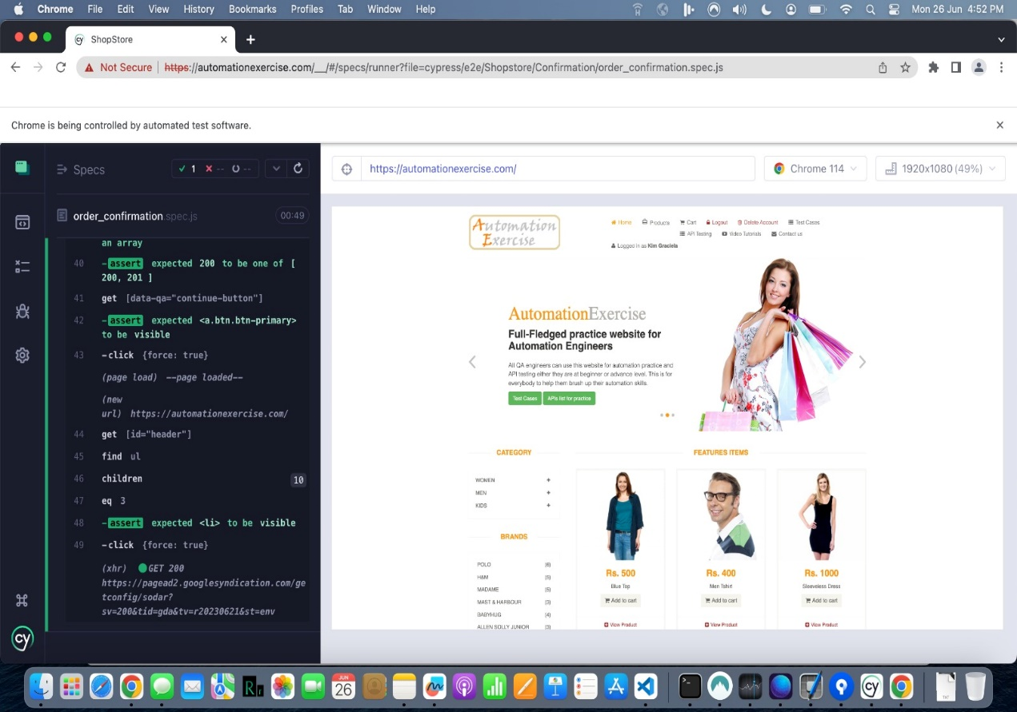

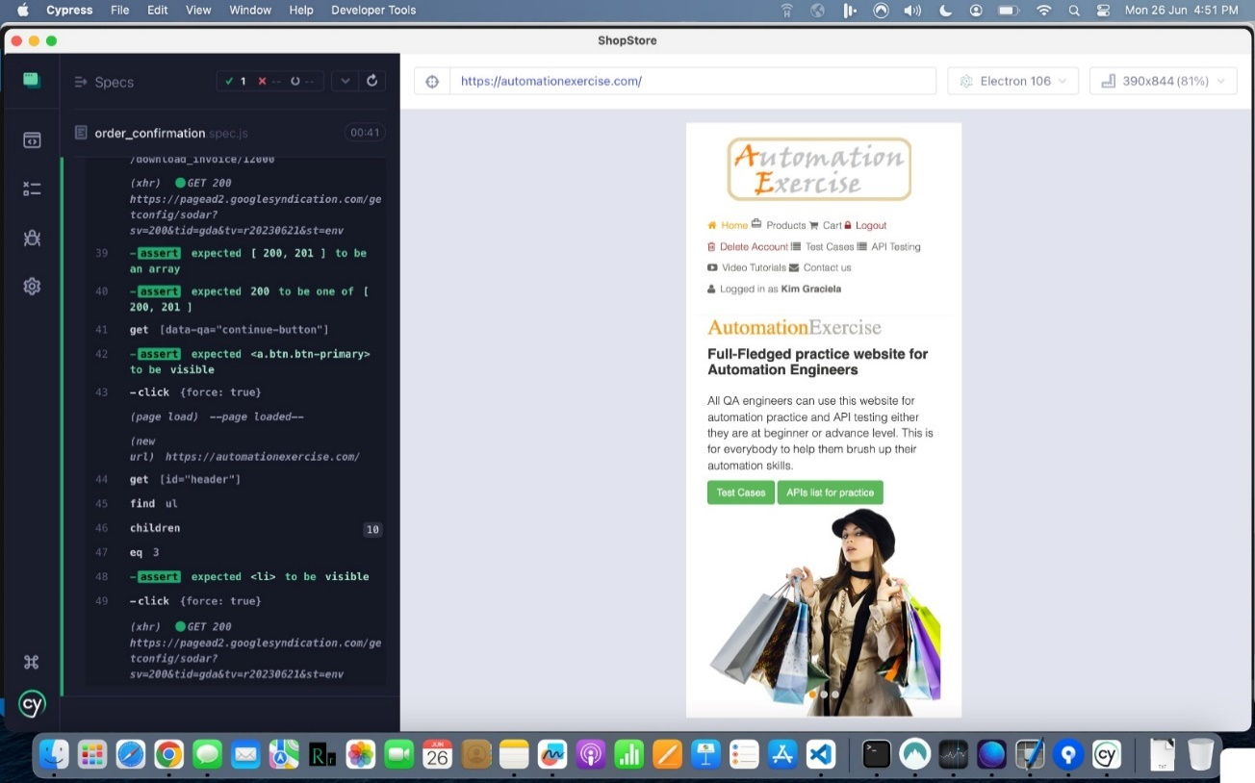

* Contact Us (Desktop and Mobile)

