YouTube Market Entry Strategy for New Creators

1. Business Problems and Project Goals
Over the past decade, rapid digital transformation has shifted consumer behavior toward online media platforms for entertainment and social interaction. YouTube has emerged as a global leader, consistently dominating U.S. streaming watch time for nearly three years. With over 2.7 billion monthly active users globally and more than 1 billion hours viewed daily in the U.S., the platform presents immense market potential. Its success is driven by accessible creation tools and monetization mechanisms, fueling a global creator economy exceeding $250 billion. As a result, an unprecedented number of aspiring creators are entering the market.
Despite its scale, growth on YouTube is highly unequal. As of 2025, the platform follows a power-law distribution: only 3% of the 60 million active channels exceed 10,000 subscribers, yet this small group accounts for over 90% of total viewership. This winner-take-all dynamic creates significant barriers for new creators, leading to high churn; over 90% of channels cease operations within their first year due to limited visibility and stagnant growth. At the same time, TikTok offers a more decentralized discovery model, lowering entry barriers and intensifying competition. This creates a strategic risk of a “creator pipeline” drain away from YouTube.
This study addresses the following research question: how can micro-creators (channels with fewer than 10,000 subscribers) systematically gain traction and succeed within a highly concentrated and competitive content ecosystem? To answer this question, the project leverages NLP and clustering techniques to uncover hidden content gaps and growth opportunities. The objective is to develop a data-driven roadmap that provides actionable insights for new creators on what to film, when to post, and how to engage effectively with their audience.
The remainder of this paper is structured as follows. The Data and Methodology section outlines data collection, preprocessing, and the analytical framework. The Market Landscape Analysis section applies K-Means clustering to segment creators and identifies strategic positioning. The Content Gap Discovery section uses NLP techniques to analyze differences between high- and low-performing content, followed by detailed results and recommendations. The Tag Strategy section evaluates tag effectiveness, optimal tag combinations, and the impact of hashtag quantity. The Timing and Duration section examines optimal posting windows and video length strategies. Finally, the Actionable Roadmap section synthesizes key findings into a practical playbook for new creators and discusses limitations and future research directions.

2. Data & Methodology

2.1 Data Collection
Data for this study was collected using the YouTube Data API to analyze video and channel performance across different creator segments. Two datasets were constructed for comparative analysis: a micro-creators dataset consisting of channels with fewer than 10,000 subscribers (n = 1,091), and a large channels dataset consisting of channels with more than 10,000 subscribers (n = 1,178). This segmentation enables a focused examination of early-stage creators while providing a benchmark against more established channels.
The dataset includes a comprehensive set of variables capturing multiple dimensions of performance. These include engagement metrics such as view_count, like_count, and comment_count; channel characteristics such as subscriber_count; content metadata including video_title, description, and tags; temporal features such as published_at; and video attributes such as duration. Additionally, text-based metadata supports downstream natural language processing (NLP) analysis and feature engineering, enabling deeper insights into content and audience engagement patterns.

2.2 Data Preprocessing
Prior to analysis, the dataset underwent several preprocessing steps to ensure data quality and consistency. First, filtering criteria were applied to remove invalid observations, such as videos with zero views, and to enforce logical constraints, including restricting like_rate to values less than or equal to one. These steps help eliminate noise and ensure the reliability of subsequent analysis.
To address the highly skewed distribution of engagement metrics such as view_count and like_count, logarithmic transformation was applied. Feature scaling was also conducted to normalize variables and improve comparability across different ranges. In addition, several derived features were engineered to enrich the dataset, including engagement metrics such as like_rate, temporal features such as publish_hour and post_day, and content-related variables such as duration_sec. These transformations enhance the dataset’s suitability for clustering and modeling tasks.
Despite these efforts, certain limitations remain. Some variables contain missing values, and tag coverage is incomplete (approximately 30%), which may limit the depth of content-based analysis.
2.3 Analytical Methods Overview
The analytical framework for this study is structured into four sequential phases, each designed to address a specific aspect of the research question.
In Phase I, K-Means clustering is applied to perform market segmentation, grouping creators based on performance-driven features to identify distinct strategic patterns. Phase II focuses on content and audience insights through NLP techniques, including sentiment analysis and topic modeling, to uncover differences between high- and low-performing content.
Phase III is divided into two components. Phase III-A applies association rule mining to identify effective tag combinations and optimize content discoverability strategies. Phase III-B utilizes time series analysis to examine temporal patterns, enabling the identification of optimal posting times and video duration strategies for micro-creators.
Together, these methods provide a comprehensive and data-driven approach to understanding how new creators can gain traction in a highly competitive environment.

3. Market Landscape Analysis
In order to uncover the opportunities for new creators, understanding the whole picture of the market landscape, types of creators help the new creators to better find a way to get in.
3.1 Creators K-mean Clustering Methodology

Step 1: EDA & Problem Context

We began by performing Exploratory Data Analysis (EDA) on both micro and large-channel datasets. As shown in Figure X (the Log-Log Scatter Plot and KDE Density Plot), the data exhibits a clear power-law distribution. The extreme skewness of raw counts (e.g., view_count, subscriber_count) suggests that these metrics, while indicative of scale, are highly susceptible to outliers, making them less effective for identifying nuanced strategic behaviors.

Step 2: Feature Selection Logic

To capture the underlying strategic nature of content creation rather than just the "size" of the channel, we pivoted to performance-based metrics: duration_sec, like_rate, and efficiency_ratio. While subscriber_count and view_count are important, they act as lagging indicators of scale. By utilizing like_rate and efficiency_ratio, we measure the effectiveness of content—which is a more actionable variable for creators of all sizes, independent of their existing reach. These metrics are more robust against extreme outliers and provide a clearer view of the "strategy" behind the engagement.

Step 3: Model Selection (K-Means)

We implemented K-Means clustering to segment the market. To determine the optimal number of clusters, we utilized both the Elbow Method and Silhouette Score Analysis to decide K value. While K=3 provided a baseline structure, the Silhouette Score for K=4 yielded better-defined cluster boundaries and more interpretable segments. This choice allowed us to isolate the creators in the most effective way.

3.2 Market Segmentation
We identified four distinct creator archetypes through K-Means clustering. These archetypes represent unique "strategic battlegrounds" on the YouTube landscape:
Rising Stars (Cluster 0): This cluster has balanced, mid-range metrics across the board. These creators represent the platform’s primary growth engine. These creators balance efficiency and engagement, serving as the baseline for emerging successful content.
Community Builders (Cluster 1): This cluster has an exceptional like rate (52.7%), vastly outperforming others. This is the "high-engagement" niche. Even with a smaller count, their content resonates deeply with a specific audience, proving that deep connection can be more valuable than sheer volume.
Authority Archives (Cluster 2): This cluster has a relatively massive duration (4,384s) compared to all other segments. These are the "long-form" content creators. They build value through depth and longevity. While their efficiency is lower, their high duration signals high audience retention—a hallmark of brand authority.
Viral Elite (Cluster 3): This cluster has extremely low duration (34.9s) but massive efficiency (184.1). These creators are masters of the "short-form" algorithm. They prioritize velocity and reach over depth, making them the most "efficient" at gaining views per unit of effort.
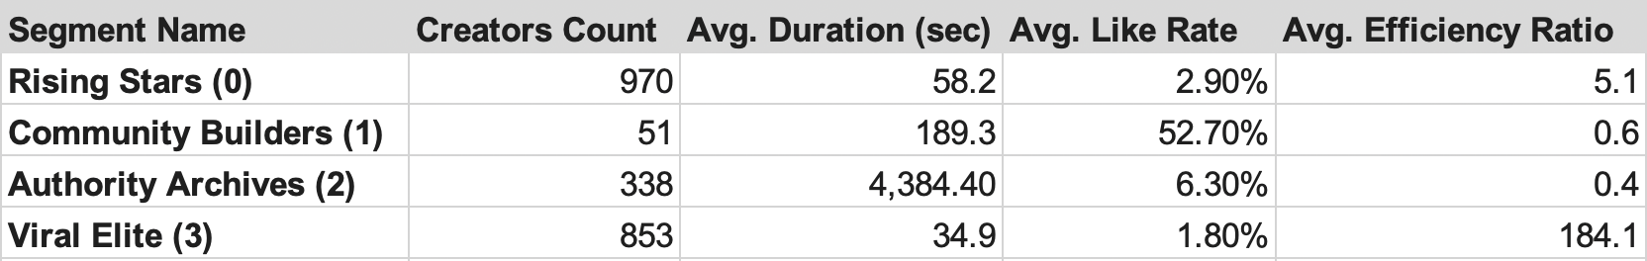
The map below shows a more clear vision of how creators were located in the market. validates that success on YouTube isn't random; it is defined by your strategic position—whether you choose to compete on engagement, authority, or viral efficiency.
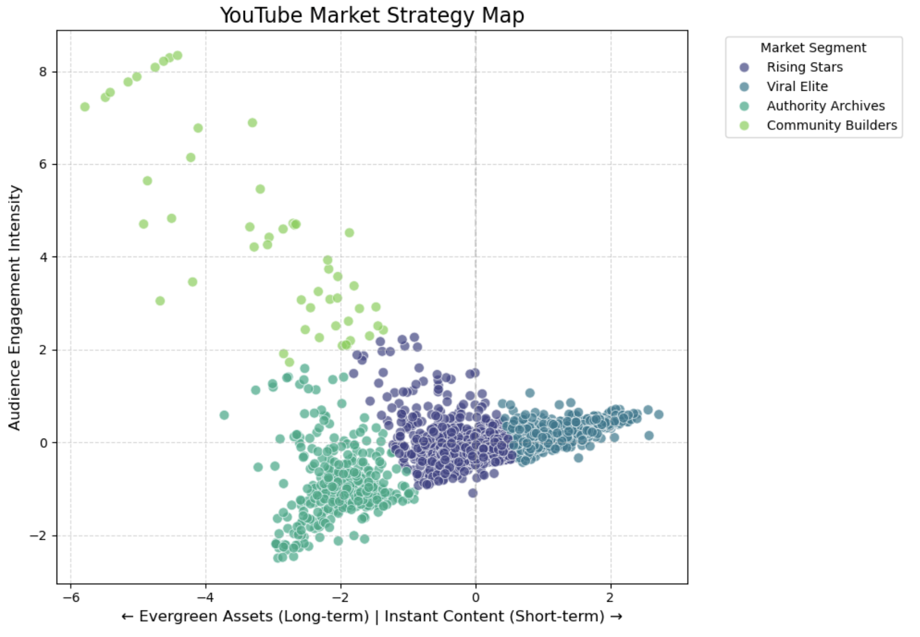

3.3 Market Opportunities
To understand how creators grab the right market opportunities and scale their channels, we moved beyond static analysis and conducted a Growth Lever Analysis. To quantify the transition between strategic archetypes, we used the Rising Stars (Cluster 0) segment as our growth benchmark. By calculating the performance ratio of each cluster relative to this baseline (as shown in Figure X), we mapped the specific "levers" that creators must pull to evolve their business models.
Our heatmap reveals a stark strategic divergence. While the Viral Elite (Cluster 3)operates by maximizing the efficiency_ratio (36x relative to the baseline), the Authority Archives (Cluster 2) shift their focus entirely to duration_sec (75x relative to the baseline). This proves that there is no "one-size-fits-all" growth strategy; creators must fundamentally transform their content DNA when moving from viral-based to authority-based growth. The Community Builders (Cluster 1) demonstrate the highest like_rate (18x relative to the baseline). This identifies a specific growth lever: for creators struggling to compete on volume or efficiency, focusing on deep community engagement provides a viable path to stability.

The heatmap below effectively serves as a "GPS" for creators. It illustrates that growth is not just about producing more content, but about sequencing the right levers at the right stage of the channel's lifecycle.
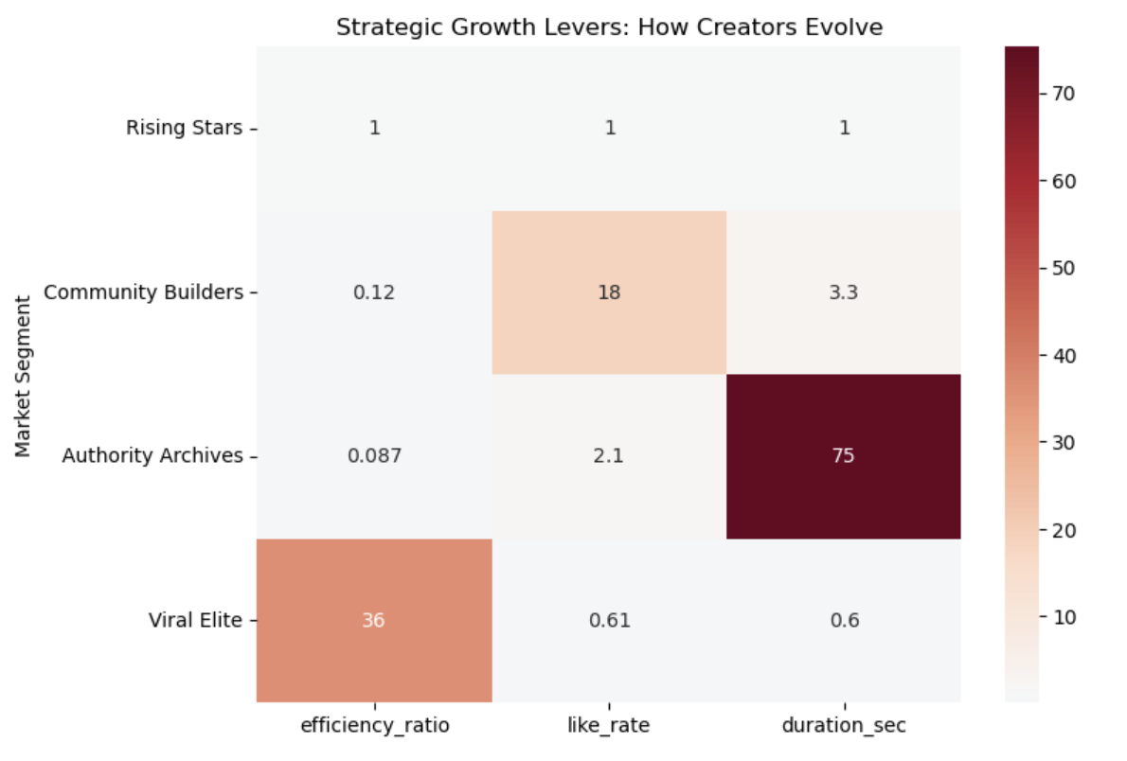
To quantify market attractiveness, we constructed a Content Opportunity Map using a Demand-Supply framework. By calculating the Opportunity Score (Demand / Supply), we visualized the strategic landscape:
- Blue Ocean Strategy: The Pets & Animals category represents a clear 'Blue Ocean,' characterized by high audience demand and limited creator supply. For new entrants, this category minimizes competition while maximizing the probability of algorithmic discovery.
- Red Ocean Warning: Conversely, the People & Blogs category resides in the 'Red Ocean' quadrant. The data shows high saturation with diminishing marginal returns on viewership, suggesting that creators entering this space without a unique value proposition face significant growth headwinds.
The Opportunity Map demonstrates that creators should not choose categories based on personal preference alone. Instead, they should utilize this data-driven framework to select niches where their content efforts are most likely to yield high audience engagement, effectively optimizing their 'Growth Leverage'.
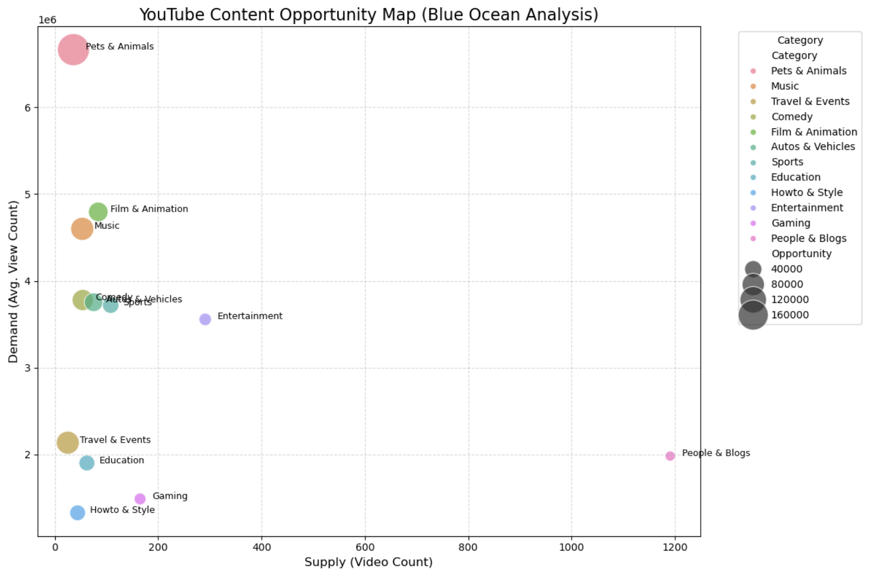

4. Content Strategy Optimization: Sentiment & Topic Gaps

4.1 Research Question
This chapter addresses a core question: do high like-rate micro-creators use systematically different language from low like-rate creators? Two sub-questions guide the analysis. First, whether high-performing videos carry a more positive or emotionally expressive tone. Second, whether successful creators occupy more distinct content niches while the low-performing group is over-concentrated in saturated content categories.

4.2 Data
The dataset was collected via the YouTube Data API v3 and contains 1,090 video records from channels with fewer than 10,000 subscribers, including video titles, descriptions, hashtags, top comments, and engagement metrics. Videos were split into balanced High and Low like-rate groups of 545 each using like rate (likes divided by views) as the grouping criterion. The dataset captures three signal types simultaneously: quantitative engagement metrics, content metadata, and audience reaction text, making it well suited for multi-dimensional NLP analysis. A notable limitation is that the data was assembled through keyword-driven API queries, resulting in over-representation of Indian creators; this is considered when interpreting cultural vocabulary findings.

4.3 Analytical Methods

4.3.1 VADER Sentiment Analysis
VADER (Valence Aware Dictionary and Sentiment Reasoner) is a rule-based sentiment tool designed specifically for social media text. It recognises punctuation emphasis and platform-specific expressions, producing a compound score from -1 to +1. VADER was applied to raw, uncleaned full text (title, description, and comments combined) to preserve exclamation marks, capitalisation, and other emotional cues that would be lost by pre-cleaning. A binary flag was added for videos with compound scores above 0.8, labelled strongly positive, to capture the most emotionally expressive content.

4.3.2 Distinctive Keyword and Bigram Analysis
Standard English stopwords were extended with generic platform terms including video, vlog, study, youtube, and subscribe, ensuring that only vocabulary with genuine discriminatory value remains. Mean term frequency was then computed per group and ranked by High-minus-Low difference. Bigram analysis was conducted separately on comments with a VADER compound score above 0.5, isolating positively engaged responses. Two-word phrase patterns reveal whether audiences are engaging with specific content themes or simply repeating promotional keywords.

4.3.3 LDA Topic Modeling
Latent Dirichlet Allocation (LDA) was chosen over k-means clustering of TF-IDF vectors because it produces soft topic assignments, better reflecting the reality that a single video may span multiple themes. LDA was run separately for each group with five topics on the title-and-description field only, excluding comments to keep the model focused on creator intent. The key output is the dominant topic distribution across each group, with distribution entropy computed to quantify topical concentration as a proxy for market saturation.

4.4 Results

4.4.1 Sentiment Analysis
High like-rate creators score a mean compound of 0.419 versus 0.327 for the Low group, a gap of 0.092. The strongly positive share is 33.0% for High and 22.9% for Low, a difference of 10.1 percentage points (Table 4.1 and Figure 4.1). This indicates that successful micro-creators are not merely marginally more positive in tone but are substantially more likely to produce content that reads as genuinely enthusiastic and warm.

Metric | High Like-Rate | Low Like-Rate | Difference
Mean Compound Score | 0.419 | 0.327 | +0.092
Strongly Positive Share (>0.8) | 33.0% | 22.9% | +10.1 pp
Mean Positive Component | 0.141 | 0.133 | +0.008
Mean Neutral Component | 0.839 | 0.853 | −0.014
Table 4.1 VADER sentiment scores by group
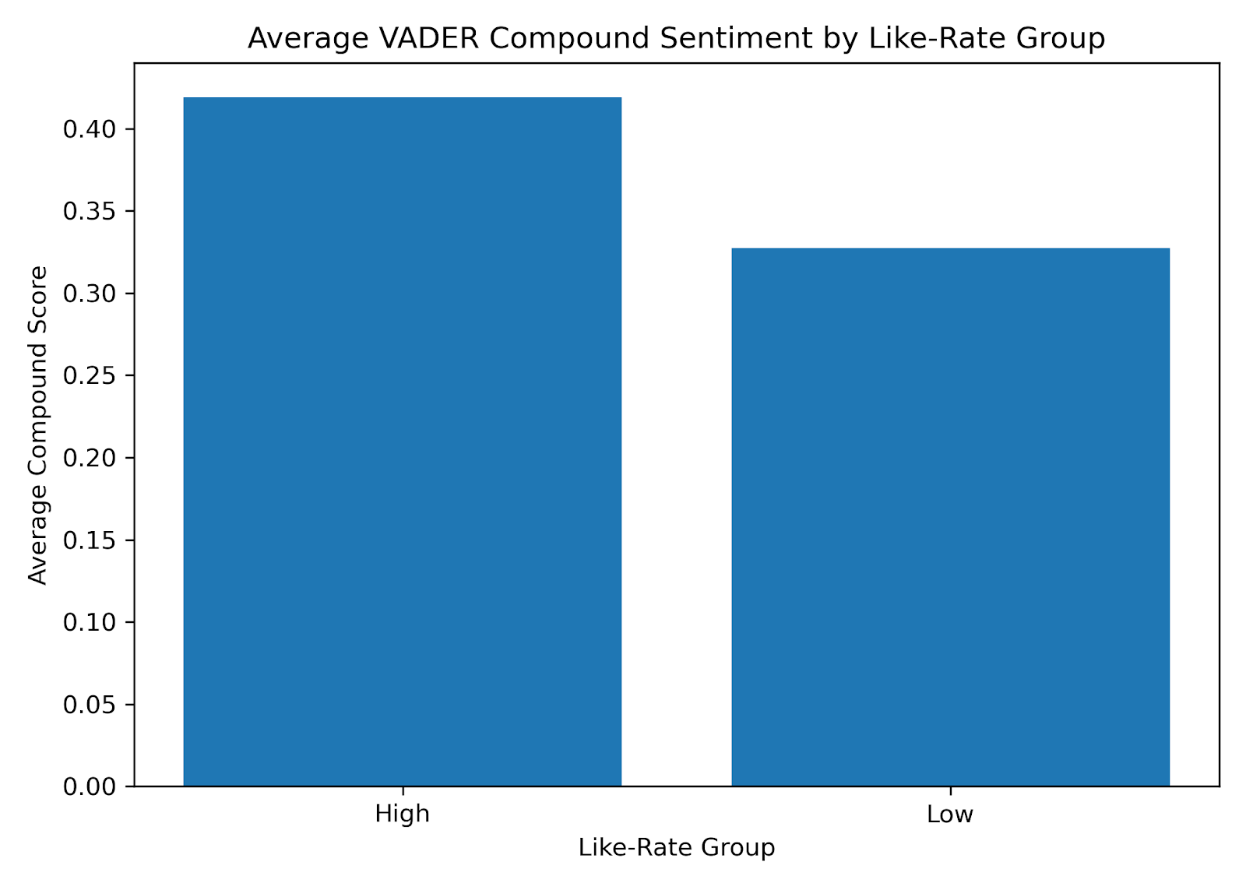 | 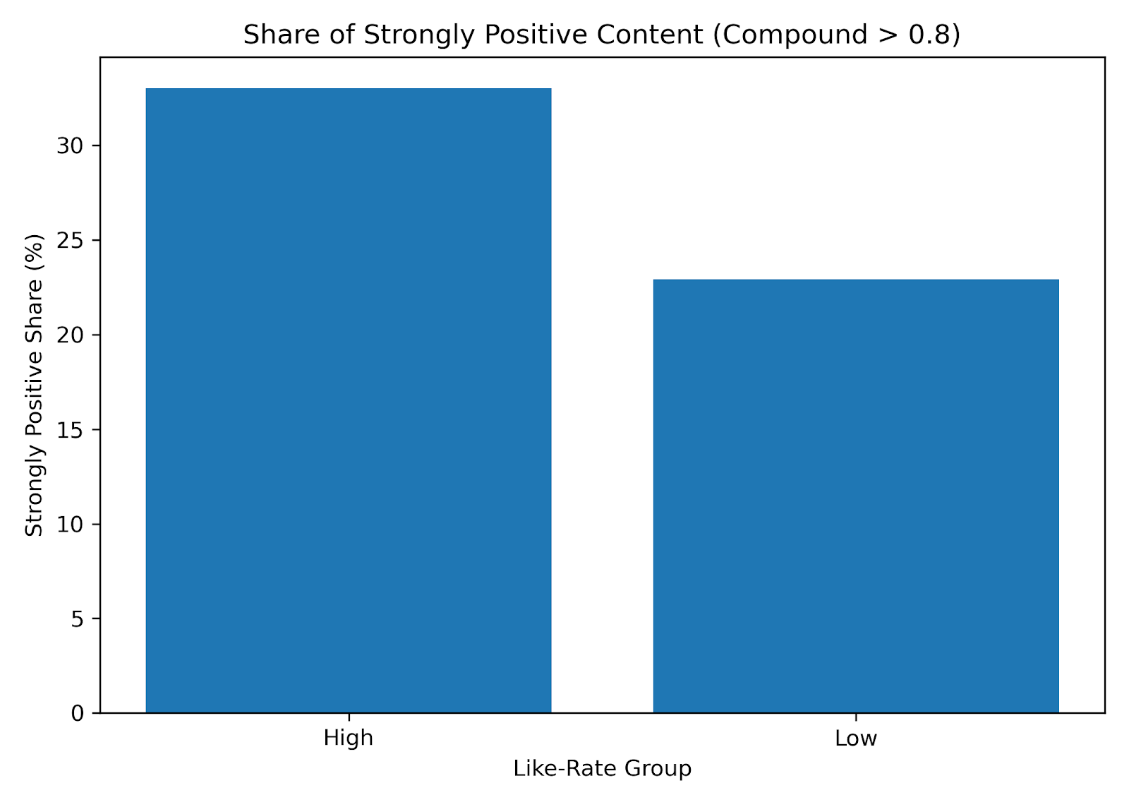
Figure 4.1 Mean VADER compound score (left) and strongly positive share (right) by group

4.4.2 Distinctive Keywords and Bigrams
After custom stopword removal, the two groups diverge sharply. The word "jee" (the Indian Joint Entrance Examination) carries the largest frequency gap of any term at +0.657. Words including haridwar, shayari, assamese, and ganga appear exclusively in the High group with zero frequency in Low, while the Low group is dominated by broad categorical terms such as food, aesthetic, and class (Table 4.2 and Figure 4.2). Positive comment bigram analysis reinforces this divide: High group comments contain identity-specific phrases such as "jee aspirant", "love shayari", and "ganga aarti", while Low group comments show repeated-word patterns including "class class" and "how how", which are characteristic of keyword stuffing rather than genuine audience expression (Figure 4.3).

High Like-Rate Keywords | Diff | Low Like-Rate Keywords | Diff
jee (exam prep) | +0.657 | food | −0.163
haridwar (holy city) | +0.191 | ssc (civil service exam) | −0.161
shayari (Urdu poetry) | +0.165 | class | −0.136
iit (tech institute) | +0.165 | aesthetic | −0.125
assamese (regional culture) | +0.105 | upsc (civil service exam) | −0.132
Table 4.2 Top distinctive keywords ranked by frequency difference
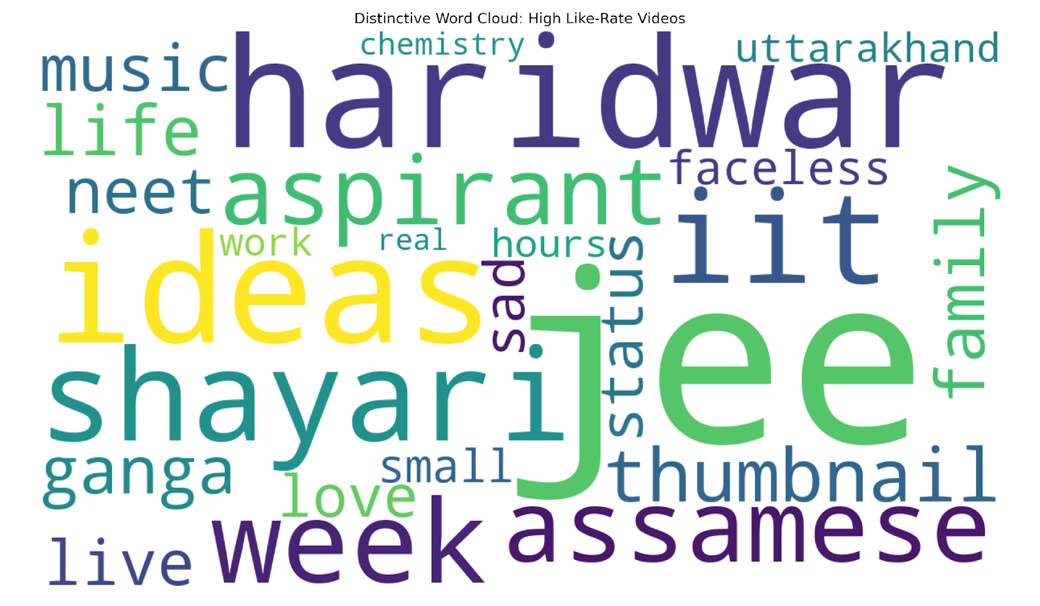 | 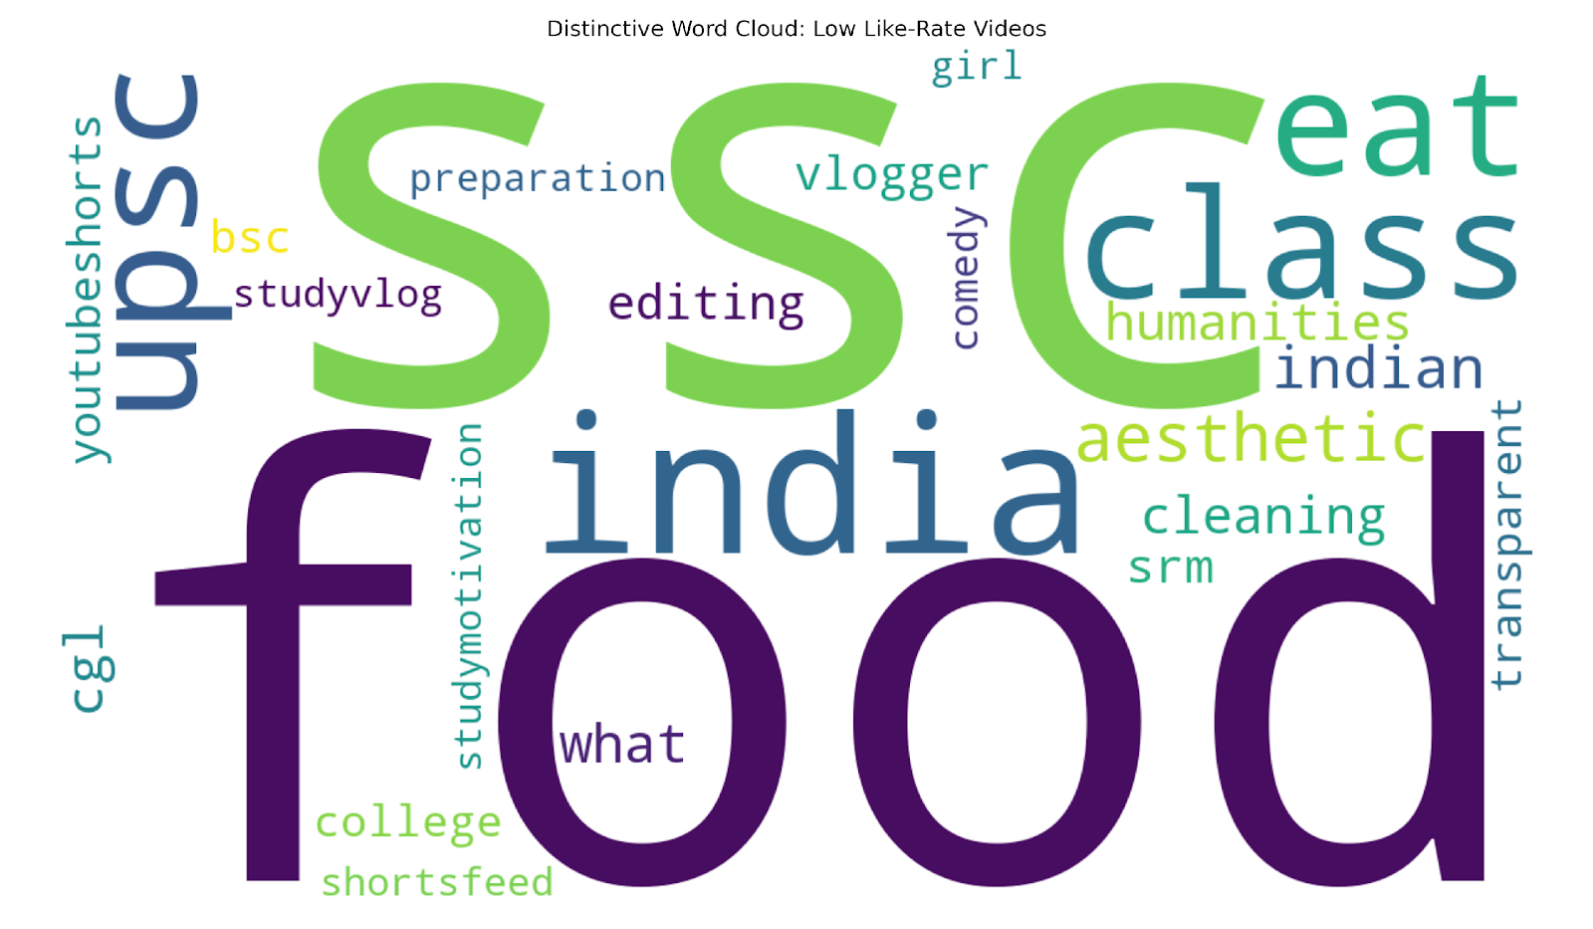
Figure 4.2 Distinctive word clouds: High (left) and Low (right) like-rate groups
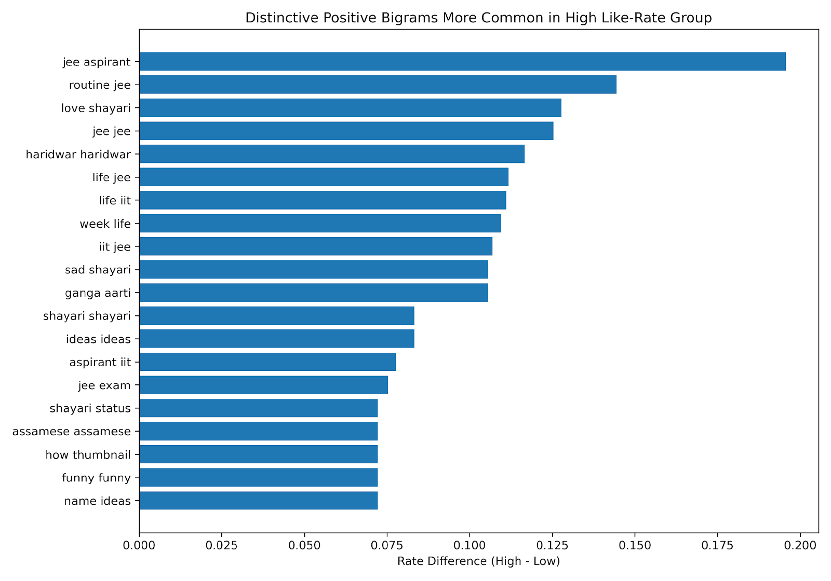 | 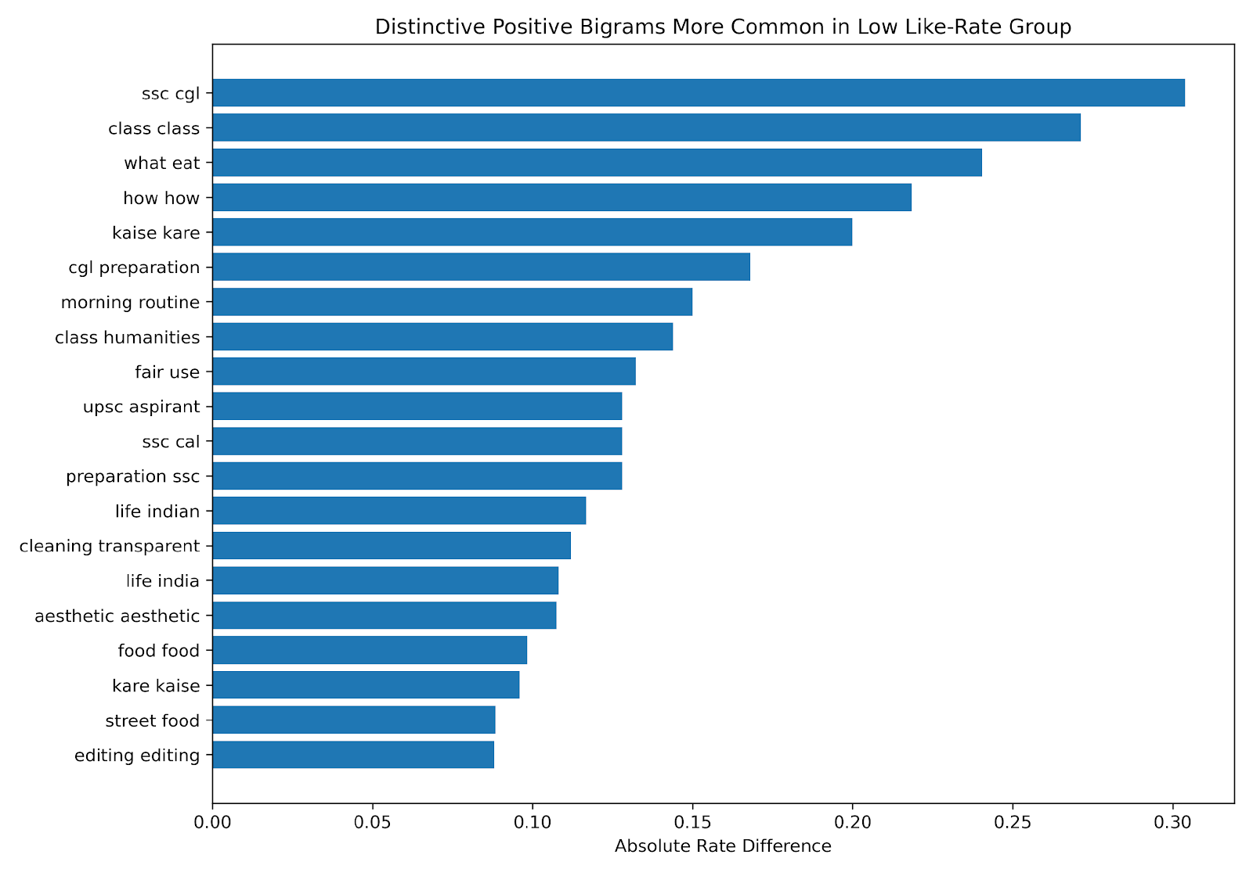
Figure 4.3 Positive comment bigrams: High (left) and Low (right) like-rate groups

4.4.3 LDA Topic Distribution
The High group spreads evenly across five topics, with shares ranging from 9.9% to 26.8% and a distribution entropy of 1.565. The Low group's Topic 1 (daily routines and lifestyle aesthetics) dominates at 39.0%, with entropy falling to 1.507 and the maximum topic share 46% higher than the High group's maximum (Table 4.3 and Figure 4.4). This concentration is a structural indicator of market saturation: when most videos in a category pursue the same formula, individual creators have limited room to differentiate.

Topic | High Group Theme | Share | Low Group Theme | Share
T1 | Hindi culture and personal expression | 22.9% | Daily routines and lifestyle aesthetics | 39.0%
T2 | Weekly life, food, focus and work | 18.9% | Study and UPSC exam prep | 12.7%
T3 | Small creator growth journey | 26.8% | SSC exams, gaming, channel support | 19.4%
T4 | Funny content, aesthetics, music | 21.5% | Food vlogs and what-I-eat content | 15.0%
T5 | JEE and NEET aspirant daily life | 9.9% | Comedy, college, aesthetic cleaning | 13.9%
Table 4.3 LDA topic themes and dominant-topic distribution by group
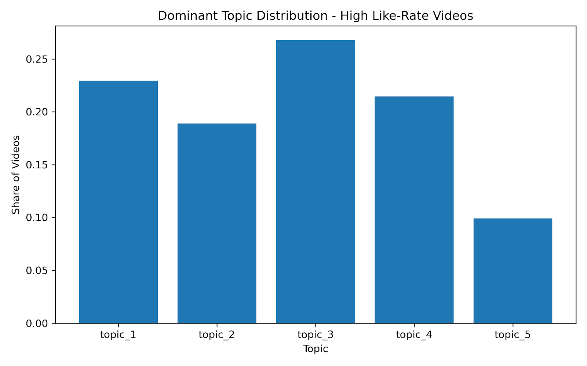 | 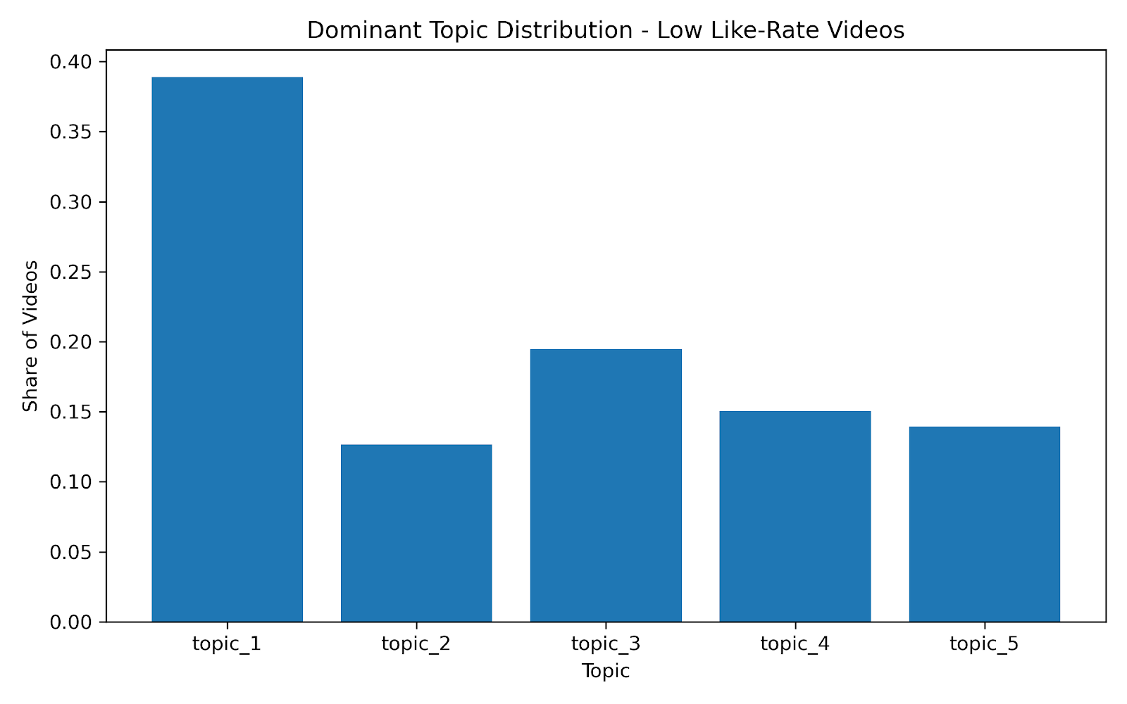
Figure 4.4 Dominant topic distribution: High (left) and Low (right) like-rate groups

4.5 Conclusions and Recommendations
Five conclusions emerge from the NLP analysis. On sentiment, the High group's compound score is approximately 28% higher and its strongly positive content share is 10 percentage points greater, indicating that audiences respond more actively to content with genuine emotional warmth. On vocabulary, the word "jee" alone generates a frequency gap of +0.657 and cultural words including haridwar, shayari, and assamese appear exclusively in the High group, confirming that deep cultural identity content outperforms generic national labels. On comment quality, High group comments use emotionally expressive, identity-specific phrases, while Low group comments display repeated-word patterns that signal keyword stuffing rather than real engagement. On topic structure, the Low group's 39% concentration in a single content category is a structural marker of market saturation. Based on these findings, new creators should write in a personal, emotionally engaged voice; commit to one identity niche and name the target audience directly; leverage specific cultural vocabulary as a differentiator; and maintain four to five content pillars, capping any single format at 25% of uploads to avoid the saturation trap.

5. Tactical Optimization — Tag Strategy
This chapter investigates the role of tag strategy in helping micro-creators gain traction on YouTube. Three questions are examined: what defines an effective tag, what types of tags are associated with higher engagement, and whether hashtag quantity affects discoverability and audience fit. Analysis draws on both the micro dataset (n=1,035) and large channel dataset (n=1,174) to provide comparative insights where relevant.
5.1 Defining Tag Effectiveness: A Two-Dimensional Framework
Tags on YouTube serve two distinct functions: increasing a video's discoverability by signaling its content to the algorithm and improving audience fit by ensuring the video reaches viewers who are genuinely interested. To evaluate tag effectiveness along both dimensions, this study constructs a two-dimensional framework using views as a proxy for discoverability and like rate as a measure of audience fit.
5.2 Which Tags Perform Best?
5.2.1 Tag type distribution: like rate vs views
To evaluate tag effectiveness along both dimensions introduced in 5.1, mean like rate — the ratio of likes to views averaged across all videos using a given tag — is used to measure audience fit, while mean view count measures discoverability. Tags appearing fewer than 10 times are excluded to ensure statistical reliability. The top 15 and bottom 15 tags are identified separately for each metric. All 30 tags per ranking are categorized into four types — Identity (describing who the creator is), Content-specific (describing what the video is about), Audience-descriptor (describing who the target audience is), and Format-chasing (describing the video format or trending style) — to examine whether systematic patterns exist across tag types.
This divergence directly reflects the trade-off between the two dimensions of tag effectiveness. Format-chasing tags such as shorts and youtube shorts generate high view counts by tapping into broad platform-wide traffic, but attract viewers with low content affinity, resulting in poor like rates. Identity and Content-specific tags such as smallcreator and daily routine attract fewer but more interested viewers, producing higher like rates despite lower overall reach. Neither tag type alone achieves the Golden quadrant defined in 5.1 — suggesting that an effective tag strategy for micro-creators requires a combination of both types to balance discoverability and audience fit. A likely explanation for why content-specific tags drive higher engagement is that viewers typically search for content they want to watch rather than seeking out a specific type of creator, meaning tags that directly describe the video content better match actual discovery behavior.
5.2.2 Tag combination patterns: what the Golden zone reveals
The previous section identified a trade-off between discoverability and audience fit: tags that drive high views tend to lower like rate, and vice versa. Drawing on this finding, tags can be broadly categorized into two functional types — platform reach tags (e.g. shorts, reels, trending), which drive discoverability by tapping into broad platform-level traffic, and content fit tags (e.g. daily routine, food, aesthetic), which attract viewers with genuine interest in the content. This raises a key question: if neither type alone achieves both high views and high like rate, can combining platform reach tags with content fit tags within a single video bridge the gap — delivering sufficient reach while maintaining audience precision?
To investigate this, association rule mining (Apriori, min_support=0.025, min_lift=1.3) is applied separately to three groups of videos defined by the quadrant framework in 5.1: Golden (high views + high like rate, n=226), Exposure Trap (high views + low like rate, n=292), and Niche (low views + high like rate, n=292). For each group, association rules are used to identify the tag combinations that most frequently co-occur within that group. By comparing these patterns across the three zones, we examine whether videos in the Golden zone share a systematically different tag combination strategy from those in the Exposure Trap and Niche zones.
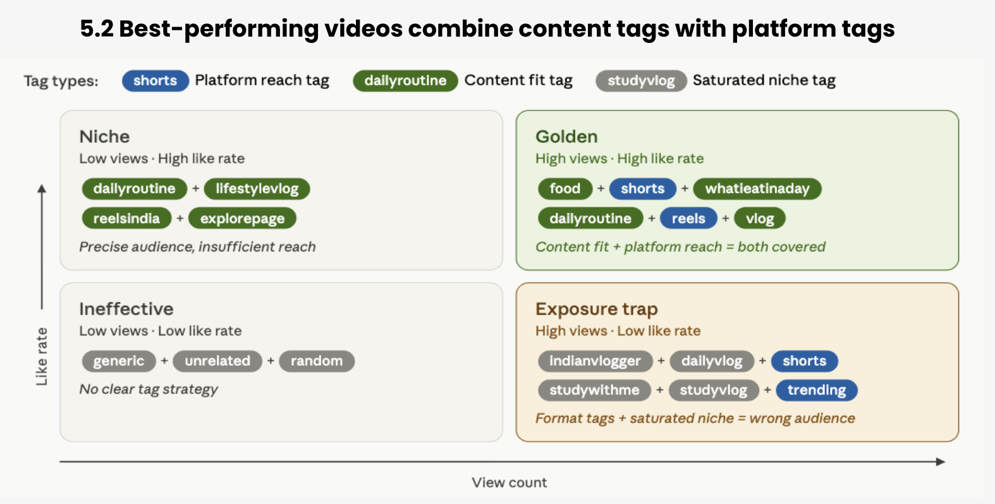
The association rule analysis reveals distinct tag combination patterns across the three quadrants. Golden zone videos consistently pair content fit tags with platform reach tags — food + shorts + whatieatinaday and dailyroutine + reels + vlog — combining both functional types within a single video. In contrast, Exposure Trap videos cluster saturated niche tags alongside platform reach tags (studywithme + studymotivation + studyvlog + shorts), generating views but attracting disengaged audiences. Niche videos use content-specific combinations without platform reach tags (dailyroutine + lifestylevlog), achieving audience precision but insufficient reach. The full association rule outputs are provided in the Appendix.
These findings support the hypothesis proposed above. Neither tag type alone is sufficient — platform reach tags without content specificity lead to the Exposure Trap, while content tags without reach tags lead to the Niche. Only the combination of both types characterizes the Golden zone, suggesting that pairing platform reach tags with content fit tags is the tag strategy most likely to achieve both discoverability and audience fit simultaneously.
5.3 Does Hashtag Quantity Matter?
A common assumption among new creators is that using more hashtags increases a video's chances of being discovered — either by improving algorithmic recommendation or by matching more user search queries. This section tests two related hypotheses: whether hashtag quantity increases views (discoverability hypothesis) and whether it increases like rate (audience fit hypothesis). Both metrics are examined across the micro dataset (n=1,035) and the large channel dataset (n=1,174) to assess whether the relationship between hashtag quantity and performance is consistent across creator scales, or whether the underlying mechanism differs between established and emerging channels.
Hashtag count is grouped into five bins: 0, 1–3, 4–7, 8–15, and 15+. For each bin, median view count and median like rate are calculated separately for both the micro and large datasets.
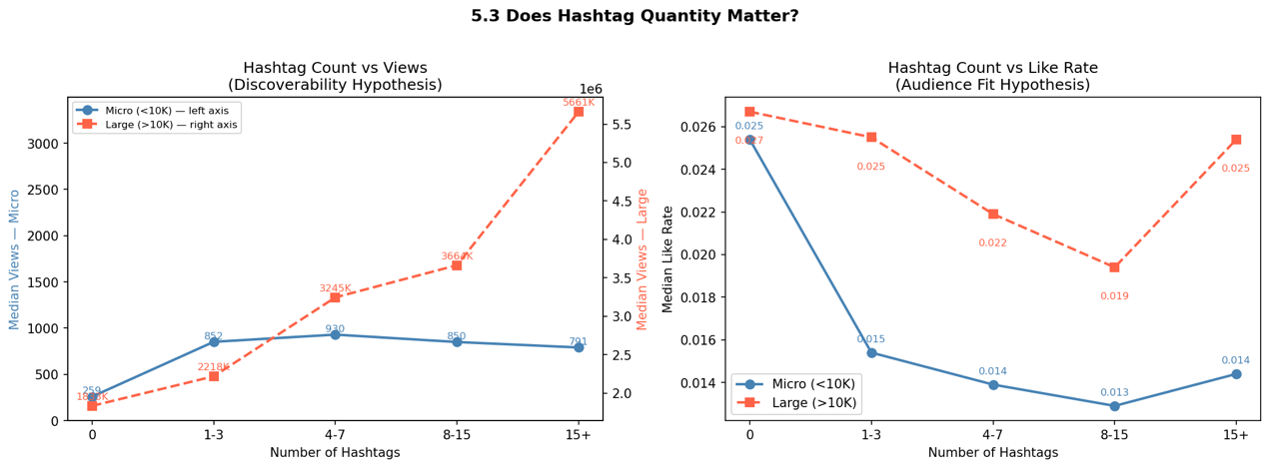
The two hypotheses yield contradictory findings. For large channels, median views increase steadily with hashtag count, reaching 5.66M for videos with 15+ hashtags compared to 1.83M for videos with none. For micro-creators, the relationship is weaker and less consistent, with no hashtags producing the lowest views (259) and 4–7 hashtags producing the highest (930). However, both datasets show a consistent decline in like rate as hashtag count increases. Videos with no hashtags achieve the highest median like rate in both micro (2.54%) and large (2.67%) datasets, while the lowest point occurs at 8–15 hashtags.
The divergence between the two hypotheses can be explained through YouTube's three-tier recommendation mechanism. The first tier provides baseline exposure to newly published videos, during which hashtags help the algorithm categorize content. The second tier is driven by engagement signals — if hashtags attract an imprecise audience, the resulting low like rate signals poor content performance to the algorithm, suppressing further distribution. The third tier is subscriber-driven：established channels have a large existing subscriber base that receives direct push notifications upon video publication, guaranteeing an initial pool of genuinely interested viewers regardless of hashtag usage. For micro-creators without this subscriber foundation, there is no such safety net: every viewer must be attracted through discovery mechanisms, making audience precision far more critical and hashtag-driven reach expansion more likely to backfire.

6. Tactical Optimization — Timing & Duration
In this chapter, our goal is to develop a holistic strategy tailored to micro content creators to help them better enter the YouTube video market. In this strategy, we encompass the following layers: video posting timing (golden window), video durations, and the content category for micro content creators to take into consideration while making and posting their videos. In order for micro content creators to easily evaluate different strategy options, we evaluated each time slot based on the score for the golden window.

6.1 Calculate the Score of Golden Window
The key concept of the score for Golden Window: micro rank (performance) - large density rank (competition).
The score of Golden Window will be situated within the range between 0 and 1. The higher the score, the closer to 1, the better the opportunity for micro content creators. The following will be the formula for calculating the score of the golden window.
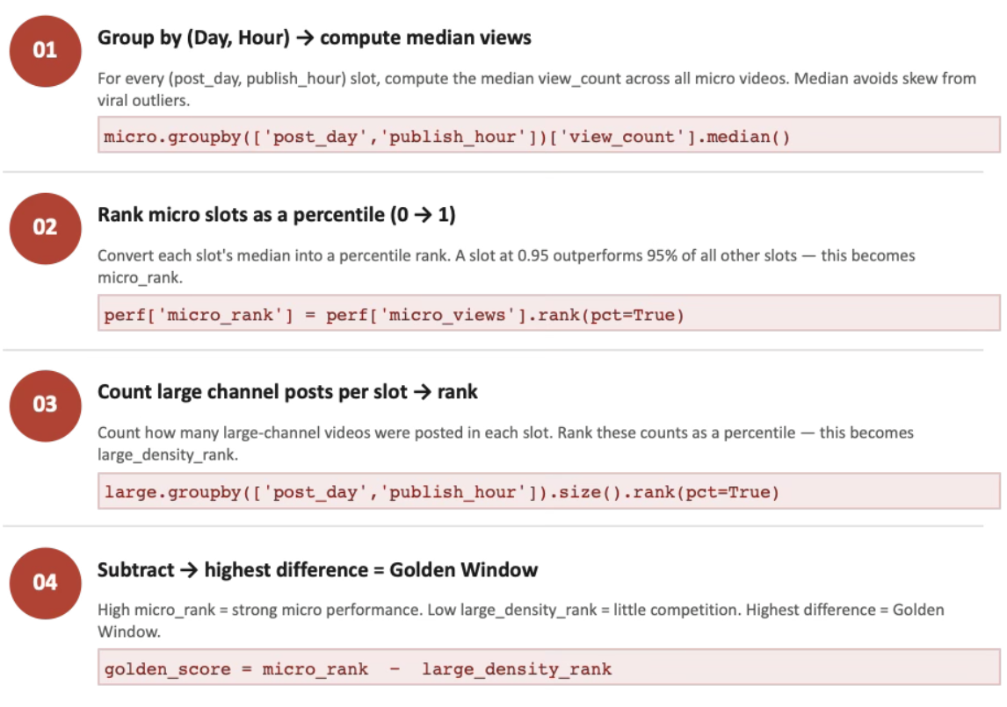

6.2 Optimal Posting Hours
Based on our analysis, the optimal posting hours for micro and large content creators are very different. Since most of the popular time slots have already been occupied by the large content creators, it means that in the popular time slots, there will be strong competition, which we didn’t recommend micro content creators to go directly to post during the popular time slots. Instead, based on the result of the Golden Window analysis, we recommend that micro content creators post in the off-peak period, such as midnight or early morning, so that they can avoid the competition with large channels.
- Best hours for micro creators: Midnight (12:00 am), 2pm, and 1pm UTC deliver the highest median views.
- The time slot that micro creators actually posted: Noon (12h) is the single most popular posting hour with 104 videos, followed by 1pm (72) and 3pm (68). These popular posting time slots also heavily overlap with those of large content creators, which is a key issue that micro content creators should reconsider if they want to gain a competitive advantage in posting timing.
6.3 Video Duration Strategy
For analyzing the video duration layer, we break all video types into three different categories. For a video that lasts less than 1 minute, we defined it as a short-length video. A video with a duration between 1 minute and 10 minutes, we defined it as a mid-length video. A video with a duration longer than 10 minutes, we classified it as a long video. To help micro content creators stand out and avoid competition with the large channels. We did the analysis on both micro and large content creators so that we can find out the options with less competition for micro content creators to enter this market.
The top three golden score based on video duration:
Short ≤1 min → Friday 4:00 UTC, 18,734 views, score 0.885
Mid 1–10 min → Friday 11:00 UTC, 9,983 views, score 1.000 (perfect — zero large channel competition)
Long 10+ min → Monday 14:00 UTC, 9,751 views, score 0.943
6.4 Micro vs Large Strategic Gap
Based on the Golden Window evaluation, we figure out there are two key considerations for micro content creators to consider in order to gain success in the video market.
- Hour misalignment: Micro content creators post most at 7am–3pm UTC but perform best at midnight and early morning. The gap score shows midnight is the single most underdeveloped time slot, with the stats supporting that micro performs 5.6 percentage points above its posting share there, meaning creators are not showing up when the opportunity is highest.
- Day misalignment: 80% of micro content creators are posted on Monday and Tuesday. Large channels spread evenly across the week, peaking on Friday, Wednesday, and Thursday. Micro creators are bunching together on the same two days and missing quieter, less contested days entirely.

7. Conclusion and Recommendations
7.1 Conclusion
This study examines how micro-creators can grow on YouTube despite a highly competitive and unequal environment. The results show that success is not random; it depends on choosing the right strategy, creating differentiated content, and making smart tactical decisions. The use of the YouTube Data API enabled the construction of two comparable datasets, allowing for a focused evaluation of micro-creators against larger channels. Through data cleaning, transformation, and feature engineering, the dataset was prepared to accurately reflect engagement patterns while reducing the impact of skewness and noise.

Through K-Means clustering and growth lever analysis, we identified four distinct creator archetypes and the strategic pivots required to scale across the YouTube ecosystem. Our findings reveal that creator success is not random but follows a phased evolutionary path—from efficiency-driven survival to authority-based brand building. Finally, by mapping category demand-supply gaps, we provide a data-driven framework to help new entrants identify 'Blue Ocean' niches that offer superior growth leverage compared to saturated categories.

Five conclusions emerge from the NLP analysis. On sentiment, the High group's compound score is approximately 28% higher and its strongly positive content share is 10 percentage points greater, indicating that audiences respond more actively to content with genuine emotional warmth. On vocabulary, the word "jee" alone generates a frequency gap of +0.657 and cultural words including haridwar, shayari, and assamese appear exclusively in the High group, confirming that deep cultural identity content outperforms generic national labels. On comment quality, High group comments use emotionally expressive, identity-specific phrases, while Low group comments display repeated-word patterns that signal keyword stuffing rather than real engagement.

7.2 Recommendations
Based on these findings, three recommendations are proposed for new creators entering the YouTube market.

First, on topic structure, new creators should write in a personal, emotionally engaged voice; commit to one identity niche and name the target audience directly; leverage specific cultural vocabulary as a differentiator; maintain four to five content pillars, capping any single format at 25% of uploads to avoid the saturation trap.

Second, on tag strategy, new creators can try to combine platform reach tags with content fit tags. Neither type alone achieves both views and engagement. Pairing one platform tag such as shorts or reels with two to three content-specific tags is the most reliable strategy for reaching both discoverability and audience fit simultaneously.
On the other hand, keeping total hashtag count between 0 and 3 is recommended — more hashtags dilute audience precision and suppress the engagement signals that drive algorithmic amplification at this stage of growth.

Third, the key takeaway for micro content creators is to post during off-peak hours (midnight or early morning) to avoid competing with large channels, since these time slots tend to perform well with low competition.

Reference

Data Sources
- Google. (2024). YouTube Data API v3: https://developers.google.com/youtube/v3

Platform & Market Data
- Nielsen. (2024). The Gauge: YouTube maintains its position as the top streaming platform in the U.S.
- Global Media Insight. (2024). YouTube User Statistics 2024: How Many People Use YouTube?
https://www.globalmediainsight.com/blog/youtube-users-statistics/
- Goldman Sachs. (2023). The creator economy could approach half-a-trillion dollars by 2027.
- Pex. (2023). YouTube by the numbers: Most content gets less than 1,000 views.
- Influencer Marketing Hub. (2024). The State of the Creator Economy 2024: Growth and churn trends.
https://influencermarketinghub.com

Competition / Algorithm Context
- Harvard Business Review. (2022). How TikTok’s algorithm is changing the creator economy.
- TikTok. (2024). How TikTok recommends content.
https://newsroom.tiktok.com
- Agrawal, R., & Srikant, R. (1994). Fast algorithms for mining association rules. Proceedings of the 20th International Conference on Very Large Data Bases, 487–499.

Appendix — Association Rules: Golden Zone
