CS 340 Project Two

SNHU

Kimberly Blackwood

Professor Scranton

December 11,2025

The project required building an interactive web dashboard for animal rescue operations that enable users to search, filter, and visualize animal data based on specific criteria such as, location, breed, and other attributes. The dashboard provides real time data visualization through interactive charts and maps, allowing rescue teams to quickly identify animals needing help in targeted geographic locations.
Key functionalities achieved are:
- Search and filter - users can filter animals by breed, location, rescue status and other criteria.
- Interactive visualizations - pie charts displaying breed distribution and maps showing the animal location.
- Real time updates - dashboard refresh data dynamically from the MongoDB backend.
- Sorting and pagination - user can sort any attributes from ascending or descending order and navigate to different pages seamlessly making their experience more enjoyable.
Below is the dashboard logo and title.
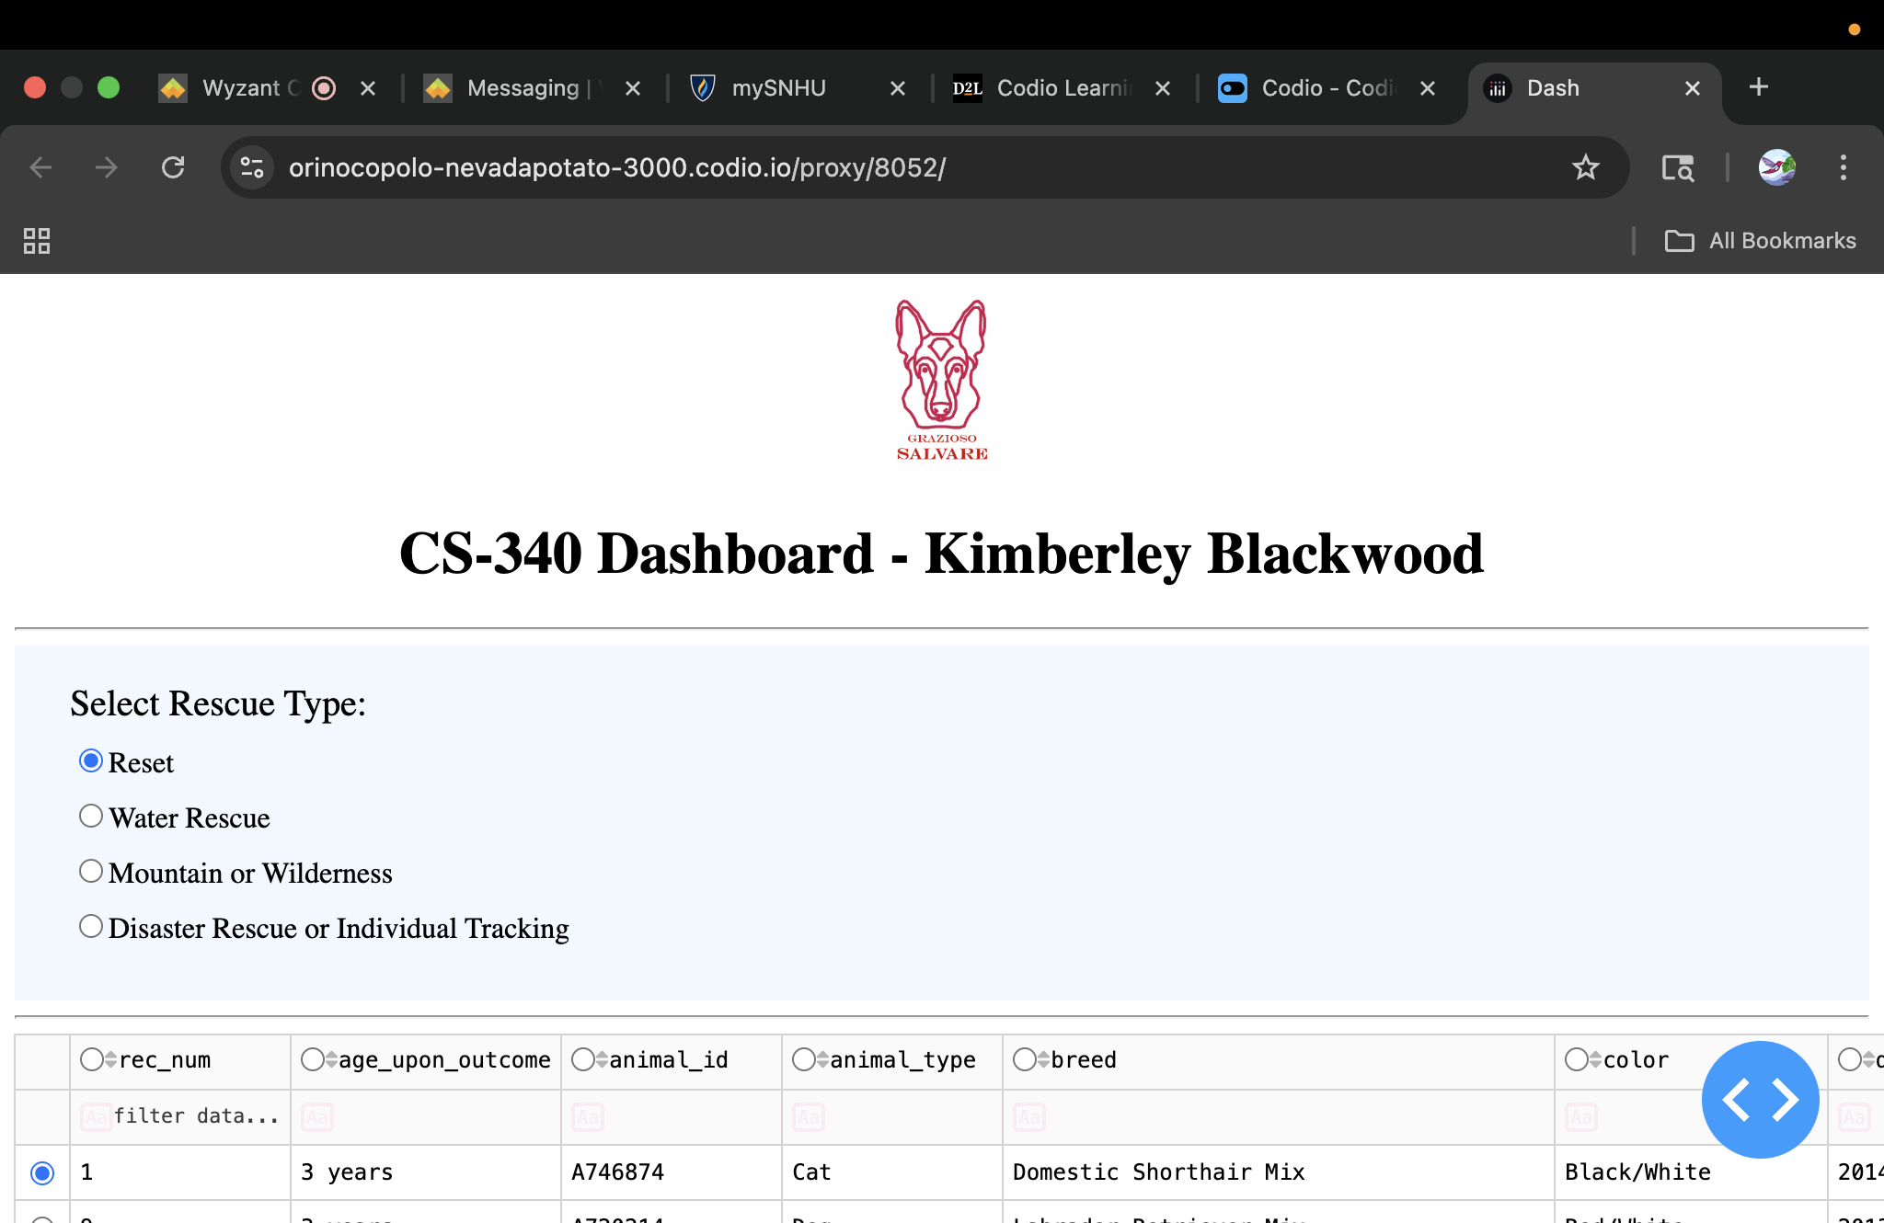
Screenshot below of the dashboard table.
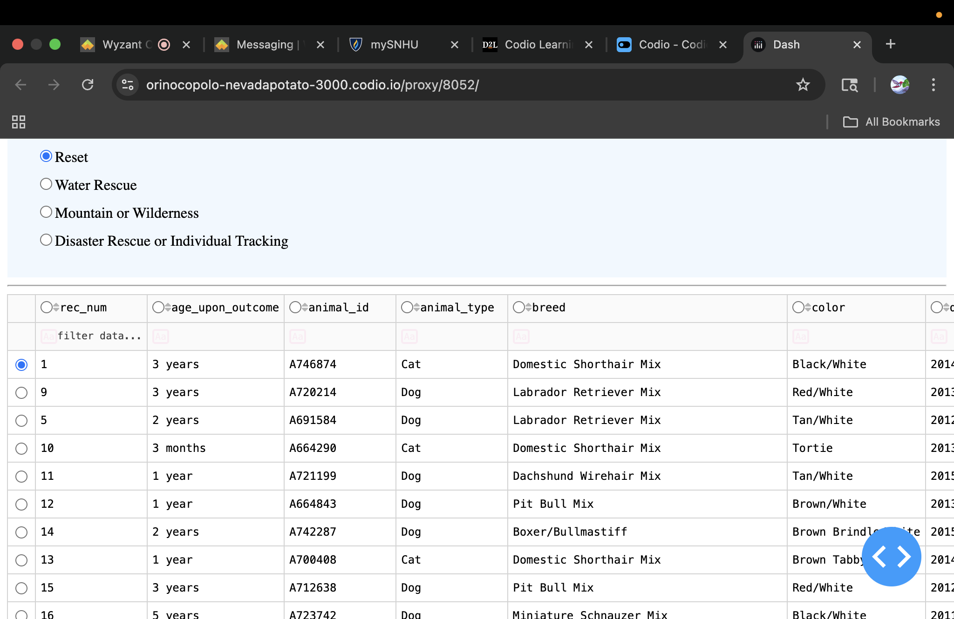
Below is the dashboard table showing mountain/wilderness selection.
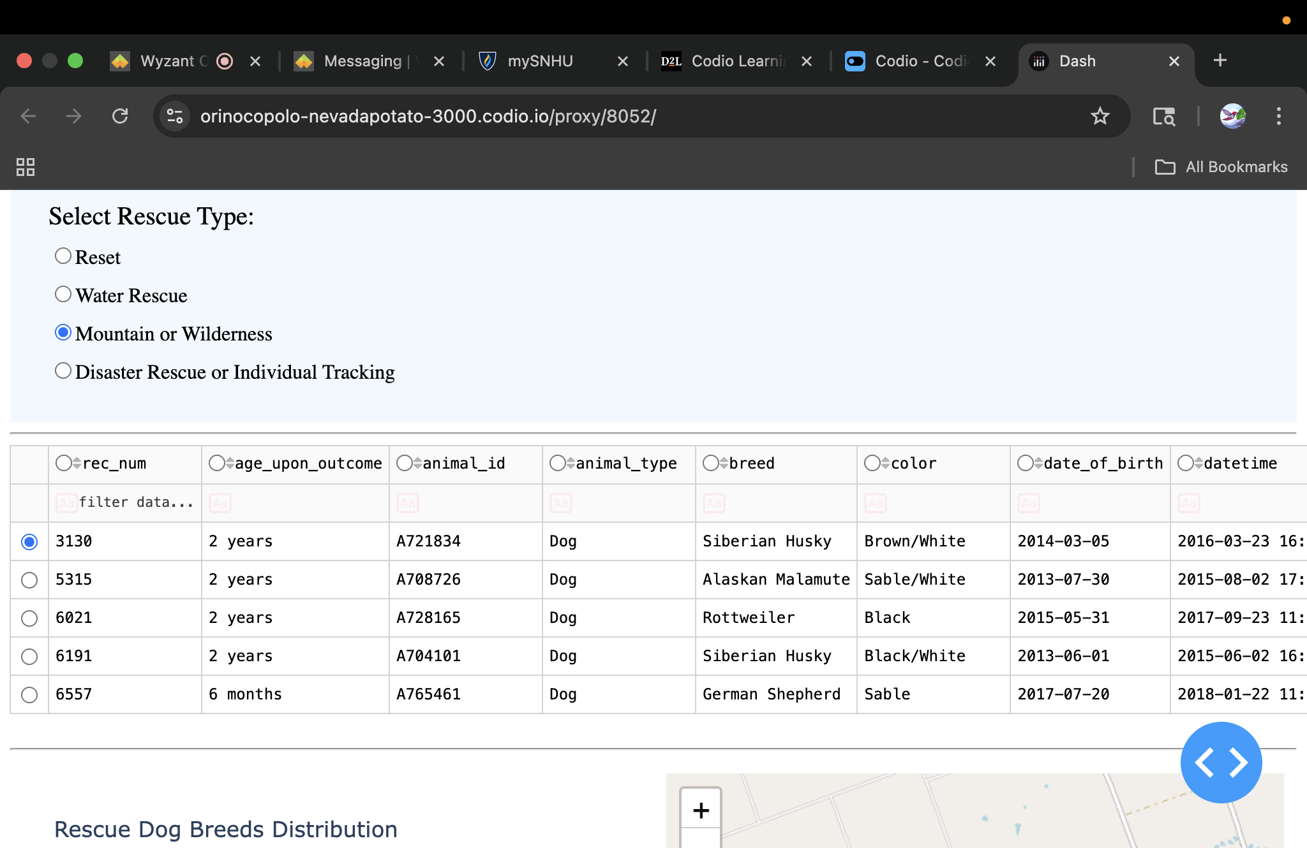
Below visual chart dynamic update after selection rescue type mountain/wilderness.

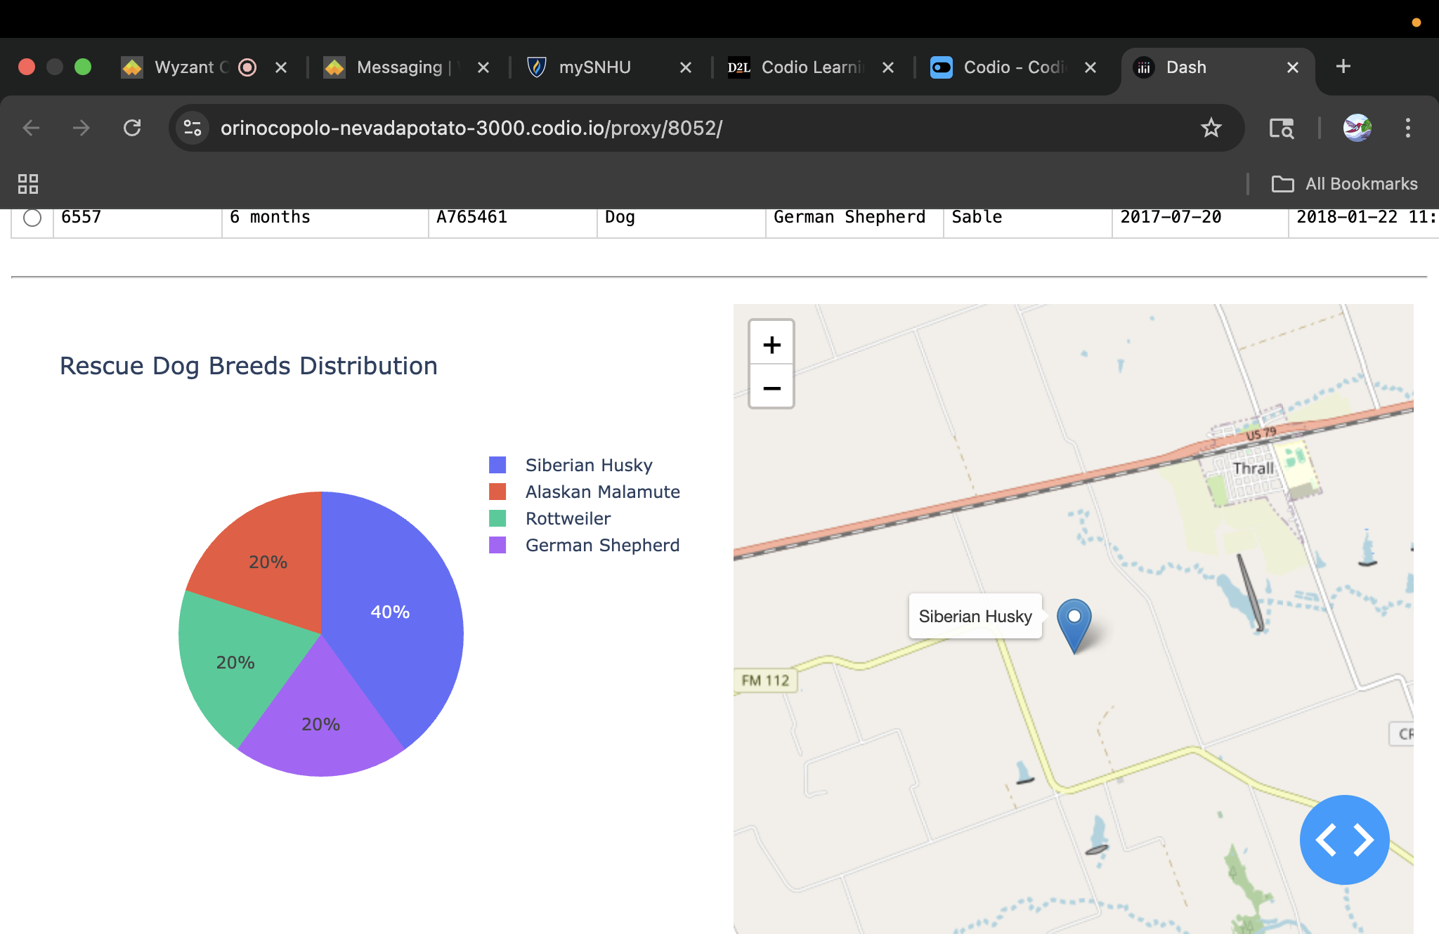

Below shows user friendly navigation of the table.
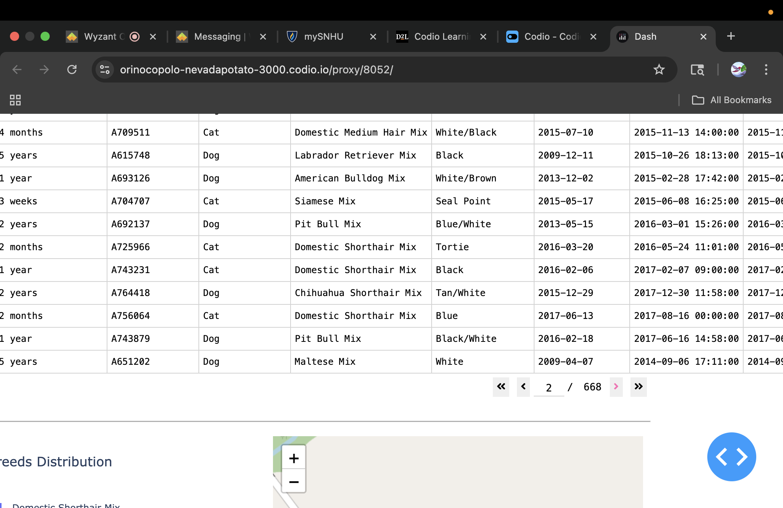

Below shows sort in descending order for attributes.
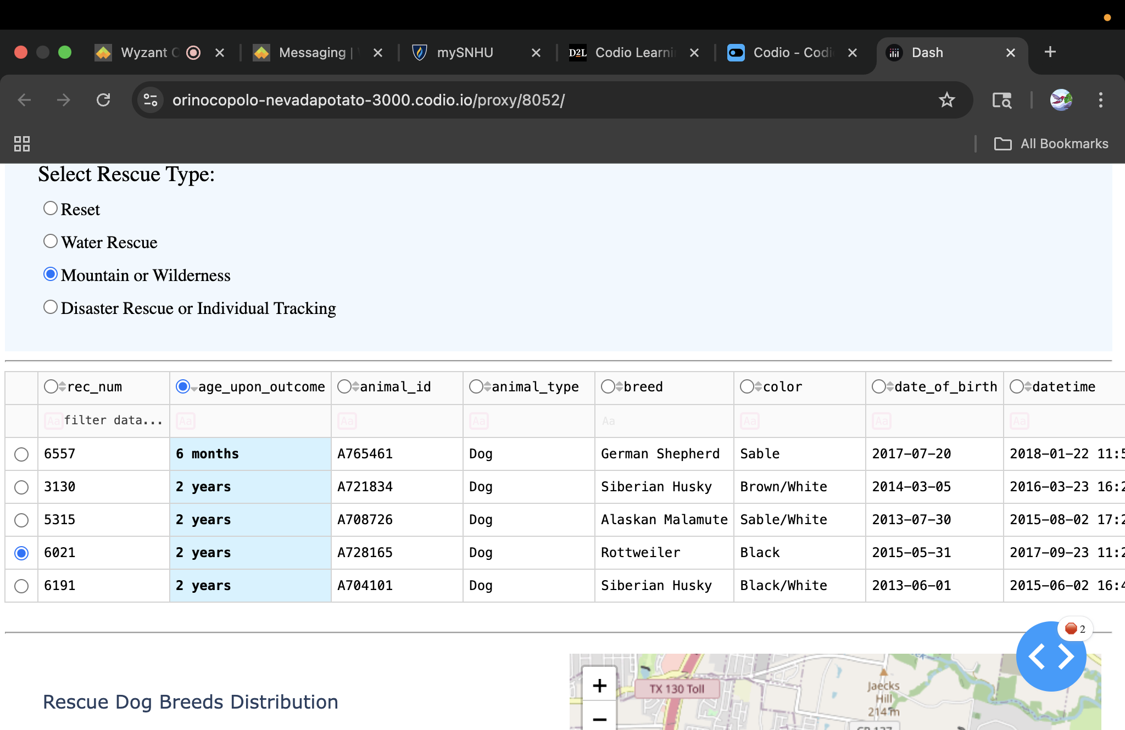

Below filter show selection of the Husky breed both tables and charts are updated accordingly.
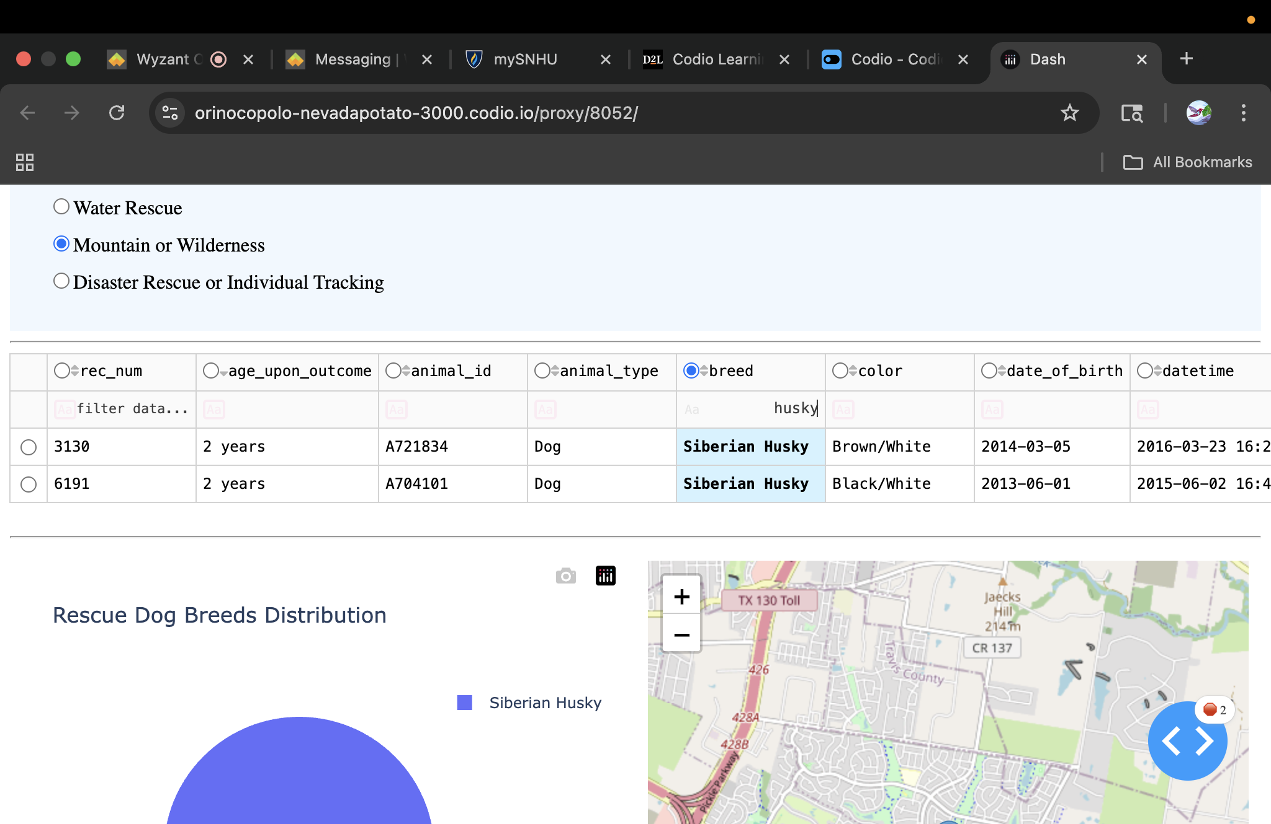
Below shows row selection functionality.
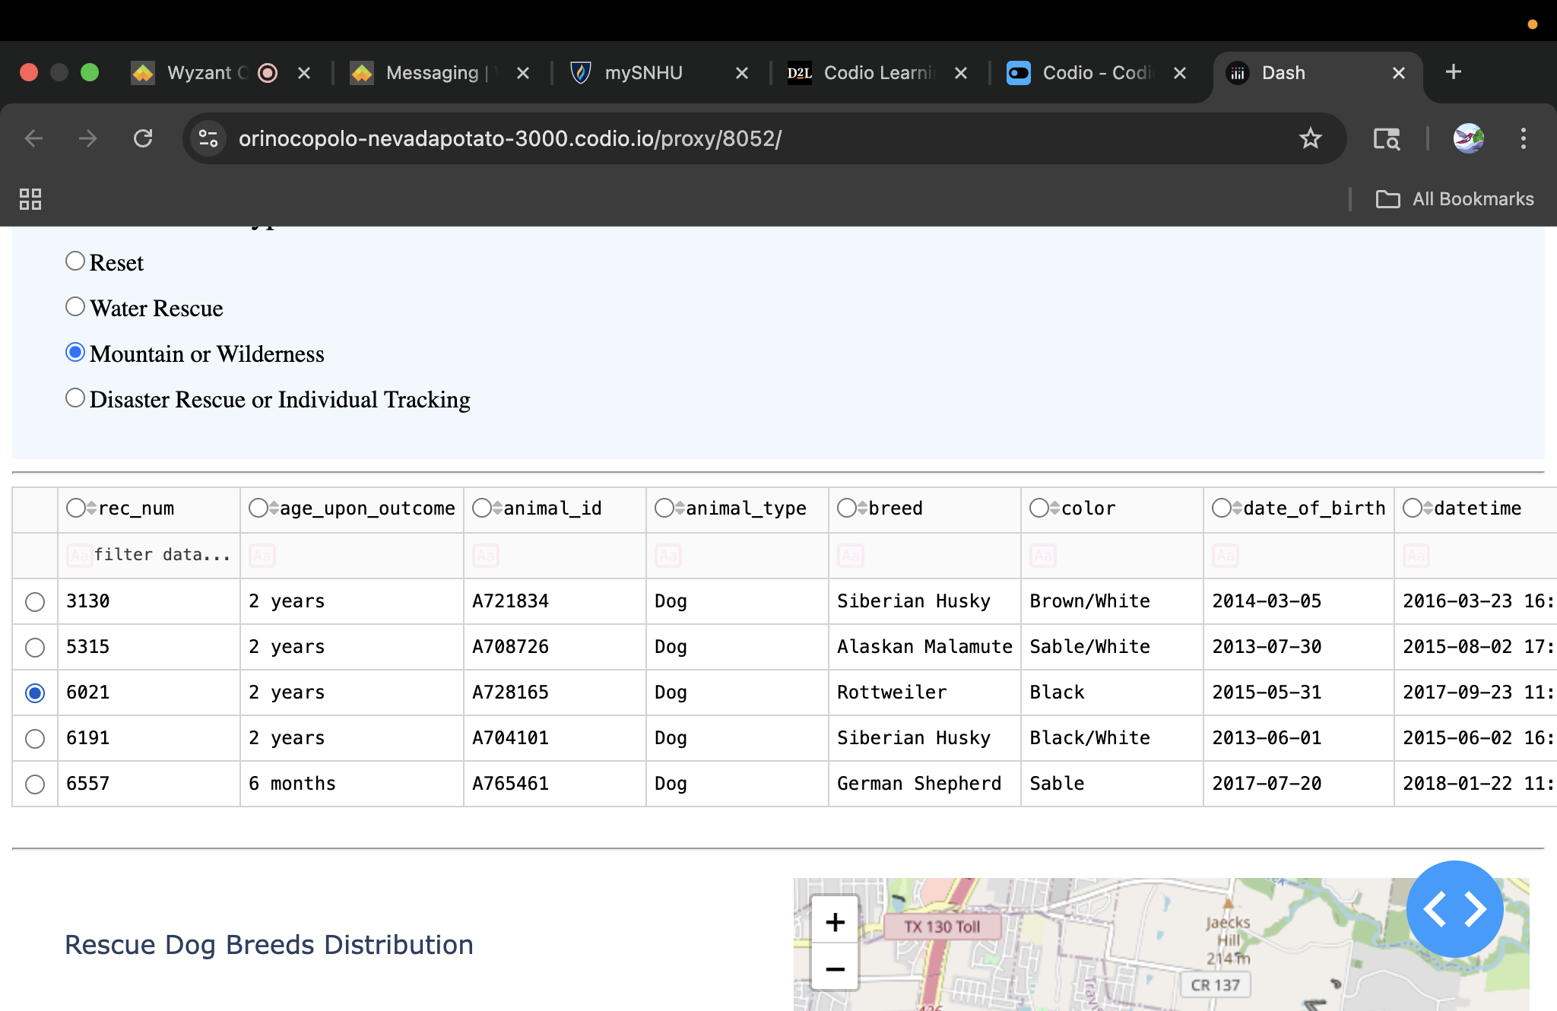

The tools used to achieve this functionality are:
- MongoDB – this database was chosen because of its NoSQL structure, its flexibility, and its ability to store and query JSON files which provides high performance and scalability.
- Python plus PyMongo – Python serves as the application logic layer with PyMongo enabling CRUD operation, PyMongo’s find(), insert_one(), update_many() and delete_many() methods map directly to Python functions.
- Jupiter Notebook – used for iterative development, debugging aggregation pipelines and testing MongoDB queries cell by cell before integrating into the dash application.
- Plotly dash (view plus controller) – dash implement the MVC patterns where:
    - Model - PyMongo CRUD operation and MongoBD.
    - View - HTML component rendered by html.div..graph.
    - Controller – callback function @app.callback, handling user input, data queries and visualization updates (Geeks for Geeks 2025).

There were several steps taken to complete the project, the steps are:
1.Setup Database – first set up animal rescues database , import csv file from momgo import tool.
2.Security configuration – created user account aac to access information, configure PyMongo connection using string with those credentials.
Model layer development (PyMongo CRUD)
Implement:
- Search animal() to do dynamic filter.
- Aggregation pipeline to do the breed distribution,
- Geographical queries for breed location.
- CRUD operation to update rescue status updates.
3.Dash Controller Development – these are the built-in callback function linking the database queries to the table and the chart.
4.View Layer (dashboard UI) – design the layout with html.div containers and created interactive pie chart using doc.graph and maps.
5.Testing – validated connections and callback for MongoDB functions verified the deployment with app.run_server and tested functionality sorting and filtering.
There were several challenges that I encountered, first the geolocator was not visible so I had to modify the html layout for the dashboard. the pie chart covered the whole thing. I had to switch it to be able to show both, fixing width and length to show pie chart and geolocation. Port number was not provided, the conflict had to be changed in order to run the test. and the mode inline was not provided to give proper screenshots, as a result I had to switch to external.

References
Geeks for Geeks.(2025) PyMongo Tools
https://www.geeksforgeeks.org/python/python-mongodb
tutorial/

