Create Bookdown File
When writing a thesis with multiple chapters using R Markdown, it is recommended to use Bookdown. Bookdown is built on top of R Markdown, so it has the same capabilities, including outputting to PDF, Word, and HTML. It also allows for cross-referencing of figures, tables, sections, etc. It creates a “book” from a series of R Markdown files, each of which is one chapter.
This manual will walk you through how to set up your own Bookdown file. There is also an introduction to Bookdown, including demo files, here: Chapter 1 Introduction | bookdown: Authoring Books and Technical Documents with R Markdown

Initializing
- If you haven’t already, download the latest RStudio and R versions.
Download RStudio and Download R
- Install the required packages:
install.packages(c("bookdown", "downlit", "tinytex"))
- TinyTeX allows you to print to PDF. You will need to install it with the following code:
tinytex::install_tinytex()
- If you already have a GitHub repository for your project, you can add the thesis to that. Otherwise, create a GitHub repository before continuing.
- Create the following folders in your project or thesis GitHub repository:
  - A main folder. For example, I named mine “Thesis”.
  - Three subfolders within this main folder:
    - References
      - This folder will contain your references (BIB file) and a reference format file (CSL file). The former can be exported from your Mendeley or Zotero library. The latter can be downloaded from Zotero (Zotero Style Repository).
    - Sections
      - This folder will contain the individual sections and chapters for your thesis (e.g., title page, abstract, lay abstract, introduction, chapter 1, etc.).
    - Images
      - This folder will contain all figures and images that you want in your thesis. You must copy them into this folder because R Markdown will not recognize file pathways outside of the main folder.
- In RStudio, create a new project in File >> New Project… (Figure 1)
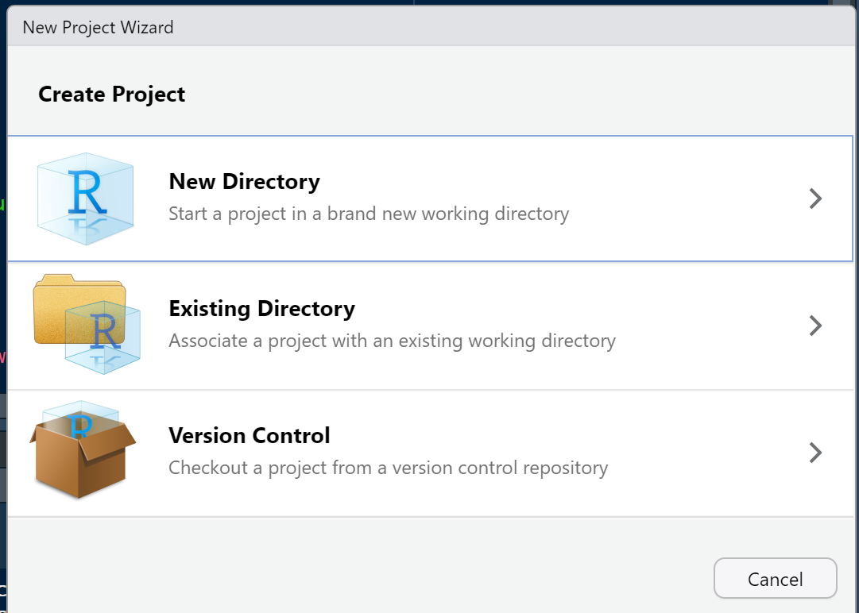
Figure 1. This is figure 1.
- Select Existing Directory and browse to your main thesis folder. (Figure 2)
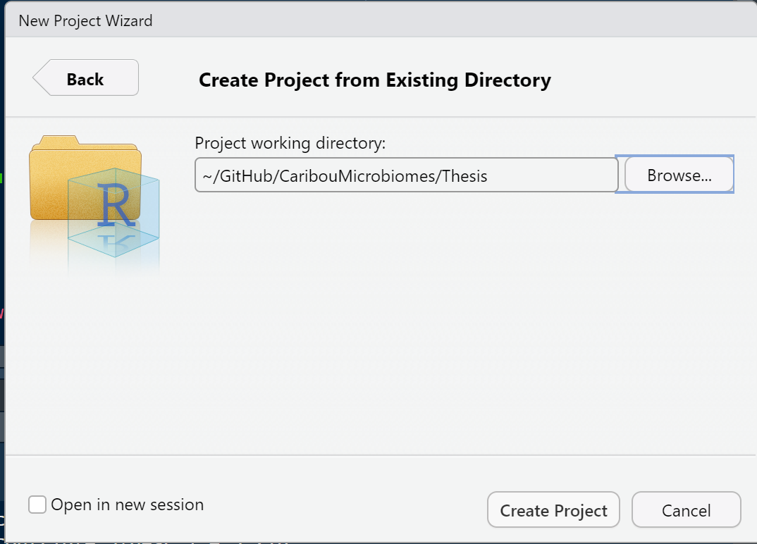
Figure 2. This is figure 2.
  - In the bottom left corner, select the checkbox to open the project in a new session.
  - Click Create Project.
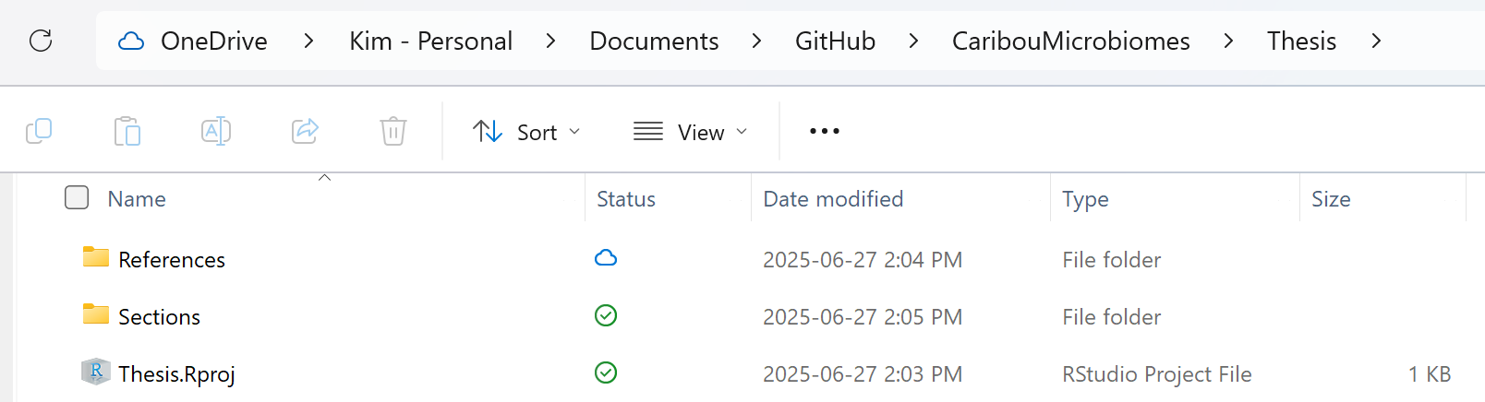
- In the R project RStudio session, below File, click the green/white plus symbol. Then click R Markdown…
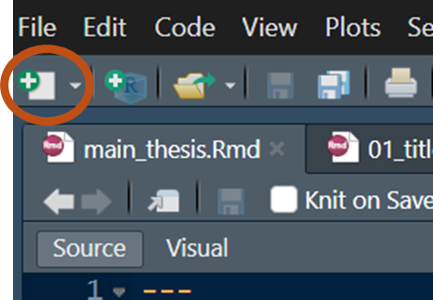
  - This first Rmd file we’ll call “main_thesis.Rmd”. It will be the main script and will call all of the thesis sections. Save it to the main folder.
- If you’d like, go ahead and create the sections.
  - For a master's thesis at UBCO, you’ll need:
    - Title page
    - Committee form
    - Abstract
    - Lay abstract
    - Preface
    - Glossary
      - This section is optional and contains any terms that are not immediately obvious to the readers.
    - Acknowledgements
      - This section is also optional.
    - Dedication
      - This section is optional and serves as a personal, rather than academic or professional, recognition.
    - Introduction
    - Chapter
    - Conclusion
    - Bibliography
    - Appendices
      - Adding appendices is optional.
      - Example appendices may include additional methods and/or data and copies of questionnaires or surveys.
      - Each appendix must start on a new page.
      - Any signatures in the appendices MUST be blacked out.
  - Generally, when creating a book or thesis in bookdown, bookdown will compile the sections alphabetically by file name. In that case, you will need to name the files starting with numbers (e.g., 01_title_page, 02_committee_form, etc.).
  - However, we will explicitly call the sections in the main_thesis.Rmd file. Nevertheless, I recommend still numbering them to make it easier to locate.
- Editing the YAML header at the top of the markdown files is very important in order for the program to compile into a book. At the very least, you will need one of the following headers (Table 1):
  - Note: toc is for the table of contents. If you are outputting to PDF, this will be added manually at a specified location in the document, so we don’t need it in the YAML header.
  - I recommend outputting to Word while in the editing stages, primarily because it makes it easier for your supervisor and committee to track edits. It also makes it easier to check grammar. HOWEVER, this document will not be formatted.
  - Once everything is done, change the output in every Rmd file to PDF [1].
Table 1. Output YAML headers.
 | PDF output: | Word output:
Main Rmd file | ---  output:  bookdown::pdf_book:  toc: no  keep_tex: no  number_sections: yes  latex_engine: xelatex  bibliography: ./References/reference_list.bib  csl: ./References/microbiome.csl  link-citations: true  --- | ---  output:  bookdown::word_document2:  toc: yes  keep_tex: no  number_sections: yes  latex_engine: xelatex  bibliography: ./References/reference_list.bib  csl: ./References/microbiome.csl  link-citations: true  ---
Section Rmd files | ---  output:  bookdown::pdf_book:  toc: no  keep_tex: no  number_sections: yes  --- | ---  output:  bookdown::word_document2:  toc: yes  keep_tex: no  number_sections: yes  ---

Syntax
Italic | One asterisk | *text*
Bold | Two underscores  Or  Two asterisks | __text__  **text**
_{Subscript} | One tilde | Text~1~
^{Superscript} | One caret | Text^2^
Inline code | One backtick | `code`
Link |  | [text](link)
Image |  | ![text](path/to/image)
Headers | Pound signs | # First-level header  ## Second-level header  ### Third-level header
Part headers | (PART) | # (PART) Part 1 {-}  # Chapter 1
Appendix headers | (APPENDIX) | # (APPENDIX) Appendix A {-}
Unordered lists | Asterisk, minus sign, or plus sign  Nest using four spaces | - One item  - Second item  - Sub item
Ordered lists | Numbers  Nest using four spaces | 1. One item  2. Second item  1. Sub item
Text reference | LaTeX | (ref:plot1) A scatterplot of fake data using **base** R graphics.  ```{r plot1, fig.cap='(ref:plot1)'}  plot(x = 1:10, y = 1:10) # a scatterplot  ```
Math equation | LaTeX | $$f(k) = {n \choose k} p^{k} (1-p)^{n-k}$$
Math equation with number and reference | LaTeX | \begin{equation}  f\left(x\right) = a\left(x\right)+b  (\#eq:linear)  \end{equation}  \@ref(eq:linear)
Math equation that is multiple lines | LaTeX | \begin{equation}  \begin{split}  \mathrm{Var}(\hat{\beta}) & =\mathrm{Var}((X'X)^{-1}X'y)\\  & =(X'X)^{-1}X'\mathrm{Var}(y)((X'X)^{-1}X')'\\  & =(X'X)^{-1}X'\mathrm{Var}(y)X(X'X)^{-1}\\  & =(X'X)^{-1}X'\sigma^{2}IX(X'X)^{-1}\\  & =(X'X)^{-1}\sigma^{2}  \end{split}  (\#eq:var-beta)  \end{equation}
Math array | LaTeX | $$\begin{array}{ccc}  x_{11} & x_{12} & x_{13}\\  x_{21} & x_{22} & x_{23}  \end{array}$$
Math box matrix | LaTeX | $$X = \begin{bmatrix}1 & x_{1}\\  1 & x_{2}\\  1 & x_{3}  \end{bmatrix}$$
Math parentheses matrix | LaTeX | $$\Theta = \begin{pmatrix}\alpha & \beta\\  \gamma & \delta  \end{pmatrix}$$
Math vertical bar matrix | LaTeX | $$\begin{vmatrix}a & b\\  c & d  \end{vmatrix}=ad-bc$$

R Code
R code, such as to make figures or tables in the document, can be added using the following:
```{r}
# Put code here
```
You can also add optional chunk options, such as echo=FALSE.

Figures
To add figures to your document:
- Create an R chunk below where you first mention the figure.
- To add a figure caption, use the chunk option fig.cap = “This is a figure.”
  - The figure is automatically labelled and numbered.
  - The base syntax for Markdown also works in the captions. For example, if you add fig.cap = “This one word is _italic_”, then the word “italic” will be italicised.
- If you want to cross-reference your figure, you’ll have to initialise the figure caption first using ref. For example:
(ref:plot1) A scatterplot of *fake* data using **base** R graphics.
This sentence references the figure (Figure \@ref(fig:plot1)).
```{r plot1, fig.cap='(ref:plot1)', echo=FALSE}
plot(x = 1:10, y = 1:10) # a scatterplot
```
  - Note that the chunk name, plot1, shows up in the initialising step and when referencing the figure. This is needed to create the reference and then call it.
- Other chunk options that may be useful are:
  - echo=FALSE
    - Hides the code chunk (but not anything that is printed, such as in the figure example above) in the knitted file.
  - include=FALSE
    - Hides both the code and output in the knitted file.
  - message=FALSE
    - Hides messages generated by the code.
  - warning=FALSE
    - Hides warning generated by the code.
  - fig.width and fig.height
    - The figure width and height in inches.
  - fig.asp
    - The aspect ratio of the figure, but you’ll still need to provide either the height or the width of the figure.
  - fig.align
    - Aligns the figure in the alignment of your choice. Your options are left, right, and center.
- If you want to include a figure without creating it in R, you can use knitr::include_graphics(). For example:
(ref:plot2) An example figure brought in from the analysis code output.
This sentence references the second figure (Figure \@ref(fig:plot2)).
```{r plot2, fig.cap='(ref:plot2)', echo=FALSE}
knitr::include_graphics(r"(path_to_fig\quality_forward.png)")
```
  - Note, though, that setting the figure dimensions won’t work here; the figure will have the same dimensions as what you saved the figure as. For example, if you put the arguments in ggsave() to save the image as 3x5 cm, then the include_graphics() will output the figure as 3x5 cm.

Tables
I generally recommend using the flextable R package to create tables because it creates highly customizable tables. You can still add captions and cross-reference them, and it’s the same way as for figures!
Here’s an example:
(ref:tab1) An example table created using the flextable package.

This is a reference to the table (Table \@ref(tab:tab1)).

```{r tab1, tab.cap='(ref:tab1)', echo=FALSE, ft.align='left'}
mtcars %>%
head() %>%
select(mpg, cyl, disp, hp, drat) %>%
flextable() %>%
theme_vanilla() %>%
set_caption(autonum = run_autonum(seq_id = "tab", bkm = "tab1")) %>%
font(fontname = "Times New Roman", part = "all")
```

Citations
Since the citation style and citations (the BIB file) have already been called in the YAML header, you only need to call them in the text. If you are using Mendeley as your citation manager, then you can edit the citation keys. If, however, you are using Zotero, then you will not be able to edit the citation keys. To call the citations, use this style, but in all lowercase:
[@LastName_FirstTitleWord_Year]

Formatting

TeX File
To format the final PDF file, you will need to call a TeX file in the YAML header that includes the formatting specifications. To start:
- Create a TXT file in Notebook.
- Write (or copy and paste) the code you need to format your file.
- Save the file (it should be a TXT file) and close it.
- Rename the file to “preamble.tex” and click “Yes” when the pop-up asks if you want to confirm changing the file name extension. This will automatically convert the TXT file to a TeX file.
- If you need to make any changes, you can open this file in Notebook, edit, and save it without having to convert to and from a TXT file.
An example preamble.tex file (with comments on what each line does) is included on GitHub.

Global Formatting in YAML Header
For global formatting, you can also add code into the YAML header. In this example, I’ve set only the font size to 12 using the following code (this line is also in the example YAML header below):
fontsize: 12pt
This sets the default font size to 12. It will be overwritten by anything in the preamble.tex file.

Example YAML Header
In your main script (“main_thesis.Rmd”), paste these lines into the YAML header:
output:
bookdown::word_document2:
toc: yes
keep_tex: no
number_sections: yes
fig_caption: yes
latex_engine: xelatex
includes:
in_header: path/to/preamble.tex
fontsize: 12pt
bibliography: path/to/References/reference_list.bib
csl: path/to/References/microbiome.csl
link-citations: yes

Headers
Because the YAML header has number_sections: yes, the headers will be automatically numbered. If you do not want the headers to be numbered, set this line to “no”. If you do not want some headers to be numbered (e.g., Abstract, Lay Summary, etc.), then add “{-}” to the end of the header name. For example:
# Abstract {-}

Inline Formatting
There are several options to change the text formatting within the document when you want specific formatting for only a small section of text to be different from the defaults set in the preamble.tex file. Note, however, that you will have to begin and end the formatting explicitly. Also note that this formatting will only show up in the PDF version because it is LaTeX code. For example, \textbf{This text will be bold} won’t show up at all in the Word version, not even the sentence.
This table will cover some of them:
Action | LaTeX Code | Comment
Center alignment | \begin{center}  This text will be centered.  \end{center
Bold text | \textbf{This text will be bold.} | Text between the curly brackets will be bolded
Italic text | \textit{This text will be italicised.} | Text between the curly brackets will be italicised
Line spacing | \setstretch{1}  \setstretch{1.5}  \setstretch{2}  \doublespacing  \setstretch{3} | For single,  1.5  double  double  triple spacing
Page numbering (roman numerals) | \pagenumbering{roman}  \setcounter{page}{1} | Set the page numbering to roman numerals and start a 1 (i)
Page numbering | \pagenumbering{arabic}  \setcounter{page}{1}
New line | \newline | Ends the current line without adding vertical space
Vertical space | \bigskip | Adds one 12pt space between the two paragraphs/items that are above and below this code
New page | \newpage
Table of contents | \tableofcontents
List of tables | \listoftables
List of figures | \listoffigures

Adding Sections
- If you haven’t already, to create the sections’ Rmd files:
  - Open your thesis project.
  - Below File, click the green/white plus symbol. Then click R Markdown…
  - Save the new file in the “Sections” folder.
- In the section Rmd files, you do not need a YAML header. So you can delete it.
- In your main thesis script, you can call the section Rmd files using the following:
```{r Title Page, child="./Sections/01_title_page.Rmd", eval=TRUE}
```
  - “Title Page” is the chunk title
  - “child” is the pathway to the Rmd I want to insert at this location.
  - “eval” tells the program whether to include this Rmd or not.
    - If TRUE, then that section will be included in the document when knitted (to PDF or Word).
    - If FALSE, then that section won’t be included. This is recommended if you don’t want to include every section during the editing stage, especially since knitting time increases as the file size grows.

Common Errors
If you get
Error in loadNamespace(j <- i[[1L]], c(lib.loc, .libPaths()), versionCheck = vI[[j]]) :
namespace ‘xfun’ 0.50 is already loaded, but >= 0.51 is required
Try
install.packages("xfun")

Bibliography
1. Reid A. 2023 Mountain Caribou Census, Central Selkirk Mountains. Nelson, BC: BC Caribou Recovery Program; 2023 Feb p. 10.

