**Differences in habitat fragmentation between Targhee National Forest and Yellowstone National Park**

Kimberly L. Wendt

*Brigham Young University*

11 April 2015

**Abstract**

Landscape patterns vary throughout time and space and are impacted by both natural and human disturbances. Our study looked at the differences in pattern between Yellowstone National Park (YNP), a landscape that is preserved in its natural state, and Targhee National Forest (TNF), a landscape used by humans for clear-cutting and other commercial activities. We analyzed aerial imagery of this area by running landscape metrics and comparing the values from each side of the forest-park boundary. We found that the patches are smaller and more numerous in TNF than in YNP. We also found differences in the proportion of land cover types in each landscape, with YNP containing more old-growth forest and TNF containing more bare ground and sparse forest. Land cover types were more aggregated overall in YNP, though there were larger patches of bare ground in TNF. This quantifiable difference in landscape pattern has an effect on the animal and plant species living there and their habitats. Future research should be done to learn how to effectively implement conservation and recovery programs in areas of human disturbance.

**Introduction**

Different land uses and land owners can contribute greatly to the patterns in a landscape. One way to examine these patterns is within the context of landscape ecology, the study of ecosystems at a broad scale and how the ecosystem processes affect the patterns of the landscape and how the patterns affect the processes. Allin (1987) explored the differences between the United States Forest Service and the National Park Service. He found that national forest areas get more recreational use and higher levels of resource damage, which leads to some regulations. On the other hand, national park areas receive less use with less resource damage, and have aggressive law enforcement to prevent the destruction of their resources.

Different techniques can be used to study these landscapes, including models or landscape metrics. Studies have been done that used simulation models to analyze how animals move within and between habitat patches (Buechner 1987). Researchers in the field of landscape ecology have come up with a variety of statistics, known as “landscape metrics,” that can be used to quantitatively analyze landscapes. Using these quantitative methods and models can help future researchers predict what will happen in areas with similar land uses.

Landscape patterns can be changed by both natural and human disturbances. Tinker et al. (2003) studied the change in pattern in Yellowstone National Park (YNP) and Targhee National Forest (TNF) over time, looking at how fires affected Yellowstone and how clear-cutting affected Targhee. They found that the Number of Patches and Edge Density increased while the Mean Patch Size decreased after forest harvesting occurred in TNF. Although YNP experienced extensive fires in 1988, the fragmentation was not as great as in TNF.

Humans have a large influence on landscape patterns. Piekielek and Hansen (2012) studied habitat fragmentation in and around four different study areas. One of the study areas they focused on was YNP. They found that the Yellowstone study area had the least amount of human impact and that private lands were more impacted than public lands.

In the past century, many forests have been impacted by logging practices. Boucher et al. (2008) found that, in 1930, old forests covered more than 75% of particular landscapes in Eastern Canada whereas today, they cover less than 15% of these landscapes. Forest harvesting also contributed to the change of conifer forests to mixed and deciduous forests. The effects of clear-cutting have also been studied in the Bighorn National Forest, located in Wyoming. They note that similar studies in other national forests will help find and stop fragmentation from occurring further (Tinker et al. 1998). With this knowledge, we could find better ways to use the land yet still preserve it for many years to come.

Habitat fragmentation could potentially affect dozens of species, if not the entire ecosystem, making this topic important to learn more about. Frair et al. (2005) studied the movement of elk based on spatial pattern. They found that elk tend to be inactive when over 50 meters away from human-made linear clearings and most likely to be relocating when close to the clearings. Wolves are also impacted by forest harvesting, especially during their denning period (Houle et al. 2009). Said and Servanty (2005) discovered that the range of deer was affected by landscape patterns, specifically the amount of edge habitat in a landscape. Grizzly bears are most often found in areas of low human access and disturbance and areas of old forest, rather than young, logged forest (Apps et al. 2004).

Fragmentation also changes the response of pests such as the mountain pine beetle. Chen et al. (2014) found that these beetles have a positive edge response, meaning that the intensity and number of infestations is highest near habitat edges. Pauchard and Alaback (2006) did a study on alien species invasion across forest edges. They looked at a different part of YNP where it borders Gallatin National Forest, another forest used for roads and logging. It was found that highway edges had the most alien species.

Our study focuses on finding the differences in landscape pattern between YNP and TNF. Since humans have the largest influence on landscape pattern, we expect to see an increase in habitat fragmentation in TNF, where clear-cutting and road construction has occurred. We will be using a variety of landscape metrics to quantify the difference between the two landscapes. This study will be helpful to future researchers by showing the results of different forest managements and how those results could potentially impact entire ecosystems.

**Data and Methods**

*Aerial imagery*

We downloaded aerial imagery from EarthExplorer, a website of remotely-sensed imagery maintained by the United States Geological Survey (USGS). We used NAIP imagery from July 2013 with a resolution of 0.5 meters (Figure 1). We used ArcMap to examine the imagery and overlay a YNP boundary line so we could see the differences between the two land use types.

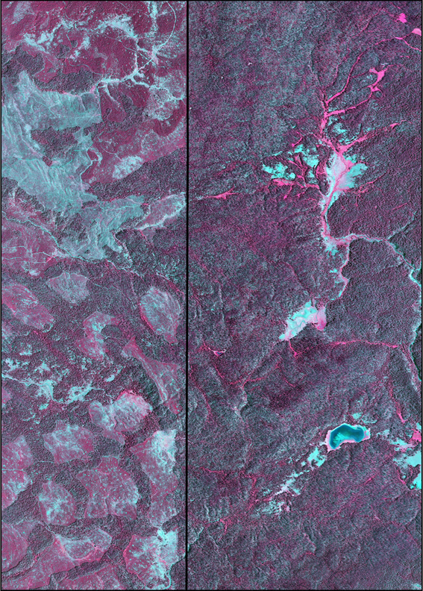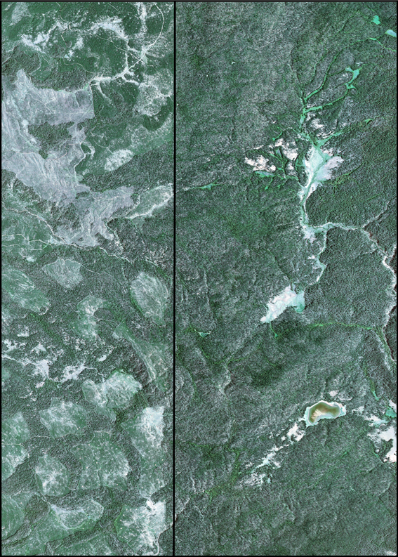

Figure 1: Aerial imagery in true color (left) and false color (right) of the boundary between Targhee National Forest and Yellowstone National Park

*Analysis*

In order to do this, we had to classify our image into different land cover types using Envi, a spectral image processing software. We did a supervised classification and used training data to specify pixels that belonged to certain cover types. The cover types we classified our image into were old forest, growing forest, sparse forest, bare ground, and water (Figure 2). We decided to use these classes because we wanted to look at the differences between the various stages of forest growth in both landscapes. After completing our classification, we re-examined the image and its classes to see if the patterns were correctly classified. To correct areas of the image where the classification was not as accurate, we added more training points and re-ran the supervised classification.

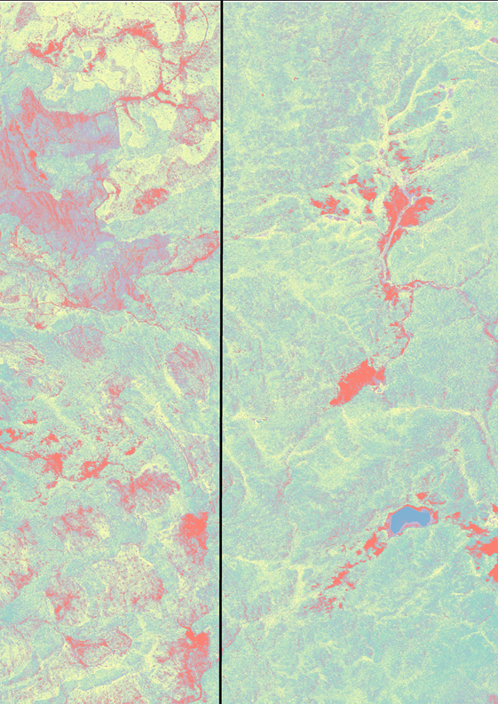

Figure 2: Classified image of the study area with five different land covers: old forest, growing forest, sparse forest, bare ground, and water

To compare fragmentation patterns between TNF and YNP, we delineated two separate landscapes along the park-forest border. Once we had our two separate images, we changed the resolution of our imagery to from 0.5 meters to 2 meters. After checking the images visually to make sure the patterns were still visible, we uploaded them to Fragstats, a spatial analyst software.

*Metrics*

We ran multiple metrics in order to quantitatively describe the differences between the two landscapes. We chose two class metrics and four landscape metrics. Class metrics quantify different patterns for each specific class within a landscape. One aspect we wanted to examine was the difference in amounts of land covers between the two images. By looking at the image, we could tell that there was more bare ground in TNF, but we wanted to find the difference of other classes that weren’t so obvious. In order to do this, we ran the Percentage of Landscape metric on each individual class. The Percentage of Landscape metric measures the proportional abundance of each land cover type in the landscape. This metric ranges from 0 to 100, where lower numbers means that the class is less common in the landscape and higher numbers means the class is abundant throughout the landscape. This metric accounted for the difference in size between our two landscapes because it gives a relative area.

We also wanted to look at how close land cover types were to each other, to see whether the clear-cutting had any effect on the location of class types relative to each other. The Aggregation Index showed us how clumped together each class was to itself. Aggregation Index measures the ratio of the observed number of like adjacencies to the maximum number of like adjacencies. It only looks at like adjacencies with the focal class and not with other class types. This metric also ranges from 0 to 100, where lower numbers correspond to disaggregation and higher numbers to increasing aggregation. The outside edges of our landscape were not included in this metric which was helpful since our boundaries were not visible boundaries on the landscape. This metric is also scaled, so we were able to compare this metric across different sized classes and landscapes.

Landscape metrics include all of the classes in a given landscape and calculate one statistic that explains the pattern of the entire landscape. Contagion Index measures the extent to which pixels of land cover types are aggregated. This index is also standardized from 0 to 100 and can be used to compare landscapes of different sizes. Values closer to 0 occur where patch types are disaggregated and interspersed. Higher values indicate aggregation of patch types. We decided to run this metric because Contagion Index is the only landscape metric in its category and we wanted to see if the metric could tell us anything about the difference in pattern between the two landscapes. We also looked at Edge Density, to give us an idea of how much edge between patches could be found in each image. Edge Density measures the complexity of the shapes of patches by adding up the lengths of all edges, dividing by the total landscape area, and multiplying by 10,000 to convert to hectares. This metric has a minimum value of 0 and has no maximum limit. A value of 0 occurs when the entire landscape consists of one patch. Because this metric gives edge length on a per unit area basis, it can be compared between landscapes of differing size.

The size and number of patches were items we wanted to analyze and thus we ran the Largest Patch Index and Patch Density metrics. Largest Patch Index measures dominance by quantifying the percentage of total landscape area comprised by the largest patch. This metric ranges from 0 to 100 percent where 100 means the patch covers the entire landscape and as the metric approaches 0, the patch covers a small amount of the total landscape. Patch Density measures the number of patches on a per unit area basis which allows comparison between landscapes of various size. This metric ranges from 0 to a maximum constrained by the cell size of the image. The maximum Patch Density value occurs when every cell in the image is a separate patch. For all of the above metrics, we decided to use the 8-neighbor rule, which refers to how patches are classified. An 8-neighbor rule, compared to a 4-neighbor rule, will create less patches in a landscape since two cells are considered connected even if they are only touching diagonally. The 8-neighbor rule was the best choice for our study because of the small resolution size of our image. Any plant or animal species that we would want to study the effects of fragmentation on would easily be able to move to a diagonal cell since each cell is only 2 meters by 2 meters.

**Results**

We found that there are higher percentages of sparse forest and bare ground in TNF and a higher percentage of old forest in YNP (Figure 3). The old forest is more aggregated in YNP while the sparse forest is more aggregated in TNF (Figure 4).

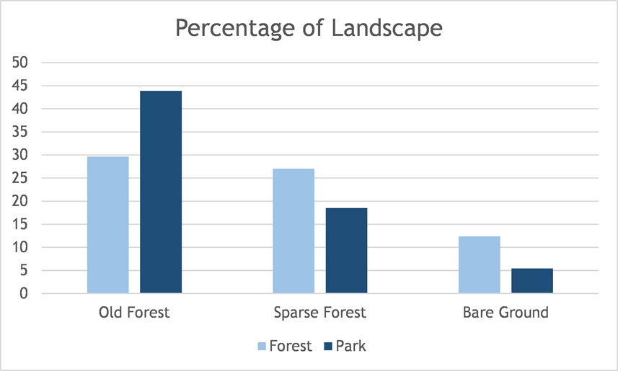

Figure 3: Percentage of Landscape calculated for old forest, sparse forest, and bare ground within Targhee National Forest and Yellowstone National Park

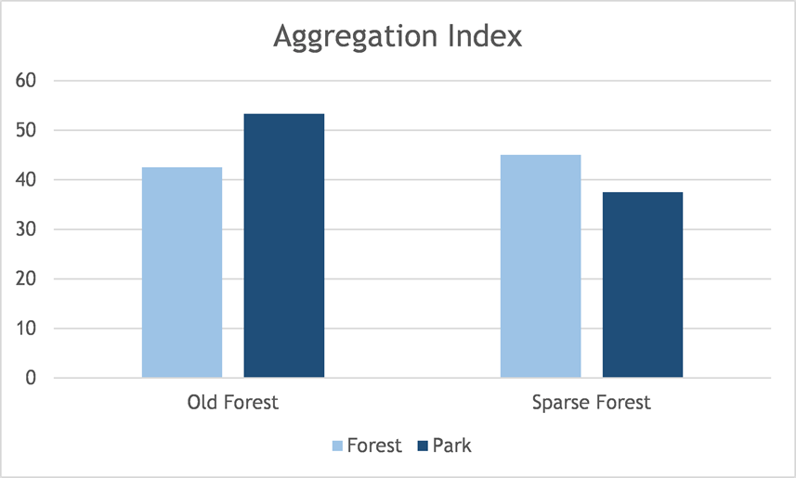

Figure 4: Aggregation Index calculated for old forest and sparse forest within Targhee National Forest and Yellowstone National Park

We found the largest patch to be five times larger in YNP than in TNF. There are 5140 meters per hectare of edge in TNF while only 5107 meters per hectare of edge in YNP. The Contagion value was higher in YNP than in TNF. There are more patches per 100 hectares in TNF than in YNP (Figure 5).

|  |  |  |  |  |
| --- | --- | --- | --- | --- |
|  | Largest Patch Index | Edge Density | Contagion | Patch Density |
| Forest | 5.3349 | 5140.8284 | 22.9585 | 25990.425 |
| Park | 25.4496 | 5107.6811 | 28.2784 | 23499.11 |
| Difference | 20.1147 | 33.1473 | 5.3199 | 2491.315 |

Figure 5: Metrics that were calculated at a landscape scale for both Targhee National Forest and Yellowstone National Park

**Discussion**

Class-level metrics related to aggregation are useful in examining fragmentation in a landscape (Neel et al. 2004). Aggregation Index shows differences between the two landscapes we studied, suggesting that there is a difference in fragmentation between YNP and TNF. Our results suggest that the old-growth forest is more clumped together in the national park because it hasn’t been fragmented by clear-cutting like in the national forest. Similarly, the sparse forest is more clumped together in the national forest because the forest is starting to grow back in large, homogenous areas where clear-cutting occurred.

Aggregation was also measured at a landscape-level with the Contagion metric. By looking at all of the land cover classes simultaneously, we found that YNP is more aggregated than TNF. From this, we can conclude that there are large areas of the same habitat next to each other in YNP and the habitat is more dispersed throughout the landscape in TNF. Large areas of habitat allow for animals to thrive. In an area like TNF, where much of the native vegetation has been destroyed, the number of patches has a negative effect on the availability of habitat for the native species (Crouzeilles et al. 2014). We found a large number of patches in TNF compared to YNP. This means that the habitat in TNF may not be suitable for many animals. To counteract this problem, we should try to connect these patches to each other to enlarge them and create a larger area of habitat for the animals still living there.

Tinker et al. (1998) found that clear-cutting and roads caused Edge Density and Patch Density to increase in Bighorn National Forest. Our study results also show a larger amount of Edge Density and Patch Density in TNF, where clear-cutting has occurred. This makes sense intuitively because logging will break up patches of forest, creating more patches and more edge around the patches. Since these patches are being broken up, it also makes sense for these patches to be smaller than the undisturbed patches in YNP. This is confirmed in our Largest Patch Index results. This large amount of Edge Density present in TNF is also concerning when looking at studies that have been done about pests, such as the mountain pine beetle (Chen et al. 2014) and how alien species respond to edges made by roads and clear-cutting (Pauchard and Alaback 2006).

YNP and TNF have differing proportions of land cover types due to logging and other commercial activities in the national forest. The old-growth forest has been cut down in the national forest. Where the old forest used to be, there is now bare ground and sparse forest where trees have begun to grow again. The logging of this old-growth forest is an active destruction of grizzly bear habitat (Apps et al. 2004). This disturbance of tree stands also impacts small mammals. Simard and Fryxell (2003) found that “protected” tree stands produced a much higher density of seeds than “disturbed” tree stands, which supports more diversity among small mammals.

Since Edge Density has increased in TNF, there is a potential for deer to make their home-ranges smaller in areas where clear-cutting has occurred (Said and Servanty 2005). This could potentially change the ranges of their predators or other ecosystem processes. Additional research on deer in this area would be helpful to measure the impact of forest fragmentation in TNF versus the natural landscape of YNP.

Elk and wolves living in this ecosystem are also impacted by human disturbance. Elk tend to stay away from areas with humans or human-made clearings (Frair et al. 2005) while wolves stay away from clearings during their denning periods (Houle et al. 2009). Our study showed that bare ground and the amount of edges were higher in TNF. These results clearly show that humans are clearing away patches of trees. The deforestation that is occurring in TNF may be pushing the elk and wolves out of their native habitat.

From our study and the Tinker et al. (2003) study, we can see the impact that humans have had on the landscape in the Greater Yellowstone Area. Although YNP has been burned extensively, there is still a lot less fragmentation there than in the clear-cut TNF. This shows that humans should be actively trying to mimic natural disturbances instead of cutting down large patches of trees. Keeping the landscape in its natural state will protect the land for future generations, while still allowing for some human use of the land.

Since the landscape metrics we ran show the difference in landscape pattern and in fragmentation between TNF and YNP, we can now analyze other landscapes in other locations or owned by other groups and compare those locations to each other and to TNF and YNP. By examining the differing amounts of fragmentation and their ecosystems, we will be able to see how much of an effect fragmentation can have on the plants and animals living in the forest.

Knowing how the difference in management styles affects the pattern of the landscape can help us know how other areas will change over time. We can expect that places owned by the U.S. Forest Service will encounter logging and other commercial activities that will change the landscape while places managed by the National Park Service will be protected in their natural state. This has implications for the conservation of threatened and endangered species. In areas where these species are present, we should actively work on protecting their habitat by making sure the land is owned by someone with a management style similar to the National Park Service.

**Conclusion**

The landscape patterns found in Yellowstone National Park and Targhee National Park are quantitatively different from each other, as measured by the landscape metrics: Percentage of Landscape, Aggregation, Largest Patch Size, Edge Density, Contagion, and Patch Density. This is due to human impacts in TNF such as clear-cutting and other commercial activities while YNP is a protected ecosystem. Logging has led to habitat fragmentation in TNF that has far-reaching effects throughout the ecosystem, impacting wildlife, invasive species, pests, and tree growth. Future researchers can continue to examine landscape patterns throughout the world to determine the areas that need to be preserved and the areas that need to be restored.

**References**

Allin, C.W. 1987. Park service v. forest service: Exploring the differences in wilderness management. Policy Studies Review 7: 385-394.

Apps, C.D., McLellan, B.N., Woods, J.G. and Proctor, M.F. 2004. Estimating grizzly bear distribution and abundance relative to habitat and human influence. Journal of Wildlife Management 68: 138-152.

Boucher, Y., Arseneault, D., Sirois, L. and Blais, L. 2008. Logging pattern and landscape changes over the last century at the boreal and deciduous forest transition in Eastern Canada. Landscape Ecology 24: 171-184.

Buechner, M. 1987. Conservation in insular parks: Simulation models of factors affecting the movement of animals across park boundaries. Biological Conservation 41: 57-76.

Crouzeilles, R., Prevedello, J.A., Figueiredo, M.S.L., Lorini, M.L. and Grelle, C.E.V. 2014. The effects of the number, size and isolation of patches along a gradient of native vegetation cover: how can we increment habitat availability? Landscape Ecology 29: 479-489.

Frair, J.L., Merrill, E.H., Visscher, D.R., Fortin, D.F., Beyer, H.L. and Morales, J.M. 2005. Scales of movement by elk (Cervus elaphus) in response to heterogeneity in forage resources and predation risk. Landscape Ecology 20: 273-287.

Houle, M., Fortin, D., Dussault, C., Coutois, R. and Ouellet, J. 2009. Cumulative effects of forestry on habitat use by gray wolf (Canis lupus) in the boreal forest. Landscape Ecology 25: 419-433.

McGarigal, K., Cushman, S.A. and Ene, E. 2012. FRAGSTATS v4: Spatial Pattern Analysis Program for Categorical and Continuous Maps. Computer software program produced by the authors at the University of Massachusetts, Amherst. Available at the following web site: http://www.umass.edu/landeco/research/fragstats/fragstats.htm

Neel, M.C., McGarigal, K. and Cushman, S.A. 2004. Behavior of class-level landscape metrics across gradients of class aggregation and area. Landscape Ecology 19: 435-455.

Pauchard, A. and Alaback, P.B. 2006. Edge type defines alien plant species invasions along Pinus contorta burned, highway and clearcut forest edges. Forest Ecology and Management 223: 327-335.

Piekielek, N.B. and Hansen, A.J. 2012. Extent of fragmentation of coarse-scale habitats in and around U.S. National Parks. Biological Conservation 155: 13-22.

Said, S. and Servanty, S. 2005. The influence of landscape structure on female roe deer home-range size. Landscape Ecology 20: 1003-1012.

Simard, J.R. and Fryxell, J.M. 2003. Effects of selective logging on terrestrial small mammals and arthropods. Canadian Journal of Zoology 81: 1318-1326.

Tinker, D.B., Resor, C.A., Beauvais, G.P., Kipfmueller, K.F., Fernandes, C.I. and Baker, W.L. 1998. Watershed analysis of forest fragmentation by clearcuts and roads in a Wyoming forest. Landscape Ecology 13: 149-165.

Tinker, D.B., Romme, W.H. and Despain, D.G. 2003. Historic range of variability in landscape structure in subalpine forests of the Greater Yellowstone Area, USA. Landscape Ecology 18: 427-439.